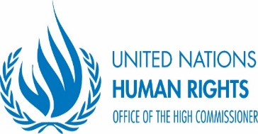
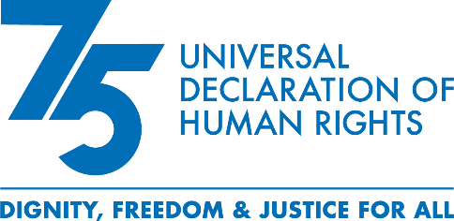

Outcome Document
Regional Consultation on the Right to development as a tool for transformation and its nexus with peace and security in Africa
8 September 2023
Addis Ababa, Ethiopia

- The Africa-wide High-level Regional Consultation on the Right to Development as a tool for transformation in Africa and its nexus with Peace and Security was convened on 8 September 2023 at the AU premises in Addis Ababa, Ethiopia by the African Union Commission (AUC) and the United Nations Office of the High Commissioner for Human Rights-East Africa Regional Office (OHCHR-EARO) in the context of the year-long commemoration of the 75th anniversary of the Universal Declaration of Human Rights (Human Rights-75). In attendance were a total of 200 participants representing a cross-section of organizations including the AU and its organs, Regional Economic Communities, senior representatives of the African Union member States including ministers, the Civil Society, National Human Rights Institutions, Youth organizations, UN Entities, Academia, Private Sector, Diplomatic Corps, and international development institutions. The meeting was officially opened by H.E. Mr. Demeke Mekonnen, Deputy Prime Minister, and Minister of Foreign Affairs of the Federal Democratic Republic of Ethiopia.

- Fruitful discussions were held with active contribution of African Union Member States. Emphasis was placed on the need to leverage the Right to Development Framework to tackle the multiple challenges Member States are facing around youth unemployment, poverty and inequality, education, debt restructuring, corruption, illicit financial flows, and gender inequality, among others, within the framework of the UN Agenda 2030 and AU Agenda 2063. Participants reaffirmed their commitment to advance the complementarity between development, human rights and peace and security and pointed out the catalytic potential of the Right to Development to further the realization of economic, civil, social, political and cultural rights without leaving anyone behind. The importance of targeted investments on economic, social, and cultural rights including by promoting a human rights economy was also underlined.

- Following the discussions under the various sessions, the following pledges and recommendations were made to advance the strategic operationalization of human rights and the right to development in Africa:

- Promote solidarity and partnerships, to make the right to development a reality for all through human rights-based policies and more importantly, their implementation – from curbing corruption and illicit financial flows to debt relief; and from climate action to fairness in global governance - including in trade, investment, and finance.

- Call for the African Union and the United Nations system to redouble their efforts to address the challenges in the global financial architecture which will be critical to enhance the capacity of African countries to promote their development in their respective states. In the same vein, encourage African countries to work for greater inclusivity, gender equality, socioeconomic and redistributive justice for its people.

- Take steps to accord the right to development and other social, civil, economic, and political rights explicit recognition in national policy and legal frameworks in African countries including in constitutions and national development plans as appropriate. In this respect, consider providing the necessary support to the AU human rights organs to enable them to discharge their responsibilities. Such support would include taking steps to ratify the Protocol to the African Charter on Human and Peoples' Rights establishing the African Court on Human and Peoples' Rights and making a separate declaration under Art. 34(6) to recognize the competence of the court to receive cases from individuals and civil society.

- Ensure broad consultation and participation is held in ongoing negotiation and implementation processes related to the African Continental Free Trade Area (AfCFTA) and address the effects of trade and investment measures particularly on populations at risk of being left behind, including women and informal cross-border traders.

- Ensure the active, free, and meaningful participation of rights holders in development policy making implementation and practice by taking the necessary legislative, policy and administrative measures at national level.

- Actively support the finalization and adoption of the draft international covenant on the right to development by the General Assembly.

- Recommend the appointment of the AU Champion on the Right to Development to the Sub-Committee on Governance, Democracy and Human Rights of the AU Permanent Representatives Committee, with no cost implication to support AU Member States at all levels to address challenges related to the operationalization of the right to development in Africa.

- Request the AUC Commissioner for Political Affairs, Peace and Security and Regional Representative of OHCHR-EARO to submit this outcome document to the Human Rights 75 High Level event in commemoration of the 75th anniversary of the Universal Declaration of Human Rights, which will be organized by the Office of the High Commissioner for Human Rights and held in Geneva from 11-12 December.

