_unlogo **United Nations Office of the**

**High Commissioner for Human Rights**

**What our part of the United Nations has done to include people with disabilities in 2020**

**This is about our work on the United Nations plan to include people with disabilities**

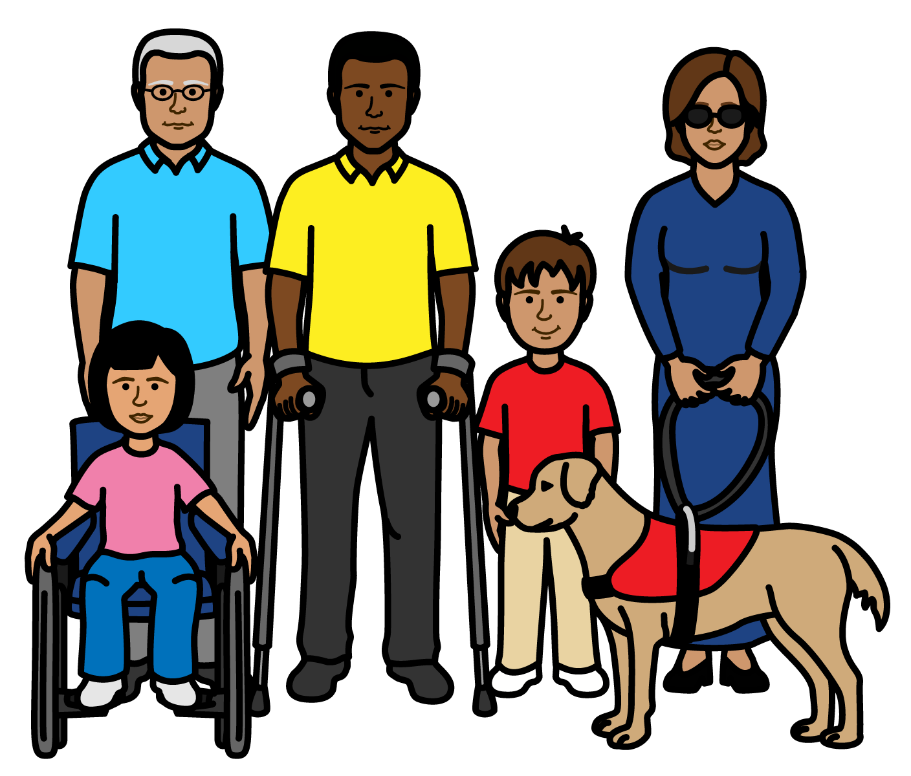

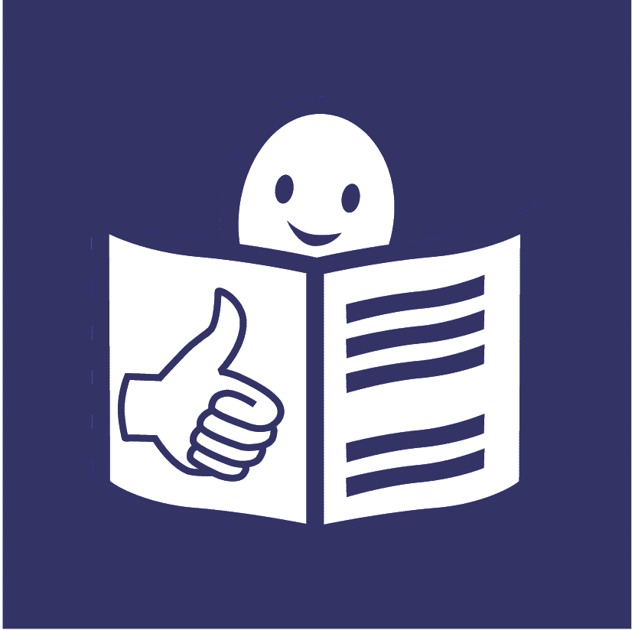

**Progress report on the United Nations Disability Inclusion Strategy**

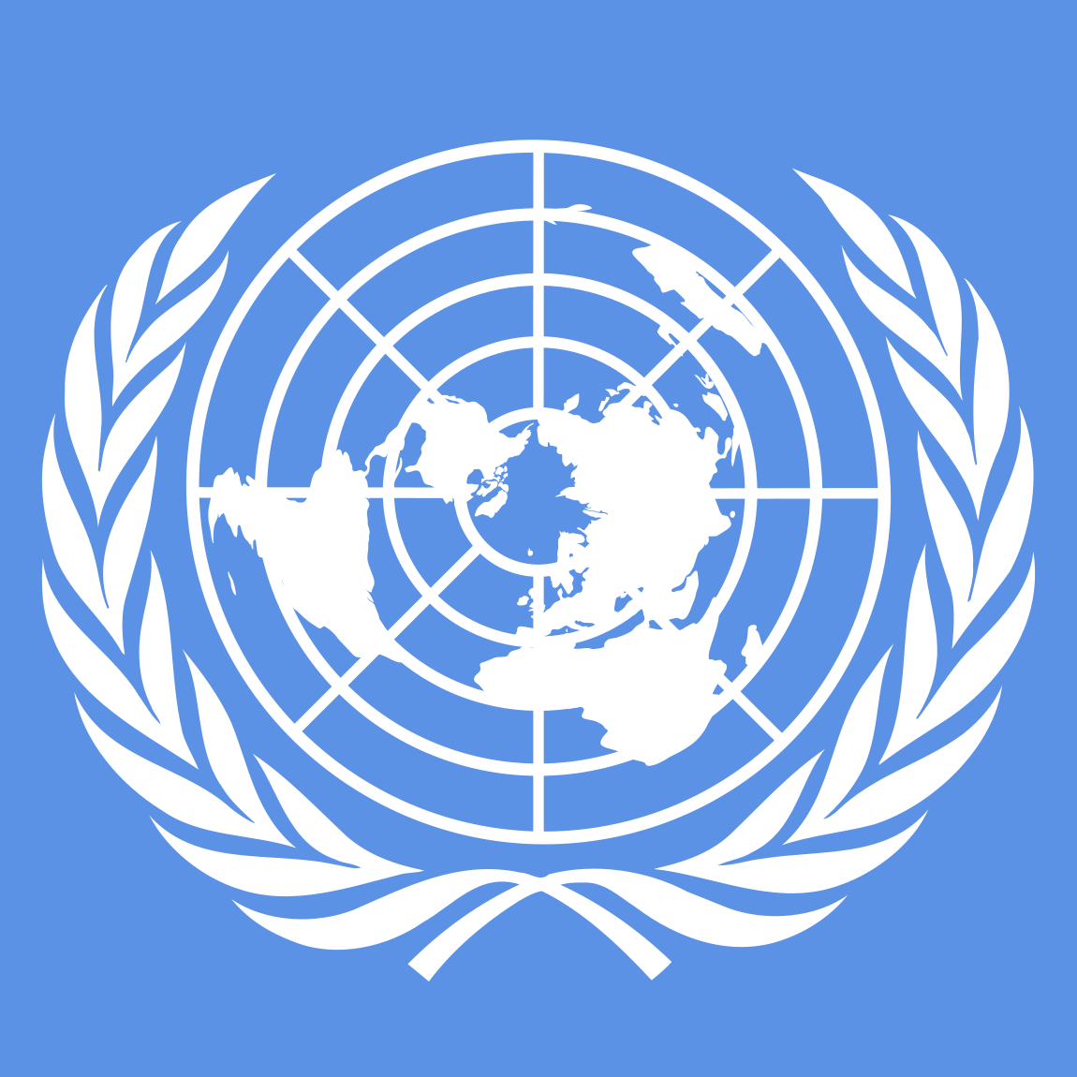**About us**

We are called the **Office of the High Commissioner for Human Rights (OHCHR)**.

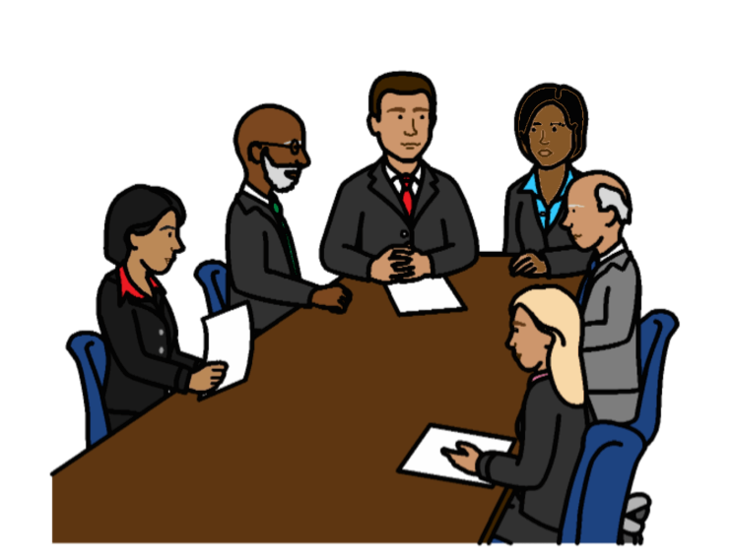

We are part of the United Nations (UN).

The United Nations is a group of countries that work to make the world better and safer.

**About this report**

The United Nations wants people with disabilities to be part of everything it does.

This means people with disabilities should not be left out.

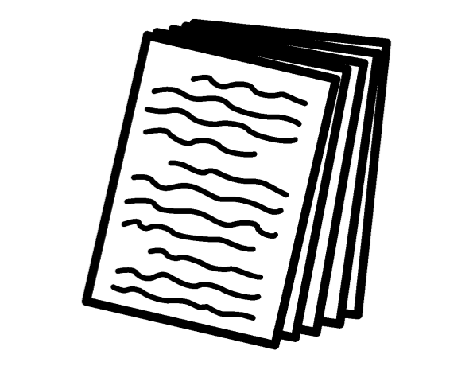

The United Nations has a plan about how to include people with disabilities.

It is called the **Disability Inclusion Strategy**.

The plan is on this website:

<https://www.un.org/en/content/disabilitystrategy/assets/documentation/Easy_to_Read.pdf>

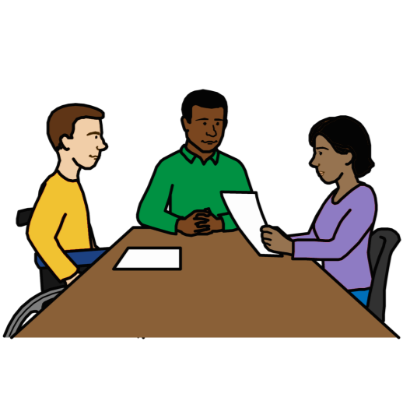

Different parts of the United Nations should say how they are doing with the plan every year.

This report tells you what we have done to include people with disabilities

in 2020.

There are 15 areas of work that we had to look at.

We had to say how well we are doing on each area that we work on.

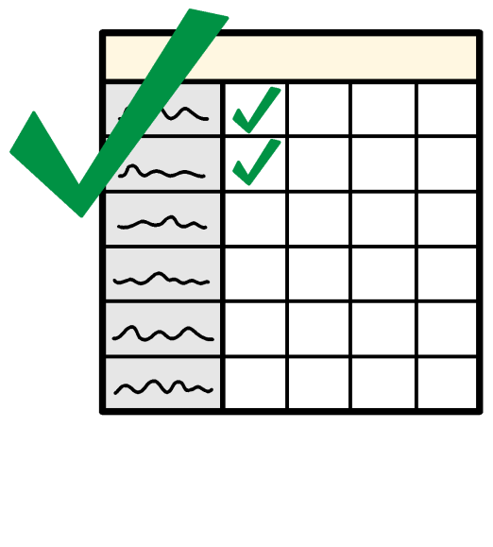

This report tells you more about what we are doing well on.

And what we need to do more on in 2021.

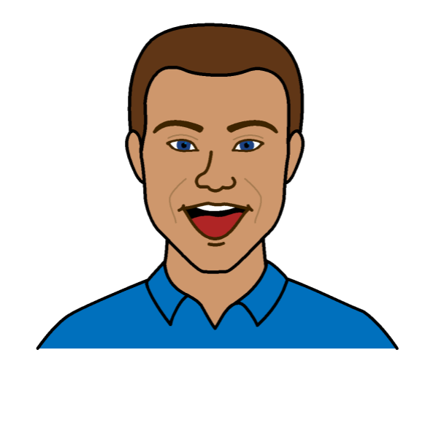**How we are doing so far to include people with disabilities**

1. **We are doing even better than we need to on some things**

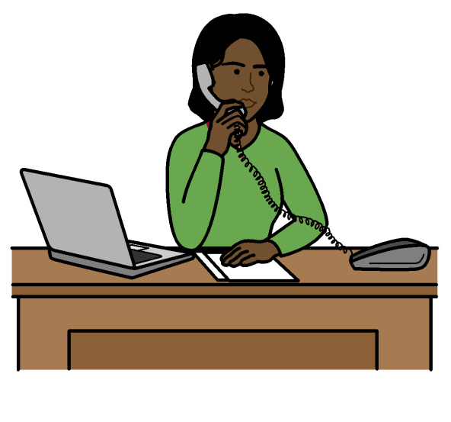

**We are doing even better than we need to on the areas of work below:**

**Making sure that senior managers make the United Nations plan about people with disabilities happen.**





**Making sure that we have a plan about how to include people with disabilities.**



**Working with other parts of the United Nations to include people with disabilities.**

Some examples of our work:

We have senior people in charge of human rights work for the United Nations.

They really support our work on the rights of people with disabilities.

From 2021 our senior managers will have to show what they have done to include people with disabilities.





We made a plan in 2020 about how we will include people with disabilities.

We will keep working on the plan.



We have worked a lot with the United Nations and other people on the rights of people with disabilities.

For example, we helped to make the United Nations plan about how to include people with disabilities.

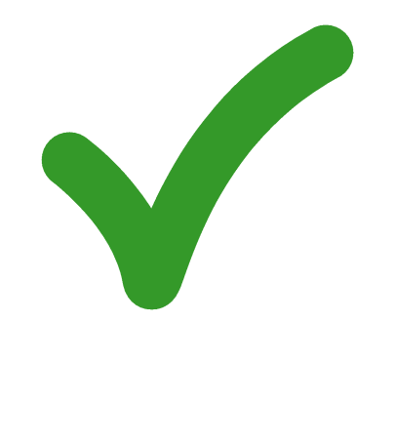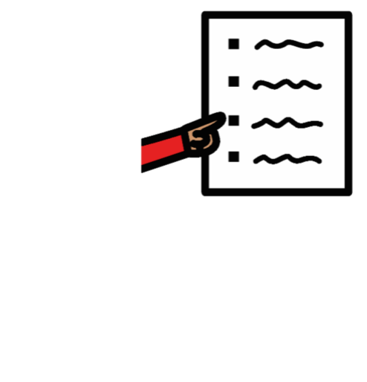**2. We are doing everything we need to do on some things**

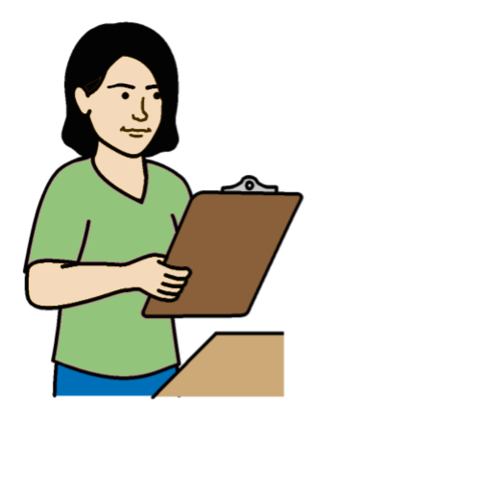**We are doing everything we need to do on the areas of work below:**

**Making sure that people check how projects are working for people with disabilities and their rights.**

**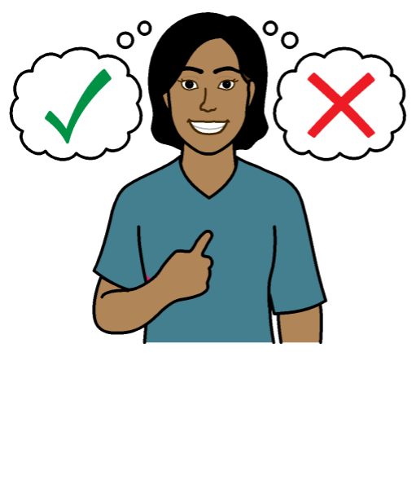**

**Making sure there are people who know about disability and human rights.**

**And making sure that people can meet to talk about disability.**

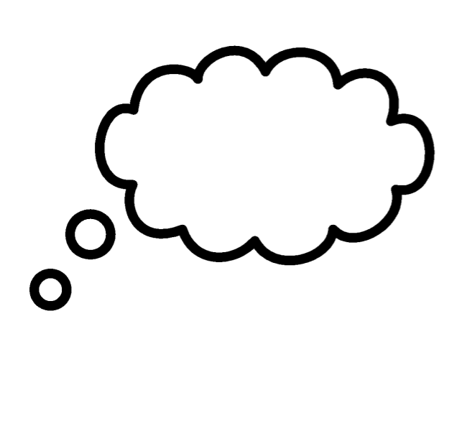Some examples of our work:

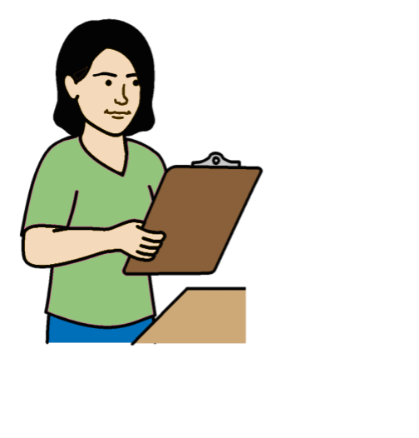

In 2020 we looked at how some of our projects are working for people with disabilities.

This includes work we are doing in different countries.

And work to stop violence.

We will check more projects in 2021.

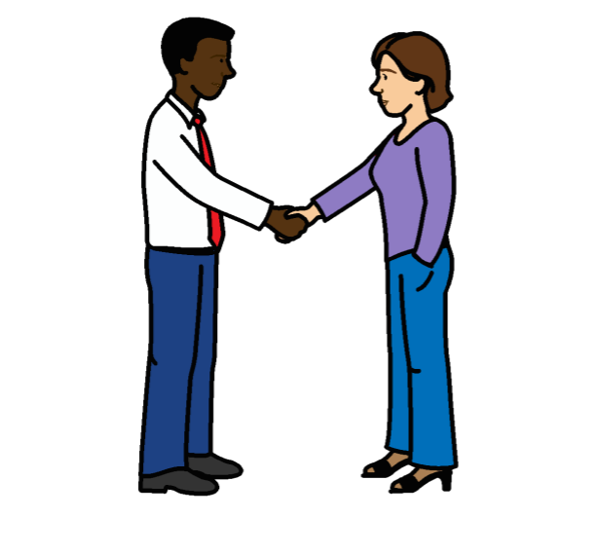

We have a person in charge of making sure that we include people with disabilities.

We now have someone else to support that person.

We set up a new way for the United Nations to share information and training about people with disabilities.

**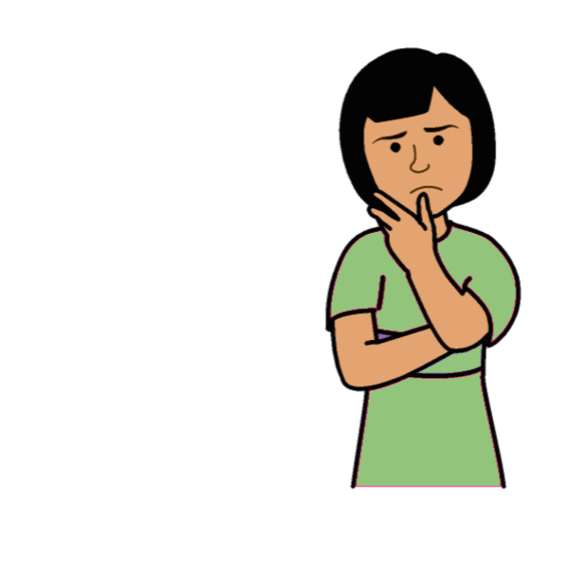3. We are not doing everything we need to yet on some things**

**We are not doing everything we need to yet on the areas of work below:**

**Making sure that our main plan**

**talks about people with disabilities and their rights.**

**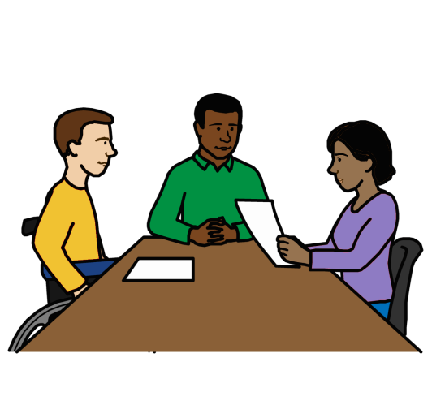**

**Helping more people with disabilities to work for the United Nations**

**and do well.**

**Making sure that people with disabilities get the right support to take part and have their say**.

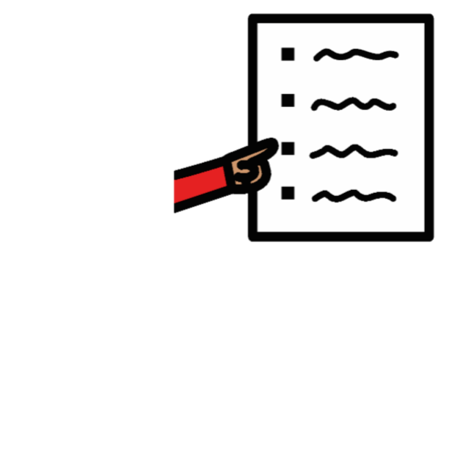Some examples of our work:



The main plan about our work includes people with disabilities.

That means we are looking more closely at the rights of people with disabilities in our work.

****

We want many different groups of people to work for us and do well.

This includes more staff and managers with disabilities.

We have a new person to help us make that happen.

We set up a group to look at how to include different groups of people in our work.

They will make a plan about what we need to do.

****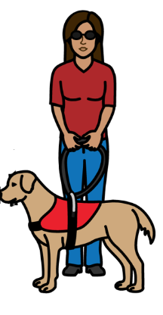People with disabilities can ask us for extra support if they need it.

For example, equipment or support to go to our events.

**But there are more things that we need to do in 2021.**

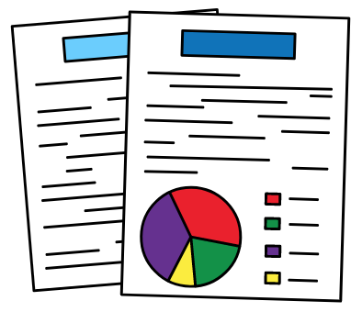For example:

We need better information about people with disabilities to help plan our work.

We will work with other parts of the United Nations to decide how to get the information.

****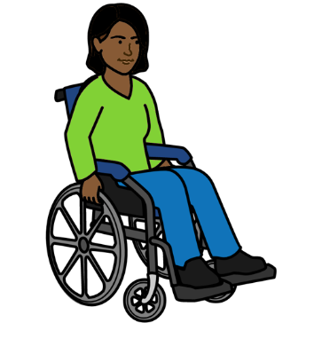

We will start a new way for people with disabilities to ask us for extra support if they need it.

**4. We are not doing enough work on some things at the moment**

**We are not doing enough on the areas of work below:**

**Working with people with disabilities and making sure they can have a say.**

****

**Making sure that everything is easy for people with disabilities to use and take part in.**

**Making sure that projects include the rights of people with disabilities and what they need.**

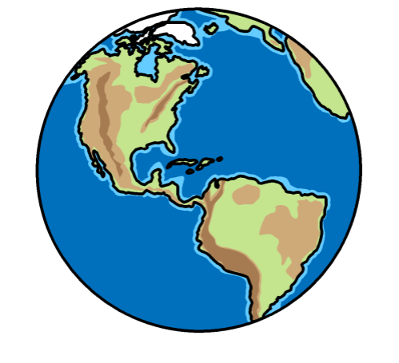

**Making sure that we include people with disabilities in our work in different countries.**

**Making sure that staff get information and training about how to include people with disabilities.**

**Making sure that the United Nations:**

* **Talks about people with disabilities in the right way**
* **Helps people to know about people with disabilities and their rights**

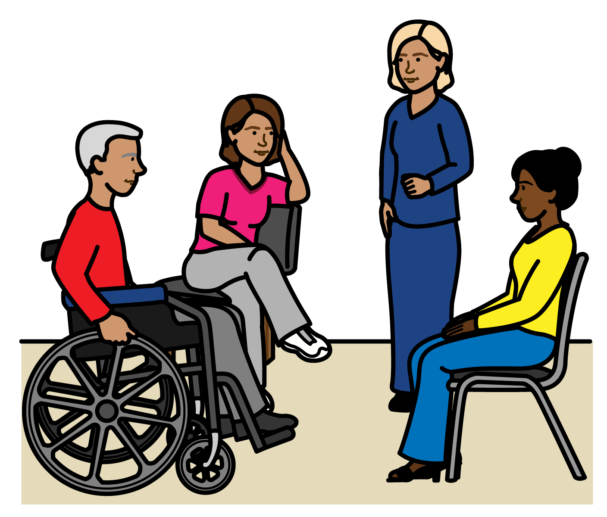

Some examples of our work:

We often ask people with disabilities what they think about things to do with disability.

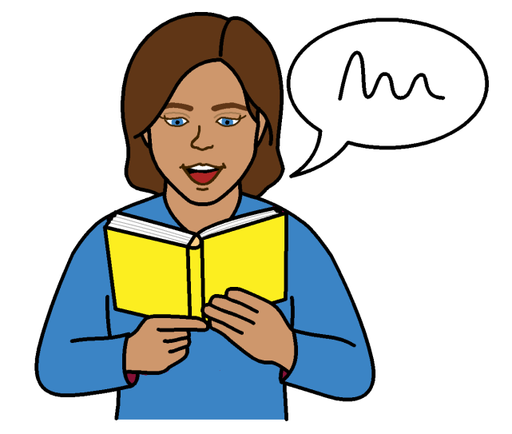

We have made some documents easier for people with disabilities to read and understand.

We work in different countries.

We check if people are getting their human rights.

We are looking more at human rights problems for people with disabilities.

**But there are more things that we need to do in 2021.**

For example:

We need a better way to check how people with disabilities are having a say in our work.

****

We will look at how to make things easy for people with disabilities to use and take part in.

We have not done enough on that yet.

We want to make more documents easier for people with disabilities to understand if we can.

We will make new rules about

making sure that projects work well

for people with disabilities.

We will work with other parts of the United Nations on the new rules.



We will give better training to staff who need it.

The training is about what they need to do to support people with disabilities.

For example, how to give extra support to people with disabilities who need it.

In 2021 we will have better rules about how to include people with disabilities in our information.

For example, how to talk about people with disabilities in the right way.

We will also look at our information to see what needs to change.

**Our work on the rights of people with disabilities during Covid-19**

Covid-19 is an illness that many people in the world have been getting.

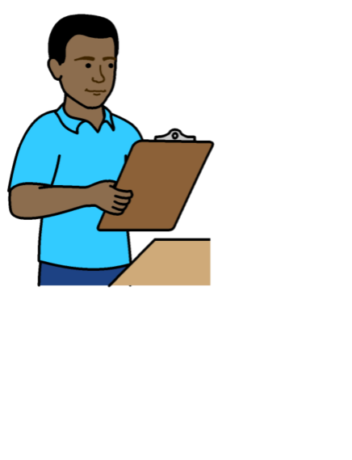

Some of the main work we have done:

We checked what was happening to people with disabilities in many countries during Covid-19.

We helped people in many countries to know about the rights of people with disabilities.

We helped governments and organizations to support the rights of people with disabilities.



We helped people with disabilities to take part in work on Covid-19.

**The Picture Communication Symbols ©1981–2016 by Mayer-Johnson LLC a Tobii Dynavox company. All Rights Reserved Worldwide. Thousands of resources available for free at** [**www.boardmakeronline.com**](http://www.boardmakeronline.com/)