A/HRC/50/CRP.4
30 June 2022

English only
Human Rights Council
Fiftieth session
13 June–8 July 2022
Agenda item 10
Technical assistance and capacity-building
Situation of human rights in Ukraine in the context of the armed attack by the Russian Federation: 24 February – 15 May 2022
Office of the United Nations High Commissioner for Human Rights
Conference room paper

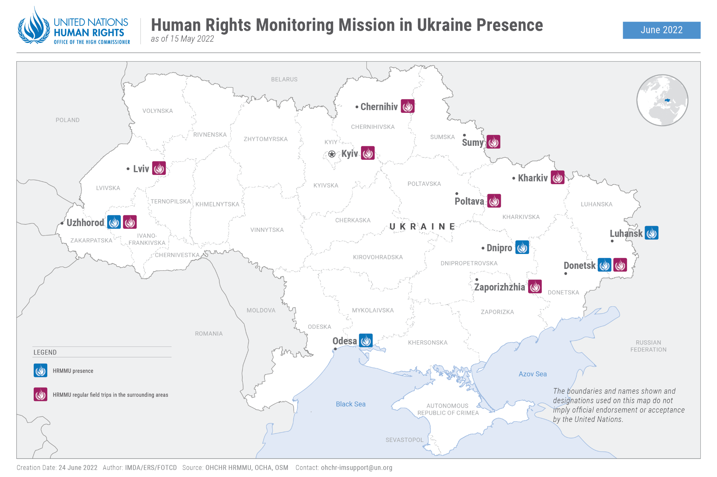

- Executive summary
- This report by the Office of the High Commissioner for Human Rights
(OHCHR) covers violations of international humanitarian law (IHL) and international human rights law that have occurred in the course of the ongoing armed attack by the Russian Federation against Ukraine. It covers the period from 24 February 2022 until 15 May 2022 and is based on the work of the United Nations Human Rights Monitoring Mission in Ukraine.
2. In the morning of 24 February, the Russian Federation launched an armed attack against Ukraine. The armed attack and associated hostilities have led to a grave deterioration in the human rights situation across the country.
3. During the reporting period, OHCHR recorded a total of 8,368 civilian casualties, with 3,924 persons killed and 4,444 persons injured. At least 95 girls, 98 boys, 985 women, 1,519 men and 1,227 persons whose sex is still unknown were killed from 24 February to 15 May, and at least 104 girls, 126 boys, 604 women, 907 men and 2,703 persons whose sex is still unknown were injured. However, actual casualty numbers are much higher, since these figures only include the cases that OHCHR has been able to fully verify.
4. As a result of hostilities, civilian infrastructure and housing have been severely impacted. OHCHR recorded damage or destruction to 182 medical facilities and 230 educational facilities as a result of attacks. The attacks also endangered the lives of civilians and infringed on the enjoyment of other human rights, including the rights to health, work, education and housing.
5. Hostilities have also had a severe negative impact on people and groups in situations
of vulnerability, including persons with disabilities and older persons. OHCHR has found that many of them were not able to access bomb shelters or quickly evacuate and had to rely on the assistance of their family members and others, when such assistance was even available.
6. The intensive and wide-scale hostilities have caused mass displacement of the civilian
population, with grave implications for the enjoyment of their human rights, including economic and social rights. The United Nations High Commissioner for Refugees (UNHCR) reported that over 6.2 million persons had fled the country by 15 May, and the International Organization for Migration (IOM) indicated that over 8 million were internally displaced. OHCHR also has concerns that the volatile security situation and other factors are restricting freedom of movement to and from regions occupied by Russian armed forces or affiliated armed groups, reducing civilians’ access to medical assistance, social protection and other basic services in Government-controlled territory. OHCHR has received reports that people attempting to leave Kherson, for example, have been denied permission to exit the region at checkpoints.
7. OHCHR monitored the processes of evacuating civilians from Mariupol
towards Government-controlled territory, or towards territory controlled by Russian armed forces and affiliated armed groups and further towards the Russian Federation. OHCHR is concerned about the manner in which the ‘filtration’ process, which evacuees are obliged to go through when passing Russian armed forces’ checkpoints, is carried out.
8. The armed conflict has led to a wide range of human rights violations of both civilians
and combatants, including the rights to life, liberty and security of persons. OHCHR verified
numerous allegations of killings and summary executions, of arbitrary detention and enforced
disappearance, of torture and ill-treatment, and of conflict-related sexual violence.
- OHCHR has documented and verified allegations of unlawful killings, including
summary executions of civilians in more than 30 settlements in Kyiv, Chernihiv, Kharkiv and Sumy regions, committed while these territories were under the control of Russian armed forces in late February and March. In Bucha alone (Kyiv region), OHCHR documented the unlawful killings, including summary executions, of at least 50 civilians. Most victims were men, but there were also women and children. As the recovery, exhumation and identification of mortal remains is not yet over, the scale is yet to be fully assessed.
10. OHCHR is also concerned about the arbitrary detention and enforced disappearance of representatives of local authorities, journalists, civil society activists and other civilians by Russian armed forces and affiliated armed groups. OHCHR documented 248 cases of arbitrary detention (214 men and 33 women, 1 boy), some of which may amount to enforced disappearance, attributed to Russian armed forces and affiliated armed groups. Among those cases, OHCHR recorded that six victims (one woman and five men) were eventually found dead. OHCHR also documented 12 cases of enforced disappearance (11 men and 1 woman) by Ukrainian law enforcement of people suspected of providing support to Russian armed forces and affiliated armed groups.
- OHCHR documented numerous cases of the widespread use of extrajudicial
punishment against individuals alleged to be marauders, thieves, bootleggers, fake volunteers (fraudsters), drug dealers and curfew violators. During the reporting period, OHCHR documented 89 such cases (80 men and 9 women) in territory controlled by the Government of Ukraine and 3 cases in territory controlled by the Russian Federation and affiliated armed groups.
- OHCHR is also looking into mounting allegations of conflict-related sexual violence
(CRSV), although it remains difficult to properly assess the extent of violations, as survivors are often not willing or able to be interviewed. Many referral pathways are not functional and law enforcement authorities have limited capacity to address CRSV cases. OHCHR verified 23 cases of CRSV, mostly attributable to Russian armed forces. They occurred in different regions of Ukraine, including Kyiv and Chernihiv regions. Women and girls constitute the majority of victims, with rape, including gang rape, being the most common form of CRSV. A few cases concern acts such as forced public nudity, where the victims (both male and female) were alleged to be law-breakers in both Government-controlled territory of Ukraine and in territory-controlled by Russian armed forces.
- The treatment of prisoners of war by the parties also raised serious concerns. OHCHR
viewed an abundance of videos publicly available online depicting interrogation, intimidation, insults, humiliation, ill-treatment, torture and summary executions of prisoners of war on both sides. It has also received numerous other allegations of torture of prisoners of war by both sides, including through 44 interviews with prisoners of war. As of 15 May, OHCHR still had no reliable information about the exact numbers of prisoners of war on both sides.
- OHCHR is alarmed at the security risks faced by journalists and media workers in
Ukraine. OHCHR documented 16 cases of deaths of journalists and media workers during hostilities and recorded 10 more cases of injured journalists (21 men and 5 women), including four cases where survivors reported they may have been targeted because of their status as journalists. Moreover, many human rights defenders (HRDs) have been unable to perform their human rights work due to ongoing hostilities and large-scale displacement, which in turn has deprived vulnerable groups of their support. There are growing concerns about possible reprisals and retaliation against HRDs in areas controlled by Russian armed forces and affiliated armed groups.

II. Introduction
- Legal framework
15. The current situation in Ukraine is characterised as an international armed conflict between the Russian Federation and Ukraine. Both parties are bound by treaty and customary international humanitarian law (IHL) applicable to international armed conflicts, primarily the four Geneva Conventions of 1949, its 1977 Additional Protocol I, the 1907 Hague Convention IV with its annexed Regulations concerning the Laws and Customs of War on Land (Hague Regulations), and other IHL treaties and rules of customary IHL.

16. The Russian Federation and Ukraine are also bound by international human rights treaties and customary international human rights law. As recognised by the International Court of Justice and by United Nations treaty bodies, international human rights law continues to apply during armed conflict. The human rights obligations of States apply extraterritorially in all circumstances where States exercise jurisdiction or effective control.

17. Some human rights treaties allow for the suspension of the operation of certain human
rights obligations of State parties, within strict parameters. On 1 March, Ukraine notified the United Nations Secretary-General of the derogation from certain of its human rights obligations, in accordance with article 4 of the International Covenant on Civil and Political Rights (ICCPR) and article 15 of the Convention for the Protection of Human Rights and Fundamental Freedoms (ECHR), for the duration of the martial law introduced on 24 February pursuant to Decree No. 64/2022 “On the Introduction of Martial Law in Ukraine”. The martial law was introduced in the entire territory of Ukraine for a term of 30 days, and it was subsequently extended twice for 30 days (until 24 April and until 24 May respectively). The Russian Federation has referred to its armed attack on Ukraine as a “special military operation”, and has not notified the United Nations Secretary-General of any derogations from any human rights treaty.
- Methodology

18. The report is based on information gathered during 11 field visits, 3 visits to places ofdetention, and 517 interviews with victims and witnesses of human rights violations, as well as relatives of victims and their lawyers, Government representatives, members of civil society and other interlocutors. It also draws from information obtained from court documents, official records, open sources and other relevant material. Findings are based on verified information collected from primary and secondary sources that are assessed as credible and reliable. They are included in the report where the “reasonable grounds to believe” standard of proof is met, namely where, based on a body of verified information, an ordinarily prudent observer would have reasonable grounds to believe that the facts took place as described and where legal conclusions are drawn, that these facts meet all the elements of a violation. While OHCHR cannot provide an exhaustive account of all human rights violations committed throughout Ukraine, it obtains and verifies information through a variety of means in line with its established methodology, and bases its conclusions on verified individual cases.

19. OHCHR applies the same standard of proof when documenting conflict-related civilian casualties. In some instances, documenting conflict-related civilian casualties may take time before conclusions can be drawn, meaning that numbers of civilian casualties are revised as more information becomes available. It should be noted that the documentation of civilian casualties is based on a factual determination, and that not all civilian casualties are necessarily deaths or injuries in violation of IHL.

20. Information in this report is used in full respect of informed consent by all sources as to its use as well as OHCHR’s assessment of any risk of harm that such use may cause. This entailed removing identifying details to ensure the confidentiality of sources.

III. Impact of hostilities on the civilian population

- Conduct of hostilities – Context
“It is hard to remember the exact date of my concussion as under shelling you get into this endless process, which has no dates.”
- An internally displaced person from Kharkiv
21. On 24 February, Russian armed forces launched an armed attack against Ukraine. It
quickly became clear that the taking of major cities and population centres was one of the initial objectives of the military operations, resulting in extensive urban warfare, which included attacks striking civilian infrastructure in populated areas in major urban centres of Ukraine. Armed forces extensively used explosive weapons in populated areas – including missiles, heavy artillery shells and rockets as well as airstrikes. Both parties have placed military positions in residential areas. Russian armed forces besieged two Ukrainian cities, Mariupol and Chernihiv, by effectively encircling them.

22. From late February until the end of March, Russian armed forces advanced towards Kyiv. They took control of territory north of Kyiv in late February and began withdrawing at the end of March.

23. Russian armed forces also heavily shelled Kharkiv, the second-largest city in Ukraine.
Ukrainian armed forces conducted a counter-offensive in mid-May, pushing Russian armed forces back from the city. The coastal city of Mariupol was also under siege after being surrounded by Russian armed forces, trapping civilians for weeks. Civilians were in constant danger due to the heavy shelling of civilian objects, and suffered through a dire humanitarian crisis in the city.

24. Many other cities in Ukraine, including in territory controlled by Russian armed forces and affiliated armed groups, were impacted by hostilities and heavy shelling. Cities in western Ukraine were hit by long-distance missiles targeting military objectives nearby. Intense hostilities created deplorable conditions for the civilian population and their enjoyment of basic human rights, notably their rights to life, security, health, food, water, education and housing.

25. The IHL rules governing the conduct of hostilities, namely the principles of distinction, proportionality and precaution, are aimed at avoiding or at the very least minimising civilian casualties and damage to civilian objects. The high number of civilian casualties and the extent of destruction and damage caused to civilian infrastructure, as documented by OHCHR, raise significant concerns that attacks conducted by Russian armed forces did not comply with IHL. While on a much lower scale, it also appears likely that Ukrainian armed forces did not fully comply with IHL in eastern parts of the country.
- Means and methods – Areas of concern- Use of explosive weapons in populated areas, including cluster munitions

26. The vast majority of civilian casualties documented by OHCHR in Ukraine since 24 February were caused by the use of explosive weapons in populated areas, such as shelling from heavy artillery, including multiple launch rocket systems (MLRS), and missile and air strikes. Some of these weapons, such as MLRS, missiles and air bombs, can carry cluster munitions.

27. OHCHR has reasonable grounds to believe that both Russian armed forces and affiliated armed groups, as well as to a lesser extent Ukrainian armed forces, have been using weapons, in most cases MLRS and missiles, equipped with cluster munitions. OHCHR notes that the use of cluster munitions in densely populated areas is very likely to breach the prohibition of indiscriminate attacks. In addition, the level of civilian casualties and the level of damage to civilian infrastructure in each case documented by OHCHR suggest numerous failures to take constant care to spare the civilian population, civilians and civilian objects in the conduct of military operations, and to take all feasible precautions in attack.

28. On 24 February, 4 civilians (2 men, 2 women) were killed and ten injured (all adults whose sex is still unknown) as a result of a cluster munition attack by Russian armed forces on a hospital in Government-controlled Vuhledar. On 13 March, 9 civilians (7 adults, 2 children) queuing at an ATM in Mykolaiv were killed and 13 injured (11 adults, two children) as a result of a cluster munition explosion. On 24 March, 8 civilians (all adults) were killed and 15 (1 woman, as well as 13 adults and 1 child whose sex is still unknown) were injured as a result of a cluster munition attack by Russian armed forces on the humanitarian aid distribution centre in Kharkiv. Each case raised concerns of indiscriminate attack or deliberate attack against civilians or civilian objects.

29. There have also been incidents involving the use of cluster munitions in populated areas by Ukrainian forces, which have resulted in civilian casualties. For instance, on 22 March, one civilian was injured in Yenakiieve (Donetsk region) controlled by Russian affiliated armed groups, after interception of a missile carrying a cluster munitions warhead.

30. OHCHR is concerned that both the Russian Federation and Ukraine have been using Tochka-U missiles armed with cluster munitions in their conduct of hostilities. These 15-120 km range missiles lack precision and are able to carry warheads with 50 cluster sub-munitions and pose a significant threat to the lives of civilians. While OHCHR notes the Russian Federation’s claims that it had replaced Tochka-U missiles with the next generation Iskander missiles in 2019, OHCHR received credible information that Tochka-U systems were used by Russian armed forces in Ukraine after 24 February 2022. OHCHR was able to identify and corroborate at least 10 attacks by Russian armed forces and 25 attacks by Ukrainian armed forces with the use of Tochka-U missiles. On 10 April, a woman was killed as a result of an attack carried out with a Tochka-U missile on premises used to store military equipment and ammunitions in armed group-controlled Novoaidar (Luhansk region). In at least 20 cases, the missiles were carrying sub-munitions that hit populated areas. Ten such incidents have resulted in at least 279 civilian casualties (83 killed and 196 injured): four incidents in Government-controlled territory (65 killed and 148 injured), four in territory controlled by Russian affiliated armed groups (16 killed and 41 injured) and two in territory controlled by Russian armed forces (2 killed and 7 injured).

Emblematic attacks with the use of cluster munitions

31.On 14 March, Russian affiliated armed groups claimed to have intercepted a
Tochka-U missile equipped with a cluster munitions warhead over the centre of Donetsk. As a result of the detonation of four sub-munitions in the vicinity of the missile’s crash site, 15 civilians were killed (3 women, 1 man, and 11 adults whose sex is still unknown) and 36 injured (20 women, 14 men, 1 boy, and 1 adult whose sex is still unknown). Ukrainian armed forces denied any involvement in the incident.
32.On 8 April, cluster sub-munitions from a Tochka-U missile that fell on the
railway station in Kramatorsk killed 60 civilians (4 men, 16 women, 5 girls, 2 boys, and 33 adults whose sex is still unknown) and injured 111 (1 man, 1 woman, 3 girls, 3 boys, and 92 adults and 11 children whose sex is still unknown) waiting to be evacuated. The day before the incident, several thousand civilians could not evacuate from Kramatorsk and were waiting for three trains which had been delayed en route to Kramatorsk due to a railway bridge suffering damage from an air strike. In the absence of any clear schedule for the next departures, and owing to the volatile security situation, prospective evacuees had been gathering at the train station since early morning.

33.Ukraine accused Russian armed forces of deliberately targeting these civilians. The Russian Defense Ministry denied the accusation, arguing that it had not planned any military operations in the vicinity of Kramatorsk on that day.

Placement of military objectives near civilian objects and the use of human shields

34. OHCHR is concerned that in the course of hostilities, both Russian armed forces and
affiliated armed groups as well as Ukrainian armed forces took up positions either in residential areas or near civilian objects, from where they launched military operations without taking measures for the protection of civilians present, as required under IHL. OHCHR is further concerned by reports of the use of human shields, which involves seeking to use the presence or movement of the civilian population or individual civilians to render certain points or areas immune from military operations. The use of human shields is specifically prohibited by article 28 of Geneva Convention IV and article 51(7) of additional protocol I.

35. OHCHR does not have reliable numbers on these cases, but the case of a care house in the village of Stara Krasnianka (Luhansk region) has been emblematic in this regard. At the beginning of March 2022, when active hostilities drew nearer to the care house, its management repeatedly requested local authorities to evacuate the residents. This was reportedly impossible as Ukrainian armed forces had allegedly mined the surrounding area and blocked roads. On 7 March, soldiers from Ukrainian armed forces entered the care house, where older persons and residents with disabilities and staff were located, as it had strategic value due to its proximity to an important road. On 9 March, soldiers from Russian affiliated armed groups, who were approaching from the opposite direction, engaged in an exchange of fire with soldiers from Ukrainian armed forces, although it remains unclear which side opened fire first. During this first exchange of fire, no staff or patients were injured.

36. On 11 March, 71 patients with disabilities and 15 staff, along with soldiers from
Ukrainian armed forces, remained in the care house with no access to water or electricity. That morning, soldiers from Russian affiliated armed groups attacked the care house with heavy weapons, with patients and staff still inside. A fire started and spread across the care house while fighting was ongoing. Some staff and patients fled the care house and ran into the forest, until they were met five kilometers away by Russian affiliated armed groups, who provided them with assistance. According to various accounts, at least 22 patients survived the attack, but the exact number of persons killed remains unknown.

37. By way of further example, in the village of Yahidne in Chernihiv region, which was
controlled by Russian armed forces from 3 to 31 March, 360 residents, including 74 children and 5 persons with disabilities, were forced by Russian armed forces to stay for 28 days in the basement of a school they had been using as their base. The basement was extremely overcrowded and people had to sit for days without an opportunity to lie down. There were no toilet facilities, water or ventilation. As a result of the conditions, ten older persons died. The incident raises concerns that Russian armed forces used civilians to seek to render their base immune from military operations, while also subjecting them to inhuman and degrading treatment.

Siege of cities

38. Since 24 February, several Ukrainian cities have been either fully or partially besieged
by Russian armed forces and affiliated armed groups for varying periods of time. The direct impact of these sieges were devastating. Some cities, like Chernihiv, while subject to extensive shelling, did not experience street fighting, while others, like Mariupol, experienced significant levels of it. For the majority of besieged towns and cities, civilians were not able to leave safely and were exposed to increased risks of being targeted or subjected to an indiscriminate attack while engaging in any type of movement. So-called ‘humanitarian corridors’, which became the subject of negotiations in mid-March, were too few in number, unreliable and too unsafe to allow many civilians to leave.

39. Sieges and attacks on populated areas also disrupted the functioning of communal services and medical establishments. As a result, civilians suffered from a lack of access to shelter, food, water, sanitation and medical aid. Emergency rescue services could often not function or were delayed due to shelling, endangering the lives of civilians who had been injured during attacks. Overall, in addition to being killed and injured as a result of the hostilities, residents of besieged areas also died because they could not get medical care and because of the stress on their health amid the hostilities.

40. IHL does not explicitly prohibit sieges as a method of warfare, as long as their purpose
is to achieve a military objective and they are in conformity with all relevant IHL rules. Therefore the effects of the siege must distinguish between fighters and civilians and any tactic which restricts civilians’ access to essential items necessary for their well-being such as water, food, and medicine is prohibited. In order to comply with these requirements, the besieging party may be required to consent to humanitarian relief operations or to allow civilian population to leave the besieged area. The besieged party, to the maximum extent possible, must endeavour to remove the civilian population, individual civilians and civilian objects under their control from the vicinity of military objectives and avoid locating military objectives within or near densely populated areas. Aside from IHL, the imposition of sieges is likely to affect the enjoyment of human rights, including the right to life; the prohibition on the infliction of cruel, inhuman and degrading treatment; the right to freedom of movement; and the right to an adequate standard of living including adequate food, clothing and housing, and to essential primary health care, including essential medicine.
The situation in Mariupol
“We were just left alone in a chaotic environment under endless shelling.”
– A man who evacuated from Mariupol to Donetsk
41.The city of Mariupol was affected by hostilities from the first days of the armed
attack by the Russian Federation against Ukraine. From 3 March, it was besieged by Russian armed forces and affiliated armed groups, with the effect that residents were only able to leave the city through so-called ‘humanitarian corridors’, periodically agreed upon by Ukraine and the Russian Federation from mid-March. Residents were evacuated either towards Government-controlled territory or to territory controlled by Russian-affiliated armed groups and sometimes further towards the Russian Federation. Although tens of thousands of people managed to leave the city through these corridors, OHCHR estimates that 150,000-200,000 residents remained in the city by the end of March. During this period, humanitarian actors were not able to negotiate with the parties to the conflict to deliver humanitarian aid to the residents of the city.

42.Shelling and air strikes by Russian armed forces and street fighting resulted in
high numbers of civilian casualties and the mass destruction of civilian infrastructure, including housing and medical establishments. One of the deadliest attacks occurred on 16 March, when the Drama Theatre with the word “Children” clearly marked on the ground and hundreds of civilians hiding inside, was hit by a powerful explosive, most likely a Russian air bomb, which caused numerous casualties. By April, all critical healthcare facilities had been affected by hostilities (three were destroyed and five were damaged). On 9 March, Hospital No. 3 was hit by a Russian air strike, injuring 17 civilians, one of whom was a woman at a very late stage of pregnancy. Neither the woman nor the foetus could be saved.

43.The premises, vehicles and staff of ambulance and firefighting services were
repeatedly shelled. By the end of April, when Russian armed forces and affiliated armed groups took control of the entire city, except the area of the Azovstal industrial plant, up to 90 per cent of the 1,880 multi-story residential houses were heavily damaged or completely destroyed. Satellite imagery analysis showed that 62 per cent of the territory of the city containing private housing had signs of damage from shelling. Survivors spent weeks in cold basements and other shelters with no heating and inadequate access to water, food and sanitation.

Treatment of the dead

44. Intense hostilities have, in many instances, resulted in the periodic retreat of both
Ukrainian and Russian armed forces from their combat positions, forcing them to leave behind their wounded and dead soldiers. This has created an environment conducive to the mistreatment of the dead, which is prohibited by IHL.

45. During their control of parts of the Kyiv region, Russian armed forces sometimes failed to bury civilians that they had allegedly killed, leaving the bodies in basements, wells and on the streets. For a period of time, they also often forbade relatives of the deceased from burying their loved ones. The parties have an obligation to prevent the dead from being despoiled.

46. OHCHR is following up on incidents which, if verified, would raise serious concern
of violations of IHL. In one case, what appears to be a Ukrainian soldier was photographed holding the severed head of a man with a self-proclaimed ‘Donetsk people’s republic’ flag stuffed in his mouth. This case raises concerns of extrajudicial execution and outrages upon personal dignity, both of which are tantamount to war crimes. In another case, bodies of deceased Russian soldiers were apparently photographed in a line to form the letter “Z”.
- Civilian casualties

“If an air raid siren catches you in the line of a grocery shop, you better stay and wait, as you may not survive without food just like you won’t survive because of a rocket.”
– An internally displaced person from Kharkiv
47. From 24 February to 15 May 2022, OHCHR verified 8,368 civilian casualties, with
3,924 persons killed (47% of casualties) and 4,444 persons injured (53% of casualties) as a direct result of the hostilities. Among them, 1,519 men, 985 women, 95 girls, and 98 boys, as well as 68 children and 1,159 adults whose sex is still unknown were killed, and 907 men, 604 women, 104 girls, and 126 boys, as well as 161 children and 2,542 adults whose sex is still unknown, were injured.
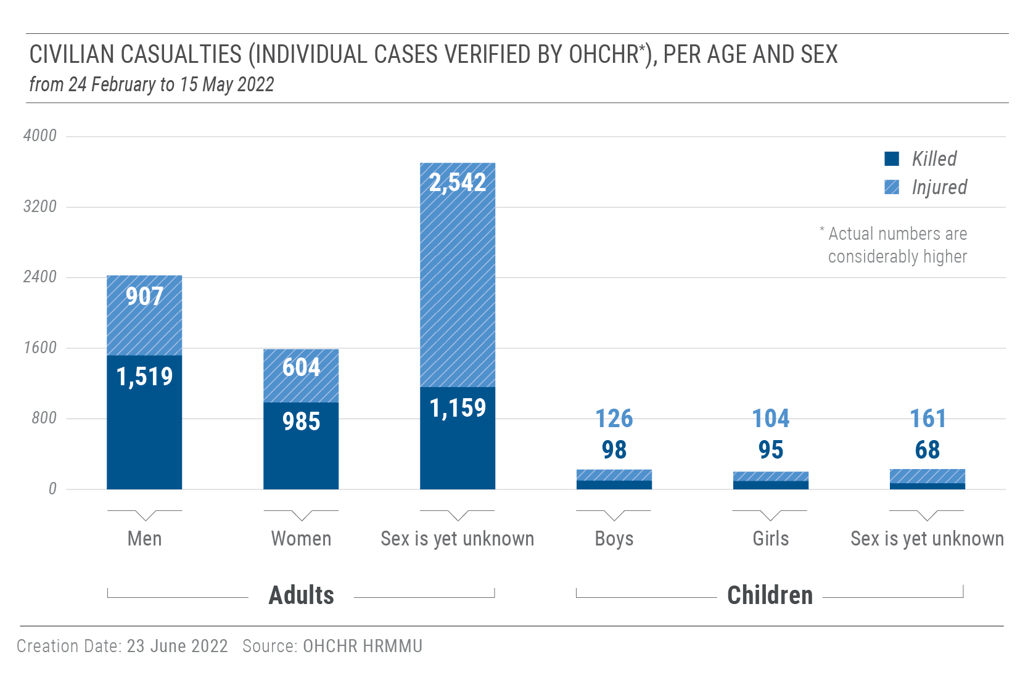

48. OHCHR believes that the actual figures are considerably higher, as the receipt of
information from some locations, where intense hostilities are ongoing or which are under the control of Russian armed forces, has been delayed and many reports are still pending corroboration.

49. HRMMU also notes that there have been thousands of military casualties on both sides
since 24 February. To date, there are no independently verified numbers of military casualties.
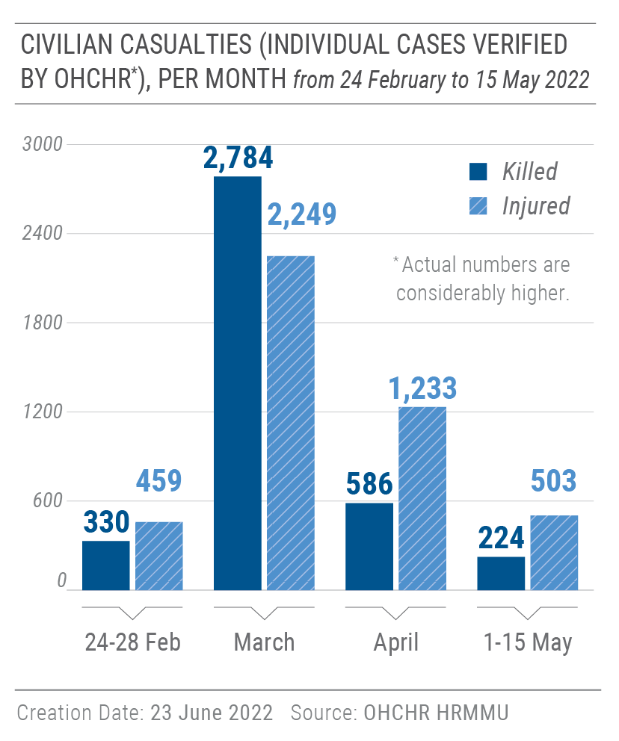
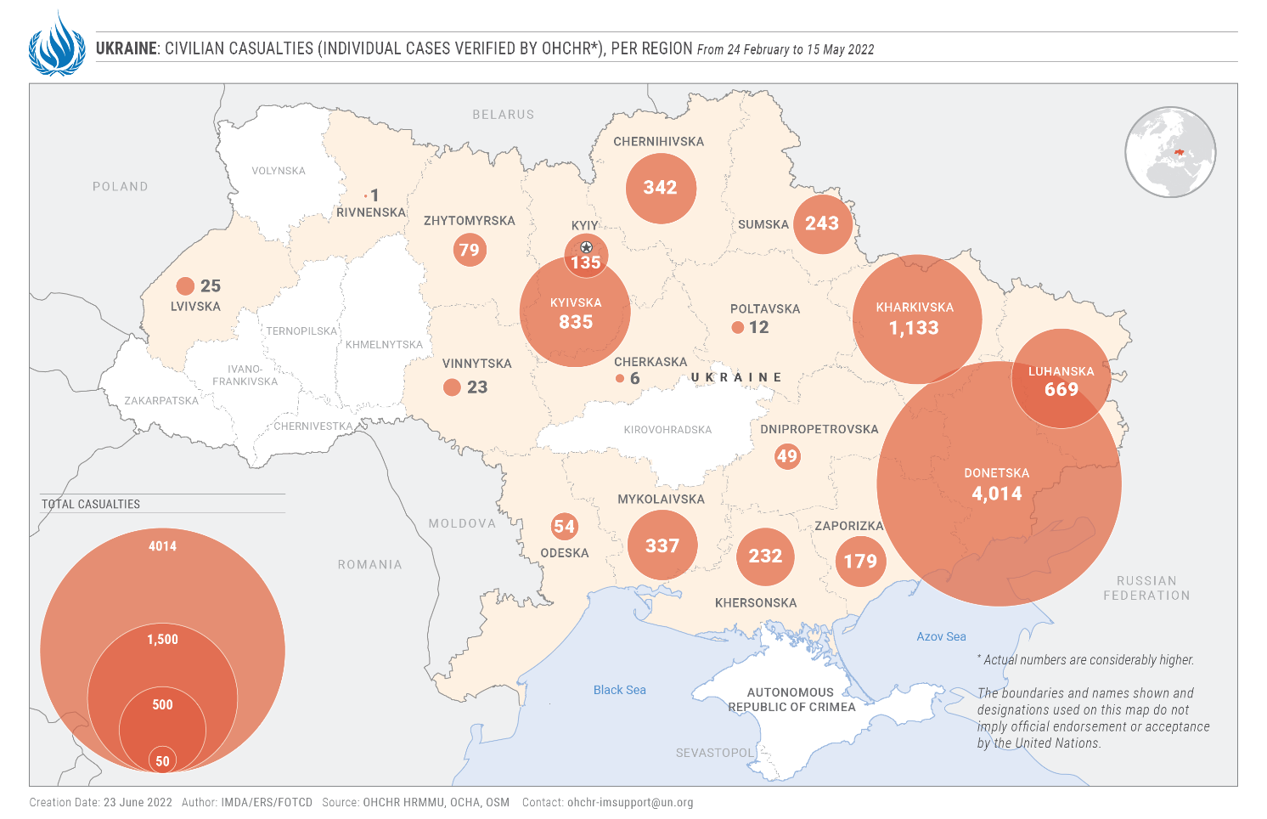

- Destruction of and damage to civilian objects

“From a window in my house, I had a view of five multi-story residential buildings in Irpin. Every morning I would look outside and count the buildings. Soon I could count only four, then three.”
– A woman who stayed in Bucha while the city was controlled by Russian armed forces

50. Since 24 February 2022, OHCHR has been verifying the widespread destruction of
and damage to civilian objects, with a particular focus on medical and educational facilities across the country, and to housing in Kyiv, Kharkiv and Donetsk regions. The majority of destruction and damage was caused by explosive weapons in populated areas. While OHCHR does not have comprehensive data on the total damage and destruction to civilian objects across the country, available data and the sheer scale of destruction strongly indicate violations of IHL.

Medical facilities

51. During the reporting period, OHCHR verified damage or destruction to 182 medical
facilities in Chernihiv, Donetsk, Kharkiv, Kyiv, Luhansk, Mykolaiv, Sumy, Zaporizhzhia, and Zhytomyr regions, mostly caused by explosive weapons in populated areas, such as heavy artillery, MLRS, missiles and airstrikes: 111 hospitals (including 10 perinatal centres and maternity hospitals, and 17 children’s hospitals), 11 psycho-neurological facilities and 60 other medical facilities. Of them, 159 were damaged, 15 were destroyed, 3 were looted and 5 were allegedly used for military purposes. The actual number of affected medical facilities is considerably higher. According to the Minister of Health of Ukraine, between 24 February and 7 May 2022, Russian armed forces destroyed 40 and damaged some 500 medical facilities.
Educational facilities

52. OHCHR verified that hostilities damaged or destroyed 230 educational facilities (155
schools, 38 kindergartens, 20 specialized schools, 16 universities and 1 scientific centre). In total, 32 education facilities were destroyed, 186 were damaged, and 12 allegedly used for military purposes. At least some of the attacks on educational facilities are likely due to the fact that both sides have used schools for military purposes. The actual number of affected education facilities is considerably higher. The Ministry of Education and Science of Ukraine reported 1,837 education facilities damaged or destroyed in the country since 24 February.
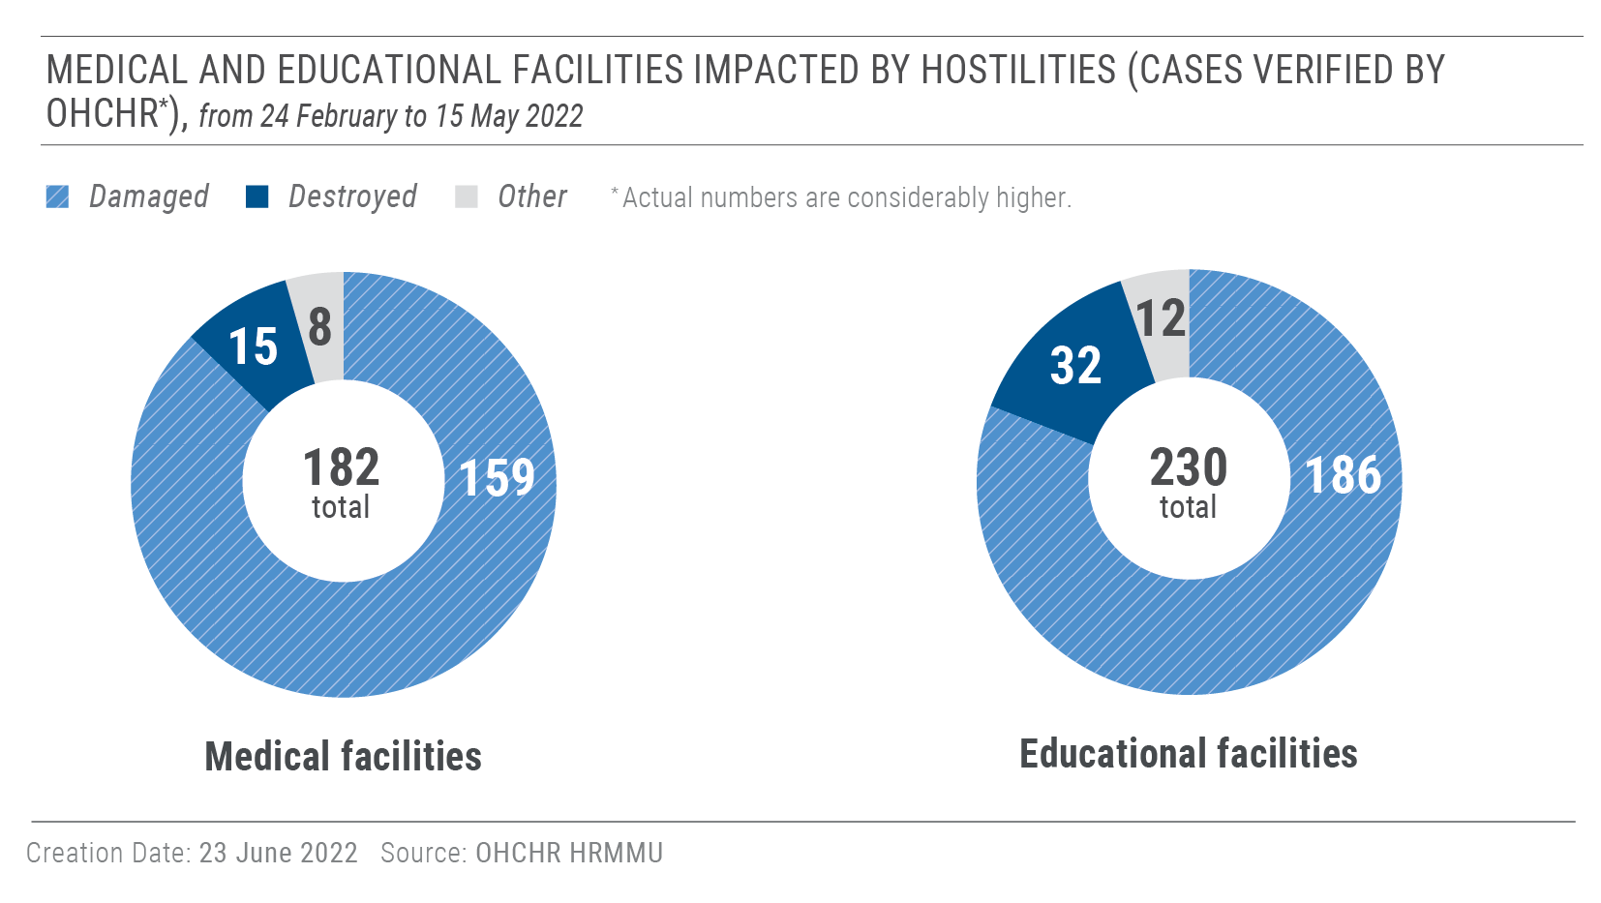
Housing

53. In the towns of Bucha, Irpin and Hostomel to the west-north of Kyiv, OHCHR verified
that at least 482 residential buildings (multi-storey residential buildings and private houses) were damaged or destroyed between 24 February and 31 March, when Russian armed forces left these towns. In the city of Kharkiv, which was heavily shelled by Russian armed forces until mid-May, OHCHR verified that at least 388 residential buildings were damaged or destroyed. OHCHR notes that local authorities have estimated over 3,000 residential buildings as being damaged or destroyed. According to the Ministry of Territorial Development, in total, 12,300 multi-storey residential buildings (12 million square meters) and 104,100 private houses (1.7 million square meters) were damaged or destroyed in Government-controlled territory.

54. In parts of Donetsk region controlled by Russian armed forces and affiliated armed
groups, OHCHR documented 806 civilian buildings damaged by hostilities, including 402 residential buildings damaged or destroyed in the city of Donetsk (mostly private houses in suburbs of the city).

55. OHCHR notes the Government’s efforts to establish a comprehensive compensation
mechanism for civilians whose housing has been damaged or destroyed. Since 26 March, the Government has enabled civilians to report damage to their houses directly through the ‘Diia’ state mobile application. Approved on 1 April at the first reading, draft law No. 7198 foresees monetary compensation, restitution, and provision of new residential housing to civilians whose houses were damaged or destroyed in Government-controlled territory. If adopted, draft law No. 7198 will significantly enhance opportunities for the affected population to receive compensation. OHCHR regrets that the draft law fails to make provision for residents of territories controlled by Russian armed forces and affiliated armed groups, and requires ownership documentation and two expert assessments of affected housing, which is likely to protract and in some cases may entirely frustrate the compensation process.
Places of worship

56. Indiscriminate shelling impacting civilian infrastructure also damaged places of
worship. During the reporting period, OHCHR documented that 34 Christian, Jewish and Muslim places of worship were destroyed and 40 damaged due to hostilities. Some buildings located in areas affected by intense hostilities, such as in Luhansk and Donetsk regions, were repeatedly damaged including the Sviatohirsk Lavra (Sviatohirsk, Donetsk region). Where buildings could no longer be used or were repeatedly damaged, this had a particularly negative impact on the religious communities and individuals’ ability to exercise their right to freedom of religion or belief.
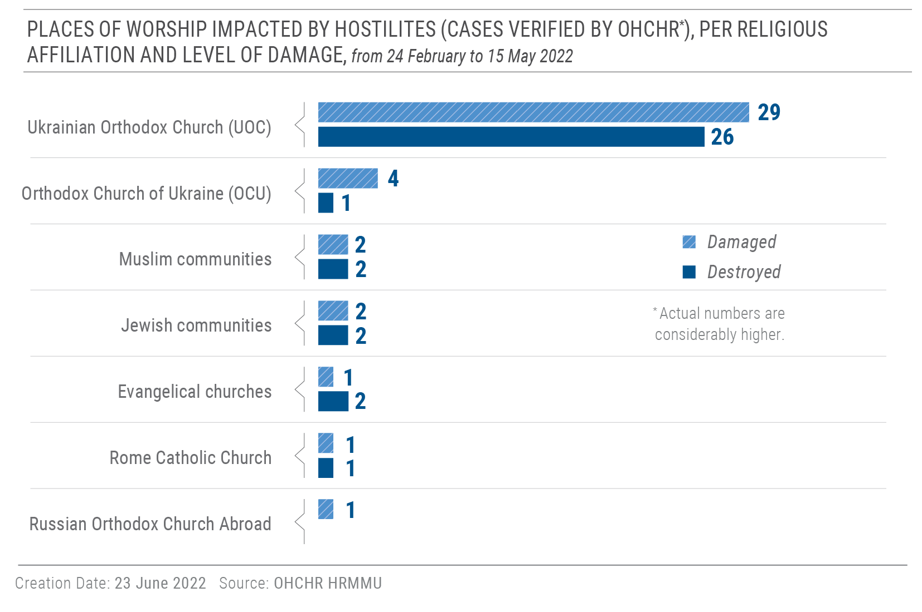
Nuclear power generating stations

57. OHCHR is concerned about the enormous risks that the conduct of hostilities near or
in nuclear power plants pose for the civilian population and their potential long-term impact.

- On 24 February, Russian armed forces took control over the Chernobyl nuclear power
plant. The plant remained under their control until 31 March. On 9 March, the Ukrainian authorities stated that the only power link to the nuclear site was destroyed during hostilities (it remains unclear by which side), leaving the plant without power for several days. Regular staff rotations were interrupted, putting at risk the staff's wellbeing and ability to perform their work duties without undue pressure. The International Atomic Energy Agency and the Ukrainian nuclear regulator lost communications with the Chernobyl site, and off-site and on-site radiological monitoring was entirely absent while the plant was under the control of Russian armed forces. Direct communication with the nuclear site was restored on 19 April.

- Russian armed forces also attacked the area of the Zaporizhzhia nuclear power plant in
Enerhodar city, the largest of the four functioning nuclear stations in Ukraine, on 4 March. A facility in close proximity to one of the nuclear reactors was damaged during the attack. Russian forces remained in control of the nuclear plant by mid-May.
- Persons at risk and groups with vulnerabilities

“We are no longer afraid. The worst has already happened: our houses and cities have been destroyed.”
A Roma woman from eastern Ukraine
Internally displaced persons

- Since 24 February, over 8 million persons – 17 percent of Ukraine’s population – have
been displaced within Ukraine. OHCHR interviewed internally displaced persons in western Ukraine and welcomes the Government’s efforts to organize the evacuation of the population from conflict-affected areas to safer places and to provide basic accommodation, access to healthcare and financial assistance in host communities. It also notes that the Government has committed to continue providing social assistance, including social benefits and pensions, to all persons who received them before, and that it distributed information to highlight how people can access their pensions and social benefits.

- OHCHR welcomes the Government’s programs to support IDPs who were forced to
flee areas affected by hostilities. In particular, as of 21 March and until the end of April, IDPs received monthly financial assistance of 2,000 UAH (about 70 USD), while 3,000 UAH (about 100 USD) were provided to displaced children and persons with disabilities. As of 1 May, the same assistance was available only to IDPs whose house was destroyed, or who fled territory currently in active fighting or under control by Russian armed forces. To support employment of IDPs in host communities, employers are compensated with 6,500 UAH (around 220 USD) for each IDP they hire. Furthermore, the Government introduced a mechanism to compensate families that provide free-of-charge accommodation to IDPs, while local authorities that provide free-of-charge shelter for IDPs in schools, kindergartens and community centres can receive compensation for increased utility bills. While temporary housing solutions provided by the Government and international and national humanitarian organizations have largely addressed the immediate needs of IDPs, long-term housing solutions will be needed for those who have lost their homes and who might remain for an indefinite time in host communities. Alternative accommodation for IDPs living in collective centres located in public buildings, such as schools or community facilities, will also be needed, as these facilities will have to be returned to their original purpose.
62. The Government of Ukraine provides financial assistance to IDPs who have registered with social protection departments and centres for the provision of administrative services, or remotely through the state-run Diia portal, as per the Resolution of the Cabinet of Ministers No. 332 of 20 March 2022. However, only people with ID documents can be registered and delays with payments were observed. As a result, people who have lost their documents and have not been able to restore them cannot be registered as IDPs. People who were deprived of ID documents before 24 February are also excluded from the IDP registration and cannot access such state assistance.
63. OHCHR notes that displacement has disproportionally affected women, children, older persons and persons with disabilities. In particular, as many men were conscripted or voluntarily joined the Ukrainian armed forces, many internally displaced women are now heads of household and have the responsibility to both care and provide for children, older relatives and any other family members requiring care, including persons with disabilities. Also, in several western regions, men can only register as IDPs after they are enrolled with military conscription offices. Fear of conscription likely acts as a disincentive for men to register, hindering their access to social assistance.
Roma persons
64. While Roma people have been included in the Government’s efforts to protect and evacuate the civilian population from areas affected by hostilities, they faced specific vulnerabilities and hardship due to lack of access to economic and social opportunities, adequate housing and quality medical assistance. In particular, Roma women face increased hardship during evacuation and settlement in host communities, as they often have large families and care concurrently for children, elderly, and family members with disabilities. Women who are heads of households often lack sufficient economic opportunities to adequately sustain their families.
Non-nationals
65. Non-nationals in Ukraine, including international students, migrant workers, family members of Ukrainian citizens, and other migrants, were able to leave Ukraine in the early weeks of the current armed conflict, without restrictions linked to the possession of ID documents or regular residence in Ukraine. However, there were some reports of discriminatory treatment of people attempting to flee Ukraine into neighbouring countries, in particular people of African, Asian, Middle Eastern and Latin American descent. As the movements of people leaving Ukraine significantly decreased, cases of denied crossing for other non-nationals, particularly undocumented migrants, were reported from April. As of 15 May, 14 migrants who had been detained prior to the armed attack for visa irregularities or for attempting to cross Ukrainian borders irregularly, remained deprived of liberty in two immigration detention centres in the Mykholaiv and Volyn oblasts, despite the severe risks to their physical safety from the hostilities. Advocacy with the Government of Ukraine has been undertaken to facilitate the release of the remaining detainees.
Persons with disabilities
66. The situation of adults and children with disabilities, both residing in communities and long-term care facilities, has also deteriorated. OHCHR observed that persons with disabilities often lack access to bomb shelters and evacuation trains and have to rely on the assistance of their family members and other people. Some older persons with movement impairments informed OHCHR that they had to wait many hours before boarding evacuation trains due to overcrowding and lack of physical means to board.
67. Moreover, OHCHR is concerned by the fact that hostilities and displacement affected a wide range of rights of persons with disabilities, including their right to health and freedom of movement. In particular, IDPs with disabilities had to leave behind assistive devices, such as wheelchairs, scooters and walkers, during their evacuation. Some interlocutors mentioned that they lacked access to necessary medications in their new place of residence.
68. The hostilities negatively affected the physical and emotional wellbeing of children with disabilities, especially in rural areas, and their access to support and rehabilitation services. While many children with disabilities in institutions were evacuated by the Government, families with children with disabilities faced difficulties in fleeing conflict-affected areas without any support from state services and the lack of available assistive devices, such as wheelchairs and crutches. Children living with visual, hearing, developmental or intellectual disabilities were at a higher risk of danger during armed attacks because they may not have learned about or understood what was happening.
69. OHCHR is further concerned about damage to long-term care facilities in Kharkiv, Mykolaiv, and Sumy regions, resulting from shelling and bombing reportedly by Russian armed forces. Aside from damage, the humanitarian situation in long-term care facilities located in territory controlled by Russian armed forces or affiliated armed groups remained dire. Many facilities lacked access to sufficient food, medication, and hygiene products for the residents and staff in Kyiv, Kharkiv, Donetsk, Luhansk, Sumy, Kherson, and Mykolaiv regions. In one case, OHCHR received information that the lack of access to healthcare led to the tragic death of 12 residents in a long-term care facility for persons with intellectual and psychosocial disabilities and older persons in Borodianka. This reportedly occurred while the area was under control of Russian armed forces in early March 2022. Persons with disabilities who stayed in long-term care facilities, and personnel of such facilities who fled to safer locations, lack specifically equipped premises and assistive devices in host communities.
Older persons
70 OHCHR observed through interviews that many older persons stayed in conflict-affected areas because they were unable or unwilling to leave their homes. This left them vulnerable to risk, injury or death, particularly in light of the lack of access to adequate food and basic services, such as heating, electricity, water, and health including medicines, especially in settlements destroyed by hostilities, such as Mariupol, Kharkiv and Kyiv regions, where urgent medical care and emergency services stopped functioning. Some services were since restored in Kyiv, Sumy and Kharkiv regions. OHCHR documented numerous cases of deaths of older persons due to the dire humanitarian situation in areas affected by hostilities.
71. OHCHR is concerned about a serious lack of adequate assistance to older persons during evacuations and in facilitating access to bomb shelters. Bomb shelters also lack adequate accommodation for older persons, especially those with limited mobility and chronic health conditions. In most cases, older persons had to rely on their relatives, neighbors and volunteers to assist them in getting food or moving to safe locations.
72. Older persons in reception centres for IDPs lacked adequate arrangements to address their complex health needs, as most housing centres were set up to address the most urgent and temporary needs of persons fleeing the hostilities.

- Evacuation of civilians from areas affected by hostilities
“At least in prison we were allowed to take daily walks outside.”
– An older man speaking about the ban on leaving houses and apartments in the town of Bucha while under the control of Russian armed forces
Evacuation from Mariupol
73. To respond to the dire humanitarian situation in Mariupol, limited evacuation of civilians was organized by the parties to the conflict in March. On 7 and 8 March, the Ministry of Defense of the Russian Federation offered two official evacuation routes from Mariupol: the first one towards Rostov-on-Don in the Russian Federation, via territory controlled by Russian affiliated armed groups, and the second one towards Zaporizhzhia, under Government control. Evacuation towards territory controlled by Russian affiliated armed groups started before the official announcement, on 5 March. The official evacuation from Mariupol to Government-controlled territory started on 14 March, after the route and security guaranties for evacuation convoys were agreed upon. Evacuation happened by private vehicles, buses or on foot, and the Government of Ukraine supported evacuation towards Zaporizhzhia by providing buses and shelter upon arrival.
74. The coercive environment created by the hostilities and the humanitarian crisis in Mariupol meant that people often felt compelled to evacuate to whichever direction possible, irrespective of their preferences. The exact number of people relocated from Mariupol to territory controlled by Russian affiliated armed groups or the Russian Federation remains unclear.
75. OHCHR conducted 11 interviews with individuals and families who were evacuated to territory controlled by Russian affiliated armed groups or to the Russian Federation, or with their relatives. They confirmed that they were offered only one evacuation option. They were able to keep their identity documents and to move further to a location of their own choice, including outside of Donetsk and of the Russian Federation, subject to their financial ability to cover the costs of travel. OHCHR does not have any information that their freedom of movement was restricted in the Russian Federation. There are reports that people were offered support to relocate to remote regions of the Russian Federation. OHCHR is concerned that people without any practical alternative, with no financial means to travel to the border, or who have lost personal identification documents, are not able to fully exercise their freedom of movement or their right to return. OHCHR has such concerns about people in vulnerable situations, in particular older people, people with disabilities and unaccompanied children, although comprehensive information is not yet available about these groups.
76. OHCHR is concerned about the manner in which the so-called ‘filtration’ is carried out on civilians leaving areas of ongoing or recent hostilities through territory controlled by Russian armed forces or affiliated armed groups. The apparent intent of the ‘filtration’ process is to identify current or former Ukrainian law enforcement officers, state officials, and members of the Ukrainian armed forces, but practice shows that any individuals perceived as having pro-Ukrainian or anti-Russian views are also identified and are subject to violations and abuses of their rights. The ‘filtration’ process includes body searches and stripping, detailed interrogations about an individual’s personal background, family ties, political views and allegiances. Those engaging in ‘filtration’ examine personal belongings, including mobile devices, and take pictures and fingerprints of everyone passing through the process. Individuals subjected to ‘filtration’ have been verbally intimidated, humiliated and beaten, which may amount to ill-treatment and, in some cases, were subjected to sexual violence. OHCHR documented at least one case where the interrogators played sexually degrading music aimed at Ukrainian women during the interrogation of a female detainee. OHCHR also received credible reports that some children were separated from their parents during and after the process, when the accompanying adult did not pass the ‘filtration’. Persons awaiting ‘filtration’ often spend nights in vehicles or unequipped premises, sometimes without adequate access to food, water and sanitation.
77. While OHCHR does not have sufficient information to fully assess the situation of those who failed to pass ‘filtration’, it has documented several cases of individuals detained after the procedure. OHCHR received reports that such persons were later held in Olenivka and Donetsk, including in the notorious ‘Izoliatsiia’ detention centre of the latter. There, the detainees would be at a particularly high risk of torture or ill-treatment. OHCHR has been seeking access to individuals who were detained after failing to pass ‘filtration’, and to those who reportedly passed ‘filtration’ but were still detained and further held in a ‘centre for evacuees’ in Bezimenne. As of 15 May, OHCHR had not been granted access to these individuals.
IV. Right to life, liberty and security of persons
- Killings of civilians
“I will shoot a bullet in your head right now and then will bring your girlfriend to say goodbye.”
– A Russian soldier intimidating a civilian man suspected of sharing information with Ukrainian forces, on 13 March, in the Chernihiv region
78. Following the departure of Russian armed forces from Kyiv and Chernihiv regions, and partially from Kharkiv and Sumy regions in the end of March and beginning of April, a large and increasing body of evidence has become available that gives OHCHR reasonable grounds to believe that serious violations of IHL were committed by Russian armed forces.
79. As of 15 May 2022, over 1,200 civilian bodies have been recovered in Kyiv region alone. These included not only civilian casualties, but others unlawfully killed, including summarily executed, and those who died because of new stresses on their health due to hostilities and unavailability of medical aid after spending days and weeks in basements or their house. They experienced restricted access to necessary services and sometimes faced threats to life and health from Russian soldiers if they tried to leave.
80. Hundreds of civilians were allegedly killed by Russian armed forces in situations that were not linked to active fighting. As of 15 May, OHCHR is working to corroborate over 300 allegations of such killings. This figure may increase as new evidence becomes available. In Bucha alone, OHCHR documented that at least 50 civilians were killed by Russian armed forces when it was under their occupation. Most victims were men, but there were also women and children. Civilians were shot while trying to leave the area in their vehicles; Russian soldiers summarily executed unarmed local civilian men suspected of providing support to Ukrainian forces or otherwise considered to pose a possible future threat; others were shot by soldiers in the streets or snipers as they tried to cross the road or otherwise gather essentials for life; some civilians seemed to had been killed completely arbitrarily. Those perceived as providing support to Ukrainian forces were sometimes tortured before being killed. Wilful killing of civilians not directly participating in the hostilities are prohibited, and torture is also prohibited at all times. Such actions would constitute grave breaches of the Geneva Convention IV, Additional Protocol I, and serious violations of customary IHL, and are war crimes.
B. Conflict-related detention
“The occupiers consider everyone who has a Diia application in their smartphones as saboteurs.”
- A local community public figure in Kherson

“They probably released me just because I am too old and have a tumor. I was asking for assistance to go to the toilet every 20 minutes and it probably made them tired of me.”
– An 80 year-old man taken from his house by Russian armed forces and detained incommunicado for four days, in the Kharkiv region

81. Since 24 February 2022, the arbitrary detention of civilians has become widespread in territory controlled by Russian armed forces and affiliated armed groups. In total, OHCHR documented 248 cases (214 men, 33 women, 1 boy) during the reporting period. The majority of victims were active or former public officials of local authorities (65 cases), human rights defenders and civil society activists (42 cases), journalists (8 cases), religious workers (4 cases), and retired servicemen of Ukrainian armed forces (10 cases). Civilians with no particular political or social position were also subjected to arbitrary detentions, with 119 cases documented by OHCHR. 170 victims remained detained or with their whereabouts unknown by mid-May, as shown on the infographic below. OHCHR believes that the actual number of affected civilians may be considerably higher.
82. OHCHR is particularly concerned that in the vast majority of these cases, the responsible authority refused to provide information to relatives about the grounds for arrest or the place of detention, or deliberately concealed the fate of the victims, effectively placing them outside the protection of the law, which may amount to enforced disappearance.
83. Victims were usually arrested on the street, at home or at their workplace during so-called ‘checks’. They were held incommunicado in improvised places of detentions - schools, buildings of government bodies, warehouses and barns, or industrial buildings. After several days or weeks of detention, an unknown number of victims were transferred to territory of the Russian Federation, to Crimea, occupied by the Russian Federation, or to territory of Donetsk or Luhansk regions controlled by Russian armed forces and affiliated armed groups. They were held in penal institutions, often together with prisoners of war. OHCHR is also aware of cases during so-called ‘filtration’, involving men that may amount to enforced disappearance.
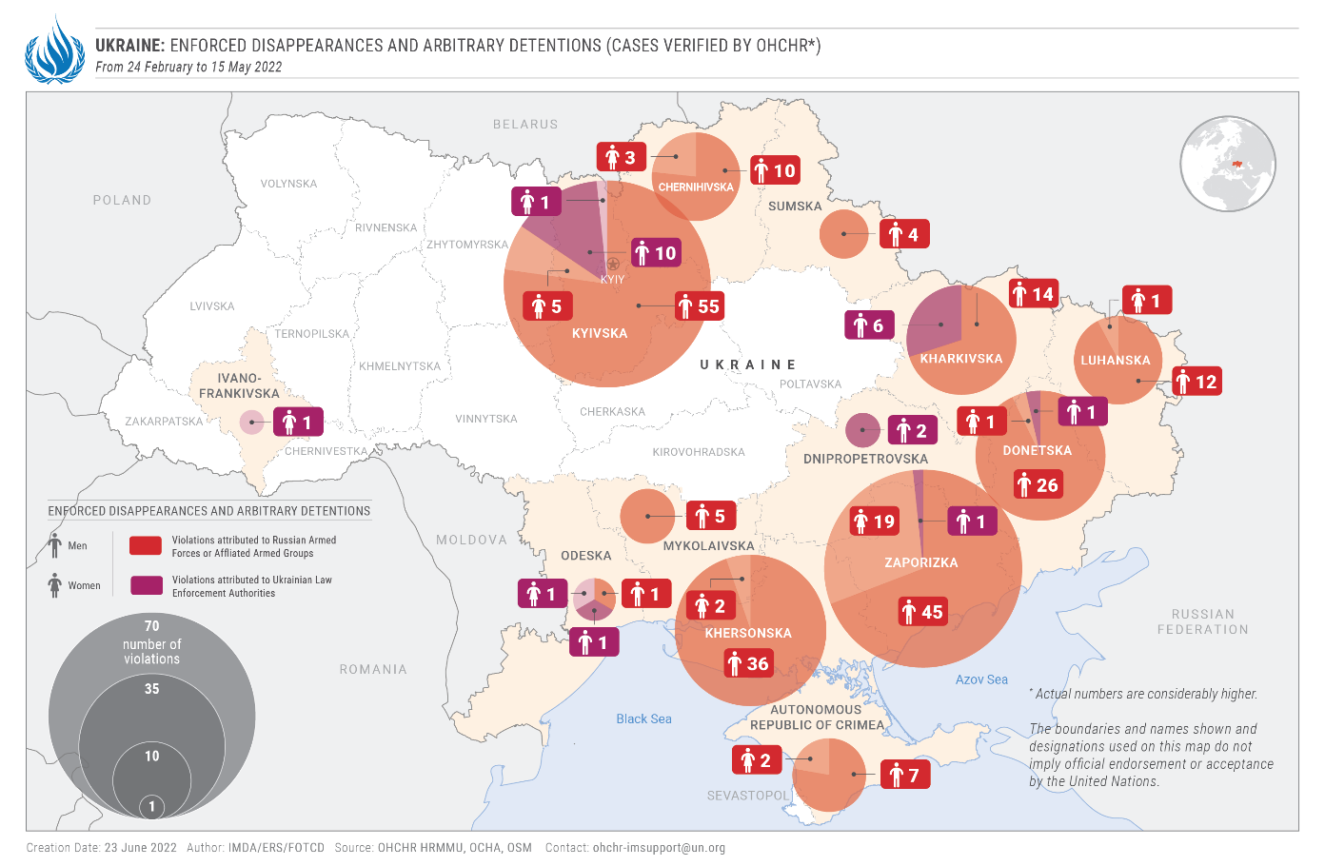

84. Some civilians were detained in order to compel them to cooperate with Russian armed forces and so-called ‘military administrations’. In relation to the former OHCHR notes with concern four cases of teachers in Zaporizhzhia region, who were taken from their homes and detained in an unknown place for four days with the aim of compelling them to teach using the Russian Federation curricula.
85. OHCHR corroborated complaints about torture and ill-treatment of persons in detention to compel them to confess cooperation with the Government of Ukraine, provide information to or cooperate with Russian armed forces. In particular, victims reported that they were kept tied and blindfolded for several days; beaten with hands, legs batons or sticks; subjected to mock executions; threatened with sexual violence; put in a closed metal box; forced to sing or shout glorifying slogans; provided with no or scarce food or water; and held in overcrowded rooms with no sanitation.

Emblematic cases
86. OHCHR documented a case of enforced disappearance of a school teacher in Zaporizhzhia region. In late March, Russian troops apprehended him in his house and did not give him the opportunity to inform his relatives about his condition and whereabouts for three weeks while he was in detention. The victim faced eight sessions of torture, including beatings, electrocution, mock executions, digging a grave for himself, sexual violence and being held in a metal sweatbox. The torture was committed by Russian military, Russian-affiliated armed groups and staff of a penitentiary facility in the Russian Federation. Each of these sessions was conducted by different perpetrators, in different locations and applying different torture methods. Within three weeks, he was kept overnight in at least eight different locations often with inhumane conditions. Inhumane treatment was also applied during transfers between locations. His relatives and friends did not receive any information about him until his release in an “exchange” in mid-April.
87. In another case, Russian troops apprehended a member of a village council in Kherson region twice, in mid-March and early April. The victim was tortured and faced threats of killing and sexual violence against himself and his family members. The perpetrators tried to extract information regarding pro-Ukrainian activists, current and former members of Ukrainian armed forces and their families who remained in the village. He was also pressured to cooperate with the armed forces of the Russian Federation while continuing his public official activities. During the second incident, perpetrators tied the victim’s hands, put a noose on his neck while he stood on the floor and kicked at his legs and genitals. This caused him to bend down reflexively, involuntarily strangling himself. The perpetrators commented: “If you do it [hang] yourself, you know, it will not be our fault”. The victim was released and managed to leave territory controlled by Russian armed forces. While in captivity, his family received no information regarding his whereabouts and condition.

88. As of 15 May 2022, 62 victims (44 men and 18 women) had been released. Most victims were released during so-called ‘exchanges of prisoners of war’ held between Ukraine and the Russian Federation. OHCHR has no reliable information about the procedure followed for such ‘exchanges’, but there are grounds to believe that some detained civilians were ‘exchanged’ for Russian prisoners of war. If it is verified that the release of these detained civilians was conditional on the release by Ukraine of Russian prisoners of war, such practice could constitute hostage taking, which in armed conflict amounts to a war crime.
89. Six victims of enforced disappearance (five men and one woman) were found dead with gunshots or signs of violent death in parts of Kyiv and Mykolaiv regions. The head of a village in the Kyiv region, her husband, and their adult son were taken by Russian armed forces from their home on 23 March and kept in an unknown place. Friends and relatives of the family tried to find information about their fate and on 26 March, the Office of the Prosecutor General informed them about the investigation into the abduction of the victims. They were found in a collective grave with signs of violent death after the Government of Ukraine regained control over the village in April. A local activist school teacher from a village in the Mykolaiv region was found with gunshots and signs of torture on 17 March, a day after his abduction by Russian armed forces. A local journalist from Bucha was detained by Russian armed forces on 6 March and found with signs of violent death in a street after the Government of Ukraine regained control over the town. A 20-year old man was found dead in a field near Zdvyzhivka, Kyiv region, with gunshot wounds in his back. Reportedly, he tried to escape from a truck that was used by Russian armed forces to bring detainees from Hostomel airport to the Russian Federation.
90. OHCHR is particularly concerned about the arrest and incommunicado detention of seven Ukrainian staff members of the OSCE Special Monitoring Mission to Ukraine (OSCE SMM) in Donetsk, Luhansk and Kherson regions, controlled by the Russian armed forces or affiliated armed groups. As of 15 May, OHCHR is aware that four of the detained staff members were released, and three other staff members remain in custody, facing criminal ‘prosecution’ in Donetsk and Luhansk for alleged cooperation with the Government of Ukraine.
91. OHCHR has also followed allegations of arbitrary detention in territory, controlled by the Government of Ukraine. The Security Service of Ukraine (SBU) and National Police have reportedly arrested more than one thousand individuals on suspicion of allegedly providing support to Russian armed forces and affiliated armed groups. Detainees were alleged to be members of sabotage groups, artillery spotters and informants, but also bloggers, journalists and administrators of social media or messaging channels, who were accused of spreading fake information or expressing support for the Russian armed attack.
92. OHCHR is concerned that many arrests may not have been carried out in line with Ukraine’s international human rights obligations, even taking into account Ukraine’s derogation from certain obligations under the ICCPR and other instruments. OHCHR documented 12 arrests (ten men and two women) carried out in a manner that raises concerns in relation to procedural and judicial guarantees of the right to liberty. OHCHR also documented 12 more cases (11 men and one woman) that may amount to enforced disappearance. In ten such cases, the victims have been released or their relatives received confirmation of their detention. In three cases, OHCHR documented the use of torture and ill-treatment.
93. OHCHR is particularly concerned about the possible enforced disappearance of a 20-year-old student who was reportedly arrested by the SBU. The SBU handcuffed him and placed a bag on his head before taking him from his hostel room in March 2022. They brought him by car to a hotel room in Zaporizhzhia where they kept him for four days. During that time, they threatened to shoot him in the leg, to send him to a zone of active hostilities and to kill him, in order to compel him to call his relatives to come to Government-controlled territory, so that the SBU could arrest them and prosecute them for state treason. His detention was not recorded and his relatives were not informed about his detention and fate. After his relatives came to Government-controlled territory and were arrested, the student was brought back to Dnipro in the same manner and released after a formal interrogation by the SBU.
C. Torture and ill-treatment of civilians
94. OHCHR documented the widespread use of extrajudicial punishment of individuals believed to be so-called marauders, thieves, bootleggers, fake volunteers (fraudsters), drug dealers and curfew violators. During the reporting period, OHCHR documented 89 cases (80 men and 9 women) in territory controlled by the Government of Ukraine and three cases in territory controlled by Russian armed forces. In most cases civilians apprehended the victims believed to be committing crimes, tied them to trees or electricity poles with adhesive tape or plastic wrap, stained their faces or bodies with the words “marauders” or “thieves” or put stickers with these words on them, filmed them and published the videos online. In 19 cases, victims were partially or fully stripped of their clothes, which may amount to sexual violence and torture, especially if they were left without clothes in cold temperature, thereby causing them even more suffering. In 11 cases, victims were beaten by the perpetrators. OHCHR notes that public officials in different regions called for killing marauders at the crime scene or punishing them, which promoted such violence. OHCHR is particularly concerned that officers of the National Police or members of the Territorial Defence were involved in nine cases of extrajudicial punishment, and even beat tied victims (two cases). The practice decreased considerably in late April-May, with only three cases documented between 1 and 15 May 2022.
95. OHCHR documented an emblematic case of two men arrested by Russian armed forces in Kherson region in May 2022 for reportedly having engaged in ill-treatment of corpses of servicemen on 26 February 2022. After their arrest, two videos were published online, where they were visibly forced to make apologies for their actions and had signs of severe beatings on their faces. One of them can be seen with a wire attached to his ear which suggests that he may have been electrocuted.
D. Conflict-related sexual violence
96. Since 24 February, many allegations of conflict-related sexual violence (CRSV) have been made by state officials, national and international NGOs, media and social media users. OHCHR has been looking into all allegations of CRSV received.
97. Due to active hostilities, the lack of security in areas controlled by Russian armed forces, the breakdown of referral pathways for services, mass displacement, and stigma associated with sexual violence, victims of CRSV are often not able or willing to speak to others or register a complaint before law enforcement authorities.
98. By 15 May 2022, OHCHR was aware of 108 allegations of acts of CRSV against women, girls, men and boys that reportedly occurred in the regions of Chernihiv, Dnipro, Donetsk, Kharkiv, Kyiv, Kherson, Luhansk, Mykolaiv, Vinnytsia, Zaporizhzhia, Zhytomyr and in a detention facility in the Russian Federation. There were 78 allegations of rape, including gang rape, 7 of attempted rape, 15 of forced public stripping, and 8 of other forms of sexual violence, such as sexualized torture, unwanted sexual touching and threats of sexual violence. The alleged perpetrators were from the ranks of Russian armed forces in 87 cases; from the ranks of Russian-affiliated armed groups in 2 cases; from the ranks of Ukrainian armed forces, including territorial defence, in 9 cases and law enforcement in 1 case; and from civilians or unidentified actors in Government-controlled territory in 7 cases and in territory controlled by Russian armed forces in 2 cases. OHCHR determined the affiliation of alleged perpetrators on the basis of an assessment comprising several factors: who had control of the place of the incident, the date of incident, and the uniform, insignia, and military equipment used by the alleged perpetrators.
99. Women and girls constituted the majority of alleged victims. Out of all allegations received, 59 allegedly occurred in the Kyiv region where Russian armed forces were stationed. Rape, including gang rape, against civilian women was allegedly the most common form of CRSV committed by Russian armed forces. It was often accompanied by other human rights violations, such as wilful killings of victims or their husbands, physical violence, or looting of their homes. In 18 cases victims were allegedly killed or died after being raped. For example, a man in the Chernihiv region reported that he discovered the body of an elderly woman, half naked with blood around her genitals.
100. Out of 108 allegations, OHCHR verified 23 cases, including cases of rape, gang rape, torture, forced public stripping, threats of sexual violence and other forms of sexual violence. 9 cases of CRSV were against women, 13 against men, and 1 against a girl (threat of sexual violence). OHCHR has not yet verified any allegations of sexual violence against boys.
101. Eleven acts of CRSV were committed by Russian armed forces and law enforcement, including rape and gang rape. For example, in the evening of 9 March, two Russian soldiers came to a house in Kyiv region where a woman lived together with her husband and a child. They shot her husband in the yard, and when she asked about him, one of Russian soldiers said: “You don’t have a husband anymore. I shot him with this gun. He was a fascist.” Then another soldier put a pistol to her head and told her to undress. They gang raped her while holding a pistol to her head. They came to her house three times. Each time they gang raped her again.
102. Five acts of CRSV were committed by Ukrainian armed forces, including territorial defence, or other law enforcement bodies, which consisted of forced public stripping and threats of sexual violence. Seven cases committed by unidentified actors and civilians (five in Government-controlled territory and two in territory controlled by Russian armed forces) were related to forced public stripping of alleged male and female looters, which may amount to CRSV.
E. Treatment of prisoners of war and other persons hors de combat
“Do you want to pet the dog? - they asked. If you say ‘yes’ – they will hit you around your ribs or kidneys, if you say ‘no’ – they will anyway hit you there. And when you ask them why they have asked – their reply is ‘how would you, hohol [derogatory word for a Ukrainian], dare to touch our dog?”
– A prisoner of war about treatment in pre-trial detention facility in the Russian Federation

103. OHCHR is particularly concerned about violations of IHL and international human rights law by both belligerent parties in relation to their treatment of prisoners of war and persons hors de combat. OHCHR has documented cases of extrajudicial execution of prisoners of war and other persons hors de combat, torture and ill-treatment, denial of medical assistance, exposure to public curiosity, and violations in relation to the conditions of their internment.
104. During the reporting period, OHCHR was only granted access to prisoners of war interned by the Government of Ukraine and interviewed 44 (all men). OHCHR had no access to places of internment of Ukrainian prisoners of war in territory controlled by Russian affiliated armed groups, including in Donetsk region where many prisoners of war were reportedly held. OHCHR interviewed three Ukrainian servicemen who were released from captivity in April-May 2022.
105. OHCHR is particularly concerned about two documented cases of summary execution and torture of Russian prisoners of war and persons hors de combat reportedly perpetrated by members of Ukrainian armed forces. In the first case, members of Ukrainian armed forces shot the legs of three captured Russian soldiers and tortured Russian soldiers who were wounded in the Kharkiv region. In the second case, members of Ukrainian armed forces reportedly shot dead a bleeding and choking Russian soldier lying on a road in Kyiv region. Through confidential interviews, OHCHR also received information about incidents where Ukrainian servicemen killed persons who were wounded and hors de combat, as well as prisoners of war. If deliberate and confirmed, such incidents would constitute a grave breach of the Geneva Conventions and war crimes. OHCHR welcomes statements of Ukrainian officials condemning such violations and notes that the General Prosecutor's Office launched an investigation into both incidents described above. OHCHR also documented three incidents where Ukrainian servicemen and one incident where Russia serviceman made public threats of giving no quarter to Russian prisoners of war, which would constitute a war crime.
106. OHCHR is also concerned about mistreatment of prisoners of war by Russian armed forces and affiliated armed groups. There are credible reports of torture and other forms of inhuman treatment of prisoners of war interned both in territory of the Russian Federation and territory controlled by Russian-affiliated armed groups. OHCHR has also documented reports about prisoners of war being subjected to so-called ‘admissions’ (torture and intimidation sessions) upon their arrival to the places of internment in Olenivka penal colony, Donetsk region, and Kursk and Taganrog pretrial detention facilities in the Russian Federation. Interlocutors complained that such practices were particularly violent in the Russian Federation. They reported being punched, kicked, beaten with batons, strangled, subjected to positional torture and intimidation, hunted with dogs and threatened with sexual violence, and that such treatment could last for the entire first night in the facility. Some lost their teeth and had swollen bodies and arms, which later would not allow them to sleep. Later they were also subjected to various forms of ill-treatment, such as not being allowed to stay on their beds during the daytime, forced to learn and reproduce the Russian anthem or national symbols, and beaten if they failed to do so. OHCHR also corroborated reports concerning the pillage of personal belongings of prisoners of war, including religious symbols, clothes, boots, and money (including the withdrawal of funds using their credit cards).
107. OHCHR notes with concern the abundance of videos publicly available online depicting interrogations of prisoners of war, mainly men, by both belligerent parties. Some women prisoners of war feature on videos, but men prisoners of war appear to face higher levels of verbal abuse. In 178 videos, prisoners of war who were partially naked or visibly in pain and needing or receiving medical assistance, faced verbal abuse and threats and were compelled to apologise, disparage their command, glorify the other belligerent party, shout glorifying slogans or congratulatory words to specific military units or people, and call on relatives and comrades to put a stop to the war or lay down weapons. During the reporting period, OHCHR documented 126 videos in open sources depicting captured members of Ukrainian armed forces and 52 videos depicting captured members of Russian armed forces and affiliated armed groups. OHCHR documented several videos of Ukrainian prisoners of war that were later broadcast on Russian television, contrary to article 13 of Geneva Convention III.
108. According to interviews with witnesses, during the reporting period, the Russian Federation and affiliated armed groups failed to create camps or camp compounds for prisoners of war in line with the requirements of the Geneva Conventions, and interned prisoners of war in pre-trial detention facilities (SIZOs) or penal colonies, in violation of the prohibition of holding prisoners of war in closed confinement or in penitentiaries. Although the Government of Ukraine established one camp for the prisoners of war in Lviv region, OHCHR observed that the vast majority of prisoners of war during the reporting period were held in pre-trial detention and penal facilities. OHCHR has not documented any complaints in relation to conditions of internment in penitentiary facilities in the territory of Ukraine, controlled by the Government of Ukraine. At the same time, OHCHR documented complaints in relation to conditions of internment of Ukrainian prisoners of war held by the Russian Federation, including through Russian affiliated armed groups, in a penal colony in Olenivka, in Donetsk region controlled by Russian armed forces and affiliated armed groups. Interlocutors complained to OHCHR about a lack of water, lack of access to sanitation and that prisoners of war had to sleep on the floor.

- Forced conscription
109. Through individual interviews, OHCHR confirmed allegations of forced conscription of men by Russian-affiliated armed groups at the end of February 2022. Some men were working in the public sector, including educational facilities, in territory controlled by Russian affiliated armed groups and were requested by their employer or local military ‘commissariats’ to come immediately to designated assembly points. Others were stopped on the street by representatives of local ‘commissariats’ and forcefully taken to the assembly points, where they observed hundreds of other recruits. Recruited men, mainly with no military training or experience, and no training on IHL or first aid, received uniforms with no insignia, and were sent to the front line just a few days after their recruitment. Men complained of being trapped in a situation where refusing to be recruited would trigger criminal prosecution under the ‘legislation’ of self-proclaimed ‘republics’, while conscription would constitute a crime under Ukrainian legislation. As civilians are forced to serve in armed groups affiliated with the Russian Federation, it may amount to compelling them to serve in the armed forces of a hostile power, in grave breach of IHL.
110. OHCHR is concerned that some conscripts forcibly mobilised in territory controlled by Russian affiliated armed groups are being prosecuted by Ukrainian authorities without due regard for applicable combatant immunity.
V. Civic space
111. OHCHR notes that the ability of individuals to enjoy fundamental freedoms has been significantly and drastically affected since the beginning of the armed attack of the Russian Federation against Ukraine. The attack’s impact on freedoms of opinion and expression as well as on freedoms of peaceful assembly and association includes both restrictions and incidents that concurrently affect other rights, including but not limited to the rights to life, liberty and security, and the prohibition of torture and ill-treatment.
A. Freedoms of opinion, expression, assembly and association
“We live in interesting times. White became black. You are now punished for calling for peace and not war.”
– A man convicted in Crimea for ‘discrediting Russian armed forces’

112. The rights to freedoms of opinion and expression, of peaceful assembly and association remain applicable during armed conflict. Ukraine has derogated from a number of its human rights obligations, including relating to the rights to freedom of expression and of peaceful assembly. Derogations are permissible only to the extent that they are strictly required by the exigencies of the situation and are not discriminatory. Ukraine also remains bound by human rights treaty obligations which it has not derogated from, as well as obligations under IHL, such as those related to the protection of journalists. The Russian Federation has not derogated from its human rights obligations under the ICCPR.
113. During the reporting period, OHCHR recorded 13 cases of arbitrary arrests and enforced disappearances appeared to be related to the exercise of the freedom of expression by the victims. Such acts have a chilling effect on the exchange of opinions and ideas beyond the victims directly affected, resulting in an additional adverse impact on freedom of expression, especially with respect to opinions and ideas that might be perceived as critical towards the Government or occupying power.
114. During the reporting period, OHCHR documented that 16 journalists and media workers were killed and 10 were injured because of hostilities (21 men and 5 women). Seven victims were killed by indiscriminate shelling, reportedly by Russian armed forces in five cases and by unknown perpetrators in the two other cases. Five victims were shot in areas of active hostilities and, in all cases, the attackers were not identified. In two cases, the exact cause of death is yet to be established as the bodies were identified among other civilian victims in areas from which Russian armed forces retreated in late March. In one case, the victim reportedly faced enforced disappearance and torture during detention by Russian armed forces and affiliated armed groups, and died shortly after his release.
115. OHCHR is concerned that four journalists were injured by perpetrators despite clearly presenting themselves as media workers. In one case, two journalists were attacked twice in two different locations while trying to leave Irpin, in Kyiv region, where they had covered the hostilities. Russian infantry and armored vehicles shot their car, even though it was marked with a white flag and visible “Press” stickers. Both victims escaped the area without injury.
116. OHCHR documented seven cases of enforced disappearance of media workers in areas controlled by Russian armed forces, including six in Kherson region. On 12 March, a journalist was detained by Russian armed forces in Kahovka, Kherson region. He spent eight days in detention with his whereabouts undisclosed to his family members, then was released.
117. In the Autonomous Republic of Crimea and city of Sevastopol, Ukraine, occupied by the Russian Federation, (“Crimea”), the already limited civic space to express dissenting and critical opinions on social media or through other means was further curtailed by the introduction of new legislation. OHCHR recalls that under international human rights law, the right to freedom of expression includes freedom to seek, receive and impart information and ideas of all kinds. Moreover, in the context of considering permitted restrictions on the right to freedom of expression, the Human Rights Committee has clearly stated that States should not prohibit the criticism of institutions, such as the army or the administration. The Russian Federation introduced a range of sanctions for the “dissemination of knowingly false information” about the activities of armed forces and “performance of functions by state authorities” outside the territory of Russia; “public actions directed at discrediting” and “obstruction” of the Russian armed forces; and “public equating” of USSR with Nazi Germany and denial of the “decisive role of the Soviet people in defeat of Nazi Germany” and “humanitarian mission of the USSR”. These vague laws of uncertain scope unduly restrict the rights to freedom of expression and of peaceful assembly in Crimea, notably opinions critical of the official position and policies of the occupying authorities of the Russian Federation, and are thus likely to severely limit the space for pluralistic media reporting on issues of legitimate public interest. In addition to concerns with respect to freedom of expression, the application of the legislation in Crimea may additionally constitute a violation of the Russian Federation’s obligations as the occupying power, to respect the penal laws of the occupied territory.
118. Since the start of the armed attack by the Russian Federation against Ukraine on 24 February 2022 until 15 May, OHCHR documented 41 cases of prosecution of Crimean residents (29 men and 12 women) for “discrediting” or “calling for obstruction” of Russian armed forces. Protesters were prosecuted for holding signs or posting phrases akin to “No to war”, “I support peace”, or “No to war with Ukraine”; writing an insult over a billboard featuring the photo of the Russian President; criticising the Russian aggression and commending the Ukrainian resistance at a food market; spitting on a car with a “Z” symbol and cutting clamps holding a “Z” banner; and private texting in mobile messaging applications.
119. The application of these laws resulted in the occupying authorities of the Russian Federation sanctioning a wide range of expressions concerning the Russian Federation’s use of force against Ukraine, including calls for peace. In one case, a 70-year-old woman was fined 35,000 rubles ($544) after she brought flowers and a handmade ‘No to war’ sign on a blue and yellow paperboard to the Taras Shevchenko monument in Simferopol to commemorate the anniversary of his birth on 9 March. The judge dismissed the woman’s argument that she supported peace and highlighted that the use of colors of an “unfriendly country” contributed to the offense. The fine presented a significant financial burden for her as the amount corresponded to double her monthly pension.
120. Multiple media outlets, previously accessible in Crimea, have been blocked since the Russian Federation’s armed attack started on 24 February 2022. The blocking of Ukrainian and foreign media, as well as Russian media perceived as critical of the authorities, has seriously restricted the right to freedom of expression and access to a range of sources of information on political and socioeconomic issues on the peninsula. The restrictions limit access in Crimea to only state-controlled media sources. Authorities blocked the website of Crimea. Realities, a leading Crimea-focused outlet of Radio Free Europe/Radio Liberty, without prior notification. Previously, Roskomnadzor had ordered Crimea. Realities to delete publications related to the forced conscription of Ukrainian citizens in Crimea.
121. Under martial law, introduced on 24 February, the military command and military administrations were provided with powers to prohibit peaceful assemblies from taking place in their respective areas of responsibility. This development, along with Ukraine’s derogation from the ICCPR, likely explains why OHCHR did not observe any significant assemblies during the reporting period. OHCHR is not aware of assemblies being forcibly dispersed or otherwise disrupted by the Government.
122. Meanwhile, in areas controlled by Russian armed forces, several peaceful pro-Ukrainian assemblies took place, mainly to protest against the occupation. OHCHR is concerned that, in at least ten cases, these assemblies were dispersed by Russian armed forces, who resorted to unnecessary and disproportionate use of force by using teargas, flash grenades and firearms (targeting above participants’ heads). The vast majority of these incidents occurred in Kherson region, others were reported in the cities of Enerhodar, Melitopol, Tokmak, Berdiansk in Zaporizhzhia region and in Crimea.
123. On 25-26 March, Russian armed forces entered the city of Slavutych, in Kyiv region. On 26 March, several thousand protesters gathered in the city centre with Ukrainian flags to express their support for Ukraine and demand that Russian armed forces leave the city. The latter attempted to disperse the protest by discharging firearms. The mayor of the city reported that three protesters were killed. OHCHR is working to corroborate the circumstances of their death, which remain unclear.
124. The occupying authorities of the Russian Federation in Crimea interfered with the legitimate work of human rights organizations by, inter alia, restricting access to websites addressing human rights and IHL issues. For example, Crimean Human Rights Group (CHRG) and Crimea SOS informed OHCHR that the authorities blocked their websites without any prior notice. Additionally, on 6 May 2022, the Russian General Prosecutor recognized the activities of CHRG as “undesirable” and determined that they “pose a threat to the constitutional order and security” of the Russian Federation. Furthermore, the Russian authorities ordered the closure of the domestic presence of leading international human rights organizations, including Amnesty International and Human Rights Watch, which also conducted human rights monitoring and reporting on Crimea.
125. The occupation of large parts of Kherson oblast by the Russian armed forces since early March 2022 has had an adverse effect on human rights defenders who were based in Kherson but worked on human rights issues in Crimea. A well-grounded fear of reprisals compelled them to flee to areas under control of the Ukrainian government.
B. Freedom of movement
General mobilisation and travel ban for men
126. On 24 February, the President of Ukraine issued Decree No. 69/2022 “On General Mobilisation” (Decree No. 69/2022). The decree introduced the general mobilisation of persons eligible for military service and of reservists. The mobilisation concerns men, as well as women. On the same day, the State Border Guard Service of Ukraine announced that men aged 18-60 are prohibited from leaving the country for the duration of the martial law. OHCHR notes that neither the martial law, nor the travel ban of the State Border Guard, provide a clear justification for its application to the majority of the male population of the country. Moreover, OHCHR received information indicating that even men who were not covered by the general mobilisation decree were prevented from leaving the country.
127. The travel ban imposed by the State Border Guard was initially applicable only to men, and therefore resulted in differential treatment. However, on 29 March and 1 April, the Cabinet of Ministers extended the travel ban to all persons who are subject to mobilisation, which, as mentioned, also includes certain categories of women who can be called up for military duty on the basis of the jobs they occupy or professions they have. The practical application of the ban after the amendment continues to disproportionately affect men, since broader categories of men are subject to mobilisation than women.
Undocumented persons
128. People who have lost their documents as a result of their displacement or those who lacked identity documents already before the current armed conflict faced restrictions to their freedom of movement. At check points, people without identity documents, in particular members of the Roma community, were reportedly detained, taken to police stations for identity verification, and denied movement across checkpoints. People lacking identity documents also faced problems in accessing buses or trains, frequently used for evacuation by the authorities or relocation by individuals.
VI. Legal developments
- On the law on international crimes
129. OHCHR is concerned that the President of Ukraine has not yet signed the law “On amendments to certain legislative acts of Ukraine concerning the implementation of provisions of international criminal law and humanitarian law” since he received it on 7 June 2021. The law harmonises domestic criminal liability for international crimes with international standards.
130. At the same time, OHCHR notes that, on 15 April, the Cabinet of Ministers registered draft law no. 7290 “On Amendments to the Criminal Code of Ukraine and the Criminal Procedure Code of Ukraine” in the Parliament. The reported objective of the draft law is to bring the provisions of the Criminal Code of Ukraine in line with international law in order to facilitate criminal prosecution for international crimes. OHCHR is concerned that this draft law is not in line with international standards and international best practices.
131. OHCHR is concerned that the adoption of this draft law could represent a step back and make it more difficult for authorities to ensure the effective, comprehensive prosecution of international crimes perpetrated in the context of the armed conflict. In particular, OHCHR is concerned about the provision regulating command responsibility, which excludes the responsibility of military commanders for negligence; that the draft law does not include a provision on universal jurisdiction for international crimes, which precludes the investigation of crimes committed outside Ukraine by foreigners not residing in Ukraine; and the definition of the crime of aggression, which is inconsistent with the approach in article 8bis of the Statute of the International Criminal Court because it does not include the responsibility of “a person in a position to effectively exercise control over or to direct the political or military action of a State of an act of aggression”. OHCHR believes that it is of the utmost importance that judicial authorities are provided with the legal tools to effectively prosecute those responsible for international crimes, including senior leaders and others who bear the greatest responsibility for the commission of such crimes.
B. On cooperation with the International Criminal Court
132. On 3 May, the law on cooperation with the International Criminal Court (ICC) was adopted by the Parliament of Ukraine. The law establishes a cooperation framework between the ICC and Ukrainian law enforcement authorities and courts.
133. OHCHR notes that the explanatory note restricts the scope of application of the law to the investigation and prosecution of only those individuals who are fighting for Russian armed forces or affiliated armed groups. Therefore, the ICC cooperation with Ukrainian judicial authorities in cases of alleged crimes committed by individuals fighting on the side of Ukraine remains outside the scope of the law and unregulated. This would have potentially serious impact on the right to effective remedy for all victims of international crimes, regardless of perpetrator. The ICC, which, on 2 March opened an investigation into the situation in Ukraine, has a key role in ensuring accountability for international crimes, and must be permitted the ability to examine such crimes comprehensively, even-handedly and impartially.
VII. Conclusions and recommendations
134. The Russian Federation’s armed attack against Ukraine has had a devastating impact on the enjoyment of human rights across the country. During the reporting period, OHCHR documented IHL and international human rights law violations which highlight the heavy toll of the conflict.
135. Armed forces have extensively used explosive weapons with wide area effects, in or near populated areas – including heavy artillery shells and various types of missiles, as well as airstrikes. The high number of civilian casualties and the extent of destruction and damage to civilian objects strongly suggests that numerous attacks conducted by Russian armed forces did not comply with IHL governing the conduct of hostilities in particular the principles of distinction, proportionality and precaution, and the prohibition of indiscriminate attacks.
136. Both parties have placed military objectives in residential areas, and Russian armed forces and affiliated armed groups have besieged two Ukrainian cities. The siege of Mariupol has led to a dire humanitarian situation in the city. Intense hostilities have created disastrous consequences for the civilian population and had a devastating impact on the enjoyment of human rights, notably their rights to life, security, health, food, water, education and housing.
137. Based on its findings from the current reporting period, OHCHR urges the implementation of the following recommendations, some of which have been raised in previous OHCHR reports:
138. To all parties to the conflict:
(a) Respect and ensure respect, at all times and in all circumstances, for international human rights law and IHL;
(b) Ensure full compliance with IHL rules of distinction, proportionality and precaution, including by avoiding the use of heavy weapons in populated areas or otherwise targeting populated areas;
(c) Ensure timely and effective investigations into all allegations of violations of IHL and human rights, including torture, ill-treatment, detention and sexual violence, and ensure that alleged perpetrators are duly prosecuted, including persons in positions of command;
(d) Respect IHL and international human rights law in relation to treatment of prisoners of war and persons hors de combat including by ceasing the practice of exposing them to public curiosity through recording and publishing videos of them. Investigate and prosecute all cases of grave breaches of IHL in relation to their treatment, regardless of the affiliation of the perpetrators;
(e) Facilitate provision to relatives of prisoners of war with information regarding their loved ones, in particular about their place of internment and status of health, and that prisoners of war are able to correspond with the outside world, in line with requirements of the detaining power under Geneva Convention III and consistent with the requirements of international human rights law;
(f) Provide unimpeded confidential access to OHCHR and other independent international monitors to all places of detention, including places of internment for prisoners of war that are in the parties’ physical custody, wherever located;
(g) Ensure access to humanitarian aid and protection by affected civilians as well as unimpeded access of impartial and independent humanitarian actors to the population in need;
139. To the Russian Federation:
(a) Immediately cease the armed attack that commenced on 24 February 2022 in the territory of Ukraine and fully comply with the binding 16 March 2022 order on provisional measures of the International Court of Justice;
(b) Respect and ensure the protection of humanitarian personnel and medical personnel;
(c) Ensure rapid and unimpeded passage of humanitarian relief for civilians in need and protection to affected civilians as well as unimpeded access of impartial and independent humanitarian actors to the population in need;
(d) Ensure that any procedures applied to the evacuees are conducted with respect to their rights, dignity and privacy and in accordance with international human rights law and IHL norms;
(e) Immediately halt practices of arrest, prosecution or conviction of civilians for acts committed or for opinions or ideas expressed before its occupation of territory in Ukraine and that were not criminalised at that time;
(f) Immediately cease the practice of enforced disappearance and investigate cases of enforced disappearance committed by Russian armed forces, law enforcement agencies, and affiliated armed groups, with a view of prosecuting and punishing those responsible, and ensure effective remedies to victims;
(g) Take all possible precautionary measures and adopt a zero tolerance policy, including clear orders prohibiting sexual violence against civilians and/or prisoners of war, as well as against members of their own forces, to prevent sexual violence;
(h) Investigate allegations, prosecute, and punish members of armed forces found to have committed violations of IHL, including summary executions, sexual violence, torture and other cruel, inhuman or degrading treatment against civilians and prisoners of war;
(i) Strengthen cooperation and exchange of relevant information with OHCHR and other international organizations by guaranteeing communication channels and appointing designated focal points;
(j) Comply with its obligations under international human rights law in occupied territory, and with its obligations as an occupying Power pursuant to IHL;
(k) Respect and ensure that the rights to freedoms of opinion and expression, peaceful assembly, association, thought, conscience and religion can be exercised by all individuals and groups in territories under its control, without discrimination and unjustified interference and take measures to create an environment conducive to the free exchange of information and ideas;
(l) Provide representatives and staff of international human rights and humanitarian institutions, including United Nations specialized agencies, with unhindered, timely, immediate, unrestricted and safe access to persons who have been transferred from conflict-affected areas of Ukraine and are held in the territory of the Russian Federation or areas controlled or occupied by the Russian Federation, and to share with relevant parties a comprehensive list of such transferred persons and their whereabouts;
140. To the Parliament and the Cabinet of Ministers of Ukraine:
(a) Extend the scope of application of the law on cooperation with the ICC to all alleged crimes committed, regardless of perpetrator or affiliation to parties to the conflict;
141. To the President of Ukraine:
(a) Act promptly to sign law No. 1164-IX “On amendments to certain legislative acts of Ukraine concerning the implementation of provisions of international criminal law and humanitarian law”;
142. To State and local authorities in Ukraine:
(a) Initiate the early planning of long-term housing solutions for IDPs and ensure that humanitarian temporary housing can be upgraded into adequate housing for IDPs;
(b) Develop an action plan to address the lack of personal identity documentation among IDPs and conflict-affected populations, as well as other undocumented people, including members of the Roma community. Measures should be taken to remove discriminatory access to public assistance and discriminatory limitations to movements resulting from the lack of identity documents;
(c) Take effective measures to ensure that all victims of sexual violence can access adequate medical and psychological services in a safe, confidential, and rapid manner, including sexual and reproductive health services, such as Post Exposure Preventive (PEP) Treatment Starter Kits;
(d) Disseminate information on evacuations from areas affected by hostilities, and take measures to ensure sufficient staff at IDP housing sites and accessible public transportation to other parts of the country for older persons and persons with disabilities;
(e) Take effective measures to ensure access of older persons and persons with disabilities who moved to other regions to timely and qualified healthcare and rehabilitation services;
(f) Cease the practice of extrajudicial punishment of individuals believed to be marauders, thefts, curfew violators, in particular, through bringing to account perpetrators in such cases;
143. To the Office of the Prosecutor-General and State Bureau of Investigation:
(a) Issue internal instructions on effective investigation of allegations of conflict-related sexual violence, ill-treatment and torture based on international standards and practice (e.g. Istanbul Protocol and the International Protocol on the Documentation and Investigation of Sexual Violence in Conflict), conduct investigations into such allegations with due regard to the rights and needs of survivors and ensure that alleged perpetrators are duly prosecuted;
(b) Investigate and prosecute all cases of enforced disappearance to hold all perpetrators accountable, regardless of their affiliation;
(c) Cease the practice of prosecution of prisoners of war, including members of Russian affiliated armed groups entitled to combatant status under IHL, for conduct which is in substance mere participation in the hostilities;
144. To the Judiciary of Ukraine:
(a) Respect, protect and ensure full enjoyment of the rights to due process and fair trial for all individuals charged with crimes in relation to the Russian Federation’s armed attack, including war crimes, in particular, guaranteeing their right to effective legal assistance, public trial by competent, independent and impartial court and guaranteeing their right to be presumed innocent until proved guilty according to law;
145. Specifically to Russian affiliated armed groups:
(a) Release individuals detained for exercising their human rights;
(b) Ensure that any procedures applied to evacuees are conducted with respect to their rights, dignity and privacy and in accordance with international human rights law and IHL norms;
146. To the international community:
(a) Continue demanding an immediate end to hostilities;
(b) Ensure that humanitarian assistance addresses the needs of women, men, girls and boys in vulnerable situations and from different marginalized groups. Special attention should be paid to specific requirements of older persons and persons with disabilities;
(c) Ensure a comprehensive and systematic response to all persons fleeing Ukraine, without discrimination. Adequate protection mechanisms should be put in place for groups at higher risk of human rights violations and in situations of vulnerability, including to address trafficking, exploitation and other potentially abusive situations, and to ensure access to sexual and reproductive health and rights;
(d) Ensure that humanitarian actors prioritize approaches in their interventions that support women’s and young people’s leadership and decision-making;
(e) Support national institutions, local civil society networks and other relevant actors by providing resources and strengthening their capacities to work with survivors of sexual violence, torture and ill-treatment and to provide non-discriminatory comprehensive services, particularly in smaller towns and rural areas;
(f) Support all efforts to ensure accountability, at the national and international level, for violations of international human rights law and IHL committed in Ukraine, and work to ensure, as appropriate, effective coordination and coherence between accountability actors at national, regional and international levels;
(g) Acknowledge and support human rights defenders who work for the protection of human rights in Ukraine, including in Crimea;
(e) Respect and ensure respect for international human rights law and IHL in Ukraine, and work collectively towards provision of remedy, redress and reparation for past violations and the prevention of further violations.

HRMMU was deployed on 14 March 2014 to monitor and report on the human rights situation throughout Ukraine, with particular attention to the Autonomous Republic of Crimea, eastern and southern regions of Ukraine, and to propose recommendations to the Government and other actors to address human rights concerns. For more information, see A/HRC/27/75, paras. 7-8.
On 2 March, the General Assembly passed a resolution in which it strongly condemned the “aggression against Ukraine by the Russian Federation” and demanded that “the Russian Federation immediately, completely and unconditionally withdraw all of its military forces from the territory of Ukraine within its internationally recognized borders”. See General Assembly Resolution ES-11/1; Human Rights Council resolution 49/1.
International Organization for Migration, Regional Ukraine Response, 12 May 2022, retrieved from https://www.iom.int/sites/g/files/tmzbdl486/files/situation_reports/file/iom-regional-ukraine-response-external-sitrep-12052022_3.pdf
The apparent intent of ‘filtration’ is to identify current or former Ukrainian law enforcement officers, state officials, and members of the Ukrainian armed forces, but the practice, while by itself arbitrary and questionable, shows that any individuals perceived as having pro-Ukrainian or anti-Russian views are also identified and subject to violations and abuses. See below paras. 76-77.
Both Ukraine and Russian Federation have ratified the Convention on Certain Conventional Weapons (CCW) Protocol II on the Use of Mines, Booby-Traps and Other Devices, 1980; CCW Protocol III on Incendiary Weapons, 1980; CCW Protocol V on Explosive Remnants of War, 2003; CCW Protocol I on Non-Detectable Fragments, 1980; CCW Protocol IV on Blinding Laser Weapons, 1995; the Convention on the Prohibition of Biological Weapons, 1972; and the Convention on the Prohibition of Chemical Weapons, 1993. Ukraine has additionally ratified the Convention on the Prohibition of the Use, Stockpiling, Production and Transfer of Anti-Personnel Mines and on their Destruction, 1997. Neither Ukraine nor Russian Federation have ratified the Convention on Cluster Munitions, 2008 and the Treaty on the Prohibition of Nuclear Weapons, 2017. However, both must comply with the general treaty and customary rules applicable to the use of any weapon when using them.
Both Ukraine and the Russian Federation have ratified the International Protocol on Civil and Political rights (ICCPR), the International Covenant on Economic, Social and Cultural Rights (ICESC), the Convention Against Torture, the International Convention on the Elimination of All Forms of Racial Discrimination, the Convention on the Elimination of All Forms of Discrimination against Women, the Convention on the Rights of the Child, and the Convention on the Rights of Persons with Disabilities. Ukraine has additionally ratified the Convention for the Protection of All Persons from Enforced Disappearance.
Notes verbales No. 4132/28-110-17625 and No. 4132/28-110-17626 of 1 March, (available at https://treaties.un.org/Pages/CNs.aspx?cnTab=tab2&clang=_en), whereby Ukraine notified the United Nations Secretary General of its waiver of obligations under arts. 3, 8(3), 9, 12, 13, 17, 19, 20, 21, 22, 24, 25, 26 and 27 of the ICCPR; arts. 4 (paragraph 3), 8, 9, 10, 11, 13, 14,16 of the ECHR; arts. 1- 3 of the Additional Protocol to the ECHR; and art. 2 of Protocol No. 4 to the ECHR. On 16 March, the Ministry of Justice of Ukraine also clarified the derogation measures to the criminal procedure and particularly to the measures of pre-trial restraint (Note verbale No. 4132/28-194/501/19782 of 16 March, available at https://treaties.un.org/doc/Publication/CN/2022/CN.78.2022-Eng.pdf).
With 229 men and 288 women.
See OHCHR, Report on the human rights situation in Ukraine, 16 February to 15 May 2019, para. 20, available at www.ohchr.org/Documents/Countries/UA/ReportUkraine16Feb-15May2019_EN.pdf.
In particular, the principles of distinction, proportionality and precaution as well as of the prohibition of indiscriminate attacks, were violated in the conduct of hostilities.
For the purposes of this report, “cluster munitions” is understood in line with art. 2 of the Convention of cluster munitions, which defines them as “conventional munitions that are designed to disperse or release explosive sub-munitions, each weighing less than 20 kilograms, and includes those explosive sub munitions”. While neither the Russian Federation, nor Ukraine are parties to the 2008 Convention on Cluster Munitions, the use of cluster munition in armed conflicts must comply with the general rules of IHL governing the conduct of hostilities, namely the rules on distinction, the prohibition of indiscriminate attacks, and the principles of proportionality and of precautions in attack.
Due to the apparently extensive use of cluster munitions (which are mostly launched with MLRS, capable of deploying a few dozen rockets at a time), OHCHR did not document all instances of their use. Instead OHCHR focused on documenting emblematic cases, where the use of such munitions appeared to be in violation of IHL.
As they are not precision-guided area weapons, cluster munitions are likely to strike military objectives and civilians or civilian objects without distinction when they are used in populated areas. See Additional Protocol I, art. 51(4); ICRC, Customary International Humanitarian Law, Vol. 1, Rules 11 and 12. Also, in the 2007 judgment of the ICTY Trial Chamber in the Martic case, the Tribunal held that use of non-guided rockets with cluster munitions in a densely populated civilian area constituted an indiscriminate attack, See ICTY, Prosecutor v. Milan Martic, Case No. IT-95-11-T, Judgment by the Trial Chamber of 12 June 2007, paras. 462–463.
See Additional Protocol I, art. 57 (2)(a)(i); ICRC, Customary International Humanitarian Law, Vol. 1, Rules 15, 16, 17, 18, 20.
Tochka-U (9K79-1) is a 15–120 km range missile able to carry a warhead with 50 cluster sub-munitions (9N24), each of 7.15 kg weight, with 1.45 kg of А-IХ-20 explosives producing over 300 fragmentation pieces.
See Additional Protocol I, art. 58.
In the absence of a legal definition in IHL, a siege can be understood as a method of warfare consisting of the military encirclement of an area with the imposition of restriction on the entry and exit of essential goods with the aim of forcing its surrender, including by an attempt to capture the besieged area through hostilities. See OHCHR, International Humanitarian Law and Human Rights Law Relevant to Siege Warfare, January 2017, available at https://reliefweb.int/sites/reliefweb.int/files/resources/sieges_legal_note_-_final_-_en_1.pdf, p. 2; Organization for Security and Co-operation in Europe (OSCE) Office for Democratic Institutions and Human Rights, Report on Violations of International Humanitarian and Human Rights Law, War Crimes and Crimes Against Humanity committed in Ukraine since 24 February 2022, ODIHR.GAL/26/22/Rev.1, 13 April 2022, available at https://www.osce.org/files/f/documents/f/a/515868.pdf, pp. 31-33.
The capture of an enemy-controlled area is a legitimate military aim and military commanders often view laying siege to a town as less costly than fighting street-to-street.
OHCHR, International Humanitarian Law and Human Rights Law Relevant to Siege Warfare, January 2017, available at https://reliefweb.int/attachments/e86a50ab-6643-3c33-8321-a00765e2e3fe/sieges_legal_note_-_final_-_en_1.pdf, p. 2.
See Additional Protocol I, Art. 70.
For instance, under Geneva Convention IV, Art. 17.
See Additional Protocol I, Art. 58.
This assessment is based on OHCHR’s analysis of open-source pictures of damages, UNOSAT and open-source satellite imagery and interviews with evacuees.
Geneva Convention I, art. 17; Geneva Convention IV, art. 130; Additional Protocol I, art. 34; Customary International Humanitarian Law, Volume II, Chapter 35, Section B. Rule 113.
The letter Z, among other letters, is associated with the Russian armed attack on Ukraine, as some Russian military equipment and weapons were marked with it in 2022, and Russian forces marked houses, cars and other areas where they had carried out checks, with this or several other letters.
The Human Rights Committee, monitoring the implementation of the ICCPR to which both parties to the conflict are States Parties, has stated in its General Comment 36 that “States parties [to the ICCPR] engaged in acts of aggression as defined in international law, resulting in deprivation of life, violate ipso facto article 6 of the Covenant [protecting against arbitrary deprivation of the right to life]”. In its resolution E-11/1 of 2 March 2022, the General Assembly “[d]eplore[d] in the strongest terms the aggression by the Russian Federation against Ukraine in violation of Article 2 (4) of the Charter”.
Through a combination of methods including site visits, interviews, analysis of open sources and satellite imagery, and remote monitoring.
IHL provides special protection for nuclear electrical generating stations. Art. 56(1) of Additional Protocol I. provides that nuclear electrical generating stations, “shall not be made the object of attack, even where these objects are military objectives, if such attack may cause the release of dangerous forces and consequent severe losses among the civilian population. Other military objectives located at or in the vicinity of these works or installations shall not be made the object of attack if such attack may cause the release of dangerous forces from the works or installations and consequent severe losses among the civilian population.” Art. 56(2)(b) establishes that “the special protection against attack provided by paragraph 1 shall cease for a nuclear electrical generating station only if it provides electric power in regular, significant and direct support of military operations and if such attack is the only feasible way to terminate such support”. OHCHR does not have information to the effect that the requirements under arts. 56(1) and (2)(b) were met.
Update 57 – IAEA Director General Statement on Situation in Ukraine, 19 April 2022, available at www.iaea.org/newscenter/pressreleases/update-57-iaea-director-general-statement-on-situation-in-ukraine.
International Organization for Migration, Regional Ukraine Response, 12 May 2022, retrieved from https://www.iom.int/sites/g/files/tmzbdl486/files/situation_reports/file/iom-regional-ukraine-response-external-sitrep-12052022_3.pdf
The programs were announced by the Prime-Minister of Ukraine on 21 March 2022 and envisage monetary, housing and employment support for IDPs. https://www.kmu.gov.ua/en/news/zvernennya-premyer-ministra-ukrayini-denisa-shmigalya-21032022
See for example www.ohchr.org/sites/default/files/2022-03/Statement-racial-discrimination-against-persons-conflict-Ukraine.pdf?symbolno=INT%2fCERD%2fSWA%2f9532&Lang=en.
Statement of the head of the Kyiv regional department of the National Police, published on 12 May, available at www.facebook.com/pol.kyivregion/posts/367850328712623?__cft__[0]=AZWGPl2pBC8W6RAGRgmSMAN7XS2m00wrLhmx5gvGqOF1diJ-omf892fSql8plB6hkiQBGQx38gfUbBjvpHGgJEuo158i8_MNvtbAxTRFBD0nTJ45dutOEScoxi-BASLBUAeP7zBvNzHgZZZtZPImTux96VeQ2bLKHXlCmu_Zb-yLPA&__tn__=%2CO%2CP-R.
Arts. 32 and 147 of Geneva Convention IV; Additional Protocol I, art. 75(2)(a)(i) and ii). Willful killings and torture are also prohibited by customary IHL (see rule 89 and 90).
See also Art. 8(2)(a)(i)-(ii) of the Statute of the International Criminal Court.
Diia is a governmental digital application that is widely used by Ukrainians who have a smartphone. It provides many administrative services, including a wallet for digital versions of official documents and access to state financial support.
The real number of enforced disappearances is much higher. The Government of Ukraine reported about one thousand civilians detained by the Russian armed forces and affiliated armed groups.
OHCHR notes that some civilians were considered by Russian armed forces to be suspicious or dangerous because they had video or radio equipment, photos or messages in their phones with information about hostilities, tattoos, etc.
Geneva Convention IV, art. 34. See also Rome Statute of the International Criminal Court, art. 8(2)(a)(viii).
These are cases involving crimes against national security (articles 109-111, chapter I of the Special Part of the Criminal Code), certain crimes against public security (articles 258, 263 chapter IX of the Special Part of the Criminal Code) and certain crimes against peace and humanity (articles 436-436² of the chapter XX of the Special Part of the Criminal Code). In this regard OHCHR also notes that on 3 March 2022, the Parliament of Ukraine amended the criminal procedure code with article 436² that criminalizes acts of justification, recognition as lawful, denial of the armed aggression of the Russian Federation against Ukraine, glorification of its participants.
See footnote 7 above. On 24 February, the Government of Ukraine enforced martial law and used existing mechanisms of derogation from the International Covenant on Civil and Political rights obligations including those affecting the right to liberty. Also, on 15 March, the Parliament of Ukraine amended the Criminal Procedure Code, allowing prosecutors to rule on pre-trial detention of suspects and decide on other matters of criminal proceedings usually authorized by investigative judges, under urgent circumstances or if an investigative judge is not available. On 24 April, the Parliament of Ukraine extended a period of arrest without an order of a judge (prosecutor) from 3 to 9 days.
Under article 9 of the ICCPR, no one shall be subjected to arbitrary arrest or detention. No one shall be deprived of his liberty except on such grounds and in accordance with such procedure as are established by law.
According to art. 1 of the Convention against Torture and Other Cruel, Inhuman or Degrading Treatment or Punishment, torture means any act by which severe pain or suffering, whether physical or mental, is intentionally inflicted on a person for such purposes as obtaining from him/her or a third person information or a confession, punishing him/her for an act he/she or a third person has committed or is suspected of having committed, or intimidating or coercing him/her or a third person, or for any reason based on discrimination of any kind, when such pain or suffering is inflicted by or at the instigation of or with the consent or acquiescence of a public official or other person acting in an official capacity. It does not include pain or suffering arising only from, inherent in or incidental to lawful sanctions. Acts which fall short of this definition may still constitute cruel, inhuman or degrading treatment or punishment (ill-treatment), though the definitional threshold between torture and ill-treatment is often not clear in practice. States have an obligation to prohibit and prevent torture through a broad range of measures, including ensuring existence of the effective safeguards against torture. States must provide everyone protection against the torture, cruel, inhuman or degrading treatment or punishment, whether inflicted by people acting in their official capacity, outside their official capacity or in a private capacity.
Mayors of many towns and cities called on citizens to punish and even shoot marauders at crime scenes, in line “with rules of martial law”. For example, on 3 March 2022, during a meeting live-streamed on social media, the Mayor of Ivano-Frankivsk called on citizens to join a “flashmob” in relation to marauders and ensure every marauder received 20 lashing on their exposed buttocks. Such statements contributed to the perception that marauders and other criminals could be punished without trial during the martial law period.
As of 15 May, 30 allegations were not possible to verify because of the lack of any specific information, ten were found false or highly unlikely to have occurred, 23 were verified and confirmed or found to be highly likely to have occurred, and 45 were being verified.
22 members of the Russian armed forces, 22 conscripted members of Russian affiliated armed groups.
In both cases, OHCHR was able to geolocate the places of incidents, which were reportedly taken under control by Ukrainian armed forces during the alleged time of the incidents. Both particular incidents matched reports or videos produced by journalists about the activities of Ukrainian armed forces in particular areas. In relation to the first incident, one of the reported participants of the events later acknowledged that some of his comrades indeed tortured and ill-treated Russian servicemen.
Geneva Convention III relative to the Treatment of Prisoners of War, arts. 21-24.
Geneva Convention III, arts. 21-22.
Art. 406 of the ‘criminal code’ of ‘Luhansk people’s republic’ and art. 388 of the ‘criminal code’ of ‘Donetsk people’s republic’.
The Ukrainian authorities have prosecuted individuals for serving in armed groups of self-proclaimed ‘republics’ on charges of membership in a terrorist organization or in an unlawful armed formation. These crimes carry different punishments (see OHCHR, Human Rights in the Administration of Justice in Conflict-Related Criminal Cases in Ukraine from April 2014 – April 2020, para. 92). Art. 258-3 of the Criminal Code of Ukraine punishes membership in a terrorist organization with a term in prison ranging from eight to 15 years, whilst art. 260 punishes participation in unlawful paramilitary or armed formations with a term in prison ranging from two to 15 years; and art. 111.2 (State treason) punishes actions against sovereignty or national defence of Ukraine during martial law with a term in prison ranging from 15 years to lifetime with confiscation of property.
Art. 51(1), 147 of Geneva Convention IV. Furthermore, art. 130 of Geneva Convention III establishes that compelling a prisoner of war to serve in the forces of the hostile Power is a grave breach. In addition, according to Rule 95 of the ICRC’s study on customary IHL, compelling nationals of a warring party to serve in the armed forces of the country with which their own country of nationality is at war is “a specific type of forced labour that is prohibited in international armed conflicts.”
While combatants shall be immune from prosecution for mere participation in hostilities, they can be prosecuted for war crimes. See https://casebook.icrc.org/glossary/immunities.
ICCPR, art. 4.
See for example Additional Protocol I, art. 79.
Human Rights Committee, General Comment no. 34, para. 23.
See General Assembly resolutions 68/262, 71/205, 72/190, 73/194, 73/263, 74/17, 74/168, 75/29, 75/192 and 76/179.
ICCPR, art. 19(2).
Human Rights Committee, General Comment no. 34, paras. 20, 38 and 42.
Criminal Code, art. 207.3.
Criminal Code, art. 280.3; Code of Administrative Offenses, art. 20.3.3.
Code of Administrative Offenses, art. 13.48.
Geneva Convention IV, art. 64; Regulations respecting the Laws and Customs of War on Land of 1907 (Hague Regulations), art. 43.
A State agency with certain law enforcement functions in media and information sectors.
Presenting opinions alternative to mainstream ones and/or contradictory to official position of Government.
The decree was approved by the Parliament through Law No. 2105, adopted on 3 March.
According to paragraph 12 of art. 1 of the Law of Ukraine “On military duty and military service”, women who carry out certain jobs and who are fit for military service can also be mobilized, following the enactment of the martial law.
At first, the State Border Guard published the information about the travel ban in its website and then amended it by adding categories of men allowed to cross the State border in the absence of any specific legal act to this effect. On 29 March 2022, the Government of Ukraine formalized the travel ban by enacting a provision which allowed individuals that cannot be conscripted into the armed forces during mobilization and certain other categories of citizens to cross the State border during martial law (see Rules on crossing the State border by Ukrainian citizens approved by the Resolution of the Cabinet of Ministers No. 57 of 27 January 1995 with subsequent amendments). Later, the Parliament (through Law No. 2169-IX of 1 April 2022) specified the categories of persons who are exempt from military service during the martial law.
As mentioned above, Ukraine derogated from a number of rights, including from the right to freedom of movement, which is enshrined in ICCPR article 12. According to the Human Rights Committee, any measure derogating from the ICCPR must be limited to the extent strictly required by the exigencies of the situation. This requires that States must provide careful justification for any specific measure taken pursuant to the derogation (CCPR/C/21/Rev.1/Add.11, paras. 4-5). In addition, see the Siracusa Principles on the Limitation and Derogation Provisions in the International Covenant on Civil and Political Rights, para. 51: “The severity, duration and geographic scope of any derogation measure shall be such only as are strictly necessary to deal with the threat of the life of the nation and are proportionate to its nature and extent” and para. 64: “The derogating state shall have the burden of justifying its actions under law”.
The list of certain jobs and professions related to the relevant military accounting specialties, after acquiring of which women are taken into the military register of conscripts is defined in the Order of Ministry of Defense No. 313 of 11.10.2021
On 29 March and 1 April, the Cabinet of Ministers of Ukraine amended its Resolution No.57 of 27.01.1995 on Rules for State border crossings by Ukrainian citizens.
On command responsibility, see Additional Protocol I, art. 86(2) and rule 153 of the ICRC study on customary IHL.
Law of Ukraine No. 2236 “On Amendments to the Criminal Procedure Code of Ukraine and Other Legislative Acts of Ukraine Concerning Cooperation with the International Criminal Court”. The law entered into force on 20 May, except for certain provisions on the investigation of violations of the right to a fair trial and on the execution of ICC’s decisions on fines, which will enter in force after the ratification of the Rome Statute.
According to art. 12(3) of the Rome Statute, the accepting State shall cooperate with the Court without any delay or exception.
Art. 4 of the Basic Principles and Guidelines on the Right to a Remedy and Reparation for Victims of Gross Violations of International Human Rights Law and Serious Violations of International Humanitarian Law (General Assembly resolution 60/147, 16 December 2005), provides that “In cases of gross violations of international human rights law and serious violations of international humanitarian law constituting crimes under international law, States have the duty to investigate and, if there is sufficient evidence, the duty to submit to prosecution the person allegedly responsible for the violations and, if found guilty, the duty to punish her or him. Moreover, in these cases, States should, in accordance with international law, cooperate with one another and assist international judicial organs competent in the investigation and prosecution of these violations”.
Ukraine did not ratify the Rome Statute. It has however accepted, pursuant to art. 12(3) of the Statute, the Court's jurisdiction over alleged crimes under the Rome Statute occurring on its territory. Furthermore, on 2 March 2022, the Prosecutor of the ICC announced that he opened an investigation into the situation in Ukraine on the basis of the referrals received. The scope of the situation encompasses allegations of war crimes, crimes against humanity or genocide committed in Ukraine from 21 November 2013 onwards (see https://www.icc-cpi.int/ukraine).
It is important to note that the ICC is complementary to national criminal jurisdiction and that, pursuant to art. 17 of its Statute, a case is admissible only if a State is unwilling or unable genuinely to carry out the investigation or prosecution.

