Check against delivery

Human Rights Council 43rd session

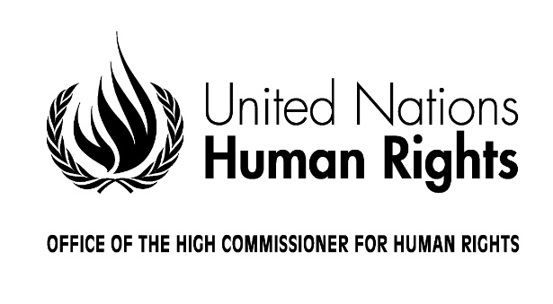

Annual interactive debate on the rights of
persons with disabilities

Statement by Michelle Bachelet
United Nations High Commissioner for Human Rights

Geneva, 6 March 2020

Madam President,
Distinguished panellists,
Excellencies,
Dear Friends,
I am pleased to speak at this annual debate.
I thank Member States for their contributions to the report on Article 8 of the Convention on the Rights of Persons with Disabilities, which focuses on the crucial issue of awareness raising.
Before we look closely at this topic, including combating discrimination and changing negative attitudes, allow me to give you a brief overview of our work since last year’s panel.
First, I would like to highlight the launch of the United Nations Disability Inclusion Strategy, which reaffirms the Organization’s commitment to upholding the rights of people with disabilities
I am happy to say that my office was a leading partner in the development of this strategy -- which will help us mainstream the issue throughout the whole UN system.
I encourage all countries and UN agencies to support its implementation.
Second, last June, my office supported Member States in the adoption of Security Council resolution 2475, the first-ever calling upon governments and parties to armed conflict to protect persons with disabilities in those situations.
The text brings a human rights-based perspective, calling for relevant actors to ensure that persons with disabilities have access to justice, basic services and unimpeded humanitarian assistance.
I encourage Member States to continue monitoring the situation, including through the implementation of the Convention on the Rights of Persons with Disabilities.
Third, in July, the Human Rights Council also took an unprecedented step -- by adopting its first resolution on the rights of persons with disabilities in the context of climate change.
It mandated my office to conduct an analytical study of ways to better protect and promote these rights, while also calling on governments to adopt a disability-inclusive approach to climate action.
Furthermore, looking at the upcoming demands of climate change adaptation and disaster risk reduction, my office also supported the development of guidelines on the inclusion of persons with disabilities in humanitarian action.
These guidelines, adopted by the Inter Agency Standing Committee last November, ensure that a human rights perspective be taken into account in emergencies.
I welcome these recent measures by international bodies, which now present persons with disabilities as agents of change.
I encourage Member States and UN agencies to implement them.
Excellencies,

Although estimates indicate that the persons with disabilities represent around 15 per cent of the world’s population, disability remains largely invisible as a human rights issue.
For too long, negative attitudes and stereotypes have been influencing laws and policies – and perpetuating discrimination against persons with disabilities.
We will never change this reality without changing perceptions and behaviours.
Without resisting negative attitudes and stereotypes.
And because these presumptions are deeply rooted in societies, we know they are not easy to shift.
We all know how difficult it can be to challenge unconscious bias and change bad attitudes.

But we must.
Attitudinal change is imperative to fulfil the rights of persons with disabilities.

Dear friends,

As one human family, we all have a role to play in combatting discrimination.
As Eleanor Roosevelt once said, human rights begin in “small places, close to home”.
That is precisely the focus of my office’s report on awareness raising.
Through effective communication strategies and campaigns, awareness raising informs and strengthens human rights.
Through training and capacity building, it can change attitudes – including of persons with disabilities themselves.
As everyone else, they must know their rights.
And they must be involved in the design, implementation and monitoring of all awareness raising programmes.
These programmes should also take into account that people with different impairments experience disability differently – and face different barriers.
With all that in mind, the United Nations Disability Inclusion Strategy includes specific targets on communication to improve the UN’s performance in this issue.
Dear colleagues,
My office’s report aims at supporting Member States in the development of programmes to challenge existing attitudinal barriers against persons with disabilities -- and to revert their effects.
Awareness raising is fundamental to the effective implementation of any policy concerning disability.
I encourage all of you to use the report -- and share it.
Excellencies,
The Disability Inclusion Strategy gives the UN a unique opportunity to support Member States in changing narratives and attitudes for the better.
Your continuous political support is fundamental to the success of this initiative.
My office is ready to support this effort – and all efforts to uphold the human rights of persons with disabilities and to ensure that they can take their rightful place as equal members of society.
Thank you.

