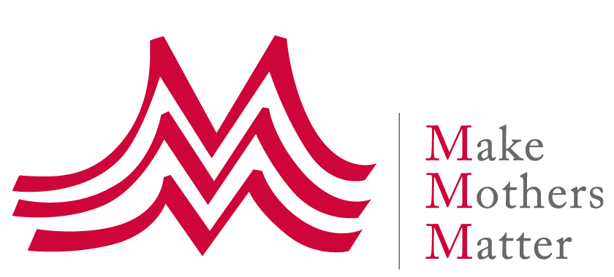
Answer to the call for input
UN Working Group
on discriminations against women and girls
Women and girls’ human security in the context of poverty and inequality

Make Mothers Matter (MMM) congratulates the Working Group on the preparation of this upcoming report and welcomes the opportunity to contribute.

Given the large scope of the topic, our answer to the questionnaire focuses on 2 main points in relation to women and girls’ human security:
- Framing the inequitable distribution of unpaid family care work as the main structural cause of gender inequality, and women’s social and economic vulnerability and insecurity
- Highlighting lone mothers as the most at-risk group of women

Risks and structural barriers

In every country around the world, women spend substantially more time on unpaid domestic and care work than men. The resulting time poverty reduces the time and opportunities for education, participation in public life and income generating activities. In particular, unpaid care work remains a barrier for many women to access the labour force, earn a decent wage, and work their way to decision making positions on an equal footing with men. The gender care gap drives the gender pay gap and pension gap, and time poverty often translates into financial poverty and social exclusion.

Moreover, the work women do for free in the home is seen as unskilled and less valuable to society, meaning that women not only are economically penalized but they are also socially deprived.

The inequitable distribution of unpaid family care work is a cause of economic and social injustice for women, in particular mothers, and a major structural barrier to gender equality. It threatens women’s security in all its forms – all the more so when women face intersecting grounds of gender discriminations linked to age, race, ethnicity, migration status, family status and motherhood.

The risks are particularly acute for lone/single mothers who have no partner to share the unpaid work of caring for and educating their children. All over the world, lone mothers are among the most at risk of poverty, homelessness and social exclusion – thus facing many forms of insecurity.

Single motherhood can have many causes: widowhood, divorce or separation from a partner or spouse, fleeing domestic violence, unintended pregnancies, as well as armed conflicts, natural disasters, displacement and migration, which can separate families. Although an increasing number of women do choose to have children on their own, especially in developed countries, they remain a minority. In the majority of cases, women do not become single mothers by choice.

Relevant data

Measuring unpaid care work

The measurement of unpaid care work and its distribution between men and women is part of the 2030 Agenda. Target 5.4 is associated with the indicator 5.4.1 – Proportion of time spent on unpaid domestic and care work, by sex, age and location, which is also among the Global Minimum Set of Gender Indicators.

However, this data can only be obtained by carrying out Time-Use Surveys (TUS), which are complex and expensive to implement. As of 2018, only 72 countries had conducted such surveys at least once, with only 27 of those countries having done so at least twice. Very few countries carry out TUS on a regular basis, which would be necessary to monitor progress in reduction and redistribution of unpaid domestic and care work: the United States is the only country which has done so on a yearly basis since 2003; Switzerland has conducted TUS every three or four years since 1992, and Norway every ten years since 1970.

The relevance and value of the time-use data must be stressed. As documented in a background report of the 2020 UN Statistical Commission, time-use data can actually inform and guide policies in a wide range of sectors – a number of them linking to women’s and girls’ security.

TUS allow in particular:
- To analyse the links between monetary poverty and time poverty, how time poverty is distributed and particularly affects women’s economic security, and how economic poverty reinforces time poverty
- To understand the connections between paid and unpaid work and support better work-life balance, in order to improve income security
- To develop public infrastructure and services such as clean water and sanitation, electricity and energy, telecommunications or transport in order to reduce the unpaid work and time needed to palliate the absence of these infrastructure and services, which disproportionately affects women and several aspects of their security
- To understand selfcare and engagement in activities that can affect health, such as eating, drinking, sleeping and sports, which are useful to assess health security
- To address the issue of girls dropping out from school because they are needed for domestic work, which pose high risk for their present and future security
- To understand the disproportionate impact of Climate Change on women – in particular the increase of unpaid work – and address or mitigate the associated risk

Target 5.4 and its indicator 5.4.1 should be given the attention and traction they deserve.

Single motherhood

Globally lone parent families represent 7.5% of all households, 84.3% of which are lone mother families. This represents more than 100 million mothers raising their children alone - and their number is on the rise. 3.4% of those mothers are younger than 25, which translates into 3.8 million extremely vulnerable young women - 127,000 of whom are estimated to be under 18 and living alone with their children.

However, those statistics on lone mothers are likely to be underestimated: they are usually derived from household surveys that typically consider men as heads of the household. In the case of extended families, this makes it difficult to capture relationships between members and identify lone mothers.

As one of the most vulnerable and insecure groups lone mothers must be made more visible to policymakers through improved statistical methodology.

Promising practices

A number of countries in Latin America have committed to address the unpaid care work issue, notably by establishing care as a basic right for all people - a right to care and right to be cared for.

Uruguay has been one of the leaders of the movement with the creation, in 2015, of the National Integrated Care System (NICS), the Care Act and the National Care Plan 2016-2020.

The objective of the NICS “…is to generate a co-responsible model of care, shared by families, government, community and market; highlighting that it should be especially shared between men and women, so that Uruguayan men and women may share care responsibilities in an equitable manner as an attempt to do away with the unjust gender-based division of work that has historically characterized our society, and which still does. That is why - at the demand of civil society itself - caregivers, for the most part, women, are integrated from a gender perspective as an active subject of rights.” (National Care Plan 2016-2020 p.5)

The NICS consists of five components: services (childcare and other), training (to professionalize care work), regulation (to ensure quality and comprehensiveness), information and knowledge management (targeting and monitoring systems), and communication (to support the cultural transformation of Uruguayan society).

Other countries like Argentina, Chile and Mexico are following similar paths. In particular, Argentina in 2020 created the Inter-Ministerial Committee for Care Policies, as a ‘space for government officials to articulate different initiatives that seek to transform cultural and economic patterns that reinforce inequality gaps’.

It may not be a coincidence that Latin America is the region where the percentage of lone mothers’ households is the highest at 9.5%.

About Make Mother Matter - MMM

Make Mothers Matter believes in the power of mothers to make the world a better place, advocating for their recognition and support as changemakers. Created in 1947, MMM is an international NGO with no political or religious affiliations, transparently voicing the concerns of mothers at the highest level: the European Union, UNESCO and the United Nations (general consultative status). MMM also federates a network of about 40 grassroots organisations working in about 30 countries across the world to support and empower mothers and their families, and to advance the human rights of women and children.

More information on www.makemothersmatter.org

Contact in Geneva: Valerie Bichelmeier - valerieb@makemothersmatter.org – Tel +41 78 930 2575

Globally, the time ratio is 3, but this figure can reach 10 in developing countries like India or Morocco. See Care work and Care jobs for the future of decent work, ILO report, 2018 – accessible on https://www.ilo.org/global/publications/books/WCMS_633135/lang--en/index.htm
This issue has also been framed as a Human Rights issue with the landmark 2013 report of Magdalena Sepulveda Carmona, the UN Special Rapporteur on Extreme Poverty and Human Rights: Unpaid Care Work and Women's Human Rights
Transforming our World: The 2030 Agenda for Sustainable Development, UN 2015 - https://sdgs.un.org/publications/transforming-our-world-2030-agenda-sustainable-development-17981
Care work and Care jobs for the future of decent work, ILO report, 2018
See MMM 2022 HLPF written statement on Prioritising Target 5.4 to ‘build forward transformatively’ and advance the 2030 sustainable development agenda https://makemothersmatter.org/prioritising-sdg-5-target-5-4-to-recognize-the-work-of-mothers-and-advance-all-the-sdgs
All figures from Families in a changing world, UN Women 2019 https://www.unwomen.org/en/digital-library/progress-of-the-worlds-women
See https://www.unwomen.org/en/news/stories/2020/2/experts-take-antra-bhatt-on-single-parent-households
See Policies and care provision in Latin America A view of regional experiences, ECLAC, 2015 - https://www.cepal.org/en/publications/37727-policies-and-care-provision-latin-america-view-regional-experiences as well as Towards the construction of Comprehensive Care Systems in Latin America and the Caribbean. ECLAC & UN Women, 2021 - https://lac.unwomen.org/sites/default/files/Field%20Office%20Americas/Documentos/Publicaciones/2021/11/TowardsConstructionCareSystems_Nov15-21%20v04.pdf
The National Integrated System of Care in Uruguay: An opportunity for the economic empowerment of women – UN Women, 2019 - https://lac.unwomen.org/en/digiteca/publicaciones/2019/10/sistema-nacional-de-cuidados-oportunidad-empoderamiento-uruguay
The Value of Care: A Strategic Economic Sector- A Measurement of Unpaid -Care and Domestic Work in the Argentine GDP https://www.argentina.gob.ar/sites/default/files/the_value_of_care.pdf
UN Women global factsheet, 2019 - https://www.unwomen.org/sites/default/files/Headquarters/Attachments/Sections/Library/Publications/2019/POWW-2019-Fact-sheet-Global-en.pdf

