UN Working Group on discrimination against women and girls
Questionnaire on women’s and girls’ human security in the context of poverty and inequality
31 October 2022
Ipas respectfully submits its inputs to the UN Working Group on the issue of discrimination against women and girls as it relates to human security in the context of poverty and inequality.
Ipas works globally to improve access to abortion and contraception so that everyone can determine their own future. When women and girls can safely get an abortion, it can not only improve their quality of life but also that of their families, communities, and even countries.
Our written evidence focuses on providing relevant information to demonstrate that when abortion access is achieved by making it legal, accessible, and affordable, the benefits are vast and far-reaching.
The information included in this submission is mainly from Ipas’s scoping review on the ‘economics of abortion’ (1, 2, 3, 4, 5, 6) completed in partnership with colleagues at Rutgers University, London School of Economics, and Maila Health.
This work was conducted to better understand and clearly synthesize the existing information on the economic outcomes of abortion services and policies. This review synthesized the evidence base and identified gaps on costs, impacts, and benefits of abortion to stakeholders at three different economics levels: microeconomic (abortion seekers and their households), mesoeconomic (communities and health systems), and macroeconomic (societies and nation states). The framework for this scoping review was developed to reflect our focus on the economics of abortion, rather than just the finances of abortion. As economics focuses on behaviors as well as money, the goal of this framework is to include outcomes—negative or positive—that go beyond financial outcomes as measured in monetary terms.
Available information was collected from over 62 countries around the world, though the majority of studies focused exclusively on the United States of America [Table 1]. Studies most often took place in countries classified as high-income (50%), followed by lower-middle-income countries (17.8%), and upper-middle-income countries (14%). However, levels of income and poverty varied at the community, family, and individual level [Table 2].

Table 1. Included studies by region and country
Region/country | # of studies |  | Region/country | # of studies
Northern America | 122 |  | Europe | 49
Canada | 7 |  | France | 3
United States | 115 |  | Germany | 1
 |  |  | Ireland | 4
Africa | 68 |  | Moldova | 1
Burkina Faso | 4 |  | Netherlands | 1
Cameroon | 1 |  | Norway | 2
Cote d'Ivoire | 1 |  | Poland | 2
Egypt | 1 |  | Romania | 4
Ethiopia | 1 |  | Spain | 2
Ghana | 8 |  | Sweden | 2
Kenya | 6 |  | Switzerland | 1
Malawi | 2 |  | Turkey | 1
Mozambique | 2 |  | United Kingdom | 22
Nigeria | 7 |  | Multiple countries | 3
Rwanda | 1
South Africa | 13 |  | Latin America & Caribbean | 34
Tanzania | 1 |  | Argentina | 1
Uganda | 4 |  | Brazil | 4
Zambia | 6 |  | Chile | 3
Multiple Countries | 10 |  | Colombia | 4
 |  |  | Cuba | 1
Asia | 53 |  | El Salvador | 1
Bangladesh | 4 |  | Guadeloupe | 2
Cambodia | 1 |  | Mexico | 9
China | 5 |  | Peru | 1
Hong Kong | 1 |  | Puerto Rico | 1
India | 20 |  | Multiple countries | 7
Indonesia | 1
Iran | 2 |  | Oceana | 9
Israel | 1 |  | Australia | 8
Kazakhstan | 1 |  | New Zealand | 1
Myanmar | 1
Nepal | 4 |  | Cross-Regional Studies | 30
Pakistan | 1 |  | Global | 18
Taiwan | 1 |  | Selected countries incl. US | 7
Thailand | 6 |  | Selected countries excl. US | 5
Vietnam | 3
Multiple Countries | 1 |  | Total | 365

Economic Costs and Impacts of Barriers to Safe Abortion Access
Abortion care has direct cost implications on the individual seeking services, which can quickly be compounded by the timing and type of care sought.

Women and girls experiencing economic difficulties and marginalization can face considerable challenges accessing safe abortion services. In a study in Kazakhstan, 40% of women identified ‘financial problems’ as the main barrier in obtaining an abortion. In the United States, 41% of the study population indicated that it was somewhat or very difficult for respondents to pay for an abortion procedure. This number was even greater (52%) among women who were not using health insurance.

The cost of abortion services can even vary within one country. For example, evidence from Poland showed that ‘illegal’ abortions cost between 2000-4000 PLN (US $500 – 1000). At the time of this study, the average monthly salary in Poland was 2000 PLN. In Kenya, the cost of an abortion ranges from KS 60 for quinine at the pharmacy to 5,000 KS (US $60) for services from a doctor. Although the evidence suggested that the women knew where the safer options for abortion services are, the cost was prohibitive. They had to choose the less expensive option as most women earned less than 220 KS (US $2.50) per day.

In some cases, the insurmountable cost of obtaining an abortion could impact pregnancy outcomes. In Thailand, three out of 30 women were unable to have an abortion because of the costs involved in the service. In Nepal, a rural woman was forced to give birth to her sixth child because she could not afford the cost of an abortion service.

The potential wide-ranging costs of abortion-related care beyond the direct cost of service are demonstrated clearly in studies where abortion care is provided free of charge. In these cases, many factors added to indirect costs of abortion care: childcare, overnight accommodation, travel costs, time off work and/or missed wages, follow-up visit, and potentially unofficial payments for services.

Many studies show when people are forced to choose unsafe abortion due to a restricted legal setting, lack of social support, economic challenges, or other reasons, they and their family can suffer financial hardship through health-care debt and job loss—and loss of lifetime earnings in cases where a woman dies from unsafe abortion. Legal abortion is connected in some studies to a decline in childbearing, which is in turn linked to a rise in women’s economic progress.

Barriers to Abortion Services for Young Girls and Adolescents
The existing evidence base is largely focused on findings about adult women, leaving a lack of knowledge on the costs and economic barriers for young girls and adolescents. This is a critical gap in the evidence as adolescents are less likely to be financially independent or have the ability to access the same level of financial support as compared to older women.

In some contexts, younger girls can be charged higher rates for abortion-related services than older women. In India, for example, the law requires a guardian’s consent foal l medical care for individuals below 18 years old. In one study, girls reported that private practitioners were willing to bypass this requirement in return for a fee up to five times the normal rate. Although abortion is legal in India, some providers reportedly took advantage of young women’s need for confidentiality due to their fear of social ostracism, and charged three to five times the normal rate for abortion services.

In the United States, evidence suggests that the cost for abortion services is the highest for very young adolescents (11-13 years); an age group that has particular difficulty acquiring the funds needed for abortion procedures.

Men’s Roles in Financing Abortion Related Care
The role of men in financing abortion care is important across many different contexts. In various studies, women often relied on their social support network, including their male family members, partners, and/or friends, to afford the direct and indirect costs of abortion care.

When women are unable to confide in and rely on their social support network, they are less likely to have adequate financial resources to access abortion services. In some cases, lack of financial resources and the fear of stigma from family, friends, and partners prevented some women from seeking abortion services entirely.

Conversely, women who could rely on their social support network for accurate information, facility recommendations, and financial support were more likely to be able to access and afford the direct and indirect costs of abortion care, demonstrating the pivotal role of supportive partners in seeking abortion services.

Economic Costs and Impacts of Delays in Abortion Care
There is a strong relationship between the cost of abortion care for individuals and delays to seeking abortion care. When women do not have the funds available to access an abortion, it can lead to delays in seeking care. Delays in receiving abortion care can subsequently increase the direct and indirect cost of service. Delays to seeking care, reinforced and perpetuated by economic factors, can prevent an individual from seeking out desired services, affect the type of services sought, and impact the gestational age at which services are sought or reached.

Across a diverse range of contexts, restrictive legal environments can impose substantial financial hardship on individuals, often resulting in costly delays to care. Prior to decriminalization in Northern Ireland, women had to travel outside of the country to access an abortion, which added additional indirect costs and time to access the service.

In the United States, TRAP laws increased service costs or decreased the availability of appointments had an impact on the time it took some women to access an abortion. For some women, a long delay in accessing services would lead to an increase in gestational age at the time of appointment, which could limit the number of providers willing to perform an abortion. While people with wealth can often get an abortion regardless of local policies, people who are low-income, young, and/or living in rural places are less able to manage increased cost and distance.

Recommendations to Improve Affordable Access to Abortion Care
In order to improve access to abortion, we need to ensure that we are framing this issue with a reproductive justice perspective, moving beyond the focus of reproductive rights. A reproductive justice framework can help provide a greater understanding of how abortion-related care intersects with the specific economic needs of individuals seeking care. In addition, to make abortion care more affordable and accessible, we recommend:

- Decriminalization of Abortion: When abortion is legal, people experience fewer delays in receiving care and are less likely to choose unsafe abortion methods that increase the risk of death and injury.

- Abortion Financing/Universal Health Coverage: Even when abortion is legal, the cost of abortion can still be a barrier for individuals seeking safe care. Universal health coverage that includes abortion and other sexual and reproductive health services is a key measure to reduce the financial burden on individuals seeking abortion services. Comprehensive universal health coverage would ensure that all individuals and communities receive essential, quality health services, free of stigma and with respect to human rights.

- More Options for Care: There needs to be enough facilities, providers, and diverse options for abortion care (such as telemedicine and abortion with pills) in order to ensure that access to abortion is available. When abortion is available in a wide range of options, fewer people must travel great distances to reach care, ensuring that abortion remains affordable for everyone.

Many studies show that when people can end an unwanted pregnancy, they have more time to establish stable relationships, complete their education, and secure financial footing. For example, a study in the United States showed that children of mothers who had previous abortions were less likely to be in single-parent households and are less likely to live in poverty than those from similar socioeconomic backgrounds who did not. Research from around the world shows that legal, accessible, and affordable abortion care not only benefits the individual seeking care, but every level of society [Image 1].

Image 1: How Abortion Access Benefits Every Level of Society
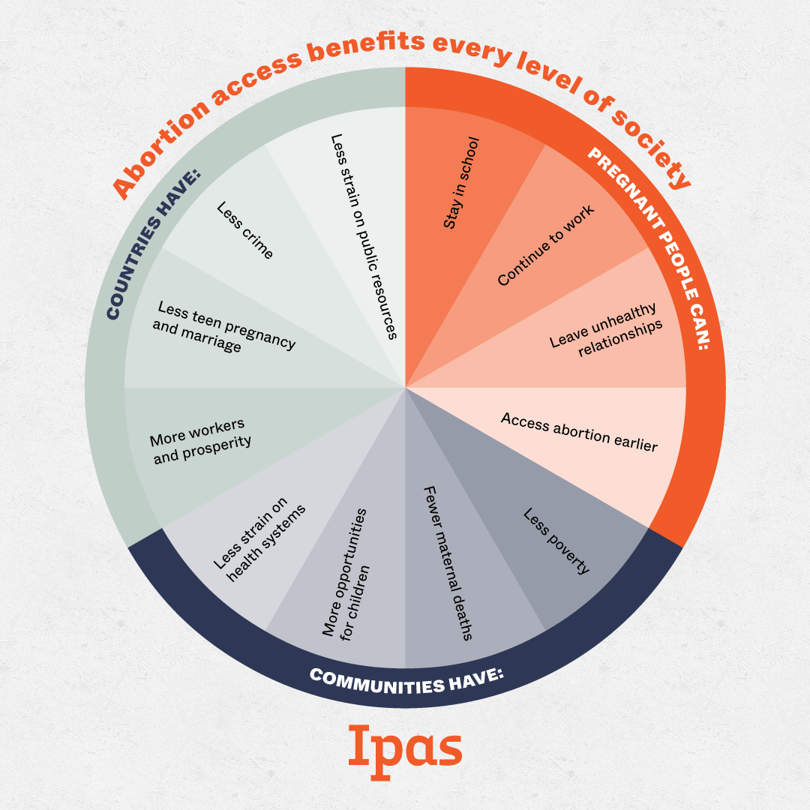
Image Source: Ipas https://www.ipas.org/news/beyond-the-individual-research-shows-abortion-access-has-widespread-benefits/

Agadjanian V. Is "Abortion Culture" Fading in the Former Soviet Union? Views about Abortion and Contraception in Kazakhstan. Studies in Family Planning. 2002;33(3):237–48. pmid:12385085
Jones RK, Upadhyay UD, Weitz TA. At What Cost? Payment for Abortion Care by U.S. Women. Women’s Health Issues. 2013;23(3):e173–8. pmid:23660430
Girard F, Nowicka W. Clear and Compelling Evidence: The Polish Tribunal on Abortion Rights. Reproductive Health Matters. 2002;10(19):22–30. pmid:12369330
Marlow HM, Wamugi S, Yegon E, Fetters T, Wanaswa L, Msipa-Ndebele S. Women’s perceptions about abortion in their communities: perspectives from western Kenya. Reproductive Health Matters. 2014;22(43):149–58. pmid:24908466
de Bruyn M. Safe Abortion for HIV-Positive Women with Unwanted Pregnancy: A Reproductive Right. Reproductive Health Matters. 2003;11(22):152–61. pmid:14708406
Wu WJ, Maru S, Regmi K, Basnett I. Abortion Care in Nepal, 15 Years after Legalization: Gaps in Access, Equity, and Quality. Health Hum Rights. 2017 Jun;19(1):221-230. PMID: 28630554; PMCID: PMC5473051.
Ganatra B, Hirve S. Induced Abortions Among Adolescent Women in Rural Maharashtra, India. Reproductive Health Matters. 2002;10(19):76–85. pmid:12369334
Ely GE, Hales T, Jackson DL, Maguin E, Hamilton G. The undue burden of paying for abortion: An exploration of abortion fund cases. Social Work in Health Care. 2017b;56(2):99–114. pmid:27960652
Wu WJ, et al. 2017
Bloomer F, O’Dowd K. Restricted access to abortion in the Republic of Ireland and Northern Ireland: exploring abortion tourism and barriers to legal reform. Culture, Health & Sexuality. 2014;16(4):366–80. pmid:24617662
Austin N, Harper S. Assessing the impact of TRAP laws on abortion and women’s health in the USA: a systematic review. BMJ sexual & reproductive health. 2018;44(2):128–34. Epub 2018/06/21. pmid:29921636.
Foster DG, Biggs MA, Raifman S, Gipson J, Kimport K, Rocca CH. Comparison of Health, Development, Maternal Bonding, and Poverty Among Children Born After Denial of Abortion vs After Pregnancies Subsequent to an Abortion. JAMA Pediatrics. 2018a;172(11):1053–60.

