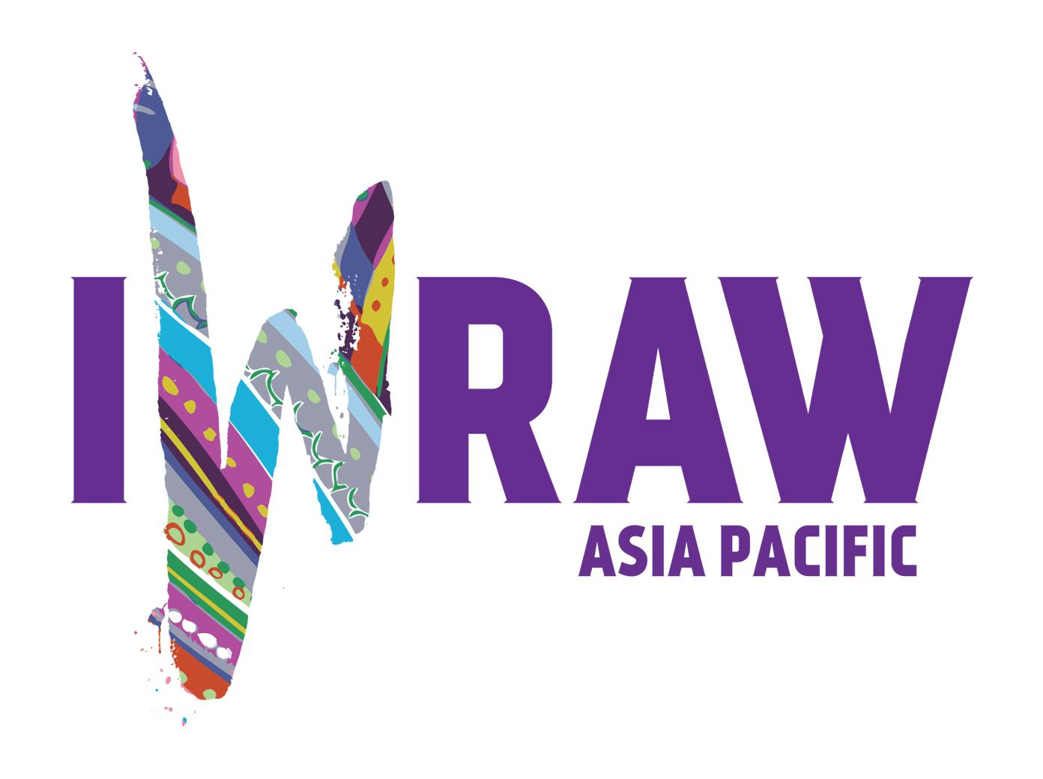
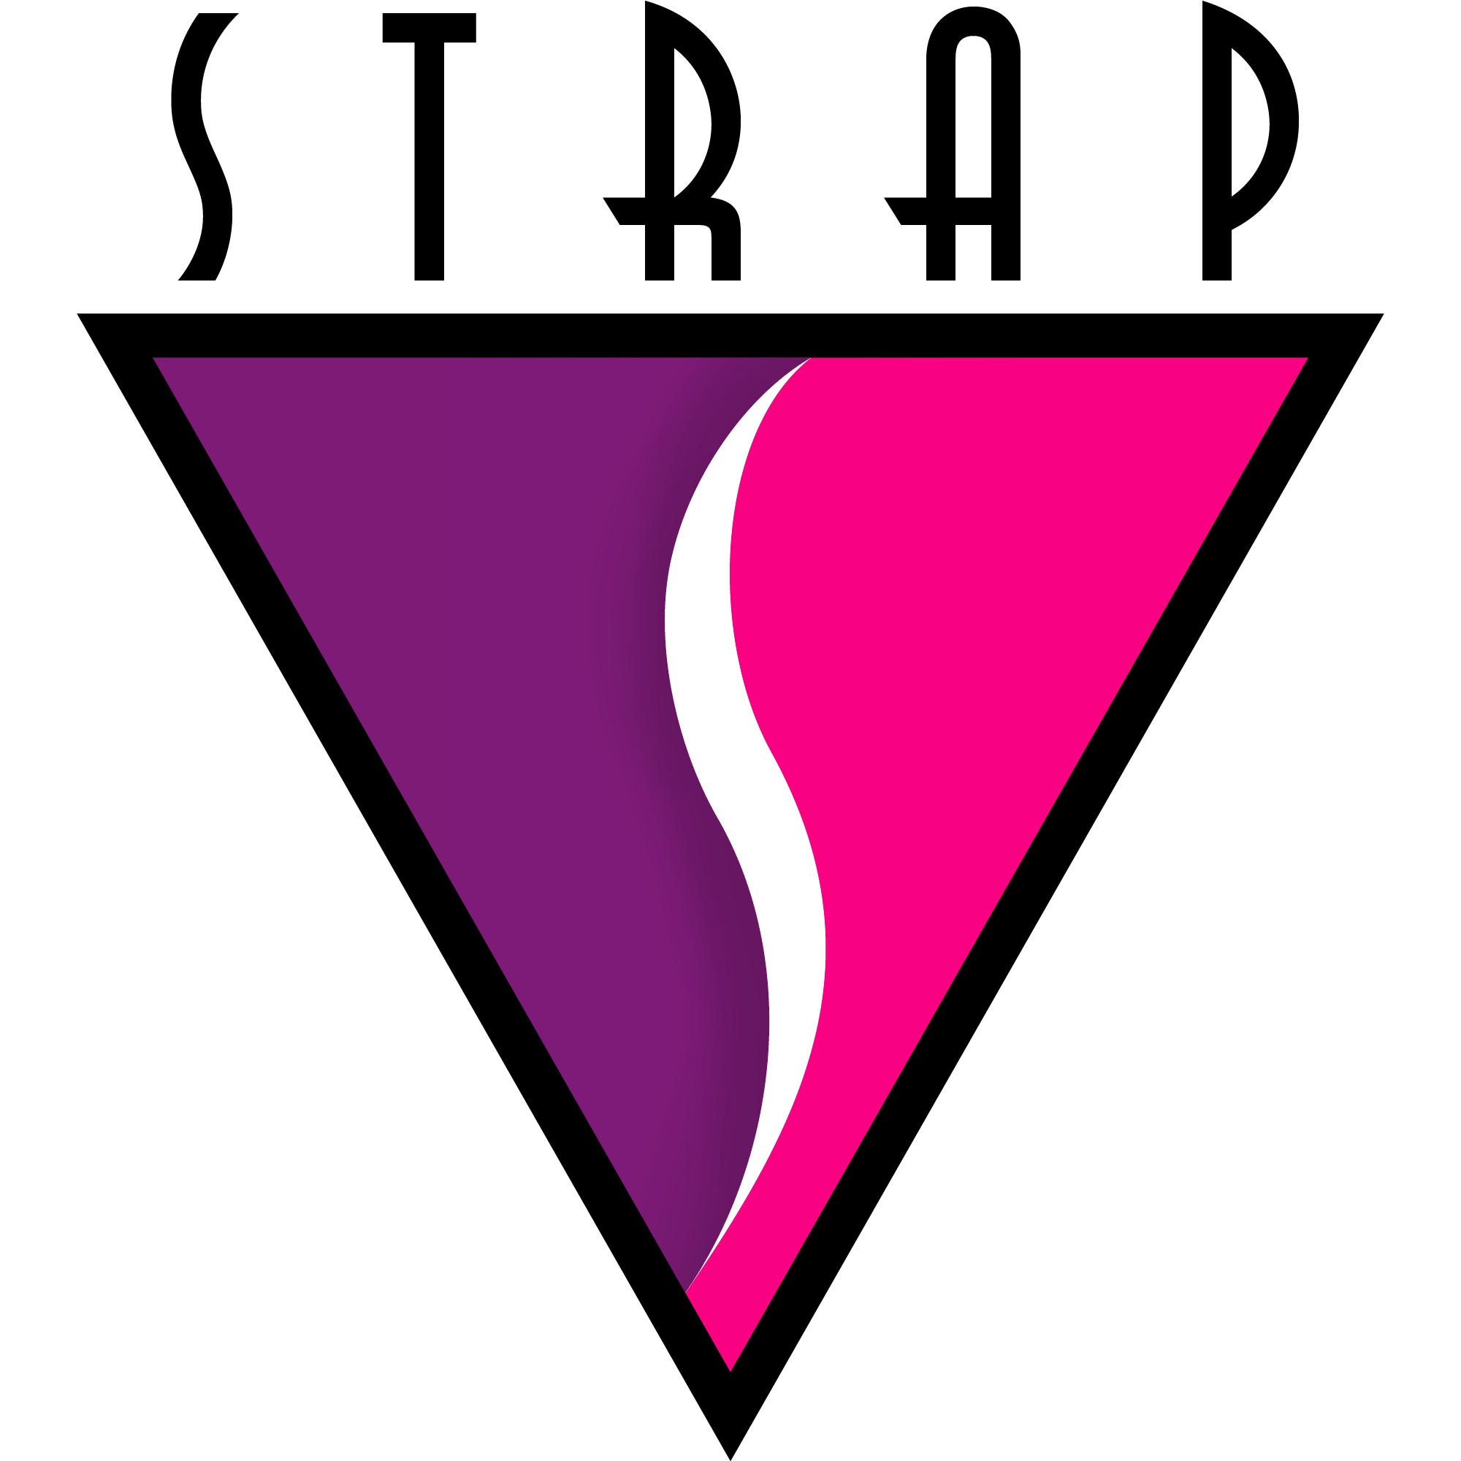
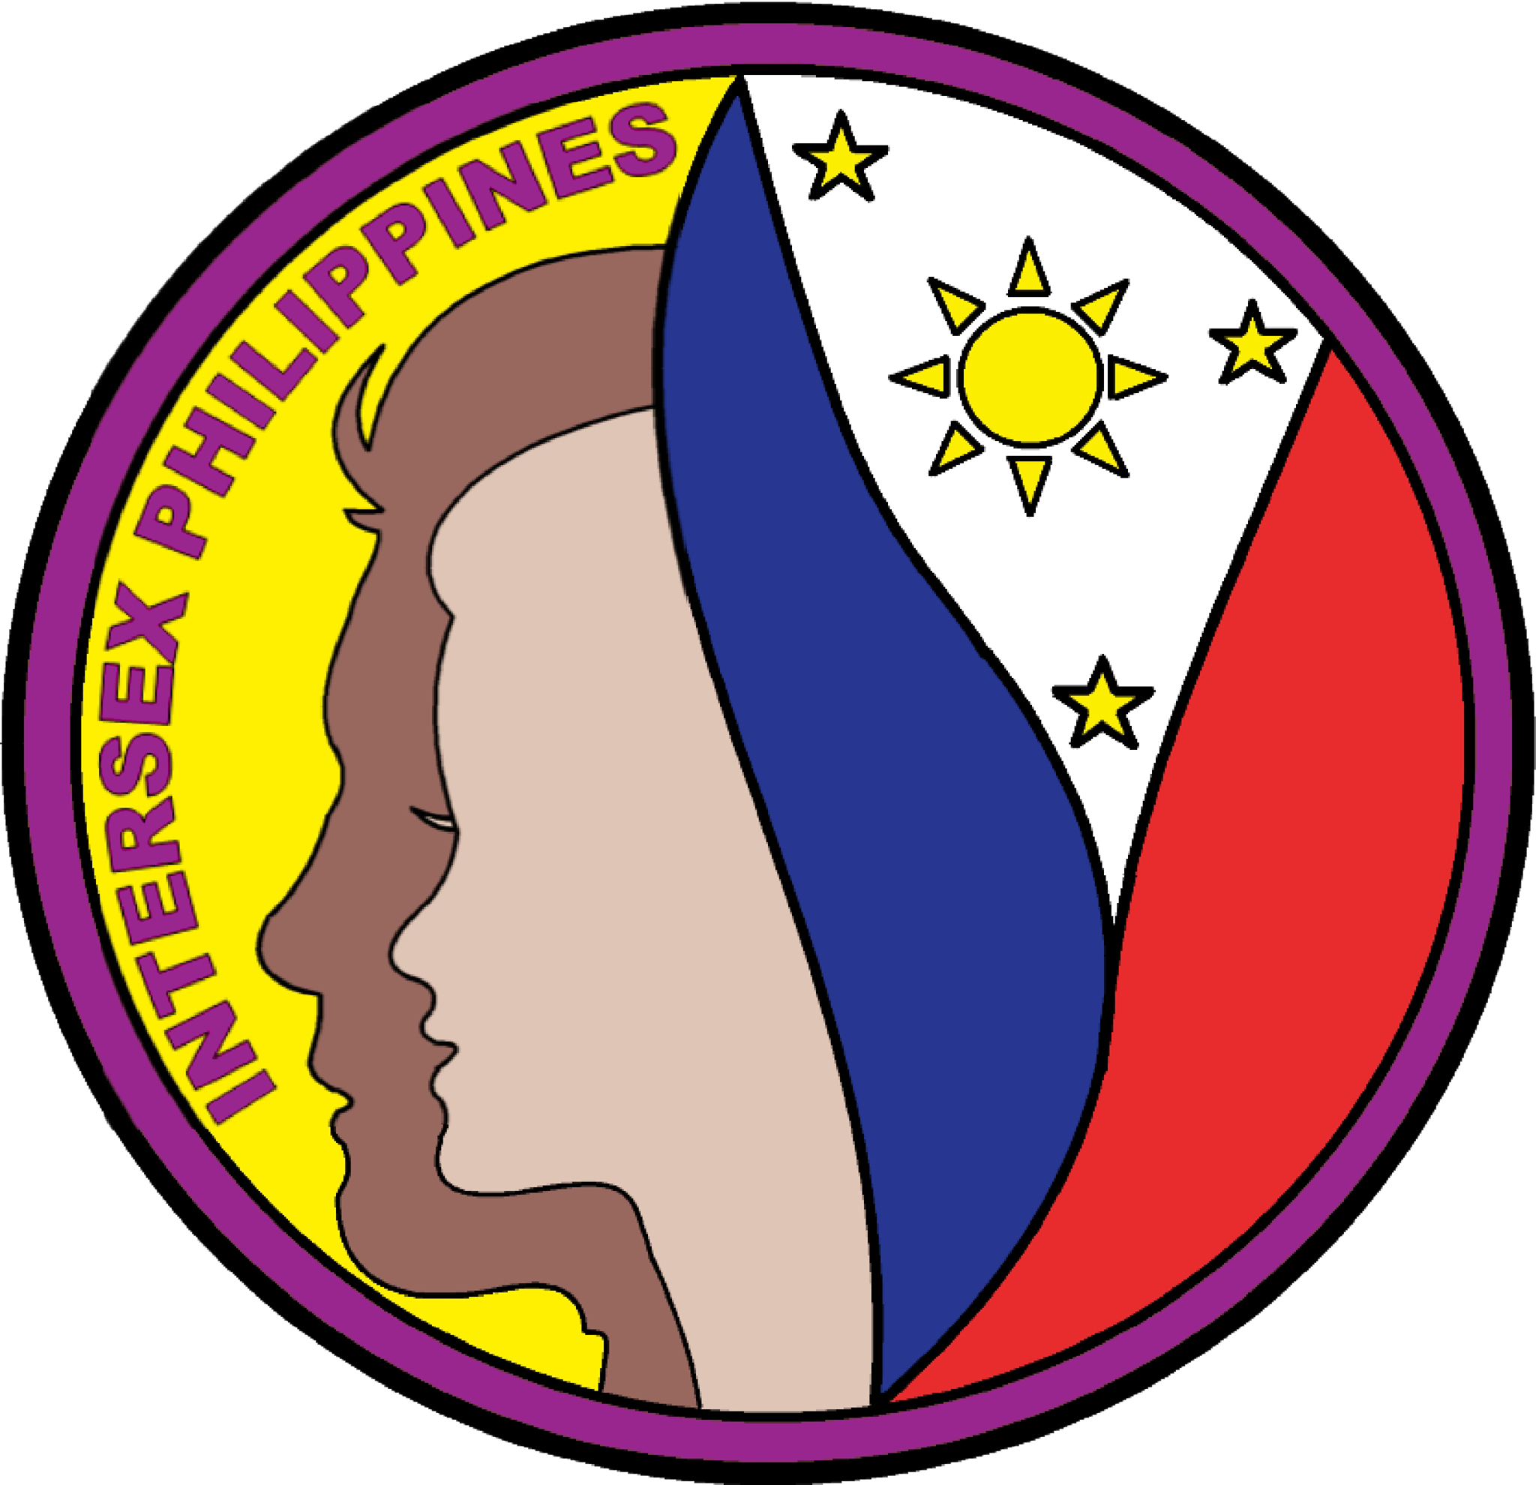

JOINT NGO SUBMISSION IN RESPONSE TO THE CALL FOR INPUT BY THE UN WORKING GROUP ON DISCRIMINATION AGAINST WOMEN AND GIRLS: HUMAN SECURITY OF WOMEN ANG GIRLS IN THE CONTEXT OF POVERTY AND INEQUALITY
Intersex Philippines, Society of Trans Women of the Philippines and the International Women’s Rights Action Watch Asia Pacific have drafted a joint submission to the working group on discrimination against women and girls on human security of women and girls in the context of poverty and inequality’s call for input to contribute to the working group’s thematic report on the 53rd session of the Human Rights Council.
The submitting organizations are committed to promoting the universality of human rights and to ensuring that no experience of gender-based violence is neglected. Our submission reaffirms the importance of UN human rights mechanisms taking a broad interpretation of gender and an intersectional approach in their human rights work. It also reaffirms the equal worth and dignity of all human beings regardless of their gender, sexual orientation, gender identity, expression or sex characteristics.

Gender-based violence as as a form of gender-based discrimination is inextricably linked with other factors that affect women in all diversity, such as race, ethnicity, religion or belief, health, status, age, class, caste and sexual orientation, gender identity and sex characteristics, thus the experience of gender-based violence by marginalised groups of women can be interlocking, unique, multiple and intersecting. It is crucial to have a broad understanding of “gender-based violence” that is inclusive of violence targeting women and gender diverse persons because of their real or perceived sexual orientation, gender identity and/or gender expression, and sex characteristics.
In our joint submission, we are primarily giving inputs on the structural barriers that transgender, intersex women and girls, and gender diverse people experience that impedes in the enjoyment of our human security.
1. BINARY NARRATIVES ON ASSIGNED GENDER PERPETUATE SYSTEMIC VIOLENCE AGAINST TRANSGENDER AND INTERSEX WOMEN AND GIRLS, AND GENDER-DIVERSE PEOPLE
Most, if not all that are born are assigned a legal gender marker in their legal birth documentation depending on the actual and/or perceived primary sex characteristics that are observed from the newborn.
Transgender women and girls who are assigned male at birth experience systemic violence and discrimination because of their assigned legal gender marker. The vast majority of transgender women and girls and gender-diverse people in the world do not have access to gender recognition by the State, which creates a legal vacuum and a climate that tacitly fosters stigma and prejudice against them. The Independent Expert Sexual Orientation and Gender Identity (IE SOGI) in its report to the HRC during the 73rd session described the experiences of transgender and gender-diverse people as a spiral of exclusion and marginalization that affects their everyday lives in access to education, employment, healthcare, social welfare, housing, livelihood, among others and experience other unique, intersecting and compounding inequalities.
The practice of assigning gender marker at birth also affects some women who are subjected to genital mutilation including intersex infants and children who undergo unncessary medical interventions as a solution to fit the bodies of intersex children within the normative definition of male and female. This type of healthcare for intersex children is based on ‘predict and control’— when an intersex child is born, health professionals try to predict the future gender of the child and control the outcome of this prediction by means of medically unnecessary and irreversible surgery, treatment with hormones, other normalising treatments and psychological support, without the prior, free and fully informed autonomous consent of the child. In some cases, these decisions are made in conference with the wishes of the parents. This predict and control method is a violation of the right of self-determination of the child and of the right to the highest attainable standard of physical and mental health. The term ‘predict’ is misleading, as it is very uncertain at the young age in which surgery is often conducted, how the identity of the child will develop in the future.
The consequences are comparable to the effects of female genital mutilation as described in CRC-CEDAW Joint General Comment no. 18, art. 19, which describes amongst others, severe pain, infections, long-term gynecological problems such as fistula, psychological effects and death. Furthermore, these practices are contrary to Article 16 of the Convention on the right to privacy. The CRC-CEDAW Joint General Comment/Recommendation No. 18/31 “on harmful practices” “call[s] upon States parties to explicitly prohibit by law and adequately sanction or criminalize harmful practices, in accordance with the gravity of the offense and harm caused, provide for means of prevention, protection, recovery, reintegration and redress for victims and combat impunity for harmful practices”.
Assignment of a binary gender marker have reinforced a very strict and rigid notions of gender that affected transgender, intersex and gender diverse communities all over the world. Transgender and intersex women and girls, and gender diverse people suffer from different forms of conversion therapy.
In 2013, the Special Rapporteur on torture and other cruel, inhuman or degrading treatment or punishment called on states to repeal any law allowing intrusive and irreversible treatments, including forced genital-normalising surgery, involuntary sterilisation, “reparative therapies” or “conversion therapies”, when enforced or administered without the free and informed consent of the person concerned. He also called upon them to outlaw forced or coerced sterilization in all circumstances.
Conversion therapy is used as an umbrella term to describe interventions of a wide-ranging nature, all of which have in common the belief that a person’s sexual orientation, gender identity and intersex characteristics can and should be changed. Such practices aim (or claim to aim) at changing people from gay, lesbian or bisexual to heterosexual, or from transgender or gender diverse to cisgender, and intersex condition to subscribe strictly to either male or female sex characteristics.
Conversion therapies are so pervasive in many dimensions of everyday life. The IE SOGI report on conversion therapy stated that the perpetrators and promoters of conversion therapies are private and public mental health-care providers, faith-based organizations, traditional healers and State agents and that promoters include family and community members, political authorities and other agents.

2 THE IMPACT OF ANTI-GENDER / ANTI-RIGHTS NARRATIVES AND MOBILIZATION AGAINST TRANSGENDER AND INTERSEX WOMEN AND GIRLS AND GENDER DIVERSE PEOPLE
In 2018, CEDAW and CRC issued a joint statement on guaranteeing sexual and reproductive health and rights for all women, in particular women with disabilities and mentioned the increasing rollback and regression on respect to international human rights norms that threatens the sexual and reproductive rights of women.
Every year transgender, intersex and LGB2SA+ communities hold the International Day Against Homophobia, Biphobia, Intersexphobia and Transphobia (IDAHOBIT) to coordinate international events that raise awareness of LGBTQIA2S+ rights violations and stimulate interest in LGBTQIA2S+ rights work worldwide. The IE SOGI informed the HRC in 2021 from his report that individuals departing from gender norms and societal expectations are under attack in many parts of the world, stripped of their rights to self-determination, autonomy, bodily and mental integrity. The harmful anti-gender narratives have resulted to exclusion, pathologization, sterilization, and genital mutilation of transgender and intersex women and girls, and gender-diverse people.
Despite the depathologization of all categories related to transgender and gender diverse people in the eleventh version of the International Classification of Diseases (ICD-11) in 2019, there still exists challenges posed by legal pathologization at the country level, and the anti-gender movements who promote re-pathologization. The current challenges faced by transgender women and girls, and gender diverse people around the world in relation to COVID-19 show that the persistence of pathologization is not only grounded in pervasive institutional cissexism; it is also deeply linked to racial and socioeconomic injustice.
Transgender women and girls, including other transgender and gender-diverse communities hold the Transgender Day of Remembrance (TDOR) as an annual observance on that honors the memory of the transgender people whose lives were lost in acts of anti-transgender violence.
Furthermore, transgender and intersex women and girls, and gender diverse people face systemic barriers in accessing available, affordable, acceptable, and good quality transgender and intersex healthcare. In the Philippines for example, the Department of Health came out with a notification declaring Congenital Adrenal Hyperplasia (CAH) to be a rare disease. Such a declaration has the potential to further stigmatise intersex people. Even though CAH has been classified as a rare disease, the government has not taken any steps towards procuring sufficient medicines for the health needs of intersex infants with CAH. Last year, the situation was so dire that Nelson Ancajas- father of an intersex child with CAH contested in the election just to raise awareness on this issue.
CONCLUSIONS/RECOMMENDATIONS
1 Call for States to pass legislation for legal gender recognition based on self-determination and bodily autonomy. Sex/gender category should not be a rigid element of the legal identity registration process. As mentioned in the Malta Declaration, the legal gender registration process must be designed “with the awareness that, like all people, intersex infants and children may grow up to identify with a different sex or gender.” At a later stage, there should be mechanisms which allow for changing the sex/gender marker through a simple administrative procedure as per the request of the individual. Legal jurisprudence coming from constitutional courts has affirmed the right to self-determine sex/gender marker in identity documents for intersex people but many of them experience difficulties in obtaining identity documents or get the gender markers changed in their identity document due to the absence of legislation regarding legal gender recognition. This is different with transgender women and girls where constitutional courts may use biologically restrictive gender category to deprive transgender women and girls and gender diverse people for legal gender recognition.
2 Call for States for the inclusion of transgender and intersex healthcare in universal healthcare. It is the obligation of the State to provide the highest attainable standard of health and that includes the health of transgender and intersex women and girls, and gender-diverse people. Distinct health needs of intersex children must be identified and the use of the informed consent model for transgender women and girls and gender diverse people in their access to gender affirming healthcare. Genetic counselling/consultation are also integral part of clinics for intersex persons and should be included in the universal healthcare. Training programs should be designed suitably to address intersex/DSD issues.
3 Call for a global investigation of the serious human rights violations against intersex women and girls. Intersex persons including intersex women and girls have a right to maintain their bodily autonomy. It should be unlawful for medical practitioners or other professionals to conduct any sex reversal treatment and/or surgical intervention on the sex characteristics of a minor when treatment and/or intervention can be deferred until the person to be treated can provide informed consent. Further, such medical or surgical treatment should be undertaken only in specialized centers which have a multidisciplinary clinical team. The specific nature of the intervention should be taken as a consensus by this multi-disciplinary team of experts with experience in handling intersex conditions and should be guided by standard medical protocols. For exceptional cases, where decision-making is difficult, these should be referred to the Government working group/ committee for approval.
Consequently, states must fulfill their obligation to investigate, prosecute and provide remedies for acts of violence, including medical abuse, torture, and ill-treatment against intersex people, infants, children, adolescents, and adults, and those who defend their rights.

4 Call for States to pass Anti-discrimination laws that includes protection against violence perpetrated based on the actual or perceived sexual orientation, gender identity and/or expression, and sex characteristics.

5 Educational reforms are necessary to address binary understanding of sex and gender. Such an approach should highlight sex and gender as a spectrum rather than as a binary. A comprehensive and inclusive education law and policy is recommended to ensure that intersex children are able to access their right to education. Specific revision of existing laws and regulations must be mandated so as to prevent discrimination in the form of bullying or harassment in educational institutions based on sex characteristics. Special measures must be taken to ensure that intersex children do not face any discrimination while appearing for exams. Further, the law should prescribe training of school teachers and staff in educational institutions. The curriculum of textbooks also needs to be revised so as to ensure inclusive education.

6 Call for States to provide for safe shelter for transgender and intersex women and girls, and gender diverse children and older persons who are at risk of being homeless.

7 It is the State’s obligation to mainstream gender by providing consciousness raising efforts on issues of transgender and intersex women and girls and gender diverse people including but not limited to the preparation of transgender and intersex affirming resources and informative materials in all local languages pertaining to awareness on issues related to transgender and intersex women and girls, and gender diverse people that is disseminated and distributed to parents, educational institutions and to the general public. In addition to the preparation of material, the Ministry in charge must be obligated by law to conduct adequate awareness programmes in all parts of the country on a regular interval through different public authorities.

See https://www.ohchr.org/en/special-procedures/ie-sexual-orientation-and-gender-identity
See https://documents-dds-ny.un.org/doc/UNDOC/GEN/G10/472/60/PDF/G1047260.pdf?OpenElement
Report of the Special Rapporteur on torture and other cruel, inhuman or degrading treatment or punishment, Juan E. Medez, Human Rights Council, 1 February 2013 (A/HRC/22/53).
See https://www.ohchr.org/en/special-procedures/ie-sexual-orientation-and-gender-identity/struggle-trans-and-gender-diverse-persons
See https://documents-dds-ny.un.org/doc/UNDOC/GEN/N18/220/41/PDF/N1822041.pdf?OpenElement
See https://www.who.int/news-room/fact-sheets/detail/female-genital-mutilation
See https://weareaptn.org/resource/conversion-therapy-practices-against-transgender-persons-in-india-indonesia-malaysia-and-sri-lanka/
See https://hivlawcommission.org/wp-content/uploads/2017/06/rbap-hhd-2015-asia-pacific-trans-health-blueprint-1.pdf
See https://www.ohchr.org/sites/default/files/ConversionTherapyReport.pdf
See https://www.ohchr.org/en/press-releases/2021/06/states-must-push-back-against-harmful-anti-gender-narratives-un-expert
See ​​https://www.ohchr.org/en/calls-for-input/report-gender-theory
See https://www.hrw.org/news/2019/03/19/japan-compelled-sterilization-transgender-people
See https://weareaptn.org/2020/06/23/trans-advocacy-week-2020-webinar-on-the-road-advancing-trans-and-gender-diverse-depathologization/
See https://www.glaad.org/tdor
See https://tbinternet.ohchr.org/_layouts/15/treatybodyexternal/Download.aspx?symbolno=INT/CEDAW/STA/8744&Lang=en
See https://www.awid.org/ours-2021
Dwight De Leon, ‘Desperate father uses COC filing stage to seek help for ill child’ (Rappler, 7 August 2021) https://www.rappler.com/nation/elections/desperate-father-uses-coc-filing-stage-ask-help-ill-child-october-2021/
See https://www.ohchr.org/sites/default/files/2021-11/Summary-Bodily-Autonomy-Integrity.pdf
Watch https://www.youtube.com/watch?v=aroYJHHE0pE

