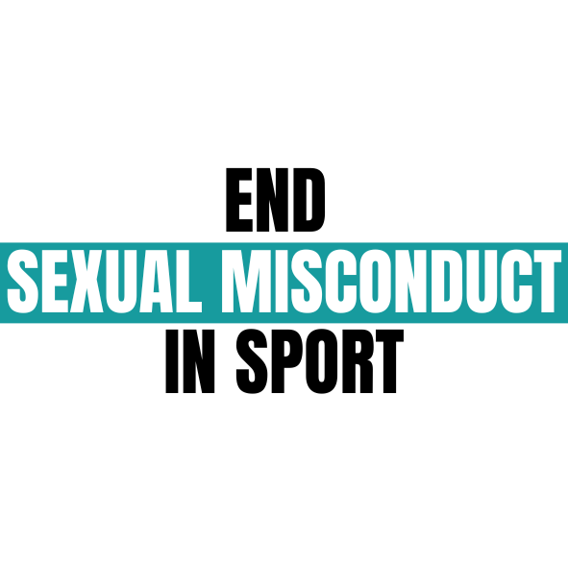

**Contribution to the report of the Special Rapporteur on violence against women and girls to the UN General Assembly on violence against women and girls in sport.**

by Miss J on behalf of End Sexual Misconduct in Sport (Scotland)

ex

*The information outlined below is specifically in relation to professional sports organisations and is provided as lived experience evidence of the culture within professional sports organisations.*

**End Sexual Misconduct in Sport (ESMIS)** is a volunteer run campaign that was started in 2022 in Scotland that has been working with professional sports teams to implement comprehensive sexual misconduct policies.

**What are the different forms of violence that women and girls in sports may experience (e.g. physical, psychological, economic, online violence, coercive control, as well as extreme form of discrimination that amounts to violence)?**

1. I want to speak specifically to non-playing engagement in sport where people who engage as fans, volunteers & employees etc. are at risk of VAWG.
2. In 2016 - 2018 I was a fan and volunteer engaging in a professional sport. I volunteered as a marketing coordinator, where I ran and participated in promotional events, the promotional cheerleading team and supported with social media. Over the course of my time doing this I recognised the toxic culture of misogyny that was extremely prevalent in not just the team I worked for but teams throughout the league all over the UK.
3. Throughout my time I experienced the following:

* internalised misogyny from female fans
* slut shaming
* victim blaming
* being the subject of ‘locker room banter’
* sexual objectification
* coercion to perform sexual acts
* misogynistic microaggressions
* sexual harassment
* sexual assault
* rape

1. These experiences were perpetuated by an acceptance of rape culture. There was an attitude that the professional athletes could do no wrong, which meant there was an element of sexual entitlement.
2. In 2017, I was raped by one of the professional athletes playing for the team I was volunteering with. I did not feel I could report what happened to me because I felt I would not be believed due to his status. I was let down by a lack of internal protocols on how to handle the situation and advised that I was best to forget about what happened. I felt like fans would be very cruel to me if it became public what had happened.
3. This incident was not a sole incident but part of a wider experience of systematic abuse within a culture that encouraged it.

*[CONFIDENTIAL: Please be aware that the player above was charged with rape in 2022 after I reported in 2020 and will stand trial for his behaviour this coming summer.]*

**What human rights of women and girls in sports are violated as a result of the exposure of women and girls in sports to violence or the risk of violence?**

1. When women and girls experience violence or the risk violence within sports, it can intersect with multiple human rights. Physical attacks are an attack on a person's right to bodily autonomy. Sexual violence is a breach of Article 3 and Article 8 ECHR. The international human rights framework recognises rape as a human rights violation that could amount to torture.
2. VAGW in sport also amounts to a breach of the right not to be discriminated against. Discrimination, fear of violence, etc. plays a fundamental role in the disparity in engagement rates in sport and is unfair prejudicing women and girls.

**Which actors are responsible for committing acts of violence against women and girls and increasing the risks of violence against women and girls in sports?**

1. I believe that, in relation to acts committed by professional athletes, the professional athletes are responsible for their behavior, however, I also believe that they are a product of a culture that often encourages entitlement. Misogyny and rape culture is ingrained in sport. Management and fans often overlook serious transgressions in favour of the skill of the player putting women and girls at risk of further violence.
2. One of example of this is Glasgow Clan Ice Hockey club who signed a player called Lasse Uusvirta who had been charged with (and admitted to under mirandized confession) first degree rape in the USA. He fled the country before he could be prosecuted and has never returned. Glasgow Clan signed him with full knowledge of this and it being the first thing that shows up on google when you search the players name. This caused significant backlash from the fans and resulted in them undoing the signing. They failed to recgonise the psychological impact that signing a player with such a history would have on the many fans that are survivors of sexual violence, many of how openly discussed how retraumatising this was for them. Glasgow Clan did not have a policy or protocols in place to handle this situation.

**What are the principal causes of the violence that women and girls experience in sports, including the structural causes of such violence?**

1. Misogyny. Rape Culture. Sexual Entitlement. Ignorance. Lack of diversity in decision making positions.

**Which groups of women and girls in sports are more exposed to violence and on what grounds?**

1. Intersectionality is key to understanding vulnerabilities of specific groups and is always important to be acknowledged and be aware of. Many women and girls are at higher risk of violence because of intersecting characteristics. However, in relation to abuse within professional organsations I always wish to highlight that those who perpetrate the abuse or the misogyny do so because of their own behaviour and when implementing policies that hopefully impact that behaviour, it is important that the onus for the behaviour remains on those at fault.
2. I had undiagnosed ADHD when I was raped, however, the player in question did not rape me because of my disability. He raped me because he was a rapist who felt entitled to do what he did. I was potentially more vulnerable to his behavior because of my disability, but the focus in policies must remain on what influenced him to believe he had the right to do what he did. This applies specifically to the work ESMIS is doing and does not apply to all forms of VAWG in sport.

**What are the responsibilities of State and non-State actors in preventing acts of violence against women and girls in sport, including in adopting measures to investigate it, and to hold those responsible for it accountable, and to provide assistance and protection to survivors of violence?**

1. It is acknowledged above that VAGW is a human rights issue, therefore the state has a positive obligation to protect survivors of rape and sexual violence, and appropriately investigate and prosecute perpetrators.
2. In the capacity of the work that ESMIS is doing, the state actors hold very little weight in relation to implementing and governing policies that can effectively fulfill the above positive obligation. This begs the question as to whether they have a duty to pass legislation to ensure they can effectively ensure that they can protect these rights. Conversations around regulators are met with contention from professional governing bodies but I guess we, as a campaign, need to consider if the state is doing enough.

**What measures do State and non-State actors have in place to ensure that incidents of violence against women and girls in sports can be effectively reported, and that they are thoroughly investigated and sanctioned?**

1. In relation to professional teams in specific, research in the top two professional football leagues, the two professional rugby teams, three professional ice hockey teams and the professional basketball teams (all in Scotland) we found no team had a specific and comprehensive sexual misconduct policy. Teams relied only on their equalities policy and disciplinary policy to handle instances of sexual misconduct. Teams were initially unwilling to engage in the conversation.

**To what extent are women and girls in sport, as well as the associations that represent them being effectively involved and consulted in the design and implementation of policies that are meant to end severe discrimination and violence against women and girls in sport at the national, regional, and international level?**

1. In Scotland, active participation in the creation and implementation of policies for professional teams has been strongly encouraged. On the 8th May 2024, End Sexual Misconduct in Sport is hosting a Parliamentary Roundtable to discuss this top which is being attended by cross party politicians, the Minister for Health, Social Care and Sport, sportscotland, key organisations from the violence against women’s sector (such as White Ribbon Scotland and Glasgow Clyde Rape Crisis), Scottish Rugby Union, Scottish Football Association, Professional Footballers Association and Scottish Women in Sport. We are extremely excited to have this collaborative conversation on the next steps of the campaign.

**Please provide examples of good practice that have been adopted by State and non-State actors with regards to ending violence against women and girls in sports?**

1. In 2022, following the situation with Glasgow Clan, I started the End Sexual Misconduct in Sport Campaign to ask all professional teams in Scotland to implement comprehensive sexual misconduct policies.
2. As of April 2024, one team had put in the suggested and approved sexual misconduct policy whilst others had made commitments to put a policy in place. Scottish Rugby has been effectively engaging with ESMIS to update their current policies and report procedures in line with our standards.
3. It should never have taken so long to get to this point, but we are now seeing teams begin to engage in the conversation and we hope that over the next few months more teams will put policies in place or at least commit to doing so.
4. Scottish Rugby Union have their “Tell Us” platform to allow people to report incidents. When we spoke with them, we noted that this platform was only on the Scottish Rugby page and not on the SRU owned professional team pages (Edinburgh Rugby and Glasgow Warriors). We highlighted this and SRU quickly implemented this feature on both teams' websites. When we next meet, we expect to receive a report on impact.

**What are the lessons learned from policies and legislations that have been adopted and implemented with regards to women and girls in sports and their implications on the safety, security, dignity, equality and participation of women and girls in sports?**

1. The biggest lesson learned over the last year when implementing these policies is that ignorance is playing a huge part in why this conversation is “taboo” for many organisations.
2. We are hopeful that these policies will begin to change the cultures within professional teams that have been ingrained for long. Cultures that put skill above safeguarding and would rather sit in silent complicity than call out inappropriate behaviour. It is too early to tell but the fact that organisations such as the Scottish Rugby Union and Scottish Football Association are engaging in this conversation shows a massive step forward. This time last year, this conversation was seen as uncomfortable and an ‘employment law issue’, but now teams know the importance of educating themselves on this issue.

**Please provide recommendations as to how violence against women and girls in sport can be prevented and what needs to be done to better respond to the needs of survivors of such violence?**

1. Comprehensive & specific sexual misconduct policies which outline the following:

* A commitment to mandatory training for all players, managers, coaches, owners and staff on the prevention of sexual misconduct including the topic of consent,
* clear protocols on how to handle complaints of sexual misconduct and guidance on the appropriate consequences and disciplinary action on players,
* clear channels to report both external and internal reports of sexual misconduct,
* clear protocols for responding to allegations (whilst also recognising that players themselves may experience misconduct) with access to confidential support for internal reporters.

[**info@endsexualmisconductinsport.com**](mailto:info@endsexualmisconductinsport.com)

[**www.endsexualmisconductinsport.com**](http://www.endsexualmisconductinsport.com)