

SUBMISSION TO THE SPECIAL RAPPORTEUR ON VIOLENCE AGAINST WOMEN AND GIRLS, ITS CAUSES AND CONSEQUENCES

**Submission by:**

ADF International   
Rue du Pré-de-la-Bichette 1

1202 Geneva, Switzerland

Web: www.ADFinternational.org

Email: UN@ADFinternational.org

**Response to the Call for Input: Violence Against Women and Gilrs in Sport**

**April 2024, Geneva, Switzerland**

*ECOSOC Special Consultative Status (2010)*

Introduction

1. ADF International is a faith-based legal advocacy organization that protects fundamental freedoms and promotes the inherent dignity of all people before national and international institutions.
2. In response to the call for inputs on violence against women and girls in sport, this written contribution argues that maintaining distinct sports categories for women and girls based on sex, along with related single-sex spaces, is crucial for safeguarding the right of female athletes to be free from all forms of violence.
3. Actors responsible for committing acts of violence against women and girls and increasing the risks of violence against women and girls in sport
4. According to UN Women, women and girls face unacceptably high risks of violence in sport, exacerbated by the lack of or ineffective prevention and response mechanisms. In particular, they are subjected to various forms of violence, including physical and emotional abuse, including sexual harassment, among others.
5. Typically, these acts are perpetrated by fellow players, coaches, physicians, and trainers. However, the failure of States and non-States actors, including sports bodies, not only to respond effectively but also to prevent such acts and mitigate associated risks, indirectly allows such violence to occur and persist. This omission constitutes a failure to uphold the rights of women and girls to be free from violence, heightening their vulnerability and also undermining the enjoyment of related human rights including the right to participate in the cultural life of the community, the right to education, and the right to work.
6. The vulnerability of female athletes to violence, abuse as well as trauma increases significantly when they are forced to compete against individuals of the opposite sex, particularly in contact sports or sports involving the use of equipment. As a growing body of scientific evidence has shown, the physiological differences between men and women are not innocuous. Allowing biological males to compete in female-only categories poses significant risks to women’s and girls’ physical and psychological integrity. Exposure to increased risks of male-inflicted injury in sports as a result of the removal of sex-separated categories also increases women’s and girls’ risk of extreme psychological distress. This distress can result, inter alia, from the potential loss academic and economic opportunities, which in many cases are crucial for advancing and thriving in their educational and professional lives.
7. The abovementioned challenges are further exacerbated when female-only spaces such as changing spaces, showering, toilet and other related facilities are accessible to males. These private facilities have traditionally been sex-separated to promote privacy, dignity, and an environment free of sexual harassment. The very removal of intimate spaces is sexually harassing—traumatic, even—for females, especially those who have been previously traumatized by male violence, as it forces them to be exposed to males, including male nudity, without their consent. For many of these women, it takes an act of sheer will to enter a space where they will encounter men. And they are traumatized at the mere thought of encountering a male in a space where they undress, attend to their private bodily needs. It should be understood that this situation not only exposes women and girls to additional risks of physical and sexual violence, but its institutionalization by state and non-state actors, whether resulting from acts or omissions, amounts to a violation of their psychological integrity.
8. Responsibilities of State and non-State actors in preventing acts of violence against women and girls in sport
9. As suggested inter alia by the Committee on the Elimination of Discrimination Against Women, States bear responsibility for any forms of violence resulting from the acts or omissions of both the State party or its actors, on the one hand, and non-State actors, on the other.
10. In the area of sport, it is imperative that States proactively mitigate risks that increase the likelihood of violence against women and girls through the enactment of legislative, policy, and other measures that safeguard—rather than remove—single-sex spaces such as locker rooms, showers, and sanitary facilities.
11. Non-state actors, particularly sports federations, bear responsibilities in the prevention of violence against women and girls within the sporting context. It is imperative that these federations design and implement effective measures, including eligibility requirements for participation in relevant competitions, that prioritize the sex-based rights of women and girls. In this regard, the principle of autonomy of sport, according to which sports bodies have a right to operate without governmental and other third-party interference, should be invoked to justify policies and practices that institutionalize sex-based discrimination and are conducive to violence against women and girls.
12. Measures undertaken in this area by both State and non-State actors must comprehensively address the various forms of violence that women and girls may encounter in sports, both on and off the playing field. Furthermore, it is essential to establish robust mechanisms that enable women and girls to report incidents of violence safely and confidentially. There must also be thorough investigations of such incidents, ensuring that perpetrators are held accountable. This comprehensive approach is critical for upholding the protection of female athletes as well as the integrity of sports.
13. Conclusion
14. In light of the aforementioned, ADF International respectfully recommends that the report of the Special Rapporteur on violence against women and girls on “Violence against women and girls in sport” upholds female-only sports categories and related spaces as a measure to safeguard women and girls from violence, both on and off the playing field, and calls on both State and non-State actors to review relevant policies and other measures accordingly.

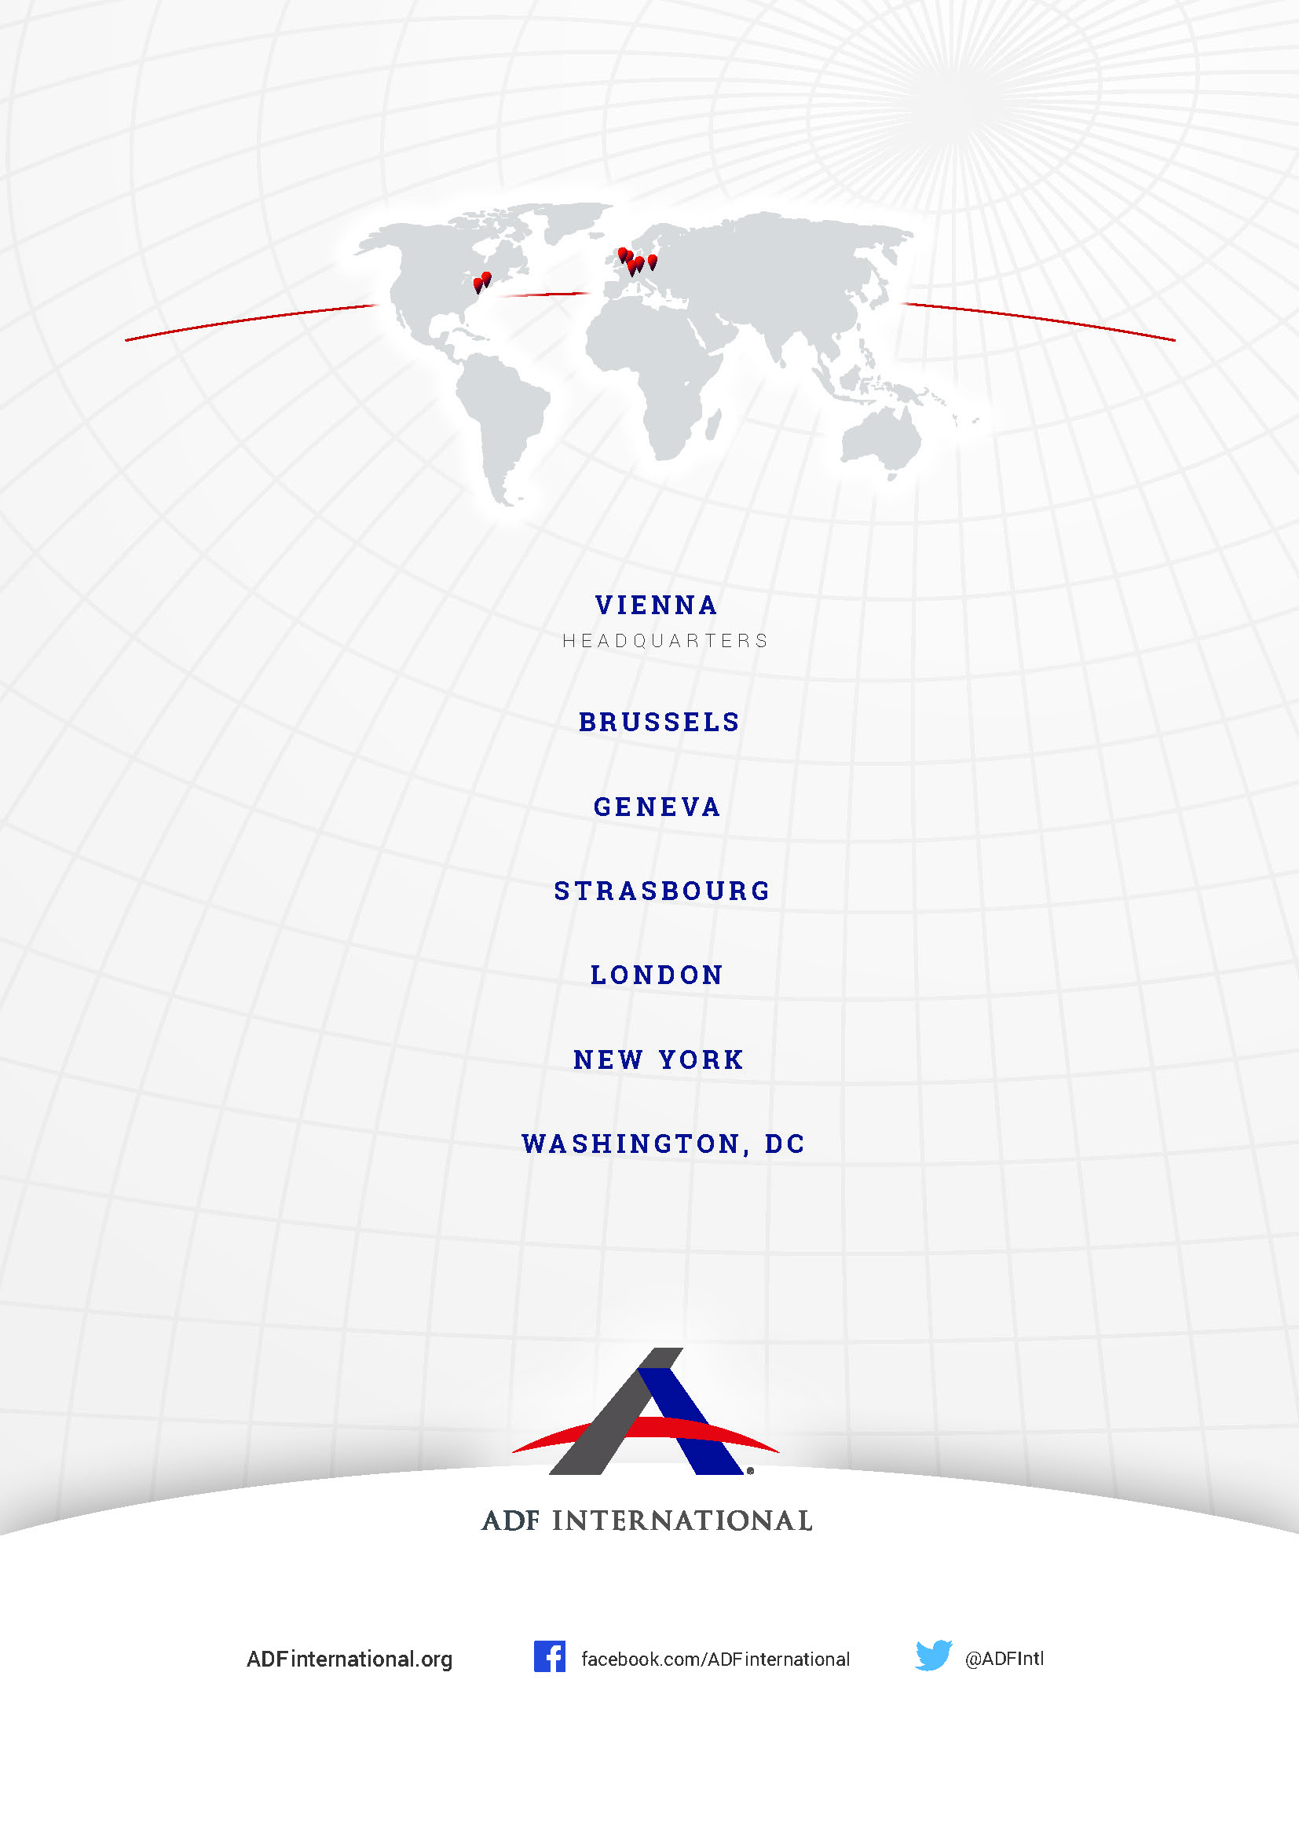

© 2023