**SUBMISSION OF ALLY MARIE DIAMONDS (DIAMONDS) AND WAHINE TOA RISING (WTR) TO THE REPORT OF THE SPECIAL RAPPORTEUR ON VIOLENCE AGAINST WOMEN AND GIRLS**

**Introduction**

Wahine Toa Rising is survivor led and supports Wahine Toa (Warrior Women) & Tamariki (Children) who have been & continue to be exploited in the sex trade in Austrralia, Aotearoa New Zealand and the Pacific Islands. ( Oceania will be used throughout the document to cover all countries)

WTR has produced a booklet with the Coalition against Trafficking in Women Australia (CATWA) which addresses 16 myths about the sex trade.

Ally Marie Diamonds is a survivor of the sextrade from New Zealand who now advocates for vulnerable women and girls's voices and hearts to be heard in this continued debate

Ally-Marie Diamond will refer to “prostitution’ as the sex trade.

**Diamonds’ further Submission**

First, I would like to thank the Special Rapporteur for this chance to be heard.

There is not alot of data from Oceania and sadly there is still a clear divide between Pornography, Trafficking, the Sextrade and Sexual Violence. Governments still do not recognise the links between them, or how one feeds into the other. For instance in Australia there are services for those being trafficked but no services for those being exploited in the sextrade.

There is a lack of understanding, awareness and education on how they feed into each other. The sex trade is seen as normal work, choice and there are no grey areas in between as you will see from Governments further into the submission.

Buyers who are majority men do not ask if a woman is trafficked, there by choice, coerced, underage, groomed or forced when they walk into a brothel. The managers of that brothel do not query age, and have no care whether you “choose” to be there or not. There is only one thing the buyer cares about, living out his fantasy he just watched on the latest porn that his wife won't succumb to, and the only thing the manager cares about is the money.

Sadly, many are not educated on Oceania at all, only hearing maybe what they want to hear while ignoring the voices of those who matter - and that’s our most vulnerable women and girls, the majority of which are women and girls of colour, women and girls in poverty, women and girls from violent homes, backgrounds, women and girls who are suffering from trauma, women and girls who live with domestic violence, sexual violence or who have come from sexually abusive childhoods.

Recently in South Australia where we are working hard to advocate for the Equality Model this has been all too apparent with Government Leaders making statements such as “Selling sex for money is like swiping left or right on a dating app”, “being prostituted is the same thing as going out to a nightclub and hooking up, except you get paid for it”, “Disabled men are unable to get sex anywhere else other than in a massage parlour”, “men should not be criminalised for wanting sex and paying for it”, “ What if we decriminalise women, won't that give them more power to be able to blackmail the men?”, “Well if women don't want to be a prostitute they can just leave.”, “There is no trafficking in Australia that only happens overseas.” These statements are from Government Leaders in Australia and the scary thing is mostly women leaders who are strong advocates against Domestic Violence. This is how normalised, and glamourised, the sex trade, trafficking, exploitation has become in Oceania.

We need to meet the needs of the most marginalized in the sex trade, who are coerced into selling sex due to life circumstances such as poverty, the ones wo have limited to no choice, the ones who have been groomed into it from child sexual abuse, violence, trauma.. Most importantly we need to STOP, LISTEN, and show vulnerable women and girls our respect by HEARING them, and SEEING them. Let’s focus on the choices of men and governments and think about whether a trade that exploits those with few to no choices is one we want to see flourish. “

“ It is argued that the sex trade is safe if it is fully decriminalised. Yet this is not the case — and the experiences of women in Aotearoa, New Zealand’s sex trade post-decriminalisation are evidence of this.

Since full decriminalisation in 2003, under the Prostitution Reform Act (PRA), violence and sexual assault within prostitution have remained, and women have died at the hands of sex buyers. A report by Aotearoa, New Zealand’s Prostitution Law Review Committee, noted that women in the sex trade were still vulnerable to ‘exploitative employment conditions’ and that there were ‘reports of some being forced to take clients against their will’. The report went on to note that ‘the majority [of women interviewed] felt that the PRA could do little about the violence that occurred’. This same report also refers to the sexual assault that women routinely experience in prostitution as ‘adverse work experiences’. The risk still inherent in this decriminalised sex trade is underscored by advice offered by the New Zealand Prostitutes Collective document ‘Stepping Forward’. When ‘dealing with violent clients’, the document advises: ‘Make as much noise as possible to attract attention. Try calling FIRE, a passerby will probably pay more attention. If you wear a whistle around your neck, blow it in his ear’.

Women and girls deserve better than a system that normalises men’s sexual entitlement and abuse of us?

Our future generations deserve better than a system that normalises the buying and selling of women and girls?”

Sex trade advocates say that women have a right to choose what they do with their bodies. Therefore, it is only right we ensure all women in the sex trade have a real choice to begin with and that our most vulnerable women and girls also are given their basic human rights. When did the rights of a few outweigh the rights of the masses?

The preamble to the Universal Declaration of Human Rights includes ‘Freedom from Fear’ as an important right. Therefore, regardless of law, it is essential that countries provide funded services to give women and young people who are being sexually exploited in the sex trade a means to safely exit, and live free from fear.

Be Brave, Courageous, Lead the nations by:

* Holding buyers accountable, and re-educate them that the buying and selling of vulnerable women and girls is not ok;
* Holding the pimps, managers, and those who profit of our most vulnerable accountable;

* Importantly support women and girls to exit, to heal, to support them to dream again, and know they are so much more valuable than a piece of meat, or a product that can just be bought and sold.
* Recognise that a disabled man does not have a right to disable women and girls for their own sexual needs, sex is not a human right.

* **Women and girls deserve so much more than this. Our women and girls have fought to be seen, heard, valued and treated with dignity and respect. Yet here Governments, leaders and politicians are still ignoring their cries for help, still turning their backs on them, still not hearing or seeing them as valued equal members of their communities, instead they base a man's so called entitled right to sex over a woman's and girls right to freedom all because they exchange money.**

There is considerable evidence that the normalisation of exploitation leads to more of our girls being involved in the sex trade.

The evidence is set out in this link

[Exited women on the Impact of Prostitution Normalization on Youth](https://ellyarrow.wordpress.com/2019/07/13/survivors-on-the-impact-of-prostitution-normalization-on-youth/)

(<https://ellyarrow.wordpress.com/2019/07/13/child-trafficking-under-new-zealands-decriminalization/amp/?__twitter_impression=true>)

It is important to note that Sexual exploitation can have serious short and long-term physical, psychological and social impacts, further impacts are also experienced by families and support networks, communities, and the wider society.

Those exploited are at an increased risk of such things as:

Physical injuries due to violence - Bruises, scars and other signs of physical abuse and torture often in areas not visible such as lower back

Physical injuries due to sexual violence

Increased risk of contracting sexually transmitted infections

Increased risk of contracting HIV

Pelvic pain, rectal trauma and urinary difficulties

Complications due to pregnancy

Infertility from chronic untreated sexually transmitted infections or unsafe abortions

Cancer, Diabetes, and other illnesses

Infectious diseases like tuberculosis

Malnutrition

Exhaustion

Serious dental problems

Physical effects due to substance use

Psychological impacts:

Psychological, emotional, cognitive, and behavioural disruptions

Depression

Anxiety

Self-harming behaviour and suicidality

Substance abuse

Personality disorders

Debilitating feelings of guilt and shame

Post-Traumatic Stress Disorder

Stockholm Syndrome/Trauma Bond

**Social impacts can include but not limited to**

Socialisation issues leading to limited social and interaction skills

Limited ability to conduct basic skills including accessing financial assistance, employment or housing search, education

Accessing basic necessities

Lack of trust leading to reliance on trafficker

Difficulty integrating into society following trafficking situation

Difficulty integrating into home or family dynamics

Fear of stigma and isolation

(https://www.ecpat.org.nz/faq)

As a survivor diagnosed with C-PTSD I relate to every challenge listed. To tell you this side of my story would be a lot more than 2000 words.

*ECPAT Alert NZ shows us that the average age of our tamariki to be introduced into the sex trade is 11 –14 years of age, New Zealand has the fifth worst child abuse record out of 31 OECD countries. These are the* Impacts Exploitation has. (it is important to note that many of our tamariki will go from child to adult in the sex trade, as many have before them. (<https://www.ecpat.org.nz/>)

If we don’t work together now to put things in place to end sexual exploitation we define a future for our young people and our communities that being exploited is normal.

*We send a message to our girls and our boys that this behaviour is acceptable. By doing nothing and turning a blind eye, we encourage trafficking, exploitation and violence rather than discouraging and eliminating it.*

**Many will say that the sex trade, violence, rape will never be abolished, but I say how do we know if we dont try. I want to leave this world a little better than when I came into it, and I most certainly want to be on the right side of history.**

**WOMEN AND GIRLS DESERVE MORE THAN BEING BOUGHT AND SOLD FOR SOMEONES ELSE SEXUAL DESIRE. WE ARE NOT PRODUCTS, WE ARE HUMAN BEINGS AND WE DESERVE OUR HUMAN RIGHTS JUST AS MUCH AS THE PRIVILEGED AND DEFINITELY JUST AS MUCH AS MEN.**

Please see this Website to learn about the current situation around Child Sexual Exploitation in Aotearoa in NZ a country that introduced Full Decriminalisation in 2003.

[Publications | Child ALERT](https://www.ecpat.org.nz/publications)

New Zealand's Model Failure

<https://hawaii-78988.medium.com/so-you-wanna-talk-sex-work-policy-the-failure-of-full-decrim-according-to-m%C4%81ori-women-4f46c1cb7a98>

Download 16 myths against the sextrade here

[Sex trade harm exposed in survivor-led trans-Tasman campaign](https://wahinetoarising.nz/sex-trade-harm-exposed-in-survivor-led-trans-tasman-campaign/)

I will leave you with this quote from myself

So, what supporters of the sex trade are saying is that vulnerable women and girls’s lives who are being coerced, forced and trafficked should be sacrificed for the few women who feel “empowered” by being bought and sold for sex? Human Rights are for all not just the few — Ally-Marie Diamond, Survivor of the Sex Trade

**WTR and Diamonds will be willing to give further evidence if needed**

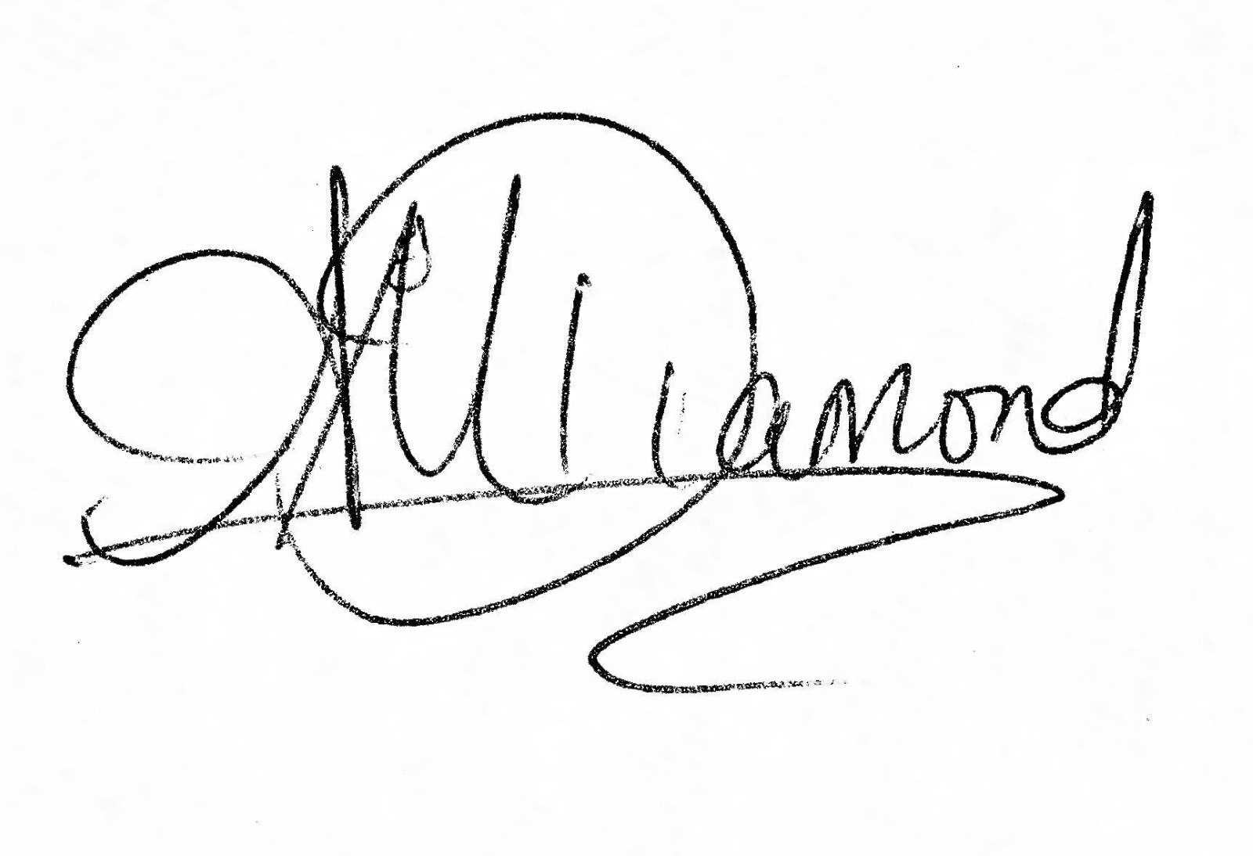

Signed Ally Marie Diamonds

Dated this day 31 January 2024

Wahine Toa Rising