Introduction

The Salvation Army is a Christian church and registered charity, which has been fighting against social inequality and transforming lives for over 150 years. We currently operate in 134 countries; this submission is from the United Kingdom. Time and again Jesus came alongside individuals who were marginalised; in being able to present this written submission we will be able to advocate for those marginalised, lobby on their behalf and help their voices to be heard by those in power. In this case the marginalised are those women and girls within prostitution.

We believe that prostitution has too high a cost of harm to all parties. We do not condone prostitution existing; there should be no price for intimate space and there is always an imbalance of power. But while it does exist, The Salvation Army through the Faith House Project in London offers outreach that provides holistic safety to reduce harm. As a result of this support, Faith House has seen individuals be able to find hope beyond their current survival mode through multi-agency working. We are also seeking behavioural and process changes within the system to enable women and girls to access statutory services that support Human Rights such as dignity, non-discrimination, health etc.

- What forms of violence are prostituted women and girls subjected to (physical, psychological, sexual, economic, administrative, or other)?
Women and girls are at high risk of every imaginable form of violence- including forms that are not yet widely recognised. We offer two examples from our recent experience:
Firstly, we have seen emerging evidence of financial exploitation. Working with a local Council we have supported women, who because of multiple vulnerabilities had lost access to banking facilities, to open a basic bank account in their own name. Time and again, these women have told us how previously money they had earned through work and/or benefits had gone into the bank account of a ‘friend who had charged them between £100 and £300 per month for the ‘service’. One of our women had not had a bank account for 30+ years, and had therefore been defrauded of tens of thousands of pounds of her own money.
Secondly, in recent years the area in which we work experienced two murders of on-street sex workers. The first perpetrator was never found; the second, who murdered one sex worker and committed rape, attempted murder and kidnap against two more, was jailed with a minimum sentence of 42 years before being considered for parole. Crucially, when these murders occurred, local policing was directed towards enforcement of anti-street prostitution laws. Subsequently police tactics have changed to prioritise safeguarding of women on the streets; the women feel safer, and trust enough to report crimes when they occur.

- How is the issue of consent dealt with? Is it possible to speak about meaningful consent for prostituted women and girls?
Section 74 of the UK’s Sexual Offences Act 2003 states that: “…a person consents if (s)he agrees by choice and has the freedom and capacity to make that choice.” ‘This means consent has two parts: the freedom to choose to enter into sexual activity and the capacity to choose’ (Rights for Women 2018, p16).
We meet very few women who have true freedom and capacity to make a choice; often their freedom and capacity are denied or limited by those making decisions for them, or – even more frequently- by circumstances which affect them. Figure 1, below, illustrates this.
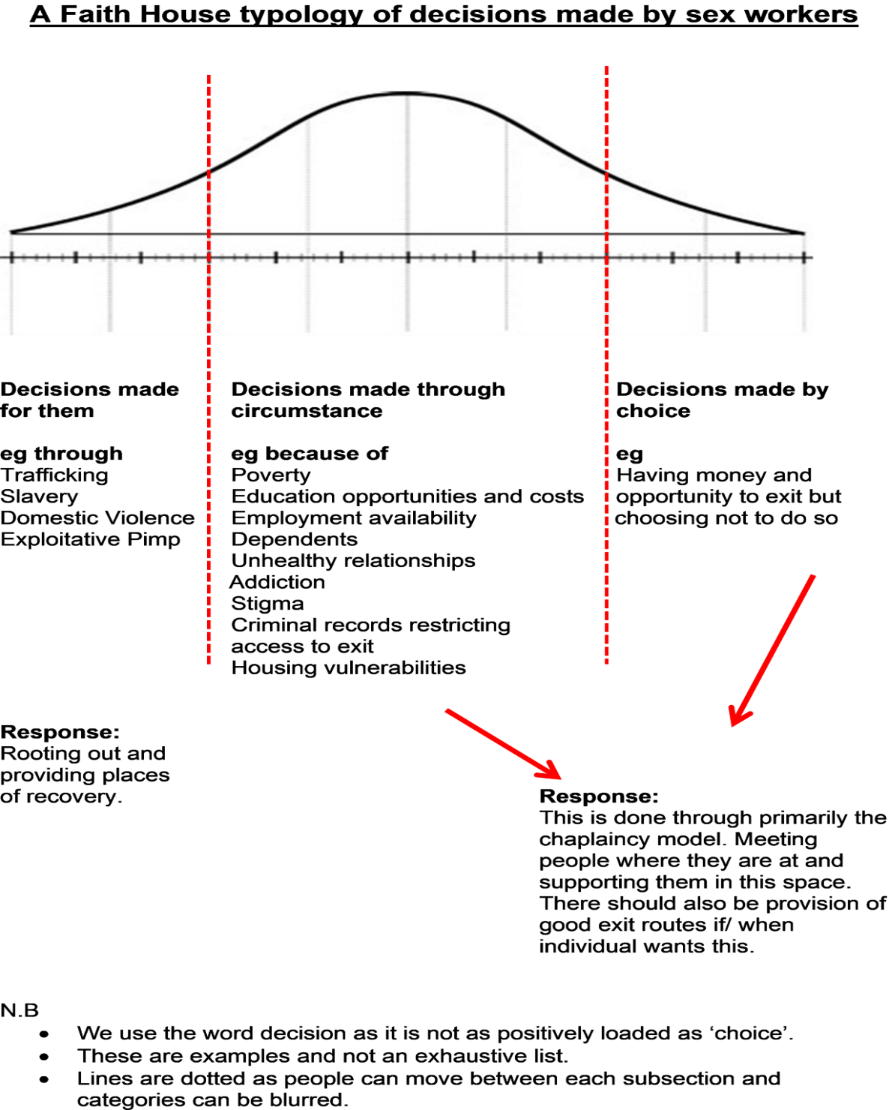
Figure 1: decision typology

In direct relation to prostitution, The Metropolitan Police (2024) write:
‘If you're a sex worker you may be the target of rape, physical and sexual abuse and robbery as offenders (often pimps or clients) think you won't report the crime’ But, if you say 'no,' it means no – it doesn’t matter if you're a sex worker or not. You have the same right over your body as anyone else and the same right to give or withhold consent as anyone else’
In addition, Rights for Women (2018) state:
‘Consent may be given to one thing but not another, for example, oral penetration but not vaginal penetration. Similarly, consent may be given and then withdrawn. As a matter of law, the fact that a person has paid for sex, or attempted to pay for it, does not mean that you have given your consent’ (p6).
However, sex workers in survivor mode will often treat rape as an ‘occupational hazard’; it is part of our outreach to reframe this corrosive narrative to ensure harm reduction occurs. But in practice this is often not respected. In a recent prosecution for the vaginal rape of a sex worker, the victim testified that the police officers to whom she reported the rape responded “You’re a Prostitute, right”; and the defence lawyer suggested that vaginal sex was just an extension of the oral sex that she had consented to. The defendant was found ‘not guilty’ despite forensic evidence to the contrary.
- How effective have legislative frameworks and policies been in preventing and responding to violence against women and girls in prostitution?
Since 2015 The Salvation Army has submitted evidence to a number of UK Parliamentary and Government inquiries on prostitution and sexual exploitation, although in general these have not produced significant legislative or policy change. For example, the UK Government’s Tackling Violence Against Women and Girls (VAWG) Strategy (2021) identifies women engaged in prostitution and sex work as being more likely to experience VAWG, but indicated no direct actions. The UK National Police Chiefs Council Sex Work National Police Guidance cites five guiding principles (see Figure 2) which, where applied, have in our experience been highly effective in preventing and responding to VAWG. However, as these are only guidance, there is no guarantee that they will be applied in every policing area.
However, real change is possible. The Salvation Army campaigned alongside the Josephine Butler Society and the National Council of Women of Great Britain to address the disadvantage experienced by women who had a record of convictions for persistent soliciting. If these women applied for a Disclosure and Barring Service (DBS) check- a safeguarding requirement for many employment and volunteering opportunities in the UK- the convictions were revealed, and remained there permanently. This could often present a barrier to leaving prostitution, holding women in a cycle of VAWG. But in 2018 the High Court of England and Wales ruled, in a case brought by women who had been groomed into prostitution as teenagers, that disclosure of their convictions for soliciting was disproportionate and a breach of the right to respect private life. Permanent marking of soliciting convictions on DBS checks does not occur now. A barrier to leaving to prostitution has been removed.
Figure 2: UK NPCC guiding principles
UK NPCC Sex Working guiding principles
- The sex industry is complex, often stigmatised, and has many evolving typologies. It is often hidden from the wider public. We recognise this environment is conducive to the abuse or exploitation of those selling sex.
- We will engage with sex workers to build mutual trust and confidence and encourage the sharing of information to improve safety. Our role does not include making judgments about personal morality.
- We will start from a position that seeks to tackle exploitation, encouraging the reporting of crimes against sex workers and taking enforcement action against criminal perpetrators.
- We will seek to maximise safety and reduce vulnerability. We will work with partners to develop a problem-solving approach that tackles these issues.
- An evidence-based ‘what works’ approach will be used to enhance awareness of officers and partners dealing with this complex environment. It will ensure the focus is on vulnerability and safety and a consistent approach across the country.

UK NPCC (2023) Sex Work National Police Guidance, p7.

- What are some of the lessons learned about what works and what does not when it comes to stemming any negative human rights consequences from the prostitution of women and girls?
- What measures are in place to assist and support women and girls who wish to leave prostitution?
- What recommendations do you have to prevent and end violence associated with the prostitution for women and girls?
It is our opinion that too much focus has been put on the act of prostitution and not on the often ramifications of being associated with prostitution. The focus on the act ‘others’ women and girls engaged in prostitution, denying them the right to be seen as human and, therefore, denying them the access to their human rights.
Thorlby (2015) states:
‘Prostitution is a highly fraught issue, both ideologically and politically. This is not surprising given that it raises fundamental questions concerning the nature of sex and sexuality, bodily integrity, autonomy and freedom, gender relations, power and violence, commercialisation, globalisation, migration and work, economic structures, and the role of legislation: in short, prostitution is an arena in which understandings of what it means to be human are constructed, contested, enacted, reflected and embodied’ (p1-2).
It is this definition that Faith House utilises when thinking about the issue of prostitution and seek to deliver harm minimalisation through a practical and pastoral model.
Practically, Faith House currently works alongside over 50 local/pan-London/national statutory and non-statutory bodies partners. It recognises that the key to providing successful responses to issues of vulnerability and marginalisation is the building of trusting relationships between agencies and stakeholders. Respectful multi-agency collaboration allows for the expertise of practitioners to be utilised without the overstretching of resources and capabilities of any one service; and for our service users to always receive expert quality care. It is through pastoral support which advocates for and empowers the women we work with to make decisions that improve their own lives, often leading to moving on from prostitution. We recognise, and stress, the need for both practical and pastoral services.

Our experience working and listening to sex workers has informed our view that enabling sex workers to build trusting relationships with the Police is a key route to addressing and preventing harms associated with sex work. In 2023 we were short listed alongside Operation Boxster (Metropolitan Police) and other Outreach groups for the Tilley Awards (a prestigious UK programme which promotes collaborative problem-solving approaches to local policing-related issues: see Annex 1.). In this case:
- The Police had a strong methodology when trying to change sex workers behaviours and encouraged diversion at all stages of police interactions.
- This co-operation helped outreach teams introduce an emergency housing pathway with the local authority which was able to house homeless sex workers in crisis. Thirteen individuals were housed in this way, with all of them accessing drug support.
- Removing policing during street outreach sessions created a ‘safe space’ which led to all Class A dependent sex workers accessing drug support.
- On three occasions sex workers disclosed they were subject to potential trafficking and exploitation to either outreach workers or police officer.
- The consistent presence of officers known to the sex workers developed a trust and belief any crimes committed against them will be properly investigated by police.
- Nine sex workers have exited sex work in a period of eighteen months.
- Funding was received to train and deploy an Independent Violence Support Advisor specifically for sex workers. This service will provide sex workers an advocate when navigating the criminal justice system and assists police investigations when trying to communicate with individuals who live a chaotic lifestyle’.
In conclusion, the ‘othering’ of sex workers facilitates frustration and violent acts (see question 1). When a concerted effort is made to reduce the stigma surrounding those in prostitution it ensures that all relevant stakeholders, including the public and statutory bodies, see the person and not a negative label: It is only then that we can stem negative human rights consequences; be able to support those who wish to leave prostitution and look to preventing and mitigating violence associated with prostitution.

We are happy to supply copies of our evidence submissions to you, on request.

