

|  |  |
| --- | --- |

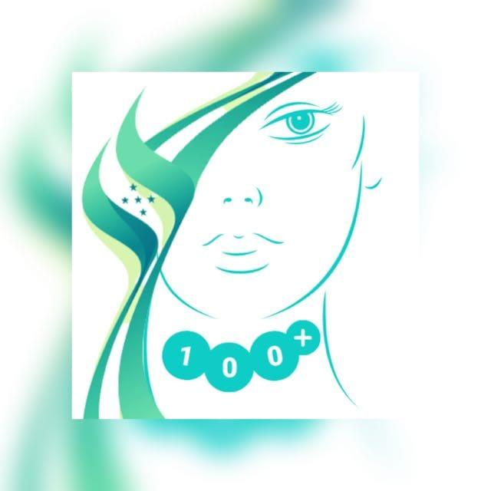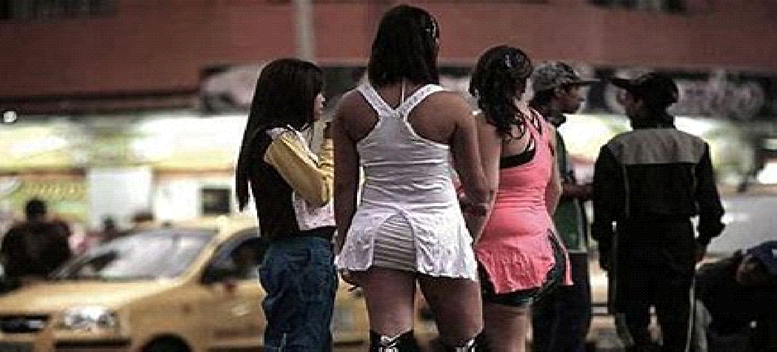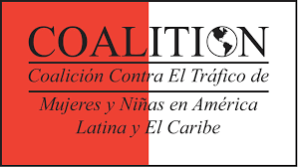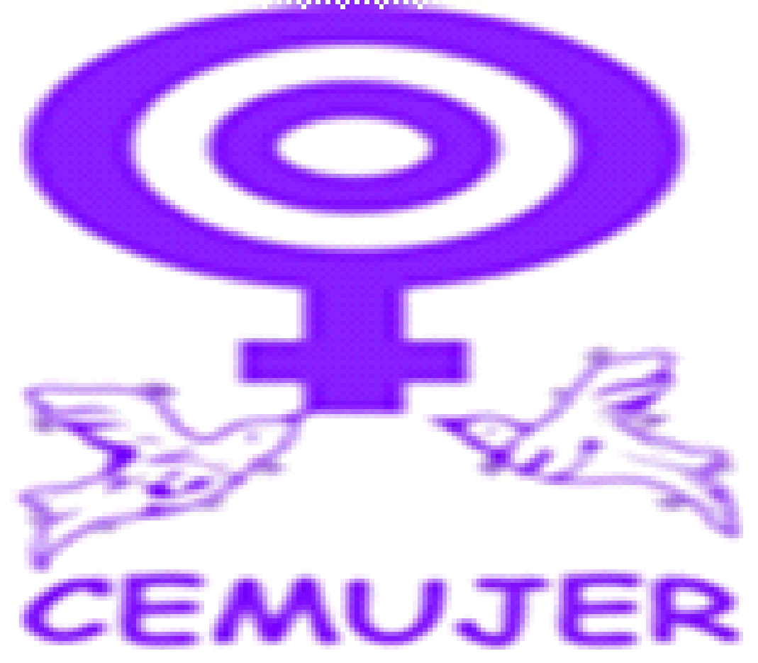

***Coordinator & Co-Author***

***Mtra. Teresa C. Ulloa Ziáurriz***

***LAC Director***

***Regional Coalition Against Trafficking in Women***

***and Girls in Latin America and the Caribbean (CATWLAC)***

***Co-Author***

***Lic. Ima Rocío Gurrola***

***Communications Officer***

***Instituto de Estudios de la Mujer***

***Norma Virginia Guirola de Herrera (CEMUJER)***

***El Salvador***

***Co-Author***

***Dr. María Angélica Patricia Milla Gutiérrez***

***+100 Mujeres***

***Presidente***

***Honduras***

**@All rights reserved. It is authorized to publish as long as the source is cited.**

**Printed at Mexico City, January 2024.**

***VIOLENCE AGAINST WOMEN AND PROSTITUTION:***

***An overview in the Norther Triangle.***

***Introduction***

1. Despite the plethora of existing legal and policy frameworks women and girls continue to comprise most detected victims of trafficking across the world, the ones with most serious syndromes and physical damages, and perpetrators enjoy widespread impunity.
2. We are using this General Recommendation because we have detected many young women and girls in illegal migration process in the massive caravans crossing Mexico trying to reach the United States of America from several countries like: Haiti, Cuba, the countries of the northern triangle of Central America (El Salvador, Guatemala, and Honduras -- the most violent place in the world without a declared war), and Colombia, Venezuela, Ecuador, Chile, Paraguay, Uruguay, Argentina, and other countries from Africa and Asia, where the minors traveling unaccompanied are retained once they cross the Mexican border by Maras SalvaTruchas and other organized crime cartels and gangs and taken to the red light districts of Chiapas to be sexually exploited, which turns them in victims of trafficking and sexual exploitation.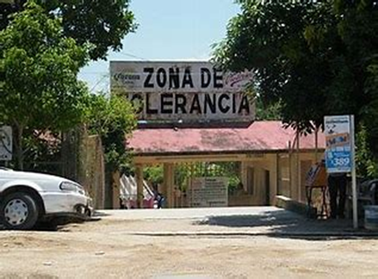
3. …A gender analysis of the crime reveals that its root causes lay in sex-based discrimination, including the failure to address the prevailing economic and patriarchal structures and the adverse and gender-differentiated impact of the labor, migration, and asylum regimes of States parties that create the situations of vulnerability leading to women and girls being smuggled and trafficked.
4. Therefore, in addition to the questions suggested by the Special Rapporteur on VAW, we will briefly include the situations of vulnerability which caused the smuggling that, after crossing the Mexican border, turn to trafficking and sexual exploitation of women and girls of countries of the Northern Triangle of Central America, mainly El Salvador and Honduras, during their transit through Mexico.
5. This report will include the vulnerability causes for recruitment in the origin countries, the risks during the travel and upon arrival, the legal frameworks, the public policies and the involvement of the organized crime, and the large number of vulnerabilities in origin, transit, and destination countries, mainly of girls and adolescents that travel unaccompanied. Some of them are as young as 8 years old.

**Questions.**

1. In the three countries of the Northern Triangle, in this case, two of origin, El Salvador and Honduras, and one of transit and/or destination, Mexico, that are ruled by the violence of organized crime, suffer displacement, poverty and extreme poverty, which have detonated the massive caravans in smuggling process to try to reach the United States.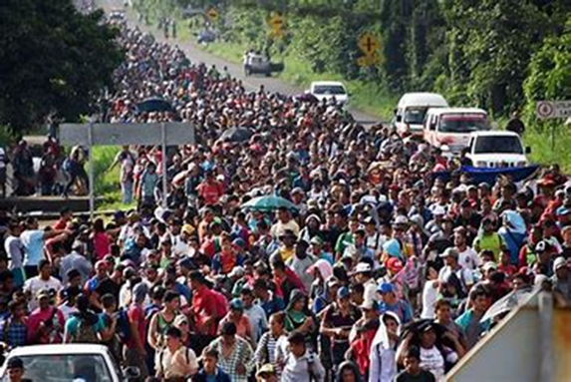

One of the most important precedents was the "Migrant Caravan" that began in Central America in mid-October 2018 and managed to bring together approximately 10,000 people from Honduras, Guatemala, Nicaragua, and El Salvador, who traveled through Mexican territory on their way to the United States.

What is true, is that no one walks miles in bad conditions, hungry, thirsty, hot, sick, pregnant, just for the pleasure of traveling. Migrating in a "caravan" is a way in which migrants have organized themselves collectively to be able to enter, transit and/or reach a given country. In Mexico, these expressions of migration have become more relevant since 2018, with the purpose of reaching the United States of America (USA) and evidencing all the dangers they face along the way, such as: robberies, extortion, kidnappings, homicides, disappearances, human trafficking, sexual violence, discrimination, abuse of authority and excessive use of force against them.

The hidden forms of prostitution detected were web prostitution, like Only Fans, and other commercial web pages, and the forced attendance of victims of trafficking to parties for organized crime plazas chiefs and politicians, as well as those who are taken to the cartels general headquarters to act as maids of the members of the cartel to cook and wash they clothes and as sexual slaves, all these activities with high rates of corruption.

1. The profile of women and girls affected by prostitution are those in a situation of vulnerability from 8 to 60+ years old or those in poverty or extreme poverty, lack of opportunities, most of them forced into prostitution or those that are in prostitution as means to survive:

Situation of vulnerability: Condition of the victim derived from one or more of the following circumstances that may result in the taxpayer carrying out the activity, service or task that is requested or demanded by the active subject of the crime:

(a) Their origin, age, sex, precarious socio-economic status.

(b) Educational attainment, lack of opportunities, pregnancy, violence, or discrimination suffered prior to trafficking and related crimes.

(c) Immigration status, physical or mental disorder, or disability.

(d) Belonging to or originating from an indigenous community.

(e) Be a person over the age of sixty.

(f) Any type of addiction.

(g) A reduced capacity to consent because you are a minor, or

(h) Any other characteristic that takes advantage of by the active subject of the crime.

According to data from the UNODC, in its Global Report on Trafficking in Persons 2022, in Central America and the Caribbean, girls are 58 per cent of the total victims of human trafficking detected between 2020 and 2022, women 25%, boys 15% and men 2%, with Commercial Sexual Exploitation being the most detected modality with 71%, while trafficking for forced labor by 21%, trafficking for organ harvesting by 1%, and trafficking for other purposes by 7%.

On the other hand, the breakdown of victims of trafficking in persons for commercial sexual exploitation continues to place girls at the highest percentage, 55%, women 34%, boys 10% and men 1%.

1. Regarding the profile of those soliciting women in prostitution, El Salvadorian, Honduran, and Mexican societies are very patriarchal, impregned by machismo and giving little value to women and girls, which feed a favorable terrain for the consumption of prostitution and the violence that it entails. The demand for prostitution is diversified, they can be of any socioeconomic level, academic degree, profession or handcraft, age, or other social, economic, political or any other condition.

In the three countries, there are Anti-Trafficking Laws that include sexual exploitation, but prostitution is left to the municipal competence, as means to circumvent the international commitments adopted by the respective States in the international treaties of human rights. All the LAC countries have ratified the CEDAW convention, but we are suffering from reiterating intents to legalize prostitution.

1. The prostituted women and girls are subjected to all forms of gender-based violence, physical, psychological, sexual, economic, etc. In our 25 years assisting and protecting victims, we learned the worst forms of violence to which the victims are subjected, as extreme humiliation, hard sexual practices, femicide, deprivation of liberty, softening process, burnt with cigarettes, cutting in the labia majora and minora, and the syndrome of learned helplessness.
2. It is important to note that there is direct responsibility for action, on the part of the perpetrators, exploitative "clients", pimps, facilitators, accomplices, links in the chain of command in prostitution structures, but there can also be responsibility for omission, connivance or acquiescence of the State and for an attitude of silence of the double standard society itself.
3. The linkages between prostitution and violation of human rights of women and girls are clear because prostitution attempts against dignity of them, with high levels of violence, all of which represent violations to human rights of this sector of population and grave psychological and physical damages to survivors.
4. The links between pornography and/or other forms of sexual exploitation and prostitution are clear because all these forms attempt against the dignity of women and girls, there is no pleasure intrinsic in these forms of sexual exploitation and prostitution, are patriarchal practices that erase sexual pleasure for women and only give pleasure to men. Pornography is the school of sexual violence against women and girls and is not compatible with societies in which they can enjoy their legitime right to a live free of violence.
5. In prostitution, there is no meaningful consent. Sexual situations resulting from the consumption of prostitution, are based on the inequality of the parts that take part in the transaction, since the economic exchange, of which the relationship is the fruit, establishes a hierarchy between product and consumer. There is consent by force and consent by necessity, because in some cases consent is not valid when it is a form of survival.
6. The legislative frameworks and policies implemented in the three countries have not been effective in preventing and responding to violence against women and girls in prostitution. One of the main obstacles is that prostitution is not recognized as violence against women and girls. For example, in Mexico there is a General Law to Guarantee the Right to a Life Free of Violence, which defines all forms of violence against women, but prostitution, pornography or any form of sexual exploitation is not included.
7. Only in Mexico, we found a National System of Information on Trafficking in Persons (SINTRA), which is a web platform with restricted access which objective is to register all the actions undertaken at federal, state and municipal level in prevention, protection and prosecution of trafficking in persons, to generate and implement public policies, and to follow up the National Program on Trafficking in Persons in effect.
8. In none of the three countries are there any public policies or measures to assist and support women and girls who wish to leave prostitution. For example, in the case of Mexico, even though the Trafficking Law establishes as an obligation to offer dignified exit options to women and girls who are in a situation of prostitution, an obligation that the Mexican government does not fulfill.
9. The main obstacles that organizations and frontline service providers are facing in their mission to support victims and survivors are the cultural barriers, the security compromised and exposed to organized crime and networks of traffickers and sexual exploiters, including the lack of funding and governmental interest in the victim’s recovery.
10. Some of the lessons learned about what works and what does not when it comes to stemming any negative human rights consequences from prostitution of women and girls, the psychological and physical damages suffered by the victims is grave and complicated, and it takes a long time for the recovery of victims and is very expensive. It is important to prioritize the restitution of rights and the protection to the families of victims.
11. The frontline organizations and survivors’ organizations are not included in policymaking at the national and international level. Frequently in the multilateral forums the voices of survivors are silenced and ignored.
12. Our recommendations to prevent and end violence associated with prostitution of women and girls is to renew the States commitment to prevent and fight prostitution generating a change in education combating stereotypes against women and girls to defeat the patriarchal and neoliberal structures that reduces women and girls to merchandise.