Submission on The Violations And Abuses Of Human Rights Rooted In Harmful Practices Related to Accusations of Witchcraft And Ritual Attacks, As Well As Stigmatization
Professor Miranda Forsyth, Professor Philip Gibbs, William Kipongi,
Anton Lutz, and Dr Fiona Hukula
14 September 2022
The purpose of this submission is to inform the drafting by OHCHR of the study requested by Human Rights Council resolution 47/8 on the situation of the violations and abuses of human rights rooted in harmful practices related to accusations of witchcraft and ritual attacks, as well as stigmatisation. Our responses are based on close to ten years of research and two decades of advocacy relating to the problems around sorcery accusations and related violence in Papua New Guinea (PNG).
We commend the UN for taking this important step to recognise the significant harms that arise from accusations of witchcraft. This is an ongoing, systemic and possibly intensifying form of human rights abuse in PNG. Civil society, church leaders and government officials have referred to the issue using the acronym SARV (Sorcery Accusations and Related Violence) and this is what we will use in this report.
- Measures to ensure the elimination of harmful practices amounting to human rights violations related to accusations of witchcraft and ritual attacks
  - What measures have been put in place, including legal and policy ones, to ensure the elimination of harmful practices amounting to human rights violations related to accusations of witchcraft and ritual attacks, as well as stigmatization?
Measures have been taken at national, provincial and local levels across PNG to address the problem of SARV. We outline the most significant here.
Legislative reforms: In 2013, the PNG government repealed the Sorcery Act 1971 that had provided a limited defence for murders committed as a result of suspicion of sorcery, and created a new provision in the Criminal Code Act 1974 (Chapter 262). Section 299A of the Criminal Code Act provides that any person who intentionally kills another person on account of an accusation of sorcery is guilty of wilful murder.
In 2022, the Criminal Code Act was further amended to include a new Division VII.4 that contains provisions directed at people acting like a glasman (diviner) and making accusations of sorcery.
In 2022, the Royal PNG Constabulary created a Constabularies Standing Order to guide the police in their response to incidents of SARV. This has not as yet been gazetted to come into force.
Policy initiatives: In 2015, the PNG government passed the National Action Plan to Address SARV (SARV NAP). This presented a holistic vision of what was required to address the problem. It covered five areas: Legal and Protection; Health; Advocacy and Communication, Care and Counselling; and Research. A meeting was held in 2022 to review the SARV NAP, with an aim of strengthening it to achieve better implementation.
In 2021, PNG’s National Parliament established a Special Parliamentary Committee on Gender-Based Violence to report back to parliament, and SARV was made a designated area of interest. The Committee’s final report made recommendations for better addressing SARV. These recommendations (recommendations 25-30) include: (1) funding implementation of the updated SARV NAP, including funding for local human rights defenders, non-government organisations (NGOs) and churches to carry out community awareness and funding to roll out training on SARV for provincial government officials, health providers, village courts magistrates and police; (2) implementing small grant funding to support CSOs and CBOs to design and roll out locally contextualised activities which aim to educate and support communities to address SARV in locally appropriate ways; this includes establishing an emergency fund to support SARV survivors to escape violence and support the safe and long-term reintegration of victims/survivors of accusations back into their communities; and (3) for the police to review their existing SARV response mechanisms and develop a specific proposal or strategy to address SARV, including clarifying specific personnel who will be dedicated to SARV investigations, along with any internal procedural changes needed to strengthen the response and associated budget requirements.
In 2020, a National Churches Strategy to address Sorcery Accusation Related Violence was signed and launched. It stated that ‘the Churches of Papua New Guinea come together in unity to address Sorcery Accusation Related Violence (SARV), which is destroying our people and our country. We acknowledge that the Government of Papua New Guinea has recognised that due to the spiritual nature of Sorcery as a belief system, Churches can have a greater influence on this belief system in order to address the accusations and resulting violence including torture, killings, damage of property, loss of homes, and fear that negatively affects our nation’.
Media campaigns: The two main national newspapers in PNG have engaged in active reporting of SARV across the country over the past two years. One of them, the Post Courier, has a page dedicated to Stopping Sorcery Accusation Related Violence. This runs every Wednesday, with stories about recent incidents and highlights the plight of survivors and victims, as well as documenting the heroism of those people who are seeking to counter the problem of SARV.
  - What measures have been undertaken to ensure that no one is deprived of the right to life, liberty or security of person because of religion or belief, and that no one is subjected to torture or other cruel, inhuman or degrading treatment or punishment, or arbitrary arrest or detention on the account of accusations of witchcraft and ritual attacks?
There have been legislative and policy frameworks put in place, as detailed above. However, the implementation of these has been hampered by many factors, including lack of appropriate resourcing, lack of consistent and determined leadership and lack of commitment by the range of state and non-state actors required. Further, the violent opposition to state interventions by perpetrators and sometimes entire communities significantly hampers efforts at intervention.
  - What measures have been put in place to ensure equal access to justice, including effective remedy, as well as psychosocial support, rehabilitation and reintegration of survivors?
There are many obstacles in the way of access to justice for survivors and their families. Research into the cases that actually reach court and result in prosecutions overwhelmingly involved male victims, whilst SARV affects both men and women in almost equal numbers in PNG.
Psychosocial support in the form of counselling was a key component of the SARV NAP but is greatly lacking in availability for victims.
Victims and survivors often have extensive injuries as a result of the torture and violence they are subjected to. The hospitals in PNG have limited resources and are not always successful in healing victims. Sometimes, they do not have the technical abilities needed to treat patients, such as those requiring surgery as a result of internal burns caused by the insertion of hot metal into their bodies, or the severing of limbs, both common forms of SARV. Anecdotally, some victims receive apathetic and even negligent care if they do make it to hospitals and health centres due to the extreme stigma against them on the part of the health care providers. There are also reports where victims have been re-victimised in hospital by other patients and their families.
Financial and other support for survivors is provided through some INGOs (e.g. Oxfam) and NGOs (Femili PNG), but it is not sufficient to cover all the needs of all survivors and their families, especially when an incident of SARV may result in the ongoing displacement of many people.
There are some (fewer than ten, nationwide) safe houses that cater to victims of SARV, often operated through the Catholic churches network, such as one called the House of Hope run by a Catholic nun in the Southern Highlands province, and one in Pina in Enga Province supported by the Catholic church. These can offer short term refuge but are mostly not sustainable long-term options. Police also offer ad hoc protection to victims and survivors of SARV in their police cells, but such assistance is problematic in terms of both the mixed messaging being sent to the public about who is being locked up, and unsuitability for victims.
Reintegration and reconciliation work is done largely through local community leaders, committed individuals, church leaders and with occasional but much valued support from state justice institutions, such as village courts and police. Examples of successful reintegration, the challenges to reintegration, and proposals for doing reintegration better are available in a report we published in 2022.
- Accountability
  - What measures have been put in place to bring to justice all perpetrators of human rights violations related to accusations of witchcraft and ritual attacks in compliance with applicable international law?
Police investigations and operations leading to arrest of perpetrators, even when the torture and murder has been photographed and captured on video by members of the mob, have been few and far between. Though incorrect, it is widely believed that for police to initiate an investigation there must be a complaint laid at a police station by the victim or an immediate family member. This inaccurate belief may be one reason that police do not initiate investigations themselves when they see tortured bodies or related social media posts - they are waiting for someone to officially complain. Measures to fix this misunderstanding have not been put in place.
The legislative framework is detailed above, however, the enforcement of these laws is fraught with difficulties, including lack of witness protection and the consequent fear of retaliation inhibiting both witnesses and survivors from lodging complaints. There is also limited knowledge about the legal framework amongst both the broader public and many frontline officers in the justice sector.
Our research has found that over the past two decades, just 12 individuals on average have been convicted each year for criminal activity that can be characterised as SARV. These numbers are very low when compared to the rates of criminal activities related to SARV throughout the country. Primarily, only the most serious form of harm resulting from SARV, namely murder, results in criminal convictions. Further, the majority of prosecutions resulting in trial or conviction involve a male victim of SARV, despite women representing almost half of SARV victims. However, the vast majority of cases that do proceed into the court system result in a conviction, with nearly three-quarters of the sentences resulting in over 16 years’ imprisonment. Our research also found that although many incidents of SARV involve large groups of people, and are incited by leaders and by glasman, most prosecutions involve only a very few perpetrators. In such incidents, it is far from certain those prosecuted are the most culpable, and as such, they may be considered as scapegoats in some way.
In addition, there are no civil compensation schemes, meaning that perpetrators of harm are not required to compensate for the loss and damage they cause, although some customary compensation regimes do require compensation payments to be paid. Generally, customary compensation involves a payment made by one group of people to another, rather than as individual payments to the victims. This means there is no certainty that compensation ever benefits accused individuals directly or alleviates their stigma.
Another issue impacting accountability is the lack of publicity of court decisions. Lack of awareness of criminal sentencing outcomes leads to a widespread belief that there is complete impunity for cases of SARV.
  - Are there comprehensive accountability frameworks that go beyond criminal justice and courts?
In PNG there are two further state sources of accountability for SARV – the Village Courts and the tort of defamation in the civil system. The Village Courts have jurisdiction to deal with minor transgressions and often play a mediating role in seeking to address sorcery accusations before they turn into mob violence. The Village Courts can also make determinations for award of compensation for defamation relating to witchcraft accusations, and this is a common practice in some parts of the country but not in others. The Village Court system has been managed with very limited resources for many years and many magistrates are not sufficiently aware of how to use their powers to best address SARV, although a training program about managing SARV in the Village Courts was run by the Department of Justice in 2019 in a number of Provinces. The civil courts, particularly the District Court, can and do find defamation for accusations of sorcery, but this approach is not pursued often.
The two main sources of accountability outside the criminal justice system are the local and customary justice institutions and the church. The customary justice system manifests in many different ways across the country and centres around the payment of compensation for harms suffered. It is often a critical component of reconciliation and is necessary before any reintegration can occur. However, if the compensation amounts are perceived as being too onerous or are not able to be paid, this can lead to problematic further cycles of retribution and resentment. There are also instances where alleged witches or sorcerers have been extorted for compensation for magical crimes that they did not commit.
There are many different churches present in PNG, some of which support prevention of SARV activities. One of the most active in regard to SARV is the Catholic Church. In the PNG Highlands region in particular, strong bishops help to ensure accountability through religious censure measures such as excommunicating people who are involved in SARV. The diocese of Simbu developed a strategy with five related components to address SARV in the 1990s, but its effectiveness has not been thoroughly evaluated.
  - What measures have been put in place to ensure the full, effective and meaningful participation of victims, persons in vulnerable situations, including women, children, persons with disabilities, older persons and persons with albinism, as well as traditional and religious leaders, and faith-based actors in all stages of decision-making processes regarding elaboration and implementation of accountability measures at all levels?
Unfortunately, there are few measures that ensure victims are involved in the development or implementation of accountability measures. The criminal justice system as a whole tends to sideline the participation of victims, and the customary justice system focusses principally on community dynamics than on individual justice for survivors. It is clear that a survivor centred approach to SARV is required, one that places the needs of victims and survivors at its heart.
- Effective protection of all persons, particularly persons in vulnerable situations, including women, children, persons with disabilities, older persons and persons with albinism
  - What kind of measures have been put in place to prevent widespread discrimination, stigma, social exclusion and forced displacement experienced as a result of witchcraft accusations and ritual attacks?
There have been some preventative measures adopted at local community levels, such as the writing of community by-laws to stop accusations being made within particular communities, and outreach and awareness activities run by the Catholic Church and some other denominations. However, these are largely ad hoc measures that are dependent upon the availability of resources and determination of particular individuals and organisations. These constraints make the long term sustainability of interventionist measures difficult and uncertain.
  - What kind of measures, including safe shelters, psychosocial support and rehabilitation services, have been undertaken to ensure effective protection of victims of human rights violations rooted in harmful practices related to accusations of witchcraft and ritual attacks?
This has been discussed above.
  - What kind of initiatives have been organized, focusing on, inter alia, gender equality, education, health, housing, livelihood, women’s autonomy and decision-making, community mobilization and awareness raising, to prevent human rights violations rooted in harmful practices related to accusations of witchcraft and ritual attacks, particularly against persons in vulnerable situations, including women, children, persons with disabilities, older persons and persons with albinism?
In terms of education, a range of initiatives has been produced. This includes films showing people standing up against SARV, a children’s book exploring how people and communities can make a difference in preventing SARV,, and an accompanying teacher’s guide to assist teachers in discussing SARV with children. Discussions are currently underway for these materials to be distributed through the PNG Education Department for use in schools.
A leading youth advocacy organisations, The Voice, has also run a series of workshops and created a television series with the workshop participants seeking to incentivise and empower youth to become change agents against SARV in their own communities. The television series has been showing across PNG on local TV stations every fortnight since July 2022.
Various training programs have been sponsored by Caritas Australia. For example, one such program was the Male Advocates against Gender Based Violence workshop, held in May 2014 at the Catholic Church in Banz.
A variety of conferences have been held on SARV. These have sought to include the voices of survivors and those who work on the frontline of addressing SARV in PNG. The most recent conference, The Harm and the Healing, was held in 2021, with 1000 online attendees via Facebook livestreaming and over 80 in person.
Yet, we should not imagine that this is a comprehensive or adequate array of initiatives able to meet the scope of SARV in PNG. While we hope these ideas and efforts are having a positive effect, we acknowledge that theiry influence is not happening fast enough, awareness raising is not happening frequently enough, nor are these initiatives reaching all of the geographically dispersed populations. For every twenty members of a community we have contact with in a given month, there are twenty thousand more who remain ‘unreached’.
  - Have you analysed human rights violations rooted in harmful practices related to accusations of witchcraft and ritual attacks, including key drivers, aggravating factors, such as unequal access to resources, poverty and socio-economic situations, climate change, humanitarian settings? If yes, what were the key findings?
Our research has found that SARV is a highly complex and dynamic phenomenon, emerging in distinct patterns across time and space. One way to understand the factors that contribute to SARV and their interaction is to conceptualise these factors and interactions using the metaphor of a wildfire.

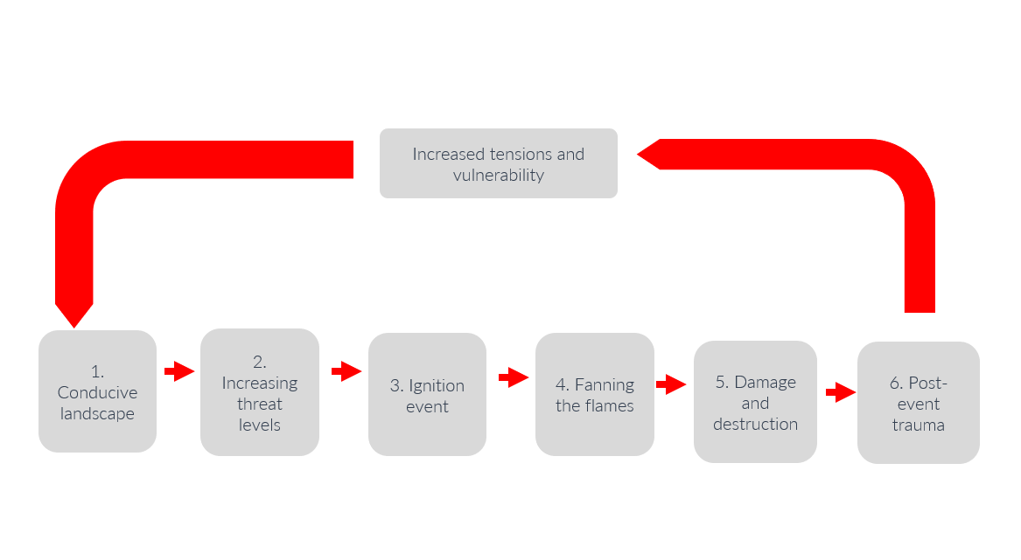
- What makes a conducive landscape?
There are two main components: cultural and socio-economic. In terms of cultural factors, one that comes through strongly in our research is a prevalent worldview in which the spirit world intervenes in the physical through human agency. This worldview is often activated through stories or narratives about sorcery, how it is used and by whom. Causal stories attribute causes of, agency over, and appropriate responses to ill fortune in ways that stigmatise particular individuals. Causal stories also play a significant role in occasioning and justifying courses of action, including violence.
The following socio-economic factors are relevant:
- High precarity of life
- Growing/new forms of inequality
- Fragile resilience
- Reduced social cohesion
- Factionalism at different scales
- High levels of uncertainty
- Normalisation of violence
- Weak law and order.
- What increases the threat levels?
These structural/landscape factors can be made more dangerous by prevailing individual and community tensions and stressors. The key stressors from an individual perspective are jealousy; desire for others’ land/goods/sexual partner; and revenge. The community level stressors include: cycles of tribal fighting; land disputes; previous disputes; ethnic tensions and the community’s and surrounding communities’ history of SARV. In our research we found 82% of cases involved a pre-existing conflict or tension between the accused and accuser. Of these, land disputes made up 35% and jealousy over money and goods made up 26%.
Each of these tensions and stressors, alone or in combination, lead to heightened emotions and social enmity, and in turn mean that when trigger events occur, the causal narrative involving sorcery – ill will – is more likely to be accepted. In addition, these tensions and stressors provide a motivation for people to start accusations.
- What triggers an accusation?
In nearly all of the cases we documented (99%), there was an immediate trigger incident preceding an accusation. The death of a person was the highest trigger incident type (50%), followed by the sickness (37%), or economic misfortune (6%) of someone.
- How are the flames of collective violence fanned?
This is a three-part process: suspicion; crystallisation of accusation and the claiming and exercising of moral legitimacy by individuals or a group to utilise violence.
Suspicions are fuelled through gossip and spread by people with vested interests, such as those seeking land from the person being accused. A typical situation involves where a man dies and his brother wants his land, leading him to start the gossip mill that it was the widow who had killed her husband through sorcery, thereby enabling him to claim the land when she and her children are driven off.
Accusations will often crystallise through the work of some kind of an authority figure, such as a glasman or a prayer warrior or a pastor. Such persons often lead a process of searching for ‘proof’ through customary rituals or through tracing the accused’s movements, with the aim of making a connection between the accused and the person who was sick or died. For example, they will seize upon instances where the accused gave the sick or dead person food or was seen near their house. This process of searching for proof can lead to torture to extract a confession or to require someone to identify others as being involved too.
Crystallisation of the accusation in this way gives rise to the moral legitimacy for violence that catalyses a group response. This, in turn, is then stimulated by factors such as drugs and alcohol; appeals to notions of masculinity; and charismatic leadership.
It is important to realise that SARV is very often a form of collective violence. Most of the violent incidents we documented were committed by large groups, with 34% of such incidents being committed by groups larger than 20, and 40% by groups of 5 to 20.
- What kinds of damage and destruction occurs?
Across four provinces (roughly one million people) for 4.5 years, we documented 1039 accusation incidents involving 1553 accused persons. Of these incidents, 298 (29%) led to physical violence or property damage and involved 546 victims. Of these victims, 65 were killed, 86 suffered permanent injury and 141 survived other serious harm, such as burning, cutting, tying or being forced into water. Overall, 93 cases involved torture, of which 20 lasted several days and 10 a week or longer.
If we assume that the rate of death and serious harm caused by SARV between 2017 and 2019 in the four study provinces is representative of the rate in the rest of PNG, then it is our estimation that across PNG every month, six people are killed and a further 23 suffer serious harm, including permanent injury, as a result of SARV.
A standard stereotype of the victim of SARV as an old marginalised woman is persistent, but the story told by our data of the characteristics of the accused complicates this.
In fact, there is wide geographic variation in the typical characteristics of those accused.
Taken at a national level, there is an even gender split between men and women. However, we found distinct gendered patterns of accusation in different regions, a finding that had the most significance in relation to Enga and Bougainville, with only 16% of those accused in Bougainville being women, whereas in Enga, this figure rose to 93%.
Two consistent factors predicted who the victims would be: whether they had previously been accused and what their relationship was with the person making the accusation. In our study, 40% of those being accused were blood related to the accuser, 15% related through family, and 17% related through tribal connections.
The age distribution of victims of accusation incidents also varies between provinces, but in general, the majority of victims (47%) are 41–60 years old, followed by the age group of 19–40 years (30%). Children of the age of 10 years and below represent 2% of those being accused. The high proportion of accused children (13%) in Jiwaka related to the trend of entire families being accused in that province. Most of the victims (86%) have a same economic status as the rest of the community and the majority of victims (57%) have been accused before.
- Data collection
  - Have you collected disaggregated data, based on gender, age, disability, ethnicity, religion etc. about human rights violations and abuses rooted in harmful practices related to accusations of witchcraft and ritual attacks, as well as stigmatization? How such data is collected? Please share available disaggregated data on the phenomenon.
Yes, we have collected data both across PNG as a whole through monitoring over 20 years of newspaper reports and national court judgments, and also through an in-detail documentation of cases across four provinces for four years. Our data collection methods are detailed in published papers. We have extensively analysed this data and prepared numerous policy briefs and journal articles, all publicly available.
Examples of our data are presented below in table form. These tables are from PNG newspaper reporting of SARV between December 1989 and June 2020, containing a total of 1368 victims.

In addition, we analysed data and prepared the infographics for the 2020 concept note on the Elimination of Harmful Practices related to Witchcraft Accusations and Ritual Killings (showing killings, disappearances, grave robberies and survivors of attacks as shown below). The methodology is explained in the concept note itself. An example of the infographic we developed is presented below. It must be noted that the data in this infographic is compiled only from online reports of HPRAWRA, and as such it very significantly under-reports the true nature of the harm that is occurring. This can be seen, for example, by comparing the data on PNG represented below and the data from our study. We found almost eight times the numbers of victims than those reported in the infographic. This disparity shows how careful documentation at local levels reveals more accurate, higher numbers, rather than using numbers sourced from relying on certain incidents making the newspapers or online reports. Given the extreme difficulty of gathering data regarding SARV harms, it is recommended that special funds be set aside to develop a robust methodology and protocols around reporting the data for it to be able to be used to track changes over time. This will also benefit increased awareness of the seriousness of SARV.

- Challenges and opportunities
  - What have been the key challenges to prevent and address human rights violations and abuses rooted in harmful practices related to accusations of witchcraft and ritual attacks, as well as stigmatization?
The challenges are manifest. They include the almost unanimous belief that sorcery is real; a lack of sustained resourcing for prevention activities (such as funding the SARV NAP ); a lack of real commitment and leadership by national and local leaders; a tendency by some of the Pentecostal-inclined churches and their followers to frame the issue in terms of spiritual warfare that gives credence to accusations of sorcery; the prevalence of law and order issues; the ongoing capacity constraints of the police; the reliance upon civil society actors to do the vast majority of the prevention and response work; the education system’s inability to encourage critical thinking amongst the population; the lack of a co-ordinated government and non-government response; and the difficulties inherent in linking the fragmented efforts being made by a range of committed actors to stopping the problem.
  - Have you identified some promising practices in this regard?
Yes, we have identified some promising practices in tackling SARV.
First, we found that direct experience of a false accusation, or close experience of a false accusation second-hand are the most common ways of creating lasting change in an individual’s preparedness to oppose a narrative of sorcery.
Secondly, active, successful addressing of SARV requires the strategy of cooperation of many different people working together from across varied, different levels of society. This must include government actors and non-government/civil society actors. We found the vast majority of work being done to address SARV is performed by largely unfunded volunteers and activists, mostly working within their own communities.
Thirdly, it is community leaders and communities who can stop idle gossip and supposition about sorcery from getting out of control and leading to harm. Village leaders play an especially important role in stamping out the sparks of SARV. Yet, they need support and encouragement to continue their commitment, as it continues to be difficult for individuals to speak out alone due to the risk of also being accused of practising sorcery. This reality means that there must be both group efforts and assistance from officials, leaders and other persons who carry authority in society, from Village leaders, media bodies and Church officials, through to government employees (including heads of departments) and politicians.
Fourthly, empathy and compassion are important values in addressing SARV. Stories shared by our interviewees and by participants during our 2021 International Conference have revealed that a strong motivation for working against SARV is having empathy for victims and understanding that SARV victims are no different from other people. Programs focused on developing emotional regulation skills that can lead to an increase in empathy and compassion for survivors are critically important.
We have summarised some of our findings about what prevention initiatives and strategies work (and which factors increase the likelihood of violence) in the infographic below:
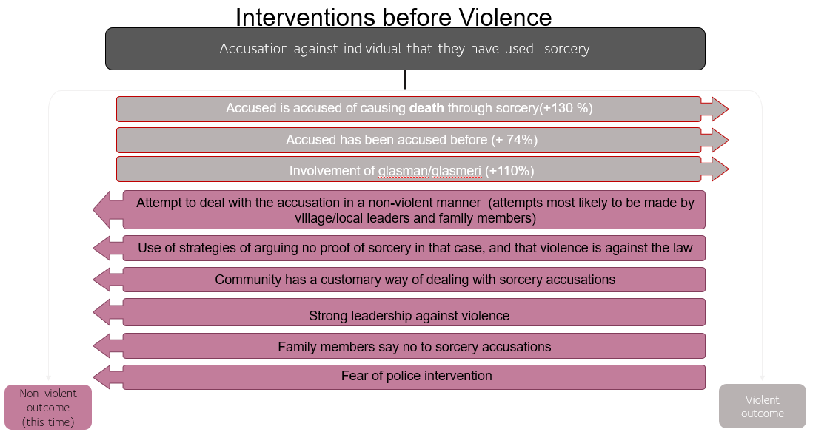

- Recommendations for action
  - What kind of further action could be undertaken by existing mechanisms at the United Nations for the elimination of harmful practices amounting to human rights violations related to accusations of witchcraft and ritual attacks, as well as stigmatization?
We propose that the following actions could be considered:
- Ensure that HPRAWRA is included in the Universal Periodic Review (UPR), which involves a periodic review of the human rights records of all 193 UN Member States.
- Create the post of a Special Rapporteur on Harmful Practices related to Accusations of Witchcraft and Ritual Attacks to take leadership of the issue within the UN system and to establish the basis for the implementation of the report.
Create an International Day on the Prevention of Accusations of Witchcraft and Ritual Attacks to provide a focal point for raising awareness of SARV and its prevention worldwide.
- Create a campaign site through the UN communications office at the OHCHR to provide legitimacy to the issue and provide a basis for funding and support to countries and NGOs wanting to work on addressing the prevention of SARV.
- Put the thematic into the hands of the Advisory Committee to the Human Rights Council for additional research.
- Develop a more elaborate incorporation of the thematic into comments and guiding notes of UN treaty bodies in respect of their various mandates, e.g., on children, women, and people with disabilities, etc.
- Support the collection of data on Harmful Practices related to Accusations of Witchcraft and Ritual Attacks at an international level (as was done for the 2020 Concept note), to be published as a yearly report to draw attention to the magnitude of the issue and its prevalence worldwide and to allow researchers and policymakers to make comparative analyses.
- Create regular opportunities for countries to share their experiences in addressing the issue, such as in expert meeting forums, regional meetings, and elsewhere.

Miranda Forsyth, Australian National University (Miranda.forsyth@anu.edu.au); Philip Gibbs, Divine Word University Papua New Guinea, William Kipongi, National Research Institute PNG, Fiona Hukula and Anton Lutz are non-academic contributors to the paper.
For an overview of the research project, its origins, funding and major findings, see https://regnet.anu.edu.au/sites/default/files/uploads/2022-03/2.%20FINAL%20SARV%20project%20final%20report%202021%20-%20for%20publication.pdf
http://www.stopsorceryviolence.org/snap-sarv-nap/
https://www.unitedforequalitypng.com/gbv-parl-committee
https://www.unitedforequalitypng.com/_files/ugd/7f0c06_50372501b8b7406b8482e9560dbd21b4.pdf?index=true
https://regnet.anu.edu.au/sites/default/files/uploads/2021-08/PB21-Prosecution-of-SARV-in-PNG-Aug-2021.pdf
https://www.pngnri.org/images/Publications/Spotlight_Vol_15_Issue_2.pdf
Forsyth, M. & Eves, R. (2015). The problems and victims of sorcery and witchcraft practices and beliefs in Melanesia: An introduction. In M. Forsyth & R. Eves (Eds), Talking it through: Responses to sorcery and witchcraft beliefs and practices, pp. 1-19, Canberra, Australia: Australia National University Press; Forsyth, M. (2013). Witchcraft and sorcery-related killings in Melanesia: The legal Issues. State Society & Governance in Melanesia In Brief, https://openresearch-repository.anu.edu.au/bitstream/1885/114535/1/Forsyth_Witchcraft2013.pdf.
https://regnet.anu.edu.au/sites/default/files/uploads/2021-08/PB21-Prosecution-of-SARV-in-PNG-Aug-2021.pdf
https://search.informit.org/doi/epdf/10.3316/informit.903648911459850
Further information on the role of the Village Courts is available here: https://www.youtube.com/watch?v=BKiFPlAX_5M
For some examples of the customary system, see further https://pngnri.org/images/Publications/Sorcery_Accusation-Related_Violence_SARV_in_Enga_Province.pdf
Philip Gibbs, William Kipongi, Anton Lutz, Ibolya Losoncz, Miranda Forsyth and Fiona Hukula, Sorcery Accusation-Related Violence in Enga Province, Issues Paper 37 (August 2021), The National Research Institute, Papua New Guinea, p. 4.
https://press-files.anu.edu.au/downloads/press/p316611/pdf/17.-Practical-Church-Interventions-on-Sorcery-and-Witchcraft-Violence-in-the-Papua-New-Guinea-Highlands.pdf
https://press-files.anu.edu.au/downloads/press/p316611/pdf/16.-Kumo-Koimbo-Accounts-and-Responses-to-Witchcraft-in-Gor-Simbu-Province.pdf
https://youtu.be/YfRZnU6UgdA
http://www.stopsorceryviolence.org/conference/
See http://dpa.bellschool.anu.edu.au/sites/default/files/publications/attachments/2017-11/ib-2017-28_forsyth-et-al.pdf; Losoncz, I., Forsyth, M., & Putt, J., Innovative data collection and integration to investigate sorcery accusation-related violence in Papua New Guinea, QMMR, 17-18(1); DOI https://zenodo.org/record/3976055#.YZR6MGBBx3g
A list of our publications is available here: https://regnet.anu.edu.au/research/research-projects/details/6589/improving-impact-state-and-non-state-interventions
https://www.ohchr.org/en/documents/tools-and-resources/concept-note-elimination-harmful-practices-related-witchcraft

