Annexure B Facts and Figures On Participation of Women in Political and Public Life

Women As Candidates:



Source: Empower Women handbook NDI UNDP

Good practices In Party Structures and Functioning



Source: Empowering Women DNI UNDP Guidebook

Percentage of Women in parliament



Women in parliament Asia-pacific 2012

Regional averages

|  |  |  |  |
| --- | --- | --- | --- |
|  | **Single House or lower House** | **Upper House or Senate** | **Both Houses combined** |
| **Nordic countries** | **42.0%** | --- | --- |
| **Europe - OSCE member countries** including Nordic countries | **23.4%** | 21.1% | 22.9% |
| **Americas** | **22.4%** | 23.3% | 22.5% |
| **Europe - OSCE member countries** excluding Nordic countries | **21.7%** | 21.1% | 21.5% |
| **Sub-Saharan Africa** | **20.4%** | 19.2% | 20.3% |
| **Asia** | **18.5%** | 14.1% | 18.0% |
| **Arab States** | **14.9%** | 6.4% | 13.2% |
| **Pacific** | **12.7%** | 34.8% | 15.2% |
| *Regions are classified by descending order of the percentage of women in the lower or single House* | | | |

Source: IPU

**Table 2: Women in Parliament, 1945-2005**

|  |  |  |  |  |  |  |  |  |
| --- | --- | --- | --- | --- | --- | --- | --- | --- |
|  | **1945** | **1955** | **1965** | **1975** | **1985** | **1995** | **2000** | **2005** |
| **Number of parliaments** | 26.0 | 61.0 | 94.0 | 115.0 | 136.0 | 176.0 | 177.0 | 187.0 |
| **% of women representatives (lower house or unicameral)** | 3.0 | 7.5 | 8.1 | 10.9 | 12.0 | 11.6 | 13.4 | 16.2 |
| **% of women representatives (upper house)** | 2.2 | 7.7 | 9.3 | 10.5 | 12.7 | 9.4 | 10.7 | 14.8 |

Source: IPU, 2005. *Women in Politics: 1945-2005.* Information kit.[1]

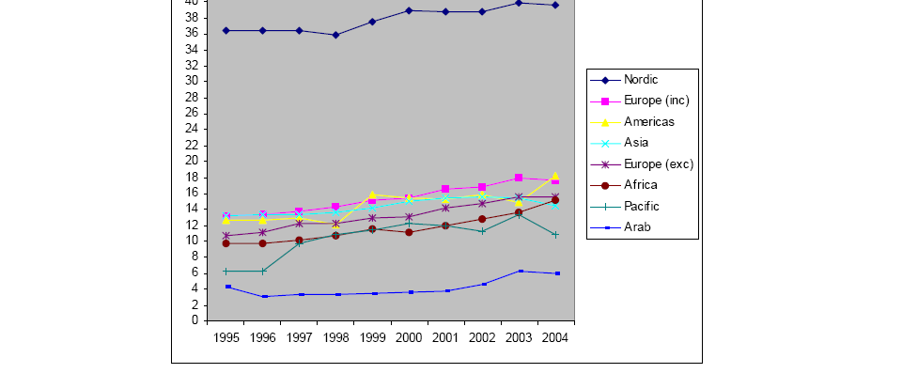

Table 3: Women in Parliament by Region, 1995-2005[2]

**Table 4: Women in the Executive, 1995-2005**

|  |  |  |
| --- | --- | --- |
|  | **1995** | **2005** |
| **Women Heads of State or Government (elected)** | 6.4 % (12 of 187) | 4.2% (8 of 191) |
| **Women Presiding Officers of a House of Parliament** | 10% (24 of 228) | 8.3% (21 of 254) |
| **Ministerial Portfolios held by Women** | No data available | 858 in 183 countries Sweden: 52.4% women ministers Spain: 50.0% women ministers |

Women in parliament- Increased representation over The Years

Source: UN Statistics Division

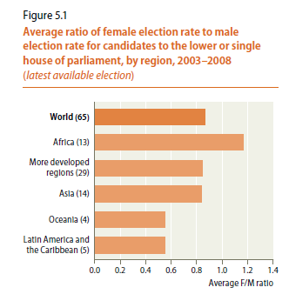

Source: World’s Women 2010: Trends UN

|  |  |
| --- | --- |
| **Countries that mandate reserved seats for women in the lower or single chamber of parliament through the Constitution or electoral law (2009)** | |
| **Region** | **Countries** |
| Eastern Africa (9) | Burundi, Djibouti, Eritrea, Kenya, Rwanda, Somalia, Sudan, Uganda, Tanzania |
| Other Africa (2) | Egypt*, Niger |
| Southern Asia (3) | Afghanistan, Bangladesh, Pakistan |
| Other Asia (2) | Jordan, Kyrgyzstan |

Source: Keiko Osaki-Tomita **Tracking the Status of Women with Statistics** - Findings from the World’s Women 2010 -UN Statistics Division



Source: World’s Women 2010 Trends UN



Source: World’s Women 2010: trends UN

1. http://www.ipu.org/english/surveys.htm#45-05
2. Ibid