Check against delivery

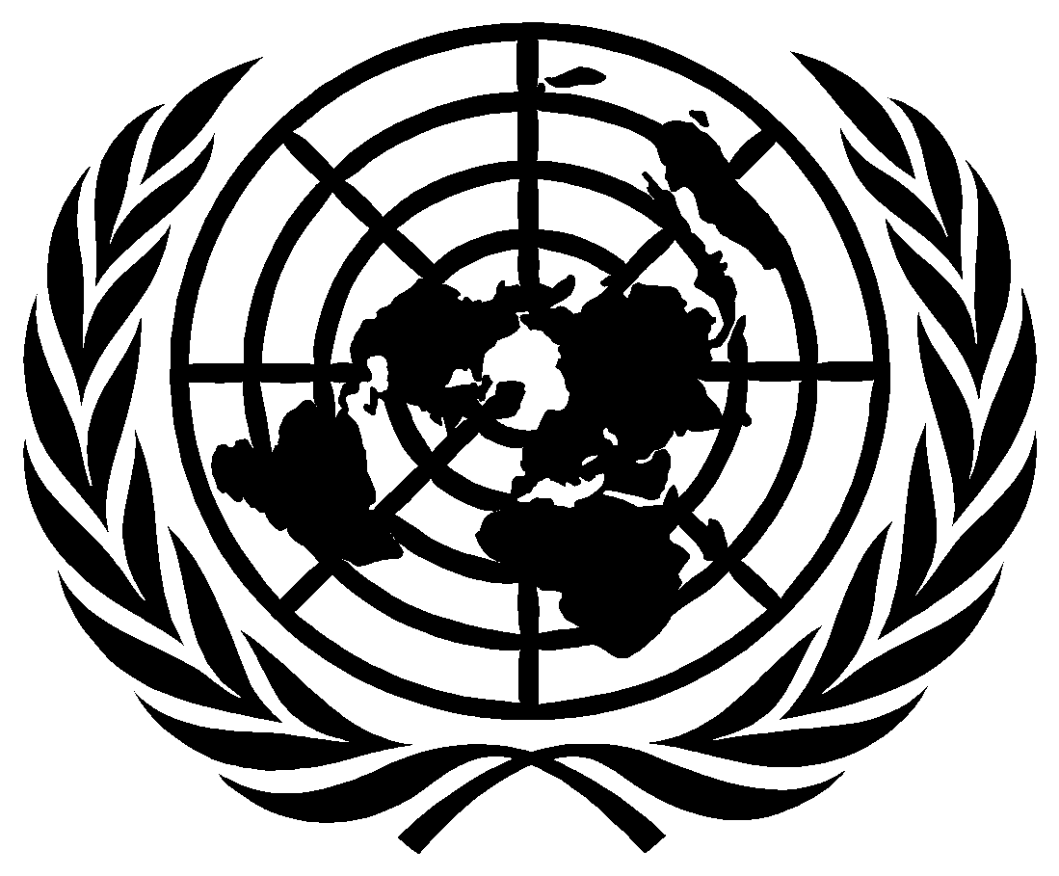

United Nations Human Rights Council

THE TWENTY-THIRD SESSION OF THE INTERGOVERNMENTAL WORKING GROUP ON THE RIGHT TO DEVELOPMENT

CLOSING STATEMENT

BY

AMBASSADOR ZAMIR AKRAM

Chair-Rapporteur of the Intergovernmental Working Group on the Right to Development

20 May 2022

Excellencies,
Distinguished delegates,
Dear participants,

We have reached the end of the 23rd session of the Working Group on the Right to Development.

As indicated, the Secretariat will issue another call for comments and textual suggestions to Member States, international organizations and other entities with observer status, global, regional and national human rights institutions and non-governmental organizations with ECOSOC consultative status.

During this session, we heard presentations on the revised draft convention on the right to development and had very substantive interactive discussions, with the experts of the drafting group, the Special Rapporteur on the Right to Development and the Chair of the Expert Mechanism on the Right to Development.

I once again regret that the EU and several other States chose not to participate in the discussion on the draft convention. I once again encourage them to actively engage with the work of this Working Group and in this important effort of international law making.

I have always strived for an inclusive, consensual conduct of the work of this Working Group, and will continue to do so. I thank all of you for your cooperation for the same.

In closing, I thank you again for the confidence placed in me and for your support during the past week. On behalf of the Working Group, I would also like to thank the interpreters and the Conference Service personnel and to the Secretariat members, for their support and efforts to facilitate the smooth conduct of this session.

Thank you!

