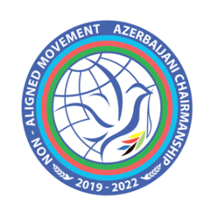
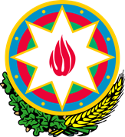
CHAIR
NON-ALIGNED MOVEMENT
GENEVA CHAPTER

Statement

delivered by the Permanent Mission of the Republic of Azerbaijan to the UN Office and other International Organisations in Geneva

on behalf of the Non-Aligned Movement,

Closure

23rd session of the

Working Group on the Right to Development

Geneva, 16-20 May 2022

Thank you, Mr. Chair,

- I have the honor to deliver this statement on behalf of the Non-Aligned Movement (NAM) Member States.

- Once again, NAM thanks H.E. Mr. Zamir Akram, Chairperson-Rapporteur of the Working Group on the Right to Development. We thank his stewardship heading this Working Group, to the fulfillment of its mandate to come up with tangible results.

- NAM welcomes the presentations made by the Special Rapporteur on the right to development, Mr. Saad Alfarargi, and the Chair of the Expert Mechanism on the Right to Development, Mr. Koen De Feyter and reiterates its support to their mandates. NAM considers that the mandate of the Special Rapporteur and the Expert Mechanism on the Right to Development are important support for the work of this Working Group and for the discussion on the elaboration of the convention on the right to development.

- NAM firmly believes that the realization of the right to development is a necessity now more than ever. In this sense, the international community must give the right to development the high profile it merits.

- The NAM Member States are committed to the promotion and protection of all universally recognized human rights, including the right to development, which is a universal and inalienable right and an integral part of all universally recognized human rights and fundamental freedoms.

- We believe that a convention on the right to development can make the development a reality for all, ensuring the operationalization of the right to development as a priority to achieve the Sustainable Development Goals, and rising the right to development, as set out in the Vienna Declaration and Programme of Action, to the same level and on a par with all other human rights and fundamental freedoms, in compliance with the mandate of the Working Group, on the basis of the principles set forth in the United Nations Declaration on the Right to Development.

- The Non Aligned Movement considers that the right to development is central to the implementation of the 2030 Agenda for Sustainable Development, and in this vein, urges all UN Member States to pay particular attention to the right to development in the context of the elaboration of their national policies in line with the 2030 Agenda.

- We call upon the United Nations, its specialized agencies, funds and programmes to mainstream the right to development in their policies and operational activities, as well as in policies and strategies of the international financial and multilateral trading system.

- Finally, NAM thanks the Working Group, for its efforts in the consideration of the revised draft convention on the right to development.

Thank you.

