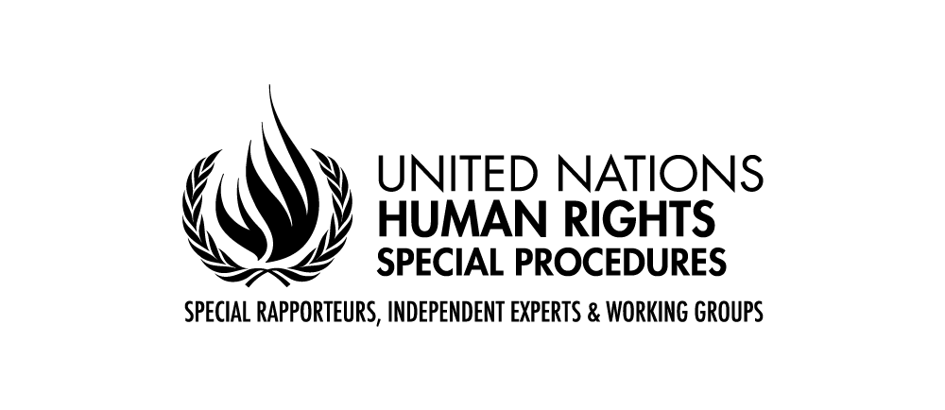

Statement by Mr. Saad Alfarargi
United Nations Special Rapporteur on the right to development

23rd Session of the Working Group on the Right to Development
Geneva, 16-20 May 2022

Interactive Dialogue, Monday, 16 May 2022

Dear Chair-Rapporteur of the Working Group, Excellencies, distinguished delegates, representatives of the United Nations and the NGO community,
It is a great pleasure and honour to address you today in my capacity as United Nations Special Rapporteur on the right to development.
- From the beginning of my mandate, I saw my role as ensuring that the right to development remains a focus in the global discourse on the post-2015 development agenda. I worked to ensure that the right to development, and indeed all human rights, are recognized as an integral part of the sustainable development discourse, while emphasizing that development should happen in accordance with human rights principles and with the goal of achieving the realization of the right to development for all, rather than simply for economic growth. The vision contained in the Declaration on the Right to Development, namely that it entitles every persona and all peoples to participate in, contribute to and enjoy development in its economic, social, cultural and political dimensions, must be the guiding force in the implementation of the post-2015 development framework.
- From the beginning of my mandate, I identified the following challenges:
- Politicization. Despite the fact that more than 35 years have passed since the adoption of the Declaration on the Right to Development, views among States are still divided. There are disagreements on the nature of the duties of States to realize the right to development and on the relative emphasis to be placed on the national dimension of State obligations (individual rights and corresponding State responsibilities, rule of law, good governance, combating of corruption) as compared to obligations of international cooperation (international responsibilities, international order, development cooperation, global governance).
- Lack of engagement. The political divide has resulted in a low level of engagement of United Nations agencies and civil society in promoting, protecting and fulfilling the right to development. Despite the progressive evolution of the concept of the right to development and its inclusion in some international and regional instruments and national constitutions, as well as in a growing number of UN Human Rights Council and General Assembly resolution, the general level of awareness and engagement for its implementation remain low. The low level of awareness of the right to development among grass-roots organizations further hampers advocacy efforts;
- Adverse global trends. The implementation of the right to development faces numerous other challenges: the global financial and economic crisis, the energy and climate crisis, the increasing number of natural disasters, the new global pandemics, the increase in automation in many sectors, corruption, illicit financial flows, the privatization of public services, austerity and other measures and the ageing of the global population, including in developing countries. There is a growing demand for resources for the realization of the right to development. The rise of nationalistic tendencies and the related trend to move away from international solidarity and cooperation further weakened international governance. Addressing these challenges will require the concerted effort of all relevant stakeholders, both at national and at international levels.
- Another issue that I consistently identified are the difficulties in ensuring active, meaningful and informed participation of all relevant stakeholders in development processes at the local, national, regional and international levels. Since the right to development entitles all persons and peoples to “participate in, contribute to and enjoy economic, social, cultural and political development”- for its implementation it is key to ensure inclusiveness and effective participation of relevant stakeholders at all levels of decision-making. Enabling disadvantaged and marginalized individuals and groups to actively participate in decision-making processes is essential to overcome structural inequalities and discrimination; to ensure their place as key actors in the development of countries; and to ensure the equal sharing of benefits.
- Other overarching issues relate to access to adequate information; means of implementation and the mobilization of existing resources; monitoring and evaluation methods; accountability mechanisms; and access to remedies.
Ladies and gentleman,
For more than two years the world lives in the shadow of an unprecedented pandemic. The COVID-19 pandemic has created a global public health and economic crisis of inestimable proportions. People who are at greatest risk of vulnerability, most marginalized and least empowered have been hit the hardest by both COVID-19 and climate change. The sustainable development goals implementation has been delayed and in many instances scaled back. The COVID-19 pandemic and policies to mitigate it have sharpened the disparities between more developed countries, where, for example, vaccines became abundant in a relatively short time, and developing countries, which continue to experience outbreaks and large death tolls.
As you know, on 18 November 2020, the Third Committee of the UN General Assembly voted a resolution, that invited me and the Chair-Rapporteur of the Working Group to present an oral report and to engage in an interactive dialogue with the Assembly, on efforts undertaken in the promotion and realization of the right to development, taking into account the context of the response to and the recovery from the COVID-19 pandemic. In that regard I would like to inform you that I am planning to devote my thematic reports in 2022 to the compliance of COVID-recovery plans with the right to development. I issued a call for information and I am grateful to all countries that took time to provide me with information on the steps taken by your governments, both nationally and internationally to elaborate plans for recovery from the COVID-19 pandemic.
In my latest thematic reports I already identified the following COVID-19 related concerns:
- Under the Universal Declaration of Human Rights, everyone is guaranteed a social and international order favourable to realizing their rights. However, thus far, in the context of the current COVID-19 pandemic there has been an inadequate degree of international cooperation between nations. Instead, States are falling back on policies meant to protect their domestic interests without considering the impact on others.
- Another key concern for many countries is that financing and liquidity facilities to respond to the COVID-19 crisis will be conditioned on imposing austerity policies.
- On this background we need to advocate for increased financial support and low-cost liquidity will be required to address the immediate health response and economic support needs in developing countries. I support sustained increases in the rapid disbursement of budget support by international organizations, including the World Bank and IMF, to developing countries. Fiscal stimulus, in the form of unconditional grants, is necessary to address the urgent health-care needs of developing countries, provide a safety net for the most vulnerable, protect jobs and support economic activity where possible.
- In cooperation with local governments and civil society, States and development finance institutions can centre individuals and communities in decision-making processes about financing for development, to the advantage of all stakeholders. To practically implement the right to development in these areas, I have recommended:
- States to uphold their commitments to providing ODA, and direct aid to those most in need;
- Within countries, Governments should allocate the most resources to the regions that are the poorest, and to vulnerable populations, including persons with disabilities, women, children and young people, minorities, indigenous peoples, people of African descent and members of other disempowered or marginalized groups.
- To address regional inequalities and better facilitate participation at the community level, States and development finance institutions should localize development financing by establishing local development centres and by providing technical support platforms for municipalities.
- States should improve their disaggregated data collection to ensure that development finance targets those most in need.
- Your Excellencies, Ladies and Gentlemen,
Today you are going to continue the review of the initial draft of the new legally binding instrument on the right to development that you started in May 2021. You have in front of you a revised draft, where the drafters have made considerable efforts to accommodate the various suggestions made during the previous discussions. The draft in front of you contains important definitions and a set of principles that can, hopefully, bridge the divide in views with regard to the nature and scope of the right to development. The draft also foresees mechanisms to evaluate and monitor the instrument’s implementation that can work to ensure that persons and peoples around the world enjoy their right to development.
I have stated on many occasions that negotiating a new international human rights instrument is a lengthy intergovernmental process, and negotiating this particular treaty will be particularly challenging. I am heartened that many of you have invested time and efforts in the negotiation process and I appeal to all of you to continue engaging in the negotiations process, involve your capitals and invest the necessary resources, despite the remaining differences. Reaching the goal would require working together in a constructive spirit. The distinguished Chair-Rapporteur of the Working Group, who is leading the drafting process, will certainly provide you with more details, insights and wisdom. The completion of this treaty would go a long way to strengthening the right to development and recognising its importance as a separate and distinct right, interrelated with all other human rights.
I am looking forward to my continued dialogues and cooperation with the Working Group and the Expert mechanism on the right to development in implementation of our respective mandates. I am looking forward to hearing your ideas and your plans and to working together so that we can come a step closer towards implementing the right to development.
I thank you all for your kind attention.

