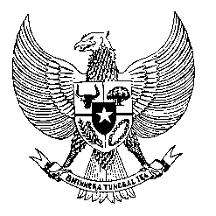

Permanent Mission
of the Republic of Indonesia to the UN, WTO,
and Other International Organizations
in Geneva

STATEMENT OF THE DELEGATION OF THE REPUBLIC OF INDONESIA AT THE 23rd SESSION OF THE WORKING GROUP ON THE RIGHT TO DEVELOPMENT
GENEVA, 16 – 20 May 2022

Thank you, Mr. Chair,
Indonesia welcomes your re-election as the Chair Rapporteur of the Working Group. We also appreciate the work in preparing this 23rd session to ensure continuation of this important platform to discuss and review progress in promoting and implementing the right to development and for the first draft legally binding instrument for consideration during this session.
With the current global undertaking to recover from the pandemic, the Working Group continues to serve as valid platform for comprehensive discussion on the implementation of the right to development with the involvement and contribution of states, civil society organizations and relevant human rights mechanisms with the mandate on the right to development. The 35th anniversary of the Declaration on the Right to Development could serve as a catalyst to further elevate the development agenda at the multilateral level.
Mr Chair Rapporteur,
Indonesia’s commitment to contribute to global recovery agenda including through capacity building programs is integrated in our national and international development policy as well as our undertaking as the current president of the G20 with our program and target including digital transformation
Mr. Chair Rapporteur,
On the national effort to operationalize the right to development, we are certain that that this WG and the other mechanisms on the right to development should lend their full support to the national development strategy, as well as international collaborative measures in this area. We encourage all mandate holders to support development efforts through genuine and constructive dialogue in strengthening the capacity of Member States to comply with their human rights obligations for the benefit of all.
I thank you.

***

