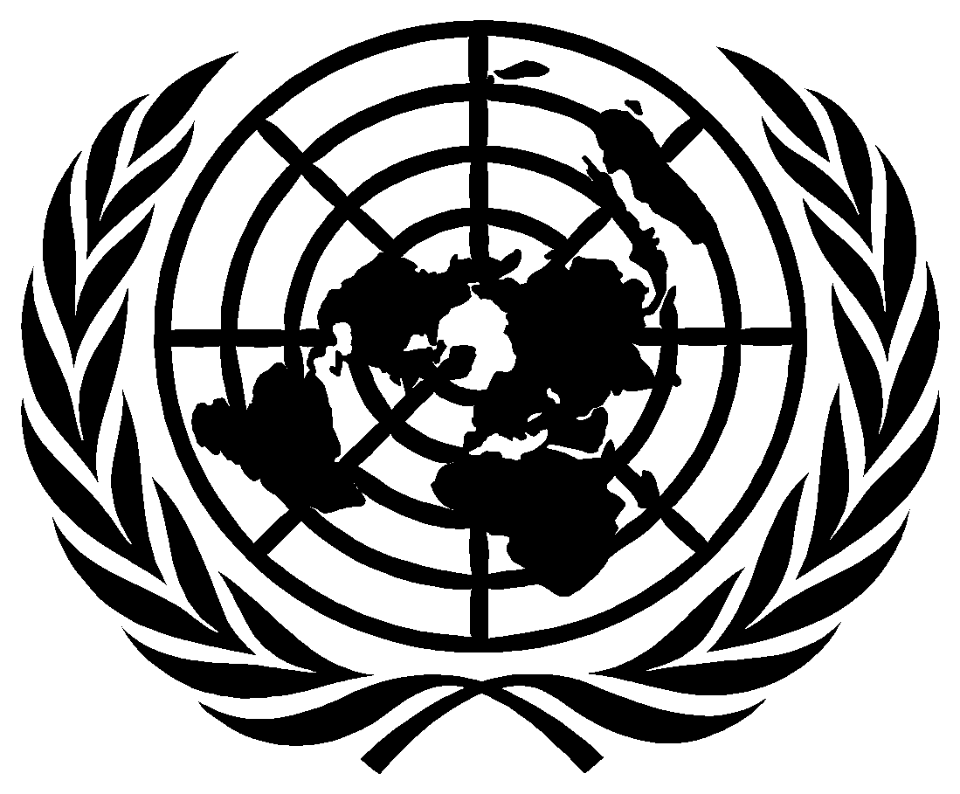

United Nations Human Rights Council

THE TWENTY-THIRD SESSION OF THE INTERGOVERNMENTAL WORKING GROUP ON THE RIGHT TO DEVELOPMENT

OPENING STATEMENT

BY

AMBASSADOR ZAMIR AKRAM

Chair-Rapporteur of the Intergovernmental Working Group on the Right to Development

16 May 2022

Excellencies,
Distinguished delegates,
Ladies and gentlemen,

It is an honour for me to be re-elected as Chair-Rapporteur of this Open-ended Intergovernmental Working Group on the Right to Development. I am grateful for your trust and your confidence.

I would like to express my appreciation to Mr. Ayuush Bat-Erdene, the Chief of the Right to Development Section, for opening the session and High Commissioner Bachelet for her remarks that will now be made in the afternoon session. I would also like to thank her for her support to the work of this Working Group and to the promotion and protection of the right to development more broadly.
The year 2022 has witnessed serious and gross human rights violations. At a time when the world is still recovering from the COVID-19 pandemic, the climate crisis and conflicts have cast a long shadow on our common future. The achievement of the Sustainable Development goals has become ever less probable within the agreed timeframe, with their possible achievement being relegated to the distant future.
As recognized in the United Nations Declaration on the Right to Development, human rights violations constitute obstacles to the full realization of the right to development. States committed to take resolute steps to eliminate massive and flagrant violations of human rights of peoples and human beings and to cooperate with each other in ensuring development and eliminating obstacles to development.
The right to development is more important now than ever before.
Ladies and gentlemen,
The mandate of this Working Group is to monitor and review progress made in the promotion and the implementation of the right to development, to analyse the obstacles to its full enjoyment and to make recommendations with the aim of promoting the implementation of the right to development.
Within this overall mandate, we will once again have the pleasure to welcome and conduct an interactive session with the Special Rapporteur on the Right to Development, Mr. Saad Alfarargi and the Chair of the Expert Mechanism on the Right to Development, Mr. Mihir Kanade. I welcome their presence and continued cooperation with this Working Group.
At the request of the Council, we have embarked on the journey to develop a draft convention on the right to development, as a means to make progress in the realization of the right to development.

At this session we will start the consideration of the first revised draft convention on the right to development. As requested by the Human Rights Council, I presented a first draft convention to the 20th session of the Working Group, in May 2020. We then considered this first draft in two consecutive sessions and received numerous oral and written comments and textual suggestions. With the support of the drafting group of experts we went through all these comments carefully. It is an honour for me to present you this first revised draft convention. I thank all those who have actively engaged in this process and encourage all others to do so as well. I regret that the EU and several other States chose not to participate in the discussion on the draft convention. I would like to once again invite them to do so.

I would also like to express my appreciation to the Ambassador of Azerbaijan, who organized, in his capacity as Chair of the Movement on Non-Aligned Countries, on 29 April, an informal discussion on the right to development, with a view to creating an enabling environment for a constructive dialogue during the present session of the Working Group.

Finally, we will have time to consider how we think this process can be brought to a conclusion, on the way forward for adopting the draft convention.
I thank you.

