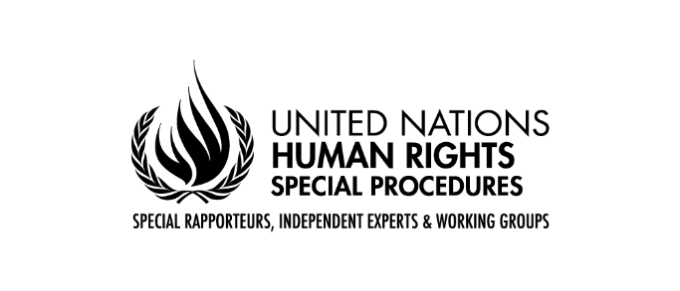

**Call for Contributions**

**Mandate of the Special Rapporteur** **on the human rights to safe drinking water and sanitation**

**Thematic report to the United Nations Human Rights Council 57th session**

**“ Nexus water-economy: water management for services and productive uses from a human rights approach.”**

**Key information sought**

To facilitate the reception of inputs, the Special Rapporteur prepared a list of key information that he considers essential for the report.

The list could be answered **entirely or partially** according to the expertise and experience of those actors willing to contribute to the report.

1. How would you prioritize the values and roles involved in managing water resources, and which ethical principles do you believe should guide these priorities?
2. Do you agree with the following expressions: ‘the water cycle is a global common good’; ‘aquatic ecosystems are natural heritage’; ‘water obtained from ecosystems is a common good’?
3. What should be the role of the State in the management of aquatic ecosystems and the water obtained from them?
4. How is water managed in your country, as a public good, a common good, a common good under public management, and an economic good?
5. If water is considered a common good, how do you think water for productive uses should be managed in conjunctural or permanent circumstances of water scarcity? Do you know of any experiences or research on allocating water rights in circumstances of scarcity, during drought periods, or in the face of new uses and demands once sustainable availability limits were reached?
6. Could you share practical experiences or research on the management of productive water uses under the uncertainty imposed by climate change?
7. Could you share significant cases where water and sanitation services have moved from public to private management, and from private to public management (for instance remunicipalisation)?
8. Could you share good experiences of participatory public management in water and sanitation services?
9. Could you please share legislation, policies, and/or practices that consider water as a "common good", particularly those of indigenous peoples and peasant communities? Are there relevant judicial rulings related to water as a common good, particularly in productive activities?
10. How does the recognition of human rights to safe drinking water and sanitation, or the human right to a safe, clean, and healthy environment, impact considering water and aquatic ecosystems as common goods?
11. Could you share good experiences of private management of water and sanitation services under an effective regulatory and institutional framework?
12. Could you share and assess significant examples of water markets or public water banks?
13. Could you share information on how the entry of water into the futures markets has panned out and what prospects can be expected?
14. Could you share concrete examples of tariff systems that you believe are exemplary?
15. Could you share examples of social management of productive uses of water, with concrete measures?

**Instructions**  
Please send your contributions in English, French, or Spanish in Word or PDF format to hrc-sr-watsan@un.org AND to maria.acostalazo@un.org. Please indicate "Contribution Economy and Water" in the email subject line; limit your contributions to a maximum of 2,500 words and, if necessary, provide links to relevant documents or attach annexes.

Your inputs must be sent no later than **April 1, 2024**.

**How inputs will be used**

All submissions will be published on the website of the mandate. Non-state actors could request the confidentiality of the submission