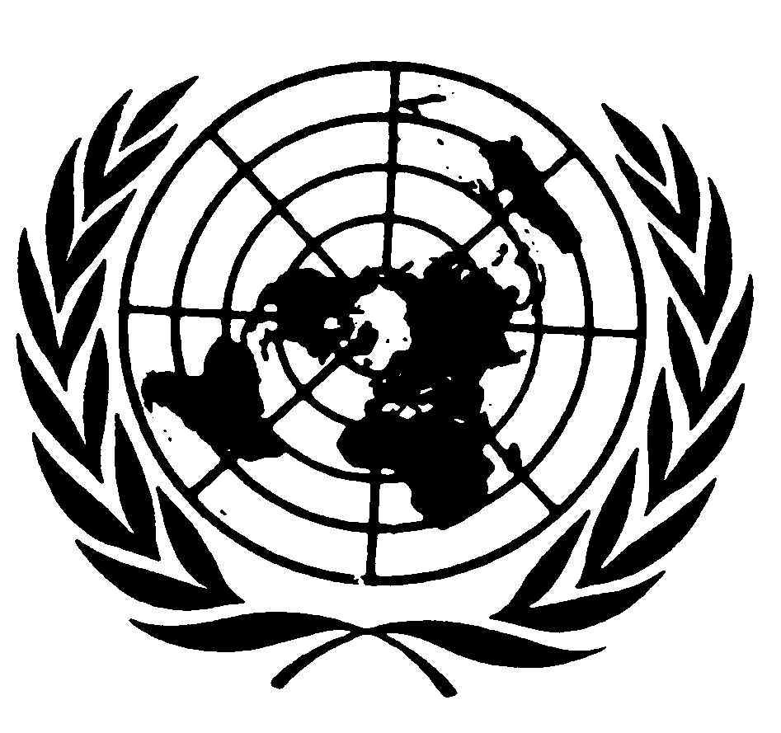

Opening Remarks, UN Special Rapporteur on toxics and human rights
Marcos A. Orellana
Interactive Dialogue, the 78th Session of the UN General Assembly
Third Committee Session
Shipping, Toxics, and Human Rights

New York, 19 October 2023

Thank you, Chair.
Excellencies, Distinguished delegates, Colleagues,

Human rights have always been relevant to shipping, considering the impacts of the shipping industry on human beings and the environment. For example, oil spills harm coastal communities; air pollution from vessels impair air quality in port cities; greenhouse gas emissions from vessels contribute to climate change; shipbreaking (and especially beaching of end-of-life vessels) releases persistent hazardous pollutants to the environment; seafarers are subjected to hazardous working conditions; and the transport of hazardous cargo poses risks to the crew and environment.

The magnitude of these impacts is apparent in the fact that 90% of globally traded goods are carried by sea. The world merchant fleet has around 96,000 ships with almost 2 billion dead weight tonnage of carrying capacity. Although the international shipping industry is key to the functioning of the global economy, the sector has been the object of serious human rights and environmental concerns.

However, regulations on shipping are largely unknown to the human rights community. And there is little indication that the shipping industry considers human rights to be relevant to its work.

Mr. President,

Toxic pollution by the shipping industry results from various sources: the combustion of heavy fuel oil; spills of oil and highly noxious substances; biofouling and anti-fouling systems; ship-breaking; dumping; the loss of containers; the release of ballast water; and discharges of black water, grey water and bilge water, among others.

Certain groups are particularly vulnerable to the adverse impacts of shipping. Coastal communities can be devastated by spills of oil or highly noxious substances. Indigenous Peoples, such as those living in the Arctic, are especially affected by marine pollution and the bioaccumulation of persistent pollutants. Seafarers are often exposed to hazardous substances and working conditions. Forced labour is still alarmingly present in the maritime sector; many live in slavery-like conditions. Women represent only 2 per cent of the world’s 1.2 million seafarers and often experience ill-treatment, sexual violence and harassment. Ship-breakers are also regularly, mortally injured in the course of their work, even in approved ship recycling facilities.

The following examples can illustrate the magnitude of the toxic impacts posed by shipping.

Oil and toxic spills remain among the most significant and environmentally damaging disasters worldwide, and arise from deliberate discharges, negligence or accidental leaks. In July 2020, for example, the MV Wakashio struck a reef off Mauritius and spilled more than 1,000 tons of fuel oil. Coastal communities are directly affected by oil and toxic spills from ships. While spills are becoming less frequent, they remain a grave concern.

Air pollution associated with marine shipping accounts for 10 to 15 per cent of the world’s anthropogenic sulphur oxide (SOx) and nitrogen oxide (NOx) emissions. In addition, approximately 1.8 million tons of particulate matter are released annually. Low air quality due to international maritime transport contributes to approximately 60,000 deaths annually.

Ship-breaking, also known as ship recycling, is a type of ship disposal involving the dismantling of an obsolete vessel’s structure for scrapping or disposal. Ship-breaking continues to be one of the most hazardous occupations in the world, with extremely poor working practices and environmental conditions prevailing in many ship-breaking yards. Ship-breaking routinely releases substances such as oil, lubricants and other hazardous chemicals, contaminating air, soil and water, all of which threaten the lives and health of workers and local communities.

The shipping industry also contributes significantly to climate change. The greenhouse gases emitted by merchant ships, including carbon dioxide and methane, have increased by 10 per cent from 2012 to 2018. As of 2022, shipping is responsible for approximately 2.89 per cent of global greenhouse gas emissions, and emissions are still increasing.

Mr. President,

Efforts have been made to reduce the environmental and human rights impact of the shipping industry. Last month I reported to the UN Human Rights Council on my official visit to the International Maritime Organization. That report contains recommendations to the IMO. The report I present today contains global recommendations to States and the shipping industry.

IMO is a public regulator and has made impressive achievements as a standard-setting authority. Under its auspices, more than 50 international treaties have been adopted, with wide-ranging and often highly technical regulations on international shipping.

However, human rights are not sufficiently considered under these conventions. While several conventions indirectly support human rights by seeking to improve safety and security at sea and the protection of the environment, there is an urgent need to implement and enforce IMO conventions in the light of the human rights obligations of States.

Without adequate global membership and enforcement, the impact of IMO conventions is vastly reduced, as they require States to be willing and technically equipped to enforce them. Several “flags of convenience” do not have the capacity to regulate the number of ships registered under them. Technical cooperation and capacity-building efforts must increase in order to establish a system of international adherence, effective enforcement and accountability.

Mr. President,

Historically, the shipping industry has been characterized by opacity. Beneficial owners and other stakeholders in the shipping sector have tried to keep away from public scrutiny. However, there is an increasing recognition of the importance of transparency in the shipping industry. Such transparency is key to global trade efficiency, shipping’s decarbonization, and a just transition. It is also essential for ensuring the protection of human rights of workers and communities adversely affected by shipping and toxics.

In regards to the toxics risks and harms posed by shipping to human rights, States have the primary responsibility for enacting appropriate laws and regulations and for monitoring, investigating and prosecuting their breaches, including breaches by the private sector.

At the same time, private shipowners or operators and others in the shipping industry are also bound by international human rights responsibilities. Such responsibilities include the avoidance of causing or contributing to the harming of human rights through their activities and, if harm unintentionally occurs, immediately taking all necessary actions to stop these negative impacts and facilitate remedial actions.

To conclude, Mr. President,

A human rights-based approach to shipping, including the protection for whistle-blowers, transparency and access to information, and accountability of States and businesses for their actions, is urgently needed.

Addressing the impact of shipping on human rights and the environment is also crucial to advance on the objectives of the 2030 Agenda for Sustainable Development. These targets cannot be achieved without properly tackling the adverse impacts of exposure to hazardous substances by the shipping industry.

Thank you very much.

