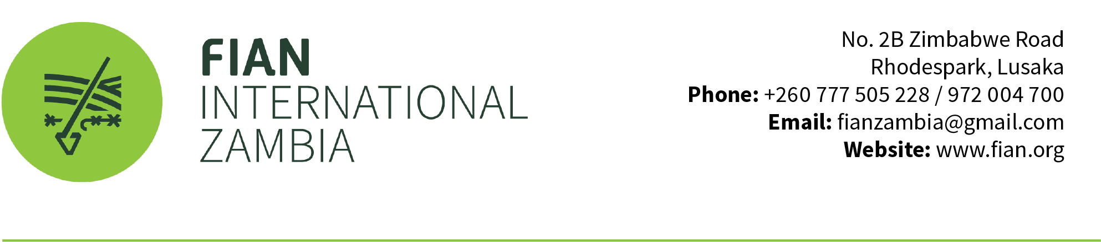

Zambia and the topic of "Toxics and Gender" in relation to the Special Rapporteur’s upcoming report.

In Zambia, women are frequently exposed to toxic pesticides across various settings, including subsistence farming, informal employment, and formal agricultural sectors. Two-thirds of the labor force in Zambia is engaged in agriculture, 78% of whom are women farmers. (Kathy short, 2022). Lack of protective equipment, limited awareness, and discriminatory practices have exacerbated these risks. Women play a significant role in pesticide application, often without adequate personal protective equipment (PPE), especially during activities like weeding and harvesting.

Due to health and environmental risks certain pesticides have been banned – regionally or on country level. Notably, Atrazine, Atrazine has been prohibited for use within the European Union (EU) since 2004, while EU countries have also banned Paraquat. Additionally, glyphosate has faced restrictions or bans in several countries due to its suspected cancer risk. Glyphosate serves as the active ingredient in various herbicides, including Roundup. Germany, for instance, has initiated legislation to entirely halt glyphosate usage by 2024. Despite these international measures, pesticides or chemicals containing the active ingredients paraquat, glyphosate, and atrazine are absent from Zambia's banned list for importation and use.

Notwithstanding the bans mentioned above, the Zambian government allows the importation and utilization of these pesticides. For example, Syngenta Zambia markets Gardomil Gold 600 SC, containing active ingredients like 102.8g/L S-Metalachlor, 248.6g/L Atrazine, and 248.6g/L Terbuthylazine. Amiran Zambia sells Scorch 20 S.L. herbicide with an active ingredient of paraquat 20g/L. Syngenta Zambia also sells Touchdown Forte 360 SL, which contains 360 g/L Glyphosate potassium salt.

Research suggests a link between the popular glyphosate weed killer Roundup and cancer, while atrazine has been associated with various cancers, premature birth, and birth defects (Environmental Research, 2011). The impact of pesticides on women and girls differs from that on men and boys. Women generally have a higher proportion of body fat, making them more likely to store pollutants that can accumulate in fat tissue. Additionally, women have more hormonally sensitive tissues, rendering them more vulnerable to pesticides, especially those with hormonal activity or known to disrupt the endocrine system. Certain pesticides, acting as mammary carcinogens and tumor promoters, have been linked to breast cancer. Pesticides are also associated with endometriosis, a painful condition that can cause infertility and poses risks to reproductive health and unborn children. Pesticides can be passed from mother to child through the womb and breastfeeding, contributing to neonatal deaths, birth defects, and impaired mental or developmental problems in children (Pesticide Atlas 2022).

Recommendations

- The Zambian government to implement regulations to ban or restrict the use of internationally banned pesticides and herbicides, such as Atrazine, Roundup (containing glyphosate), and Glyphosate.
- The Zambian government to enhance regulatory frameworks for pesticide management, including registration, importation, distribution, and use. Strengthen enforcement mechanisms to ensure compliance with safety standards and monitor the quality of pesticide products available on the market.
- The Zambian government to conduct comprehensive training programs on pesticide safety and handling for farmers, agricultural workers, and pesticide applicators, with a focus on women who are disproportionately affected. Promote the use of PPE during pesticide application.

https://usrtk.org/pesticides/atrazine/
https://justicecounts.com/paraquat-lawsuit/where-is-paraquat-used-most-often/
https://www.consumernotice.org/environmental/pesticides/roundup/ban/
https://health.uct.ac.za/sites/default/files/media/documents/zambia_-_banned_chemicals_for_use_pops_2016__0.pdf
https://www.syngenta.co.zm/product/crop-protection/gardomil-gold-600-sc
https://infobwana.com/product/ckbf7zsmw06k801493ecgw3ib
https://infobwana.com/product/ckbf7zsmw06k801493ecgw3ib
https://www.syngenta.co.zm/product/crop-protection/touchdown-forte-360-sl

