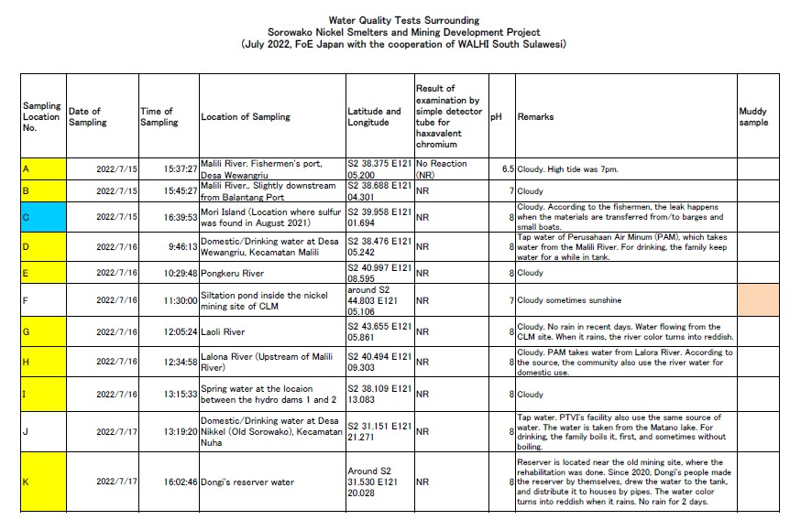
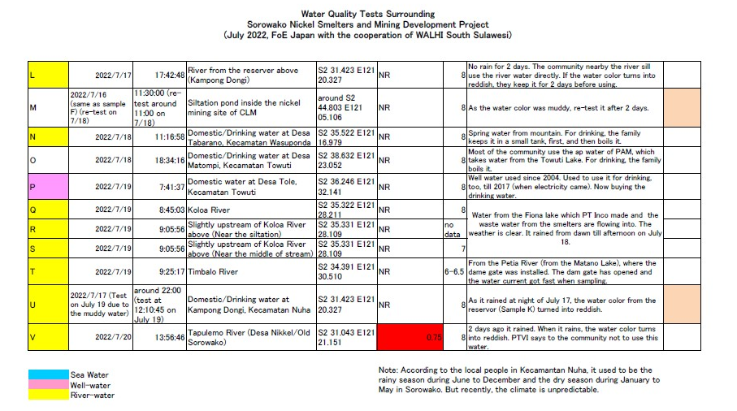

Sorowako Nickel Smelters and Mining Development Project in Indonesia

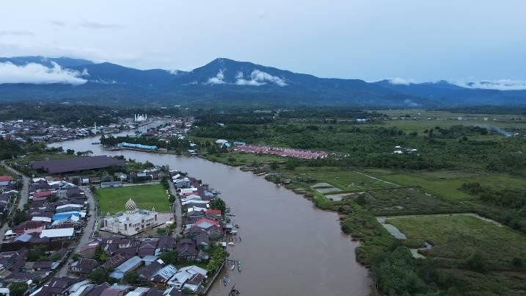
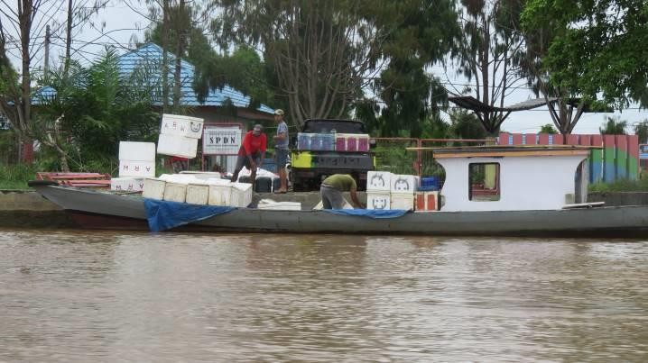

Malili River (July 15, 2022) Fishermen and boat along the Malili River (July 15, 2022)

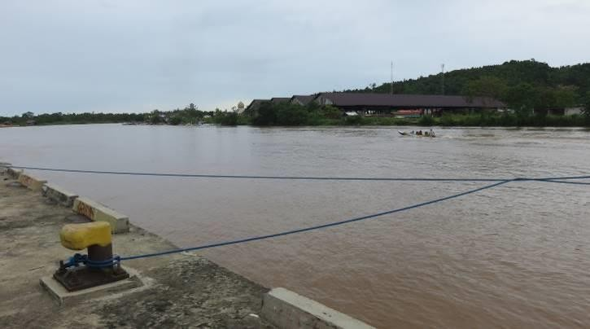
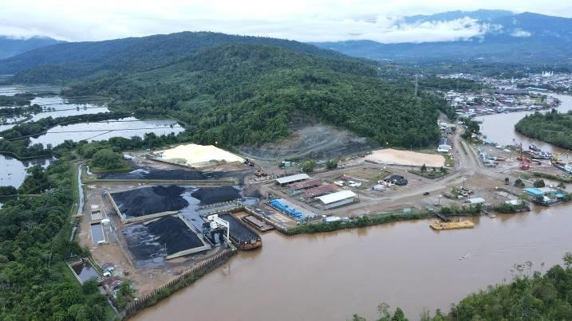

Location of Water Sampling A (July 15, 2022) Balantang Port. Location of sampling B (July 15, 2022)

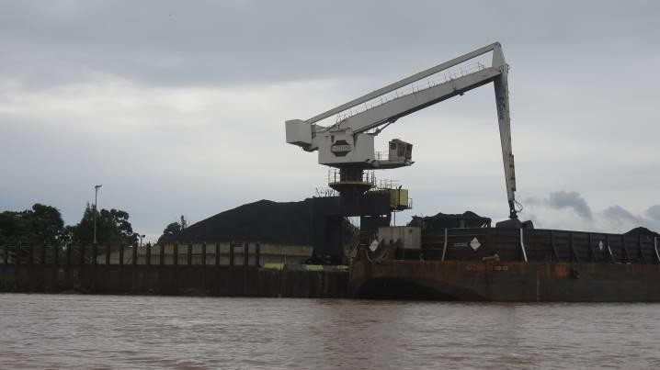
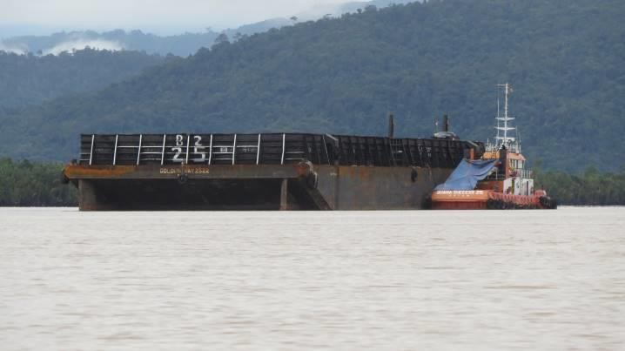

Coal for the smelters as fuel (July 15, 2022) Barge and a small boat for loading purpose (July 15, 2022)

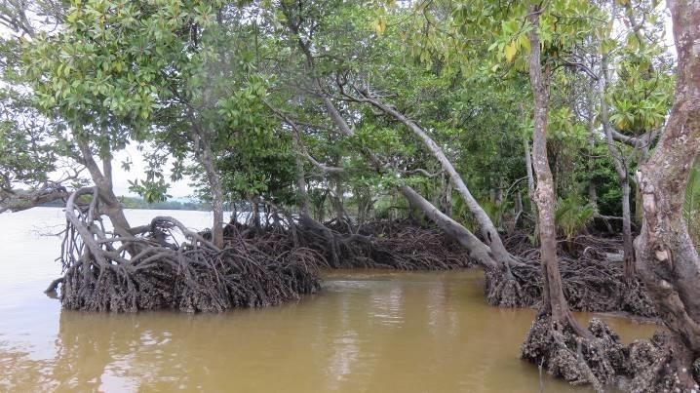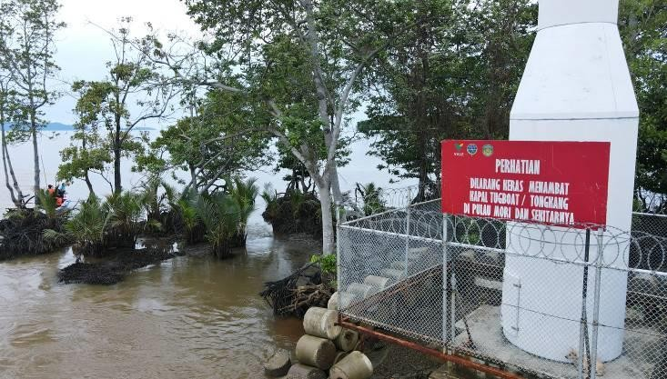

Mori Island where sulfur leakage was reported in August 2021. Location of Sampling C (July 15, 2022)
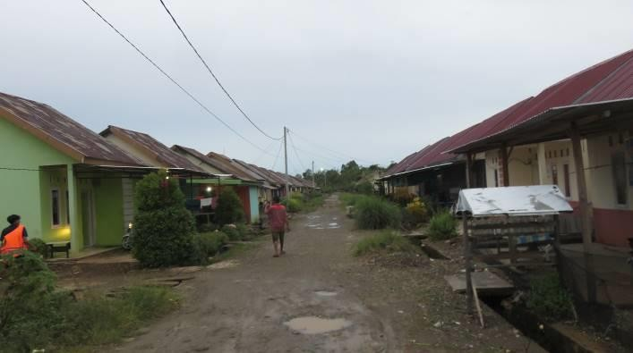
Housing program for fishermen’s family by the government at Desa Wewangriu, Kecamatan Malili. (July 15, 2022)
Caution by PTVI says “It is strictly forbidden to moor a tugboat / barge on the island of mori and its surroundings.” (July 15, 2022)

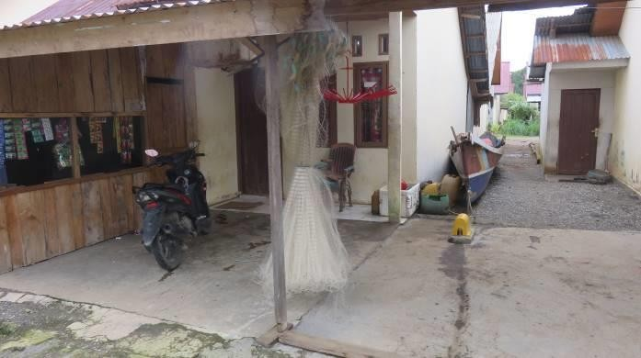
Desa Wewangriu, Kecamatan Malili. (July 15, 2022)

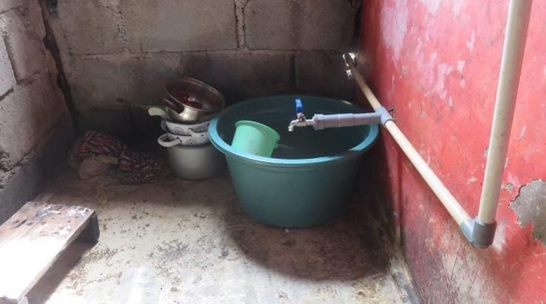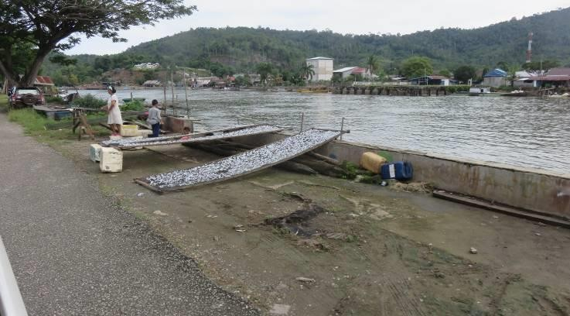

Desa Wewangriu, Kecamatan Malili. Location of sampling D (July 16, 2022)
Desa Wewangriu, Kecamatan Malili. (July 16, 2022)

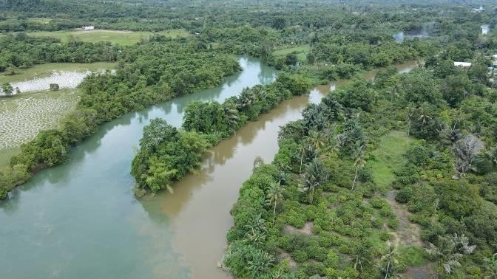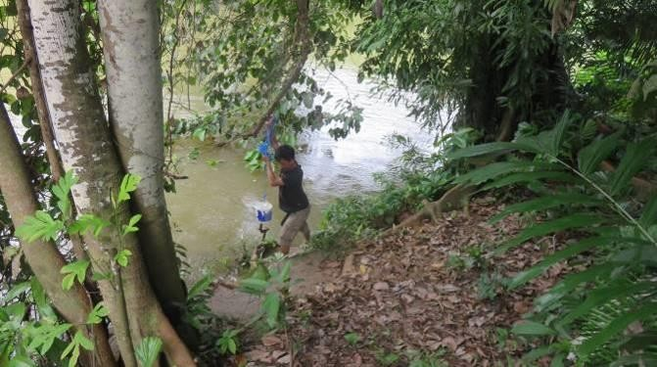

Merge point of Lalona River (left) and Pongkeru River (right) into Malili River (July 16, 2022)
Pongkeru Rivert. Location of sampling E (July 16, 2022)

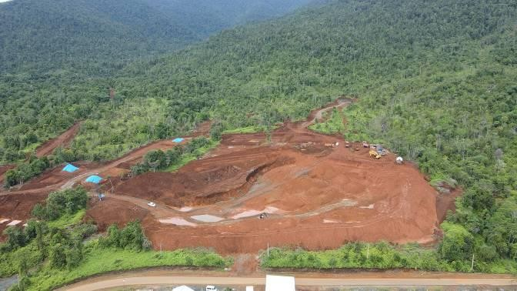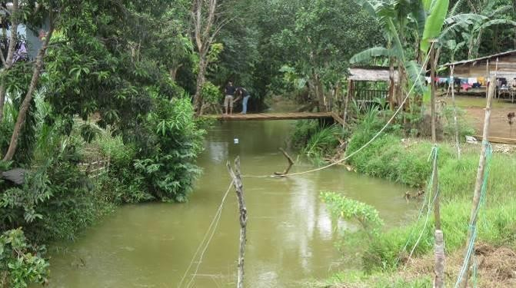

Siltation ponds for PT CLM. Location of sampling F (July 16, 2022)
Laoli River near the nickel mining site of PT CLM. Location of sampling G (July 16, 2022)

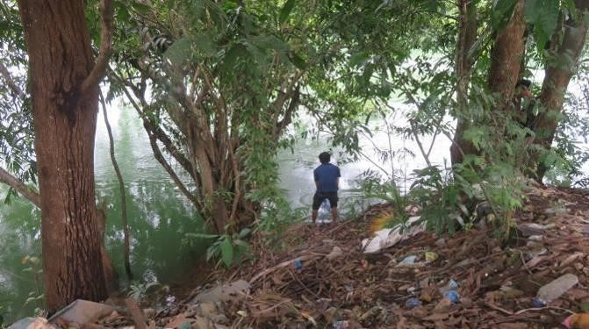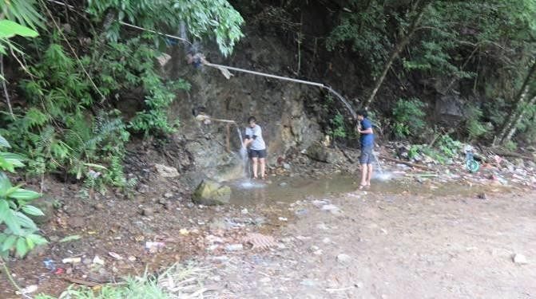
Lalona River. Location of sampling H (July 16, 2022) Spring water near PLTA 2. Location of sampling I (July
16, 2022)

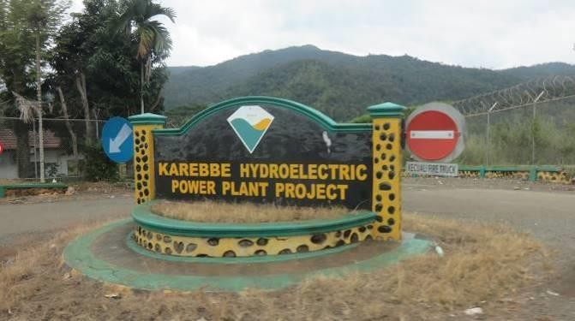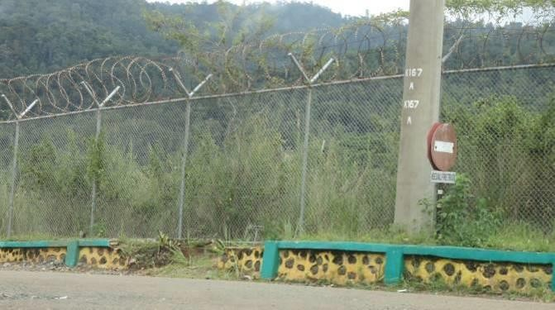
Entrance of PLTA 1 (July 16, 2022) PLTA’s area is surrounded by the fence as a concession area of PTVI (July 16, 2022)

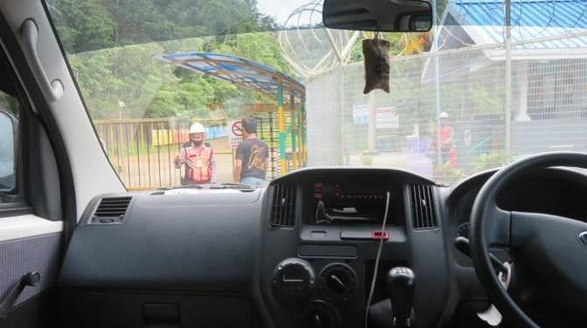
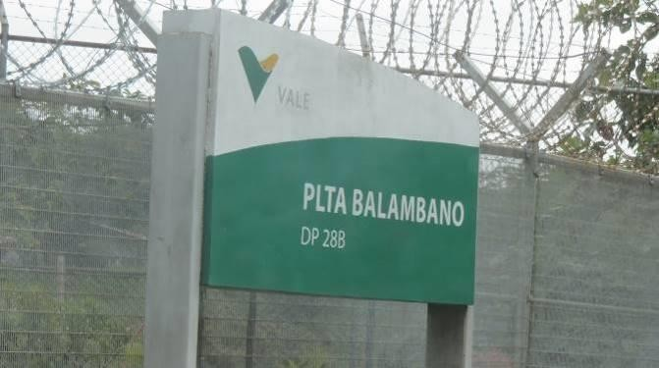

Entrance of PLTA 2. There are two private guard and a police (July 16, 2022)
Entrance of PLTA 2. (July 16, 2022)

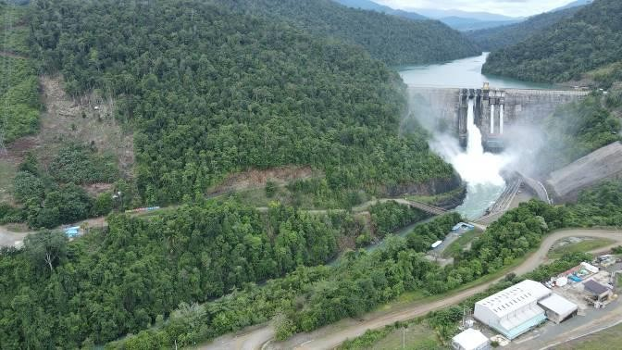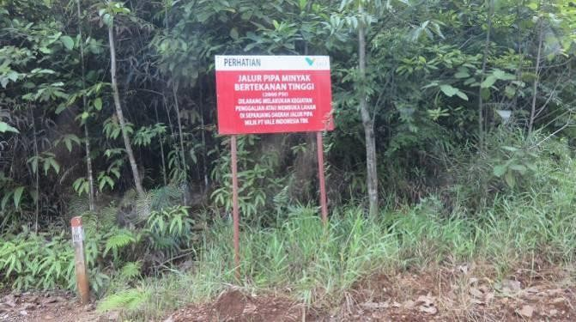
PLTA 2 (July 16, 2022) The pipeline comes from Lampia to Sorowako, and there are many sign boards; “Caution: High pressure oil pipeline (2000 PSI). It is prohibited to carry out excavation or clearing of land along the pipeline area belonging to PTVI” (July 16, 2022)

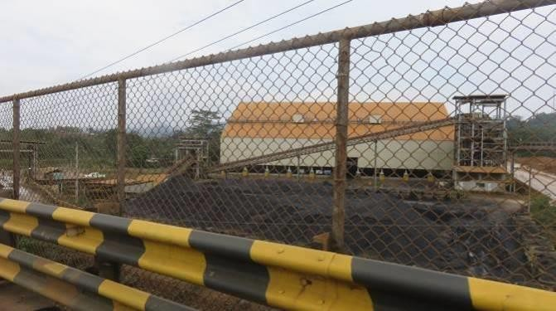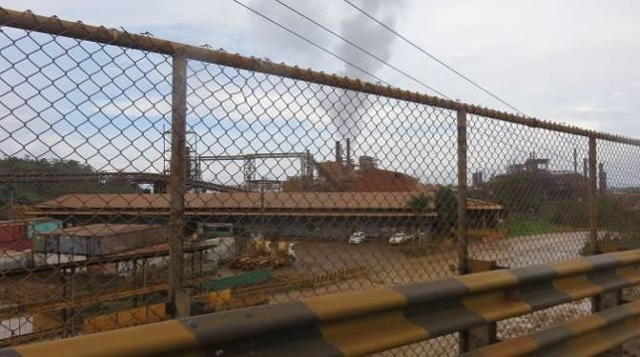
PTVI’s site and coal stockpile (July 17, 2022) PTVI’s site and smelters (July 17, 2022)

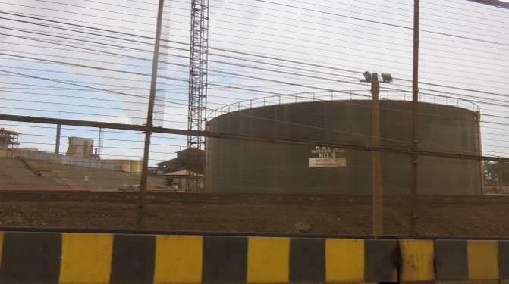
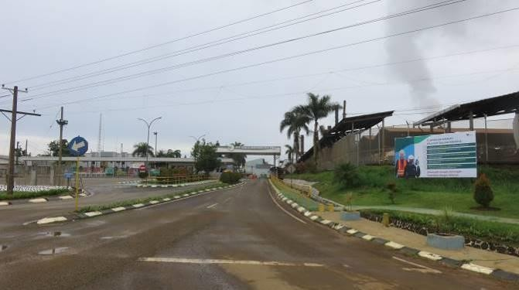
PTVI’s site (July 17, 2022) Entrance of PTVI site (July 17, 2022)

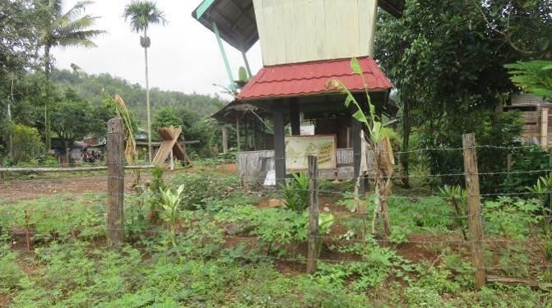
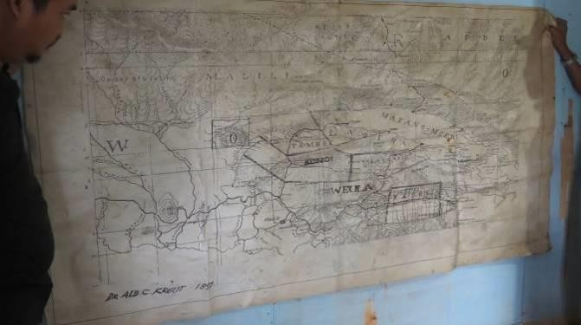

Entrance of Kampong Dongi, Kecamatan Nuha (July 17, 2022)
Old map left at Kampong Dongi by Mining Watch Canada around 2000s (July 17, 2022)

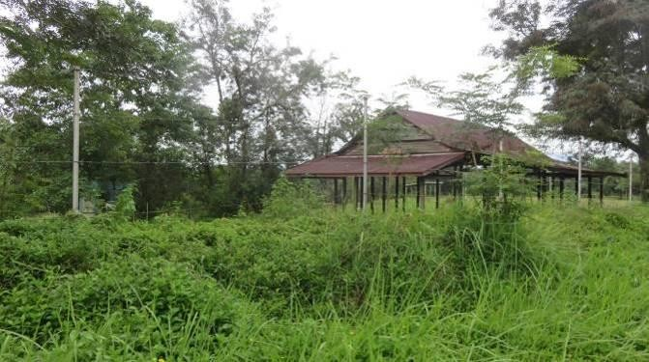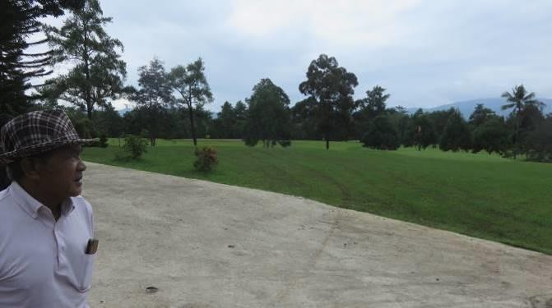

The fence was put up 2021 by PTVI surrounded Kampong Dongi, which is one of the harassments against Dongi people. (July 17, 2022)
Gold playground. It is used to be the house settlement area for Dongi People. (July 17, 2022)

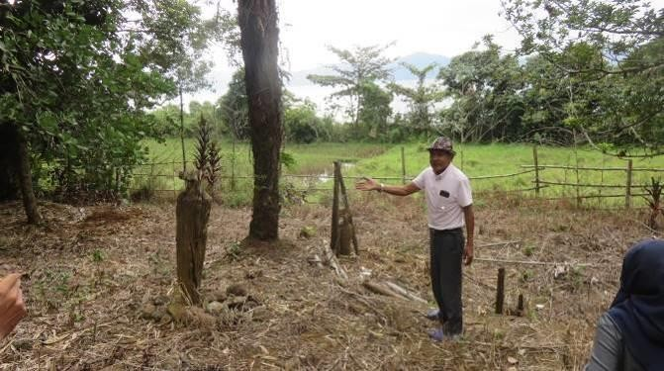
The 18th century’s grave for Dongi people located inside the settlement area for PTVI’s employees. (July 17, 2022)
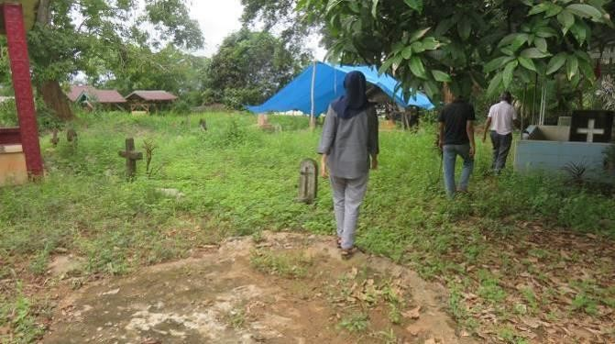
The 19th century’s grave for Dongi people located inside the settlement area for PTVI’s employees. (July 17, 2022)

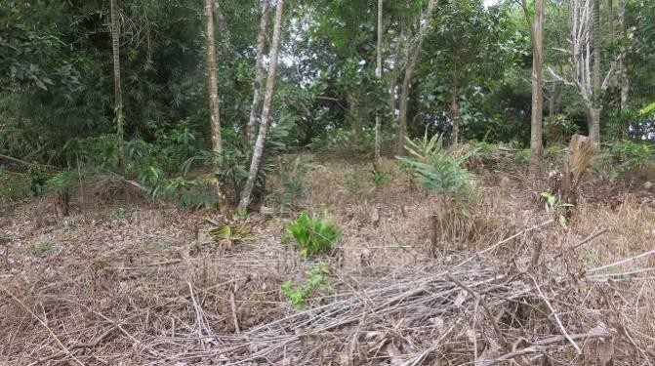
The 18th century’s grave for Dongi people located inside the settlement area for PTVI’s employees. (July 17, 2022)
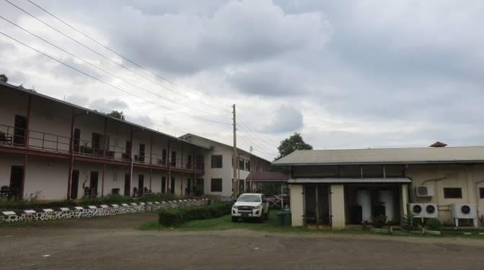
The settlement area for PTVI’s employees. (July 17, 2022)

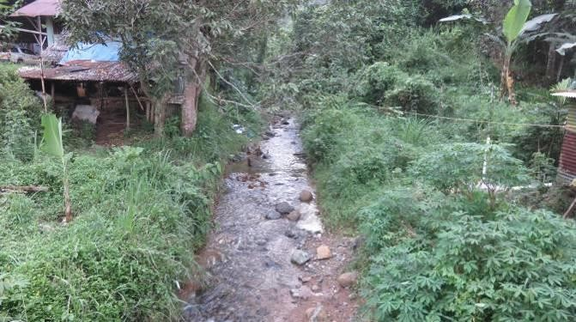
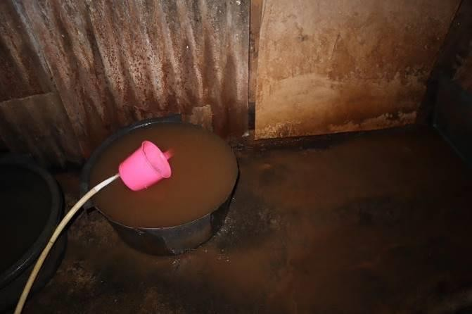
River whose color turns into reddish when it rains in
Kampong Dongi. Location of sampling L (July 17, 2022) Kampong Dongi’s domestic water from the reservoir.
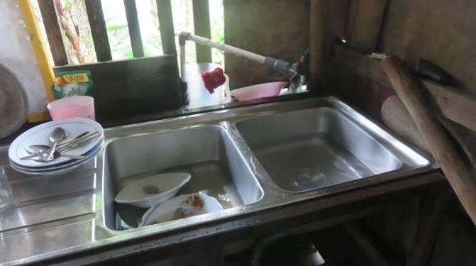
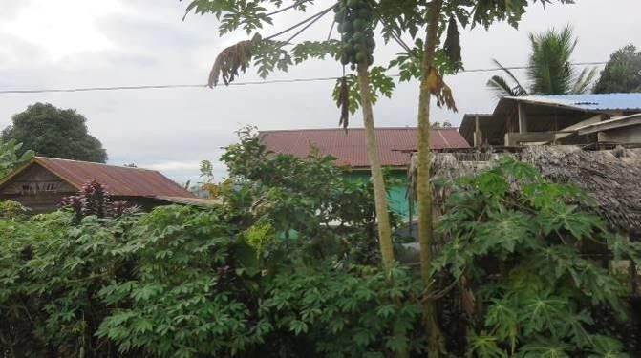
The color turned into reddish after raining at night. Location of sampling U (July 17, 2022)

Domestic/drinking water for the family of Desa Tabarano, Kecamatan Wasuponda. Location of sampling N (July 18, 2022)
Desa Tole, Kecamatan Towuti. The community reports that the zinc roof seems to get rusty faster than usual, and they need to change it every 3 years. (July 19, 2022)

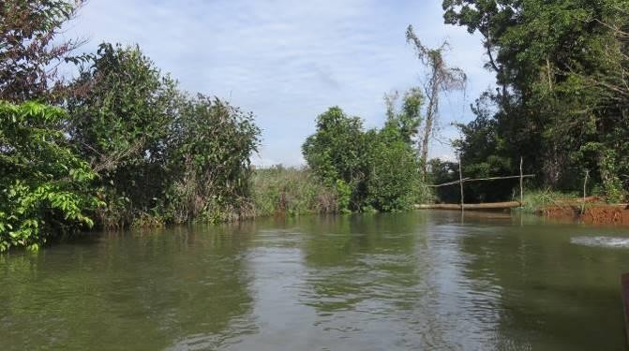
Koloa River flowing into Mahalona Lake. Location of sampling R and S (July 19, 2022)

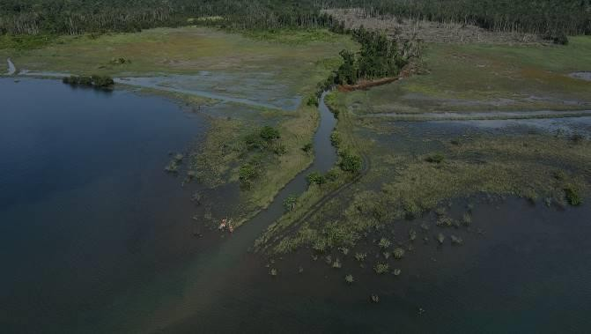
Koloa River flowing into Mahalona Lake. Location of sampling Q, R and S (July 19, 2022)

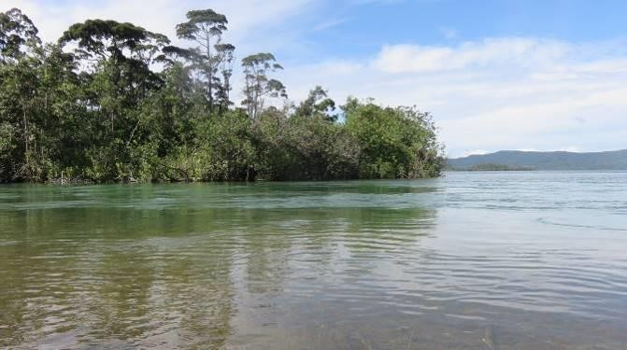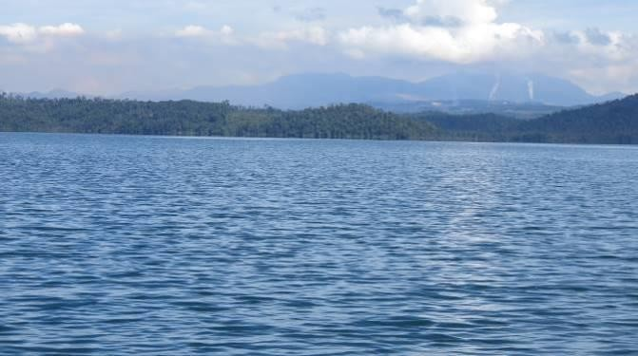

Timbalo River flowing into Mahalona Lake. Location of sampling T (July 19, 2022)
PTVI’s smelters and project site view from Mahalona Lake (July 19, 2022)

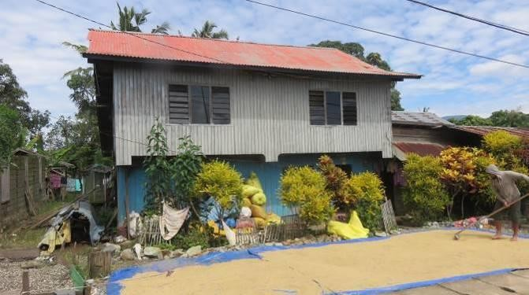
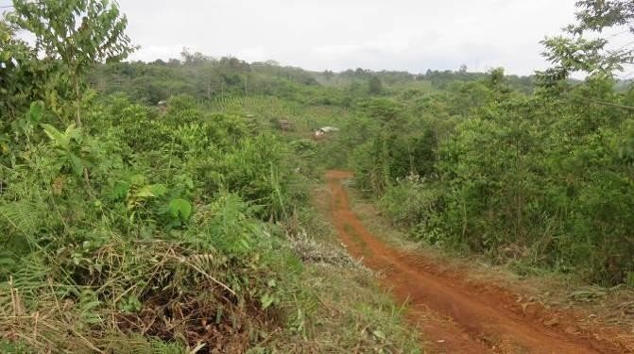

Rice harvest drying on the street, Kecamatan Towuti (July 19, 2022)

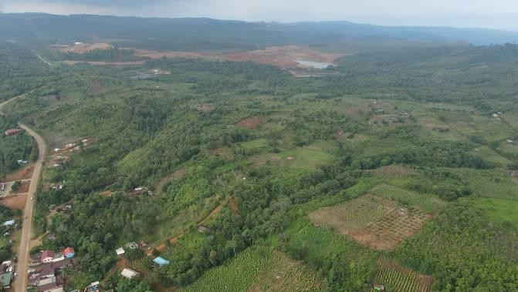
White papper field which hasn’t yet been paid by PTVI while it is inside the concession at Desa Asuli, Kecamatan Towuti (July 19, 2022)
White papper field which hasn’t yet been paid by PTVI while it is inside the concession at Desa Asuli, Kecamatan Towuti (July 19, 2022)
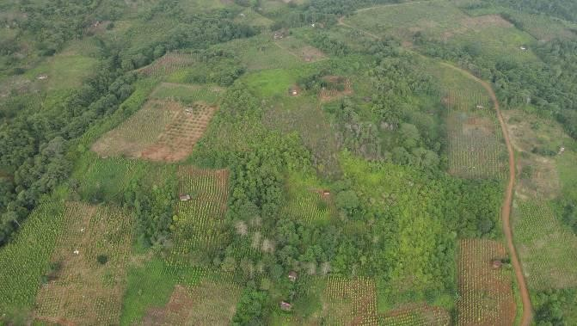
White papper field which hasn’t yet been paid by PTVI while it is inside the concession at Desa Asuli, Kecamatan Towuti (July 19, 2022)

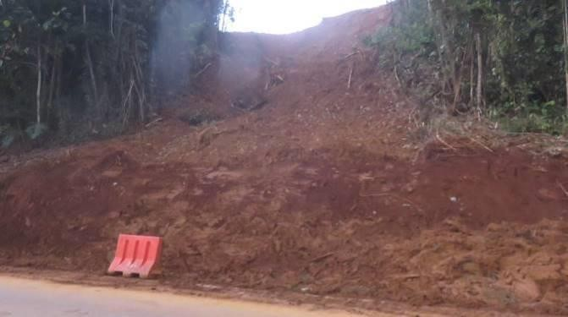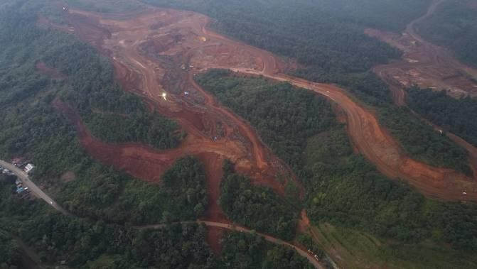

The erosion happened in earlier week of July due to the operation of PTVI nickel mining. (July 19, 2022)
The erosion happened in earlier week of July due to the operation of PTVI nickel mining. (July 19, 2022)

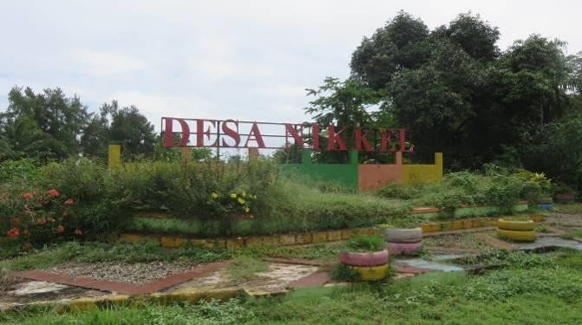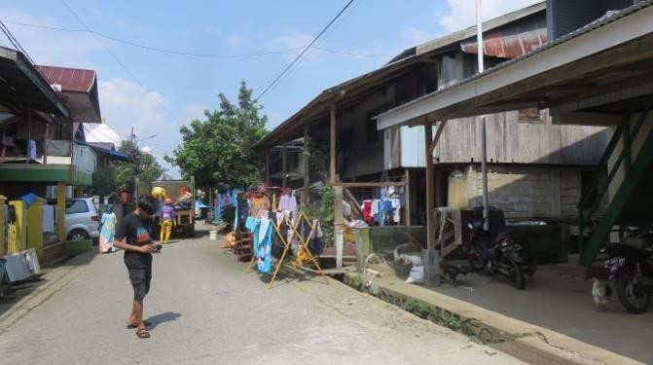
Sign of Desa Nikkel (July 17, 2022) Desa Nikkel (July 20, 2022)

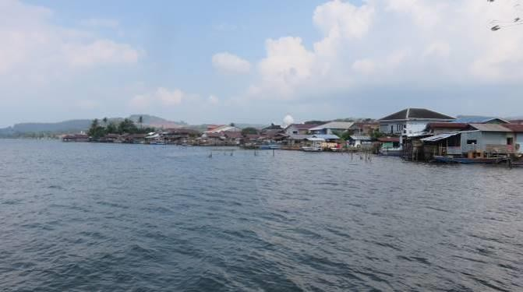
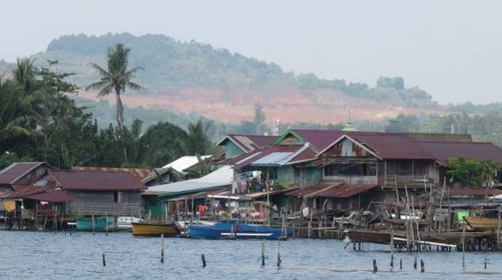
Along Matano lake, Desa Nikkel (July 20, 2022) PTVI’s mining site can be seen along Matano Lake, Desa
Nikkel (July 20, 2022)

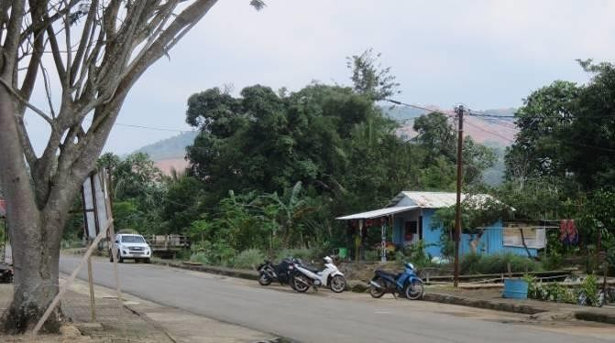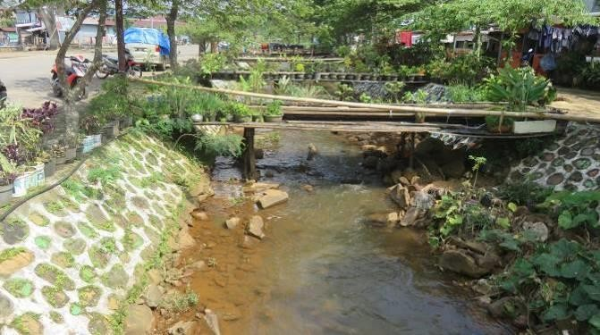

PTVI’s mining site can be seen along Matano Lake, Desa Nikkel (July 20, 2022)

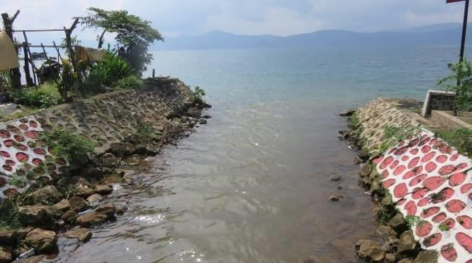
Tapulemo River coming from the PTVI’s mining site. The river color turns reddish when it rains. Location of sampling V (July 20, 2022)

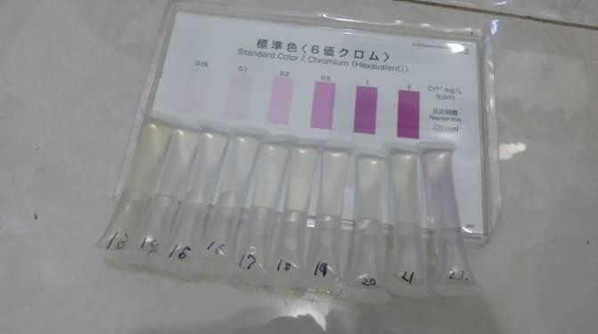
The results of examinations by simple detector tube for hexavalent chromium: All the water sampling M to U was no reaction [no detection], while the right one (Sample V) was 0.75 mg/L. (July 20, 2022)
Tapulemo River coming from the PTVI’s mining site. The river color turns reddish when it rains. Location of sampling V (July 20, 2022)
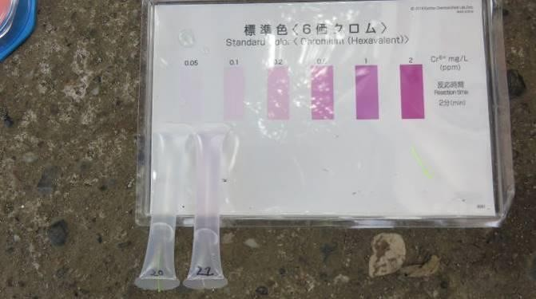
The results of examinations by simple detector tube for hexavalent chromium: The left was water sampling point T [no detection] and the right was sampling point V [0.75 mg/L]. (July 20, 2022)

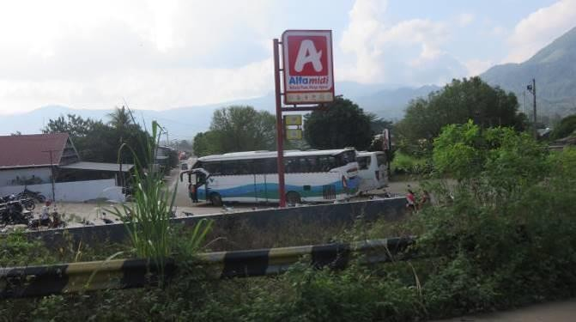
PTVI’s and its sub-contractors’ buses pick up the workers point by point. The photo location is at Kecamatan Wasuponda. (July 20, 2022)

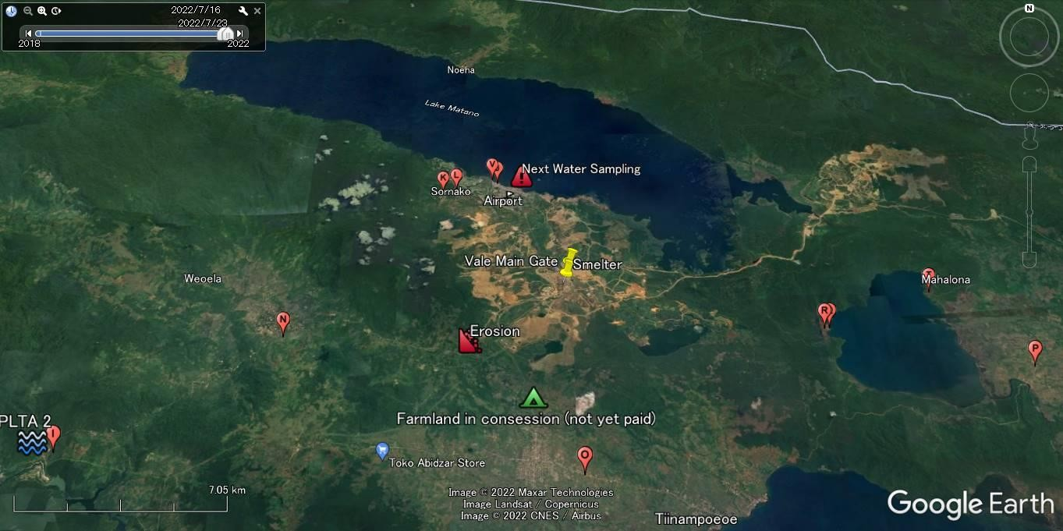
Tapulemo River

(Map) The Sorowako Nickel Smelters, Nickel mining sites, the Tapulemo River, and Water Sampling points (July 15 to 20, 2022)

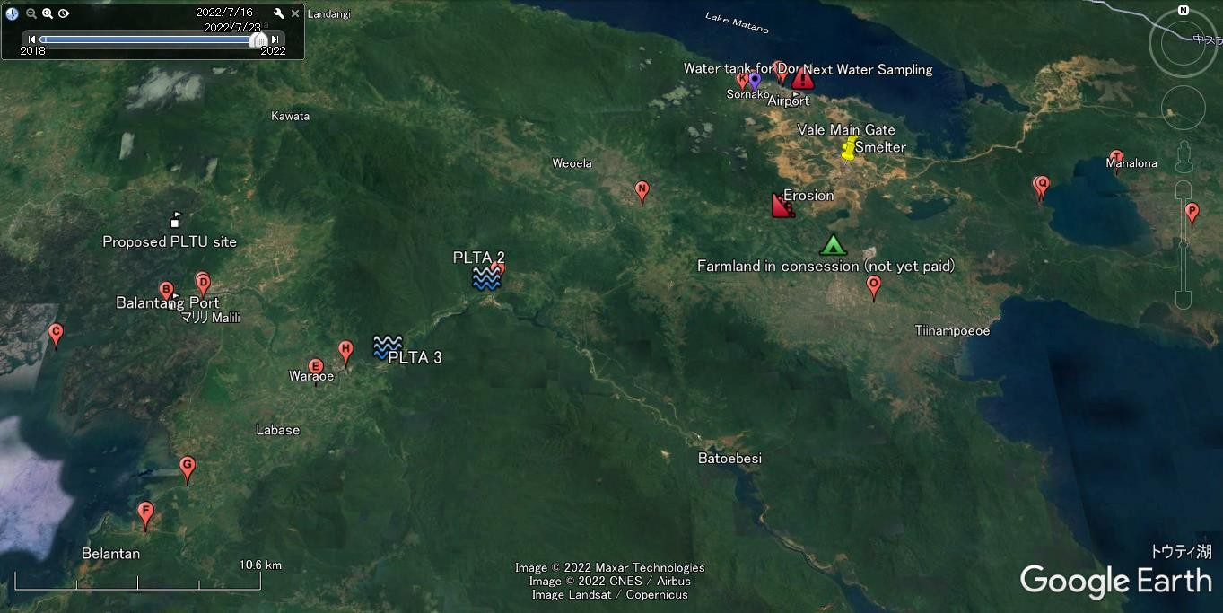

(Map) The Sorowako Nickel Smelters, Nickel mining sites, the Malili River, and Water Sampling points (July 15 to 20, 2022)

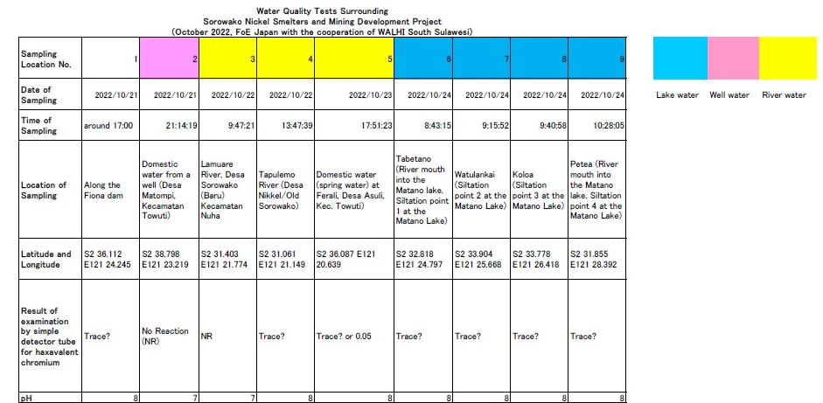

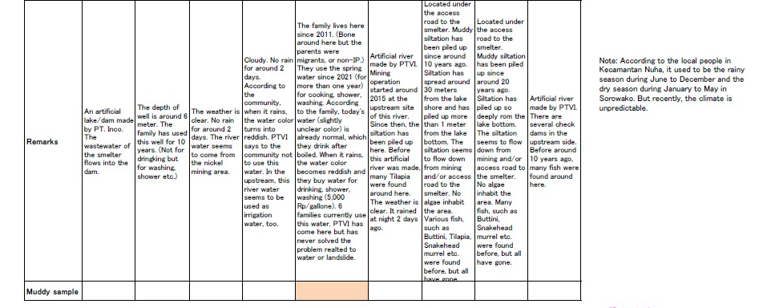

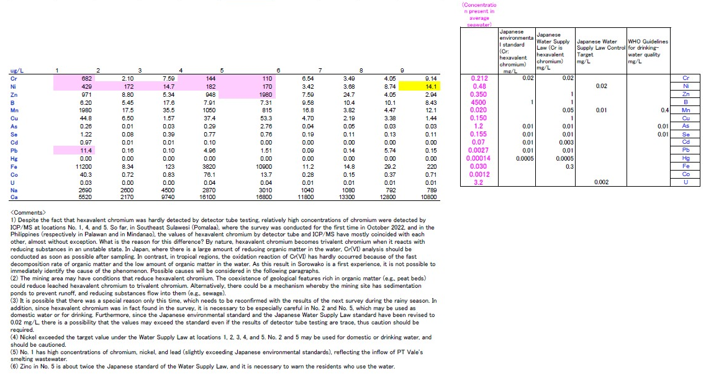

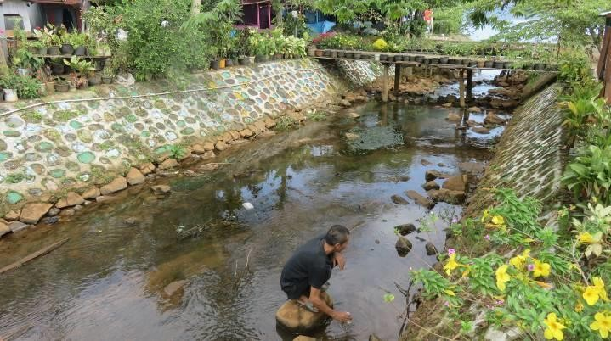
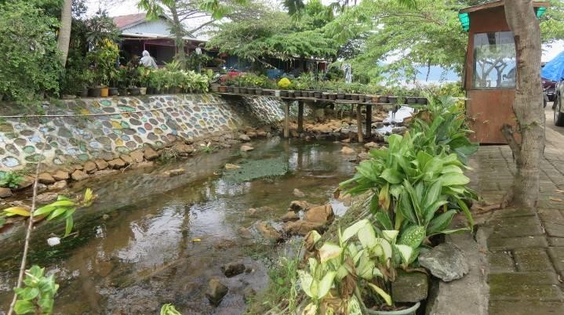
Water Quality Tests Surrounding Sorowako Nickel Smelters and Mining Development Project in Indonesia

Sampling point No. 1 – Lawewu River near the Lake Matano. (January 10, 2023)
Sampling point No. 11 – Lawewu River near the Lake Matano. (January 11, 2023)

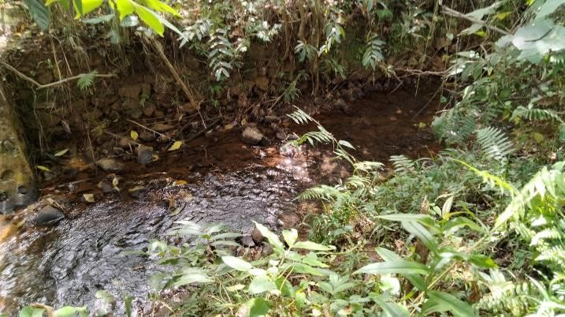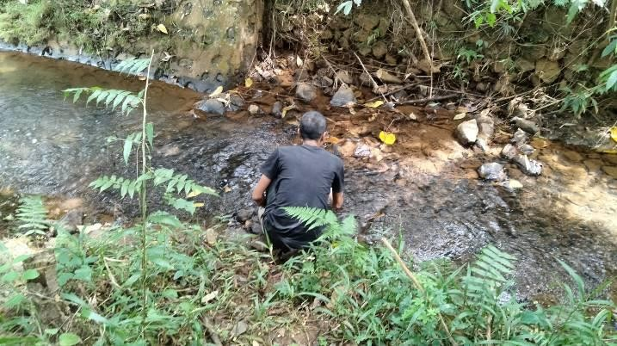

Sampling point No. 2 – Lawewu River near the road (January 10, 2023)
Sampling point No. 10 – Lawewu River near the road (January 11, 2023)

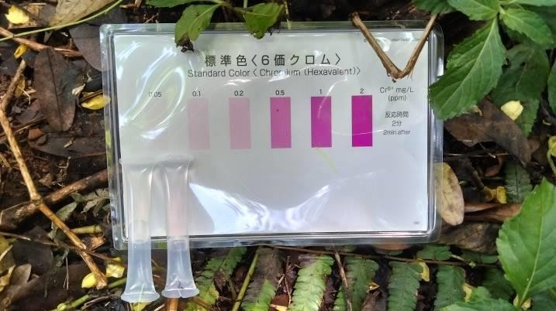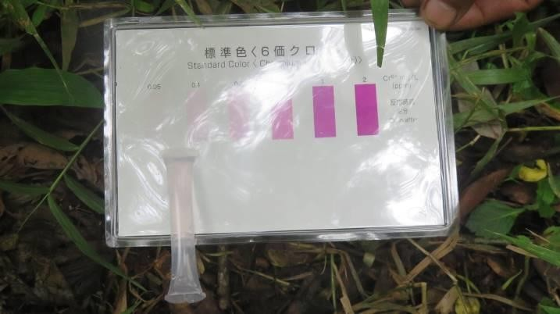

Results of simple hexavalent chromium detector tube tests (From the left, sample No. 1 and 2) (January 10, 2023)
Results of simple hexavalent chromium detector tube tests (Sample No. 10) (January 11, 2023)

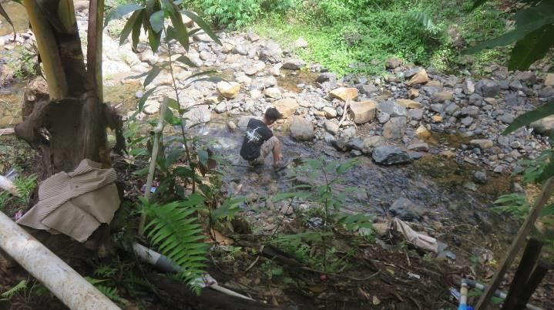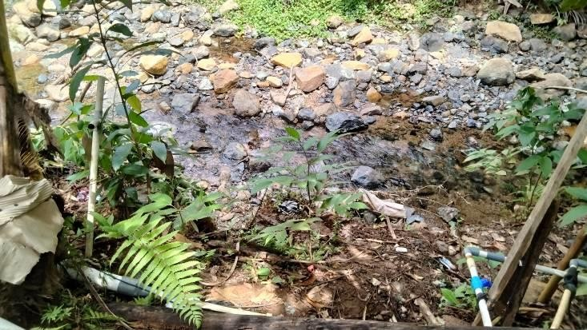

Sampling point No. 3 – Tapulemo River in Kampong Dongi using for domestic water. (January 10, 2023)
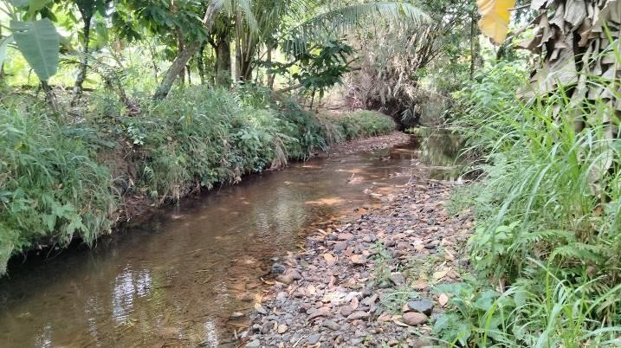

Sampling point No. 4 – Tapulemo River near the Lake Matano. (January 10, 2023)
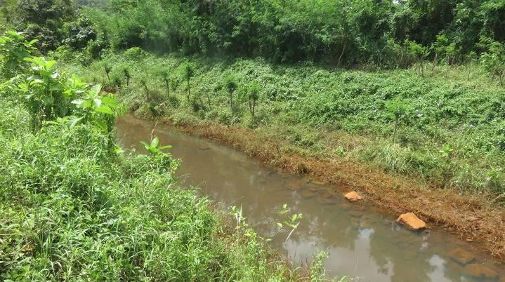

Sampling point No. 5 – Lamuare River near the road (January 10, 2023)
Sampling point No. 9 – Tapulemo River in Kampong Dongi using for domestic water (January 11, 2023)
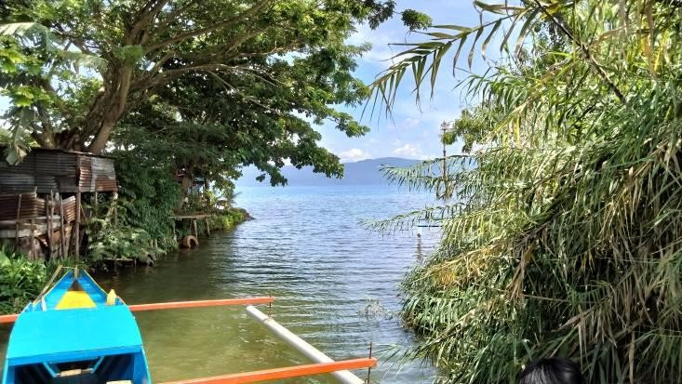
Sampling point No. 6 – Lamuare River near the Lake Matano. (January 10, 2023)
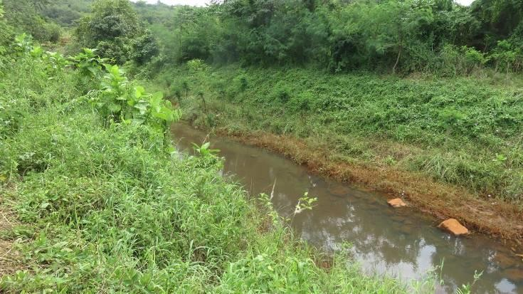
Sampling point No. 12 – Lamuare River near the road (January 11, 2023)

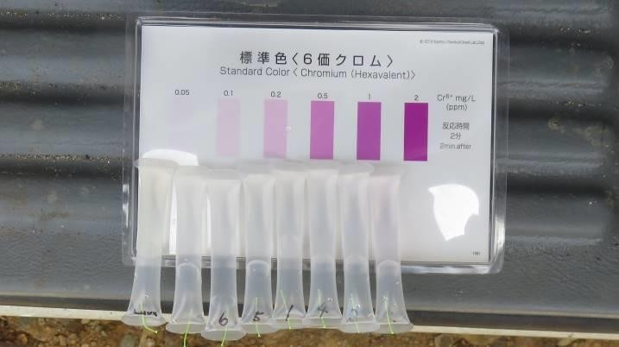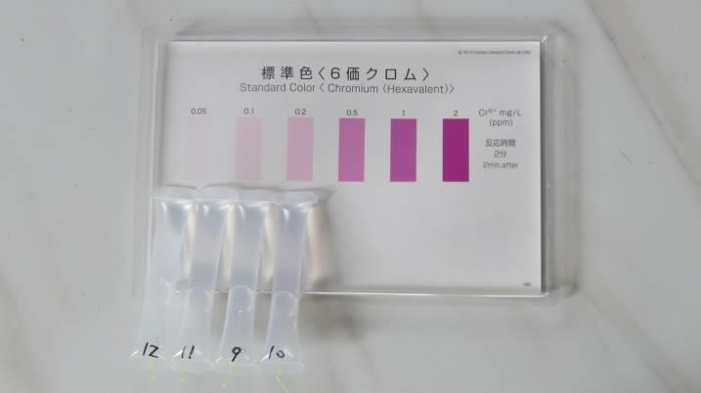

Results of simple hexavalent chromium detector tube tests (From the right, sample No. 2, 3, 4, 1, 5, and 6) (January 10, 2023) *the two samples in the left side were not taken in Sorowako area.

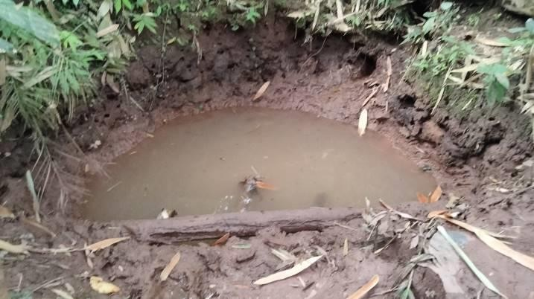

Sampling point No. 7 – Spring water source for the domestic use of 20 families (January 10, 2023)
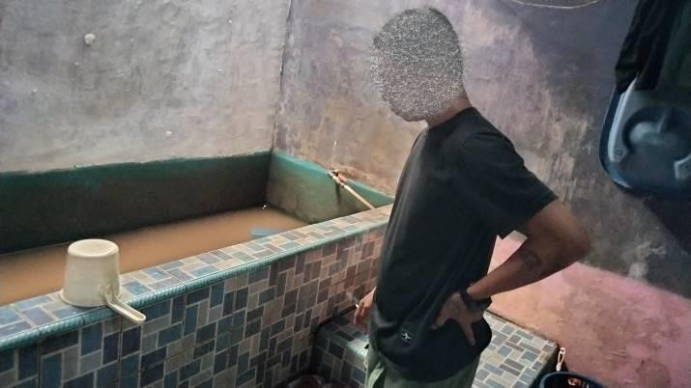

The families save little by little the spring water (Sampling point 7 and 8) for domestic use. (January 10, 2023)
Results of simple hexavalent chromium detector tube tests (From the left, sample No. 12, 11, 9, and 10) (January 11,
2023)

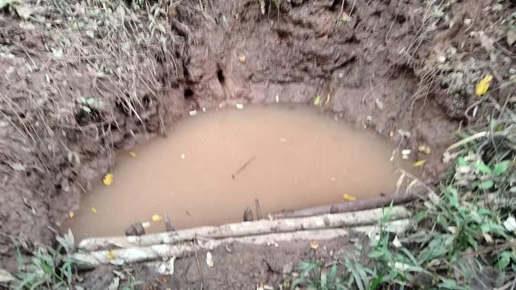
Sampling point No. 8 – Spring water source for domestic use of 6 families (January 10, 2023)
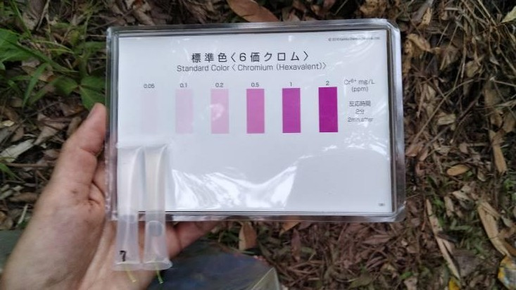
Results of simple hexavalent chromium detector tube tests (From the left, sample No. 7 and 8) (January 10, 2023)

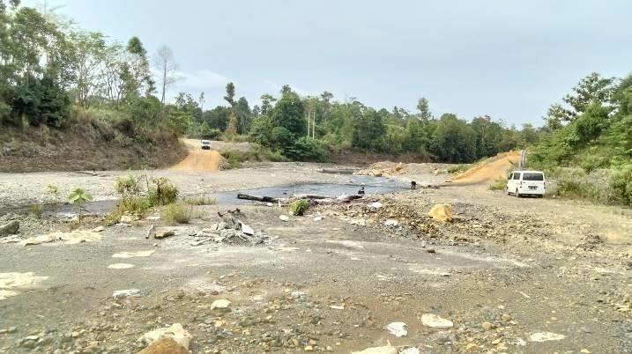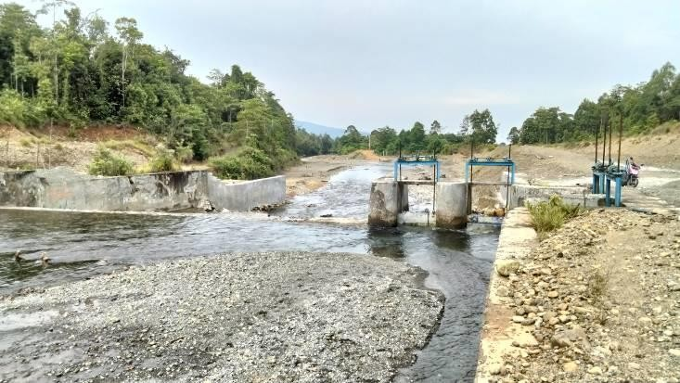

Sampling point No. 13 – Mahalona River (January 14, 2023) Irrigation facility prepared by the government agency at
Mahalona River (January 14, 2023)
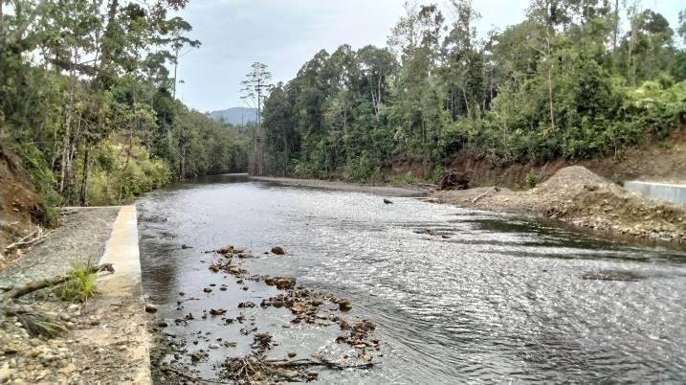
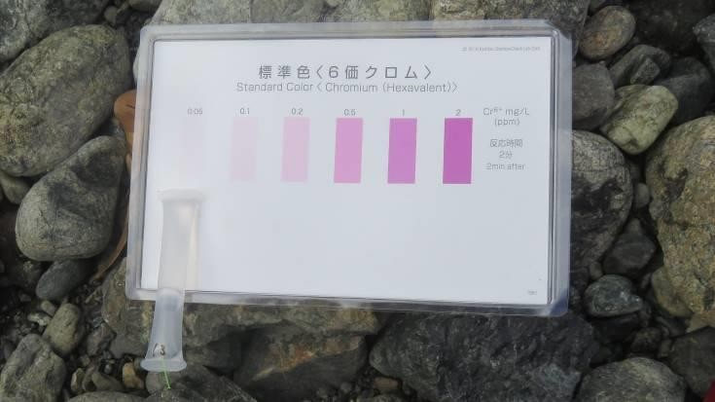

The view of upstream side from the irrigation facility at Matalona River (January 14, 2023)
Results of simple hexavalent chromium detector tube tests (Sample No. 13) (January 14, 2023)

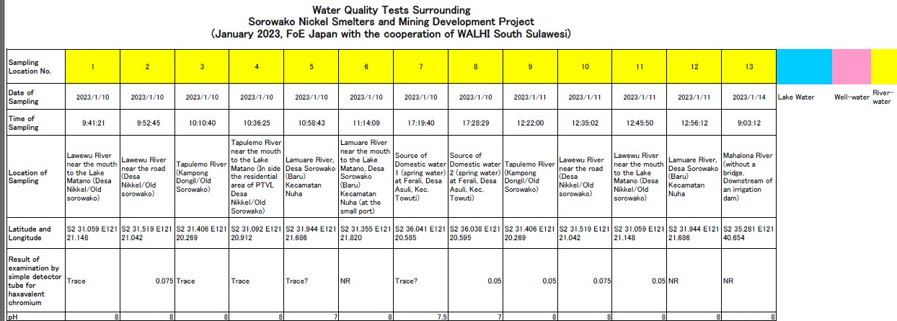

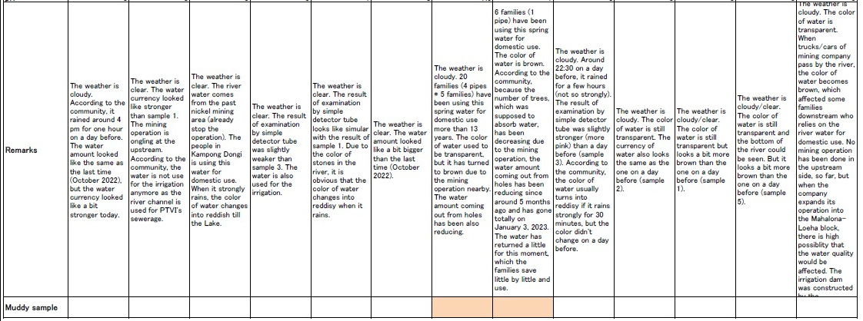

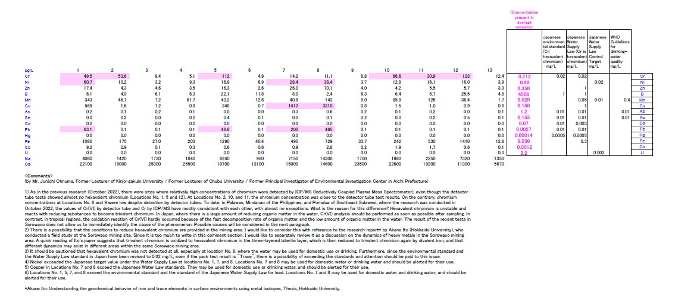

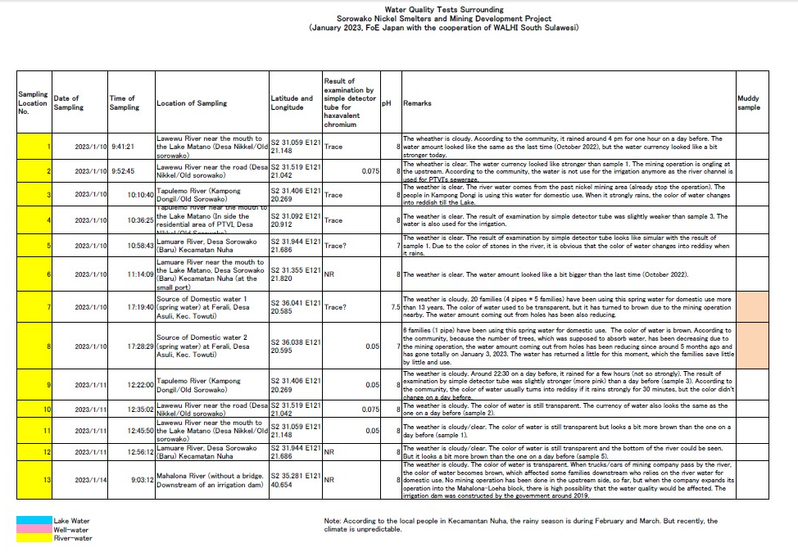
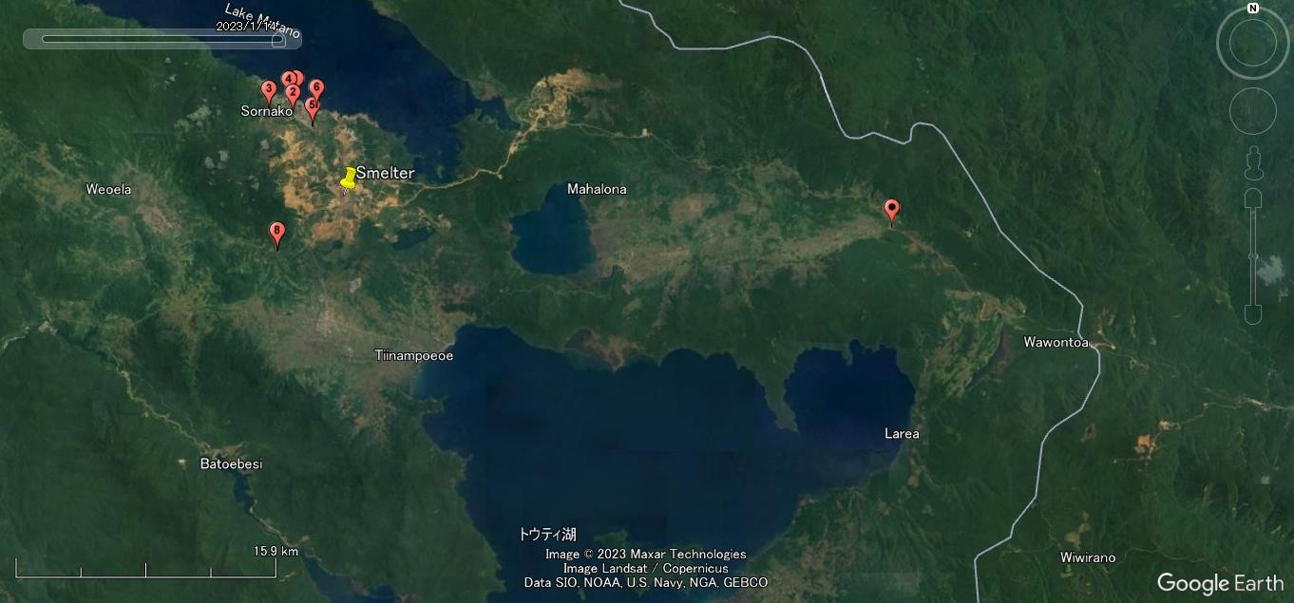
13
Lawewu River
Mahalona River

(Map) The Sorowako Nickel Smelters, Nickel mining sites, the Lawewu River, the Mahalona River, and Water Sampling points (January 10, 11 and 14, 2023)
Note: Sampling points 1/11, 2/10, 3/9, and 5/12 are the same points. Sampling point 8 is located at 20 meters north-eastern part of Sampling point 7.

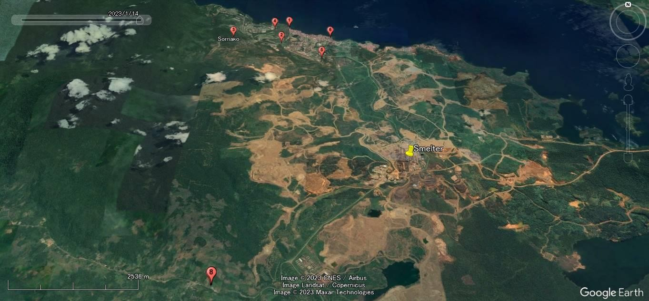
Lawewu River
(Map) The Sorowako Nickel Smelters, Nickel mining sites, the Lawewu River and Water Sampling points (January 10, 11 and 14, 2023)
Note: Sampling points 1/11, 2/10, 3/9, and 5/12 are the same points. Sampling point 8 is located at 20 meters north-eastern part of Sampling point 7.

