WALHI South Sulawesi
JL. Aroepala, Kompleks Permata Hijau Lestari Blok Q1, No.8,
Rappocini, Kota Makassar, Sulawesi Selatan 90221
muhammad.al.amien@gmail.com / walhisulsel@gmail.com
+62-8229-3939-591
Executive Director
Muhammad Al Amin

Subject: Inputs on Increasing Heavy Metal Toxic Pollution in Rivers and Community Water Sources Due to PT Vale Indonesia's Nickel Mining and Smelters in the Context of Higher Demand of Battery Material

March 5, 2023

Dear Dr. Marcos Orellana,
United Nations Special Rapporteur on toxics and human rights

We, WALHI South Sulawesi and Southeast Sulawesi, environmental and human rights organizations, in Indonesia, together with Friends of the Earth (FoE) Japan, would like to provide inputs on toxic pollution (hexavalent chromium in particular) already caused and to be exacerbated in rivers and community-used water by nickel mining and smelters of PT Vale Indonesia (PTVI). Hexavalent chromium, which is a known carcinogen and also causes liver and skin damages, has been found with high concentration surrounding the nickel projects of PTVI. Thus, we, working with local communities, including indigenous peoples, farmers, fisherfolk, youth, workers, and women in PTVI’s concession area in Sulawesi, call on the project proponents and relevant states to provide social justice, uphold human rights, especially women and children’s, and protect environmental rights.

1. Supply Chain of Nickel from PTVI for Battery
(1) Sorowako, East Luwu Regency, South Sulawesi
PTVI mines laterite nickel ore (within the concession area of 70,566 hectares in East Luwu) and processes it into nickel in matte (the average volume of production per year is 75,000 tons). The entire product is exported to Japan, among those 20 % to Sumitomo Metal Mining (SMM). SMM's nickel refinery in Japan, produces electrolytic nickel as well as nickel sulfate, which is used in battery materials. The battery materials are supplied to Toyota Motor Corporation's battery subsidiary, Primearth EV Energy, as well as to electric vehicle giant Tesla Inc. through Panasonic Holdings Corporation.
In addition, there is a plan to develop a new High-Pressure Acid Leach (HPAL) plant in Sorowako to produce around 60,000 tons of nickel in Mixed Hydroxide Precipitate (MHP) to be used for batteries.
(2) Pomalaa, Kolaka Regency, Southeast Sulawesi
PTVI’s concession area covers 20,286 hectares in Pomalaa, where a massive mining operation is expected to start as a new HPAL plant is under construction to produce up to 120,000 tons of nickel in MHP per year. Ford Motor Company has joined the project since July 2022.
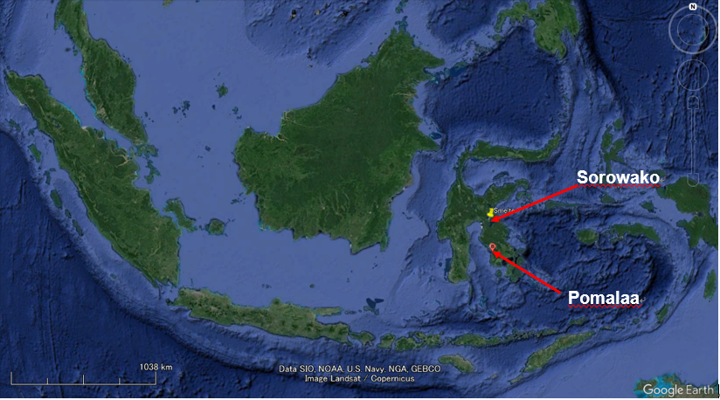

2. Toxic Pollution Caused/to be Exacerbated Surrounding the Nickel Projects of PTVI and its Impacts on Communities
Hexavalent chromium Cr(VI) is known as a toxic and carcinogenic heavy metal, and international and national water quality standards for hexavalent or total chromium have been established;
- Guidelines for drinking-water quality by World Health Organization (WHO)
- Guideline value of total chromium: 0.05 mg/L
- Water quality standards for rivers / lakes etc. by the Indonesian government
- Standard value of Cr(VI) for drinking water: 0.05 mg/L
- Standard value of Cr(VI) for irrigation water and freshwater fish pond cultivation: 0.05 mg/L
- Environmental quality standards for human health and Drinking water quality standards by the Japanese government
- Standard value of Cr(VI): 0.02 mg/L
In the communities surrounding the nickel projects of PTVI, we have documented levels of Cr(VI) exceeding the above-mentioned water standards as described below.

(1) Sorowako, East Luwu Regency, South Sulawesi
We conducted water quality testing in July and October 2022, and in January 2023 in Sorowako. Hexavalent or total chromium exceeding the above-mentioned water standards was found in the Lawewu River, Nickel Village (Old Sorowako), Nuha District (0.031–0.144 mg/L) and in community water source in Asuli Village, Towuti District (0.110 mg/L). This heavy metal pollution is caused by nickel mining activities in PTVI’s concession area.

Community water sources in Asuli Village
In 2017, PTVI started to expand its mining operation into the area right above the community water source, or spring water source, as well as their residential houses. Since then, the color of spring water has been changed to brownish and the amount of water coming out has not been stable. In addition, Cr(VI) exceeding the WHO standards was found when we conducted water testing in October 2022.
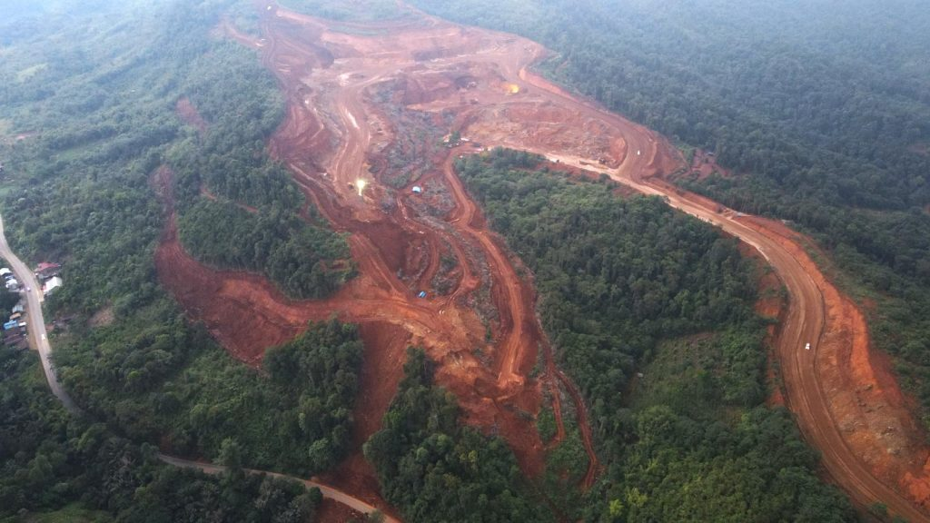  PTVI’s mining operation expanded into the area right above the community water source and their residential houses in Asuli village. (Photo: July 2022) | 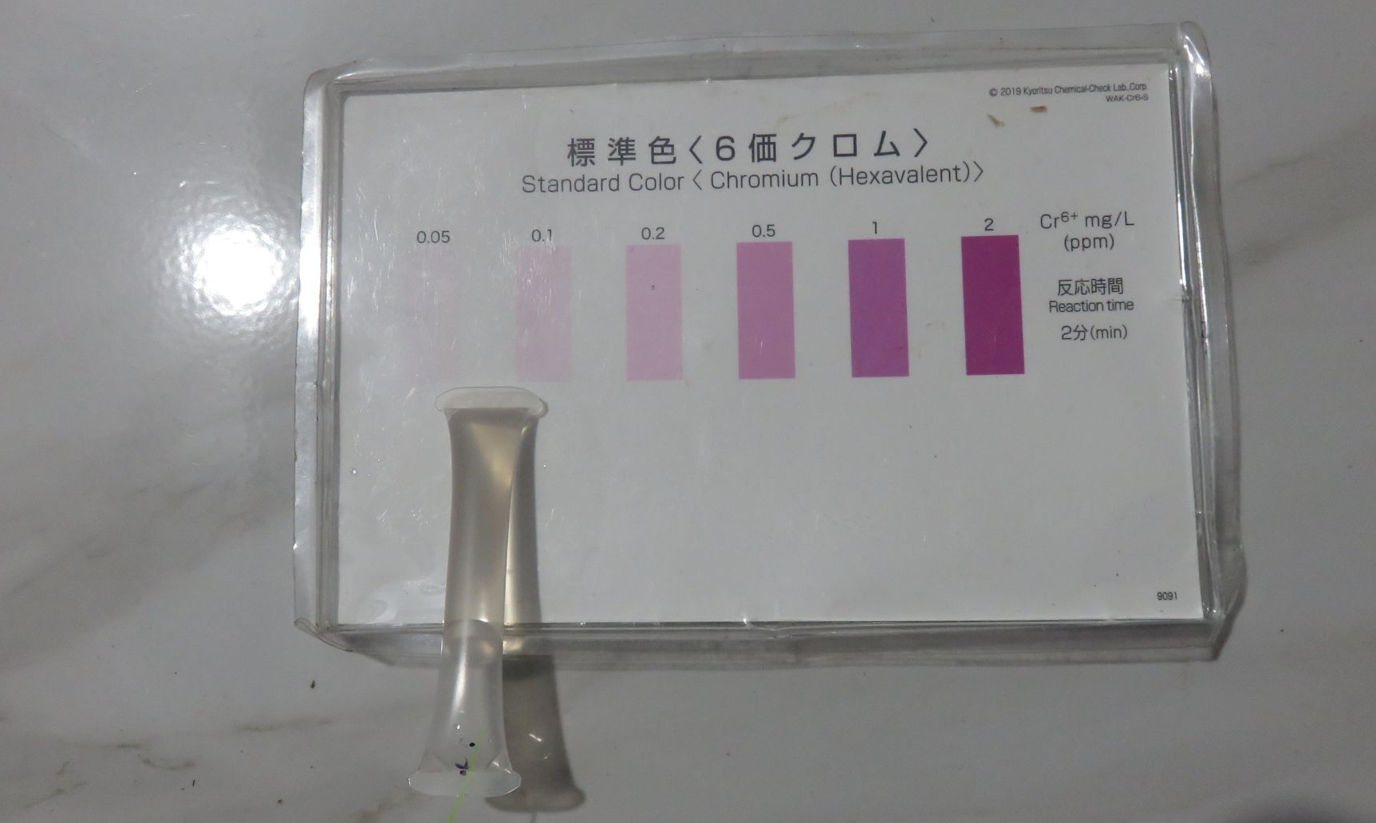  Results of simple Cr(VI) detector tube test on the community water in Asuli village (0.05 mg/L) (Photo: October 23, 2022)
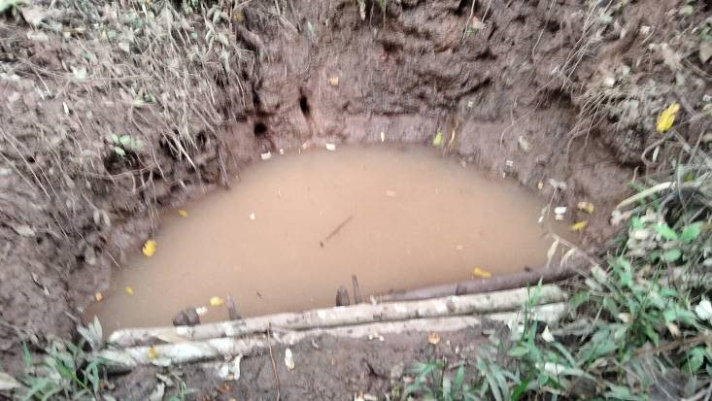  One of the community water sources (used by 20 families) affected by PTVI’s mining operation in Asuli village. (Photo: January 10, 2023) | 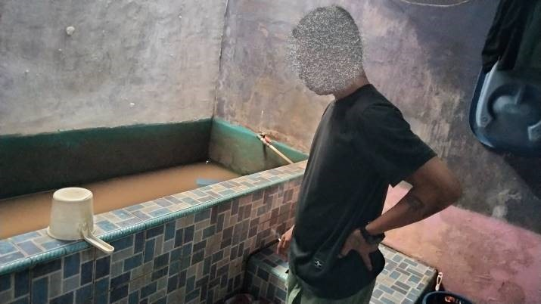  The families in Asuli village are saving the contaminated spring water little by little for domestic use due to no other water source. (January 10, 2023)

Regardless of the weather, the community's water source in Asli village remains murky. Especially during the rainy season, the people have to use very turbid water for bathing, and consume water that contains dangerous levels of heavy metals, such as Cr(VI) and nickel.
Women and children are the group most vulnerable and most affected by pollution resulting from PTVI's nickel mining activities. Women in Asuli Village are the most dominant group consuming water. This means that women in the village are the first and the biggest group to receive health risks due to consuming water contaminated with high concentration levels of heavy metals from nickel mining activities. The second is children, especially toddlers. The community water contaminated by Cr(VI) are naturally consumed by children and toddlers, and this condition disrupts toddlers and children’s growth and development.
In addition, it should not be overlooked that the freedom of expression of communities demanding clean and safe water is being suppressed. In early February 2023, the community in Asuli village made protest actions and called on PTVI to immediately take its responsibility for their life, including water access. However, the community had to stop their protest due to the intervention or intimidation by local authorities, such as police and intelligence who summoned a community leader and told him to stop their protest.

Lawewu River, Nickel Village (Old Sorowako)
In the upstream of the Lawewu River, the operation of nickel mining by PTVI is ongoing. And the Lawewu River flows into Lake Matano which has the status of a conservation area or highly protected ecosystem area, according to the decision letter of agrarian minister No. 274/Kpts/Um/4/1979 on April 24, 1979.

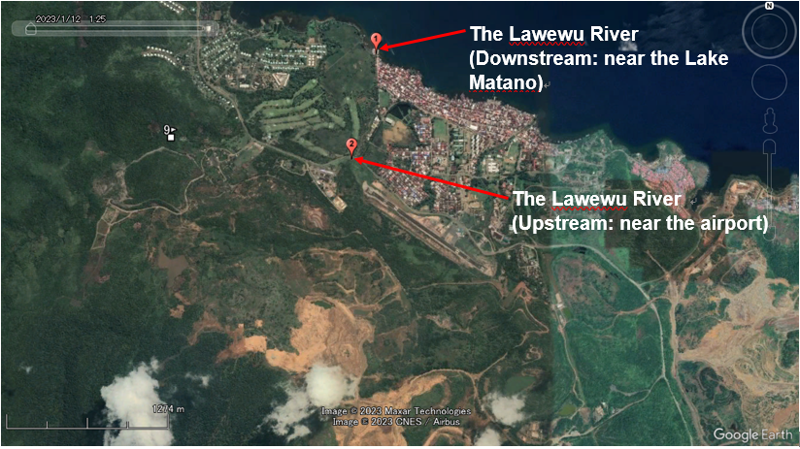
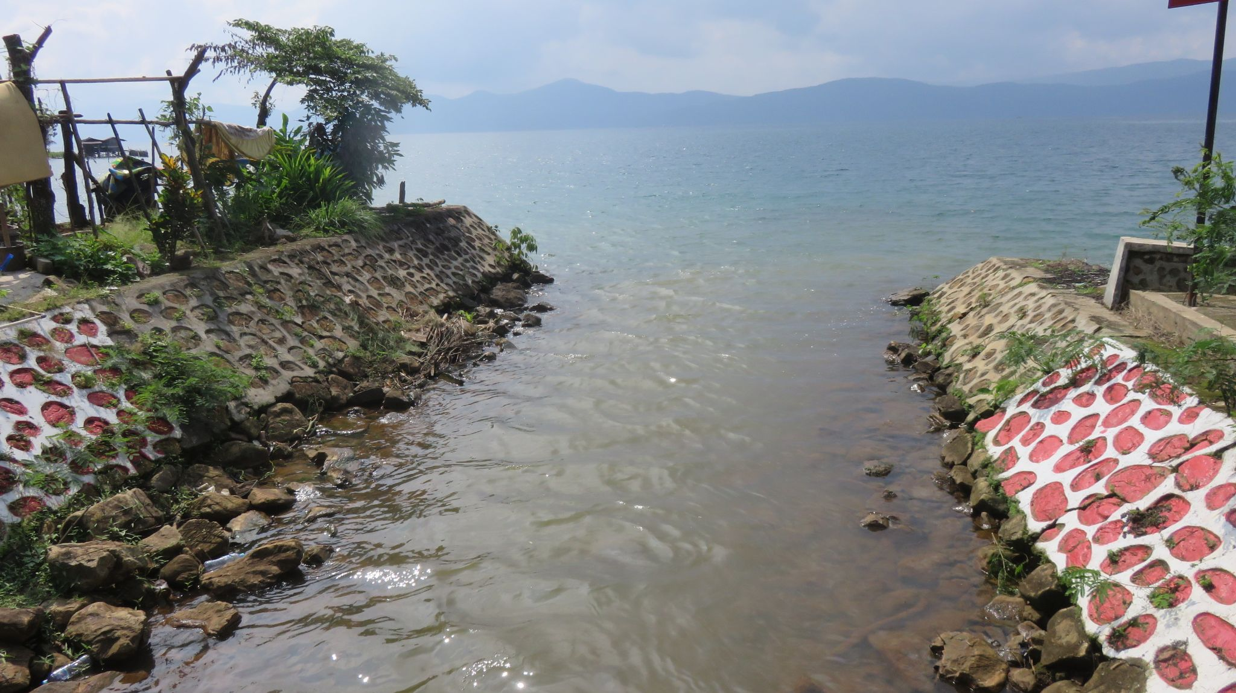  The Lawewu River (downstream) flowing to Lake Matano. (Photo: July 20, 2022) | 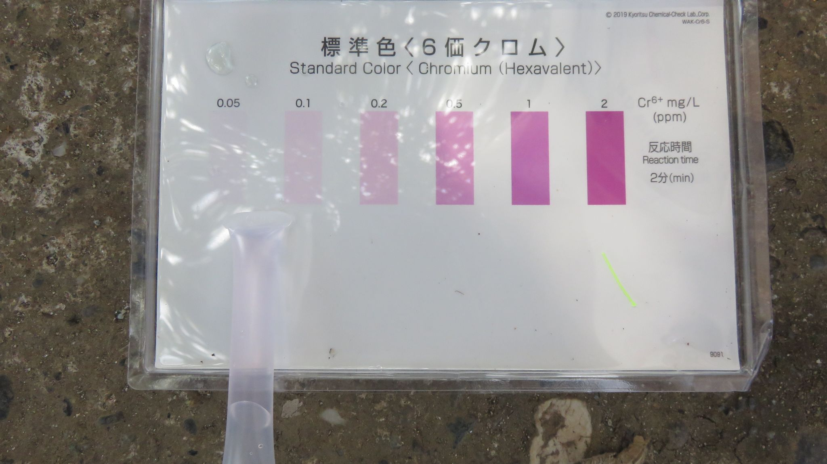  Results of simple Cr(VI) detector tube test at the Lawewu River (downstream) (0.075 mg/L) (Photo: July 20, 2022)
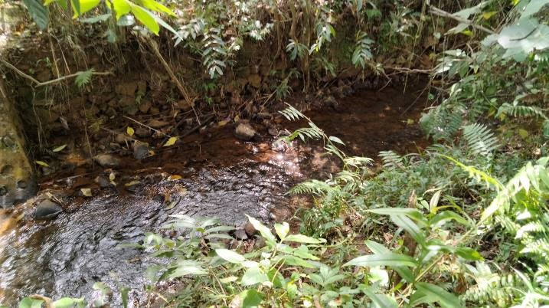  The Lawewu River (upstream, near the airport) flowing to Lake Matano. (Photo: January 10, 2023) | 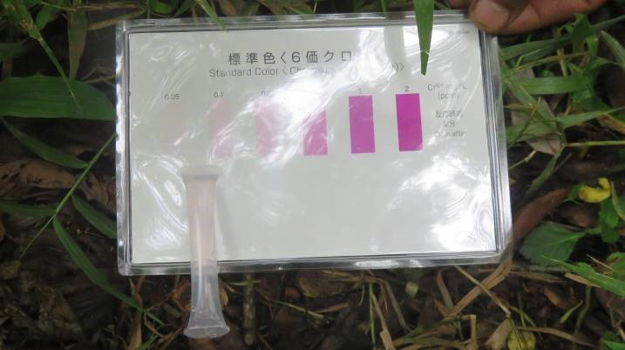  Results of simple Cr(VI) detector tube test at the Lawewu River (upstream) (0.075 mg/L) (Photo: January 11, 2023)

Table 1: Results of Water Analysis on Hexavalent Chromium in the Lawewu River
(Remarks: The figures in boldface are the water samples which exceeded the water quality standards for rivers in Indonesia (not exceeding 0.05 mg/L))
(Unit: mg/L)
Month/Year |  | July 2022 | October 2022 | January 2023
Upstream  (near the airport) | Total Cr* | --- | --- | 0.067
 | Cr(VI)** | --- | --- | 0.075
Downstream  (near Lake Matano) | Total Cr* | --- | 0.144 | 0.031
 | Cr(VI)** | 0.075 | Trace | 0.05
(*) Examination by ICP-MS, or Inductively Coupled Plasma Mass Spectrometer, at the laboratory in Japan
(**) On-the-spot examination by simple detector tube for Cr(VI)

The results of water quality tests on the spot and in the laboratory show that the Lawewu river has been constantly polluted with levels of Cr(VI) exceeding the above-mentioned water standards due to PTVI’s nickel mining activities. In other words, PTVI's nickel mining activities have also indirectly polluted highly protected Lake Matano.
Due to the recent extreme weather caused by climate change, when it's the rainy season, the rainfall is high. Then, the Lawewu river that has been contaminated with Cr(VI) flows into Lake Matano with a large volume. It could make Lake Matano’s ecosystem even more polluted by heavy metals. And because of the derivative impacts, endemic and non-endemic biota in Lake Matano are likely to begin to decrease, and gradually become extinct.

Potential risk of toxic pollution in more communities and rivers
Due to PTVI’s plan to develop a new HPAL plant, which needs more nickel ore, it is expected that the company continues to expand its nickel mining operation within the current concession area. In fact, the company has started its exploration in a new mining block, or Loeha-Mahalona block since early 2022. If deforestation or mining operations start in this block, there is a high potential risk of toxic pollution to disturb more communities and rivers. For example, the Mahalona River being used for domestic and irrigation water, would be contaminated with high levels of Cr(VI).

(2) Pomalaa, Kolaka Regency, Southeast Sulawesi
Under WALHI Southeast Sulawesi monitoring, the environmental impact of nickel mining is very visible in Pomalaa. And the results of our investigation in October 2022 confirmed that toxic pollution occurred around the area affected by nickel projects. One significant pollution with hexavalent or total chromium exceeding the above-mentioned standards (0.021-0.124 mg/L) was found in the Oko-Oko River which has long served as the source of community water, including irrigation for rice fields in Lamedai Village, Tanggetada District, Kolaka (adjacent to Pomalaa District).
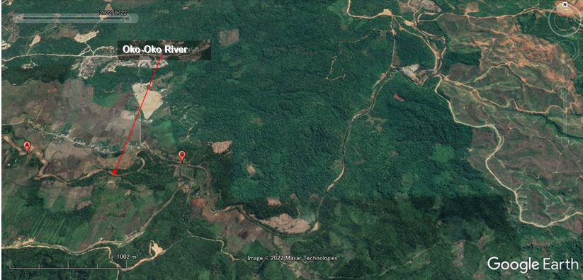
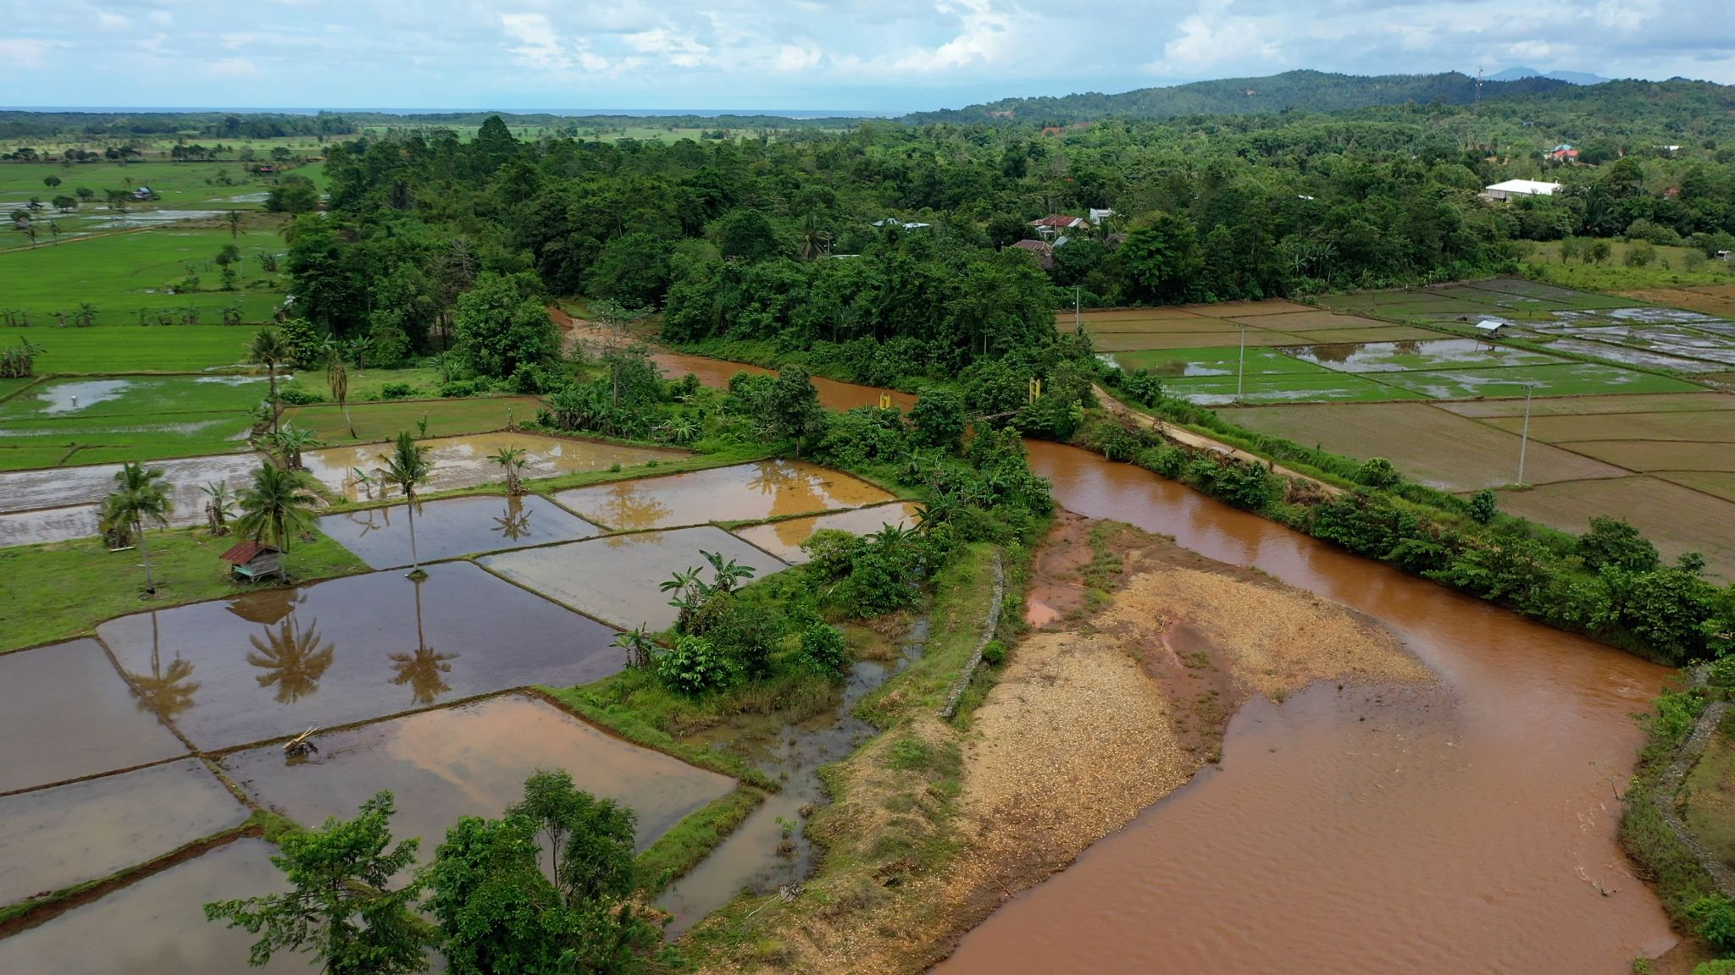  The Oko-Oko River used for irrigation water (Photo: October 28, 2022) | 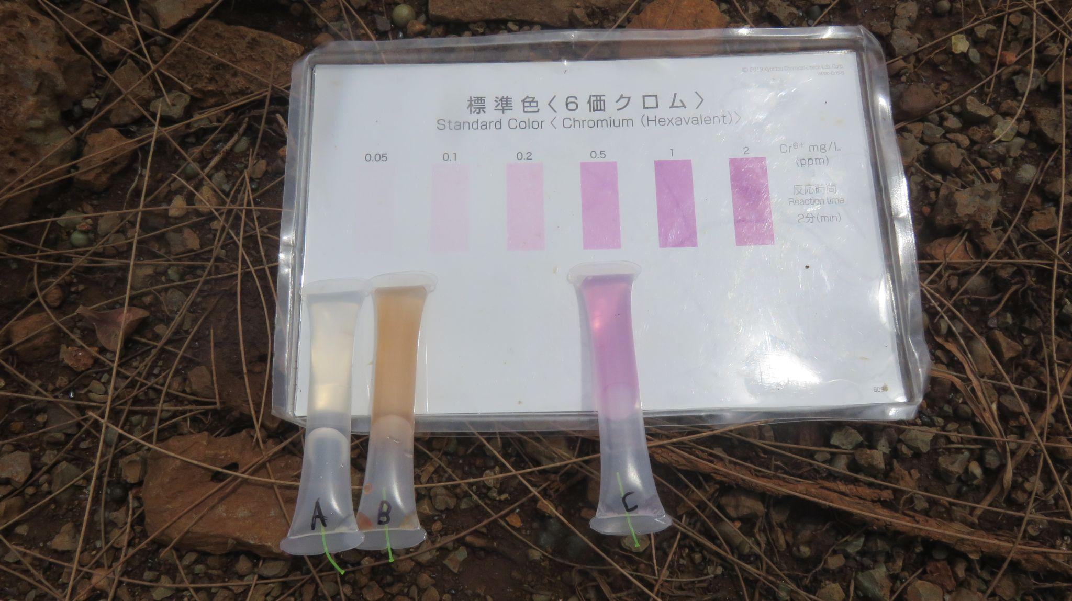  Results of simple Cr(VI) detector tube test. The 1st (point A in the above map) (Trace) and 2nd (point B) (0.05 mg/L) ones from left side were on the Oko-Oko River (Photo: October 28, 2022)

While the Oko-Oko River has been polluted and silted as a result of illegal nickel mining activities by unidentified companies, PTVI’s concession area covering 20,286 hectares (in Pomalaa and Baula districts, Kolaka) is also located in the upper part of Oko-Oko River. Since a massive mining operation is expected to start in PTVI’s concession area due to the new HPAL plant’s operation, toxic damage in the Oko-Oko River could become even worse, considering the past operation of PTVI in the other areas.
The mining activities of PTVI could lead to the loss of the forest function as water catchment area, potentially resulting in more floods and the loss of farmers' livelihoods with toxic polluted water from the Oko-Oko River.
The river has frequently overflowed during rainy season. The farmers in Lamedai have experienced a severe flood inundating some 750 hectares, including 450-hectare productive rice fields, eventually leading to crop failures, while Lamedai has been one of the largest food (rice) producing areas in Southeast Sulawesi.
The region long known for its wealth in agriculture, forestry, and marine is bound to destruction and loss due to the mining activities. Those who work as farmers and fisherfolk for their source of livelihood suffer significant toxic pollution impacts. The loss of livelihood forces them to adapt or else they would have to be slowly marginalized out of the space where they grew up and live. Pollution, contamination, and other effects are now part of the everyday life in the community.
3. Recommendations
We believe that heavy metal toxic pollution, especially Cr(VI) exceeding international and national water standards, in rivers and community water sources due to mining activities is a kind of corporate crime and clearly a violation of international standards, including the UN Guiding Principles on Business and Human Rights. There is no country or company that can justify such pollution to procure battery material, while addressing climate change.
Therefore, given the ongoing/potential toxic pollution caused/to be exacerbated by the nickel projects in Sulawesi as described in the above, we, working with local communities in nickel mining area of PTVI would like to ask OHCHR to thoroughly look through the activities of PTVI, the largest nickel mining and processing company in Indonesia, and to recommend the followings to each entity concerned in order to stop and prevent toxic pollution in rivers and community water sources as well as save people's lives, especially women and children;
For PTVI and its shareholders (including Vale Canada and SMM, and Citibank New York on behalf of Government of Norway);
- To immediately ensure the proper remedy for clean and safe water of the community in Asuli village;
- To make a plan to prevent recurrence of similar problems and to disclose it;
- To stop nickel mining activities in essential ecosystem areas, such as forests and river areas, especially upstream, and in community water sources area, in order to prevent toxic pollution in the future;
- To restore the environment in river areas and community water sources areas;
- To respect the local community’s human rights to health and living, including access to clean and safe water;
- To respect the freedom of expression of the community affected by its nickel projects.

For the companies who procure/will procure nickel products from PTVI (including SMM, Tesla, Toyota, Panasonic, and Ford);
- To ensure PTVI to respect human rights of the community affected by its nickel projects, according to the international human rights standards and each own policy related to supply chain management;
- To ensure PTVI to immediately provide proper remedies for the community in Asuli village.

For the states, belonging to whom multinational companies involved in PTVI as shareholders or/and buyers;
- To fulfill duty to protect human rights of the community affected by PTVI’s nickel projects;
- To ensure PTVI to immediately provide proper remedies for the community in Asuli village.
For Indonesian Government, including the President and Minister of Energy and Mineral Resources;
- To review PTVI’s concession area and exclude essential areas from its concession;
- To firmly enforce its own national water standards to protect the community’s human rights;
- To protect the freedom of expression of the community affected by the nickel projects.

Annexes:
1. Threat of ecological damage in Pomalaa district, Kolaka Regency, Southeast Sulawesi by WALHI Southeast Sulawesi
https://drive.google.com/file/d/1rgznUgK7il4aw4pMjSIE_Z3aQTimxVgV/view?usp=sharing

2. WALHI South Sulawesi and FoE Japan’s water quality testing surrounding Sorowako nickel smelters and mining development project (including photos and maps) in July and October 2022 and in January 2023
https://drive.google.com/file/d/1eV_cjAhDxxv2FtvXebc4kYwouQZj-9WF/view?usp=sharing

3. WALHI Southeast Sulawesi and FoE Japan’s water quality testing surrounding Pomalaa nickel smelter and mining development project (including photos and maps) in October 2022
https://drive.google.com/file/d/1q-Vnac76XIPLMwKhH8HKA4LLbkBLVQDJ/view?usp=sharing
(The water quality testing in July in Sorowako was only conducted on the site. In October 2022 and January 2023, after our on-site testing, we brought the water samples in PE bottles to the laboratory in Japan for analysis in detail.)

https://www.vale.com/en/indonesia/about-pt-vale
https://www.smm.co.jp/en/corp_info/location/domestic/nickel/ ; https://www.smm.co.jp/en/ir/library/integrated_report/pdf/2022/2022_All_EN.pdf
https://www.smm.co.jp/en/news/release/2020/03/001230.html
https://www.smm.co.jp/en/news/release/uploaded_files/130926_E.pdf
https://www.vale.com/documents/44618/1438416/PT+Vale+and+Huayou+Show+Sustainability+Commitment+by+Building+a+new+HPAL+Plant+for+Limonite+Nickel+Ore+in+Luwu+Timur.pdf/3f0a54cf-12f6-845e-94e2-3950d845d998?version=1.0&t=1668006561928
https://www.vale.com/documents/44618/1438416/Press_Release_Groundbreaking+Pomalaa_ENG.pdf/7dffceb6-3ad8-dce9-b567-7a933d102e1d?version=1.0&t=1669813755933
https://www.vale.com/documents/44618/1438416/PT+Vale+Welcome+Ford+Motor+Co.+to+Pomalaa+HPAL+Project.pdf/b88839b5-665e-de62-dad4-d8d3a15e5225?version=1.0&t=1668006563830
https://www.who.int/teams/environment-climate-change-and-health/water-sanitation-and-health/water-safety-and-quality/drinking-water-quality-guidelines
https://jdih.setkab.go.id/PUUdoc/176367/Lampiran_VI_Salinan_PP_Nomor_22_Tahun_2021.pdf
https://www.env.go.jp/content/000077408.pdf ; https://enviliance.com/regions/east-asia/jp/report_4557
https://www.mhlw.go.jp/stf/seisakunitsuite/bunya/topics/bukyoku/kenkou/suido/kijun/kijunchi.html#01
https://walhisulsel.or.id/3853-walhi-sulsel-beberkan-3-dampak-sosial-lingkungan-tambang-nikel-pt-vale-indonesia-di-desa-asuli-luwu-timur/

