The Making of Lynas’ Toxic Legacy in Malaysia
Lynas Rare Earth (formerly Lynas Corporation) is a heavily traded company listed with the Sydney Stock Exchange. Lynas mines and concentrates rare earth (RE) ores through its Mount Weld operations in Western Australia; then transports and ships the concentrate some 6,500km to its secondary processing plant, Lynas Advanced Materials Plant (LAMP) in Malaysia – to separate and process the RE concentrate into different RE oxides/chlorides/carbonates. & These compounds are then sold to companies in Japan and China to refine into individual elements for their respective industrial applications.

Lynas has No Social Licence to Operate in Malaysia
The LAMP has embroiled in controversies and attracted widespread and diverse protest actions since Malaysians first found out about it through a series of New York Times articles in 2011 . The limited public consultation, the 12-year tax break awarded to Lynas, its large-scale operation and ‘zero-harm’ claims, on top of Malaysia’s own poor track record in managing rare earth pollution and radioactive waste have all contributed to Malaysians and their overseas allies responded through a decade of protest actions against the LAMP. What ensued has been termed “Malaysia’s most far-reaching experience with a popular environmental resistance” . At the height of the protest, over 1.2 million signatures were collected in a petition to shut down the LAMP.
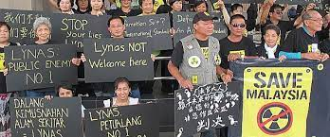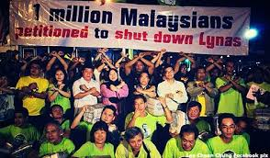

The Malaysian Government has largely been captured by Lynas and is under tremendous geopolitical pressure to accept the environmentally unjust deal instead of acting in the interest of public and environmental health and to prevent another toxic radioactive legacy.

Lynas Advanced Materials Plant
The LAMP occupies 100 hectares of mostly reclaimed peat mangrove forest near the Kuantan Port, thereby expanded the Gebeng Industrial Estate. To the north and south of the LAMP, fishing villages, housing estates, peri-urban towns, and holiday resorts (including Club Med) dotted along the white sandy beaches along the coastal strip of the South China Sea.

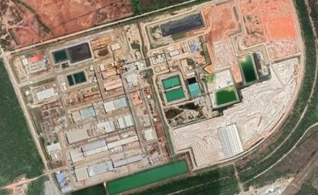
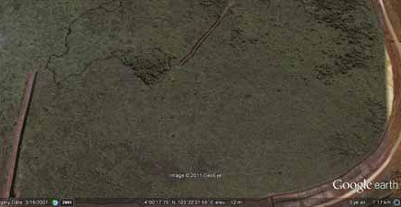
Satellite images of the LAMP site taken in July 2007 LAMP September 2020

According to an independent evaluation of the LAMP by Germany’s Institute of Applied Ecology (OEKO), the LAMP
“.. has several deficiencies concerning the operational environmental impacts. The environment is affected by acidic substances as well as from dust particles, which are emitted into the air in substantially larger concentrations than would be state-of-the-art in off-gas treatment in Europe. The storage of radioactive and toxic wastes on site does not prevent leachate from leaving the facility and entering the (sic) ground and groundwater. For the long-term disposal of wastes under acceptable conditions concerning radiation safety a sustainable concept is still missing.”
The International Atomic Energy Agency (IAEA), an advocate of ‘peaceful’ nuclear technology and traditionally, a nuclear weapon inspector, too raised concerns around uncertainties surrounding the permanent storage of the radioactive waste and the need for Lynas and the Malaysian Government to stringently monitor a range of radiological issues; and to be transparent and engaging with the public at every stage of licencing decision making. Lynas established the LAMP under a regime notorious for its corruption scandals. Although a reformist new regime was popularly elected in May 2018, it was ousted after a brief 2.5 years through parliamentarians switching parties to form a new Coalition aligned with the old regime. IAEA’s diplomatic approach to encourage member states to heed its recommendations and advice have largely been ignored beyond positive aspects of its findings being quoted to justify the LAMP.

Local Impacts
Since Lynas began operation in 2013, Kuantan residents have experienced sudden and regular water supply disruption. LAMP utilises 12 megalitre of raw water every day. Every hour, 500,000 litres of effluent flows from the LAMP through an open canal into the Balok River through its estuary into the South China Sea The diminishing Balok peat mangrove forest, which the LAMP built on, is ecologically significant for its diversity of mangrove flora and fauna. It is the only habitat for the mangrove horseshoe crab (Carcinoscorpius rotundicauda) along the east coast of Peninsular Malaysia.
Balok is traditionally well known for its mud crabs and seafood, which local captures from the mangrove floodplain, the estuary and the marine environment. Balok Mangrove’s ecological and local livelihoods importance have not protected it from degradation from pollution and land clearing.
The LAMP generates two streams of wastes - a scheduled/hazardous waste from the neutralization underflow (NUF) stream, and the water leach purification (WLP) stream. The WLP waste is contaminated with between 1655 to 1953 ppm or (6 to 8 Bq/g) of long-live radionuclides of thorium and small amount of uranium. Thorium and uranium are sources of ionising radiation and there is no safe dose of this form of radiation exposure, hence the adoption of the linear no-threshold regulatory approach to radiation safety and protection by responsible governments. Small quantities of non-radiological toxic elements including iron, lead, cadmium, nickel, chromium, arsenic, etc, and 20-30% of lanthanum and cerium are also present in the WLP waste. The waste is predominantly an acidic iron gypsum, a medium from which toxic elements can be mobilised and leached from rainwater intrusion over time into the surrounding land, surface and ground waters, essentially posing “an indefinite or perpetual management risk” to the local communities and the environment.
Recent research has revealed health and environmental hazards from REE contamination, especially on pregnant women and children. The safe and proper management of long- lived radioactive and heavy metal contaminated waste is costly. Lynas and the Malaysian regulators have lowered the classification of the WLP waste against established IAEA and international guidelines by classifying it as a very low-level radioactive waste when it should be a low-level radioactive waste that involves well engineered facility that can safely prevent radioactive and toxic contamination under tight competent institutional control for at least 10,000 years.

Below: Reddish brown radioactive WLP waste at the back stacked up exposed to the weather
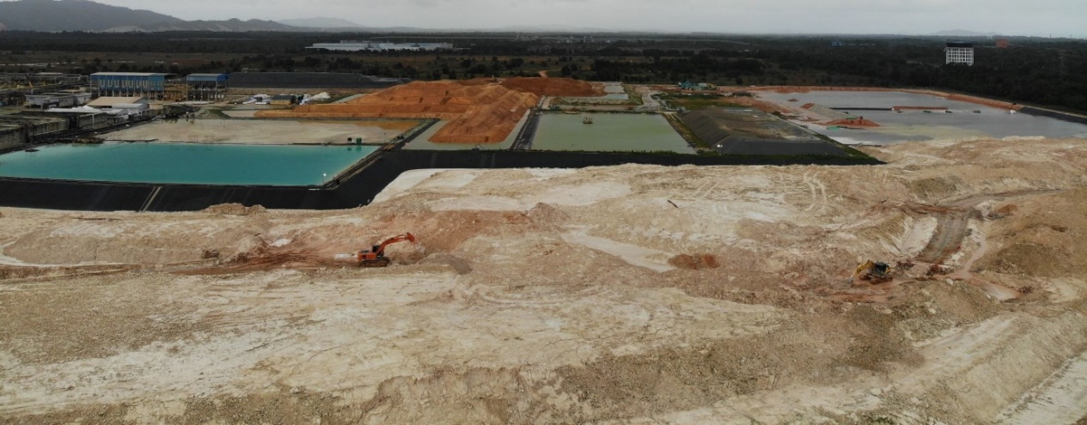
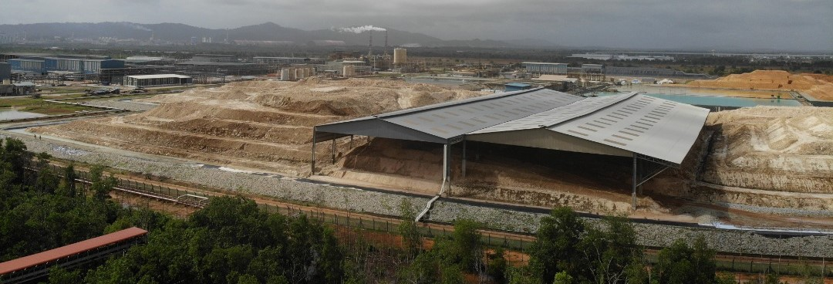
Above – Scheduled waste supposed to be commercialised stacked up near the LAMP
A review by the Malaysian Government in 2018 revealed serious groundwater contamination from samples obtained from Lynas’ own monitoring stations from a Health Impact Study,
“…The nickel concentration on March 15, 2016 at the GW13 monitoring station was at 96,100 μg/L, which is 1,281 times more than the Dutch Intervention Value (DIV) of 75 μg/L.”.
However, the Government did not follow up from the HIA findings even though there are fifty families nearby relying on groundwater for their daily uses.

Lynas is currently seeking a location to establish a permanent disposal facility (PDF) for its radioactive waste, despite its previous legal undertakings and licence conditions to remove the waste from Malaysia. Its application to locate the PDF in a major water catchment and forest reserve in Kuantan has recently been rejected by the Malaysian Government. At the time of this article, Lynas has submitted its terms of reference for a new coastal location next to the LAMP. Lynas has no social licence to operate, least of all, to leave its radioactive waste in Malaysia. It should not have operated without a safe permanent storage facility for the radioactive waste. Radiation hazards are cumulative and can be passed down to future generations. The delayed effect is a form of slow violence which results in intra and intergenerational injustice where younger and future generations will be left to shoulder the burden, health hazards and potentially clean-up cost of the toxic legacy from Lynas.

Conclusion
The Lynas LAMP and proposed PDF is an example of development and corporate aggression. It is a case of green extractivism driven by geopolitics which leaves behind a toxic legacy for Malaysia. While REE ar e critical for transition technologies crucial in tackling climate change, it is important that their mining and processing do not replicate the negative impacts of fossil fuel and minerals extractive industries. Lynas has promoted itself as a green and sustainable mining corporation, when in truth, it has simply pushed its hazards, pollution and carbon emissions onto a global South nation, Malaysia. It is critical for CSOs to advocate against this type of green extractivism when campaigning for actions and solutions to tackle climate change. We must advocate for a just energy and technological transition that is clean and safe, especially for those who have not contributed to climate change.

https://www.researchgate.net/publication/323452073_Evaluating_Rare_Earth_Element_Deposits
AGV Environment, Figure 5.2.2 Mass Balance of LAMP Process extracted from Ch 5 Project Description, Proposed Development of a Dedicated PDF for the WLP Residue at Bukit Ketam, Mukim Kuala Kuantan, Daerah Kuantan, Pahang, Malaysia
https://www.nytimes.com/2011/03/09/business/energy-environment/09rare.html
https://www.youtube.com/watch?v=sTKSQh0nuY8
https://cilisos.my/30-years-ago-a-huge-radioactive-incident-happened-in-perak-heres-the-story-behind-it/ & https://consumer.org.my/chronology-of-events-in-the-bukit-merah-asian-rare-earth-development/
https://www.researchgate.net/publication/336062623_Malaysia's_Green_Movement_Old_Continuities_and_New_Possibilities
https://www.taylorfrancis.com/chapters/edit/10.4324/9781315474892-37/malaysia-structure-agency-environmental-movement-fadzilah-majid-cooke-adnan-hezri
https://rightnow.org.au/opinion-3/rare-earth-mining/
https://shewalkstheworld.com/2020/08/13/kitesurfing-balok/
2011 IAEA Mission report recommendations (no longer online but e-copy downloaded previously) and 2014 follow-up report via: https://www.iaea.org/sites/default/files/lynas-report-20052015.pdf accessed July 2021
https://www.ft.com/content/dccf3226-c636-11e8-ba8f-ee390057b8c9
https://theconversation.com/how-malaysian-voters-defied-the-odds-and-ousted-corruption-96622
https://www.theguardian.com/commentisfree/2020/mar/03/the-guardian-view-on-a-royal-coup-a-king-overturns-a-historic-election
https://www.researchgate.net/publication/228880933_Mangrove_Forest_Species_Composition_and_Density_in_Balok_River_Pahang_Malaysia
https://www.sciencedirect.com/science/article/pii/S235234091831566X
https://www.researchgate.net/publication/331644748_Effects_of_shore_sedimentation_to_Tachypleus_gigas_Muller_1785_spawning_activity_from_Malaysian_waters
2008 Environ Consulting Services (M) Preliminary Environmental Impact Assessment submitted by Lynas for licensing purpose, Vol 1, Main Report, page 5-55: WLP contains 1655ppm of Thorium Oxide and 22.5ppm of Uranium Oxide
https://www.researchgate.net/publication/262997550_Thorium_Uranium_and_Rare_Earth_Elements_Content_In_Lanthanide_Concentrate_LC_And_Water_Leach_Purification_WLP_Residue_Of_Lynas_Advanced_Materials_Plant_LAMP
IAEA Guidelines stipulate that any substance containing >1 Bq/g of thorium or uranium is radioactive and should be regulated for radiation safety and protection – see full report via https://www.iaea.org/newscenter/news/malaysian-government-releases-iaea-report-lynas-project
https://wwwn.cdc.gov/TSP/PHS/PHS.aspx?phsid=658&toxid=121
https://ieer.org/resource/factsheets/uranium-its-uses-and-hazards/
See Table 2 and Table 3 page 2-3 of https://www.arpansa.gov.au/sites/default/files/legacy/pubs/rps/rps15.pdf?acsf_files_redirect for risks to different human organs; http://www.dmp.wa.gov.au/Safety/Guidance-about-radiation-safety-6950.aspx
“Ionizing radiation has sufficient energy to change the structure of molecules, including DNA, within the cells of the human body. Some of these molecular changes are so complex that it may be difficult for the body’s repair mechanisms to mend them correctly…. Radiation-induced mutations would be expected to occur in the reproductive cells of the human body (sperm and eggs), resulting in heritable disease”. Source: https://www.nap.edu/read/11340/chapter/2#6
https://www.nap.edu/catalog/11340/health-risks-from-exposure-to-low-levels-of-ionizing-radiation : “. . . current scientific evidence is consistent with the hypothesis that there is a linear, no-threshold dose-response relationship between exposure to ionizing radiation and the development of cancer in humans”
REO Mass Balance from Figure 5.2.2” Mass Balance of LAMP Process from Ch 5 - see Ref no 2.
Environ Consulting Services (Malaysia), Safety Case for Radioactive Waste Disposal LAMP, 2011 Table 1 p.26
https://mjas.analis.com.my/mjas/v22_n6/pdf/NurShahidah_22_6_6.pdf
Mudd G.M. & Currell M.J., Submission to the Malaysian Department of Environment, 19 March 2021
https://www.ncbi.nlm.nih.gov/pmc/articles/PMC7075196/
https://www.ncbi.nlm.nih.gov/pmc/articles/PMC3601293/; https://link.springer.com/chapter/10.1007/978-3-030-52421-0_1 & https://issuu.com/oecd.publishing/docs/reducing_the_health_risks_of_the_copper__rare_eart
https://www.parlimen.gov.my/images/webuser/jkuasa%20lamp/Laporan%20Jawatankuasa.pdf (in Malay)
Malaysian Government Executive Review Report on the LAMP, December 2018 p.79 to 81 https://www.parlimen.gov.my/images/webuser/jkuasa%20lamp/Laporan%20Jawatankuasa.pdf
Ionizing radiation has sufficient energy to change the structure of molecules, including DNA, within the cells of the human body. Some of these molecular changes are so complex that it may be difficult for the body’s repair mechanisms to mend them correctly…. Radiation-induced mutations would be expected to occur in the reproductive cells of the human body (sperm and eggs), resulting in heritable disease. Source:https://www.nap.edu/read/11340/chapter/2#6

