Images Taken Of the Lynas Advanced Materials Plant (LAMP) – the secondary processing plant in the Gebeng Industrial Estate in Kuantan, Pahang, Malaysia.

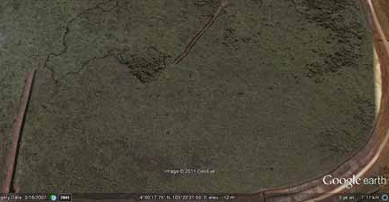
Satellite images of the LAMP site taken in July 2007, with an intact peat mangrove forest

Satellite Image of the LAMP September 2020
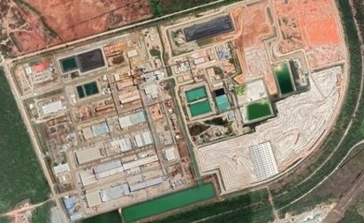

Below: Reddish brown radioactive waste at the back stacked up exposed to the weather
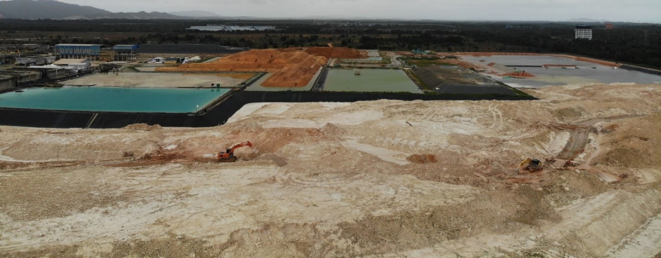
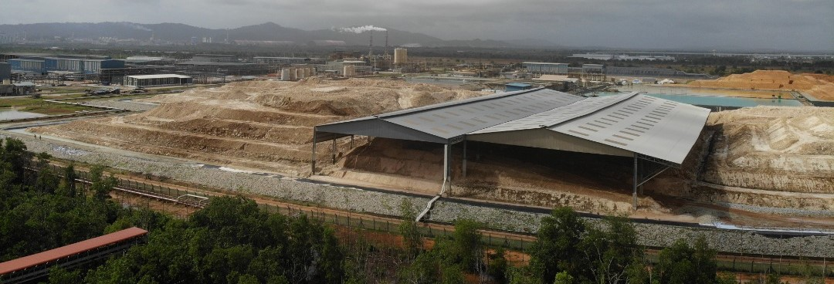
Above – Scheduled waste supposed to be commercialised stacked up near the LAMP
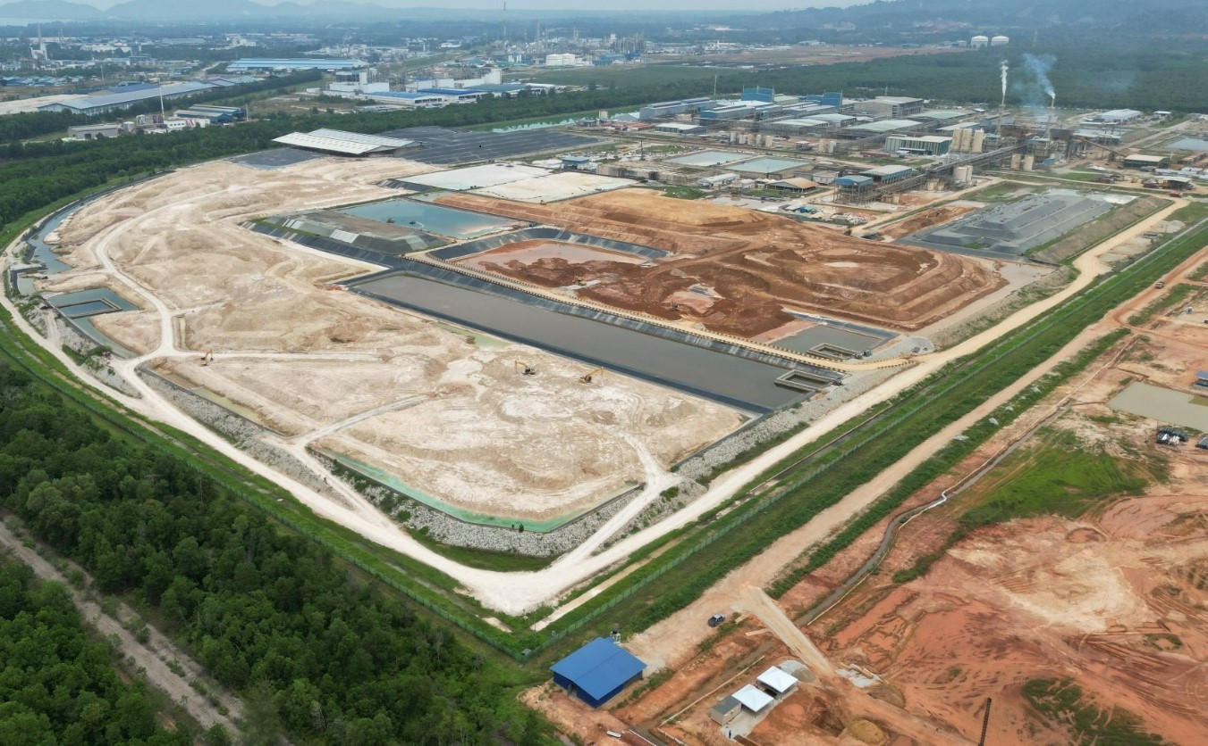
Drone view of the LAMP (top right hand corner) with its waste storage dams to the right. Reddish brown piles are radioactive waste. Site at the bottom right corner is the proposed location for the permanent disposal facility for the radioactive waste. Image taken August 2022.
Drone view of the peat swamp location for the permanent disposal facility for the radioactive waste. Image taken August 2022.
