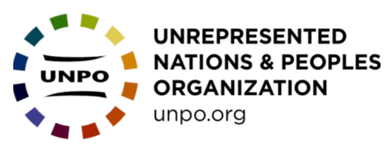
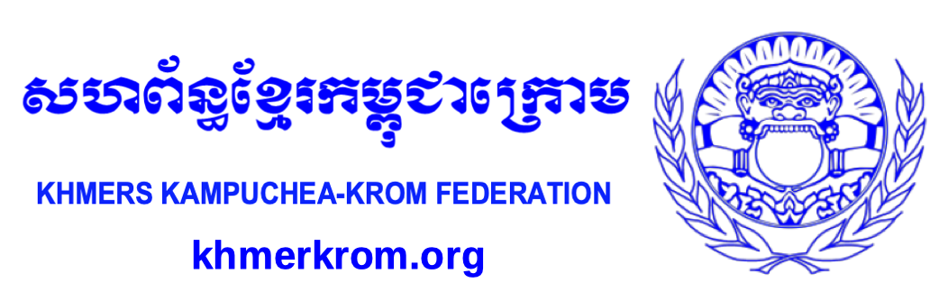

23 May, 2022
49-51 rue de Trèves
1000 Brussels, Belgium
unpo@unpo.org
UN Special Rapporteur on toxics and human rights
Special Procedures Branch
UNOG-OHCHR
CH-1211 Geneva 10, Switzerland

RE: Call for input on the impact of toxics on Indigenous peoples

To: United Nations Special Rapporteur on toxics and human rights

The Khmers Kampuchea-Krom Federation (KKF) and Unrepresented Nations and People’s Organization (UNPO) wish to bring to your attention the harmful impact of toxics on the Khmer Krom. The information shared in the submission was collected from Khmer Krom community members living in the Mekong Delta.
The KKF and UNPO request that the Special Rapporteur on toxics and human rights take note of the detrimental impact of toxics on the Khmer Krom indigenous group, and take appropriate action.

About UNPO

The Unrepresented Nations and Peoples Organization (UNPO) is an international movement and organization established to empower the voices of unrepresented and marginalized peoples worldwide and to protect their rights to self determination. The Khmer-Krom have been members of UNPO since 2001.

The nations and peoples represented within the UNPO membership are all united by one shared condition: they are denied equal representation in the institutions of national or international governance. As a consequence, their opportunity to participate on the national or international stage is limited, and they struggle to fully realize their rights to civil and political participation and to control their economic, social and cultural development. In many cases, they are subject to the worst forms of violence and repression.

About KKF

The Khmers Kampuchea-Krom Federation (KKF) is an organization based in the United States, representing millions of voiceless Khmer-Krom people living in the Mekong Delta and its surrounding regions of current day Vietnam, as well as thousands living in exile.
The mission of KKF is, through the use of peaceful measures and international laws, to seek freedom, justice, and the right to self-determination for the Indigenous Khmer-Krom Peoples in Kampuchea-Krom (Mekong Delta region).
About the Khmer-Krom
The Khmer-Krom people have lived continually on their ancestral land in the Mekong Delta for thousands of years. In the Khmer language, the Khmer-Krom people call their homeland Kampuchea-Krom.
The government of Vietnam refuses to recognize the Khmer-Krom as an indigenous people, and label them as an ethnic minority group (“Khmer”). As the Mekong Delta's indigenous peoples, the Khmer- Krom identify themselves as Khmer-Krom to both preserve their identities (tied to their ancestral land in the Mekong Delta), and to distinguish themselves from their Khmer siblings in Cambodia.
Lacking recognition as indigenous peoples, the Khmer-Krom continue to face violations of their human rights which should be protected under the United Nations Declaration on the Rights of Indigenous Peoples (signed by Vietnam in 2007).

As a one-party state, namely the Communist Party of Vietnam, Vietnam does not allow freedom of association. There are no independent NGOs operating in Vietnam. Rather, there are only Government-Organized NGOs (GONGOs). There are millions of the Khmer-Krom living in the Mekong Delta, but the Khmer-Krom have no legal association to advocate for the protection of their rights.

Advocates within and for the Khmer-Krom community face significant challenges when attempting to gather information or raise awareness about community issues. Individuals within the community risk persecution and reprisals by the Vietnamese government if they speak out about the issues facing the Khmer-Krom.

This submission is based on information reported by Khmer-Krom community members from the Mekong Delta, focusing on the impact of hazardous substances and toxic waste on Khmer-Krom communities.

Impact of the Toxics from Garbage disposal areas
As the indigenous peoples of the Mekong Delta, most Khmer-Krom are farmers living in the villages surrounded by rice fields. The Khmer-Krom used to enjoy the fresh air and living in a peaceful environment in their villages.

As Vietnam has started to emerge as one of the most developed countries in Southeast Asia, the amount of solid municipal waste has increased. The Vietnamese government has not implemented an appropriate policy for waste management, which is needed to reduce its environmental impact.

In some areas of the Mekong Delta, especially in the rural areas where the Khmer-Krom live, Khmer-Krom community members report that they suffer from unbearable odors emanating from nearby garbage disposal areas, adversely affecting their health. The Khmer-Krom have made complaints about this issue to the local government, but the Vietnamese authorities have not taken any action to prevent it. This lack of action has raised serious concerns within the Khmer-Krom communities.

Below are two examples of garbage disposal areas near Khmer-Krom villages in the Mekong Delta:
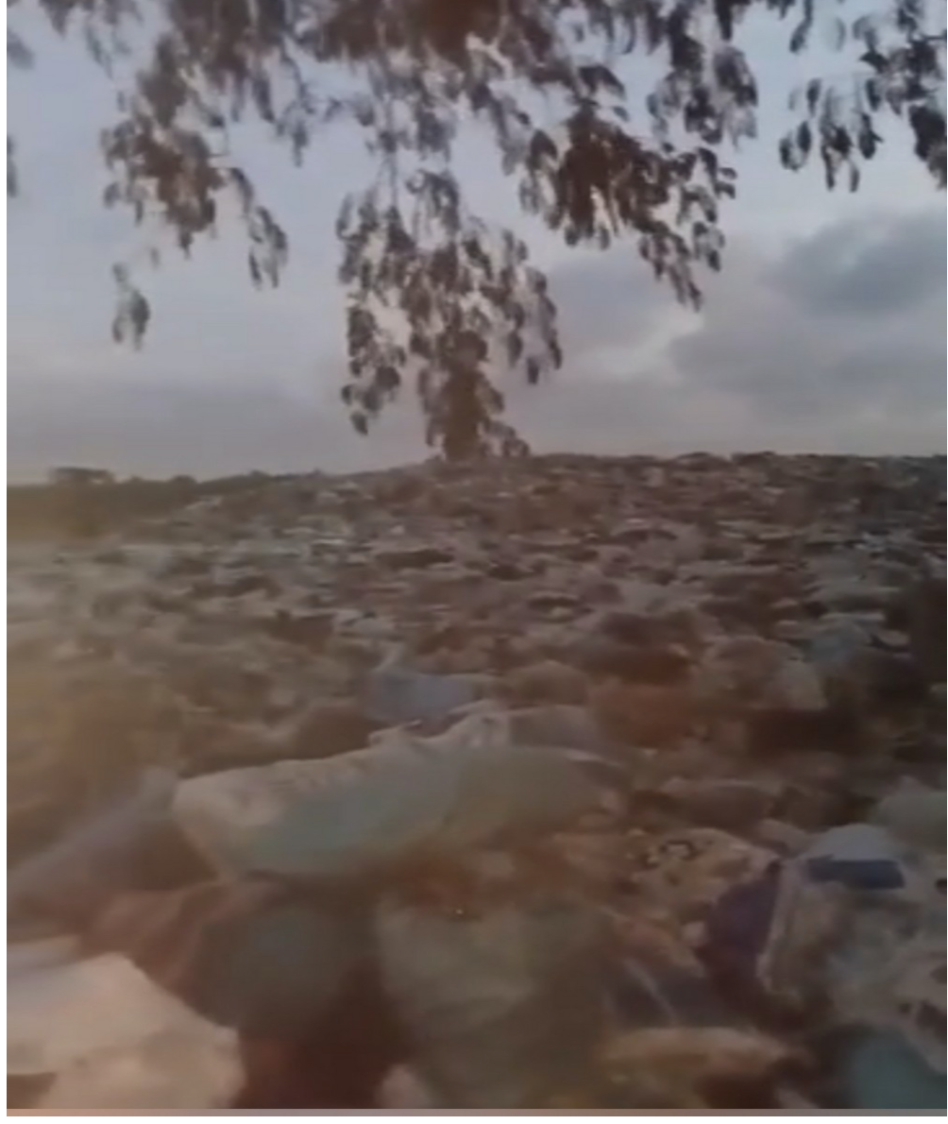
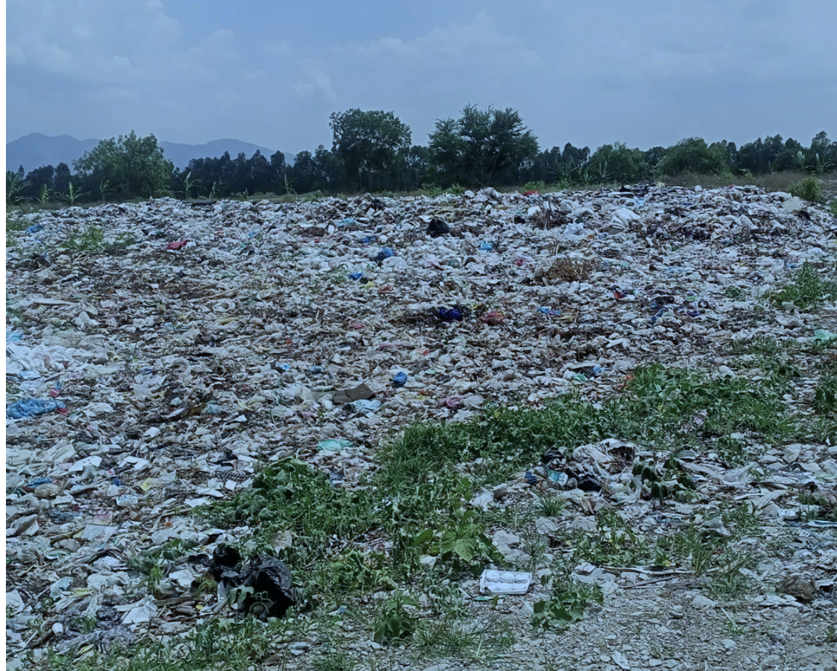
(Image 2: A garbage disposal area near a Khmer-Krom village in Tinh Bien district, An Giang province)

(Image 1: A garbage disposal area near a Khmer-Krom village in Cau Ngang district, Tra Vinh province)

Abnormal Phenomenon of Blindness
Khmer-Krom living in Soc Trang and Bac Lieu provinces continue to suffer from complete or partial blindness caused by toxics present in drinking water.
Thousands of Khmer-Krom individuals have been affected by the blindness in one or both eyes. The main cause of this blindness is contaminated drinking water, which is mainly polluted by pesticides, herbicides, and fertilizers. The most impacted area is in Vinh Chau district, Soc Trang province because the farmers use these chemicals to protect their onion crops. Despite the government’s recent claims that no chemicals are allowed, blindness cases continue to occur in this area.
Most of the blinded Khmer-Krom blinded people now live on the donations of temples near their villages.

Damaged the Ecological Environment
Traditionally, the Khmer-Krom farmers only farmed once a year, which was sufficient for the community’s needs. This traditional agricultural cycle has been disrupted, as the government now forces the Khmer-Krom to farm rice three times per year in order to meet external demand for rice. Vietnam ranks in the top five rice-exporting countries. Vietnam's Mekong Delta produces 90% of the country’s rice exports, despite accounting for only 25% of the country’s farmland.

This forced change in traditional agricultural practices has led to soil quality degradation in the once-fertile farmland of the Mekong Delta. In order to meet international demand for rice, the government has encouraged the use of fertilizers and pesticides to increase crop yields. Without using fertilizers, the rice could not be grown fast enough to plant and harvest three times per year. Using pesticides has also damaged the ecological environment. The water in the farmlands is contaminated, which kills fish, crabs, and snails – all of which are sources of food for the Khmer-Krom. The Khmer-Krom also now fear to eat the rice that they produce, because of the quantity of chemicals used in their production.

Recommendations
The UNPO and KKF request that the United Nations Special Rapporteur on toxics and human rights take the following actions:
1) Conduct a country-visit to examine the extent to which the Khmer-Krom are adversely impacted by the presence of toxics in their water and soil;
2) Call on the government of Vietnam to provide a platform for the Khmer-Krom to raise concerns and complaints, without fear of persecution, about the impact of garbage disposal areas on their health;
3) Call on the government of Vietnam to investigate the continuing cases of blindness associated with contaminated drinking water;
4) Call on the government of Vietnam to provide health care and financial assistance to the Khmer-Krom people who have suffered complete or partial blindness;
5) Call on the government of Vietnam to stop forcing the Khmer-Krom to produce rice three times per year.

https://unpo.org/downloads/2372.pdf
https://unpo.org/downloads/2718.pdf
European Parliment, & Soutullo, J. (2019, November). The Mekong River: geopolitics over development, hydropower and the environment. Policy Department for External Relations. https://doi.org/10.2861/718814
Eyler, B. (2021, June 8). New Evidence: How China Turned Off the Tap on the Mekong River. Stimson Center. https://www.stimson.org/2020/new-evidence-how-china-turned-off-the-mekong-tap/

