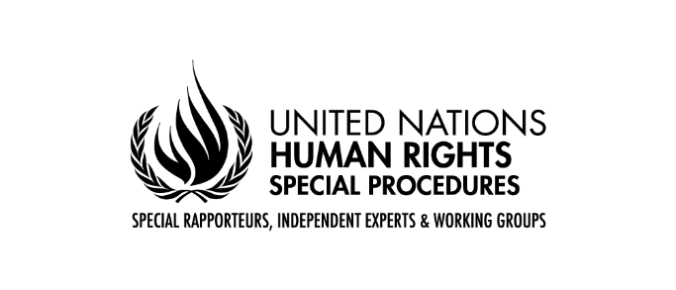
Questionnaire to Indigenous peoples and civil society

Call for submissions “The impact of toxics on Indigenous peoples”
Mandate of the Special Rapporteur on toxics and human rights

The Special Rapporteur on toxics and human rights, Marcos Orellana, wishes to thank States, Indigenous peoples, civil society organisations, academic institutions, businesses, international organisations and other stakeholders for the continued engagement with this mandate. He launches the process of gathering inputs from States and other stakeholders to inform his thematic report on the impacts of toxics on Indigenous peoples and human rights. The report will be presented at the 77th session of the United Nations General Assembly in October 2022. The Special Rapporteur kindly requests States, UN agencies, civil society organizations, academics, business enterprises and all other interested parties to share views and relevant information, which could feed his work, as explained below.

Introduction

Indigenous peoples throughout the world are disproportionately affected by toxics and hazardous waste. Indigenous peoples maintain a deep connection to the environment, and therefore environmental pollution severely affects their bodies and cultures. The dumping of hazardous wastes in Indigenous lands is a direct assault on their rights and wellbeing.

Often, Indigenous peoples live in territories rich in natural resources, which are often exploited by business entities in irresponsible ways that contaminate the land and expose Indigenous peoples to hazardous substances. For example, artisanal and small-scale mining is causing widespread environmental toxification with mercury. Other extractive industries, such as uranium mining, have serious adverse effects on Indigenous peoples’ rights. In addition to extractive industries, agro-businesses use highly hazardous pesticides that compromise the enjoyment of human rights.

Exposure of Indigenous peoples to hazardous substances and waste infringe on their collective and individual human rights. These rights include free prior and informed consent, self-determination, lands and resources, health and well-being, culture, development, a healthy environment, water, food and subsistence, life, and security of person.

In light of these considerations, and pursuant to the Human Rights Council resolution 45/17, which calls for monitoring of “adverse consequences for persons and groups in vulnerable situations, including indigenous peoples,” the Special Rapporteur on toxics and human rights has decided to focus his upcoming thematic report to the 77th Session of the United Nations General Assembly on the impact of toxics on Indigenous peoples.

The following questionnaire seeks information on how toxics have affected Indigenous peoples’ rights and how States are taking steps to eliminate the effects of toxic exposure on Indigenous peoples. This information may include ways that Indigenous peoples are being exposed to toxics, ways that countries are preventing Indigenous peoples’ exposure to toxics, and the legal rights and remedies available to Indigenous peoples exposed to toxics and hazardous waste.

From Ellen Gabriel; Indigenous Land Defender, Kanehsatà:ke (Quebec, Canada)

Questionnaire

You can choose to answer all or some of the questions below

- Is your Indigenous community (or one that you represent) suffering from the adverse effects of hazardous substances and toxic wastes? Please describe the case and circumstances of these effects in detail, including the source of the toxic exposure, the types of hazardous substances you are being exposed to, the degree of government/company consultation and consent to relevant activities, as well as any efforts made by the government/company to provide effective remedies.
The Kanien’kehá:ka community of Kanehsatà:ke, 1 hour north west of Montreal, has been inundated with development from urban sprawl of condominium development, an old uranium mine that has been shut down since 1980 but contains waste from the initial mines activities; another level of exposure originates from and a toxic waste dump named “GNR”owned by two (2) Mohawk brothers and a ‘silent’ partner. This dump was approved by the colonial created entity called the Mohawk Council of Kanesatake(sic) without the free prior and informed consent of the Kanien’kehá:ka (people of the Flint known as Mohawk) of Kanehsatà:ke. The dump contains raw sewage, construction materials and old fridges and air conditioners but it is not known what other contaminants are in the environment as the company refuses to allow any testing of the tailing ponds and the contents of the dump.
Seepage from liquid contaminants threaten the small creeks, rivers and water ways including community aquifers upon which half of the community relies upon.
No level of government is willing to stop the dumping and community members are afraid to speak out due to retaliation by the owners and their silent partners.
Canada, Quebec and the municipality of Oka continue to execute the centuries old land dispossession for their economic prosperity to what is tantamount to land theft. There is no Free Prior and Informed Consent, and purported land negotiations under Specific Claims does not include land; only monetary compensation for stolen land under which the government of Canada admits to a derogation of their assumed, fiduciary responsibility.

What are the adverse impacts of toxic and hazardous waste on your Indigenous community’s (or the Indigenous peoples you represent) collective and individual rights, such as your rights to lands, resources, culture, health, livelihood, political and economic involvement, etc.? A recent report by the Kanesatake Health Center revealed that the rate of cancer is 3 times higher in Kanehsatà:ke than the neighbouring Quebeçois municipality of Oka, QC. A 2021 report on water quality by environmental groups from Montreal, notably Eau Secours reported high levels of a magnesium and other heavy metals in the water systems used by homes nearby. The community of Kanehsatà:ke has been laid helpless as we witness more of our people suffering from cancers such a lung, pancreatic and leukemia. No federal nor provincial institution is willing to conduct a study on the rates of cancer or other auto-immune diseases such rheumatoid arthritis, lupus etc, to make a link to the toxins contaminating the environment due to the high number of development taking place around the community without the FPIC of the Kanien’kehá:ka under Kainaera’kó:wa (the Great Law of Peace of the Iroquois Confederacy) All development on our Homelands do not have any environmental assessments. On top of the dangerous toxins of the dump, there is also industrial farming, as well as a golf course which sprays toxic pesticides for their corporations. There are increasing levels of asthma and allergies linked to these activities as well as contamination of the environment. We are then denied access to our Homelands due to the theft of our lands under colonial laws rooted in the Doctrine of Discovery. We are denied access to any legal remedies as we watch more of our land stolen for a diversity of development.

- Is the government implementing a right to free, prior, and informed consent regarding exposure to toxics and hazardous substances on your lands and territories? No – Neither Canada, the province of Quebec nor the colonial entity of the Mohawk Council of Kanehsatake (MCK) are taking the initiative to halt the toxic waste dump. In spite of GNR’s licences being revoked numerous times, they continue to dump. A member of Parliament has raised the issue in Parliamentary discussions but only to have her questions either answered with rhetoric that it is up to Quebec, Quebec saying it is a federal matter and the Mohawk Council of Kanesatake, unwilling to take any action. As Indigenous peoples of this land, our land base is persistently being infringed upon and if we protest or send letters to government or developers, we are ignored, marginalized, ostracized and criminalized. While Canada decides who is the legal authority under its colonial imposed laws. We continue to have less access to our Homelands every passing year causing threats to the protection of our traditional knowledge of medicines and plants, and consequently our Kanien’kéha language. All these comprise support for our mental, physical and spiritual health but are treated as expendable for economic prosperity of individuals.

- Is the company responsible for producing the toxics and hazardous waste implementing dialogue with regards to those substances and their consequences with your community? There is currently no dialogue with GNR whose silent partners from Montreal are not well known. The construction, raw sewage and other construction debris originating from the island of Montreal persists as the city undertakes its numerous activities to update its infrastructure. Since the criminalization of Indigenous traditional governments by Canada in 1924, the state has refused to acknowledge and respect Indigenous governments, such as, the Rotinonhseshá:ka – Haudenosaunee nations under which the women are the title holders to the land. As an Indigenous Land Defenders, we are told by Canada and Quebec that the only legal authority is the band council (MCK), thereby excluding the Rotinonhseshá:ka. In the meantime, more toxic waste is brought into the community. As for a land speculator Gregoire Gollin who admitted that this is Kanien’kehá:ka land, continues to sell land for condominium development in spite of dialogue, and being sent a lawyer’s letter of caution. This letter was deliver by a bailiff. Canadian and Quebec courts are costly and there are no law firms willing to take our case saying that it is too complicate. Talks with developers always ends up with statements that they are willing to sell land which the Government of Canada can buy from them. These ‘compensations’ to develolpers remains another level of cost in order for Indigenous peoples to continue to enjoy access to our Homelands and have our rights to self-determination respected. But Canada seems unwilling to act and to accept culpability to a problem they created along with the Seminary of St. Sulpice of France, who have are also located in Montreal, Quebec.

- Have you tried to take action (either legal action, advocacy campaign, etc.) to raise awareness on the issue and/or have you tried to obtain compensation? The land issue in Kanehsatà:ke is over 300 years old. Multiple generations have been trying to resolve this land theft issue by the colonizer for generations. But we have not had any success. In 1990 the community of Kanehsatà:ke was surrounded and eventually occupied by the Canadian Army and Quebec provincial police known as the Surete du Quebec (SQ), and had our fundamental human rights violated. This dispute was over the land grabbing of a private golf course, Oka Golf Club, and took place, officially, for 78 days. The government promised to resolve the issue but instead, we have lost more land and there is an agreement that was conducted coercively that denies us rights to our Homelands. We are persistently trying to be part of discussions through letter writing but to no avail. We conduct protests accompanied by press releases, speaking to members of Parliament, even lawyers but there is no political will to resolve our centuries old land dispute. Lawyers and courts are costly and we do not have any funding for this. Minister Marc Miller of Indigenous Affairs has stated that this problem, is with Quebec and that they cannot tell Quebec or Oka what to do. As previously mentioned, a lawyer’s letter of caution (pro bono) was sent to a land speculator, Gregoire Gollin to stop selling our land. However, he created divisions within the community with the MCK to denounce the Kanehsatake Land Defenders as criminals “carrying guns”, partnering with MCK on a social media platform. This effort was to cause damage to our peaceful efforts, we never had any weapons but tried through social media campaigns, letter writing and petitions to Canada, dialogue only to be shut out at every turn. As for GNR, their tactics of threats and intimidation has caused people to be silent and the invisible hands they are associated with allow this atmosphere of fear to continue. Canada and Quebec have gone through the motions with public statements of reports being in the process but after 8 years, nothing significant has been done. Each level of government has done little to be part of the solution, claiming that it is someone else’s problem and jurisdiction

- What are the most significant challenges to eliminating exposure to toxics in your community? Systemic Racism is the foundation for all these challenges as Canada decides who is the ‘legitimate’ authority over lands. It ignores the traditional governing body, the Rotinonhseshá:ka or Haudenosaunee and denies us access to any dialogue or negotiations. The most significant challenge is the toxic waste itself and trying to remove the threats to the environment, the water, and the people. However, there is no access to legal remedies unless we can find millions of dollars to bring Canada, Quebec, the Seminar of St. Sulpice, the developers all to a courts system that remains rooted in the Doctrine of Discovery. Another level of challenge remains with the fact that community members are too afraid to speak out on the dump, the condominium development and industrial farming due to retaliation by those who stand to gain economically. There is no willingness to sit with all parties and discuss solutions to the contaminants that threaten our aquifers – half the community uses well water, and threats to the environment; the lack of respect for our rights to self-determination and towards the women of the Rotinonhseshá:ka (People of the Longhouse or Haudenosaunee); lack of access to alternative dispute resolutions; Canada’s refusal to repudiate the Doctrine of Discovery; lack of funds to have this taken to the Hague as domestic remedies do not recognize Indigenous peoples’ rights to self-determination.

- What community education does your country, or the responsible company, provide for Indigenous peoples living in areas with high exposure to toxic and hazardous waste? There is no education being conducted by government on the consequences of exposure to contaminants. Only individual efforts to try and make change through social media or quiet discussion locally as it is too dangerous to speak loudly on this issue, for fear of reprisals by GNR, the developer and policing authorities.

- What specific actions has your country taken to protect the rights of Indigenous persons exposed to toxics, in particular women and children? Absolutely none.

- Are there any national health assessments or studies that your country conducts to measure the rate of toxic exposure that Indigenous peoples do experience?
Public Health Service of Canada is busy with the pandemic. I do not know if they are but there is no education efforts conducted by Canada or Quebec in Kanehsatà:ke.

- Does your country provide any services to Indigenous peoples and individual persons exposed to toxics, such as health care, education, etc.? the only effort is once a person is sick or has a serious illness, Canada’s Medicare system is used.

- Do Indigenous peoples and individuals in your country have a constitutional or legal right against the exposure of toxics on their persons or their traditional lands and territories, or are there any environmental laws/policies that require environmental remediation? Canada has weak environmental protection. Our inherent rights are purportedly protected under Canada’s Constitution Act, 1982. However, there is a gap and in order to define what those rights are, we are forced into Canada’s costly court system, and criminalized when we protect our rights to self-determination. Canada’s existing environmental laws are weak in environmental assessment impacts, and in regards to all development. The right to health is ignored by Canada and Quebec in order to allow development to continue on the Rotinonhseshá:ka of Kanehsatà:ke Homelands. In 1998 when the first toxic waste dump began by these two Mohawk brothers, Environment Canada was called on how to stop this or alert them to this matter in order to stop this. I was told “Environmental laws do not apply on reserve”! We as a community cannot rely upon government, especially their policing authorities to help. We are left on our own to defend our Homelands and water, people and rights to self-determination.

- What are the available remedies for Indigenous peoples and individuals exposed to toxics that have experienced damages (in the form of land, health, livelihood, etc.), and what are the challenges to obtaining these remedies in your country? There are little opportunities for remedy and has been previously explained, Canada only recognizes the colonial entity of band council – MCK threatening the rights to self-determination of the Rotinonhseshá:ka. Canada has consistently refused to act citing provincial jurisdiction which exacerbates the problem of contamination to the environment, and threats to our safety and well-being. Canada’s existing laws only call for compensation for loss of land, and yet the Supreme Court of Canada has stated that in any serious impacts upon the rights of Indigenous peoples’ that it must seek Indigenous peoples’ free prior and informed consent. Canada stalls any progress through its’ criteria that we must show occupation of our Homelands since time immemorial; this requires a team of researchers, traditional knowledge holders, and a legal team all of which require time, money and human resources which during a pandemic, exposing elders to public forums is risky.
- Is traditional Indigenous knowledge and medicine available in your community to treat people exposed to toxics? Yes traditional knowledge and medicine is practiced in the Kanien’kehá:ka community of Kanehsatà:ke. Our efforts to preserve this knowledge, our medicines and water are being threatened by Canada’s systemic racism under its colonial laws and policies.

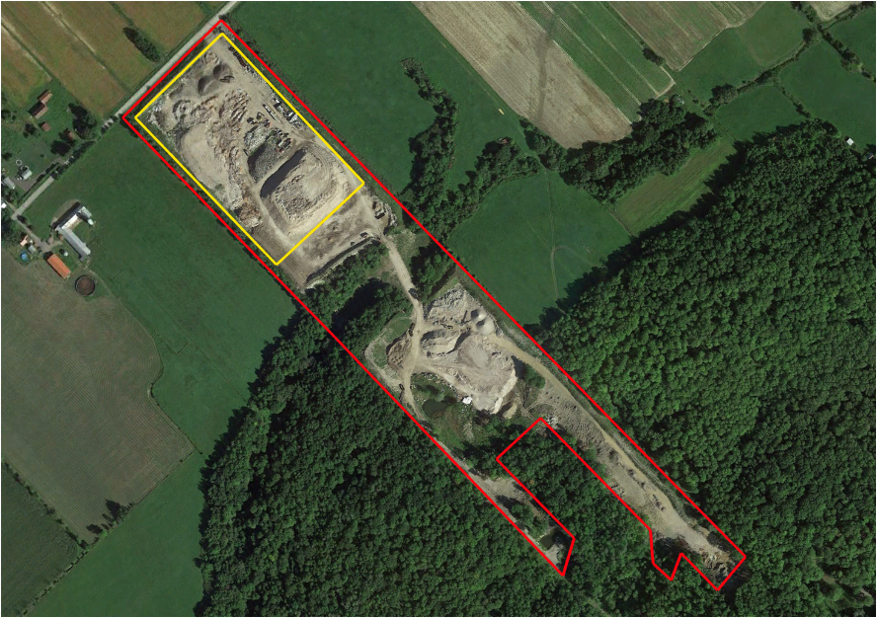
The yellow area is the actual limits of the toxic waste dump – this was approved by the Mohawk Council of Kanesatake for 33 years without free, prior and informed consent.

Aerial view of GNR toxic waste dump taking 3 times its’ allowable land infringing upon the Homelands of the Kanien’kehá:ka of Kanehsatà:ke. This is prime agricultural land that is surrounded in fact, by farmers
Given that the soil underneath the Kanehsatà:ke forests is fine and sandy, development-led deforestation presents threats of erosion and further ecological instability
Kanien’kehá:ka concerns is to protect our right to self-determination and to maintain the ecosystems on which we have depended on for millenia. The Rotinonhseshá:ka (Haudenosaunee) Kanien’kehá:ka of Kanehsatà:ke’s land rights have been denied and our territory subjected to state-imposed environmental violence for over 300 years. Resulting disputes are unresolved to this day In spite of our best efforts to resolve our over 300 year old land dispute, we have been unsuccessful. Canada remains tethered to the Doctrine of Discovery, in spite of passing legislation to implement the UNDRIP.
We as Indigenous Land Defenders have sent lawyer’s letter of Caution to a land developer who has admitted that the land he is selling belongs to the Kanien’kehá:ka of Kanehsatà:ke. He continues still to sell land which we have been helpless to stop.
Indigenous Affairs Canada has refused to intervene on all development, be it condo or toxic waste dump leaving the Kanehsatà:ke Land Defenders vulnerable to racist propaganda that criminalizes and ostracizes our peaceful efforts.
As for the toxic waste dump of GNR, a petition, social media campaign and enlisting the help of a member of Parliament to stop dumping, are the actions we have taken. Canada claims it is Quebec’s jurisdiction, Quebec claims it doesn’t want to interfere with ‘land claims’. We say enough stalling as we are losing our Homelands, its resources to contamination and dysfunctional systemic racist systems that not only stall a solution, but does not respect our rights to a healthy environment as we attempt to protect our rights to self-determination.

