Dear Dr. Marcos A. Orellana
I respectfully submit the information regarding ship’s sewage and food waste, in response to your invitation for submission to “impact analysis of the IMO” on issues related to SR toxics and human rights. It is hoped that this submission could contribute to the analysis of the main issues concerning protection of human health and the environment that the IMO should strengthen.
- Sewage
Our aqua environment has improved over the past century, thanks to our society’s initiative on sewage pollution control. The IMO’s MARPOL Annex IV, which regulates ships’ sewage (black water) was approved in the 1970s and entered into force in 2003. Sewage discharge to sea is prohibited, except when it is
- processed by a comminuting and disinfecting system (CDS) and discharged > 3nm land, or
- treated by an approved sewage treatment plant (STP), or
- discharged from a sewage holding tank > 12nm from land under certain conditions.
These options were mirrored as Type I, II and III Marine Sanitation Devices under the US rules implemented a few decades earlier. Sewage can also be offloaded to port reception facilities.
The effectiveness of these sewage rules has been questioned, and the MARPOL Annex IV is under revision now [1,2]. However, some important issues are left out of this work, such as 1) certified non-conformities, 2) grey water pollution, and 3) discharge of visible floating solids from sewage in high seas. These issues, if left unresolved, can deny the maritime industry from arriving at effective Annex IV.
  - Certified non-conformities
    - Regulatory regimes vs treatment performance
Marine Sewage Treatment Plants need to be type tested and approved. But the performance standard is applicable to type tests only, but not to the point of discharge during operation. Once in operation, there is no compliance monitoring or performance verifications. The IMO tightened the performance standard twice within 10 years, but in reality, the vast majority of STPs/MSDs discharge ‘virtually untreated sewage’ [3-6], widening the gap between rules and realities [7]. The extent of failure is unique and shocking in our society.
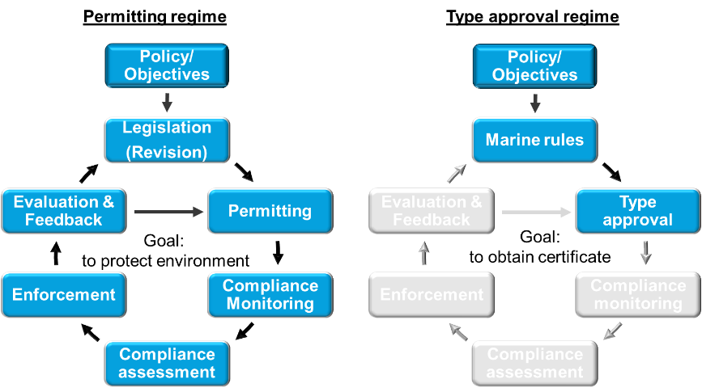
Wastewater industry on land has goal-based regulations by adopting a permitting regime that relies on compliance monitoring at the point of discharge to protect environment. The ‘regulatory cycle’ (figure) ensures evidence based, practicable, and sustainable regulations. They provide a level playing field that encourages the best technologies. Such permitting regime has been proven successful under Alaska’s large cruise compliance program for 20 years [8] – this is the only effective marine wastewater regulatory framework in the maritime industry.
In contrast, the type approval regimes are the foundation of marine equipment certification. When the vast majority of STPs failed to perform, people question training, operation and maintenance [3,9], but not the certified equipment itself. Such faith in the certified equipment is evidently misplaced.
    - Magic boxes and non-conformities
The core of type approvals is conformity. Sadly, many certified STPs have not conformed, some even contravened science.
Sewage treatment produces sludge, it is a fact. But many certified STPs have ‘no-sludge’. The IMO introduced a residual chlorine limit to reduce effluent toxicity, but STPs without a de-chlorination step remain certified to this day. As explained by the joint articles, these magic boxes contravene science [10,11].
The latest MEPC.227(64) Guidelines prohibit STP sewage sludge from being returned to its feed tank, because it would make the test invalid. Under the same Guideline, sending untreated grey water to an STP’s final stage became a non-conformity. Yet, multiple STPs have been certified with such non-conformities [12,13].
These certified “magic boxes” and non-conformities have plagued thousands of ships. They can be cheaper, smaller and ‘care-free’. STPs that conform to the rules have been ‘value-engineered’ to compete, losing their ability to perform during such a race to the bottom. Certificates of environmental technologies have been turned into licenses to pollute.
    - Corrective actions?
For many years, the calls for corrective actions have been dismissed by the approval authorities as skirmishes among equipment manufactures [14-16].
In 2018, in an historical and courageous attempt, one approval authority withdrew the certificate of a ‘no-sludge’ STP [17,18]. However, the root-cause was not revealed. The withdrawn STP remained a certified Type II Marine Sanitation Device. Other ‘no-sludge’ STPs are advancing by obtaining additional certificates [15,19].
To summarise, the certified non-conformities are wide-spread and persistent. They must be recognised and corrected in an effective and transparent way. While the type approval regime can have an important role in ensuring the sea worthiness of marine environmental technologies, its role in serving a goal-based environmental regulation needs to be supported by evidence.
  - Grey water
    - Grey water pollutes
A ship’s grey water comes from showers, wash basins, laundries, and galleys. The grey water has greater environmental impact than black water. Ignoring grey water pollution is illogical. But grey water remains unregulated after repeated attempts [20,21] – a startling contrast to the rules and practices of the rest of our society.
Unregulated grey water has also caused widespread non-conformities to existing rules and regulations. For example, sending grey water to the final stage of a STP is a non-conformity wrongly approved and promoted by the classification societies since 2016 [13]
Increasingly, grey water systems are becoming the dumping ground for the regulated wastes, such as food waste and food waste derivatives, often by design and by approval (see section 2).
    - Regulating grey water is a necessity
A ship’s sewage (black water) is far more concentrated than urban wastewater [22, 23, 24]. This is because it does not contain ground water infiltration, rainwater or grey water. In addition, ship’s vacuum collection system consumes only 10-20% of water comparing to a gravity flushing system, making ship’s sewage the most concentrated across all industries.
Ships also face additional challenges. Ship operators can never be as familiarised or dedicated to a STPs as full-time operators of municipal wastewater treatment plants (WWTP); ships have less space and poorer access; ships have far greater logistics challenges; ships pitch and roll, ships may use sea water flushing ...
Yet, the shipping industry is given the most stringent sewage treatment performance standard across all industries.
Regulating grey water can bring operational conditions closer to that on land. Afterall, STPs are type tested on land using urban wastewater that already contains grey water. In Alaska, where the large cruise environmental compliance program has been a proven success, black and grey water are regulated together.
Because grey water is often interconnected with black water on ships, regulating grey water can be essential for effective implementation of the proposed sewage management plan and record books [2], as well as to help resolve grey water related non-conformities.
To summarise, regulating grey water is a necessity for an effective Annex IV, and needs to be discussed and reviewed at the IMO.
  - Discharge of visible floating solids in high seas
    - Rules and practices
A ship’s sewage contains the so-called screenings material, which contains plastics, rags, wipes, and other spent sanitation products [24]. Its description under the MARPOL Annex IV is ‘visible floating solids’.
MARPOL Annex IV permits discharge of visible floating solids in high seas, via the notorious [25] Sewage Comminuting and Disinfecting Systems (CDS) at a distance of > 3 nm from land, or via the untreated sewage at > 12nm.
Annex IV prohibits visible floating solids in STP effluent, but this is not effective. Many STPs use ‘fine maceration’ instead of screens. Thousands of physical-chemical STPs are designed to be switched off at > 12 nm from land.
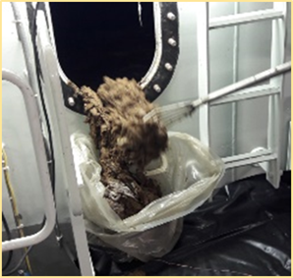
But the most important contributing factor is the sewage holding tank. Once sewage enters these tanks, much of the screenings material tends to form a thick layer of floating scum (photos). This scum layer is not readily broken up by a mixing device or removed by transfer pumps. Thus, the trapped screenings can only be flushed out on the high seas during periodical tank cleaning.
    - Why this needs to stop
The existing MARPOL Convention prohibits the discharge of plastics and garbage, from all ships and in all waters. Society in general has been working hard to keep sewage screenings and plastics from our natural environment [26, 27, 28].
Hence, ‘visible floating solids’ is a regulatory loophole which needs to be closed asap to achieve integrated and consistent marine waste regulations, and to align maritime industry with the best practices of our society.
- Food waste and food waste derivatives
  - National biosecurity laws and MARPOL Annex V
Food waste can disseminate plant pests and animal diseases such as swine fever, rabies, foot and mouth disease, or avian flu by international conveyances. Many countries have strict biosecurity laws to secure safe food sources, and to protect people’s livelihood and agricultural interests.
In Europe, international food waste is Category 1 Material which carries the highest level of risks [29]. In US territorial waters, food waste onboard or removed from a ship is ‘regulated garbage’ if the ship has been in any port outside the US and Canada within the previous 2-year period [30]. Canada has rules that mirror those of the US [31]. Australia considers international food waste a biosecurity risk [32,33]. In New Zealand, international food waste is regulated as ‘risk goods’ under its biosecurity laws [34,35].
Under these national biosecurity laws, food waste is to be secured onboard the vessel, and when applicable, transported in covered, leakproof, containers to approved facilities ashore, such as incineration plants and special landfill sites.
Alternatively, such food waste can be discharged outside the territorial waters, which is consistent with the requirements of MARPOL Annex V.
MARPOL Annex V permits three disposal routes for food waste: to the sea (> 3 or 12 nm from land), to an onboard incinerator, or to port reception facilities. The actual disposal route must be recorded in the Garbage Record Book.
Although Annex V makes no reference to national biosecurity laws, its implementation Guidelines MEPC.295(71) requires that food waste be directed to a holding tank when discharge to sea is prohibited. It also acknowledges the biosecurity requirements. Food waste carrying a risk of diseases or pests ‘should’ be kept separately and stored in clearly marked and tightly covered containers, and preferably retained for discharge at port reception facilities in accordance with the laws of the receiving country.
However, many ships are given non-compliant solutions by design and by approval.
  - Non-compliance
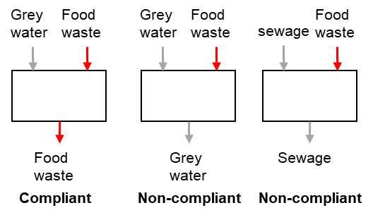
Annex V states that, when garbage is mixed with other substances having different discharge requirements, the more stringent requirements shall apply. Hence, when food waste is mixed with unregulated grey water, the mixture shall be regulated as food waste (figure). Likewise, the mixture of food waste and sewage shall comply with both Annex IV and V.
In reality, food waste and food waste derivatives have been connected to ship’s black and grey water systems [36], sometimes via food waste disposers [37], food waste reject water [38], and food waste digesters [39]. These systems are not labelled or managed as food waste, and hence these systems make food waste disappear, by design and by approval.
Such practices violate the international MARPOL Annex V and the national biosecurity laws because food waste and food waste derivatives can thus be discharged in disguise as sewage and grey water within territorial waters or to local environments via port reception facilities.
Such non-compliant designs have been endorsed by some Flag States and approved by classification societies, unfortunately at the expense of the agricultural interests of many Port States. Once approved and installed, little can be done by ship operators and masters, or even by the inspectors. Unchallenged, this non-compliance has become systematic and widespread over a decade.
The issues have been raised to maritime authorities for many years, as well as published as joint articles [36-39], but to no avail. The aviation industry, which is subject to the same biosecurity rules, serves as a startling contrast [40,41].
To summarise, food waste and food waste derivatives have been made to disappear by design and by approval. The systematic non-compliant practices against international marine rules and national biosecurity laws need to be recognised by the approval authorities, and the relevant inspection regimes. Greater clarity is needed to define international food waste in the context of marine operations.

The IMO has made striking and tangible progress in many areas of its environmental initiatives. However, there is room for improvement. The issues mentioned above are not on the agenda of the IMO’s MEPC or its subcommittees. Some of the issues have been outstanding for over a decade. It is important that the issues are recognised, and reviewed, so that both the environment and the industry can benefit from effective implementation of the goal-based regulations.

Yours sincerely

Wei Chen

Author  Dr Wei Chen  Future program development manager  Wartsila Water Systems Ltd  https://www.wartsila.com/marine/build/waste-treatment | Reviewer  Marie CAILLERIE,  former Flag State Representative at the IMO, Consultant for NauticaLex  https://nauticalex.com/

References
[1] MEPC 74/14, Norway, 2019,
[2] PPR 8/7, Norway, 2021.
[3] MEPC 71/INF.22, the Netherlands, 2017.
[4] PPR 7/16/1, China, 2019
[5] PPR 8/7/4, Iran, 2021
[6] https://beta.regulations.gov/document/EPA-HQ-OW-2019-0482-0013. Yearly data available for 2002-2020.
[7] http://178.62.53.118/articles/prevention-of-pollution-by-sewage-from-ships-rules-and-realities
[8] https://beta.regulations.gov/document/EPA-HQ-OW-2019-0482-0012. Yearly data available for 2002-2020.
[9] PPR 8/7/8, India, Japan, Liberia, Palau, Panama, Republic of Korea, CLIA, BIMCO and ICS, 2021.
[10] https://www.linkedin.com/feed/update/urn:li:activity:6770412800591376384/
[11] https://www.linkedin.com/feed/update/urn:li:activity:6757944192019816448/
[12] https://www.linkedin.com/feed/update/urn:li:activity:6764478961243226112/
[13] https://www.linkedin.com/feed/update/urn:li:activity:6761939034337017856/
[14] Monitoring required for compliance with standards, by W. Chen, Ship & Offshore, 2014
[15] https://www.linkedin.com/feed/update/urn:li:activity:6721362924335611904/
[16] MarED-18-746, POL-11 (MarED Internal Document), 2018.
[17] https://assets.publishing.service.gov.uk/government/uploads/system/uploads/attachment_data/file/803462/22.05.19_-_Safety_Bulletin_on_Tecnicomar.pdf
[18] https://www.linkedin.com/feed/update/urn:li:activity:6732701587682185216/
[19] https://www.maritime-executive.com/features/tecnicomar-overcomes-compliance-issues-and-launches-new-sewage-systems
[20] MEPC 72/26/6, FOEI, Greenpeace, WWF, CSC and Pacific Environment, 2018
[21] https://oceanconservancy.org/protecting-the-arctic/take-deep-dive/grey-water-passenger-vessels-alaska/
[22] https://www3.epa.gov/npdes/pubs/vgp_graywater.pdf
[23] https://helcom.fi/wp-content/uploads/2020/01/Technical-guidance-for-the-handling-of-wastewater-in-ports.pdf
[24] https://www.slideshare.net/WeiChen43/marine-wastewater-pollution-foeiwwf-11-may-2015-50245101
[25] https://www.maritime-executive.com/editorials/support-for-major-reshape-of-marpol-annex-iv
[26] https://www.epa.ie/pubs/advice/water/wastewater/EPA_water_treatment_manual_preliminary.pdf
[27] https://www3.epa.gov/npdes/pubs/final_sgrit_removal.pdf
[28] https://www.linkedin.com/feed/update/urn:li:activity:6766052931142791168/
[29] https://eur-lex.europa.eu/legal-content/EN/TXT/PDF/?uri=CELEX:02009R1069-20140101&from=EN; and https://eur-lex.europa.eu/legal-content/EN/TXT/?uri=CELEX:02011R0142-20190320
[30] https://www.govinfo.gov/content/pkg/CFR-1998-title7-vol5/pdf/CFR-1998-title7-vol5-sec330-400.pdf; and https://www.govinfo.gov/content/pkg/CFR-2012-title9-vol1/pdf/CFR-2012-title9-vol1-sec94-5.pdf
[31] https://laws-lois.justice.gc.ca/eng/regulations/c.r.c.,_c._296/page-5.html#docCont
[32] https://www.agriculture.gov.au/biosecurity/legislation and https://www.agriculture.gov.au/biosecurity/avm/vessels
[33] https://www.igb.gov.au/sites/default/files/documents/transhipment-vessel-stores.docx
[34] https://www.mpi.govt.nz/dmsdocument/19757/direct
[35] https://members.wto.org/crnattachments/2016/SPS/NZL/16_2249_01_e.pdf
[36] https://shipinsight.com/articles/vanishing-food-waste-flouts-maritime-and-national-law/
[37] https://www.maritime-executive.com/index.php/editorials/avoiding-non-compliance-in-ship-generated-food-wastes
[38] https://www.linkedin.com/feed/update/urn:li:activity:6709398505745649664/
[39] https://www.linkedin.com/feed/update/urn:li:activity:6742411045723287553/
[40] https://www.iata.org/contentassets/821b593dd8cd4f4aa33b63ab9e35368b/summary-icw-case-for-smarter-regulation.pdf
[41] http://www.mediacentre.gatwickairport.com/press-releases/2017/17_03_24_waste_plant.aspx

