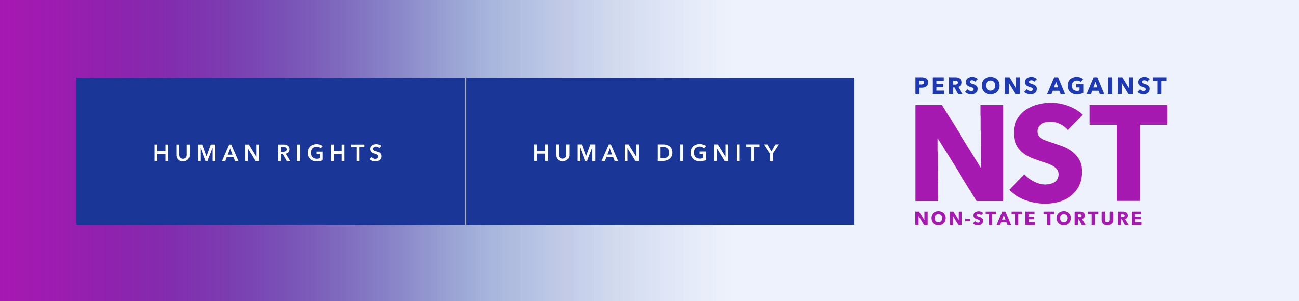

**Non-State Torture Crimes: The Most Underreported Global Human Rights Crime Perpetrated against Women and Girls—A Canadian Perspective**

By: Jeanne Sarson, MEd, BScN and Linda MacDonald, MEd, BN

Co-founders Persons Against Non-State Torture (NST), Human Rights Defenders

[www.nonstatetorture.org](http://www.nonstatetorture.org) | [contact@nonstatetorture.org](mailto:contact@nonstatetorture.org)

361 Prince Street, Truro, NS, Canada B2N 1E4 |

P: 1.902.895.6659 | C: 1.902.956.2117

A submission to Dr. Alice J. Edwards’, Special Rapporteur on Torture and Other Cruel, Inhuman or Degrading Treatment or Punishment, call for input to a report: “The duty to investigate crimes of torture in national law and practice.” Sent to email: [hrc-sr-torture@un.org](mailto:hrc-sr-torture@un.org), 22 November 2022

**Introduction**

Having just learned of this call for submissions we are short on time so share:

1. Canada’s law on torture,
2. Specific knowledge with recommendations based on our almost 30 years of independent scholarship, participatory research, and grassroot supporters and human right defenders of women who survived family and non-family non-State torture crimes,[1]and
3. Information of our participation to involve women who survived non-State torture crimes and their supporters in the “Stop Non-State Torture: Enforce the Human Rights of Women & Girls” Exhibition held on 14 to 17 November 2022, in the United Nations Rotunda in Vienna.[2]

**Canada’s Law on Torture**

Canada’s law on torture is State-centric and defined in the *Criminal Code of Canada* as:[3] Section **269.1** **(1)** Every official, or every person acting at the instigation of or with the consent or acquiescence of an official, who inflicts torture on any other person is guilty of an indictable offence and liable to imprisonment for a term not exceeding fourteen years.

**Definitions: (2)** For the purposes of this section, ***official*** means

**(a)** a peace officer, **(b)** a public officer, **(c)** a member of the Canadian Forces, or **(d)** any person who may exercise powers, pursuant to a law in force in a foreign state, that would, in Canada, be exercised by a person referred to in paragraph (a), (b), or (c), whether the person exercises powers in Canada or outside Canada; (*fonctionnaire*)

***torture*** means any act or omission by which severe pain or suffering, whether physical or mental, is intentionally inflicted on a person

**(a)** for a purpose including

**(i)** obtaining from the person or from a third person information or a statement,

**(ii)** punishing the person for an act that the person or a third person has committed or is suspected of having committed, and

**(iii)** intimidating or coercing the person or a third person, or

**(b)** for any reason based on discrimination of any kind, but does not include any act or omission arising only from, inherent in or incidental to lawful sanctions. (*torture*)

**No defence**

**(3)** It is no defence to a charge under this section that the accused was ordered by a superior or a public authority to perform the act or omission that forms the subject-matter of the charge or that the act or omission is alleged to have been justified by exceptional circumstances, including a state of war, a threat of war, internal political instability or any other public emergency.

**Evidence (4)** In any proceedings over which Parliament has jurisdiction, any statement obtained as a result of the commission of an offence under this section is inadmissible in evidence, except as evidence that the statement was so obtained.

**Regulatory Frameworks: Canada’s State-Centric Law Misnames Non-State Torture Crimes**

**The United Nations Committee against Torture-Canada Session**

Social and legal patriarchal discrimination has existed globally for decades in that torture committed by non-State actors, predominately against women and girls, is not criminalized as a torture crime. A previous Special Rapporteur on torture Juan Méndez noted that historically the framework on torture crimes was globally seen as “disproportionately affecting men” (Méndez, 2018).[4] Such global discrimination reflects human rights patriarchal misogynistic conditioning given that articles of the 1948 United Nations Universal Declaration of Human Rights told women they had human equality with the right not to be subjected to torture.[5]

Similarly noted, was this response of Claudio Grossman, Chair of the United Nations Committee on Torture, to Mr. Kessel a representative from Canada. Mr. Kessel informed the Committee it should refrain from asking questions . . . relating to violence against women or trafficking in persons.[6] Mr. Grossman said “the Committee could not affect [this] due to its obligations to the Convention; discriminatory treatment for women or men that could constitute torture was clearly listed in article 16.”[7] Although the Committee recommended Canada had a duty to incorporate torture by non-State actors within its national law, Canada rejected this as a soft law recommendation explaining that;

Canada’s longstanding view is that the general comments and concluding observations of the UN treaty bodies are not legally binding. General comments and concluding observations of the treaty bodies, and this includes the Committee against Torture, are given serious consideration by governments in Canada, but Canada’s view is that States Parties are not legally bound to implement them (E. Brady, personal communication, July 11, 2013).

Honourable Jody Wilson-Raybould, P.C., Q.C., M.P., Minister of Justice and Attorney General of Canada, reinforced this State-centric legal position saying (written correspondence, 9 January 2017):

Under the Criminal Code, the existing specific offence of torture is meant to deter the infliction of pain and suffering by persons acting on behalf of a state for state purposes such as obtaining information or a confession. This policy was set by the Convention against Torture and Other Cruel, Inhuman or Degrading Treatment or Punishment . . . The enactment of the Criminal Code offence of torture in 1985 implemented this treaty obligation in Canadian law. . . .

Please be assured that the Government of Canada takes the interests of victims of crime very seriously and is committed to ensuring the safety and protection of all Canadians.

She further suggested that *Criminal Code* offences such as aggravated assault address non-State torture crimes.

**Bill C-242, An Act to Amend the Criminal Code (inflicting torture)**

This Private Member’s Bill C-242 was introduced into the House of Commons by Mr. Peter Fragiskatos, M.P., February 26, 2016.[8] It passed Second Reading and was referred to the Standing Committee on Justice and Human Rights, April 21, 2016.[9] The Committee recommended the Bill not proceed, November 29, 2016.

We gave testimony on NST crimes to this Standing Committee. The Committee also received a brief from Alexandra Lane, explaining she was born into a NST family, escaping by fleeing Canada, and her husband and advocate, Robert G. Holodak, Jr., describing the importance that non-State torture victimization be criminalized as a torture crime.[10] Alexandra Lane also sent the Committee her “Victim Impact Statement” stating:[11]

*[W]ords chosen and language used is vital for the victims. Accurately naming the crime gives the victims a sense of empowerment. I, along with all torture victims don’t get to name the crime committed against us…*

*Instead of getting some control back we get more taken from us.*

*As a victim it is so simple. Anyone who has been through or cares about someone who has been through non-State torture would say it is a crime. Period.*

*Unless this crime is named ‘torture’ I won’t be an actual person. I will always be the dirty object with no rights.*

**Defining the Crime**

Women we support have strong re-victimization responses when society and legal systems fail to criminalize acts committed by non-State torturers as a torture crime;

The *International Classification of Crime for Statistical Analysis* has four criteria that must be met when defining a crime.[12] These are:

1. Define the **behaviours** **or actions** of the perpetrators—of non-State torturers;  
  
2. Define the perpetrators’ **intentionality**—torturing another human being is never accidental and neither is their use of tools for torturing;  
  
3. Define **who** **is being** **victimized** bythe perpetrators—predominately millions of women and girls—daughters, sisters, and a spouse.[13]   
   
4. Define the **relationship** between perpetrators and the persons they torture—parents, like-minded family members, others known & unknown, groups, gangs, human traffickers, pimps, buyers, pornographers, or employers.

Perpetrators of acts of non-State torture meet the four defining criteria of being a crime.

**Family and Non-Family Non-State Torture Crimes**

This section shares our nursing-based grassroot science developed over almost 30 years assisting women recover and heal from torture and exploitation organized and committed by family and non-family non-State actors. These non-State actors include parents, family and non-family like-minded such as human traffickers and various other exploiters, organizing criminal informal networks for their ultimate intentional pleasure of torturing the girls and women—their daughters or spouse—treating them as non-human. Some women tell us, that they perceived them-Self as an “it,” or a “nothing”[14] as Sara did, the first woman who sought our support.[15]

**Evidence Collection and Innovation: Grassroots Science of Non-State Torture Victimization and Recovery**

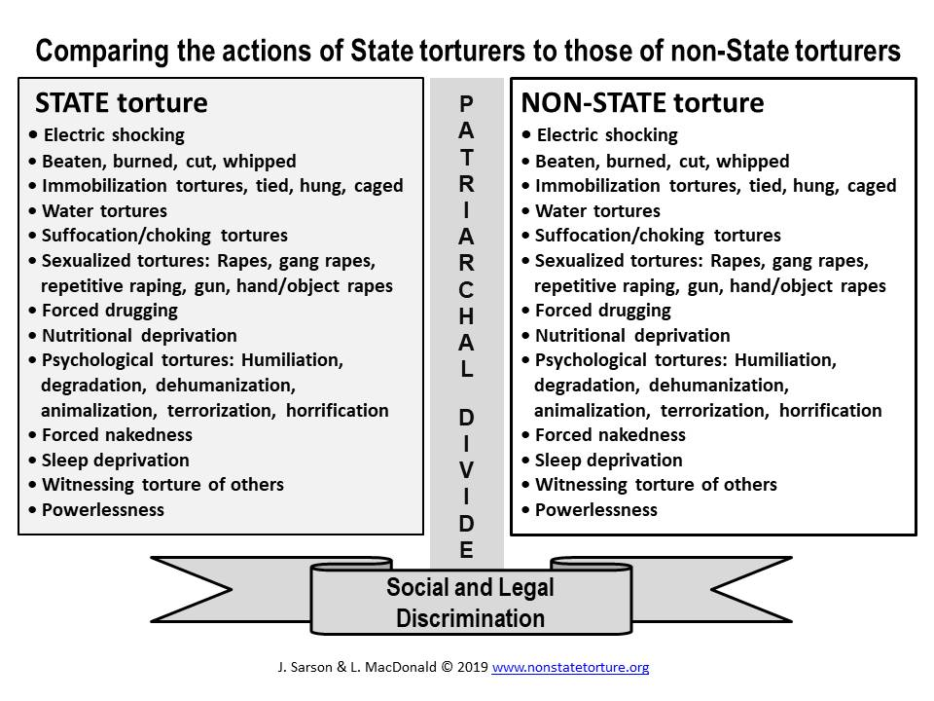Fig. 1: Patriarchal Divide Model

Developing our grassroots science of non-State torture (NST) informed care began in 1993 when Sara sought our support, disclosing acts of NST victimization. Unable to find NST informed support for her in Canada, we decided not to abandon her. Knowledgeable literature defining NST and recovery were fairly non-existent. To create a NST definition we researched how the United Nations Special Rapporteurs and NGOs such as Amnesty international defined acts of State torture, often referred to as “classic” torture, we developed the “Patriarchal Divide Model, figure 1. This model revealed that State and non-State torturers inflict the same or similar acts of “classic” torture.

We also developed a universal participatory NST questionnaire. It breaks down the different forms of “classic” NST into 48 specific acts. Shared as figure 2, is Sara’s response to the questionnaire plus she added additional forms of NST, specifically related to psychological conditioning that kept her normalizing NST victimization since infancy. While electric shocking is a distinct form of classic torture as is water torture; however, we broke water torture down into forced submersion in a tub, toilet, bucket, or stream. Physical tortures were broken-down into being burnt, cut, whipped, and limbs twisted or broken, for example. Sexualized tortures included torture-raped by one or more individuals, with objects, animals, and forced impregnation and violent abortions. Also listed were chemical torture or forced polydrugging; immobilization tortures included being tied down; choking, suffocation, and being sat on were examples of life-threatening acts. Degradation, humiliation, and dehumanization, included being treated as non-human, provided further insights into the meaning of NST victimizations. Utilizing this questionnaire assisted primarily women to Self-identify the acts non-State torturers inflicted against them and they often send us extra comments as this woman did, saying:[16]

*I was not abused, I was tortured! Torture is SO TOUGH. I am recovering, but it is crucial to call it by its real name. I am even more encouraged to do so after filling out this survey*.[17]

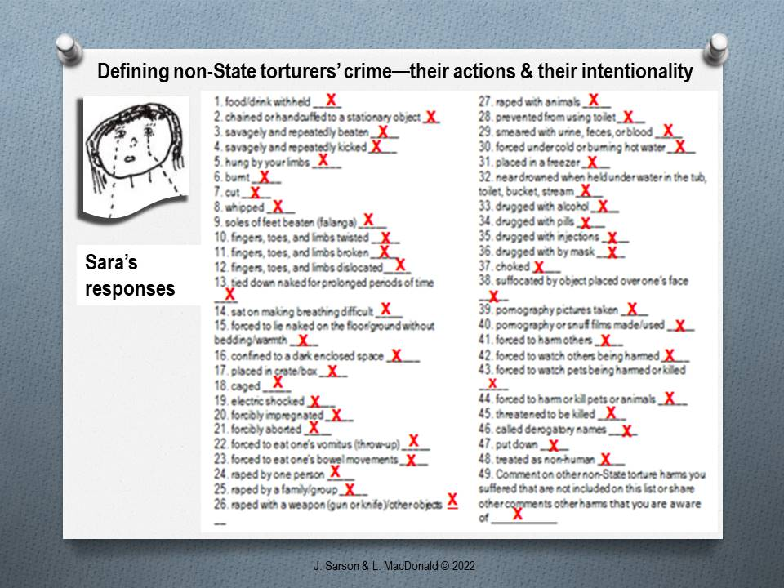Fig. 2: Universal Participatory Non-State Torture Questionnaire

**Further Global Validation**

We further verified that State and non-State torturers inflict comparable acts of “classic” torture by examining what women we support, from Canada, the U.S., the UK, Western Europe, Australia, and New Zealand, described surviving to that of: [18]

1. 100 Mexican women arrested, jailed, and tortured by security forces, police, army and navy members,[19] and
2. 100 Asian and African women who immigrated to the UK tortured mainly by State actors but also by non-State actors.[20]

The outcome showed that similar atrocities are intentionally and purposefully committed by State and non-State torturers.

**NST Victimization-Traumatization Informed Care**

In 2008 the Committee against Torture released General Comment No. 2. It stated that if State parties are reasonably aware that torture by non-State actors is occurring and fail to exercise their due diligence this enables non-State actors to commit torture with impunity.[21] When this General Comment was released it offered validation that NST crimes existed; this validation came 15 years after we had begun supporting women, in 1993, who described surviving NST crimes.

The most supportive literature validating our developing practices arrived in 1997 articles by Ochberg,[22] and Shatan,[23] describing their work with U.S. Vietnam veterans. Their articles validated the *NST victimization-traumatization informed care* *model* we developed.[24] To assist women recover and heal we had learned that an average meeting lasted two hours but up to seven hours when intense terror, horror, and torture memories, including cellular “body talk” memories, were being re-remembered. This integration is intense and painful work when women’s bodies release torture pain memories. But when processed they recover and heal. Ochberg voiced what we came to know, “that people victimized by acts of human cruelty and evil need to tell their victimization ordeals more than they need to tell their consequential traumatization responses.”[25] Our experience and conclusion is that NST must be identified as a torture crime and the care needed for recovery be NST victimization-traumatization informed.

**A Resource: The Non-State Torture Wheel**

We developed the non-State Torture Wheel, shown as figure 3, with a fact sheet as a resource to assist others gather insights into the actions of non-State torturers’ crimes.[26]

Understanding the NST Wheel begins with the outer black ring which names non-State torturers’ expressions of power and pleasure. Women repeatedly said the torturers had pleasure torturing them as children or adults. Profit can occur if women or girls are also trafficked and exploited. The inner black half-circles reinforce naming non-State torturers’ power and pleasure, or fun, they derive committing acts of NST, as described in the wheel’s eight segments. Cover of respectability refers to non-State torturers’ efforts to prevent being exposed. They are from any social class. Naming organized networks refers to the connections they can have to like-minded individuals, groups, or rings who perpetrate NST crimes. These criminal informal networks can be local, national, or international when trafficking the women and girls.

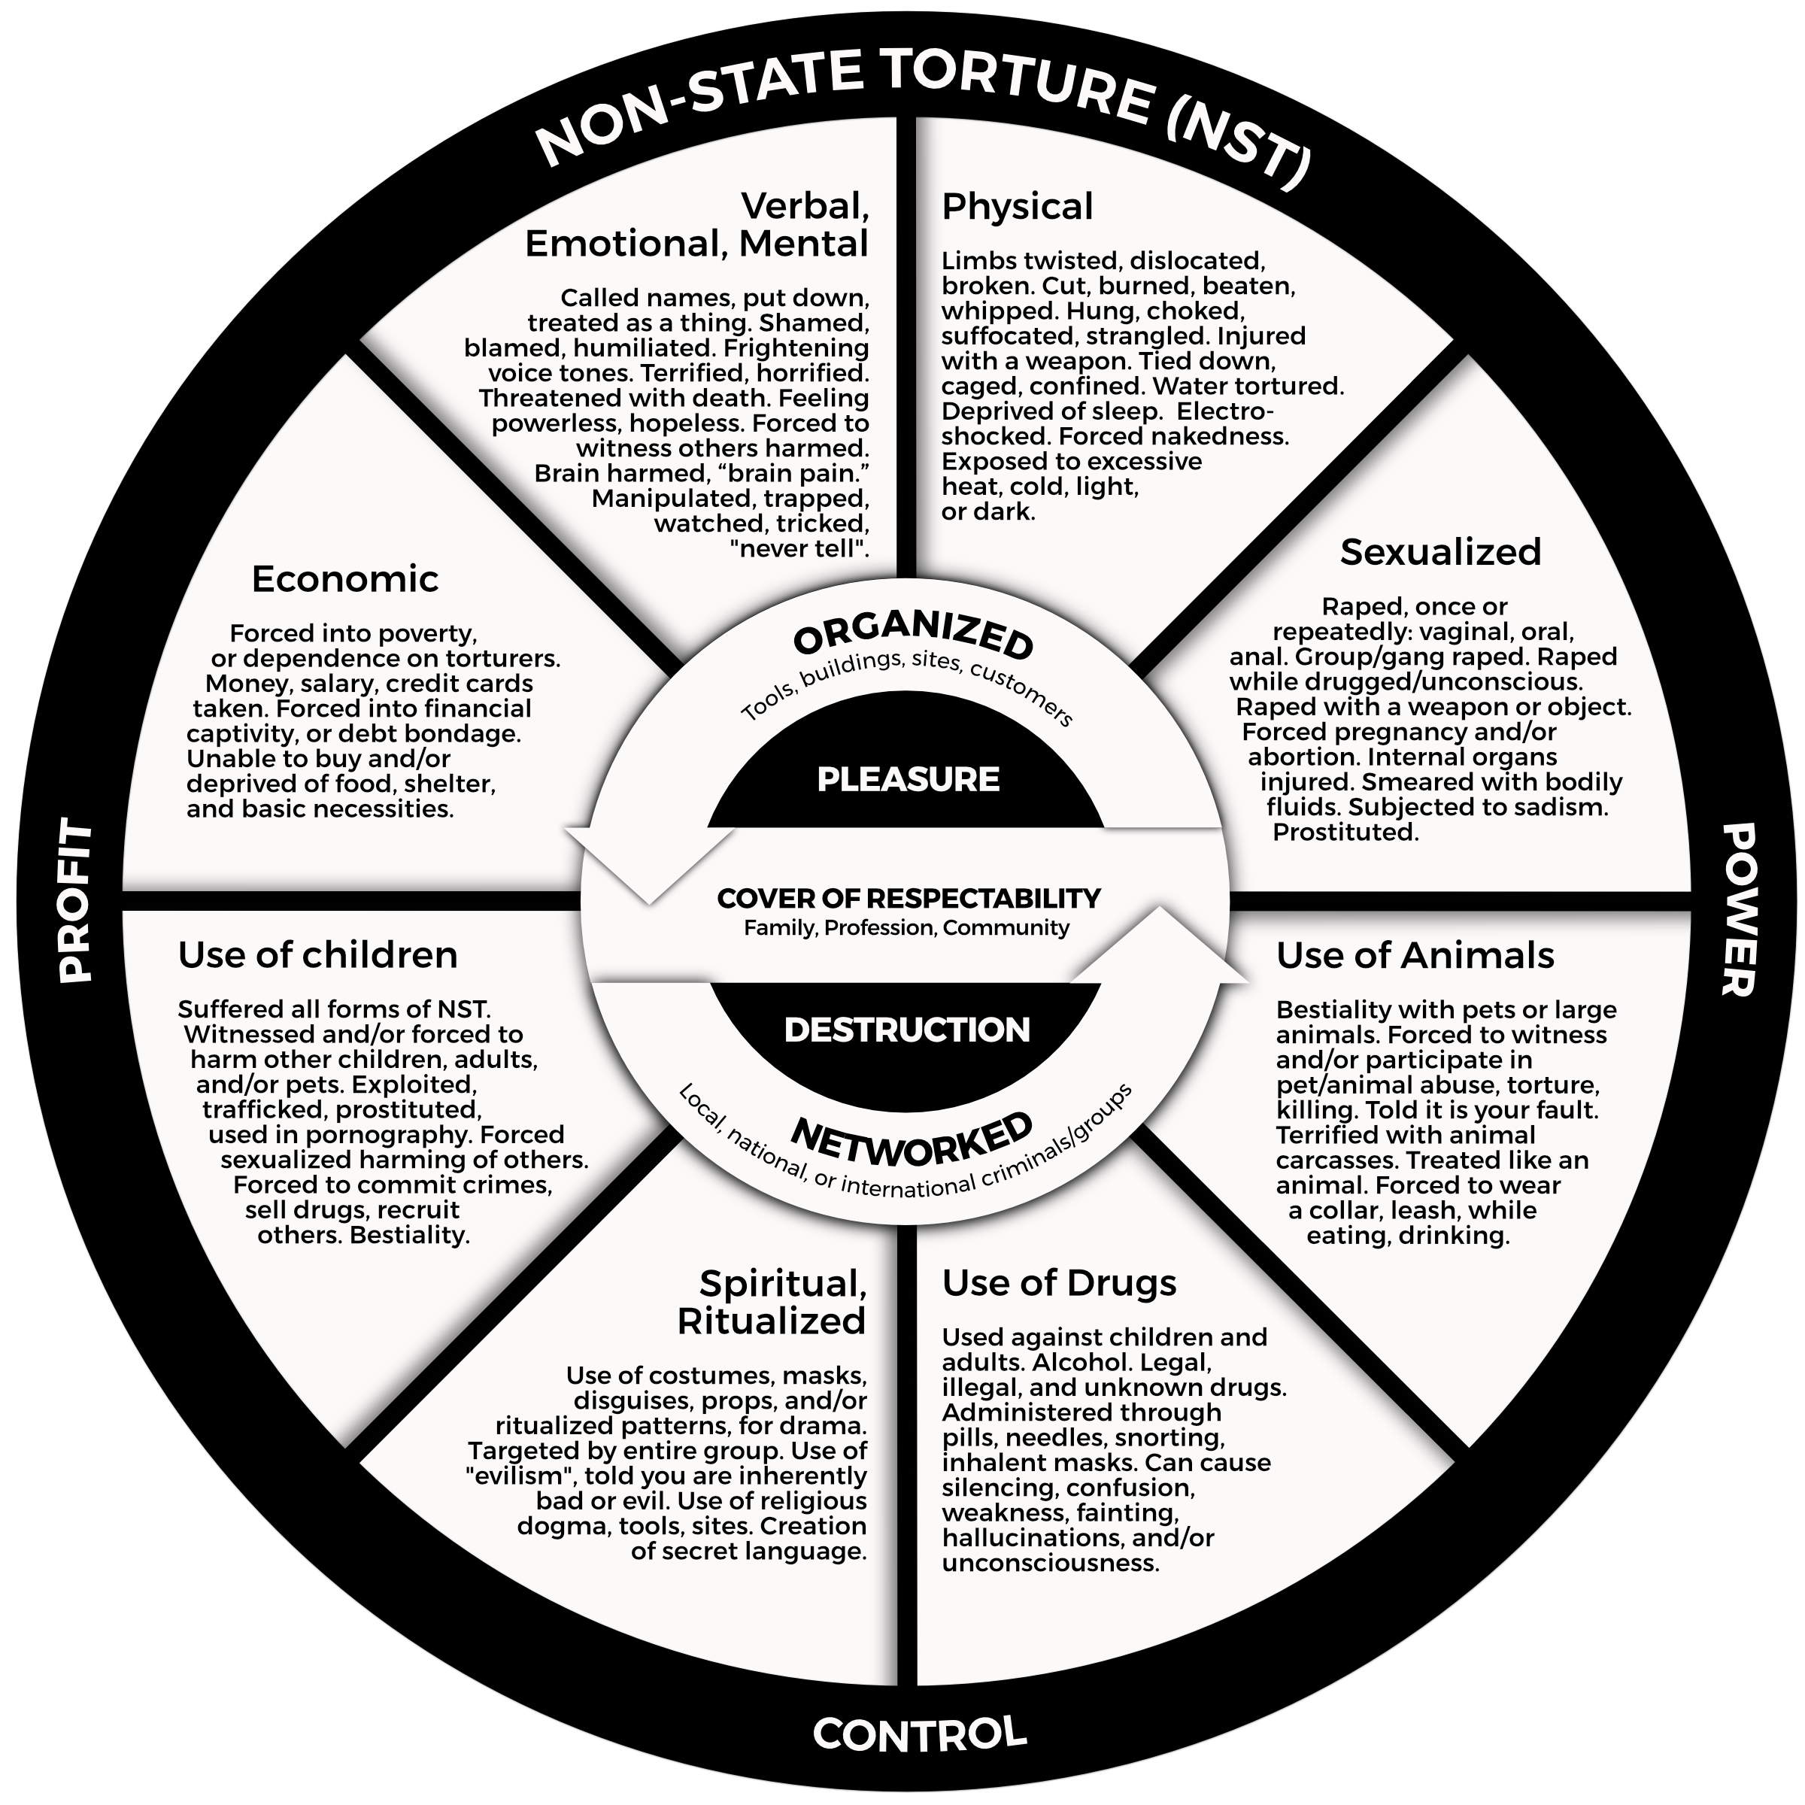

Fig. 3: Non-State Torture (NST) Wheel

**NST Victimization: Women’s Participation and Protection**

**Stop Non-State Torture Exhibition**

This exhibition event was organized and coordinated by members of the non-State torture working group of the Alliance of NGOs on Crime Prevention and Criminal Justice, in cooperation with the NGO Committees on the Status of Women and on Sustainable Development Vienna.

Fig. 4: Art of Elizabeth Gordon

As independent members of the Alliance,[27] and the NST working group,[28] we participated by recording 15 videos, of two to three minutes each, of seven women who spoke of the NST crimes committed against them as children and or as adults.[29] The remaining eight videos were of advocates, including two male partners of two women who spoke of the NST crimes committed against them. In addition, with women’s consent, we shared some of their art and drawings depicting NST victimization and or their recovery, which are recorded in the “Walkthrough NST Exhibition.”[30] One example, figure 4, is the art work of Elizabeth Gordon which was used as the flyer to promote the NST educational exhibition supported by the State parties of Honduras and Finland.

**A Declaration on Ending Non-State Torture Crimes**

Our next step is to support women from many countries who tell us, that the non-State torture crimes they suffered are legally invisibilized. Consequently;

**Non-State torture is the most underreported human rights crime committed against women and girls. We propose the establishment of a declaration focused on developing global awareness to end non-State torture crimes.**

1. Sarson, J., & MacDonald, L. (2021). *Women unsilenced: Our refusal to let torturer-traffickers win*. FriesenPress. <https://nonstatetorture.org/research/our-book-women-unsilenced>
2. See <https://nonstatetorture.org/application/files/9916/6749/3401/NSTUNViennarotundaflyer.pdf>
3. Government of Canada. (2020, October 19). *Torture*. <https://laws-lois.justice.gc.ca/eng/acts/C-46/section-269.1.html#:~:text=269.1%20(1)%20Every%20official%2C,term%20not%20exceeding%20fourteen%20years>
4. Méndez, J. E. (2018). *Introduction*. In Center for Human Rights & Humanitarian Law Anti-Torture Initiative (Ed.), *Gender perspective on torture: Law and practice* (pp. xi-xiv). <https://www.wcl.american.edu/impact/initiatives-programs/center/documents/gender-perspectives-on-torture/>
5. See <https://www.un.org/en/about-us/universal-declaration-of-human-rights>
6. Committee against Torture. (2012). *Summary record (partial)* of the 1076th meeting* (CAT/C/SR.1076), para 12. Geneva, CH: United Nations.
7. *News & Media*. (2012). Committee against torture hears replies of Canada*,* p. 4*.* Geneva: United Nations.
8. See <https://www.parl.ca/DocumentViewer/en/42-1/bill/C-242/first-reading>
9. See Private members’ Business Criminal Code <https://www.ourcommons.ca/DocumentViewer/en/42-1/house/sitting-44/hansard>
10. Lane, A., & Holodak, R.G. (2016). *Brief to: The House of Commons Standing Committee on Justice and Human Rights in view of its study of bill c-242 an act to amend the Criminal Code (inflicting torture).* <https://www.ourcommons.ca/Content/Committee/421/JUST/Brief/BR8406577/br-external/LaneAlexandra-e.pdf>
11. Lane, A. (2016). *Victim Impact Statement from Alexandra Lane Re: Bill C-242 An act to amend the criminal code (inflicting torture).* [*https://www.ourcommons.ca/Content/Committee/421/JUST/Brief/BR8486871/br-external/LaneAlexandra-2016-10-15-e.pdf*](https://www.ourcommons.ca/Content/Committee/421/JUST/Brief/BR8486871/br-external/LaneAlexandra-2016-10-15-e.pdf)
12. See <https://www.unodc.org/documents/data-and-analysis/statistics/crime/ICCS/ICCS_English_2016_web.pdf>
13. Nowak, M. (2008). Report of the Special Rapporteur on torture and other cruel, inhuman or degrading treatment or punishment [A/HRC/7/3]. UN General Assembly.
14. See note 1, Sarson & MacDonald. (2021). Women unsilenced.
15. Sara is not this woman’s real name; it is the name she chose to protect her identity.
16. See note 1, Sarson & MacDonald, Women Unsilenced.
17. See note 1, Sarson & MacDonald, Women Unsilenced, 289.
18. Jones, J., Sarson, J., & MacDonald, L. (2018). How non-state torture is gendered and invisibilized: Canada’s non-compliance with the committee against torture’ recommendations. In Center for Human Rights & Humanitarian Law Anti-Torture Initiative (Ed.), *Gender Perspectives on Torture: Law and Practice* (pp. 33–56). <https://www.wcl.american.edu/impact/initiatives-programs/center/documents/gender-perspectives-on-torture/>
19. Amnesty International. (2016). *Surviving death police and military torture of women in Mexico*. London, UK: Author.
20. Smith, E., & Boyles, J., (2009*). Justice denied:* *The experiences of 100 torture surviving women of seeking justice and rehabilitation*. London, UK: Medical Foundation for the Care of Victims of Torture.
21. Committee against Torture. (2008). *General comment no. 2 Implementation of article 2 by state parties* (CAT/C/GC/2). Geneva, CH: United Nations.
22. Ochberg, F. M. (1997). Introduction: Twenty years after defining PTSD. *Mind & Human Interaction*, *8*(4), 201–203.
23. Shatan, C. (1997). Living in a split time zone: Trauma and therapy of Vietnam combat survivors. *Mind & Human Interaction, 8*(4), 204–222.
24. See note 1, Sarson & MacDonald, Women unsilenced.
25. See Jones, Sarson & MacDonald. (2018). How non-state torture is gendered and invisibilized.
26. See <https://nonstatetorture.org/application/files/7415/3694/3648/NSTwheelFACTSHEETkeepv2.pdf>
27. See <https://crimealliance.org/>
28. See <https://crimealliance.org/what-we-do/nst/>
29. Persons against Non-State Torture (2022, October). *Exhibition: Stop non-state torture – Enforce the human rights of women & girls* [Video]. YouTube. <https://www.youtube.com/watch?v=yv5UpnVu1sY>
30. Persons against Non-State Torture (2022, October). Walkthrough NST exhibitions [Video]. YouTube. <https://www.youtube.com/watch?v=5o4nicsd8lE&t=87s>