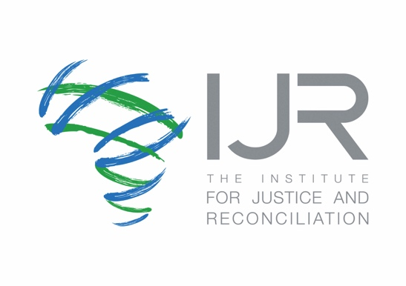

Report on the Impact of Counter-Terrorism on Peacemaking, Peacebuilding, Sustaining Peace, Conflict Prevention and Resolution

Submission by the Amanda Lucey, Senior Project Leader at the Institute for Justice and Reconciliation

Terrorism on the African continent is rising, encompassing 48% of global terrorism deaths in 2021, according to the Global Terrorism Index. Countries and regions previously seen to be less at risk of terrorism, such as Mozambique and Southern Africa more broadly, are increasingly witnessing spates of attacks. This suggests that current approaches to Counter-Terrorism (CT) and Preventing Violent Extremism (PVE) in Africa need to be revisited.

Currently, the United Nations Security Council (UNSC) counter-terrorism (CT) framework largely reflects the concerns of the Global North, particularly the views of some members of the Permanent Five (P5). For example, the United Nations Security Council (UNSC) Counter-Terrorism (CT) framework often focusses on thematic issues such as Foreign Terrorist Fighters and imposing targeted sanctions on those supporting terrorism. These resolutions have included sanctions against all individuals, and entities associated with Al-Qaida and/or the Taliban and/or the Islamic State in Iraq and the Levant (ISIL) (Dae’sh) and their affiliates. Later sanctions also extended specifically to Africa, including against the Islamic State West Africa Province, the Islamic State in the Greater Sahara, and ISIL – Libya.

In the African context however, insurgent groups that operate under ISIL influence are fragmented and localized, often drawing on socio-economic grievances and operating under a “marriage of convenience.” Africa also struggles with other regional groups, such as Boko Haram in West Africa, Jama'at Nasr al-Islam wal Muslimin (JNIM) in the Sahel region, and Al Shabaab in the Horn of Africa, that have not been the subject of UNSC resolutions or action. The African Union (AU) and other regional organizations spend a significant amount of time and resources implementing the UNSC framework under Chapter VII of the UN Charter, even though it is not always applicable to the African context. UNSC statements laud the work of these organisations but stress the responsibility that regional organizations have in securing human, financial, logistical, and other resources, thereby placing most of the responsibility for taking action on Africa.

In Africa, insurgent groups draw on socio-economic grievances and operate in situations of conflict. Governance is therefore a key issue that needs to be addressed. Until now, the work of the AU has been somewhat disjointed and has failed to adequately consider the root causes of conflict on the continent, including governance and human rights violations by Member States. It is unclear where Countering and Preventing Violent Extremism (C/PVE) will be located under the new reforms, but previous governance structures failed to be adequately integrated into the AU’s Peace and Security Architecture. More importantly, African Union Peace and Security Council (AUPSC) decisions on governance have been inconsistent, as crises in Mali, Sudan, and Zimbabwe have shown, with the AU alluding to principles of sovereignty and non-interference as a reason for failing to hold Member States accountable. As such, there is a need to move towards a human-security focussed approach, that is people-centred, prevention oriented and comprehensive. The UN can better therefore incorporate African priorities, needs and perspectives by broadening the work of the Counter-Terrorism Committee Executive Directorate (CTED) to consider governance and human rights, placing African C/PVE issues more firmly on the UNSC agenda, and by considering UNSC resolutions on human security and C/PVE.

Human rights concerns are also a serious problem across African CT responses, which have manifested in various ways, such as through legislation, disregard for the protection of due process and rights, and extrajudicial killings. Bilateral engagements, where some African countries have brought in private military contractors to support government efforts to root out armed groups, have also posed challenges in terms of human rights standards and accountability. In CAR, the Wagner group (a Russian mercenary group thought to be linked to the Russian government – an accusation that Russia emphatically denies) has supported a weak government and its interventions have been characterized by many, including the UN, as flouting human rights principles, such as through the indiscriminate killing of Muslims, which are likely to only drive radicalization. The definition of terrorism is also problematic in many African countries. As such, the UN and AU should develop a technical working group to highlight problematic definitions of terrorism among African Member States and strengthen the connection between the implementation of UNSC resolutions and human rights and democracy, in collaboration with the APSA. The UN can also provide technical and financial support to the AUPSC to develop multilateral approaches that enforce accountability and transparency in terms of human rights, especially in terms of counter-terrorism operations.

State-centric responses also fail to provide meaningful engagement with civil society actors, with a lack of clarity on roles and responsibilities. In this regard, there is also a need to prioritise civil society engagement in C/PVE, and to share innovative multi-stakeholder and community-led approaches to C/PVE from around the world to demonstrate good practices to the African continent. A good example is found in Kenya, which has developed country-level PVE action plans in addition to its national PVE action plan, supported by calls for robust collaboration between National and County governments and civil society organizations, but this needs to be better supported financially and technically.

In sum, addressing CT and C/PVE approaches in Africa requires a comprehensive, context-specific and prevention-oriented approach, that involves a wide range of stakeholders. It is important to draw on the wide range of tools available for conflict prevention and peacebuilding. Addressing governance and human rights should be at the heart of any response.

For more detailed information please see https://resolvenet.org/research/lessons-africa-20-years-un-security-council-counter-terrorism-policy.

UNSC Counter-Terrorism Committee Executive Directorate (CTED), Civil Society Perspectives: ISIL in Africa – Key trends and Developments, April 2022, https://www.un.org/securitycouncil/ctc/sites/www.un.org.securitycouncil.ctc/files/files/documents/2022/Apr/cted_civil_society_perspectives_isil_in_africa_april_2022.pdf
UNSC, Statement by the President of the Security Council, 04 December 2020, https://www.securitycouncilreport.org/atf/cf/%7B65BFCF9B-6D27-4E9C-8CD3-CF6E4FF96FF9%7D/s_prst_2020_11.pdf
United Nations Human Rights Office of the High Commissioner (UNHCR), CAR: Experts alarmed by government’s use of “Russian trainers”, close contacts with UN peacekeepers, UNHCR, 31 Match 2021, https://www.ohchr.org/en/NewsEvents/Pages/DisplayNews.aspx?NewsID=26961&LangID=E

