Victor Madrigal-Borloz
United Nations Independent Expert on sexual orientation and gender identity

January 15, 2023

Re: Submission to the report on FoRB and SOGI

Dear Mr. Victor Madrigal-Borloz,

Please find enclosed our input to your thematic report on exploration of the right to freedom of religion or belief (FoRB) in relation to sexual orientation and gender identity (SOGI). This is a joint submission by two allied but distinct entities: the Metropolitan Community Church of Toronto (“MCC Toronto”) and Rainbow Faith and Freedom (“RFF”), a non-profit organization based in Toronto.

MCC Toronto is a progressive, inclusive, Christian-based LGBTQ+ church, spiritual community and human rights organization. While its roots are Christian and LGBTQ+, MCC Toronto welcomes all and is made up of a diverse community. It is part of the broader Universal Fellowship of Metropolitan Community Churches denomination, which was founded in 1968 by an out gay former Pentecostal pastor, Troy Perry. The two primary contributors from MCC Toronto to this report are Reverend Junia Joplin, Associate Pastor of Programs and Congregational Care, and Bennett Jensen, Director of Human Rights. A pastor for 20 years, Rev. Joplin holds a Master of Divinity from the Baptist Theological Seminary at Richmond and has pursued further education at Harvard Divinity School and Columbia Theological Seminary. She has been named as one of Canada’s Top 25 Women of Influence and received the Canada 150 Community Leadership Award from the Parliament of Canada. Bennett Jensen is a lawyer and human rights advocate who has practiced law in the United States and in Canada, served as the Director of Litigation to Canada’s Minister of Justice and Attorney General, and has been recognized as one of the top young lawyers in the United States.

For 40 years, the senior pastor of MCC Toronto was Reverend Dr. Brent Hawkes. During this time, Rev. Dr. Hawkes presided over the first legal same-sex marriages in the world and became a renowned internationally-recognized social justice activist. He has received the Order of Canada, the Order of New Brunswick and three honorary degrees for his work on behalf of diverse SOGI communities. Upon his retirement from MCC Toronto, Rev. Dr. Hawkes founded RFF with a mission to combat religious-based LGBTQ+ discrimination. RFF is an organization that transforms the hearts and minds of individuals to make the world a safer and more inclusive place for LGBTQ+ people by confronting and ending religious-based homophobia and transphobia. Along with Rev. Dr. Hawkes, RRF’s Stephen Low, the Faith-Based Resources Team Lead, is a primary contributor to this submission. Mr. Low holds a PhD from Cornell University and has taught in the Department of Gender and Women’s Studies at Trent University. His research focuses on queer theory, sex and sexuality, gender, race, cultural studies, and gay culture.

Our input into the requested topics is informed by the identities and backgrounds of these four primary contributors. As follows, we have responded to questions 1-4, 7 and 11.

1. What are the actual or perceived points of tension (if any) between the right to manifest one’s freedom of religion or belief, and freedom from violence and discrimination based on sexual orientation and gender identity? Are there any areas in which they are mutually exclusive?

This question turns on the meaning of “manifest.” MCC Toronto and RFF submit that the protection of freedom of religion is critical in free societies, and, indeed, members of both entities have benefited greatly from this right. The protection of freedom of religion would generally extend to the right to manifest (meaning to “display or show”) one’s freedom of religion or belief. However, tension arises when “manifest” is taken to mean acting upon one’s freedom of religion or belief. The right to manifest one’s freedom of religion or belief cannot extend to imposing beliefs on or otherwise harming others. The issue is not one of religious freedom in terms of the right to believe what one chooses, it arises where individuals or groups seek to impose these beliefs on others in a way that discriminates.
There are two articulations of a framework to navigate these tensions that MCC Toronto and RFF would recommend: 1) The approach of the Supreme Court of Canada, as outlined in its 2018 decision Trinity Western University and Brayden v. the Law Society of Upper Canada; 2) The analysis of the International Network of Civil Liberties Organizations (INCLO) in its 2015 report, “Drawing the Line: Tackling Tensions Between Religious Freedom and Equality.” Both documents are included with this submission, along with a description of Canada’s approach to freedom of religion by Canada’s Department of Justice.
The Supreme Court of Canada has noted that “the freedom to hold beliefs is broader than the freedom to act on them” (Trinity Western University v. British Columbia College of Teachers, [2001] 1 S.C.R. 772 at paragraph 36), and the INCLO similarly concludes:
Religious freedom means the right to our beliefs. That right is fundamental and must be vigorously defended. But religious freedom does not give us the right to impose our views on others, including by discriminating against or otherwise harming them. No matter how sincere our beliefs, we cannot refuse service in our restaurant to someone of a different race because we believe God intended the races to be separate, we cannot deny our child lifesaving care because our faith opposes medical intervention, and we cannot refuse to treat women in a hospital because our faith tells us not to touch women who are not relatives. We can hold all those beliefs, deeply, but we cannot act on them to the detriment of others while in the public sphere.
Simply put, discrimination and violence cannot be permitted in a free and just society even when cloaked in the right to manifest one’s freedom of religion or belief.
2. Are there any ways in which the right to freedom of religion or belief, and freedom from violence and discrimination based on sexual orientation and gender identity are mutually reinforcing?
Yes. At their essence, the right to freedom of religion or belief and the right to be free from violence and discrimination based on SOGI are rooted in the freedom for individuals to determine for themselves who they are in this world. The will of the state or majority cannot dictate the identity of an individual—there can be no tyranny or sovereignty over souls.
3. Are there examples where gender and sexual diversity have been used in religious, traditional, or indigenous narratives or values in a manner which promotes the acceptance of LGBT+ individuals or protects LGBT+ individuals from violence and discrimination? Has this informed any legal interventions or public policies?
Yes. The Universal Fellowship of Metropolitan Community Churches, of which MCC Toronto is a member, is a strong example of an LGBTQ+-affirming Christian denomination. The Fellowship includes 222 member congregations in 37 countries and specifically focuses on LGBTQ+ individuals, families and communities.
In approaching your analysis of the questions at hand, MCC Toronto and RFF urge you to keep in mind that often in debates about religious freedoms and SOGI, certain faith-based voices and beliefs are privileged over others. Many faith institutions, organizations, and leaders have been able to reconcile LGBTQ+ identity and religious belief, but these are not often given the same space in political or media discourse. Religious views and texts are often weaponized and politicized in defence of discrimination against diverse communities. The justification for religious-based homophobia and transphobia is often presented by interpretations of sacred texts. These interpretations are portrayed as axiomatic, immutable, ahistorical, and the unequivocal word of God or a prophet, even though in reality, the meaning of religious texts is debated, disputed, and hugely dependent on the moment in history. (An obvious example is the historical reliance upon religious text to justify slavery in the United States, explored more fully in the INCLO report.)
We draw your attention to the comprehensive explanation of the beliefs of the Fellowship, included with this submission (Companion Guide to the Statement of Faith), as an example of what scripture-based LGBTQ+ acceptance can look like. Like other progressive religious institutions and faith leaders, the Fellowship and MCC Toronto rely upon the central religious tenets of compassion and love to teach acceptance and inclusion of all, including LGBTQ+ individuals.
MCC Toronto was founded in 1973. In the 50 years since, MCC Toronto has been a key influencer on Canadian public policy, including securing protection from discrimination on the basis of sexual orientation in human rights legislation, the recognition of same-sex marriage and associated legal rights and benefits, and the criminalization of so-called conversion therapy practices (described below).
4. What are the key trends or significant instances of discriminatory or abusive practices by individual providers of goods or services in the public sphere against LGBT+ and gender-diverse persons that rely on religious narratives?
In the Canadian context, conversion “therapy” practices, namely efforts to change an individual’s sexual orientation to heterosexual, to change an individual’s gender identity to cisgender, or to change their gender expression to match the sex they were assigned at birth, are often justified on religious grounds or narratives. For gender-diverse individuals, these efforts often intersect with the denial of medically necessary health care.
Research into these practices in Canada has been limited historically, but we refer you to the included work of Dr. Travis Salway and the Community Based Research Centre which revealed the continued prevalence of conversion practices in Canada (as of 2019) (Salway T, Juwono S, Klassen B, et al. Experiences with sexual orientation and gender identity conversion therapy practices among sexual minority men in Canada, 2019-2020. PLOS One 2021).
7. Are there any examples of State restrictions based on preventing violence and/or discrimination against LGBT+ persons that prohibit or limit practices undertaken in the name of the religion or spirituality, such as public accommodation non-discrimination protections? If so, have they been legally challenged on the basis of freedom of religion or belief? If yes, explain the outcome and rationale of the case(s).
In 2021, Canada passed a criminal law ban of conversion therapy practices. To our knowledge, this ban has not been legally challenged, but a consideration of its interactions with the right to freedom of religion was tabled in Canada’s House of Commons by the Justice Minister in advance of the bill’s passage and is included with this submission. This Charter Statement notes that any encroachment on the freedom of religion is balanced by the harms of conversion therapy practices:
Conversion therapy has been denounced by medical and psychological professionals as being ineffective and harmful. The harms that can be caused by conversion therapy include distress, anxiety, depression, stigma, shame, negative self-image, a feeling of personal failure, difficulty sustaining relationships, sexual dysfunction and having serious thoughts or plans of – or attempting – suicide. Conversion therapy has also been denounced by the United Nations Independent Expert on preventing violence and discrimination on the basis of sexual orientation and gender identity, who has called for the banning of conversion therapy in all settings. Conversion therapy is harmful, even when sought by consenting adults, including because it perpetuates myths and stereotypes that the sexual orientation, gender identity or of LGBTQ2 people are undesirable, and that they can or should be changed.

11. Good Practices:
  - Provide any examples of good practice – at the international, national or local level – where State and non-State actors (including faith leaders, groups and organisations, international organisations, civil society organisations, and the UN human rights system) have taken effective measures to protect and promote freedom of religion or belief of LGBT+ and gender-diverse persons, and made efforts to prevent, mitigate and respond to any violence and/or discrimination justified in the name of religion.

The contributors to this submission are actively engaged in the work of changing the hearts and minds of religious individuals and communities and making the latter safer and more affirming for LGBTQ+ and gender-diverse persons. There is no single practice or action that works, but the following practices support this goal:
- Helping religious individuals, families and communities reconcile their faith with the acceptance of LGBTQ+ and gender-diverse people.
  - Many people of faith do not have a deep understanding of what their sacred documents really say and so they often believe what fundamentalists perpetuate: that their sacred texts condemn LGBTQ+ people. Educating them about the diversity of interpretations allows people of faith to move away just from the fundamentalist perspective.
  - Once individuals have learned how to reconcile their faith with their sexual and/or gender identity, they become very effective change agents.
  - Teaching family members of LGBTQ+ people that their family members can be faithful to their religious positions while also further affirming their LGBTQ+ identity can be a critical factor in the acceptance, happiness, and well-being of an LGBTQ+ or gender-diverse individual.
  - This support is also needed for religious leaders, who are in the most effective position to either advance religious-based homophobia and transphobia or counteract it.
- The visibility and prominence of openly religious allies and out LGBTQ+ and gender-diverse people.
  - MCC Toronto’s work and impact over the past decades reflects this potential of shifting public opinion: a media outlet covering MCC Toronto’s first same-sex weddings in 2001 conducted a poll measuring public acceptance of same-sex marriage before and then six weeks after the weddings. After these six weeks of exposure and coverage, acceptance increased so dramatically that it was referred to as the biggest shift in public opinion on any social issue in Canada.
  - Empowering people of faith who are 2SLGBTQ+ to come out and be effective communicators can have a major impact on their families and communities. These individuals are well-positioned and empowered to counteract any negative attitudes or actions.
  - Training and supporting family members to speak to other families have proven very effective in helping parents to accept their children.
  - Having supportive parents speaking publicly has proven to shift public opinion on LGBTQ+ human rights.
  - Similarly, high-profile individuals like politicians, artists and athletes who are out or allies have dramatically shifted public support for LGBTQ+ and gender diverse individuals.
  - Gathering and sharing stories of hurt arising from religious-based homophobia and religious-based transphobia also has the power to shift public opinions.

Thank you for your consideration of our submissions.

Sincerely,

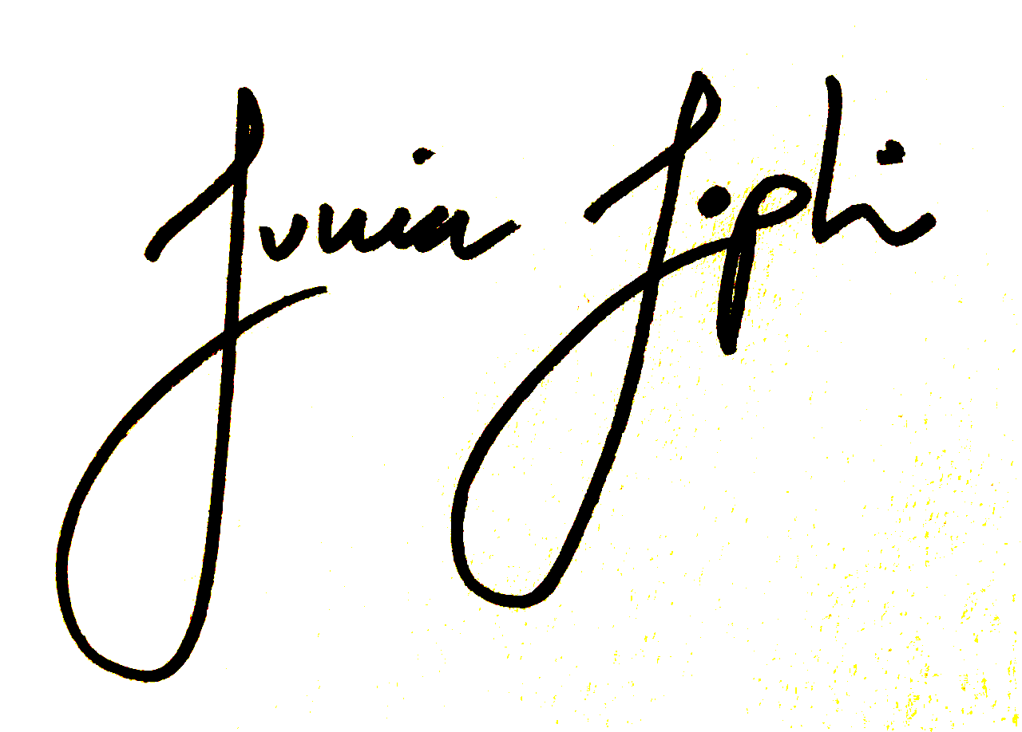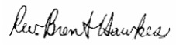
Rev. Junia Joplin Rev. Dr. Brent Hawkes

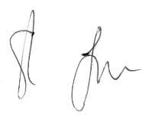
Bennett Jensen Dr. Stephen Low

On behalf of MCC Toronto On behalf of Rainbow Faith and Freedom

