8 February 2023

Mr. Victor Madrigal-Borloz
UN Independent Expert on Sexual Orientation and Gender Identity

Via email: ohchr-ie-sogi@un.org

Re: Submission to the report on FoRB and SOGI

Dear Mr. Madrigal-Borloz:

On behalf of the Southern Poverty Law Center, a leading U.S. civil and human rights organization, I write to provide responses to your recent call for input regarding religious freedom and sexual orientation/gender identity.

The SPLC was founded in 1971. Since that time, the SPLC’s mission has been to stamp out hate and extremism and to ensure the rights of all persons are equally protected. Our work includes litigation and policy advocacy to advance the rights, dignity and freedom of the LGBTQ community in the Southern United States. A comprehensive review of our research and work on the current landscape of anti-LGBTQ extremist activity in the U.S. is contained in testimony submitted to Congress in December 2022.

We write today to express our grave concerns regarding the “International Religious Freedom Summit” (IRF), which took place in Washington, D.C., last week (31 January to 1 February 2023). While we have no quarrel in concept with an event that brings people from different political and ideological perspectives together to debate and promote religious freedom, we are alarmed that the IRF prominently featured speakers and sponsors the SPLC has identified as espousing and promoting extremist ideologies, especially anti-LGBTQ and anti-Muslim hate. Importantly, many of these speakers and sponsors, couching their extremism in the language of “religious freedom,” have co-opted the rhetoric of human rights to advocate privileging their own claims to religious freedom, while dehumanizing and limiting the rights of others, including LGBTQ people, Muslims and other minority religions.

Former Kansas Governor Sam Brownback, whom former President Trump appointed ambassador-at-large for International Religious Freedom, was a co-chair of the event.

While governor, Brownback issued an executive order allowing Kansas religious groups and political subdivisions to legally discriminate against LGBTQ people. He also co-authored an op-ed with Tony Perkins, leader of anti-LGBTQ hate group Family Research Council (FRC), that claimed Western culture is “increasingly hostile to foundational Christian beliefs about marriage, sexuality and ethical behavior.”

Perkins, who spoke at the Summit, has claimed that pedophilia is “a homosexual problem” and that the gay community is “… intolerant, they’re hateful, vile, they’re spiteful.” Perkins equates marriage equality with “the loss of religious freedom.” His organization, the Family Research Council, espouses the same views in its publications. In an interview about his participation in the IRF, Perkins criticized what he described as groups in the U.S. “infringing upon religious freedom because of ‘special rights that are being pushed.’”

Not only does FRC view “religious freedom” in competition with LGBTQ rights, but FRC also understands “religious freedom” to include a right to discriminate against LGBTQ people – or any group the organization deems morally inferior. An FRC senior fellow was recently asked if “religious freedom” allows discrimination and responded affirmatively:

“So, when did religious freedom become an excuse to discriminate? From the beginning. We discriminate any time we make a moral judgment. The primary purpose of the First Amendment has always been to prevent governments from labeling the beliefs of people they disagree with as “dangerous” and punish them as a result. The biggest change is in the marketing. The things we once celebrated as “freedom” are now ridiculed as ‘discrimination.’”

IRF co-chair Brownback has also had close associations with other individuals the SPLC has identified as anti-LGBTQ extremists. For example, David Barton, who has served as an adviser to Brownback, espouses anti-LGBTQ hate speech on his right-wing radio program. Barton has stated that gay people die decades earlier than others and have hundreds of sexual partners. He falsely told his listeners that the “leading pediatric association” in the U.S. had advised against providing education about homosexuality, when in fact the group he cited was a splinter group with only a few hundred members. But according to Brownback, Barton “provides the philosophical underpinning for a lot of the Republican effort in the country today.”

Brownback’s association with extremist ideologies and groups has extended also to other issues, including anti-Muslim extremists. While governor, and in a nod to prominent anti-Muslim extremists like Robert Spencer and Pamela Geller who lauded the move, Brownback signed a bill that banned the state from using “sharia law.” With this record, Brownback’s appointment as a U.S. Ambassador was supported by individuals like Frank Gaffney who are known as “validators” of Islamophobia and “leading misinformation experts” spreading Islamophobia.

Samaritan’s Purse is identified as a presenting partner of the IRF. Its president and CEO, Franklin Graham, is frequently associated with anti-LGBTQ groups and has made deprecatory remarks about LGBTQ persons, linking such persons to what he called the “deepening depravity that now vexes our country.” IRF panelist Eugene Yapp has claimed that calls to simply leave LGBTQ people and groups alone could be an infringement on religious freedom.

Another anti-LGBTQ hate group, Alliance Defending Freedom (ADF), is identified on the event website as a partner organization. It has supported the re-criminalization of sexual acts between consenting LGBTQ adults and defended state-sanctioned sterilization of trans people. It has also worked to develop so-called religious freedom legislation and court decisions that allow discrimination against LGBTQ people in public accommodations.

ADF is an organization with international reach. It regularly demonstrates its anti-LGBTQ extremism cannot be contained by national borders. The SPLC has documented the efforts of the group to lobby for criminalization of homosexuality in Central American and Caribbean countries, for example.

Liberty University School of Law also has contributed enough money to be at least a “convening partner” of the IRF. Liberty University was founded in 1971 by Jerry Falwell, the conservative pastor who called AIDS “God’s punishment for homosexuals.” LU Law School’s former dean, Mat Staver of the anti-LGBTQ hate group Liberty Counsel, used the case of Lisa Miller – a woman who kidnapped her child to Nicaragua rather than share custody with her former partner and whom Liberty Counsel defended – in his law classes. Staver encouraged “civil disobedience” to laws that promote LGBTQ equality and noted Miller’s case as an example of counseling a client that they have an obligation to ignore the law and engage in “civil disobedience” in order to uphold God’s law.

Additional speakers and sponsors at the IRF that have ties to extremism and promote extremist ideologies include the Religious Freedom Institute (RFI), an organization that promotes “license to discriminate” legislation, which would allow U.S. doctors to refuse to treat transgender people or provide abortion care. RFI’s South and Southeast Asia Action Team Senior Fellow wrote in 2021, “While acknowledging that there are groups calling upon the LGBTQ people to be left alone and not be prosecuted when charged for alleged offenses, this could in effect be tantamount to creating a set of special privileges and rights for the LGBTQ person to be exempted from the rule of law. In such a case, the LGBTQ individual or group are really a special class of persons who can do anything and yet enjoy the protection and exemption from the due process of the law.”

In addition, organizations tied to Franklin Graham – who has called Islam “wicked” and “evil” and regularly demonizes LGBTQ people – are sponsoring the IRF, as is a relatively new group, Advancing American Freedom, led by former Vice President Mike Pence. The group claims as members of its advisory board individuals like Pastor Robert Jeffress, who said Islam promotes pedophilia and quoted the Levitical admonition “they shall be put to death” to express his view of how God would respond to the “issue of gay marriage,” and Gary Bauer, the former president of Family Research Council, who frequently advocates anti-LGBTQ and anti-Muslim extremism and said “hyphenated Americans...put a wedge into the heart of One Nation.”

Research conducted by the SPLC has shown that once-fringe extremist ideologies are becoming increasingly accepted in mainstream conservative politics. Given that the IRF featured anti-LGBTQ extremist speakers and sponsors alongside participants such as Samantha Power, administrator of USAID, and David Beasley, executive director of the U.N. World Food Programme, we have grave concerns that the event has been used to further the mainstream platforming of the purveyors of LGTBQ hate disguised as religious freedom. These hate groups already have found success in exporting their ideologies to global right-wing groups, and their prominent presence at this event may lend them an even greater air of legitimacy in mainstream politics.

It is deeply concerning that organizations mobilized against LGBTQ persons and groups are using the language of religious freedom, a key civil liberty, to call into the question the human rights of LGBTQ persons. We regret that U.S. Secretary of State Antony Blinken, Ambassador Beth Van Schaack and USAID Administrator Samantha Power all failed to express any concerns in this regard. Sadly, very few participants at the IRF raised this weaponized use of religious freedom, missing an opportunity to address the concerns of and dangers to entire communities.

I hope that this submission will prove useful to you as you prepare your report. Please do not hesitate to contact me if you have any questions or if there is any further information we can provide.

With best regards,
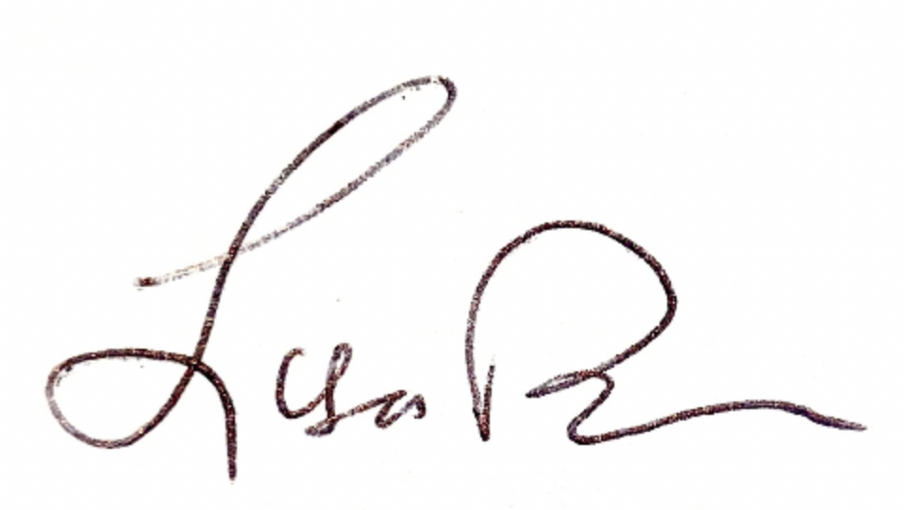
LISA W. BORDEN
Senior Policy Counsel, International Advocacy

