Freedom of religion or belief and sexual orientation and gender identity
Response to call for input by the Independent Expert on protection against violence and discrimination based on sexual orientation and gender identity
January 2023

Introduction
This response is from Sex Matters, a UK-based human-rights organisation campaigning for clarity on sex in law and policy. As such, it largely reflects evidence and experience from the UK, where our human-rights framework is based on the European Convention on Human Rights.
We are an organisation supporting human rights, in particular of people who are “gender-critical”: that is, we believe that sex is binary, immutable and important.
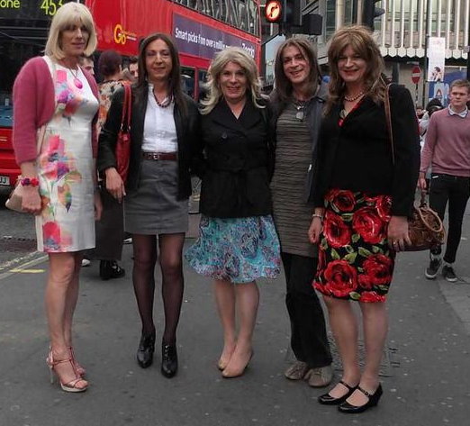
This is an ordinary belief we share with the great majority of people in the world – whether it is rooted in religion, culture, science or simply the experience of being a member of a species of evolved mammals who can recognise what sex people are, whatever clothes they are wearing.

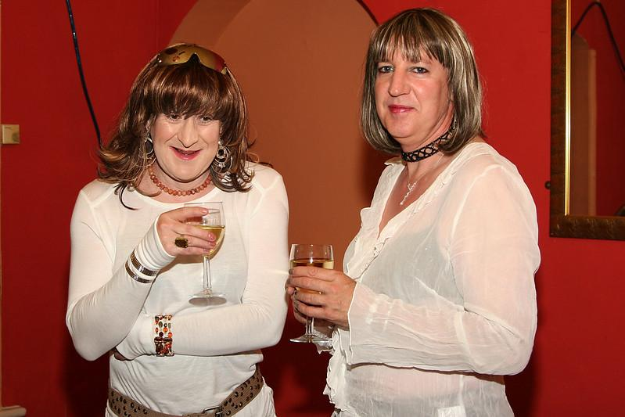
Expressing “gender-critical belief” is entirely compatible with respecting the rights of people who believe in the idea of “gender” and that people are “cisgendered” or “transgendered”.

We do not believe that straight men can become lesbians, or that gay women can become straight men. We do not think that male prisoners should be placed in female prisons. We think that everyone has a right to decide who gets to see and touch their body intimately, and that no one should be required to pretend they can’t tell what sex other people are. We are deeply concerned about the practice of telling gender non-conforming children that they may be “born in the wrong body” and attempting to convert them with hormones and surgery.
We do believe that people should be able to express themselves and live as they choose, while respecting others’ rights, and that everyone should be protected from violence.

Freedom of belief is a fundamental human right
Your call for input sets out a framework that is not based on a robust and universal conception of human rights. Rather, it rather seeks to undermine freedom of belief. You set up a straw man about freedom of belief that relates it to “the unified substance of religious traditions across space and time”. In fact, it relates to every individual’s right to believe, to change their beliefs and to make up their own minds. Freedom of belief is fundamental to a democratic society.
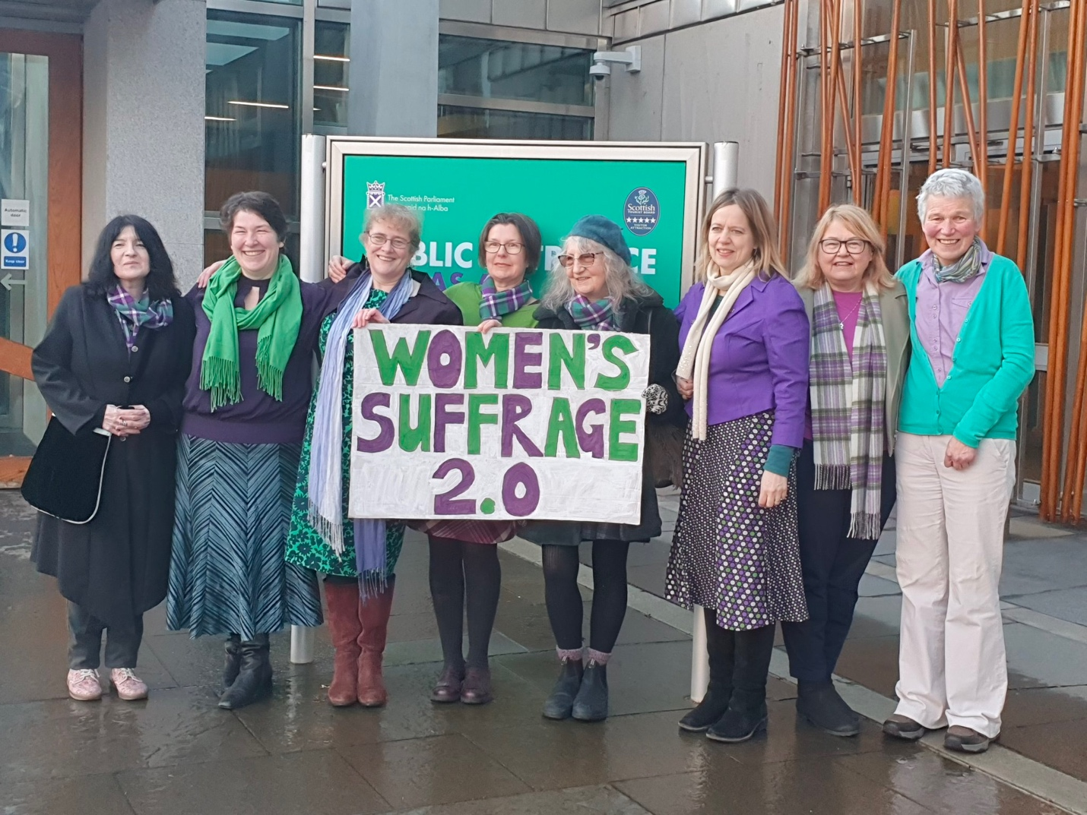
We implore you to start your inquiry with respect for the universal human rights to freedom of belief, and freedom to manifest beliefs – equally, whether those beliefs are based in religion or not, and whether you share them or not.

Many gay, lesbian and bisexual people do not share the belief in gender identity
The idea that there are marginalised “SOGI” people on one side and people with “harmful” beliefs on the other is a misrepresentation of human rights and of reality.
Sexual orientation is generally considered to be a matter of sexed bodies, not gender identities. Lesbian, gay and bisexual people are same-sex attracted. For many, their sexual orientation is therefore incompatible with a belief in gender theory. An insistence on the primacy of same-gender attraction can lead, for example, to lesbians being accused of transphobia for saying they are not sexually attracted to males.

Discrimination against people with gender-critical views
In countries where gender ideology has taken hold of public institutions, people who express contrary opinions are discriminated against. In the course of the UK’s national discussion about how to treat sex and gender identity in law and policy, many gender-critical people – overwhelmingly women – have been subjected to personal abuse, threats, loss of jobs and livelihoods, and even physical assault.
You are contributing to discrimination with the approach you take to your mandate, which delegitimises gender-critical belief and speech, and links them to violence and human-rights abuses.
Writing in the Times, journalist Janice Turner gives an account of the shutting down of gender-critical belief and speech.
“Almost every day I hear from Guardian journalists, principled, progressive writers, who are terrified of uttering what now counts as WrongSpeak. As the tram-tracks of left-wing discourse have narrowed… suggesting a humane balance must be reached between trans activist demands and women’s rights, can result in vicious censure from colleagues, even demands that they are sacked. Questions imply criticism: disagreement is hate-speech. When journalists cannot address issues for fear of losing their jobs, a void is created in the public sphere. If moderate views are unprintable, they become unspeakable. Cancellation trickles down. … [T]he Scottish children’s author Gillian Philip, who defended JK Rowling, was sacked. Many others have written to me: feminist authors dumped by agents, who in turn are frightened for their own livelihoods. Female academics endure constant professional defamation, petitions to no-platform them, exclusion from publications, talks on subjects unrelated to gender aggressively picketed or cancelled.
“ ‘I was disinvited from giving lectures on courses I’ve worked on for years,’ one says sadly, including courses I’ve helped to write’. A corporate lawyer was reported to her chief executive just for following feminist accounts on Twitter; a teacher was shopped to her head by a student intern who’d overheard her criticise the trans child charity Mermaids. A charity worker faced a complaint to her board because she’d ‘liked’ a JK Rowling tweet: ‘For days, I was utterly terrified for my future. I shouldn’t have to live like this because of the views I hold.’ A copywriter who queried why ‘woman’ must be replaced with ‘womxn’ but not man with ‘mxn’, says speaking out ‘results in fewer chances to work on projects or limits promotion’. These people are denied free speech for utterances that are within the law.’ ”
https://www.thetimes.co.uk/article/the-woke-left-is-the-new-ministry-of-truth-vmrgt823b

Violence and discrimination are not the same thing
The mandate of the special representative comprises two different kinds of rights. They are different, though both are important:
- Freedom from violence is one of the most fundamental values of democratic societies. The prohibition against torture and inhuman or degrading treatment or punishment is absolute; no derogation is permissible. The right to life is similarly protected with very limited exceptions.
- Freedom from discrimination is a different kind of right. It complements the other substantive provisions of the Convention. There is no absolute prohibition on discrimination as such; only against discrimination that unacceptably infringes on the enjoyment of other human rights. Many of these rights are qualified and need to be balanced with other legitimate interests, and other people’s rights.
The danger with the formulation “violence and discrimination” is that it can be used to unjustly override protection for other people’s rights by conflating violence with discrimination.
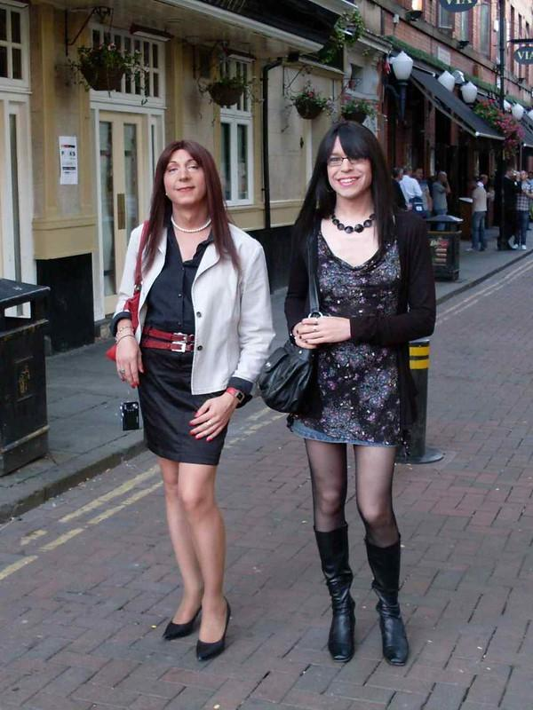
Furthermore, you wrongly equate not treating people as the opposite sex on demand with discrimination. It is not.
If a man wants to wear feminine clothing, grow his hair, change his name and take on mannerisms associated with women (and vice versa for women who want to adopt stereotypically masculine self-presentation), or to have cosmetic surgery or take sex hormones, he should not be subjected to violence or discriminated against in services such as housing, transport and financial services, or in employment.
But other people are not required to believe (or pretend to believe) that he has changed sex, or that he shares a defining inner sense with women.
Many people see your belief as fundamentally sexist. Men and women should be free to wear what they choose, and to conform or not to gender stereotypes, but being a woman does not mean wearing make-up, stockings or high heels. These are things men can do too, and there is no reason to force people or institutions to pretend those men are women.
There is a conflict between men who, as part of their lifestyle, want to use women-only spaces and the women for whom these spaces are intended. Women rely on female-only spaces and services for privacy, dignity and safety. It is not unlawful or illegitimate to exclude men (all men, including men who wear women’s clothes, etc.) from female-only spaces. Destroying women-only spaces, sports and associations by forcing them to include men who identify as women discriminates against women. Women saying “no” to men is not violence.

Links between opposition to self-ID and violence are spurious
Throughout your work you link deplorable violence such as “death threats, beatings, corporal punishment, arbitrary arrest and detention, abduction, incommunicado detention, rape and sexual assault, humiliation, verbal abuse, harassment, bullying, hate speech and forced medical examinations” with the question of whether states should issue people with identity documents recording them as members of the opposite sex.
“Trans persons are particularly vulnerable to human rights violations when their name and sex details in official documents do not match their gender identity or expression. Inaccurate or inadequate identity documents may result in greater levels of violence and extortion, exclusion from school and the official labour market, housing, health and access to other social services, and in being able to cross borders.”
You give no evidence for this purported linkage. There is no reason to think that the people (mainly men) who would commit violence, extortion, rape and exclusion against feminine men or masculine women would be deterred by a piece of paper.

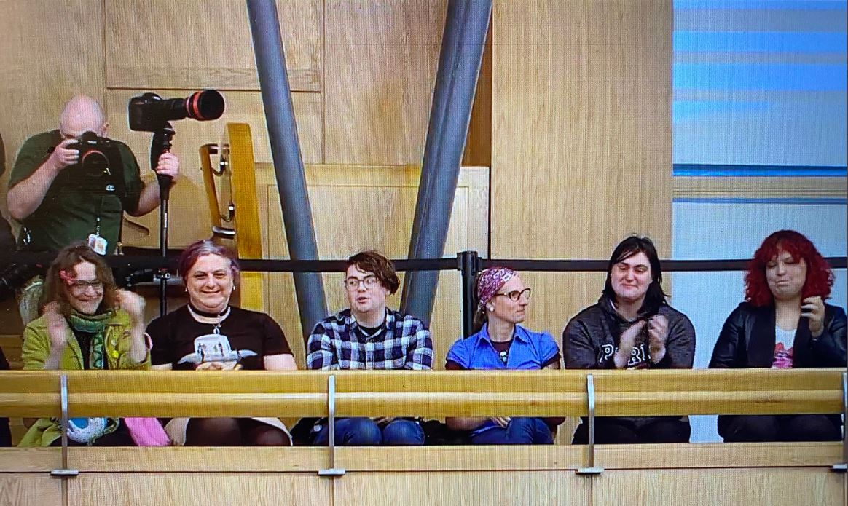
In the UK, the vast majority of people who identify as trans (some 100,000–250,000) have not changed their birth certificates, and there are no reports of killings, death threats, beatings, abduction etc. These people’s right not to be discriminated against by the police, or in the provision of healthcare and public services, is protected by the Equality Act.

Argentina, by contrast, passed the world’s first gender self-ID law in 2012, since when the country has seen 82 trans people die by violence. In the same period there have been five deaths of trans people by violence in the UK, none of which was linked to the individual having or not having a GRC.
The UK Gender Recognition Act was passed not to address violence, but after a case relating to the right to marry (an issue now superseded by same-sex marriage) and the qualified right to privacy. The right to privacy is a limited right that must be balanced in practice with the rights of others, including freedom of belief, the right to give and receive information, freedom of association and freedom from humiliating treatment.
In practice, the right to keep your sex private is extremely limited. A person’s sex is usually impossible to hide.

Protection of Freedom of Belief
The UK has already seen several legal cases testing the balance of rights between people who want to suppress freedom of belief in order to avoid causing offence to trans people, and people who want to express the ordinary belief that sex matters.
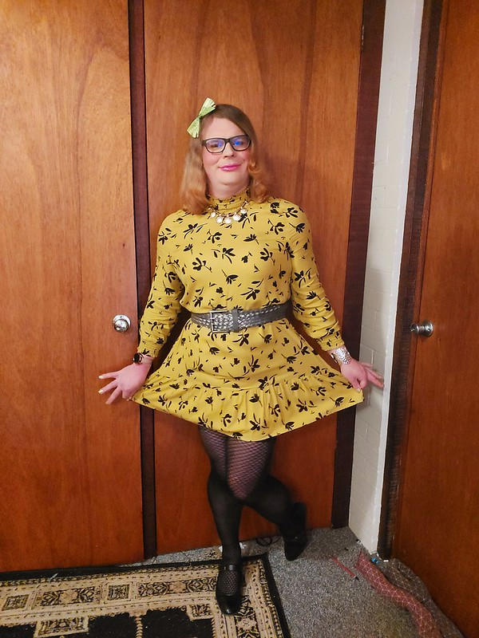
In 2019, in the case of Forstater v CGD Europe, an employment tribunal ruled that the belief that biological sex is real, important, immutable and that sex matters was “not worthy of respect in a democratic society”. This meant that someone who held that belief could be required in all circumstances to suppress its expression for fear of causing hurt or offence to trans people, on pain of being subjected to discrimination at work or dismissed, with no remedy in law. That tribunal took the view (which seems to accord with yours) that gender-critical beliefs are harmful and that in the contemporary debate about sex and gender, the only democratically and legally acceptable use of language is that which accords primacy to self-determined gender identity.
This judgment was overturned on human-right s grounds (Forstater v CGDE [2021] EAT). The appeal was supported by the NGO Index on Censorship and by the Equality and Human Rights Commission, which is the National Human Rights Institution. Costs were crowd-funded by thousands of small donations.
The Employment Appeal Tribunal ruled that gender-critical beliefs are protected under Articles 9 and 10 of the European Convention on Human Rights, and by the Equality Act. (So too are beliefs in gender theory.) Protections for freedom of belief apply to people on both sides of the debate.
The judgment rests on Article 17 of the Convention, which prohibits the use of the Convention to destroy the rights of others. One cannot, for example, rely on the right to freedom of expression to espouse hatred, violence or a totalitarian ideology that is wholly incompatible with the principles of democracy. But equally, one cannot rely on the right to privacy to shut down other people’s ability to speak.
The EAT found that the level at which Article 17 becomes relevant is clearly (and necessarily) a high one. Thus, when the European Court of Human Rights referred to Article 17 in considering whether a philosophical conviction is worthy of respect in a democratic society and not in conflict with the fundamental rights of others, it would have had in mind that only a conviction that challenges the very notion of democracy would fail to command such respect. To maintain the plurality that is the hallmark of a functioning democracy, a very broad range of beliefs and convictions must be tolerated.
Where belief involves promoting “torture or inhuman punishment”, it should be denied protection. Such violations go far beyond what might be regarded as potentially justifiable interference with a right: they seek to destroy rights.
However, as the court found, believing that sex is immutable, that “trans women” are men and “trans men” are women does not come close to holding the kind of belief that falls foul of Article 17.
Even comments which are “serious, severely hurtful and prejudicial”, or which promote intolerance and detestation of homosexuals or trans-identifying people, would not fall entirely outside the scope of Article 10. That does not mean that the individual making such comments is free to make them in all circumstances. An individual’s freedom to express their views is limited to the extent provided for by Article 10(2), and it will then be for the Court to assess whether any limitation imposed by the State is justified.

The importance of freedom of belief and freedom of expression
You ask whether there are any ways in which freedom of religion or belief, on the one hand, and freedom from violence and discrimination based on sexual orientation and gender identity, on the other, are mutually reinforcing.
At an overarching level, the answer is yes. Protecting the ability of people to live freely, whether they are gay, lesbian or bisexual, or transvestite or transsexual, depends on the very rights that protect the ability of people who are religious conservatives or gender-critical to live freely.
Where the rights of individuals conflict – as they frequently do – just resolutions require engagement, discussion and good-faith debate, not vitriol and vilification.
Protection against violence and discrimination for everyone depends on functioning civil and criminal-justice systems, and on laws that can be understood and trusted. This in turn depends on democratic institutions, which cannot function properly in the absence of freedom of belief and freedom of expression.

Picture credits

Page
2 | https://www.flickr.com/photos/alessiacross/
3 | https://www.flickr.com/photos/sallypayne/
4 | Nicole Jones
5 | https://www.flickr.com/photos/sallypayne/
7 | https://www.flickr.com/photos/alessiacross/
8 | https://www.flickr.com/photos/alessiacross/
9 | https://www.flickr.com/photos/sallypayne/
10 | Scottish Parliament live video feed
11 | https://www.flickr.com/photos/rjrgmc28/

This work is licensed under the Creative Commons Attribution 4.0 International License.
Sex Matters is a not-for-profit company registered by guarantee.
Company number: 12974690
Registered office: 63/66 Hatton Garden, Fifth Floor Suite 23, London, EC1N 8LE

