Report of the Independent Expert on protection against violence and discrimination based on sexual orientation and gender identity

Topic: Freedom of religion or belief and freedom from violence and discrimination based on sexual orientation and gender identity

Inputs From: - OPTIMUM FOUNDATION - MALAWI

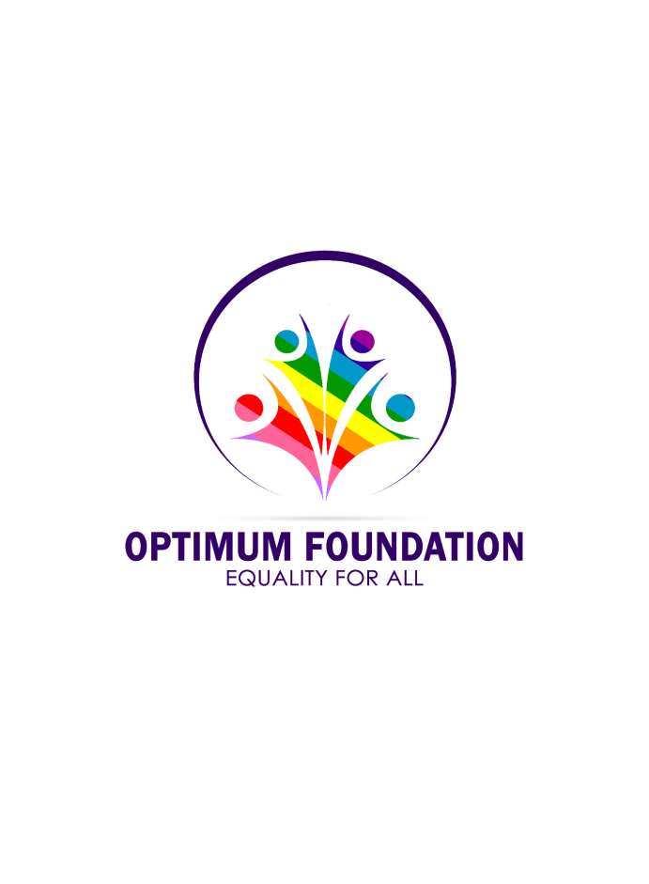

INRODUCTION
Optimum Foundation (OPTIMUM) is an organization–oriented non –profit making non-partisan non –governmental and non-denomination. As unique founded and led organization it create a forum at which the marginalized community of Malawi interact intellectually and enhance their reasoning and participation on activities that affect their lives by creating opportunity and eradicate threats for later generation through being involved in overall decision making .
OPTIMUM does not segregate on political, religions and ethnicity ground filmy believing that such would impend some particular members participation in the collective effort of mainstreaming community empowerment activities at community and national level.
OPTIMUM strives to negotiate for the inclusion of LGBTIQ+ as well as marginalized community as torch bearer and active partakers in all efforts targeting the community members for sustainable Malawi development collaborating with policy makers but without being politically partisan .

Call for Inputs

As the Independent Expert invites all interested States, civil society organisations, faith-based institutions, faith leaders, academics, international organisations, national human rights institutions, activists, corporations, and others, to provide written input to the following questions for his thematic report.

- What are the actual or perceived points of tension (if any) between the right to manifest one’s freedom of religion or belief, and freedom from violence and discrimination based on sexual orientation and gender identity? Are there any areas in which they are mutually exclusive?

- Are there any ways in which the right to freedom of religion or belief, and freedom from violence and discrimination based on sexual orientation and gender identity are mutually reinforcing?

- Are there examples where gender and sexual diversity has been used in religious, traditional, or indigenous narratives or values in a manner which promotes the acceptance of LGBT+ individuals, or protects LGBT+ individuals from violence and discrimination? Has this informed any legal interventions or public policies?

- What are the key trends or significant instances of discriminatory or abusive practices by individual providers of goods or services in the public sphere against LGBT+ and gender-diverse persons that rely on religious narratives?

- Has the State adopted, in public policy, legislation or jurisprudence, norms purportedly based on protecting freedom of religion or belief that promote, enable and/or condone violence and discrimination against individuals based on sexual orientation or gender identity? If so, please give examples, with commentary as needed to explain context, scope, and application.

- Has there been any legal challenge to these policies/provisions under any domestic, regional, or international human rights provisions? If so, state the outcome and rationale of the case. If not, provide your opinions as to why such a challenge has not yet been brought.

- Are there any examples of State restrictions based on preventing violence and/or discrimination against LGBT+ persons that prohibit or limit practices undertaken in the name of the religion or spirituality, such as public accommodation non-discrimination protections? If so, have they been legally challenged on the basis of freedom of religion or belief? If yes, explain the outcome and rationale of the case(s).

- What role (if any) has the concept of conscientious objection played in limiting the full enjoyment of the right to freedom from violence and discrimination on the basis of sexual orientation and gender identity?

- Has the scope and application of conscientious objection been sufficiently defined, limited, and/or regulated so as to strike a fair balance between manifestation of one’s freedom of religion or belief, and freedom from violence and discrimination based on SOGI? Where the doctrine is invoked to permit the withholding of goods or services to members of the LGBT+ community (such as in the context of sexual and reproductive healthcare, provision of marriage licences, access to consumer goods, etc.), do State laws provide alternative access to goods or services?

- Where State legislation or policy requires the reasonable accommodation of religious beliefs, practices, and/or institutions, are there instances where such laws or policies limit freedom from violence and discrimination against LGBT+ and gender-diverse persons? These may include but are not limited to exemptions from non-discrimination legislation, and/or accommodations within the workplace, educational institutions, healthcare-settings, the justice system, etc. Are there reports of violence, spiritual abuse, and/or other forms of discrimination against LGBT+ and gender-diverse persons because of these practices?

- Good Practices:

  - Provide any examples of good practice – at the international, national or local level – where State and non-State actors (including faith leaders, groups and organisations, international organisations, civil society organisations, and the UN human rights system) have taken effective measures to protect and promote freedom of religion or belief of LGBT+ and gender-diverse persons, and made efforts to prevent, mitigate and respond to any violence and/or discrimination justified in the name of religion.

  - Provide any examples of measures by State or non-State actors to ensure effective participation of people with diverse gender identities and sexual orientations in religious, cultural, social, and public life. Please provide relevant examples where LGBT+ people have asserted their individual or collective rights to access (or establish) religious or spiritual frameworks and institutions.

RESOLUTIONS
- We as Optimum we took our time to provide our inputs to the call and provided is our response to it:-

- Everyone has a right to freedom of thought conscience and religion and the right includes freedom to change religion or belief and freedom either alone or in community with others and in public or private to manifest his religion or belief, in worship teaching practice and observance (Article 9 in the constitution of Malawi). Most of the religion they stand on 5 elements of the belief system like belief in God Adoration of the spiritual ideal the moral conception, the form of worship and philosophy of life (source the books of worship of the God). So as Malawi there is a lot of the LGBTIQ+ at community for them to have a right to manifest freedom of religion or belief and freedom from violence and Discrimination among the faith leaders in Malawi are astonished when they discover their member LGBTIQ+ Identity Hence they have negative reaction couple with rejections, intolerance and harassment of their members (LGBTIQ). Subsequently they create an hostile environment that increases the risk for mental health spiritual and wellbeing of the (LGBTIQ) member. More unsupportive behaviour from faith leaders lower self-esteem of LGBTIQ+ member, who also became isolated and discriminated by both churches and society. The lack of love care and respect demonstrated by faith faith leaders towards their LGBTIQ members negatively impact on their upbringing consequently leading to risk behaviours.
- As optimum, After the survey, we’ve been conducted the trainings in salima Nkhata-bay and other PE district involving the faith leaders on mind set change and understanding the right SOGIESC as well as human right to mutually reinforcing the right to freedom of religion or belief and freedom from violence and discrimination based on sexual orientation and gender identify, We tried to adopt this strategy intervention that reduces some behaviours that contribute to the LGBTIQ mental health problems spiritual life and promotes inclusion equality and well-being. We encourage the faith leaders to adopt the concept of the training more especially on human right issues, sexual orientation and gender identity to the church and church youth forums. The faith leaders should also take part in community sensitisation on human right and gender identity.
- In Malawi, they are not quite a lot of examples whereby the religious including traditional narrative has been used to promote freedom. The acceptance of the LGBT + and the freedom from violence and discrimination. Even coming to the political structure, in late 2009, two Malawians, a man and a transgender woman, united in an engagement ceremony, resulting to a charge of Malawi’s anti sodomy case. Despite different interventions from human rights bodies and of course UN, the two were emphasized to offend Malawi and its people since Malawi is painted as a “God-fearing country “and they condemn homosexuality. Coming to the instance, in 2016, around a month of April, Various donors wanted Malawi to respect gay rights but catholic bishops and other faith leaders including Muslim sheiks warned against it. According to. Archbishop Thomas Msusa of Blantyre voice to President of Malawi by then, Peter Mutharika that the issue is “alien to Malawi”. He said Catholic Church doesn’t support same sex. Unions and that the church will strictly follow its doctrine. From this, surely, the churches in Malawi have never been in Support of the KP and promotion of their freedom in all dimensions. From the writing of Raphael Mweninguwe, a freelance journalist based in Malawi, In general, Malawi criminalizes same sex conduct and the KP often face violence, threats an discrimination.
- Schools should be safe places for everyone. But in the Malawian students who are lesbian, gay, bisexual, and transgender (LGBT) too often find that their schooling experience is marred by bullying, discrimination, lack of access to LGBT-related information, and in some cases, physical or sexual assault. These abuses can cause deep and lasting harm and curtail students’ right to education, in Malawi and In terms of religion that is perhaps the strongest obstacle in terms of embracing full equality for our LGBTIQ+ Community. For church has been the central institution ever since. And the Bible has been the center of the church. But it has often been a very conservative interpretation of the Bible, so we have latched on to this conservatism, especially as it relates to sexuality in general and homosexuality in particular. Right to have equal justice the laws fail to conform to the right to non-discrimination and the right to be equality before the law, our laws in Malawi are not clear about the laws on how to protect the LGBTIQ+ community hence the laws were been suspended and then lastly, Most Parents and families of LGBTIQ+ People in Malawi are astonished when they discover their Childs LGBTIQ+ identity. Hence, they have negative reactions couple with rejection, intolerance and harassment of their LGBTIQ+ child as well as well chasing them out from their respective homes. Subsequently they create a family hostile environment that increases the LGBTIQ+ person risk for mental health and wellbeing, moreover the family un-supportive behavior lowers self-esteem of LGBTIQ+ family members, who also became isolated and discriminated by both the family and society. The lack of love, care and respect demonstrated by parents and families towards their LGBTIQ+ children negatively impact on their up-brining consequently leading to risk behavior like alcohol and drug abuse, criminality, depression, suicidal and School Dropouts. Most of the Parents believe being an LGBTIQ+ community is a Sin and it’s all about demons. ( Chapter of 4 of the constitution of the republic of Malawi talks much about the Human Rights including a Right to have a Place to live)
- Yes, because the law was suspended by the members of parliament of Malawi 2012 and we can also say No, because in Malawi there is no document in black and white that was signed and adopted to protect freedom of religion or belief that promote and overlook violence and discrimination against individuals based on sexual orientation. During former president regime Bingu the issue was just noted and pardon. Because of this reactions LGBTIQ community are not having access to social services.
- Government of Malawi does not conceder then LGBGTIQ community in government institution like Malawi prison does not allow Male in-mates to have access to health services like condoms and it is doesn’t involving other stakeholders to take part in providing health services in Malawi prisoners in addition, Because of not considering LGBTIQ this promote not to be comfortable when we are accessing health services in Malawi.
- Government of Malawi does not have restriction that prevent violence against LGBTIQ communities but then restriction are facilitated by Civil Society Organization (CSO’s) That fight and promotes human right.
- It has played a role in the sense that LGBT community faces violence and discrimination in many aspect of life. Sometimes the law enforcers the law enforcers can apprehend or assault a community member without legal producers for a reason where a community member was exercising some of the rights entitled to eg heath rights to associate with other the end result its social stigma hence they cannot attain individuals self-censoring act in fear of any suspicion of non-conformity may lead violence or arrest. This can be regarded as a threat because if there is no clarity on the right of a human being in Malawi regardless of sexual orientation individuals will be compacting avoiding LGBT community from enjoying their rights.
- The scope and application of conscientious objection has not been sufficiently been defined. in reference to number 8, the state does not provide laws as alternatives to goods and services “only” through interventions at other organization that actually provide access to health care among others.
- Through the constitution of Malawi Act 9, states that:- everyone has a right and freedom of religion and belief, although it is not clearly to the LGBTIQ+ community and since Malawi as a country has only defined to human Rights not the LGBTIQ+ community it is not clearly accommodating the KPs, there is a limitation of freedom from violence and Discrimination against LGBTIQ+ community and reports are there.
- The trainings/ workshops conducted by the CSOs that promotes the wellbeing of LGBTIQ+ community and Inclusion to prevent and minimize the Violence and Discrimination of LGBTIQ+ community that involves the Faith leader as well as Individual providers help a lot. And this saves as good practices. The suspension of the law that discriminate the LGBTIQ+ community, can be marked as one of the good example that the state provide to ensure effective participation of people with diverse gender identities and sexual orientation in religious, cultural, social and public life. Currently the LGBTIQ+ community are able to participate in different forums as well as to come out.

