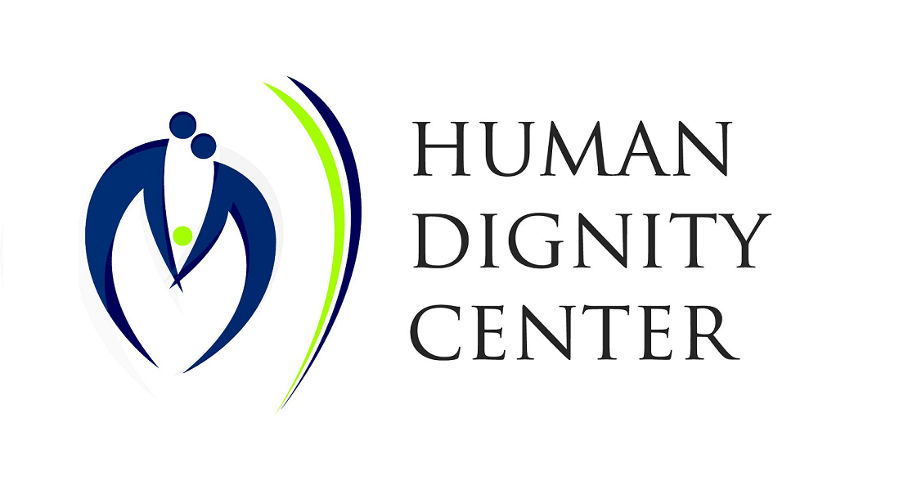
Victor Madrigal-Borloz
Independent Expert on Protection Against Violence and Discrimination
Based on Sexual Orientation and Gender Identity
Office of the UN High Commissioner for Human Rights

via email <ie-sogi@ohchr.org>

February 21, 2021

Re: Gender, sexual orientation and gender identity

Dear Mr. Madrigal-Borloz,

I write on behalf of Human Dignity Center a nonprofit organization based in Hungary. We are engaged in advocacy for issues related to marriage and family, protection of women and children. We believe that we can provide some aspects that could be helpful in your current report.

We would like to address the questions related to the protection of LGBTIQ people, children and national sovereignty: questions 1, 3, 4 and 12 in the ”Call for input to a thematic report: Gender, sexual orientation and gender identity”.

Protection of LGBTIQ people – respecting differences

No one can deny the truth supported by science: there are clear differences between the biological sexes. In order to protect all – and leave no one behind – laws must reflect reality. Recent criminal offences question the proper protection of LGBTIQ people and people around them in countries where public spaces or prisons ignore the biological differences between men and women.

The growing number of criminal offences by men claiming to be women, especially against women or minor girls, fuel opposition towards trangender people. States must respect the biological differences and keep them reflected in their laws. In the long run this is the only way to protect the human dignity of LGBTIQ people and people around them.

Several European countries have already realized the need for this clarification and made their position clear.

Protection of physical and mental integrity of each and every individual is the obligation of both the medical profession and the states. Neither medical practices nor laws should allow inducing lifelong infertility. Regret is real for approximately 20% of patients who went through sex-change surgeries. Sex reassignment surgreries can damage mental health as well: transgender people who went through surgery are 20 times more likely to commit suicide than the general population. Mental challenges of this minority also needs to be addressed.

Protection of children – protecting their innocence

”States Parties shall take all appropriate national, bilateral and multilateral measures to prevent the abductionof, sale of or traffic in children for any purpose or in any form” - CRC (1990), Article 35.

Reproductive rights and related services for LGBTIQ people fuel the surrogacy industry. Renting a woman's womb and putting a price tag on babies are unacceptable in modern societies. Every child has the ”right to know and be cared for by his or her parents”. Protection of children's relationship to their birth-mother can never be bargained for individual purposes.

Violence against children is never acceptable. School programs that include sexual content, analyse sexual behaviours and reactions to sexual stimulus, expose children to pornographic materials or adult content are not fit for classroom context. Children have different levels of knowledge on sexual topics, they need time to discover their sexuality in their own pace otherwise teachers or invited speakers trespass on their private sphere. Schools must never be obliged to transfer knowledge on sexuality disrespectful of the children's individual maturity. Unfortunately, Comprehensive Sexuality Education programs do exactly this kind of trespassing on children's innocence with no respect to their individual needs and comfort in these issues. Probably this is why several countries rejected CSE programs of such content. Sexuality programs that lack the emphasis on long-lasting and responsible relationships backfire and produce negative statistics regarding the number of teenage pregnancies and STDs.

Protection of children – including intersex children – is of extreme importance. They need comfort from their family and proper medical care from their doctors independent of political trends. It must be clear that intersex people ”are not tools to dismantle transphobia” and should never feel ”being on display at the freak show” as a transgender person complained. Clarification of definitions would greatly help to eliminate the ideological nature of ”gender”.

Protection of national sovereignty – supporting cultural diversity

”The implementation of the recommendations […] contianed in the present document is the sovereign right of each country, consistent with national laws and development priorities, with full respect for the various religious and ethical values and cultural backgrounds of its people, and in conformity with universally recognized international human rights.” - ICPD +5 (1990), Preamble 5.

States define gender in different ways, and they have the competence to do so. The democratically elected governments have the authority to shape their countries' education system, economy, healthcare and all areas within their own legal systems. Besides, several UN documents include the protection of national sovereignty and respect for various religious and ethical values and cultural backgrounds of its people. It serves to preserve the cultural diversity of the world while shaping it for the welfare of its population through respecting internationally binding documents.

Sincerely,

Edit Frivaldszky
Human Dignity Center
Hungary

https://www.sciencedaily.com/releases/2017/05/170504104342.htm
https://www.dailymail.co.uk/news/article-8211325/Female-prison-officers-raped-inmates-self-identify-trans-women-claim.html?
https://data.consilium.europa.eu/doc/document/CM-5123-2020-INIT/en/pdf Definition of gender, submission by Bulgaria, Hungary and Poland.
The growing number of the community who regret transitioning is alarming: https://sexchangeregret.com/
A survey conducted in Sweden shows high mental risks after sex reassignment surgery: https://journals.plos.org/plosone/article?id=10.1371/journal.pone.0016885
https://www.forbes.com/sites/zhanavrangalova/2017/11/15/growing-evidence-for-a-link-between-gender-dysphoria-and-autism-spectrum-disorders/?sh=2122e85a153e
Article 7, Convention on the Rights of the Child. https://www.ohchr.org/EN/ProfessionalInterest/Pages/CRC.aspx
CSE promoted by UN agencies promote different sexual behaviours at a very young age as well as non-UN consensus ”sexual rights” https://mltsg.files.wordpress.com/2020/12/leafletcse_2018may.pdf
Study from the independent Institute for Research and Evaluation (US) at https://familywatch.org/2020/01/30/re-examining-the-evidence-for-comprehensive-sexuality-education-in-schools-a-global-research-review-the-institute-for-research-evaluation/#.YC_NUehKjb0
https://medium.com/gender-2-0/the-rift-between-us-intersex-and-trans-discourse-62dee7f7a73
https://data.consilium.europa.eu/doc/document/CM-5123-2020-INIT/en/pdf
ICPD +5 (1990), Preamble 5.

