



**Mr. Victor Madrigal-Borloz**

**Independent Expert on protection against violence and discrimination based on sexual orientation and gender identity.**

**United Nations Human Rights Council.**

**Office of the High Commissioner for Human Rights**

**Palais Des Nations**

**1211 Geneva 10, Switzerland**

**March 12, 2021**

Dear Mr. Madrigal-Borloz,

We fundamentally disagree with the radical and unscientific transgender ideology that seems to form the basis of your “Call for input to a thematic report on Gender, Sexual Orientation and Gender Identity”. It would seem that the conclusions are either already written or that the request is clearly leading to the desired contributions.

**We are deeply concerned that:**

1. **There is an aim to change the scientific understanding of the human race**

We are deeply concerned that the goal of your request for submissions aims to change the scientifically proven and universally held biological understanding of the human race, which is comprised of males and females whose immutable sex is genetically imparted at conception, to the unscientific, completely unfounded, radical and dangerous concept of “gender identity” that individually can be changed from woman to man, man to woman, and moreover, also to dozens of other “gender identities”. Sex is fixed by nature and not a “social construct.” The principal problem with the call for input lies in the biased, unscientific, and frankly, unacceptable definitions and assumptions made about so-called “gender theory”, such as “recognizing the validity of a wide range of sexual orientations and gender identities” and “challenging the assumption that gender identity necessarily correlates with biological sex”.

With all due respect, we do not recognize the intentional framing of the topic of gender identity which seeks to eliminate biological sex as the only necessary correlative and with the intention to validate more than one “gender identity.” We do not accept the promotion of the gender ideology or the “LGBTI+ agenda” by challenging, pretending to modify and trying to erase centuries and millennia of the science of biology. Leaving ideologies aside, looking around we will realize that “gender ideology” is just that, an ideology with thousands or even millions of followers that has no grounding in biology, sociology or history.

There is a clear confusion between feelings, thoughts, acts (including sexual acts) and scientific fact. Many tend to mix some or all of them. Feelings, thoughts, acts, could change due to many circumstances, internal or external. Biology doesn't change. It could very well be the case that someone changes the feelings for persons of the same or the other sex, that someone even changes the relationships or sexual preferences with people of the same or the other sex, but the biological fact that a baby girl - a human being that has two of the same kind of sex chromosome (XX) - will become a girl and then a woman cannot change and will not change. A baby boy - a human being that has two different kinds of sex chromosomes (XY) - will become a boy, and, a few years later, a man… Biology, in spite of ideologies that some try to impose on the main population, does not change.

1. **There is a stigmatization of people and groups who criticize radical gender theory or policies.**

We reject the interpretations of the terms “violence” and “discrimination” in Questions 5, 6 and 10 as encompassing any criticism of radical gender theory or policies that go against the biological reality of human life. Those ideologies bump into centuries of human recognition of the reality and the science of biology and now pretend to be carrying a universal truth that has to be followed strictly in the strongest of terms.

Of course, we must fight violence and discrimination against all people, but its must be done without unscientific and radical notions like “gender theory” based on the multitude of subjective gender identities that can be modified at whim. We also reject the name-calling of ideas or measures which are critical of transgenderism and gender theory. Calling names at those who disagree with radical new “gender ideology” theories is not the answer.

1. **There is an intent to arrogantly create a “blacklist” based on people’s opinion.**

Question 10 of your call for input intends to create a “blacklist” of actors who adhere to scientific, biological and commonly-held ideas and opinions about sex and gender. This unacceptable step evokes terrible historical times when such lists were created to stigmatize and oppress people and groups with certain beliefs. Such a list, as you intend to create, could be used to silence speech, to limit public funding, to eliminate public tax deductions, and, or to remove "public interest" status.

We are concerned that such a list could be used to incite reprisals against people who exercise their rights to freedom of expression, freedom of speech, and religious liberty. It is untolerable and in a democratic society such an ideology promoting unscientific “gender ideology changing within the time” should never be applied as a cult that punishes those who peacefully and ideologically disagree with.

1. **Transgender ideology harms women.**

The categories of women and girls will become utterly meaningless if a man can be considered as a woman at whim, too. It will negatively affect the protection of women and girls. We are committed to protecting women’s private spaces (e.g., toilets, locker rooms, women’s shelters and prisons), so we oppose the idea that men who identify as women can be accommodated in these places.

Athletic performance is influenced by genetic and environmental factors. In some sports qualities such as flexibility, coordination, time sense, mental strength, and agility are required. In other sports the main qualities required are: height, strength, resistance, muscular power, endurance or speed. Physical qualities are determined by many factors like diet, genetics, training, effort, will to improve and many others, however we cannot allow gender ideology to deny that biological sex may be one of the most important for some sports.

The transgender ideology will affect definitely sports, and there are several examples around the world already. Biology affects women and men in a clear way and trained athletes perform differently if they were born as baby girls or as baby boys. Even a well trained female athlete will have to face really difficult circumstances if she had to compete against an individual with male biological sex who identifies as a transgender woman.

1. **Comprehensive sexuality education harms children.**

We express our concern that in Question 4 there is a promotion of “Comprehensive sexuality education” (CSE).

CSE has never been accepted in a binding treaty or major UN consensus document. Member States who have expressed strong objections to CSE should be respected by the SOGI mandate holder.

The American College of Pediatricians has stated that “comprehensive sexuality education is a dangerous assault on the health and innocence of children.” How can the SOGI expert endorse and adopt such a controversial kind of education? (Ample evidence backing this claim can be found at ACPeds.org and at stopcse.org.)

It is totally unacceptable how UN bodies put transgender agendas, that follow mostly an ideology or non-scientifical ideas, in sexuality education programs. It is also with great surprise and concern that we denounce the eventual imposition of those programs to children without giving the parents or legal guardians their right to disagree.

The 2018 UNESCO ‘International Guidance on Sexuality Education’ teaches children, aged 9-12 so-called “transgender theory,” teaching them how to “define gender identity (knowledge)” and “explain how someone’s gender identity may not match their biological sex.”[1] And, the WHO Regional Office for Europe and BZgA Standards for Sexuality Education in Europe teaches children about the “differences between gender identity and biological sex.”[2]

This is an outrageous interference into the lives of families and children. Parents, not the UN, are their children’s first educators, and the UN has no business forcing radical concepts of a sexual nature on impressionable and malleable children. This could be construed as a gross violation of consent, as children due to their age and development are not capable of consenting to these sexual notions.

1. **There is a clear overstep in the mandate as well as an obvious lack of independence.**

The mandate of the Independent Expert on protection against violence and discrimination based on sexual orientation and gender identity has been controversial since the beggining and approval via a recorded vote at the United Nations Human Rights Council back in June 2016.

With this request for submissions, with an almost predetermined result and a clear direction towards the desired contributions, we can see another serious overstepping of the mandate which appears in past reports as well.

Independence is compromised when there is such a clear promotion of an ideology that wants to overstep hundreds and thousands of years of Biology. Gender Ideology, as Mr. Madrigal-Borloz is recognizing in the call for inputs itself, has been promoted and created in the last four decades. Can we force it over children, adolescents, adults alike? Is it possible or acceptable to name and shame those who disagree with such a non-scientific and ideological cult-style agenda? Is calling names the answer to those who disagree with radical new “gender ideology” theories ?

1. **There is no respect for the sovereignty of UN member states.**

The proposal to investigate gender-critical actors, who are protected by their (member) states’ laws, is not just legally problematic, but goes against member states’ sovereignty, and also smacks of authoritarianism.

This is especially true given that no binding international agreements negotiated by the full body of UN Member States mention the term “gender identity”. Every time it has been proposed, it has been rejected by UN Member States because it is too controversial.

On the other hand, the only internationally approved binding document that has defined gender ever is the **Rome Statute of the International Criminal Court** that states in its article **7 (3): “...the term “gender” refers to the two sexes, male and female, within the context of society. The term “gender” does not indicate any meaning different from the above”.**

**Thank you for your consideration,**

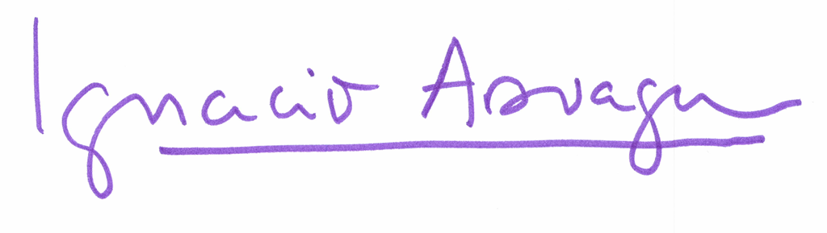

**Ignacio Arsuaga  
President of HazteOir.org (CitizenGO Group)**

1. International technical guidance on sexuality education: an evidence-informed approach UNESCO, 2018. <https://unesdoc.unesco.org/ark:/48223/pf0000260770>
2. WHO Regional Office for Europe and BZgA Standards for Sexuality Education in Europe WHO, 2010. <https://www.bzga-whocc.de/fileadmin/user_upload/WHO_BZgA_Standards_English.pdf>