Response to the call for contributions of the Special Rapporteur on Freedom of Religion or Belief on the Protection of Freedom of Thought

30 June 2021, Geneva, Switzerland

SUBMISSION TO THE SPECIAL RAPPORTEUR ON FREEDOM OF RELIGION OR BELIEF

Submission by:

ADF International
Rue Pré-de-la-Bichette 1
1202 Geneva, Switzerland

Web: www.ADFinternational.org
Email: UN@ADFinternational.org

ECOSOC Special Consultative Status (2010)

Introduction

- ADF International is a faith-based legal advocacy organization that protects fundamental freedoms and promotes the inherent dignity of all people before national and international institutions. As well as having ECOSOC consultative status with the United Nations (registered name “Alliance Defending Freedom”), ADF International has accreditation with the European Commission and Parliament, and the Organization of American States. ADF International is also a participant in the FRA Fundamental Rights Platform.

- In response to the call for inputs issued by the Special Rapporteur on freedom of religion or belief, this submission calls attention to the crucial importance of protecting freedom of thought (“FoT”) as a foundational human right. States are prohibited from interfering with this fundamental freedom, which warrants absolute protection as pertaining exclusively to the forum internum. FoT serves as a prerequisite for the exercise of myriad other fundamental human rights, including the freedom of religion or belief (“FoRB”).

- While difficult to detect due to their internal nature, infringements of FoT do transpire and are evident in a variety of human rights violations that are pervasive today, including, inter alia, anti-conversion laws and overly vague laws restricting expression or opinion. This submission focuses primarily on the convergence between FoT and FoRB, and in particular, the key role that FoT plays with regard to conversion or changing beliefs. It also examines FoT in light of a perceived “right” to freedom from thoughts, concluding that FoT does not serve to shield the individual from the thoughts of others. In its conclusions and recommendations, this submission highlights the duty of States to guarantee the necessary inviolability and absolute protection of FoT with due regard for these complexities.
- Definition of Freedom of Thought in International Law and Jurisprudence

- The United Nations Human Rights Committee stated in its General Comment No. 22 (1993) that FoT is “far-reaching and profound, encompassing freedom of thought on all matters”. Per the International Covenant on Civil and Political Rights, “everyone shall have the right to freedom of thought, conscience and religion”. The provision makes clear that these freedoms include the right to have or adopt a religion or belief, in addition to both private and public dimensions of manifesting one’s religion or belief. The relationship between FoT and rights to manifest and express are evident, although FoT is distinct as pertaining exclusively to the forum internum—the innermost personal space of an individual—as opposed to the outward forum externum.

- While the freedoms of conscience and religion have both internal and external dimensions, FoT is unique insofar as it relates specifically and exclusively to the forum internum. Thoughts can of course translate into external ramifications that interplay with other rights, but FoT in and of itself is entirely internal. It thus warrants absolute and non-derogable protection. This is because the forum internum forms a fundamental part of the individual’s autonomy and freedom—the private sphere that relates to the sovereignty a person has over his or her own mental state.

- Despite its internal characteristic, it follows that FoT is more robustly protected when related externally-oriented rights are fully protected. These related rights include freedom of conscience, religion or belief, expression, association, and the right to raise children in accordance with the beliefs of parents. The high burden for restrictions on these rights outlined in international human rights law serves to strengthen FoT, as the protection of the manifestations and practices that arise from thought has a symbiotic relationship with the flourishing of FoT itself.

- The provisions of international law that protect the forum internum do so with the prevention of State interference in mind so that personal thought, conscience, and religion remain an individual’s prerogative. This is demonstrated in Nolan and K. v Russia, heard before the European Court of Human Rights (‘ECtHR’), which highlights that the State cannot dictate what a person is to believe and cannot take coercive steps to make a person change his or her beliefs.

- The ECtHR has considered cases such as Sodan v Turkey in which it emphasizes that religious convictions are solely of a private nature. Further, in Folgero and ors. v Norway, the ECtHR held that religious convictions are some of the most intimate aspects of private life, and should be protected as such. Given that the protection of the forum internum is without limitation, the focus of human rights practice for FoT should be on preserving the capacity for self-determination of one’s religion or any other belief, with the ultimate goal of avoiding undue control or manipulation of the FoT of individuals.

- In emphasizing the private nature of religious conviction, it must be clarified that FoT, as a fundamental right of its own accord, is a prerequisite for FoRB, but is not all that FoRB embodies. Religion or belief goes beyond a person’s forum internum, as made clear by the right to worship, observe, practice, and teach in community or in public. FoRB has both internal and external dimensions, and must never be reduced to the mere freedom to hold a religion or belief in private. It is crucial that an appropriate, and much needed, emphasis on FoT not be misconstrued to unjustifiably limit a comprehensive understanding of FoRB in all its dimensions. For instance, a framework in which the individual enjoys unfettered protection of their internal religious convictions, but an extremely restricted ability to manifest their beliefs externally would violate the fullness of the fundamental right to FoRB.

- Despite its status as a fundamental human right, FoT has not been widely litigated or commented upon in human rights practice. There is a practical lack of international case law on FoT specifically; the vast majority of jurisprudence focuses naturally on rights relating to the forum externum. This may be due to the challenging nature of demonstrating that violations of FoT have occurred because of its internal quality. As they are interrelated, interdependent, and indivisible, a lack of attention to FoT necessarily affects the protection of other fundamental rights. This can be seen in particular with regard to the freedom to convert or change beliefs inherent in FoRB, in addition to the ambit of parental rights.
- FoT and Religious Freedom
- The act of discerning one’s religion or belief occurs as part of the forum internum, and consequently merits absolute protection. Like FoT, this element of FoRB cannot be subject to restriction; however, the freedom to convert is in jeopardy in many parts of the world. Former Special Rapporteur on freedom of religion or belief Heiner Bielefeldt highlighted the key importance of protecting the right to religious conversion in his comments before the General Assembly in 2012, outlining that States must abolish punishments against conversion and remove administrative obstacles, in addition to ensuring that those who convert are not threatened, for example with violence by third parties, or even by the State.

- A worrisome trend to enact “anti-conversion-laws” or “proselytism bans” severely threatens FoRB in violation of international law, and also has serious implications for FoT. First and foremost, it is impermissible to frame these bans as necessary to protect FoT, as FoRB very clearly encompasses the freedom to manifest and teach one’s religion or belief, subject to the individual’s right to be free from coercion. Absent coercion, manifesting one’s religion or belief does not impinge upon the forum internum of the other.

- Restrictions on the freedom to convert or change belief, whether legal or practical, in fact directly threaten FoT. We are entitled to freely discern our religious and other beliefs, and there is a strong element of thought that necessarily goes into this process. FoT thus is necessary for the subsequent freedom to manifest these thoughts through a religion or belief of one’s choice. States must respect the absolute nature of this right by abolishing bans or punishments for conversion, removing administrative obstacles, and protecting against third-party infringements, in addition to promoting a societal climate in which one can change religions or beliefs without fear and free from discrimination.

- It bears noting that thoughts as relating to both religion and other beliefs often are first expressed in the family—the most intimate area of communication, and the starting point for education. FoT is inextricably linked to parental rights. The Universal Declaration of Human Rights, article 26(3), regards the parental right to educate one’s children in accordance with one’s convictions as a “prior right”. Similarly the ICCPR accords parental rights the greatest respect. General Comment No. 22 recognizes ICCPR article 18 as protecting the “liberty of parents or legal guardians to ensure that their children receive a religious and moral education in conformity with their own convictions”. This protection is so important that the Committee expressly noted that, “public education that includes instruction in a particular religion or belief is inconsistent with article 18(4) unless provision is made for non-discriminatory exemptions or alternatives that would accommodate the wishes of parents and guardians”. To put this statement another way, the rights of parents to raise their children in accordance with their religion or belief in article 18(4), as well as the requirement of States to have respect for the liberty of parents, is a fundamental aspect of the freedom of thought, conscience, and religion as protected in article 18(1). This right “cannot be restricted”.

- Similarly, General Comment No. 22 explicitly states that beliefs or practices that constitute an “official ideology” of the State “shall not result in any impairment of the freedom under article 18 or any other rights recognized under the Covenant nor in any discrimination against persons who do not accept the official ideology or who oppose it”. This statement relates directly to FoT in that States that wish to impose an “official ideology” on individuals are per se attempting to control or eradicate certain thoughts. Article 18 forbids such attempts at control expressly for the protection of individuals and parents.
- FoT and the Thoughts of Others

- FoT also must be considered in light of the numerous, and increasingly prolific, laws that attempt to curb the freedom of expression and opinion by way of overly vague and arbitrary means, often with criminal sanctions. The right to share one’s beliefs freely and publicly inevitably has the potential to influence the thoughts of others. This is a natural, and ultimately, desirable aspect of living together in society. A detrimental corollary of this is the possibility for the manipulation of thoughts through indoctrination. Growing threats regarding the spread of both misinformation and disinformation through increased technological connectivity undoubtedly give rise to real concerns. However, what constitutes misinformation or disinformation is for the most part inherently subjective, inviting governments to abuse their power when making determinations in this area.

- Governments often will target and label the speech and practices of disfavored minorities as misinformation or disinformation in order to establish an official ideology of the State. Herein it is evident that censorship undermines the ability of the individual to ascertain what is true. It is critical that the freedom to manifest one’s religion or belief and other rights of expression be subject only to narrow restrictions in accordance with international legal parameters. These freedoms are the antidote to misinformation and disinformation, and an essential precondition for the flourishing of FoT.

- The absolute protections required by FoT must not be mistaken to imply an absolute freedom from the thoughts of others. International law is clear that the freedom to manifest and express one’s religion or belief does not infringe upon the forum internum of the other unless coercion is present. If we had such a “freedom,” it would be impossible to engage in a conversation or to read a book as one is constantly engaging with the thoughts of those around them. There is no right to live free of opinions other than our own. The ECtHR in the landmark case of Handyside v UK articulated that even expressions that shock, offend, and disturb must be part of and, in fact, hold value for society.

- In the rare instance where expressions require restriction, the thoughts that precede them still merit absolute protection. Absolute protection of the forum internum necessarily precludes any judgment as to whether thoughts are legal or illegal. Although thinking is often a precursor to action, no interference is permissible unless this line is crossed. Any attempt to limit thinking is an unjustifiable limitation of a person’s right to mental autonomy. George Orwell’s Nineteen Eighty-Four portrays with uncanny accuracy laws that so alter language, impose conformity, and punish dissent that the forum internum is directly violated. As he notes with sarcasm in describing the effect of policing thought in order to mandate belief in an official ideology, “Don’t you see that the whole aim of Newspeak is to narrow the range of thought? In the end we shall make thought crime literally impossible, because there will be no words in which to express it”.

- Ultimately, it must be emphasized that FoT is a negative right whereby governments are prohibited from interfering with this fundamental freedom. A State has no corresponding positive right or obligation to foster certain ways of thinking, and doing so can severely infringe upon the fundamental freedoms of its citizens. General Comment no. 22’s explicit prohibition on mandating belief in an “official ideology” directly speaks to a State’s inability under international law to foster certain ways of thinking or specific thoughts. Further, any attempt of a State to enforce certain ways of thinking under the guise of protecting FoT—for example, by interfering with parental rights in education or the internal doctrines of religious organizations—would itself violate FoT by preventing the development of conscientious thought. At the same time, as new technologies emerge, States may have a positive obligation to prohibit public and private attempts to directly control thoughts, in previously unseen ways, without consent.
- Recommendations
- In light of the aforementioned, ADF International suggests that the following recommendations be included in the Special Rapporteur’s report on Freedom of Thought, to be presented at the 76th session of the UN General Assembly.

- In particular, the Special Rapporteur may wish to call on States to:
    - Clarify that FoT is afforded absolute protection under international human rights law;
    - Emphasize FoT as a prerequisite for FoRB, as embodied by the right to convert or change beliefs, and reaffirm that States are under an obligation to remove all barriers to the enjoyment of this fundamental freedom;
    - Emphasize that full respect for FoT requires robust protections for related freedoms, such as freedom of conscience, religion or belief, expression, association, and the right of parents to raise their children in accordance with their religion or beliefs.

    - Advocate for an authentic understanding of all human rights as interrelated, interdependent, and indivisible, and thus in emphasizing the absolute protection of FoT, also caution States against disregarding the essential external dimension of FoRB in accordance with international human rights law.

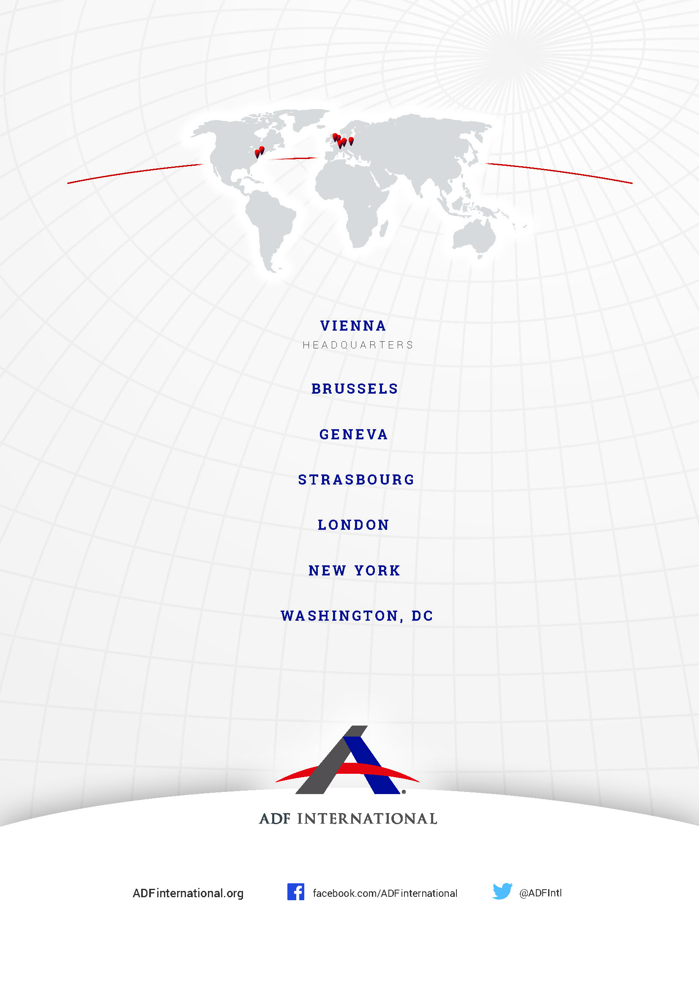

© 2021

U.N. Human Rights Comm. (HRC), General Comment No. 22: Article 18: Freedom of Thought, Conscience or Religion, ¶ 1, U.N. Doc. CCPR/C/21/Rev.1/Add.4 (July 30, 1993) [hereinafter HRC, General Comment No. 22].
International Covenant on Civil and Political Rights (ICCPR) art. 18(1), opened for signature Dec. 19, 1966, 993 U.N.T.S. 3.
Metzinger, T. K. (2013). The myth of cognitive agency: subpersonal thinking as a cyclically recurring loss of mental autonomy. Front. Psychol. 4:931. doi: 10.3389/fpsyg.2013.00931.
Murdoch, J., Protecting the right to freedom of thought, conscience and religion under the European Convention of Human Rights. Interpreting Article 9 of the Convention: general considerations, p.18.
Application no. 2515/04 (2009).
ibid para 73.
Application No.1860/50, para. 30.
Application No. 15472/02, para 98.
ICCPR, supra note 2, art. 18(1).
Bielefeldt, H., Elimination of all forms of religious intolerance, A/67/303, New York, 13 Aug. 2012.
Meghan Grizzle Fischer, Anti-conversion laws and the international response, 6 PENN ST. J. LAW & INT’L AFF. 1 (2018).
Heiner Bielefeldt (Special Rapporteur on freedom of religion or belief), Interim report of the Special Rapporteur on freedom of religion or belief, ¶ 15, U.N. Doc. A/67/303 (Aug. 13, 2012) [hereinafter Bielefeldt, Right to convert].
Universal Declaration of Human Rights, C.A. Res. 217A, art. 26(3), U.> GAOR, 3d Sess., 1st plen. Mtg., U.N. Doc. A/810 (Dec. 12, 1948)
ICCPR, supra note 2, art. 18(4).
HRC, General Comment No. 22, supra note 1, ¶ 6.
Id.
General Comment No. 22, para. 8.
Id. ¶ 10.
See Paul Coleman, ‘Censored: How European ‘hate speech’ laws are threatening freedom of speech’ (Vienna, 2016).
ICCPR, supra note 2, art. 18(2).
Application No. 5493/72, para. 49.
Orwell, George, Ben Pimlott, and Peter H. Davison. Nineteen Eighty-Four. London: Penguin Books in association with Secker & Warburg, 1989, Part 1, Chapter 5.

