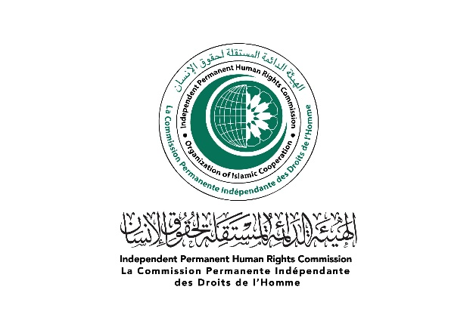

Statement by Ambassador Mahmoud Mostafa Afifi
Member of the OIC Independent Permanent Human Rights Commission

on the occasion of
OHCHR “REGIONAL MEETING FOR THE MIDDLE EAST ON THE INTERNATIONAL DECADE FOR PEOPLE OF AFRICAN DESCENT ”
PANEL DISCUSSION 1:
RECOGNITION: Sharing best practices in the promotion of equality and non-discrimination

31st October 2022

Geneva

Honorable Chair, Ladies and Gentlemen!

Good Morning!

On behalf of the Independent Permanent Human Rights Commission (IPHRC), it is my privilege to be invited to participate in the proceedings of this panel discussion.

At the onset, I join my colleagues in congratulating the OHCHR for this excellent initiative for providing visibility to this subject and bring it within the human rights discourse. The International Decade for People of African Descent, proclaimed by General Assembly resolution 68/237 provides a solid framework for the United Nations, Member States, civil society, in particular people of African descent, and all other relevant actors to join together, and take effective measures for recognition, justice and development.

I also appreciate the seminal role played by OHCHR in conducting various activities in collaboration with regional mechanisms and sharing of best practices for protection and promotion of human rights globally.

Ladies and Gentlemen
Racial discrimination, including one based on descent, remains a barrier to the full realization of human rights. The people of African descent remain a living legacy of erstwhile slavery and colonialism which continue to persist in different intersecting forms till today. The people of African descent have endured worst forms of marginalization and discrimination for centuries, but they have managed to regain their human rights after a protracted struggle in which OIC and its Member States have remained at the forefront.
The major concentration of people of African descent lives in Latin America and North America. There are sporadic pockets of people of African descent within the OIC Member States. These people are either descendants of those Africans who were subjected to transatlantic slave trade many generations back, or more recent migrants who have travelled to the Americas, Europe, Asia and within Africa itself. Even Afro-descendants who are not directly descended from slaves face the racism and discrimination that still persists today, generations after the slave trade has ended.
There is a growing consensus that racism and racial discrimination have caused marginalization of the people of African descent from many aspects of public life. They have suffered and continue to suffer exclusion and poverty. The factors that lead to poverty among people of African descent are mainly structural. Discrimination is apparent in the unequal access these groups have to basic services for example, in access to education, healthcare, markets, loans and technology. They are often ‘invisible‘ in official statistics and national policies. There has been progress, but the situation persists, to varying degrees, in many parts of the world.
Ladies and Gentlemen

Human rights are part and parcel of religion of Islam which is a prescribed way of life. Islam was the first religion that laid down universal fundamental rights for humanity, which are to be observed and respected in all circumstances. Islam calls for full equality among human beings regardless of their race, religion, language, ethnic origin or social status and places ‘hukook ul ibad’ or ‘rights of the people’ on a very high pedestal. The virtuous and time-honored mores, credited with the oldest human rights pact in Islam; the Charter of Medina, the last sermon of the Prophet Mohamed Peace Be Upon Him and the values of justice, equality and peace of Islamic civilization underpin the conception of human rights in Islam.

The OIC Charter contains specific provisions for the promotion and protection of human rights and fundamental freedoms. OIC Charter in its preamble sets a guiding principle to Member States “to preserve and promote the lofty Islamic values of peace, compassion, tolerance, equality, justice and human dignity”. It calls upon all Member States to uphold and promote, at the national and international levels, good governance, democracy, rule of law, human rights and fundamental freedoms.

OIC recognize that racism, racial discrimination, xenophobia and related intolerance occur on the grounds of race, colour, descent or national or ethnic origin and that victims can suffer multiple or aggravated forms of discrimination based on other related grounds including social origin, birth or other status.

OIC as an organization remains at the forefront of the fight against racism and played active role as an Organization and also its individual Member States to establish normative standards to help in the fight against racism. Today, almost all OIC Member States are Parties to International Convention for Elimination of Racial Discrimination. These OIC Member States, in their respective national capacities, are meeting their international human rights obligations to implement non-discrimination and racial integration policies as enshrined in Art. 3 of ICERD which condemns “racial segregation and apartheid and undertake to prevent, prohibit and eradicate all practices of this nature in territories under their jurisdiction”.

OIC Member States played an active role in adoption of the comprehensive Durban Declaration and Programme of Action (DDPA), in 2001 which acknowledged that slavery and the slave trade, were appalling tragedies in the history of humanity and are a crime against humanity. OIC Member States stood by the recognition that Africans and people of African descent were victims of these acts and continue to be victims of their consequences. OIC Member States consider that colonialism and persistence of its effects have been among the factors contributing to lasting social and economic inequalities in many parts of the world today.

Ladies and Gentlemen

IPHRC mandated by the OIC Council of Foreign Ministers revised the previous Cairo Declaration of Human Rights in Islam. The revised document has brought compatibility of the OIC human rights normative framework with the universal human rights standards. The focus on eliminating any racial superiority and emphasis on non-discrimination and equality as key to human dignity is amplified.

Article 1 of CDOHR conceptualize the Human Dignity as “All human beings form one family. They are equal in dignity, rights and obligations, without any discrimination on the grounds of race, color, language, sex, religion, sect, political opinion, national or social origin, fortune, age, disability or other status.” Also, “Gross and systematic human rights violations, and also slavery, servitude, forced labor and trafficking in persons, shall be prohibited in all forms, and under any circumstances.” This sets the ground for normative standards within the OIC Member States to bring an end to any and every form of discrimination against any race. This is followed by equality in access to legal justice for remedy (Art. 22), equal right to participate in the conduct of public affairs and freedom of peaceful assembly and association (Art. 23) and equality of access and opportunity to health, education and different social services.

Recognizing that poverty is both a cause and a consequence of discrimination, States are gearing up to strengthen programmes for eradicating poverty that take account of the specific needs and experiences of people of African descent. There is a deep understanding among the OIC Member States to focus on social investment in childhood and youth as a strategy to combat poverty without any discrimination that could help prevent the continued exclusion of a new generation of people of African descent from the benefits of economic, social and human development. The Member States have embarked on Ten Year Plan of Action and UN Sustainable Development Goals to leave no one behind which provides a basis for comprehensive inclusion of people of all races without discrimination.

Ladies and Gentlemen
It is of paramount importance to recognize the contributions of people of African descent worldwide, advance social justice and inclusion policies, eradicate racism and intolerance, promote human rights, and assist in creating better, more prosperous communities.
There has to have a political ownership both at global and national levels for racial equality and justice. Africans and people of African descent, like all human beings, are born free and equal in dignity and rights. Based on comprehensive international obligations and commitments, States must
show stronger political will to accelerate action for racial justice and equality, including by taking concrete steps to implement the recommendations made by United Nations and regional human rights mechanisms, national human rights institutions and equality bodies;
involve people and communities of African descent to guide the design and implementation of legislative processes through effective participation, including broad and inclusive consultations;
collect disaggregated data of these Afro descendant communities in their respective jurisdictions to guide the policy making and for targeted social interventions in health and education sector to alleviate marginalization;
Finally, the role of civil society actors, faith based leaders, media and National Human Rights Institutions is of paramount importance to create an enabling environment of equality for implementation of policies.
As Nelson Mandela has said that our choices must reflect our hopes, not fears.
Thank you for your attention
************

