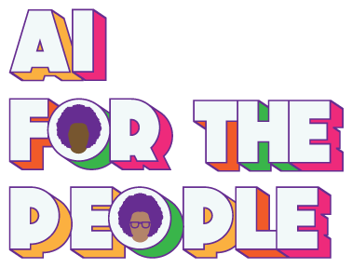

**Input for paragraph Section 20**

**pursuant to the UN General Assembly resolution 77/205**

**Title**

*The need to classify algorithmic bias as a systematic form of racism and racial discrimination : Case Study Black women and Online Speech*

**Author:**

Mutale Nkonde, AI for the People registered non profit in the United States.

💻 [mutale@aiforthepeopleus.org](mailto:mutale@aiforthepeopleus.org)

<https://aiforthepeopleus.org>

**Keywords**

Online Violence/ Black women/ women of African Descent/ AI, Algorithmic Bias /

Social Media / UN Declaration for the Rights of People of African Descent/

UN Permanent Forum of People of African Descent/ Office of the United Nations High Commissioner for Human Rights/ (OHCHR) / Article X Coalition.

**Overview**

This input has been written by AI for the People, a US NGO and founder member of the Article X Coalition, a group of digital organizations from across the globe advocating for inclusion of an Article on freedom from Algorithmic Bias in the forthcoming UN Declaration on the Rights of People of African Descent.

Algorithmic bias is a phenomenon in which machines instead of people advance racist/sexist/homophobic/transphobic or any other attitude that disadvantages a group only because of their identity. It is particularly insidious because technical systems can make biased determinations despite having never been trained to consider the race, gender, sexual identity and/or economic status of the user. The bias becomes embedded into technical products by using training data generated by social systems in which bias is present. Once this data is used its results act as a racial proxy. For example home ownership rates are a proxy for the distribution of economic opportunity across society, arrest data is a proxy for ideologies that drive policing and/or health data which is a proxy for the environmental conditions people live in.

This particular paper is designed to provide input for report

*“A global call for concrete action for the elimination of racism, racial discrimination, xenophobia and related intolerance and the comprehensive implementation of and follow-up to the Durban Declaration and Programme of Action”,*

~ pursuant to resolution 77/205

This paper builds on the pioneering work of two Special Rapporteurs. The first is E. Tendayi Achiume, whose thematic report A/HRC/44/57 on racial discrimination and emerging technologies submitted to the Human Rights Council in June 2020 laid the foundation to discuss the specific ways AI driven technologies like social media express racial bias[1]. And A/HRC/38/47 a thematic report on women and online violence submitted to the Human Rights Council in July 2018 by Ms. Dubravka Šimonovic, then Special Rapporteur on online violence against women[2].

We also could not write this paper without the 2018 Amnesty International report on women and online violence that ***paid particular attention to the online lives of Black women.*** There is so little work done specifically on Black women that it’s results are cited throughout and for that we are deeply grateful[3]. Lastly we appreciate the work already being done by Ms. Catherine Namakula (Chair), Ms. Barbara Reynolds (Vice-Chair), Ms. Miriam Ekiudoko and Mr. Sushil Raj, the Working Group of Experts on People of African Descent;people of African descent, who condemned the increased use of the n word on the Twitter platform when it was taken over by Elon Musk[4]

**Our call to the UN General Assembly**

***This paper is designed to position the spread of online hate as a case study on how algorithmic bias harms Black people across the globe.*** We implore the UN General Assembly to make the elimination of algorithmic bias an area of focus as they seek to integrate anti-racist approaches into the human rights framework. Through ***the inclusion eliminating algorithmic bias in section 20 o****f the**global call for concrete action for the elimination of racism, racial discrimination, xenophobia and related intolerance*

**PART ONE: Anti-Black Racism has Gone Online Extent and impact of systemic racism**

**Social Media a New Site of Racist Violence**

1. Social Media has empowered ordinary citizens to speak truth to power. We saw this during Arab Spring in 2011[5] and the hashtag #BlackLivesMatter which first appeared on Facebook 2013[6], and became the rallying cry for global racial justice protests in 2020[7]. Underpinning all online social movements is the feeling of solidarity that users derive from taking part in a collective experience. Within this experience people who have the same beliefs are provided free access to communications platforms in which they can freely exchange ideas. However very little is said about the ways in which social media platforms use AI driven algorithms to deliver information to our social media feeds. This report shows how racial and gender based bias helps drive those decisions and in doing so violate the rights of Black women and girls across the globe.

2. Our online experiences are mediated through three systems. The first is the activation of a web of algorithmic recommendation systems that highlight relevant content[8]. Once the relevant content has been identified by the company, it is then filtered by another set of content moderation algorithms that decide which elements of the relevant content appear on our social media feeds. This process is optimized to increase the profitability of advertising value of the platform[9]. Finally, this social media content impacts the on and offline behavior of user groups by stimulating their psychological drivers[10].

Please see Fig 1 below:

Fig 1:

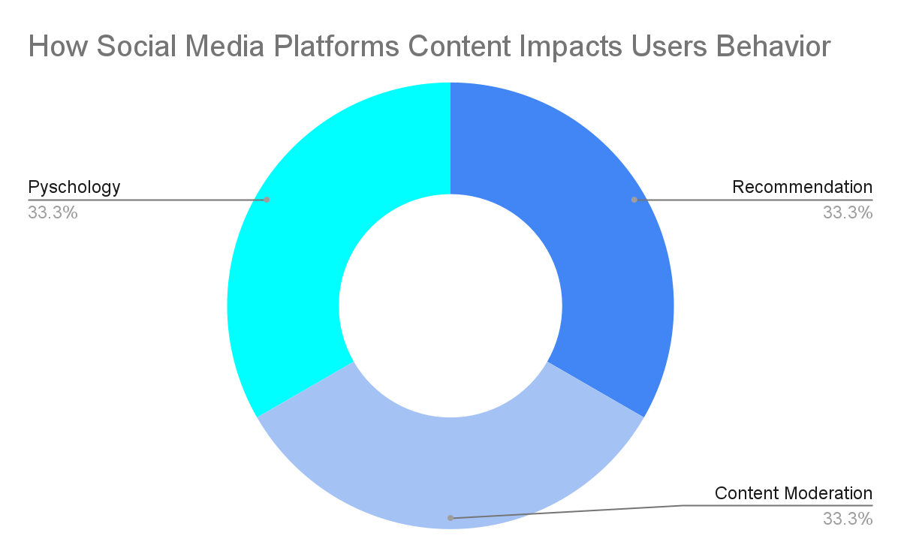

This is a circular process which is meant to increase the profitability of platform companies, without regard for the end user, which has been found to generate a number of human rights concerns.

**How our online experiences work with our psychology**

3. Further to this, researchers at the Wharton School of Business have identified that anger can encourage people to share social media content on a mass scale (also known as going viral) more so than stories that are neutral[11]. This is a matter of concern when we consider the online lives of Black women. Black women and girls are 84 percent more likely to experience online hate than white women[12]. There are many reasons why Black women and girls are targeted more than white women, one the major reason is they have shoulder the burden of societal levied towards Black people and women at the same time, a phenomenon called misogynoir.

4, Misogynoir a term coined by media scholar Moya Bailey who developed the phrase by combining the term misogyny with the word noir, the French word for the color black, to describe the interlocking oppressions of sexism and racism which Bailey states Black women do not experience separately, but rather as a “inseparable amalgamation of toxicity”, when in online spaces[13]. UN actors may be more familiar with the term intersectionality which relates closely to misogynoir; the only difference between the two is that ***misogynoir is an online phenomenon***. AI for for the People has adopted the definition of intersectionality offered by the United Nations Division for the Advancement of Women in their 2000 expert group report on gender and racial discrimination, which states:

*The idea of “intersectionality” seeks to capture both the structural and dynamic*

*consequences of the interaction between two or more forms of discrimination or*

*systems of subordination. It specifically addresses the manner in which racism,*

*patriarchy, economic disadvantages and other discriminatory systems contribute to creating layers of inequality that structures the relative positions of women and men, races and other groups. Moreover, it addresses the way that specific acts and policies create burdens that flow along these intersecting axes contributing to create a dynamic of disempowerment[14].*

5. It is important to state that the term misogynoir is used more than intersectionality because we are discussing the online lives of Black women and girls. Although the term misogynoir builds from the concept of intersectionality. The notion of intersectionality has been enshrined into the thinking of the human rights council through a series of resolutions but the one we are drawing attention to is 44/17 adopted in July 2020 that draws attention to how gender based discrimination intersects with race[15].

6. When we combine how misogynoir impacts the online loves of Black women with evidence that anger as a drives social media engagement and social media companies do not want remove harmful content because the anger it induces increases the advertising value of social platforms[16]. We can see why social media platforms are so dangerous for Black women.

7. This information has been shared with social media companies by human rights organizations like Amnesty International and others. However, instead of social media companies developing content moderation policies that protect Black people and others from stigmatized groups. Facebook whistleblower Frances Haugen leaked documents that showed that Meta, Facebook’s parent company, upgrades anger inducing content because its relative virality increases the advertising value of the platform by increasing the time social media spend online to engage in these conversations.[17]

8. ***The hosting of online hateful content is what makes social media platforms a site of racial discrimination.*** This is because it provides a public venue for people to express their offline prejudices in online discourse, which can lead to Black people being attacked offline. For example in 2015 white supremacist Dylann Roof reported typing “white on Black crime” - which is not a real phenomenon it is racists dog whistle. Racist dog whistles are misleading terms or phrases used to appeal to people with racist tendencies[18]. However the Google search engine is a software program that is designed to provide website links to help people find information to satisfy their inquiries, software programs do not have the capacity to read the social and political context in which people search for information. Therefore inquiry that led him to white supremacist social networks that made him so angry with Black people in America, he went into a church in South Carolina and murdered nine Black people while they were at Bible study[19] . This number included seven Black women who are one of the most vulnerable groups to online hate[20]. This is an example of what Dubravka Šimonov, former special rapporteur on Violence Against women, describes as a ***offline/online violence against women continuum***[21].

9. The Google search engine directed Dylann Roof to white supremacist social platforms because it has the ability to analyze the words in his search inquiry and then use this to ***decide*** which websites would provide him the information he was seeking. This is what makes Google and other “smart” technologies that engage in decision making ***artificially intelligent***, because it is performing a task associated with human cognition. However the problem discussed above is that the Google search engine is a software program with no ability to make value judgements.

10. One way the ability for social media platforms to decide what content we are allowed to see can be weaponized against Black women was seen in the run up to the 2016 US Elections. During this time the Trump campaign paid for online ads targeting 3.5 million Black US based social media users in the most competitive electoral districts in the country. These social media users were selected through a process called targeted advertising. Targeted advertising is a process by which people or organizations can pay social media platforms to ensure their ads are seen by groups of people who have already shown interest in the vertical in which they operate[22]. In this case the users targeted by the Trump campaign had already watched online videos about the 2016 US Presidential campaign. Therefore because YouTube - the platform the Channel Four News team focused their investigation on had no incentive to remove these videos that include misinformation about Hilary Clinton, that is information that is misleading, and disinformation about Hilary Clinton which is misleading information that is spread with malicious intent. This impact had a disproportionate negative impact on Black female voters because they are the most loyal Democratic voting bloc in the Democratic Party, the party for which Clinton was running[23]. Therefore YouTube became complicit in hosting and spreading mis/disinformation designed to disenfranchise Black women. ***This is an example of algorithmic bias.***

.

**The Need to Take a Black Feminist Approach to Combating Online Violence**

11. Black feminism is a school of thought that dates back to the nineteenth century abolitionist movement and which grapples with the lived experiences of people in the United States who are both ***Black and female presenting***. This is because Black women living in the United States have to navigate the legacies of slavery and sexism which includes the invention of race to justify the commodification of Black people. Within this context women are not extended the affordances to white women who are viewed as fragile, need protection and are given grace when they make mistakes. This is seen most pointedly within the criminal justice systems where white women are given shorter sentences than their Black counterparts[24]. Black feminist thought was developed in response to the lack of care Black women received within feminist spaces that do not apply an anti-racist analysis to their gender justice. And racial justice spaces which maintain gender hierarchies in which men are elevated above women. One of the central tenets of Black feminist thought is policies that benefit Black women, benefit all people because Black women have intersectional identities[25].

**Example of How Algorithmic Bias Harms Black Women in Online Spaces**

12. Online attacks on Black women, girls, non binary femmes and our lesbian, bisexual and queer siblings do not happen in the abstract. Each attack is devastating, but the targeted attacks on women building power present the most acute human rights challenges. In each case we see how the commercial gains made by social media platforms are put ahead of the safety of women who are suffering attacks driven by what American scholar Sarah Haley described as shaped by “anti-Blackness and (the desire to) terrorize their victims”[26]. There are many sites in which Below are harmed in online spaces but for brevity we will only discuss how algorithmic bias impacts Black female journalists.

13. A 2021 report commissioned by UNESCO and produced by the International Center for Journalists found that ***three quarters of female journalists from 125 countries had experienced online abuse on social media***. Although the term social media refers to a number of platforms, our discussion of Black female journalists centers on Twitter. Twitter is the platform of choice for US based journalists and so there is more information about the experiences of female journalists than Linkedin which is the most popular platform for journalists across the world[27]. As stated above this online abuse is a failure of content moderation systems that are optimized to privilege advertising content, even when that content is harmful. UNESCO uses the generic terms “female journalists” and acknowledges that online harassment is more severe due to online misogyny. As stated earlier, misogynoir describes the interlocking oppression of sexism and racism which Black women can not experience separately. Instead, Black women are exposed to what media scholar Moya Bailey described as the “inseparable amalgamation of toxicity” in online spaces[28]. The UNESCO report also examines the impact on female journalists who also simultaneously experience homophobia, xenophobia, religious bigotry, and other forms of discrimination. All these forms of discrimination are used to attack women whose jobs are to speak truth to power. In societies driven by patriarchal, white supremacist, capitalist systems. As UN Secretary General António Guterres states:

*Online violence against women journalists is designed to: belittle, humiliate, and shame; induce fear, silence, and retreat; discredit them professionally, undermining accountability journalism and trust in facts; and chill their active participation (along with that of their sources, colleagues and audiences) in public debate. This amounts to an attack on democratic deliberation and media freedom, encompassing the public’s right to access information, and it cannot afford to be normalized or tolerated as an inevitable aspect of online discourse, nor contemporary audience-engaged journalism*

He went onto tweet

Fig: 4 UN Secretary General António Guterres supports female journalists

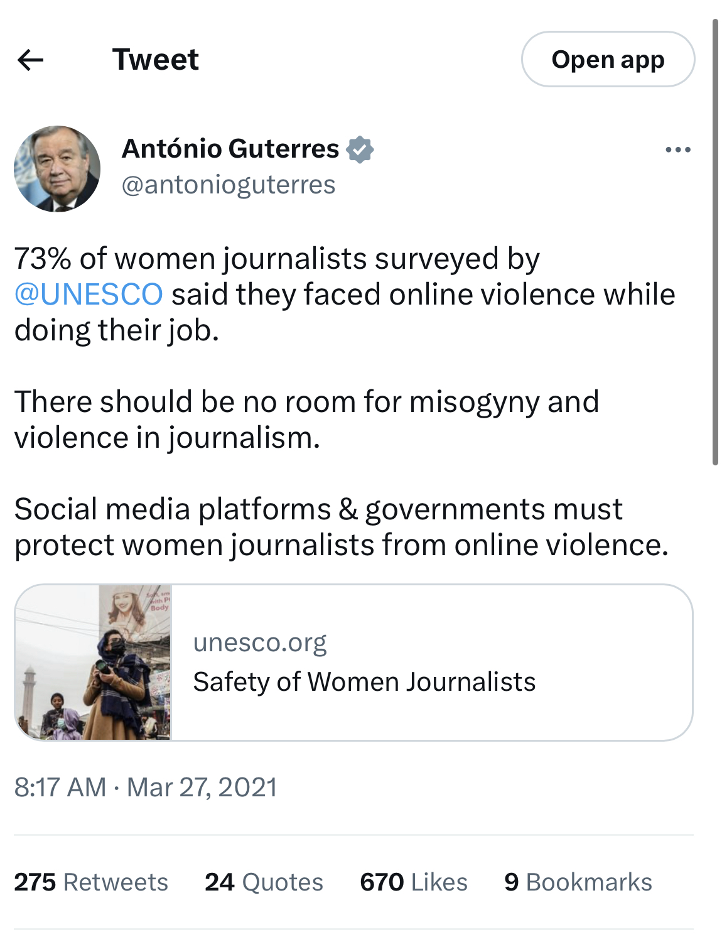

which garnered only 670 likes and 275 retweets on a platform where Guterres has 2 million followers[29]. This indifference to the call made by Guterres for social media companies to remedy this issue is mirrored by the experiences of female journalists on the ground.

One such woman is South African Broadcasting Corporation's Cresilda Lewis. Lewis became subject to online attacks after reporting on the rising tensions between Black South Africans and foreign nationals, a movement punctuated by the hashtag #OperationDudula on Twitter and other social media platforms.

Operation Dudula started in Soweto’s Alexandria township, one of the poorest areas in South Africa, which economists describe as one of the most unequal countries in the world[30], which can be best seen in unemployment rates. In the first quarter of 2022, 34 percent of the South African population was unemployed. Black South Africans were the most impacted as we can see in the table below:

Fig 1: 2022 Unemployment Rate in South Africa

|  |  |
| --- | --- |
| Racial Classification | Unemployment Rate (% of population) |
| Black | 38.6 |
| Colored (multi racial) | 25.9 |
| Asian | 17.1 |
| White | 10[31] |

Despite the structural reasons for South Africa’s problems with inequality, Operation Dudula activists are view Black foreigners as one of their biggest problems because they feel they are given more access to public houses, low level jobs and other public goods[32]. Lewis was targeted because of her professional obligation to understand the rise of anti-xenophobic sentiment in South Africa. Instead of her coverage of the Operation Dudula resulted in her been accused of spreading disinformation, leaving her open to online attacks[33].

The UNESCO report found 44 percent of respondents were attacked online after engaging in political reporting and so Lewis is not alone. This percentage was followed by women reporting on human rights and social policy, but the female journalists who received the most abuse are those who reported on gender. The decision by Lewis’s detractors to accuse her of spreading disinformation[34] is a form of attack levied against female journalists in the UNESCO report they state 41 percent of respondents faced this accusation. Female journalists also reported:

* to threats of physical violence, including death threats,
* threats of sexual assault and
* ***20 percent of respondents in the UNESCO study reported experiencing offline violence associated with the online threats.***

Fig 2 Impacts of online attacks against journalists

|  |  |
| --- | --- |
| Impact of online attack | % of respondents who reported it |
| Negative impact mental health | 26 |
| Self censoring online | 30 |
| Withdrawing from social media | 20s[35] |

These impacts are felt most acutely by Black women who we know are 84 percent more likely to experience online hate than their white counterparts[36].

14. Online attacks against female journalist inhibit their right of freedom of expression, protected in Article 19 of the Universal Declaration of Human Rights[37]. The attacks on female political reporters and those reporting on human rights and social policy are particularly sinister because of the potential for these women to withdraw from social media. ***This is a potent example of algorithmic bias*** because it is marginalizing the online voices of female journalists in their professional field.

15. This should be of huge concern for the General Assembly because of the role journalists play in uncovering human rights abuses. Given that Black women who do this work are some of the most attacked should be an indicator this and all forms of eliminating algorithmic bias should be a focus for the UN and should be discussed in paragraph 20 of the upcoming report.

**Effective legal, policy and institutional measures that address algorithmic bias also known as online racism**

AI for the people has four suggestions on approaches the UN General Assembly Can Take In Guiding Member States on How to Eliminate Algorithmic Bias

16. In 2018 Achiume drew attention to how online hate speech was advancing neo Nazism[38]. She pointed out how member states are obligated to act upon this under article 7 of the Convention to eliminate racism[39]. AI for the People urges the UN General Assembly to broaden their conception of freedom of expression as a consequence of algorithmic bias and in doing so taking a global stance against the algorithmic amplification of online speech.

18. In the United States there is a proposal for the use of human rights impact assessments being adopted[40] to mitigate the harm that advanced technological systems like social media platforms have on Black women and other vulnerable groups. AI for the People demands that this becomes a global standard by preventing companies who do not comply with access to the global market, because of the role social media companies play in undermining democracy.

18. Although international human rights law is only directly legally binding on States, civil society actors see it as a model for state and federal regulation and urge their peers to look to use its language in local contexts.

19. In writing about the role private companies can play in reducing algorithmic bias. Mutale Nkonde argues it should become a core function with the corporate social responsibility space[41]. This complies with the Guiding Principles on Business and Human Rights, which states industry has a responsibility to respect human rights, including through human rights. One possible model developed through the Office of the High Commission for Human Rights is the Business and Human Rights in Technology Project (B-Tech Project), which provides authoritative guidance and resources for implementing the United Nations Guiding Principles on Business and Human rights to tech companies[42].

20. The Toronto Declaration on Human Rights and AI, is another excellent model. It points out

*“As machine learning systems advance in capability and increase in use, we must*

*examine the impact of this technology on human rights.[43].” This underscores the obligations businesses have to ensure their AI use is not at the detriment of our human rights.”*

**In closing**

In closing AI for the People do not think that a paragraph 20 which is meant to address the extent and impact of systemic racism and effective legal, policy and institutional measures that address racism beyond a summation of individualized acts will not reflect the current reality of Black people unless it addresses algorithmic bias. If you would like to discuss this further please contact:

Mutale Nkonde

CEO AI for the People

💻 [mutale@aiforthepeopleus.org](mailto:mutale@aiforthepeopleus.org)

<https://aiforthepeopleus.org>

1. E. Achiume, TendayI UN. Human Rights Council. Special Rapporteur on Contemporary Forms of Racism, Racial Discrimination, Xenophobia and Related Intolerance,

   A/HRC/44/57 (June 18, 2020) ,Racial discrimination and emerging digital technologies : a human rights analysis, ,read the report here <https://digitallibrary.un.org/record/3879751?ln=en#record-files-collapse-header>
2. Dubravka Šimonov (July 18, 2018) report on violence against women , A/HRC/38/47 UN Human Rights Council, special Rapporteur on violence against women,read the report here <https://documents-dds-ny.un.org/doc/UNDOC/GEN/G18/184/58/PDF/G1818458.pdf?OpenElement>
3. Amnesty International (December 18, 2018) Crowdsourced Twitter study reveals shocking scale of online abuse against women, read the report here <https://www.amnesty.org/en/latest/press-release/2018/12/crowdsourced-twitter-study-reveals-shocking-scale-of-online-abuse-against-women/>
4. UN Human Rights Council (January 6, 2023) Freedom of speech is not freedom to spread racial hatred on social media: UN experts, read the article here <https://www.ohchr.org/en/statements/2023/01/freedom-speech-not-freedom-spread-racial-hatred-social-media-un-experts>
5. Zeymep Tufekci (2017) *Twitter and Tear Gas: The Power and Fragility of Networked Protest,* pages 118-119, Yale University Press, New Haven & London
6. Sarah Jackson, Moya Bailey & Brooklyn Foucault Welles (2020), pages 124-130, Massachusetts Institute of Technology Press, Cambridge Massachusetts.
7. Damien Cave, Livia Albeck-Ripka and Iliana Magra (Pub. June 6, 2020, updated June 9, 2020) Huge Crowds Around the Globe March in Solidarity Against Police Brutality, New York Times, read the story here <https://www.nytimes.com/2020/06/06/world/george-floyd-global-protests.html>
8. Artificial Intelligence is a branch of computer science in which machines are engineered to carry out multi step processes associated with high level neurological activity associated with human beings. For example, decision making involves processing textual and/or visual information, then processing this information, weighing it against a set of desired goals and then deciding what course of action to take. These are some of the processes social media recommendation algorithms undertake which results in these platforms being described as *artificial intelligence.*
9. Rosanna E. Guadagno , Daniel M. Rempala , Shannon Murphy, Bradley M. Okdie (November, 2013) What makes a video go viral? An analysis of emotional contagion and Internet memes, [Computers in Human Behavior](https://www.sciencedirect.com/journal/computers-in-human-behavior), read the article here <https://www.sciencedirect.com/science/article/abs/pii/S0747563213001192>
10. Christopher Wylie (2019) Mindf*ck: Cambridge Analytica and the Plot to Break America, pages 77-78, Random House, New York
11. Rosanna E. Guadagno , Daniel M. Rempala , Shannon Murphy, Bradley M. Okdie (November, 2013) What makes a video go viral? An analysis of emotional contagion and Internet memes, [Computers in Human Behavior](https://www.sciencedirect.com/journal/computers-in-human-behavior), read the article here <https://www.sciencedirect.com/science/article/abs/pii/S0747563213001192>
12. Amnesty International (December 18, 2018) Crowdsourced Twitter study reveals shocking scale of online abuse against women, read the report here <https://www.amnesty.org/en/latest/press-release/2018/12/crowdsourced-twitter-study-reveals-shocking-scale-of-online-abuse-against-women/>
13. Moya Bailey (2020) Misogynoir Transformed: Black Women’s Digital Resistance, page 38,New York University Press
14. United Nations Division for the Advancement of Women (21-24 November 2000) Gender and racial discrimination Report of the Expert Group Meeting, read the report here <https://www.un.org/womenwatch/daw/csw/genrac/report.htm>
15. UN Human Rights Council, 44th Session (July 17, 2020) 44/17. Elimination of all forms of discrimination against women and girls, find the resolution here <https://documents-dds-ny.un.org/doc/UNDOC/GEN/G20/187/95/PDF/G2018795.pdf?OpenElement>
16. Laura L. Hayes (April 9 2014) How to Stop Violence:Mentally ill people aren’t killers. Angry people are, Slate, read the article here <https://slate.com/technology/2014/04/anger-causes-violence-treat-it-rather-than-mental-illness-to-stop-mass-murder.html>
17. Jeremy B. Merrill and Will Oremus (October 26, 2021) Five points for anger, one for a ‘like’: How Facebook’s formula fostered rage and misinformation, Washington Post, read the article here <https://www.washingtonpost.com/technology/2021/10/26/facebook-angry-emoji-algorithm/>
18. Ian Olasov (November 7, 2016) Offensive political dog whistles: you know them when you hear them. Or do you?, Vox, read the article here <https://www.vox.com/the-big-idea/2016/11/7/13549154/dog-whistles-campaign-racism>
19. Rebecca Hersher (January 10, 2017) What Happened When Dylann Roof Asked Google For Information About Race?, NPR, read the article here <https://www.npr.org/sections/thetwo-way/2017/01/10/508363607/what-happened-when-dylann-roof-asked-google-for-information-about-race>
20. NPR Staff (June 18, 2015) The Victims: 9 Were Slain At Charleston's Emanuel AME Church, NPR, read the article here <https://www.npr.org/sections/thetwo-way/2015/06/18/415539516/the-victims-9-were-slain-at-charlestons-emanuel-ame-church>
21. Dubravka Šimonov (July 18, 2018) report on violence against women , A/HRC/38/47 UN Human Rights Council, special Rapporteur on violence against women, pages 5, read the report here <https://documents-dds-ny.un.org/doc/UNDOC/GEN/G18/184/58/PDF/G1818458.pdf?OpenElement>
22. Anthony Nadler, Matthew Crain and Joan Donovan (October 17, 2018) Weaponizing the Digital Influence Machine: The Political Perils of Online Political Ad Tech, page 5, read the report here <https://datasociety.net/wp-content/uploads/2018/10/DS_Digital_Influence_Machine.pdf>
23. Vanessa Williams (November 12, 2016) Black women — Hillary Clinton’s most reliable voting bloc — look beyond defeat, Washington Post, read the article here <https://www.washingtonpost.com/politics/black-women--hillary-clintons-most-reliable-voting-bloc--look-beyond-defeat/2016/11/12/86d9182a-a845-11e6-ba59-a7d93165c6d4_story.html>
24. Melanie M. Holland and Ariane Prohaska (2021) Gender Effects Across Place: A Multilevel

    Investigation of Gender, Race/Ethnicity, and Region in Sentencing, Sage Publications read it here <https://journals.sagepub.com/doi/pdf/10.1177/2153368718767495>
25. Demita Frazier and Barbara Smith (1977) The Combahee River Collective

    Statement, read the statement here <https://americanstudies.yale.edu/sites/default/files/files/Keyword%20Coalition_Readings.pdf>
26. Sarah Haley (2016), “Convict Leasing, (Re)Production, and Gendered Racial Terror,” No Mercy Here:

    Gender, Punishment, and the Making of Jim Crow Modernity, page 67.
27. Mark Jurkowitz and Jeffrey Gottfrie (June 27, 2022) Twitter is the go-to social media site for U.S. journalists, but not for the public, Pew Research Center, read the article here <https://www.pewresearch.org/fact-tank/2022/06/27/twitter-is-the-go-to-social-media-site-for-u-s-journalists-but-not-for-the-public/>
28. Moya Bailey (2020) Misogynoir Transformed: Black Women’s Digital Resistance, page 38,New York University Press
29. Julie Posetti (April 2021) Chilling: Global Trends in online violence against female journalists , research discussion paper, pages 1-4, find the report here <https://en.unesco.org/sites/default/files/the-chilling.pdf>
30. Aljazeera (March 10, 2022) South Africa most unequal country in the world: Report, read the article here <https://www.aljazeera.com/news/2022/3/10/south-africa-most-unequal-country-in-the-world-report>
31. Cheryl Kahla (June 1, 2022) Unemployment: White citizens least affected while black youth have no prospects, the Citizen, read the article here <https://www.citizen.co.za/news/unemployment-white-citizens-versus-black-youth-south-africa/>
32. Pumza Fihlani (March 13, 2022) Dudula: How South African anger has focused on foreigners, BBC News, find the article here <https://www.bbc.com/news/world-africa-60698374>
33. Ibid
34. Disinformation is the organized spread of misleading information with malicious intent, and has a particularly negative impact on female journalists.
35. Julie Posetti (April 2021) Chilling: Global Trends in online violence against female journalists , research discussion paper, pages 7-13, find the report here <https://en.unesco.org/sites/default/files/the-chilling.pdf>
36. Amnesty International (December 18, 2018) Crowdsourced Twitter study reveals shocking scale of online abuse against women, read the report here <https://www.amnesty.org/en/latest/press-release/2018/12/crowdsourced-twitter-study-reveals-shocking-scale-of-online-abuse-against-women/>
37. Universal Declaration of Human Rights, Article 19, find it here <https://www.un.org/en/about-us/universal-declaration-of-human-rights>
38. E. Achiume, TendayI UN. Human Rights Council. Special Rapporteur on Contemporary Forms of Racism, Racial Discrimination, Xenophobia and Related Intolerance (August 6, 2018) Report of the Special Rapporteur on contemporary forms of racism, racial discrimination, xenophobia and related intolerance, page 9 read the report here <https://documents-dds-ny.un.org/doc/UNDOC/GEN/N18/251/48/PDF/N1825148.pdf?OpenElement>
39. E. Achiume, TendayI UN. Human Rights Council. Special Rapporteur on Contemporary Forms of Racism, Racial Discrimination, Xenophobia and Related Intolerance (June 18, 2020) , *Racial discrimination and emerging digital technologies : a human rights analysis*, page 16 ,read the report here <https://digitallibrary.un.org/record/3879751?ln=en#record-files-collapse-header>
40. Algorithmic Accountability Act of 2022, read the one pager here <https://www.wyden.senate.gov/imo/media/doc/2022-02-03%20Algorithmic%20Accountability%20Act%20of%202022%20One-pager.pdf>
41. Mutale Nkonde (November 9, 2021) Is AI Bias a Corporate Social Responsibility Issue?, read the article here <https://hbr.org/2019/11/is-ai-bias-a-corporate-social-responsibility-issue>
42. OHCHR and business and human rights, The B-Tech Project read more here <https://www.ohchr.org/en/business-and-human-rights/b-tech-project>
43. The Toronto Declaration, Human rights and AI, read it here <https://www.torontodeclaration.org/about/human-rights-and-ai/>