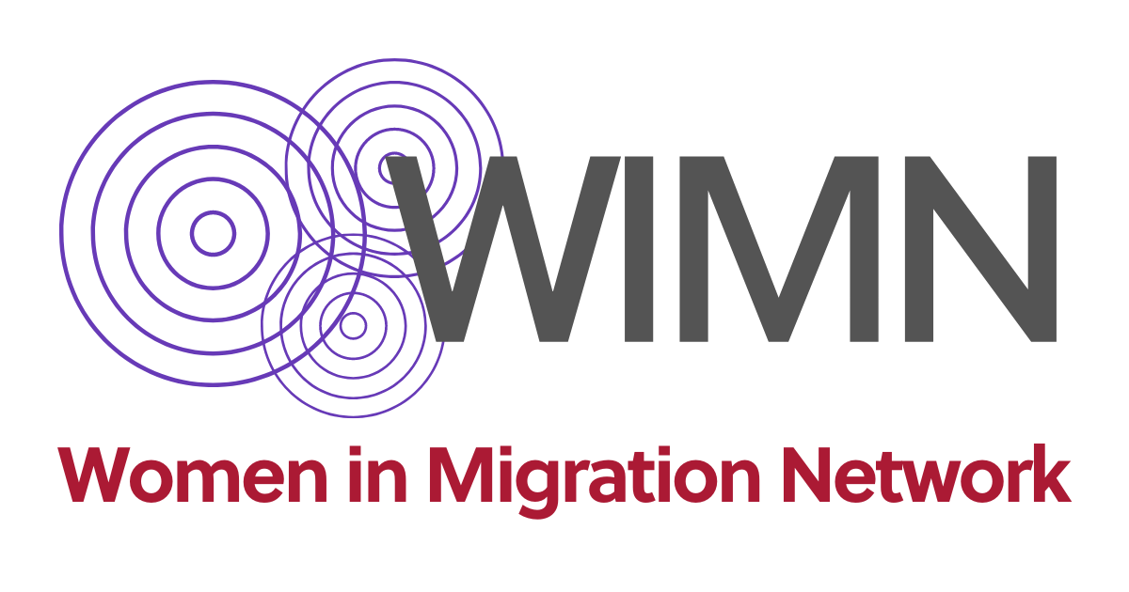

**Submission to CMW/CERD joint comment on public policies for addressing and eradicating xenophobia and its impact on the rights of migrants, their families and other non-citizens affected by racial discrimination**

**About WIMN**

Women in Migration Network (WIMN) is an international network focused on the rights of women in migration. We create and promote human rights-based and feminist global migration policies in an era dominated by economic, social and political inequities and hostile systems towards people in migration. We lift up and support the experiences, voices and agency of all women in migration as essential changemakers on the road to a more just world. Our members are organizations and individuals working at the national, regional and international levels, advocating for women, migrant, human rights, and labor rights.

**Introduction**

Addressing xenophobia, gender discrimination, and racial discrimination requires comprehensive and intersectional policies that recognize the complex interactions between different forms of oppression and privilege. These forms of oppression are deeply interconnected and mutually reinforcing.

Global inequalities, gender inequalities, the impact of historical legacies of colonialism and systemic racism interact with and are root causes of xenophobia. An intersectional approach needs to consider and to examine historical inequalities and structures, including social and political structures, for evidence of built-in racism and xenophobia, and not just the cumulative disadvantages or injustices.

Migrant women and LGBTIQ+ migrants are particularly impacted by xenophobia due to intersecting forms of discrimination based on their gender, sexual orientation, gender identity, and immigration status, among other intersecting forms of discrimination. These groups are disproportionately targeted for violence, harassment, and hate crimes motivated by xenophobia and intolerance. They may face physical, verbal, and sexual abuse due to their perceived foreignness, gender identity, or sexual orientation.

Xenophobia can create barriers to accessing essential services and support for migrant women and LGBTIQ+ migrants. They may encounter discrimination and hostility when seeking healthcare, housing, legal assistance, or social services, which can prevent them from accessing the resources they need.

1. **How xenophobia should be addressed through an intersectionality lens?**

Addressing xenophobia through an intersectionality lens requires addressing underlying structural inequalities and systems of oppression. It involves understanding the root causes and manifestations of xenophobia within specific contexts and examining how intersecting systems of power, privilege, and oppression, such as racism, nationalism, colonialism, and capitalism contribute to xenophobic attitudes, policies, and practices. Here's how this approach can be addressed:

**Understanding intersections of identity and multiple oppressions**: Recognize that individuals experience discrimination and marginalization based on multiple aspects of their identity such as race, ethnicity, nationality, religion[1], gender, sexual orientation, disability, and socioeconomic status among others. Understand how these intersecting identities shape their experiences of xenophobia and compound their vulnerability to discrimination and violence.

**Centering Lived Experience Voices**: Centre the voices and experiences of individuals and communities who are most affected by xenophobia. Amplify their narratives, perspectives, and demands in efforts to combat xenophobia. Ensure that policies, programs, and interventions are informed by their lived experiences and prioritize their needs and priorities.

**Coalition Building**: Foster collaboration and solidarity among diverse social justice movements and marginalized communities to combat xenophobia collectively. Recognize the interconnectedness of struggles against racism, sexism, homophobia, ableism, and other forms of oppression. Build alliances across movements to challenge xenophobic rhetoric and policies and promote inclusive and equitable societies.

**Policies and measures**: Policies and legal frameworks should address the intersecting forms of discrimination faced by groups affected by xenophobia. Support initiatives that protect the rights of migrants, refugees, asylum seekers, and other displaced populations, while also addressing the specific needs of women, LGBTQ+ individuals, people with disabilities, and other marginalized communities within these populations.

**Education and Awareness**: Promote education and awareness initiatives that challenge stereotypes, myths, and misconceptions about migrants, refugees, and other marginalized groups targeted by xenophobia. Encourage critical thinking, empathy, and cultural competency to foster understanding and solidarity across differences.

**Community Empowerment**: Policies should support community-led initiatives that empower groups affected by xenophobia to resist discrimination, build resilience, and advocate for their rights.Here are some examples of civil society initiatives addressing discrimination by intersectional practice and organizing:

* Migrant women agricultural workers from Moroccan origin working in Southern Spain have self organized to face exploitative conditions. They have a feminist and anti-racist discourse to face these demands[2].
* Black Alliance for Just Immigration (BAJI) and Instituto para las Mujeres en la Migración (IMUMI) documented that Mexico denies systematically Haitian displaced populations right from seeking and receiving asylum. Adding to the long and dangerous journey of the Haitian migrant population, Mexico has decided to deport them, to increase the obstacles to migratory regularization, limit the time allowed to stay in the country, impede access to basic services, and in some cases, promote openly discriminatory practices such as racial profiling. Less than half of the asylum applications received during 2020 and 2021 from Haitians were successfully recognized, which contrasts with the 97-98% of recognized applications from Venezuelans or the 84-85% of recognized applications from Hondurans, reflecting structural racism against Haitians migrants.
* Mobilizing against exploitation and wage theft of migrant women workers can unite labor rights, anti-racist and migrant rights groups. This is the case of the movement to abolish the Kafala sponsorship system which ties workers to their employers; limits their mobility and their capacity to claim rights and report violations; and infringes on their basic labor rights. In this case, the International Domestic Workers Federation (IDWF)[3], MigrantRights.org[4], and the AntiRacist Movement (ARM)[5], are among the groups that mobilize to end the Kafala system in the Gulf countries and other countries in the Middle East such as Lebanon.
* In India, informal women workers led by Self-Employment Women's Association (SEWA) have joined with other social movements, including trade unions and women’s rights ’ movements, to mobilize against the caste system.
* Agricultural workers have organized as a response to climate change events. For example, Honduran agricultural women workers from the banana sector affected by hurricanes have organized to avoid wage theft.

The above mentioned initiatives show how an intersectional feminist approach to movement-building is critical for working across movements and for collective political action. This means breaking through the narrow confines of “silos” to identify systemic inequalities, common ground, and promote cross-sectoral alliances for movement-building and organizing against discrimination and inequalities.

1. **How a public policy aimed at preventing and eradicating xenophobia should be reciprocally complemented with policies directed to prevent and eradicate racism?**

Policies addressing xenophobia should also consider the racialized experiences[6] of those migrants affected by both xenophobia and racism. Similarly, anti-racism policies should address the experiences of migrants targeted by xenophobia. These policies can reciprocally complement each other by:

**Legal Protections:** Strengthen legal protections against both xenophobic and racist discrimination and hate crimes. Enforce existing anti-discrimination laws and policies to address instances of discrimination and violence targeting migrants, refugees, and racialized communities. Ensure that legal frameworks provide avenues for redress and justice for victims of xenophobia and racism.

**Data Collection and Monitoring**: Collect disaggregated data on both xenophobic and racist incidents to understand the intersectional dynamics of discrimination and violence. Use this data to inform evidence-based policies and interventions that address the root causes of both xenophobia and racism.

**Policy Coordination**: Ensure coordination and collaboration between government agencies, civil society organizations, and community groups working on issues related to xenophobia and racism. Develop comprehensive and integrated policy frameworks that address the intersecting needs and priorities of migrants.

**Capacity Building**: Provide resources, training, and capacity-building support to organizations and individuals working to address both xenophobia and racism. Empower migrant organizations and individuals to lead initiatives that challenge discrimination, promote inclusion, and advocate for their rights.

**Community Engagement:** Foster community engagement and dialogue initiatives that bring together diverse communities to address xenophobia and racism collaboratively. Facilitate opportunities for meaningful interactions, mutual understanding, and solidarity building among migrants, refugees, racialized communities, and their allies.

1. **Which measures should be put in place for ensuring a gender approach within a comprehensive policy against xenophobia and gender-based discrimination?**

Ensuring a gender approach within a comprehensive policy against xenophobia and gender-based discrimination involves integrating gender perspectives and addressing the specific needs and experiences of women, girls, and gender-diverse individuals who are affected by xenophobia and gender-based discrimination. The following are some measures that can be put in place:

**Intersectional Analysis**: Conduct an intersectional analysis to understand how gender intersects with other forms of identity such as race, ethnicity, nationality, migration status, religion, sexual orientation, and disability, among others, to shape experiences of xenophobia and discrimination.

**Gender-sensitive Data Collection**: Collect disaggregated data by sex/gender, ethnicity, race, sexual orientation, gender identity, disability, nationality and migration status on xenophobic incidents and gender-based discrimination to understand the intersecting dimensions of discrimination faced by women, girls, and gender-diverse migrants. Use this data to inform evidence-based policies and interventions that address their specific needs and priorities.

**Legal Protections:** Strengthen legal protections against both xenophobic and gender-based discrimination. Enforce existing laws and policies that prohibit discrimination on the basis of gender, race, ethnicity, nationality, and other factors. Ensure that legal frameworks provide effective remedies and redress for victims of xenophobia and gender-based discrimination.

**Gender-responsive Services**: Ensure that support services for victims of xenophobia and discrimination are gender-responsive and accessible to women, girls, and gender-diverse individuals. Provide specialised services, such as trauma-informed care, counselling, legal assistance, and healthcare, that address their unique needs and experiences.

**Prevention and Awareness**: Implement prevention and awareness-raising initiatives that challenge gender stereotypes, promote gender equality, and combat both xenophobia and gender-based discrimination. Foster critical thinking and empathy to promote understanding and solidarity across gender and cultural differences.

**Capacity Building**: Provide training and capacity-building support to service providers, law enforcement agencies, and other stakeholders to effectively respond to cases of xenophobia and gender-based discrimination. Build their awareness of gender issues and equip them with the skills and knowledge to provide gender-sensitive support and assistance.

**Empowerment and Participation**: Empower women, girls, and gender-diverse individuals to participate in decision-making processes and advocacy efforts aimed at combating xenophobia and gender-based discrimination. Ensure their meaningful inclusion in policy development, program design, and implementation to address their needs and priorities.

**Research and Evaluation:** Conduct research and evaluation to assess the impact of policies and interventions on addressing xenophobia and gender-based discrimination. Monitor progress towards gender equality and social inclusion, and use findings to refine and improve policy responses over time.

1. **Which measures should be implemented for intersecting xenophobia with other factors forbidden by the principle of non-discrimination, including age, gender, disability, sexual orientation, racial and ethnic origin, among others?**

To effectively address xenophobia in conjunction with other forms of discrimination prohibited by the principle of non-discrimination, including age, gender, disability, sexual orientation, racial and ethnic origin, among others, several measures should be implemented:

**Intersectional Policies:** Develop intersectional policies and initiatives that address the unique experiences and needs of individuals who face multiple forms of discrimination. Recognize the intersecting nature of discrimination and design targeted interventions that consider the diverse identities and vulnerabilities of affected populations.

**Policy Coherence:** Ensure coherence and coordination across policy areas to address intersecting forms of discrimination comprehensively. Integrate intersectional perspectives into policies and programs related to employment, education, healthcare, housing, and social services to address systemic barriers and inequalities.

**Legal Frameworks:** Strengthen and enforce comprehensive legal frameworks that prohibit discrimination based on multiple grounds, including age, gender, disability, sexual orientation, race, and ethnicity. Ensure that these laws provide robust protections and effective remedies for victims of intersecting forms of discrimination, including xenophobia.

**Data Collection and Monitoring:** Collect disaggregated data on discrimination and hate incidents to understand the intersectional dynamics of discrimination faced by marginalized groups. Analyze patterns and trends to identify overlapping forms of discrimination and inform evidence-based policy responses.

**Capacity Building**: Provide training and capacity-building support to policymakers, law enforcement officials, service providers, and civil society organizations to effectively respond to intersecting forms of discrimination. Build their awareness of intersectionality and equip them with the skills and knowledge to address diverse needs and experiences.

**Support Services**: Ensure that support services, such as legal assistance, counselling, healthcare, and social support, are accessible and responsive to individuals facing intersecting forms of discrimination. Tailor services to meet the diverse needs of affected populations and provide specialised support where necessary.

**Accountability Mechanisms**: Establish accountability mechanisms to monitor progress and hold governments, institutions, and individuals accountable for addressing intersecting forms of discrimination. Ensure transparency, accountability, and meaningful participation of affected communities in decision-making processes.

**Awareness and Education**: Conduct awareness-raising campaigns and educational programs to challenge stereotypes, prejudices, and misconceptions that fuel xenophobia and other forms of discrimination. Promote understanding, empathy, and respect for diversity across age, gender, disability, sexual orientation, race, and ethnicity, among others.

1. The US attorney’s office in Del Rio (Texas, USA) charged more than 200 migrants with violating federal law that criminalizes migrants who don’t enter the US at a checkpoint and present themselves to a customs office to report their entry. More than 60% of the individuals charged were from Muslim-majority countries, including Afghanistan, Syria, Iran, and Mali.
2. Jornaleras en Lucha “Se debe saber lo que hay detrás del fruto rojo que se compra a precio de oro”, El Salto, 12 jun 2020.
3. IDWF campaign End Human Trafficking, Support Domestic Workers! at https://idwfed.org/campaigns/end-human-trafficking-support-domestic-workers/
4. MigrantRights.org campaign “End the Kafala System” at https://www.migrant-rights.org/campaign/end-the-kafala-system/
5. Anti-Racist Movement campaign to Abolish Kafala at https://armlebanon.org/abolish-kafala/
6. Racial bias creates widespread discrimination, racial violence, and diminished access to the resources that exist for migrants. S. Priya Morley et al., “There is a Target on Us” – The Impact of Anti-Black Racism on African Migrants at Mexico’s Southern Border, Instituto para las Mujeres en la Migración (IMUMI) and Black Alliance for Just Immigration (2021).