CERD-CMW Joint General Comment/Recommendation on Obligations of State Parties on public policies for addressing and eradicating xenophobia
A submission by the Scalabrini International Migration Network (SIMN)
About SIMN
The Scalabrinian International Migration Network (SIMN) is an entity established to safeguard and promote the dignity and rights of migrants, refugees, forcibly displaced persons, internally displaced persons and seafarers worldwide.
SIMN encompasses 250 Scalabrinian partner entities and provides support to more than half a million people on the move each year, in 32 countries on the 5 Continents.
SIMN fulfills its mission through an extensive network of social service centers, shelters, senior centers, orphanages, medical clinics, kindergartens, schools, employment centers and cultural centers.
SIMN works closely with other local Church entities, governments and civil society institutions, promoting comprehensive service programs and advocating for the dignity and rights of migrants and their families.
Through an extensive network with a presence on five continents, migrants, refugees and displaced people receive food, housing, medical care, psychosocial support, legal assistance, entrepreneurship programs and other services.
A contribution to the questions around: Education, Child Welfare and Youth Policies
A lack of understanding of the complex, internationally connected, history of human societies leads not only to xenophobia, but the perpetuation of oppressive systems as well as tools that prevent individuals from getting to know the world they live in and the people who share it.
The transmission of racist beliefs from guardian to minor, in school, church or household, results in the misapprehension of basic subjects as well as the lack of interaction (avoidance) of beautiful sides of human culture around the world. If one interprets human culture in its entirety as part of a shared human heritage, the perpetuation of racism and xenophobia, prevents people from knowing themselves, the groups they belong to and the complex, intertwined, history all around them.
Considering the great percentage of attacks against Latin American, Arab, African and Asian populations and their descendants, in this specific political moment of criminalization of Global South to Global North migration, it becomes essential to include in the school curriculum the questions below.
It is essential to insert within the Education system, the following subjects:
- What is Latin America?
- Who is Latin-American?
- What is race? How has the concept of race been defined and used for imperialistic and dominance practices across history?
- “False” sciences and their connection with xenophobia?
- What is “Arabia”? Who is Arab? What is Islamism?
- The division of Africa, the dangers of a single idea of human development and the answer to the question: is Africa a “problem” for white people to “solve”?
- The “Chinese” virus. Why is China seen as a menace by other countries in the complex landscape of international relations? What do Chinese citizens have to do with it?

- “Hordes of aliens” – the history of criminalizing migration and its historical consequences, from the Chinese exclusion act to the March 2024 Texas law that incentivizes migrant arrest at the border.
Incentivizing the scaling and creation of programs like the one below by the nonprofit one-to-world is absolutely essential for continuous anti-xenophobia curriculum.

The eye-to-eye contact between teenager and international adult helps to break the barrier of foreigness constructed by fantasyzing about a racialized, terrifying, other
In the words of the New-York-City-Based non profit:

“One To World's Global Classroom program trains international university students & Fulbright scholars to be Global Guides in public schools and after-schools throughout New York City, where they can lead interactive workshops about world cultures and global issues. Global Guide learn to design workshops through the training and mentorship of Global Classroom staff. A Global Classroom staff member also joins them in the classroom to support and co-facilitate the workshop.”

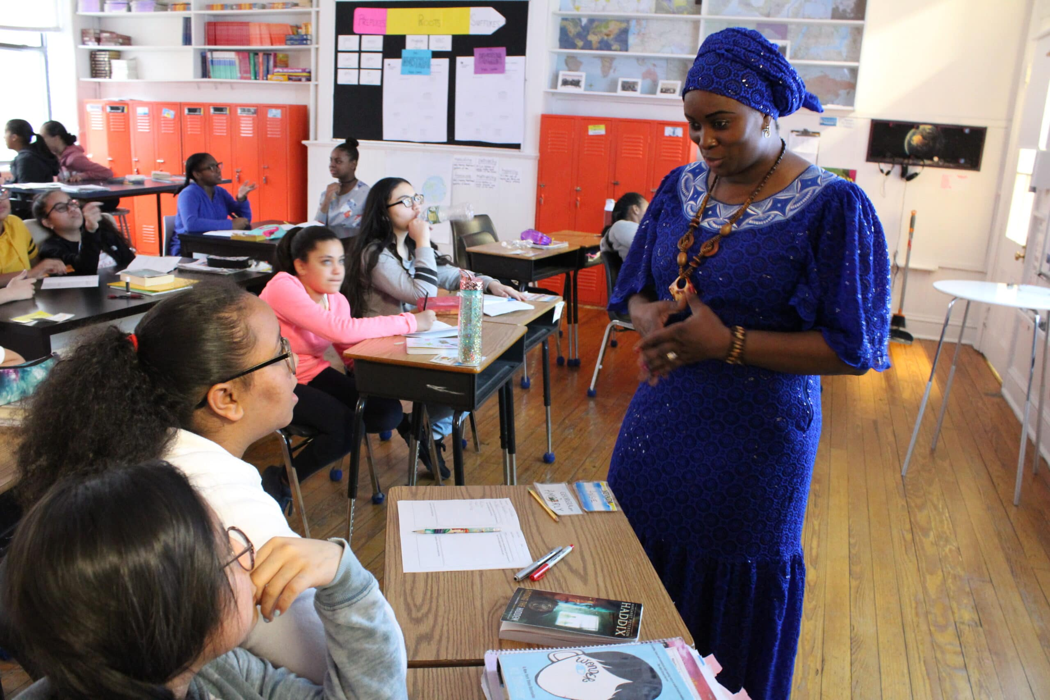

Source: One to World Global classroom, 2024. https://onetoworld.org/global-classroom/

Programs like this help bring concretness to the combat against xenophobia in schools. Initiatives, and trainings like Global Classroom can be easily replicated with the right incentives to schools and speakers, such as a certificate and the promotion of participant institutions by the government.

Again, in the words on One-to-World:
“One To World’s Global Classroom connects New York City youth with trained, international university students through interactive workshops to engage students in learning about world cultures and global issues. Through face-to-face interactions and meaningful cross-cultural exchange, today’s NYC K-12 students develop the skills, awareness, and understanding to become global citizens in their communities, both locally and worldwide.
Our workshops are based on meaningful exchanges with international university students and visiting Fulbright scholars (known as “Global Guides”) in interactive presentations and discussions with K-12 students. Global Guides bring insights into classrooms based on their own lived experiences and serve as role models for children and youth. Global Classroom educators work directly with program partners, classroom teachers, and after school coordinators to tailor our curriculum to schools’ specific needs and interests and incorporate diverse global perspectives in reaching their curricular goals.”
Finally, due to the recent rhetoric spread in countries like the United States and the UK it would be necessary to develop a Global Classroom-based program that articulates the combat of xenophobia through specific lenses.
Workshops hosted by refugees, muslim people, Chinese citizens, and other groups especiallly targetted in anti-immigration rhetoric is essential for the effective, compationate, combat of xenophobia and the construction of a better, less divided, society.
Accompanying initiatives like Global Classroom, books like “Areli is a dreamer” – which present the personal narrative of a child in an irregular migration route, continue this essential work and should be made wildely available.
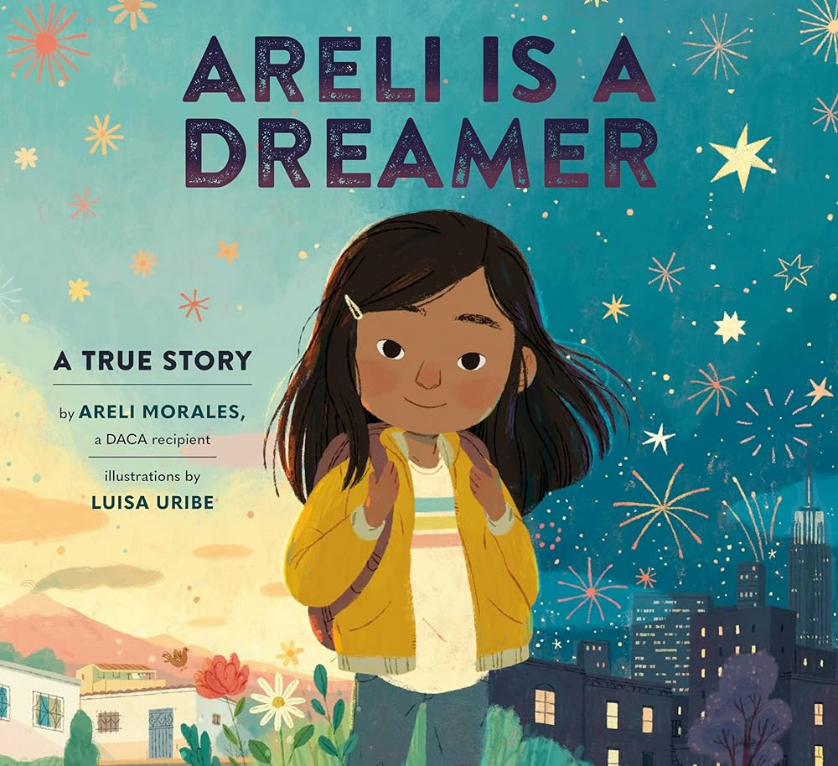 - Book, Areli is a Dreamer -
https://booksofwonder.com/products/9781984893994
Book fairs and international affairs events inside academic institutions featuring narratives that are seldom showcased in a positive context can have a great impact on the partipant communities, as suggested by this study: https://www.sciencedaily.com/releases/2024/03/240311145819.htm/.
To ensure the success and continuation of the program:
Certification for participant schools and speakers
Lottery system for extra funding to be given to participant schools
Monitoring and evaluation of the program:
Interviews with participant students and their families before and after the workshop/event acessing their responses to subjects related to their relationship with other cultures and migrants in general.
Exposing young students to the consequences of a fear culture around migration and immigrants can make them less likely to increase the problem. Exposing them to one of the 40% of individuals polled in the National Survey of Latinos who reported, for example, that they had experienced some of discrimination in the last year, including being criticized for speaking Spanish in public, being told to go back to their home country, or being called offensive names (Lopez, Gonzalez-Barrera, & Krogstad, 2018) can help deconstruct the dehumanization these groups face in different realms of public life.
Turning a program like global classroom into an online activity or telivision program assigned to the curriculum of schools around the world can help spread it to remote, less diverse, corners of the globe, more effectively reaching the very communities that need it most.
Having a fund for production companies to develop programs based on this initiative could lead to the spread of anti-xenophobic actions into children’s television and in schools.
In a smaller scale, Global Classroom had a short participation on PBS NJ that can be seen as a mold for the development of future subsidized programming.
Global Classroom on PBS: https://www.pbs.org/show/global-classroom/
Understanding the construction of the xenophobic mind: Training Teachers and Parents on 9gaga, Reddit, 4Chan and other online communities
While programs like Global Classroom help students have contact with necessary facets of human behavior, often teachers, governments and parents are asked to combat xenophobia with only a faint idea of the concept as well as when and where it spreads.
Most programs to combat xenophobia, although necessary, only articulate defenses against charicatures of xenophobic bahavior. In an online world, it is important for educators to see how these ideas are spread and how racist speech is concealed by concerns against “the future of Western civilization”, “the white men” etc…
Training in schools, education ministries and parent-teacher conferences can better prepare the adults in children’s lives to more easily and critically identify this content.
A quick search through any common, unmoderated or moderated only in name, meme page can result in the encounnter with highly xenophobic and racist content, which gets absorbed uncritically by young audiences without actual conversations on these ideas.
Below, it is possible to find to images found in the easily accessible home page of the website 9gag – a popular global meme website accessed by young adults and teenagers:
Source: https://9gag.com/gag/ayNE16X
This image above of muslim constitutional officials in a town in the U.K, without sources or accurate information, is a solid representation of how xenophobia is spread online: images with no context, presence of speech that spreads fear of unfamiliar cultural practices (such as women wearing the hijab) othering migrants and using their likeness to further spread fear.
Below the commenter reffering to “they” – uses exactly the kind of rhetoric that has historically been a part of opressions system and an ‘us versus them’ division that can easily be interpreted by some as simply “A speaker defending his right to claim his culture”.
The critical analysis of said memes is an essential work among community leaders, educators and interested parents.

(...)

Developing programs that can allow for an effective decunstruction of xenophobia starts with introducing interested parties in the language actually utilized on certain popular internet corners not accessible to most adults. Furthermore, it becomes unavoidable, once in contact with said media, to confront the need for intersectional conversations (see comment above on “the fall of the LGBT”.
It is our hope at SIMN that civil society organizations like ours will be included in taskforces for the development of anti-xenophobia initiatives, building bridges between the marginalized populations we care for the society at large.

