Check against delivery

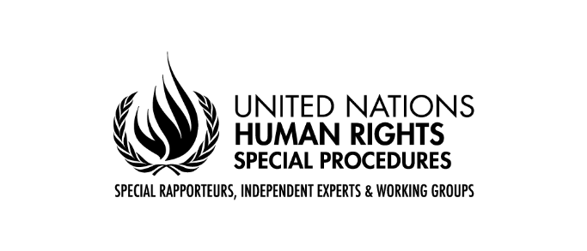

Claudia MAHLER
Independent Expert on the enjoyment of all human rights by older persons

New York, 28 September 2023

UNITED NATIONS GENERAL ASSEMBLY

78th session

Mr. Chairperson,
Excellencies, Distinguished delegates,
Dear participants,
I am honored to address you as Independent Expert on the enjoyment of all human rights by older persons. I would like to thank all the stakeholders who have engaged with me and to those who have shared their written contributions to the call for inputs, and in the five regional consultations organized in preparation of my thematic report.
The report focuses on the human rights of older persons in the context of climate change-induced disasters and how to build forward more equally. Climate change results in extreme weather events and disasters that are greater in frequency and intensity, disproportionately affecting people in the most vulnerable situations. In 2019, more than 97 million people were affected by climate- and weather-related disasters.
Older persons are more likely to be severely affected by climate-related disasters, such as heatwaves, typhoons, hurricanes, droughts, and floods. Research shows that they face disproportionate negative impacts on their human rights, including to adequate standard of living but also their health, housing, livelihoods, well-being and access to food, land, water and sanitation. Physical, political, economic and social factors, including poverty, location, lack of transport and disruption of care and support services, as well as ageism and age-related discrimination further exacerbate the impact of climate change related events and disasters on older populations.
Older persons tend to be excluded, isolated and left behind when facing natural disasters and related emergencies. Currently two thirds of older persons across the globe are living in low- and middle-income countries that face a higher risk of climate-related disasters. Older persons, particularly those experiencing multiple and intersecting forms of discrimination, among others, based on sex, gender, disability, race, ethnicity, or economic status, suffer disproportionate impacts of climate-induced disasters.
Against this backdrop, the growing challenge of climate-induced disasters for the human rights of older persons requires urgent action from States, UN agencies, civil society and all relevant stakeholders to ensure appropriate and age-responsive disaster preparedness, response and recovery, as well as climate mitigation and adaptation, that take the specific needs and conditions of older persons into account.
Mr. Chairperson,
The recognition of the impacts of climate change on human rights is limited in international law. The Paris Agreement on climate change and the right to a clean, healthy and sustainable environment do establish the link between human rights and climate change. However, the fragmented and inconsistent coverage of the rights of older persons in the international human rights framework fails to provide them with a comprehensive legal protection in the face of climate change.
In the absence of a dedicated international human rights instrument on the rights of older persons, provisions of other human rights treaties may apply to some extent. In contrast to the relative invisibility of older persons in international human rights law, the relationship between climate change, disaster risk reduction and the human rights of older persons has received some recognition in non-binding policy documents. Regional legal frameworks also contribute to safeguarding older persons' human rights, including in disaster situations.
Distinguished delegates,
In the context of climate change-induced disasters, it is imperative to consider the human rights of older persons through the three phases of such situation: before, during and after a climate change-induced disaster.
Despite their particular needs and situations of vulnerability, older persons in their full diversity are often overlooked in disaster prevention and preparedness. Effective laws, policies and plans are essential to prevent and mitigate harm caused by climate-induced disasters, which are often unexpected, unpredictable or have unknown consequences.
Measures for building community resilience are important in combating the isolation and exclusion faced by older persons, particularly those who live alone. Many efforts related to capacity-building for climate adaptation and disaster risk reduction are community driven. However, States may display an over-reliance on communities and on civil society organizations to provide care for older persons and prepare for disasters, while it falls under the State’s responsibility and obligations to protect the older populations’ human rights in these situations. Economic security, solid social protection systems, adapted and age-friendly housing solutions, steady and accessible health services and effective systems for communicating disaster-related information, among others, are essential to preparedness for climate-related disasters and protect older persons.
During climate-related disasters, even when States take extensive measures to prepare and adapt, it may not be possible to prevent or avoid all their impacts on older persons. It remains essential to have measures in place to respond to disasters as they occur and to protect older persons’ human rights throughout.
There is a risk of age-related discrimination from poorly designed policies and plans. A lack of understanding of older persons, and their particular needs often results in inappropriate service delivery during disasters. The risks for older women and older persons with disabilities are further exacerbated.
Older persons must be prioritized in evacuation efforts, regardless of their degree of mobility. Older persons living in long-term care facilities should also be appropriately prioritized. It is also essential that the means of delivery and distribution of humanitarian aid be accessible and non-discriminatory for older persons. Health care provided during a disaster including provision of vital medications, should be accessible and age-responsive, and should include care for chronic illnesses, palliative care and mental health support.
In the aftermath of a climate-related disaster, adverse impacts on older persons continue. Migration and displacement, lack of adequate housing exposing older persons to adverse weather conditions, financial obstacles to rebuilt and economic insecurity are some of the challenges faced by affected populations, and disproportionately faced by older persons after a disaster. Older persons should receive post-disaster assistance, including displaced older persons. States should facilitate access to recovery-related aid, loans and schemes, as well as provide support to older persons’ economic activities and access to pensions.
It is crucial that older persons be given meaningful opportunities to participate in all facets of disaster preparedness, response and recovery. They can, and do, make important contributions to post-disaster management and recovery, as well as to climate adaptation, based on their past experiences.
Mr. Chairperson,
Distinguished delegates,
Being the fastest growing age group worldwide, older persons and their rights must become a priority on the agenda of all Governments, especially in the face of the planetary crisis of climate change. The adoption of an international legally binding instrument on the human rights of older persons would offer the best protection for the human rights of older persons, including in the context of climate-induced disasters.
I thank you for your attention and look forward to our discussion.

