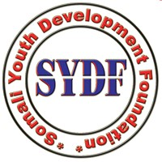

STATEMENT REPORT

Subject: Multi-stakeholder meeting on human right rights of older persons (HRC Res48/3 Statement
Date of report: 25th August 2022
Mission to : UN
SYDF Participant Name: Abdullahi Abdi Mohamed
Country /organization Participants: Somali Youth Development Foundation (SYDF)
Attachments:N/a

STATEMENT.

Somali Youth Development Foundation (SYDF) is accredited by the economic and social council of the united nations and works with its mission and vision that enhance the environment , old people and advocate it, after we have worked with many challenges, including wars , and lack of safety to amputees ,disabled personnel in Somalia lack of housing with special needs community or concern are for gotten in housing and caring and to submit Multi-stakeholder meeting on human right rights of older persons in Somalia (HRC Res48/3) will be a place to discuss this needs.

More than 30 years of wars and lack of central government function and need to supporters of Somalia are enhanced the lives of thousands of Somali families while working the government and international and local institutions. however they migrated or resentment in abroad thousands and have changed but older peoples plan are left the central government in shaping housing, and feeding them, let alone polices and plans are not achievable this mission and below SYDF recommendation as follows:

- In hence housing and funding the older people and hire for them care givers
- To increase health sector and monitor their lives, such us amputees and disable or other in need community
- To encourage and create patience fund and care givers in Somali sub governmental states plans.
- To urgent help and lobby other funds and allocate them and their families a wealth, better place for living ,housing and reunion of their families with good diet

END

