Enhed
Boligpolitik og -økonomi

Sagsbehandler
Emilie Sofie Rohr

Koordineret med

Sagsnr.
2022 - 1345

Doknr.
497693

Dato
29-03-2022

Annex 1. Data on older persons

Tabel 1. The Danish housing stock

Source: Statistics Denmark and Agency of Housing and Planning

Tabel 2. Population by age and type of housing
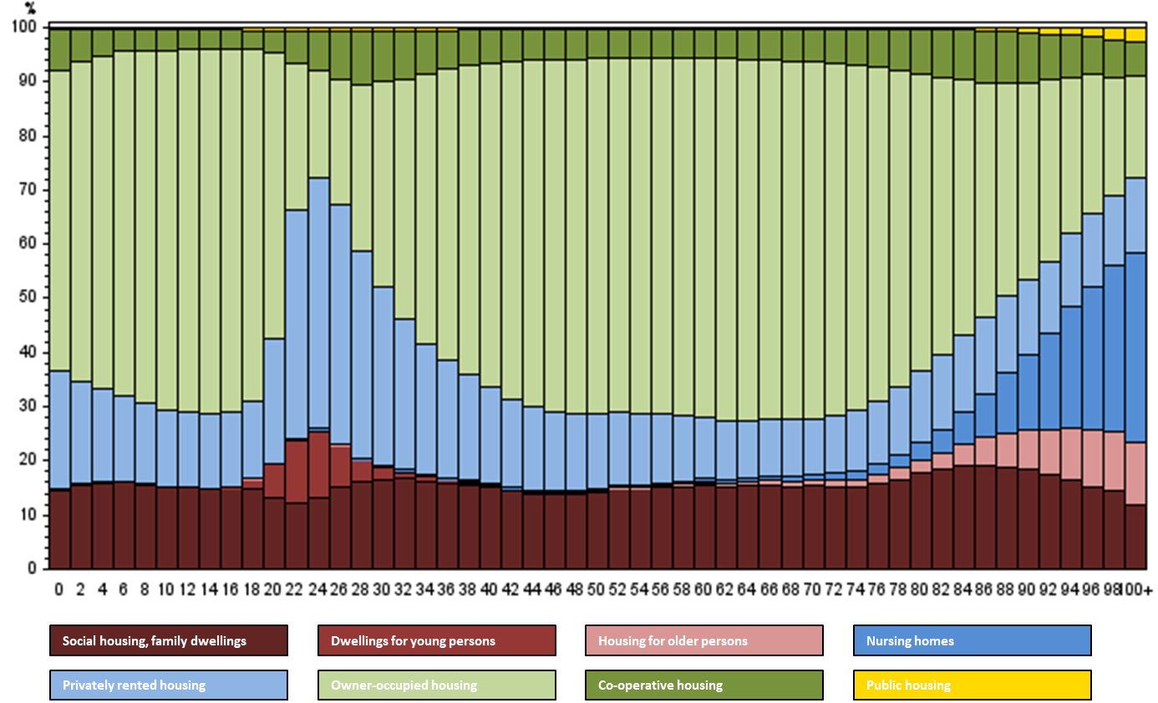
Source: Statistics Denmark and Agency of Housing and Planning

Tabel 3. Older persons by households

Source: Statistics Denmark

Tabel 8. Recipients of homecare and help in 2010 and 2020, persons aged 65 years and over
 | Recipients of personal care only | Recipients of practical care only | Recipients of both personal and practical care | Recipients of home care and help in total
2010 | 14.475 | 71.297 | 63.184 | 148.955
2020 | 15.073 | 59.900 | 50.945 | 125.918
Source: Statistics Denmark og Agency of housing and planning

