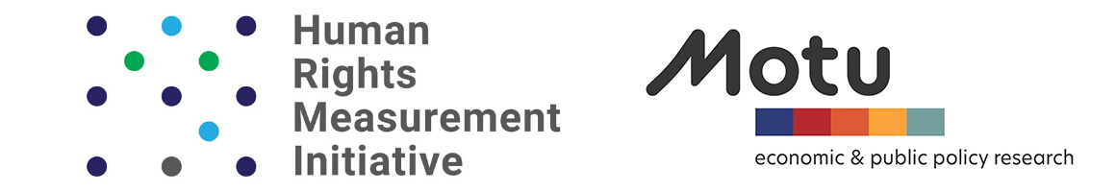

The Right to Adequate Housing
Report for the Independent Expert on the Enjoyment of All Human Rights by Older Persons

The Human Rights Measurement Initiative (HRMI) is the first global project to comprehensively and independently track the human rights performance of countries. HRMI is independent, non-profit, and our methodology is award-winning and peer-reviewed.

For 200 countries in the world, HRMI publishes annual scores on the right to adequate housing, showing how well a country is keeping its human rights commitments under the International Covenant on Economic, Social, and Cultural Rights. Crucially, HRMI’s methodology also takes into account each country’s level of resources.

HRMI’s housing scores include measures of:
- access to water
- access to basic and/or improved sanitation
- housing affordability.

For 39 countries, HRMI also publishes data on the experiences of older persons specifically, noting where they are at extra risk of not enjoying their right to adequate housing (among other rights).

All of these data are published, and best viewed, on the Rights Tracker: https://rightstracker.org/

In this submission, we provide narrative descriptions of all our relevant data, including regional averages. We also present calculations of the improvements in the right to housing that are within reach for each country, given the level of GDP per capita.

How HRMI produces the scores
HRMI produces scores for five economic and social rights, for around 200 countries, using indicator data supplied by countries to international databases. Our team analyses the data using the award-winning SERF Index our co-founder Susan Randolph developed with her colleagues, Sakiko Fukuda-Parr and Terra Lawson-Remer.

The SERF Index is unique because it takes into account a country’s financial resources. The income-adjusted score shows how close a country is to meeting its urgent duty, compared with other countries with similar resources – for these rights, the realistic target is 100%.

The scores are constructed from internationally-comparable, publicly-available objective data, such as statistics on access to water on premises, and housing affordability. They also take into account the fact that, as stated in Article 2 of the ICESCR, each country is obligated to progressively achieve economic and social rights “to the maximum of its available resources.”

Indicator data can help to tell us the extent to which individuals in each country enjoy economic and social rights. But it is not until the country’s GDP per capita is also taken into account that we can get a good sense of whether a country is complying with its obligations to progressively respect, protect, and fulfil those rights. These measures do just that.

This methodology, the Social and Economic Rights Fulfilment (SERF) Index, has been developed by Sakiko Fukuda-Parr, Terra Lawson-Remer, and Susan Randolph, and is highly regarded by the human rights community. In 2016, a book detailing this methodology – Fulfilling Social and Economic Rights by Sakiko Fukuda-Parr, Terra Lawson-Remer, and Susan Randolph – won the American Political Science Association prize for the best book in human rights scholarship, and in 2019, the three authors were awarded the prestigious Grawemeyer Award for Ideas Improving World Order.

For more information you might like to watch Susan Randolph’s TED talk on measuring economic and social rights, or read our detailed methodology handbook.

Older people and the right to housing

Since 2017, HRMI has also conducted a global human rights survey of in-country experts in a growing number of countries (39 in 2021).

Part of the survey asks human rights practitioners which groups of people are particularly likely not to enjoy their right to adequate housing. We present the results in word clouds such as this one, for Fiji, which shows that 20% of our expert respondents in Fiji identified older people as being at extra risk of having their right to adequate housing violated:
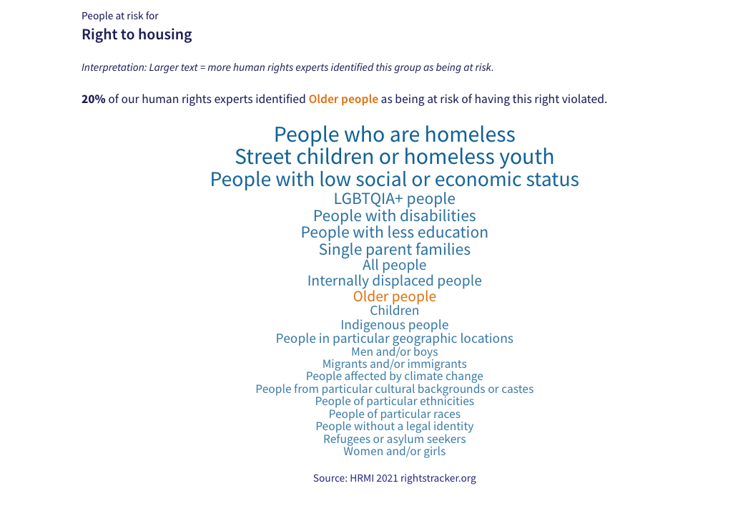

Rights of Older Persons
In 2021 we asked human rights experts in 39 countries about human rights violations in their country. In 34 of these 39 countries, respondents said that older people were at particular risk of violations of the right to housing.

Of those 34 countries, 25 are low or middle income countries, and 14 are high income countries.

Geographically these 34 countries are spread out:

- 20 are East Asia and Pacific (16 Pacific and 5 East Asian: 10 low income and 6 high income in Pacific, 2 low income and 3 high income in East Asia)

- 4 are Americas (3 Latin American countries and the USA: 3 low income countries in Latin America and USA being the high income country)

- 4 are Sub-saharan African (all low income countries)

- 3 Europe and Central Asian (United Kingdom, and 2 Central Asian Countries: United Kingdom is the High income country, the 2 low income countries are Central Asian)

- 1 Middle east and North African (Saudi Arabia: High Income country)

- 1 South Asian (Nepal: low income country)

South Asia

- 15% of our human rights experts in Nepal identified older people as being at risk of having the right to housing violated.

Middle East and North Africa

- 11% of our human rights experts in Saudi Arabia identified older people as being at risk of having the right to housing violated.

Europe and Central Asia

- 9% of our human rights experts in the United Kingdom identified older people as being at risk of having the right to housing violated.
- 10% of our human rights experts in Kyrgyzstan identified older people as being at risk of having the right to housing violated.
- 14% of our human rights experts in Kazakhstan identified older people as being at risk of having the right to housing violated.

Americas

- 39% of our human rights experts in Brazil identified older people as being at risk of having the right to housing violated.
- 13% of our human rights experts in Mexico identified older people as being at risk of having the right to housing violated.
- 25% of our human rights experts in the United States of America identified older people as being at risk of having the right to housing violated.
- 18% of our human rights experts in Venezuela identified older people as being at risk of having the right to housing violated.

Sub-Saharan Africa

- 23% of our human rights experts in Angola identified older people as being at risk of having the right to housing violated. When asked to provide more context about who was particularly unlikely to enjoy their right to housing in 2020, our respondents mentioned ‘Elderly people’.
- 44% of our human rights experts in the Democratic Republic of Congo identified older people as being at risk of having the right to housing violated.
- 14% of our human rights experts in Liberia identified older people as being at risk of having the right to housing violated.
- 40% of our human rights experts in Mozambique identified older people as being at risk of having the right to housing violated.

East Asia and Pacific

- 20% of our human rights experts in American Samoa identified older people as being at risk of having the right to housing violated.
- 25% of our human rights experts in Australia identified older people as being at risk of having the right to housing violated.
- 29% of our human rights experts in Cook Islands identified older people as being at risk of having the right to housing violated.
- 20% of our human rights experts in Fiji identified older people as being at risk of having the right to housing violated.
- 20% of our human rights experts in Guam identified older people as being at risk of having the right to housing violated.
- 13% of our human rights experts in Hong Kong identified older people as being at risk of having the right to housing violated.
- 60% of our human rights experts in Kiribati identified older people as being at risk of having the right to housing violated.
- 20% of our human rights experts in Malaysia identified older people as being at risk of having the right to housing violated.
- 38% of our human rights experts in Marshall Islands identified older people as being at risk of having the right to housing violated.
- 20% of our human rights experts in the Federated States of Micronesia identified older people as being at risk of having the right to housing violated.
- 5% of our human rights experts in New Caledonia identified older people as being at risk of having the right to housing violated.
- 19% of our human rights experts in New Zealand identified older people as being at risk of having the right to housing violated.
- 33% of our human rights experts in Papua New Guinea identified older people as being at risk of having the right to housing violated.
- 17% of our human rights experts in Samoa identified older people as being at risk of having the right to housing violated.
- 14% of our human rights experts in Solomon Islands identified older people as being at risk of having the right to housing violated.
- 29% of our human rights experts in South Korea identified older people as being at risk of having the right to housing violated.
- 14% of our human rights experts in Taiwan identified older people as being at risk of having the right to housing violated.
- 25% of our human rights experts in Tonga identified older people as being at risk of having the right to housing violated.
- 30% of our human rights experts in Vanuatu identified older people as being at risk of having the right to housing violated.
- 7% of our human rights experts in Vietnam identified older people as being at risk of having the right to housing violated.

Global overview of scores for the right to housing
Our right to housing scores are currently not disaggregated by age, but the ‘people at risk’ data discussed above shows that older people are routinely over-represented among those experiencing violations of the right to housing.

In this section we will show, by region, how well each country is doing in ensuring people’s right to adequate housing. For each country, 100% represents what is feasible at that country’s level of income; any score lower than 100% means the country can realistically achieve more, right now, and is therefore in breach of its ICESCR obligations.

In calculating HRMI scores, we choose indicators best suited, or most available for, countries in two income categories: low and middle income, and high income. We do however produce scores for all countries on all indicators, where available. On the Rights Tracker click ‘switch view’ to see additional scores for a country.

In this report we focus on the scores divided into those two income groups.

Low and middle income country scores

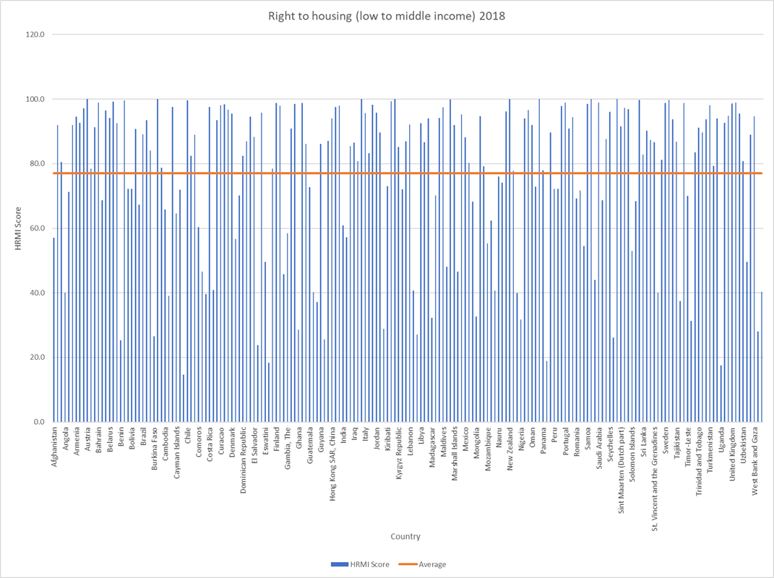

The global average for low and middle income countries is 77%, a score which means a country has a long way to go to meet its human rights obligations. Further, 70 countries fall below that global average score.

High income country scores
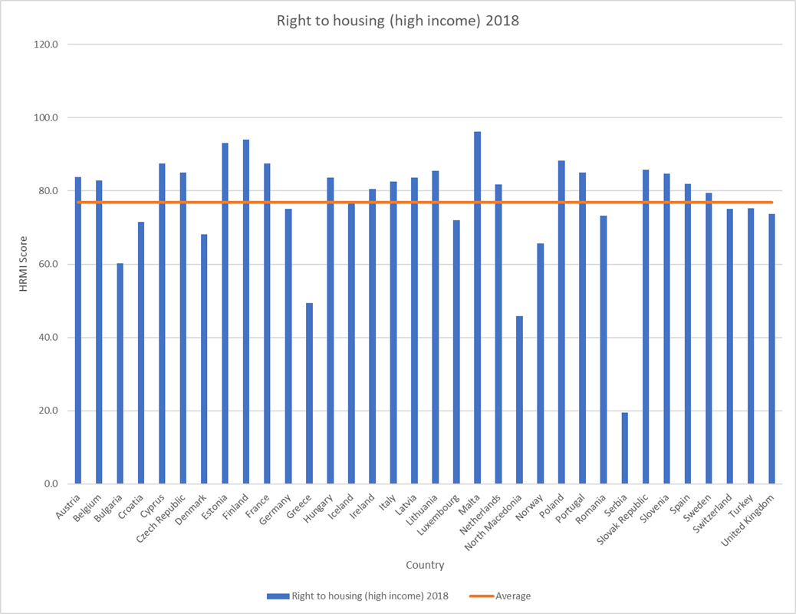

The average score for high income countries is 76.9%, with 13 countries falling below the average score. High income countries not appearing on this graph are missing data on housing affordability, and will be discussed separately.

Housing affordability is not measured uniformly across high income countries, so we have many high income countries for which we cannot produce scores. This is a data problem that could be remedied with international cooperation, so that we could better measure how countries are doing in this area.

Regional Breakdowns (low and middle income)
Americas
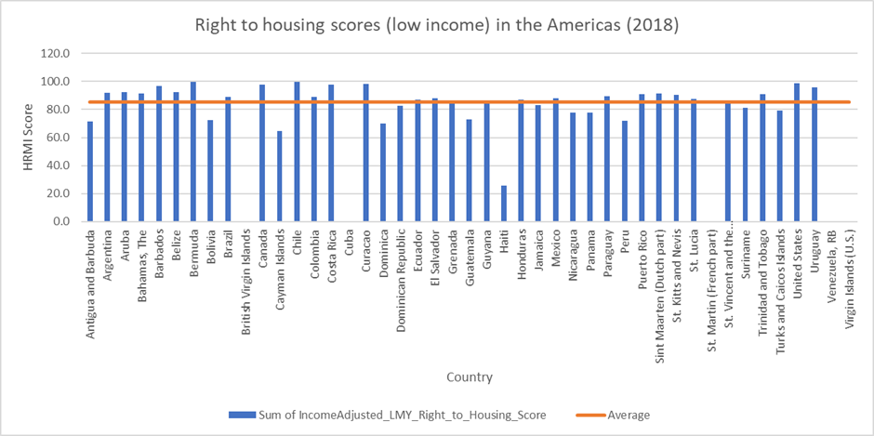

The Americas have 45 countries in the region; the average housing score is 85.26% for the low and middle income standard. 12 countries fall below the average for the region.

Middle East and North Africa
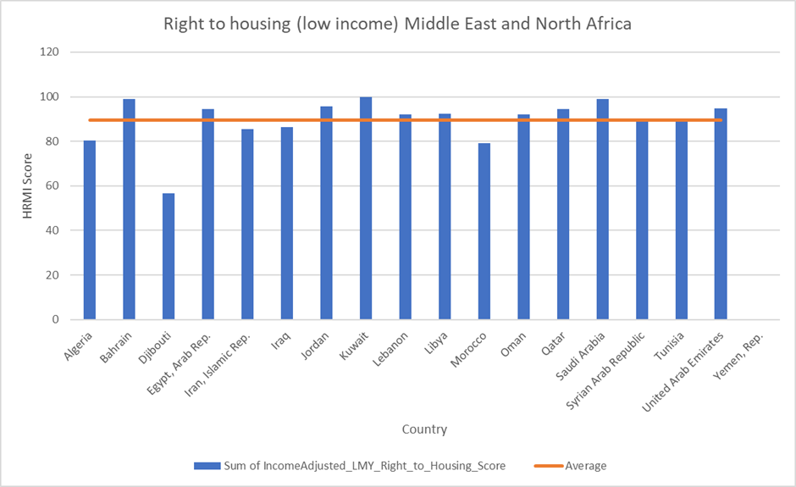
The Middle East and North Africa have 18 countries in the region; the average housing score is 89.50%. 5 countries fall below the average for the region.

Sub-Saharan Africa
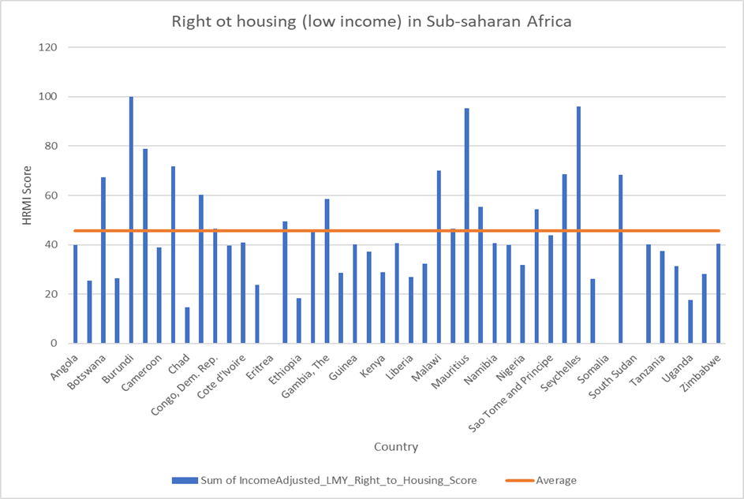
Sub-Saharan Africa has 47 countries in the region, the average housing right score is 45.77%. 27 countries fall below the average score.

Europe and Central Asia
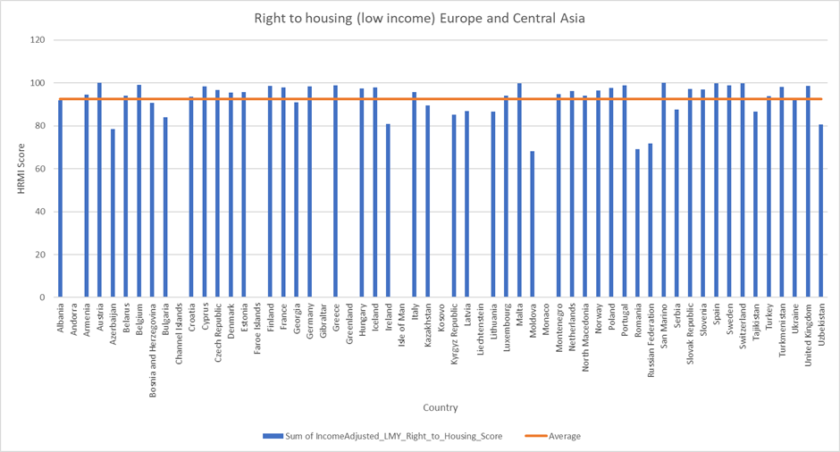
Europe and Central Asia have 59 countries, the average housing right score is 92%. 24 countries fall below the average.

South Asia
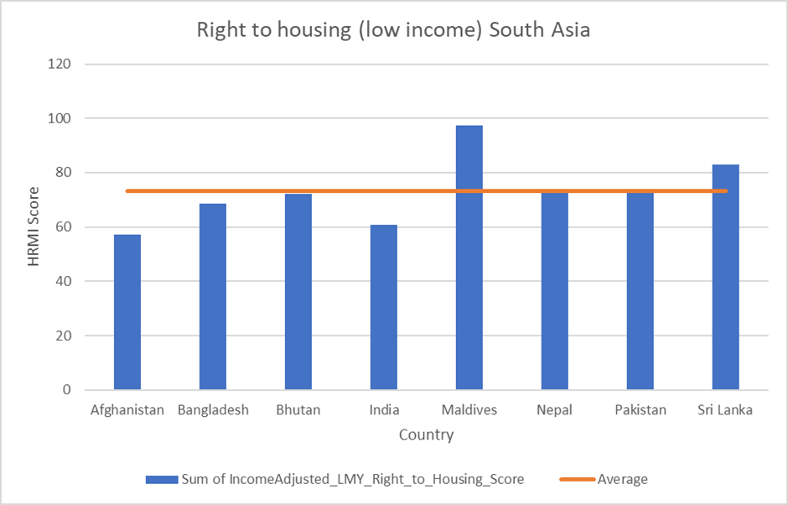
South Asia only has low and middle income countries. Within this region we have 8 countries, and an average housing right score of 73.27%. 4 countries fall below the average.

East Asia and Pacific
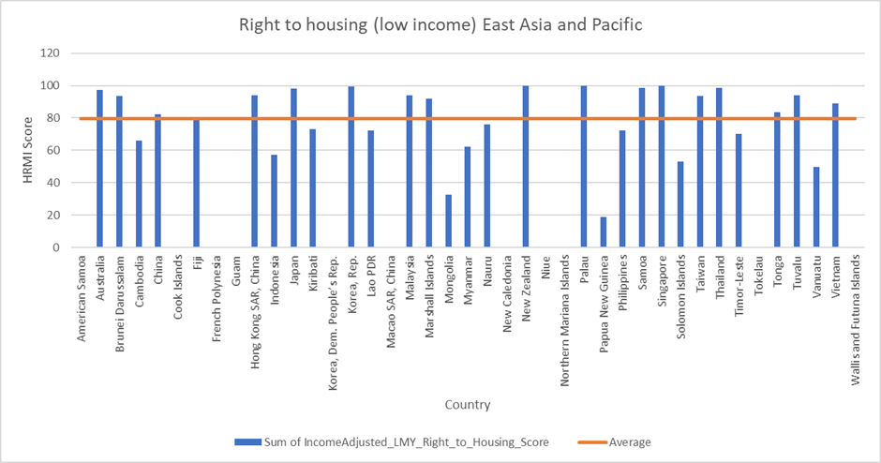
East Asia and Pacific has 41 countries, the average housing right score is 79.65%. 21 countries fall below the average.

Regional Breakdown (high income countries)
Americas
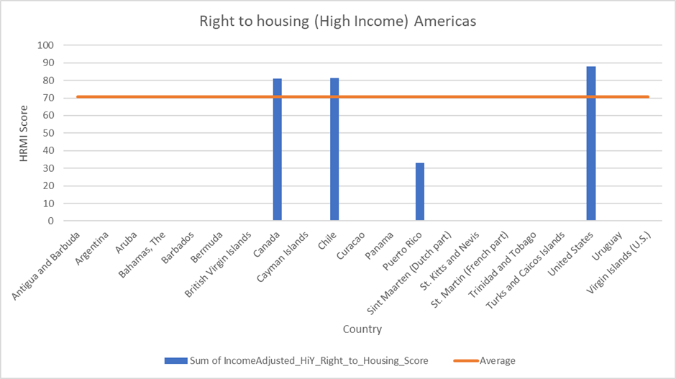
The Americas only have 4 high income countries which are assessed by access to safely managed sanitation, as housing affordability data is not available using the same definition as for European countries.

The average high income housing right score is 70.77%; Puerto Rico is the only country to fall below the average.

Middle East and North Africa
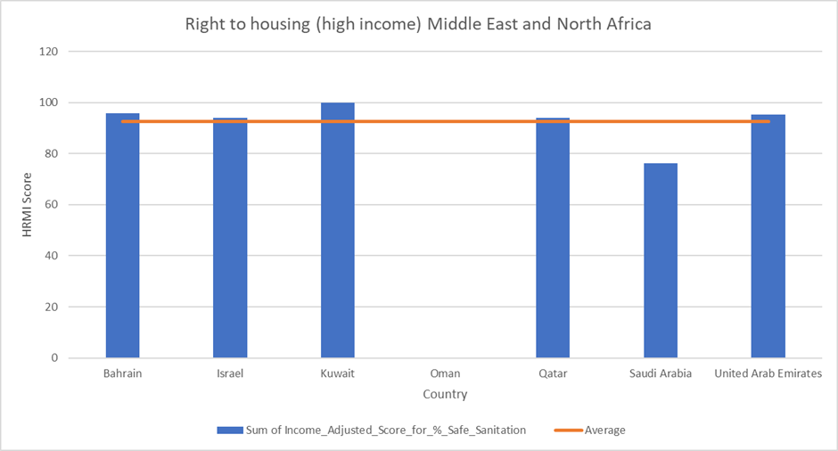
The Middle East and North Africa region has 7 high income countries which are assessed by safely managed sanitation. The average high income housing right score is 92.55%; Oman and Saudi Arabia are the only countries to fall below the average.

Europe and Central Asia
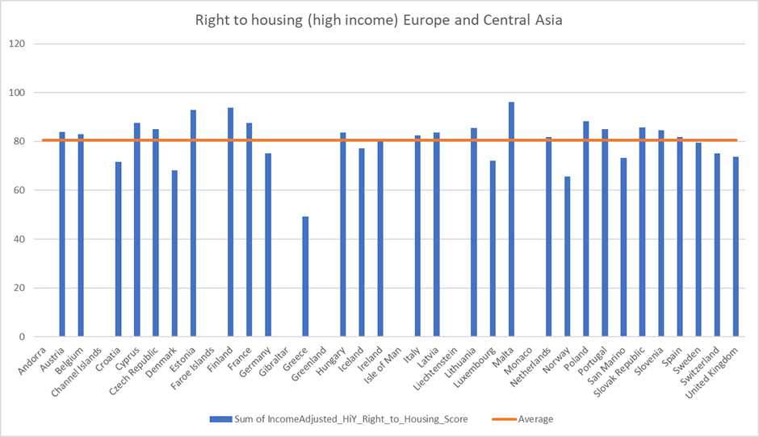
Europe and Central Asia have 37 high income countries (with 30 countries assessed by the full assessment standard including a measure of housing affordability). The average score of the region is 80.71%; 19 countries fall below the average.

East Asia and Pacific
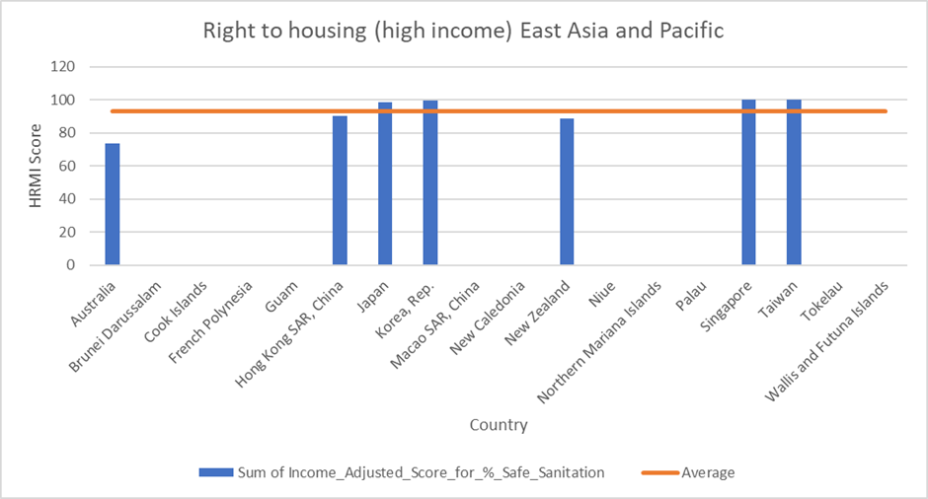
East Asia and Pacific include 18 high income countries which are assessed by access to safely managed sanitation. The average housing score is 93.01%; 14 countries fall below the average.

Older people at risk

In this section we take a closer look at the 34 countries where older people have been identified in our annual human rights survey as being at extra risk of violations of the right to adequate housing.

For each country we will discuss the HRMI score and what it shows. Then we will compare the scores to the average of other low and middle income countries in the region, or other high income countries.

Finally, we will analyse the country’s performance based on the raw indicator values, asking this question: if countries want to achieve 100% – what we calculate to be feasible at their level of income – how much these indicators have to increase in percentage score value, as well as number of people having access to the right.

Americas
Brazil
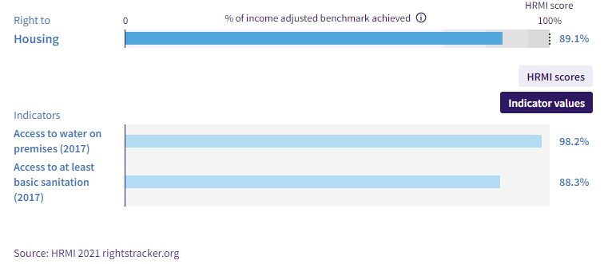
Brazil has a Right to Housing score of 89.1%; this means that Brazil is only achieving 89.1% of what is possible for their level of income. Looking at other low and middle income countries in the Americas, Brazil is doing above average, but its score falls in the ‘fair’ range.

If Brazil wants to achieve a 100% score, they will need to increase water and basic sanitation scores by 1.81% and 11.71% respectively. If Brazil prioritised people’s rights to housing, and improved to 100%, 24,329,341 more people in Brazil would have access to basic sanitation and 3,754,747 more people would have access to water on premises.

Mexico
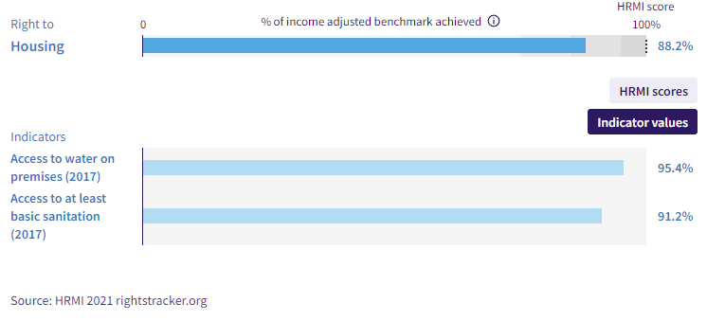
Mexico has a Right to Housing score of 88.2%; this means that Mexico is only achieving 88.2% of what is possible for their level of income. Looking at other low and middle income countries in the Americas; Mexico is doing above average.

If Mexico wants to achieve a 100% score, they will need to increase water and basic sanitation scores by 4.6% and 8.82% respectively. In terms of people Mexico would have to improve access for 11,001,548 people for basic sanitation and 5,739,507 people for water, in order to reach the realistic target of 100% and meet its human rights obligations.

United States
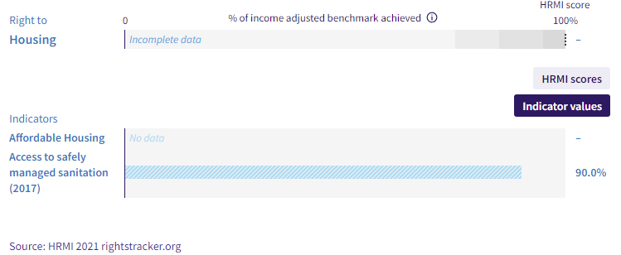
The United States has a Right to Housing score of 88% (if we just take the Safely managed sanitation as the high income assessment standard). This means that the United States is only achieving 88% of what is possible for their level of income. Looking at other high income countries; the United States is doing above average. If the United States wants to achieve a 100% score, they will need to increase the Safely managed sanitation score by 10.33%. In terms of people the United States would have to improve access for 32,619,509 people for safely managed sanitation, in order to reach achieve what we calculate is feasible given its income.

Europe and Central Asia
Kazakhstan
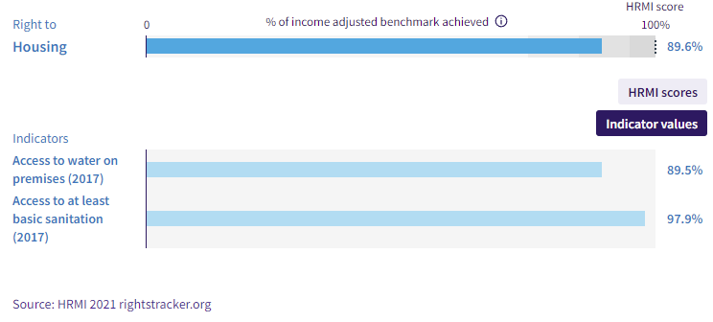
Kazakhstan has a Right to Housing score of 89.6%; this means that Kazakhstan is only achieving 89.6% of what is possible for their level of income. Looking at other low and middle income countries in Europe and Central Asia, Kazakhstan is doing slightly below average.

If Kazakhstan wants to achieve a 100% score, they will need to increase water and basic sanitation scores by 10.49% and 2.13% respectively. In terms of people, that would mean Kazakhstan would improve access for 383,537 people for basic sanitation and 1,891,757 people for water.

Kyrgyzstan
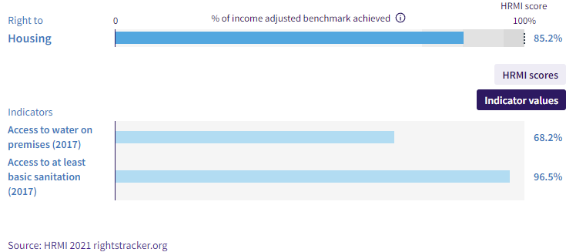

Kyrgyzstan has a Right to Housing score of 85.2%; this means that Kyrgyzstan is only achieving 85.2% of what is possible for their level of income. Looking at other low and middle income countries in Europe and Central Asia; Kyrgyzstan is doing below average (7.39% below). If Kyrgyzstan wants to achieve a 100% score, they will need to increase water and basic sanitation scores by 23.93% and 3.49% respectively. In terms of people Kyrgyzstan would have to improve access for 216,499 people for basic sanitation and 1,482,901 people for water, in order to reach the realistic target of 100% and meet its human rights obligations.

United Kingdom
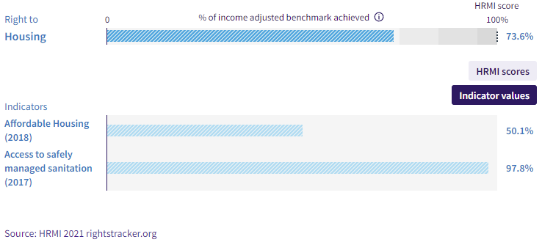
The United Kingdom has a Right to Housing score of 73.6%; this means that the United Kingdom is only achieving 73.6% of what is possible for their level of income. This score is slightly below average among high income countries, and falls into the ‘very bad’ range, largely because of housing unaffordability.

If the United Kingdom wants to achieve a 100% score, they will need to increase affordable housing and safely managed sanitation scores by 49.9% and 2.25% respectively. In terms of people, the United Kingdom would have to improve access for 1,483,342 people for safely managed sanitation and 32,963,371 people for affordable housing, in order to reach the realistic target of 100% and meet its human rights obligations.

Middle East and North Africa
Jordan
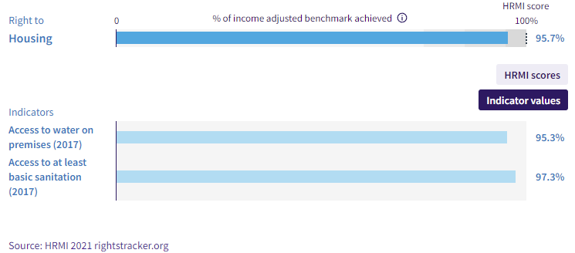

Jordan has a Right to Housing score of 95.7%; this means that Jordan is achieving 95.7% of what is possible for their level of income. Looking at other low and middle income countries in the Middle East and North Africa; Jordan is doing above average. If Jordan wants to achieve a 100% score, it will need to increase water and basic sanitation scores by 4.7% and 2.66% respectively. In terms of people Jordan would have to improve access for 260,327 people for basic sanitation and 460,377 people for water, in order to reach the realistic target of 100% and meet its human rights obligations.

Saudi Arabia
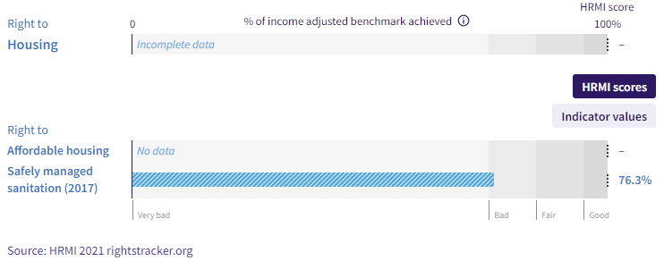
Saudi Arabia scores 76.3% for the right to sanitation. This means that Saudi Arabia is only achieving 76.3% of what is possible for their level of income. Looking at other high income countries; the Saudi Arabia is doing above average, but its score falls near the bottom of the ‘bad’ range.

If Saudi Arabia wants to achieve a 100% score, they will need to increase the safely managed sanitation score by 22.25%. In terms of people, Saudi Arabia would have to improve access for 7,364,305 people for safely managed sanitation, in order to reach the realistic target of 100% and meet its human rights obligations.

South Asia
Nepal
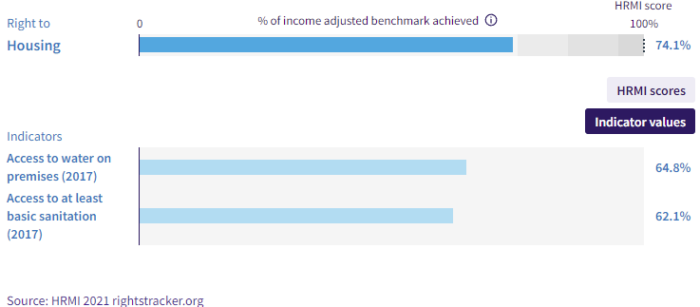
Nepal has a Right to Housing score of 74.1%; this means that Nepal is only achieving 74.1% of what is possible for their level of income.

Looking at other low and middle income countries in South Asia; Nepal is doing above average, but with a score that falls in the ‘very bad’ range.

If Nepal wants to achieve a 100% score, they will need to increase water and basic sanitation scores by 17.43% and 27.29% respectively. In terms of people, Nepal would have to improve access for 7,542,170 people for basic sanitation and 4,815,617 people for water, in order to reach the income-adjusted target of 100%.

Sub-Saharan Africa
Angola
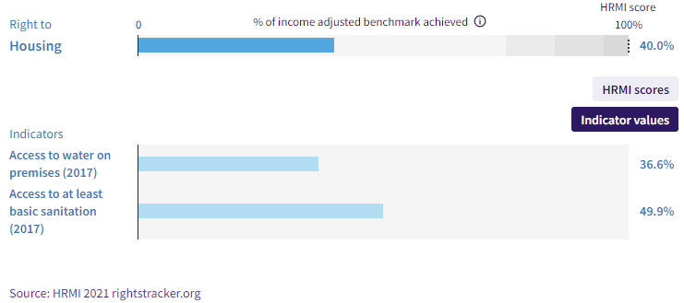

Angola has a Right to Housing score of just 40%; this means that Angola is only achieving 40% of what is possible for their level of income.

Looking at other low and middle income countries in Sub-Saharan Africa, Angola is doing below average (5.77% below).

If Angola wanted to achieve a 100% score, it will need to increase water and basic sanitation scores by 60.42% and 50.12% respectively. In terms of people Angola would have to improve access for 14,945,065 people for basic sanitation and 18,015,714 people for water, in order to reach the realistic target of 100% and meet its human rights obligations.

Democratic Republic of Congo
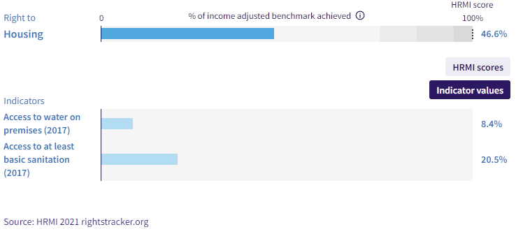
DR Congo has a Right to Housing score of 46.6%; this means that DRC is only achieving 46.6% of what is possible for their level of income. Looking at other low and middle income countries in Sub-Saharan Africa, DRC is doing above average, but with a score that falls in the ‘very bad’ range.

If DRC wanted to achieve a 100% score they will need to increase water and basic sanitation scores by 24.13% and 9.91% respectively. In terms of people DRC would have to improve access for 8,062,857 people for basic sanitation and 19,644,849 people for water, in order to reach the realistic target of 100% and meet its human rights obligations.

Liberia
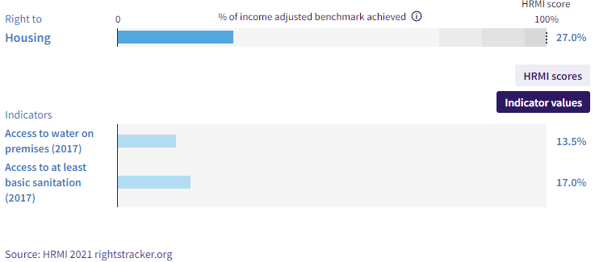

Liberia has a Right to Housing score of 27%; this means that Liberia is only achieving 27% of what is possible for their level of income.

Looking at other low and middle income countries in Sub-Saharan Africa, Liberia is doing well below average, and with a score that falls in the ‘very bad’.

If Liberia wants to achieve a 100% score, they will need to increase water and basic sanitation scores by 41.71% and 40.35% respectively. In terms of people Liberia would have to improve access for 1,897,198 people for basic sanitation and 1,961,124 people for water, in order to reach the realistic target of 100% and meet its human rights obligations.

Mozambique
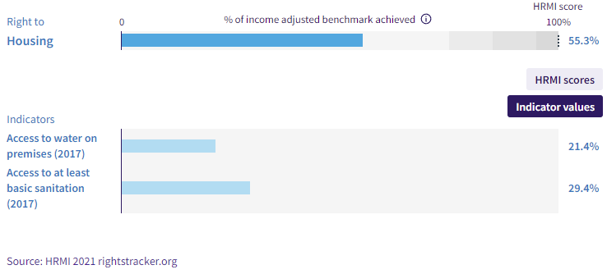

Mozambique has a Right to Housing score of 55.3%; this means that Mozambique is only achieving 55.3% of what is possible for their level of income.

Looking at other low and middle income countries in Sub-Saharan Africa, Mozambique is doing above average, but with a score that falls in the ‘very bad’ range.

If Mozambique wanted to achieve a 100% score, they would need to increase water and basic sanitation scores by 24.29% and 16.63% respectively. In terms of people, Mozambique would have to improve access for 4,765,064 people for basic sanitation and 6,957,516 people for water, in order to reach the income-adjusted target of 100%.

East Asia and Pacific
Australia
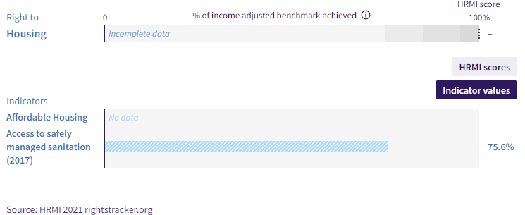
Australia has a right to sanitation score of 73.7%, falling in the ‘bad’ range. This means that Australia is only achieving 73.7% of what is possible for their level of income.

Looking at other high income countries; the Australia is doing just above average. If Australia wants to achieve a 100% score, they will need to increase the Safely managed sanitation score by 24.36%.

In terms of people Australia would have to improve access for 5,993,045 people for Safely managed sanitation, in order to reach the realistic target of 100% and meet its human rights obligations.

Fiji
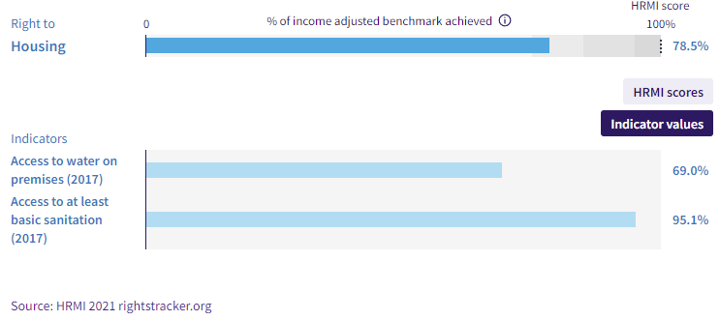

Fiji has a Right to Housing score of 78.5%; this means that Fiji is only achieving 78.5% of what is possible for their level of income.

Looking at other low and middle income countries in East Asia and Pacific, Fiji is doing slightly below average, and with a score that falls in the ‘bad’ range.

If Fiji wants to achieve a 100% score, they will need to increase water and basic sanitation scores by 30.97% and 4.93% respectively. In terms of people, Fiji would have to improve access for 43,240 people for basic sanitation and 271,716 people for water, in order to reach the realistic target of 100% and meet its human rights obligations.

Hong Kong
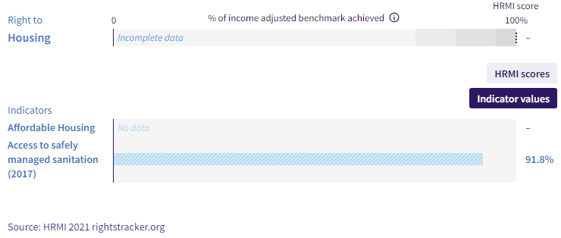
Hong Kong has a right to sanitation score of 90.1%. This means that Hong Kong is only achieving 90.1% of what is possible for their level of income. Looking at other high income countries, Hong Kong is doing above average. If Hong Kong wants to achieve a 100% score, they will need to increase the safely managed sanitation score by 8.23%. In terms of people Hong Kong would have to improve access for 608,082 people for safely managed sanitation, in order to reach the realistic target of 100% and meet its human rights obligations.

Kiribati
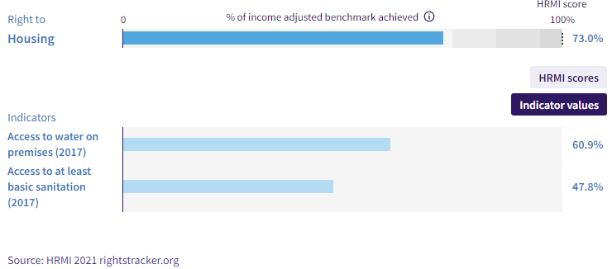
Kiribati has a Right to Housing score of 73%; this means that Kiribati is only achieving 73% of what is possible for their level of income.

Looking at other low and middle income countries in the East Asia and Pacific, Kiribati is doing below average, and with a score that falls in the ‘very bad’ range.

If Kiribati wants to achieve a 100% score, they will need to increase water and basic sanitation scores by 11.34% and 29.74% respectively. In terms of people, Kiribati would have to improve access for 33,945 people for basic sanitation and 12,949 people for water, in order to reach the realistic target of 100% and meet its human rights obligations.

Malaysia
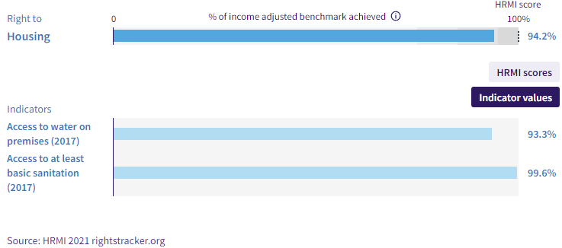

Malaysia has a Right to Housing score of 94.2%; this means that Malaysia is achieving 94.2% of what is possible for their level of income. Looking at other low and middle income countries in East Asia and Pacific; Malaysia is doing above average.

If Malaysia wanted to achieve a 100% score, they will need to increase water and basic sanitation scores by 6.67% and .428% respectively. In terms of people, Malaysia would have to improve access for 133,117 people for basic sanitation and 2,074,904 people for water, in order to reach the realistic target of 100% and meet its human rights obligations.

Marshall Islands
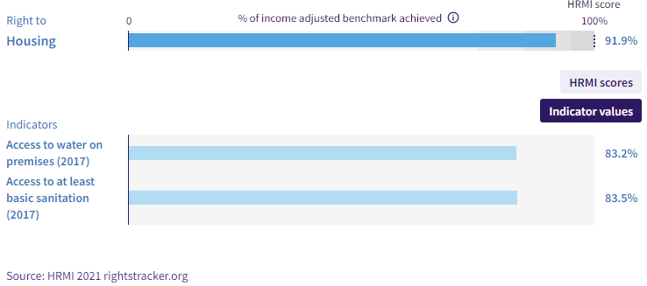
Marshall Islands has a Right to Housing score of 91.9%; this means that Marshall Islands is only achieving 91.9% of what is possible for their level of income. Looking at other low and middle income countries in East Asia and Pacific; Marshall Islands are doing above average.

If the Marshall Islands wanted to achieve a 100% score, they would need to increase water and basic sanitation scores by 3.66% and 11.34% respectively. In terms of people, the Marshall Islands would have to improve access for 6,585 people for basic sanitation and 2,124 people for water, in order to reach the realistic target of 100% and meet its human rights obligations.

Federated States of Micronesia
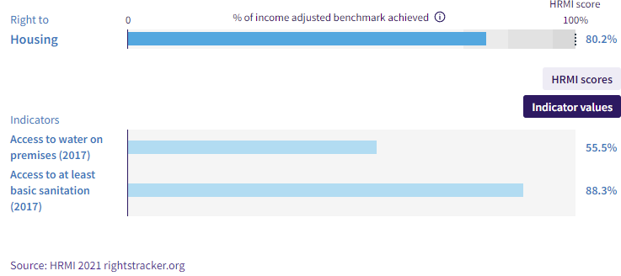
Federated States of Micronesia has a Right to Housing score of 80.2%; this means that it is only achieving 80.2% of what is possible for their level of income. Looking at other low and middle income countries in East Asia and Pacific, FSM is doing above average.

If FSM wanted to achieve a 100% score they would need to increase water and basic sanitation scores by 29.58% and 4.49% respectively. In terms of people, it would have to improve access for 5,008 people for basic sanitation and 32,964 people for water, in order to reach the realistic target of 100% and meet its human rights obligations.

New Zealand
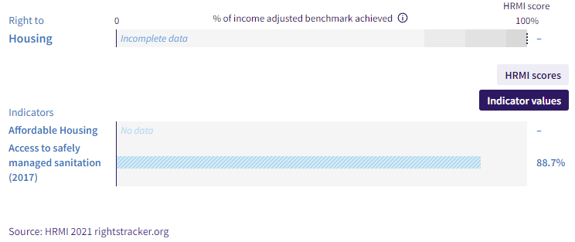
New Zealand has a Right to sanitation score of 88.6%. This means that New Zealand is only achieving 88.6% of what is possible for their level of income. Looking at other high income countries; New Zealand is doing above average. If New Zealand wants to achieve a 100% score, they will need to increase the Safely managed sanitation score by 11.32%. In terms of people, New Zealand would have to improve access for 544,935 people for Safely managed sanitation, in order to reach the realistic target of 100% and meet its human rights obligations.

Papua New Guinea
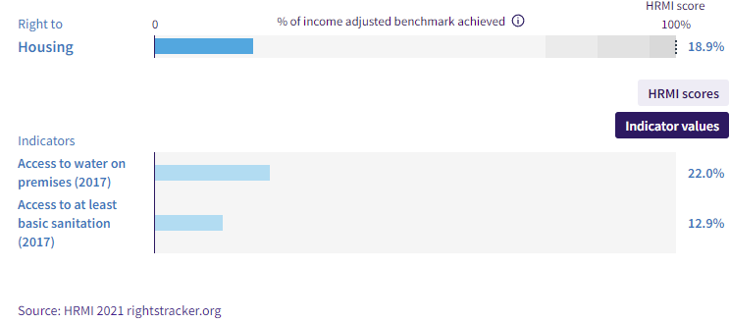
Papua New Guinea has a Right to Housing score of just 18.9%; this means that Papua New Guinea is only achieving 18.9% of what should be possible for their level of income. Looking at other low and middle income countries in East Asia and Pacific; Papua New Guinea is doing well below average (60.75% below).

If Papua New Guinea wants to achieve a 100% score, they will need to increase water and basic sanitation scores by 67.39% and 84.9% respectively. In terms of people, Papua New Guinea would have to improve access for 7,163,969 people for basic sanitation and 5,686,714 people for water, in order to reach the realistic target of 100% and meet its human rights obligations.

Samoa
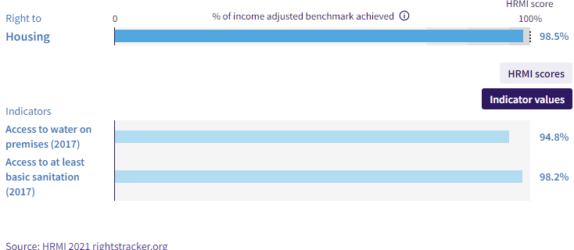
Samoa has a Right to Housing score of 98.5%; this means that Samoa is achieving 98.5% of what is possible for their level of income. Looking at other low and middle income countries in East Asia and Pacific; Samoa is doing above average. If Samoa wanted to achieve a 100% score, they would need to increase water and basic sanitation scores by .83% and 1.83% respectively. In terms of people, Samoa would have to improve access for 3,579 people for basic sanitation and 1623 people for water, in order to reach the realistic target of 100% and meet its human rights obligations.

Solomon Islands
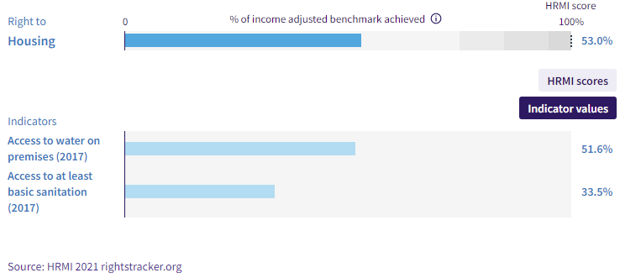
Solomon Islands has a Right to Housing score of 53%; this means that Solomon Islands is only achieving 53% of what is possible for their level of income.

Looking at other low and middle income countries in East Asia and Pacific, Solomon Islands is doing well below average (26.67% below).

If Solomon Islands wanted to achieve a 100% score, they would need to increase water and basic sanitation scores by 26.35% and 50.84% respectively. In terms of people, Solomon Islands would have to improve access for 323,341 people for basic sanitation and 167,589 people for water, in order to reach the income-adjusted target of 100%.

South Korea
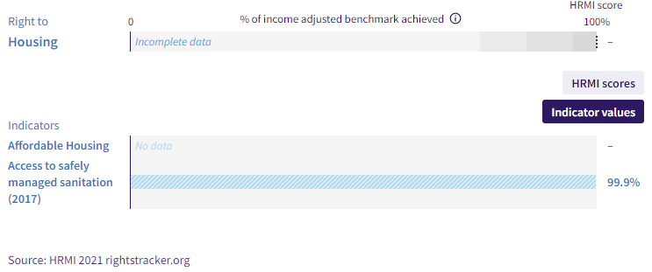
South Korea has a Right to sanitation score of 99.9%. This means that South Korea is achieving 99.9% of what is possible for their level of income. Looking at other high income countries, South Korea is doing above average. If South Korea wants to achieve a 100% score, they will need to increase the Safely managed sanitation score by .1%. In terms of people, South Korea would have to improve access for 49,149 people for Safely managed sanitation, in order to reach the realistic target of 100% and meet its human rights obligations.

Taiwan
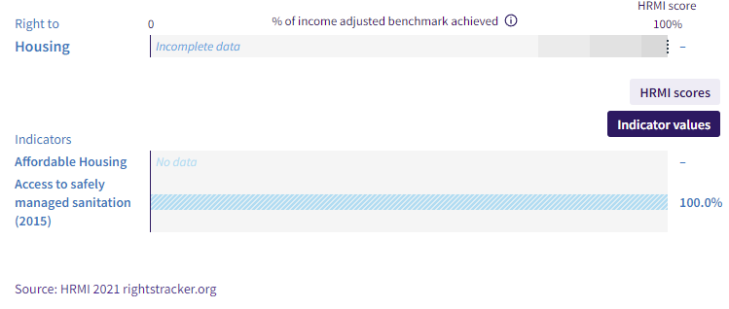
Taiwan has a Right to Housing score of 100% (if we use just the Safely managed sanitation score as the high income assessment standard). This means that Taiwan is achieving the possible best for their level of income. However, Taiwan can still do more by ensuring facilities and access is up to date around the country to maintain their position, and focusing on equity of access. Looking at other high income countries; the Taiwan is doing above average. However, the continual upkeep and management of resources in this area while the population continues to grow will ensure that Taiwan’s scores remain high.

Tonga
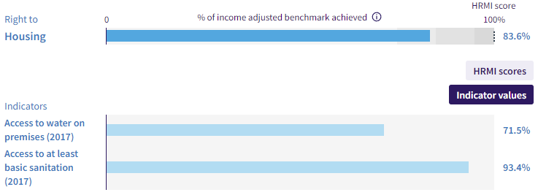
Tonga has a Right to Housing score of 83.6%; this means that Tonga is only achieving 83.6% of what is possible for their level of income.

Looking at other low and middle income countries in East Asia and Pacific, Tonga is doing above average, but with a score that shows progress can be made.

If Tonga wants to achieve a 100% score, they will need to increase water and basic sanitation scores by 24.17% and 6.56% respectively. In terms of people, Tonga would have to improve access for 6,686 people for basic sanitation and 24,650 people for water, in order to reach the realistic target of 100% and meet its human rights obligations.

Vanuatu
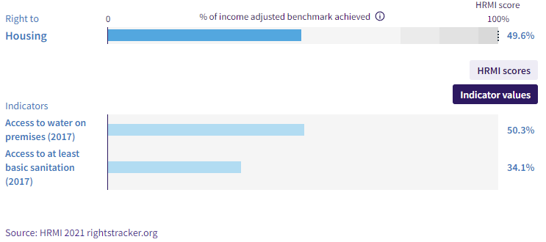
Vanuatu has a Right to Housing score of 49.6%; this means that Vanuatu is only achieving 49.6% of what is possible for their level of income. Looking at other low and middle income countries in East Asia and Pacific, Vanuatu is doing well below average (30.07% below).

If Vanuatu wants to achieve a 100% score, they will need to increase water and basic sanitation scores by 32.02% and 55.45% respectively. In terms of people, Vanuatu would have to improve access for 158,313 people for basic sanitation and 91,414 people for water, in order to reach the realistic target of 100% and meet its human rights obligations.

Vietnam
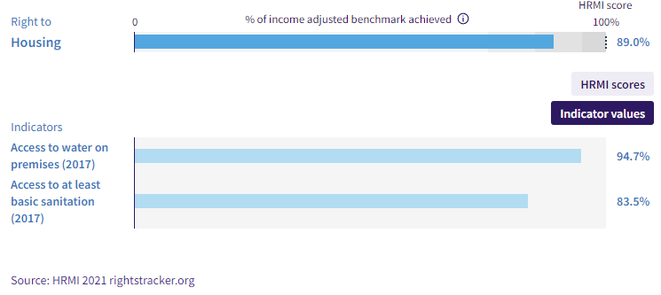
Vietnam has a Right to Housing score of 89%; this means that Vietnam is only achieving 89% of what is possible for their level of income. Looking at other low and middle income countries in East Asia and Pacific Vietnam is doing above average, but with room for improvement.

If Vietnam wants to achieve a 100% score, they will need to increase water and basic sanitation scores by 2.1% and 16.49% respectively. In terms of people, Vietnam would have to improve access for 15,594,869 people for basic sanitation and 1,987,903 people for water, in order to reach the realistic target of 100% and meet its human rights obligations.

Thematic and Intersectional Analysis

We have further analysed the qualitative responses from our annual survey to reveal themes relevant to the experiences of older people.

The following themes emerge from coding the additional qualitative responses from experts, on which groups of people were particularly at risk of not enjoying their rights to adequate housing.

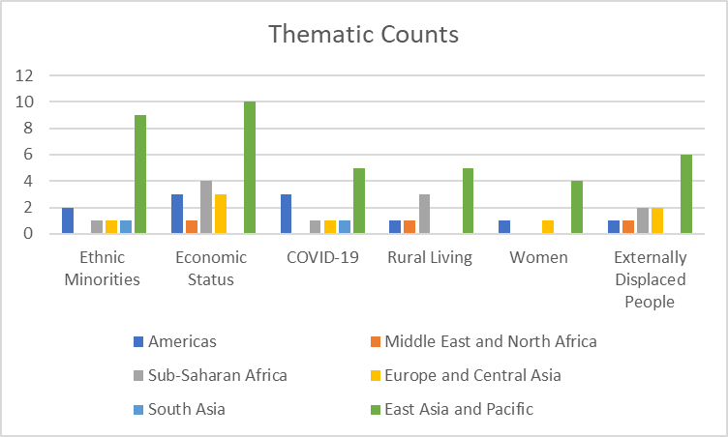

Summary

In most countries in the world, older people are over-represented among those who are not enjoying the right to adequate housing.

In most countries in the world, governments have sufficient resources to significantly improve the situation of their people, including older people, when it comes to the right to adequate housing.

Investment in access to water and sanitation would not only provide dramatic improvements in people’s quality of life, but is also within reach of nearly every government.

We look forward to seeing all countries’ HRMI scores increase in coming years, and the corresponding improvement in the lives of all older people.

Submitted by the Human Rights Measurement Initiative, 1 April 2022

