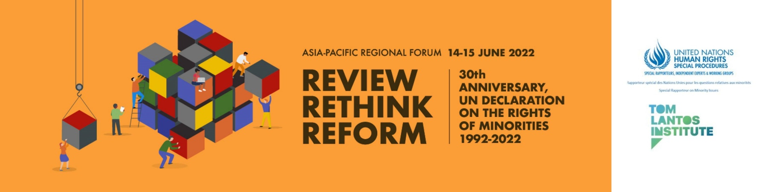

Programme of Work

(subject to change)

Day 1 14 June 2022
07:00-08:00 (GMT+02:00 - Geneva) Opening Session
10:00-11:00 (GMT+05:00 - Islamabad)
13:00-14:00 (GMT+08:00 - Kuala Lumpur)
17:00-18:00 (GMT+12:00 - Wellington)

Welcoming remarks

Anna-Mária Bíró, Director of the Tom Lantos Institute

Opening Remarks
Shigeru Aoyagi, Director, UNESCO Bangkok (pre-recorded message)
Cynthia Veliko, Regional Representative, OHCHR Regional Office for South East Asia
Stefano Sensi, Deputy Regional Representative of the High Commissioner for Human Rights in the Pacific
Ambassador Nassima Baghli, Permanent Observer of the Organisation for Islamic Cooperation Delegation in Geneva
Fernand de Varennes, United Nations Special Rapporteur on minority issues

Rules and Guide to Proceedings

Anna-Mária Bíró, Director of the Tom Lantos Institute, will set-out the process and explain the rules of proceedings for the forthcoming sessions.

08:00-08:30 (Geneva, GMT +2) Technical Break

08:30-10:30 (Geneva, GMT +2)
Thematic Session 1: Normative framework: existing norms and interpretations
11:30-13:30 (GMT+05:00 - Islamabad)
14:30-16:30 (GMT+08:00 - Kuala Lumpur)
18:30-20:30 (GMT+12:00 - Wellington)

Moderator: Jerald Joseph, now Former Commissioner, Human Rights Commission Malaysia & Advisor Pusat Komas, Malaysia

Experts: Mohammad Shahabuddin, Chair in International Law & Human Rights, Birmingham Law School, University of Birmingham
Ambika Satkunanathan, human rights lawyer and activist, former Commissioner of the Human Rights Commission of Sri Lanka
Asif Aqeel, Deputy Director, Center for Law & Justice
Razia Sultana, Coordinator for Women and Children’s Affairs, and Trafficking Prevention, Free Rohingya Coalition

Interactive dialogue

10:30-11:30 (GMT+02:00 - Geneva) Break

11:30-13:30 (GMT+02:00 - Geneva)
Thematic Session 2: Implementation: Institutions, Mechanisms, Policies, and Programmes
14:30-16:30 (GMT+05:00 - Islamabad)
17:30-19:30 (GMT+08:00 - Kuala Lumpur)
21:30-23:30 (GMT+12:00 - Wellington)

Moderator: Ayako Hatano, UN Advocacy Coordinator of the International Movement Against All Forms of Discrimination and Racism (IMADR)

Experts: Sima Samar, member of the United Nations Secretary-General’s High-Level Panel on Internal Displacement
Dolkun Isa, President, World Uyghur Congress
Khatija Khader, OHCHR Consultant and independent researcher

Interactive dialogue

Day 2 15 June 2022

07:00-09:00 (GMT+02:00 - Geneva)
Thematic Session 3: Minority participation as a procedural and substantive right and process
10:00-12:00 (GMT+05:00 - Islamabad)
13:00-15:00 (GMT+08:00 - Kuala Lumpur)
17:00-19:00 (GMT+12:00 - Wellington)

Moderator: Sriprapha Petcharamesree, Advisor, Institute of Human Rights and Peace Studies, Mahidol University
Experts: Ghazala Jamil, Assistant Professor, Centre for the Study of Law and Governance, Jawaharlal Nehru University, New Delhi, India
Chet Narayan Rasaili, former Senior OHCHR Fellow, President of the Dalit Youth Alliance
Fareeda Panjor, Center for Conflict Studies and Diversity, Prince of Songkla University
Puja Kapai, Associate Professor, Faculty of Law and Convenor of the Women’s Studies Research Centre at the University of Hong Kong
Interactive dialogue

09:00-10:00 (GMT +02:00 – Geneva) Break

10:00-12:00 (GMT+02:00 - Geneva)
Thematic Session 4: Moving Forward: Reforming the Protection and Implementation of the Minority Rights Framework
13:00-15:00 (GMT+05:00 - Islamabad)
16:00-18:00 (GMT+08:00 - Kuala Lumpur)
20:00-22:00 (GMT+12:00 - Wellington)

Moderator: Sajjad Hassan, Convenor, the South Asia Collective
Experts: Dukthen Kyi, Heads the UN, EU and Human Rights Desk at the Department of Information and International Relations, Central Tibetan Administration
Manjula Pradeep, Director of Campaigns, Dalit Human Rights Defenders Network Project
Nina Mariani Noor, Programme Executive, Globethics.net and Lecturer in School of Graduate Studies, UIN Sunan Kalijaga Yogyakarta
Interactive dialogue

12:00-13:00 (GMT+02:00 - Geneva) Break

13:00-13:30 (GMT+02:00 - Geneva) Presentation of Recommendations
16:00-16:30 (GMT+05:00 - Islamabad)
19:00-29:30 (GMT+08:00 - Kuala Lumpur))
23:00-23:30 (GMT+12:00 - Wellington)

In this session, the proposed recommendations developed during the four thematic sessions will be made available to participants to consider.
The session will be introduced by Fernand de Varennes, UN Special Rapporteur on minority issues, following which Marcus Oda, Programme Manager at the Tom Lantos Institute, will present the list of recommendations.
Participants can make any final comments on specific recommendations using the Interactio chat function.
Moderator: Anna-Mária Bíró, Director of the Tom Lantos Institute

13:30-14:00 (GMT+02:00 - Geneva) Concluding remarks
16:30-17:00 (GMT+05:00 - Islamabad)
19:30-20:00 (GMT+08:00 - Kuala Lumpur)
23:30-00:00 (GMT+12:00 - Wellington)

Fernand de Varennes, UN Special Rapporteur on Minority Issues

Simultaneous interpretation is anticipated in English and Bahasa Malay

