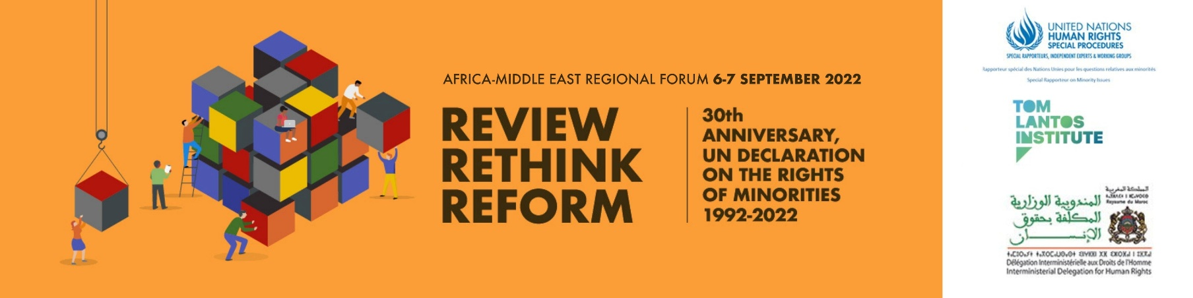

Programme of Work
(draft – subject to change)
All time are GMT +1 (Rabat)

Day 1 – Tuesday 6th September 2022
10:00-11:00 Opening Session

Welcoming remarks

Opening Remarks

Abdelkarim Boujradi, Secretary General of the Interministerial Delegation for Human Rights (IDHR), Kingdom of Morocco
Hon. Rémy Ngoy Lumbu, Chairperson, African Commission on
Human and Peoples' Rights

Nouhoum Sangaré, OHCHR Regional Representative for Central Africa

Abigail Noko, OHCHR Regional Representative for Southern Africa

Anis Anani, Officer in Charge, MENA Section, OHCHR

Benjamin Hounton, Deputy Regional Representative and OIC of OHCHR Regional Office for Western Africa

Marcel Akpovo, OHCHR Regional Representative for East Africa and to the African Union

Fernand de Varennes, UN Special Rapporteur on Minority issues

Rules and Guide to Proceedings

Anna-Mária Bíró, Director of the Tom Lantos Institute, will set-out the process and explain the rules of proceedings for the forthcoming sessions.

11:00 - 11:30 Technical Break

11:30 - 13:30 Thematic Session 1: Normative framework: existing norms and interpretations

Moderator: Fasil Mulatu Gessesse, chair of Center for Human Rights, Addis Ababa University
Experts: Bertus De Villiers, adjunct Professor Curtin Law School
Beza Dessalegn, Assistant Professor, Hawassa University
Laila Alodaat, Deputy Secretary-General, Women’s International League for Peace and Freedom

13:30 - 14:30 Break

14:30 - 16:30 Thematic Session 2: Implementation: Institutions, Mechanisms, Policies, and Programmes
Moderator: Hannah Forster, Executive Director, African Centre for Democracy and Human Rights Studies (ACDHRS)
Experts: Timothy Pagonachi Mtambo, Minister for Civic Education and National Unity, Malawi
Agnes Kabajuni, Managing Director, Minority Rights Group International – Africa, and Executive Director at Centre on Economic Social Cultural Rights in Africa
Felix Nkongho, Director, Centre for Human Rights and Democracy in Africa
Hassan Jabareen, Founder and General Director, Adalah

Day 2 – Wednesday 7th September 2022

09:00 - 11:00 Thematic Session 3: Minority participation as a procedural and substantive right and process
Moderator: Naji Moulay Lahsen, Executive Director, Network of the Independent Commission for Human Rights in North Africa
Experts: Kwadwo Appiagyei-Atua, Associate Professor, School of Law, University of Ghana
Inas Miloud, Co-Founder and Chair of Board of Directors, Tamazight Women’s Movement
Mona Silavi, Co-founder, Voice of Ahwazi Women
Awat Taieb, Co-founder, Yesna Organization for the Development of Zoroastrian Philosophy and representative of the Zoroastrians in the Ministry of Endowments and Religious Affairs in the Kurdistan Regional Government

11:00 - 12:00 Break

12:00 – 14:00 Thematic Session 4: Moving Forward: Reforming the Protection and Implementation of the Minority Rights Framework
Moderator: Tahani Irfan Ruhi, journalist, lecturer, trainer, human rights defender
Experts: Prosper Nobirabo Musafiri, Associate Professor, University of Kisangani
Mina Thabet, MENA regional Coordinator, PEN International
Nadia Hasan Khalo, Nadia’s Initiative
Mohamed Ben Moussa, Professor of Architecture and Senior Lecturer & Researcher, High School of Architecture and Urbanism of Tunisia

14:00 – 15:00 Break

15:00-15:30 Presentation of Recommendations

In this session, the proposed recommendations developed during the four thematic sessions will be made available to participants to consider.
The session will be introduced by Fernand de Varennes, UN Special Rapporteur on minority issues, following which Marcus Oda, Programme Manager at the Tom Lantos Institute, will present the list of recommendations.
Participants can make any final comments on specific recommendations using the online chat function.

15:30-16:00 Concluding remarks

Fernand de Varennes, UN Special Rapporteur on minority issues

Simultaneous interpretation will be provided in Amazigh, Arabic, English, French and Arabic Sign Language

