Independent Commission for Human Rights

Report On:
“Migration and Migrants in the South Of Morocco”

Prepared and presented:
Essallami Zoubida
Hamadi Filali
Naji Moulay Lahsen.

December 2021

General introduction:
The national strategy in the field of migration and asylum is a multi-dimensional public policy that takes into account the human rights and economic aspects, and is based on the integrative approach of Africans, on the human rights dimension that King Mohammed VI often adopts. From his speeches since assuming the throne, and about the universal principles of human rights contained in international charters, then the principles of the 2011 constitution, and the comprehensive report prepared by the Ministerial National Council for Human Rights. The delegate in charge of human rights and the International Organization for Migration 2013.
In dealing with the migration file, Morocco tried to combine border control to limit the flow of migrants, and regularize the status of those who descend into Morocco and fulfill the conditions.
Despite the strong initiative, Morocco realizes that the problem of migration in Africa is beyond its capabilities. African migrants flock to the Moroccan borders, in an effort to move to Europe via Spain, and in light of the Spanish security strictness in controlling its borders with Morocco and coordination between Rabat and Madrid in combating the flow of migrants, it turns Morocco to a land of residence instead of being a land of transit in the past, which poses greater problems for it due to the need to settle the situation of these people and take care of their affairs.

The first axis: the foundations of Morocco’s policy in the field of immigration and asylum:
Paragraph 1: The Royal Institution’s contribution to the development of the national strategy for migration and asylum:
The royal vision is based on a strategy that consists of five requirements that lie in respecting the human rights of migrants, strengthening the fight against clandestine immigration, encouraging legal immigration and guaranteeing the rights of refugees and asylum seekers, as well as the exceptional settlement of illegal immigrants. In order to reach these noble goals, Morocco first signed several international agreements. Secondly, to create a Directorate of Migration and Border Control at the Ministry of Interior and the National Migration Observatory, Thirdly, a new law was enacted in 2003 stipulating the imposition of a prison sentence of up to 20 years for anyone involved in the secret displacement file. This policy resulted in a decrease in the number of immigrants. The best evidence is the figures issued by the Spanish Civil Guard, which indicate that the rate of clandestine immigration decreased during The past few years are noticeably a result of the coordination of efforts between Morocco and Spain and the role played by the Moroccan authorities.
In confirmation of this trend, King Mohammed VI said: “… “Aware of the danger of this phenomenon, which is contrary to human dignity and negatively affects relations of cooperation and good neighbourliness, Morocco has adopted strict modern legislation to criminalize and combat gangs trading in clandestine immigration, recruiting all public authorities under the rule of law and true to its obligations.” Bilateral, regional and international, and we have also created specialized agencies in the affairs of clandestine immigration and border control, as a contribution from Morocco in creating public policies. Effective to limit it in full cooperation with our neighbors and partners to curb illegal immigration and address its deep motives and negative repercussions, stressing the firm determination of the Kingdom of Morocco to coordinate its efforts in this regard with its brothers in the Maghreb Union, in support of Morocco for all the initiatives that fall into this difficult and long path... ”
King Mohammed VI, in a message addressed to the participants in the work of the French-African Summit on Peace and Security on 6/12/2013, emphasized “...to confront the phenomenon of migration, which is often accompanied by human tragedies and is a source of insecurity, it is necessary to Developing a new approach based on voluntary, generous and humane steps, without neglecting security requirements.”
Managing the migration file requires the implementation of a comprehensive and integrated strategy that combines ensuring the flow of legal migration flows, combating human trafficking networks, and a common development policy, as previously emphasized by the Euro-African Symposium on Migration and Development held in Rabat in 2006.
The Kingdom of Morocco, which was a country of origin and then a country of transit, has transformed a few years ago into a destination preferred by many illegal immigrants from sub-Saharan Africa, and based on the duty of solidarity, and the traditions of hospitality and reception that characterizes it, Morocco has recently developed a new immigration policy.
Within the framework of full respect for its international commitments, Morocco has waged a pioneering national policy in the region that is humane in its approach and responsible in its steps, and that fully takes into account the basic rights of migrants and refugees in terms of its purposes. We express here our pride in the great support that this initiative received, especially at the African levels. And the European, and we re-present the Moroccan proposal to establish an “African Coalition for Migration and Development” that stems from this initiative, and constitutes a unified framework that examines the dangers of illegal immigration, the opportunities for legal immigration and joint development that must be achieved and that reflects the joint responsibility between Europe and Africa in this field.
In a speech marking the 38th anniversary of the Green March, King Mohammed VI renewed the call for the government to develop a comprehensive policy on issues of migration and refugees, in accordance with a humanitarian approach that is consistent with Morocco's international obligations and respects the rights of migrants..
The 2011 constitution was written through the preamble and chapter three to protect rights and freedoms according to what has been internationally recognized. Therefore, the 2011 constitution, as the highest legal document that seeks to regulate the relationship between the authorities and control balances within the Moroccan political system, also seeks to distribute rights and freedoms equally among the citizen. Moroccan and immigrant, while providing institutional guarantees in order to defend and advocate for the rights of immigrants through preparing reports It was submitted to the authorities concerned with the preparation of public policies in the field of migration, and this was demonstrated by the preparation of the thematic report on the reality of migration in Morocco, where it was submitted to King Mohammed VI, who called on the government to expedite the development of a national strategy for the integration of illegal African immigrants according to a human rights and human rights approach, and then strengthen the security approach Through border control with Algeria, Mauritania and Europe.
Paragraph 2 : Protection of migrants and asylum seekers under international covenants and the National Council for Human Rights.
- First: the protection established under international covenants for the rights of migrants and asylum seekers :
The optional conventions and protocols ratified by Morocco constitute the human rights reference for the various policies that it worked on. Among these national strategic policies for immigration and asylum, which is our subject, which was based on the Universal Declaration of Human Rights issued in 1948 and then the International Covenant on Economic, Social and Cultural Rights in 1966, ratified It was Morocco in 1979 ,The Optional Protocol to the International Covenant on Economic, Social and Cultural Rights, which was signed by Morocco,
The International Convention on the Protection of the Rights of All Migrant Workers and Members of Their Families, which became effective in 2003, and the International Labor Organization Convention No 87 on Freedom of Association and Protection of the Right to Organize, in force since 1950, not signed by Morocco and then the International Labor Organization Convention No. 143 regarding Migrant Workers, which has been in force since 1978, and Morocco has not signed it.
Among the agreements that form the basis of the national strategy for migration and asylum, the Geneva Convention relating to the Status of Refugees 1951 and its Additional Protocol 7619, ratified by Morocco, the signing of the protocol in 1971, and the 1989 Convention on the Rights of the Child ratified in 1993,
The Convention on the Elimination of All Forms of Discrimination against Women 1979 and its Optional Protocol 1999, which was ratified in 1993, all reservations were lifted and its Optional Protocol was ratified in 2011. We can ask about the contribution of the National Council through the reports it prepares in protecting the rights of migrants and asylum seekers in Morocco?
- Second: The National Council for Human Rights protects the rights of migrants and asylum seekers.
The creation of the National Council for Human Rights embodies Morocco’s keenness and commitment to protecting the rights and freedoms of citizens and its commitment to respecting its international obligations with regard to the protection of human rights as recognized internationally. for human rights, which was established in 1990 in light of the political reforms launched by Morocco and in order to reconcile with the gross violations of human rights, The National Council for Human Rights is an independent national institution whose function is to protect and promote the rights and freedoms of citizens and to spread a culture of human rights. It was established in accordance with the Paris Principles regulating national human rights institutions. The National Council for Human Rights has broad competencies at the national or regional level, and this fact enhances its independence.
The National Council for Human Rights exercises its competencies in public and private issues related to the protection of the rights of individuals and groups. It also works to monitor and track the human rights situation at the national and regional levels, and expresses its opinion on all issues presented to it by the King in the field of respect for human rights, and in this context King Mohammed VI gave orders to the National Council for Human Rights to prepare a report on the situation of migrants in Morocco, and the latter worked on preparing a thematic report and submitted it to King Mohammed VI, highlighting all the manifestations of imbalances and weaknesses in the migration file, and made recommendations to advance the file and respect the international conventions that Morocco ratified it.
The National Council can also carry out all the investigations and meetings necessary for the formation and collection of confirmed and reliable information. The Council also works on preparing reports that include the conclusions and results of the monitoring or investigations and investigations it conducted, and submits reports to the competent authority, with the need for recommendations to address violations. The Council considers In all violations and violations of human rights on his own initiative or based on a complaint by those concerned, and in this context, the National Council for Human Rights receives complaints, studies and addresses them, tracks their paths and outcomes, and submits recommendations regarding them to the competent authority.
Thus, the foundations of the civil state are based on respect for human rights as they are universally recognized, including the need to respect the rights of migrants, by providing them with several economic, social, cultural and political rights, to facilitate their integration into the fabric of Moroccan society, and to reduce the security and social repercussions of clandestine immigration. on Morocco and neighboring countries.
The second axis: the dimensions of Morocco's policy to protect migrants :
The issue of immigration in Morocco has always been an embarrassing problem that has haunted successive governments for decades. Between “turning a blind eye” at one time and being strict with security at another, African immigrants have remained invisible in the Moroccan equation for decades, with the adoption of a purely security approach.
The security approach found its justifications among its defenders in the fact that many “illegal” African immigrants practice prohibited activities punishable by law: theft, fraud, drug trafficking, currency counterfeiting, beggary, prostitution, and the security concern is nothing but a front to cover up a political obsession in which it plays Political accounts play an important role, in the absence of human rights and social concern.
Consequently, the new national strategy in the field of migration and asylum carries with it humanitarian and human rights dimensions as outlined in the international declarations of human rights, and the political and human rights concerns also govern the situation of Africans in Morocco.
Paragraph 1 : The human and legal dimension of migration policy in Morocco :
The Constitution of the Kingdom of Morocco guarantees the human rights dimension of immigration and asylum policy, when it stresses the commitment to human rights as they are recognized internationally, and stipulates the prohibition of all forms of discrimination based on gender, color, belief, social or regional affiliation, or any personal status.
From this point of view, the presence of citizens of African countries in Morocco must be considered an issue of human dignity and an issue of the human right to live, work and stability, especially when citizens flee under duress from conditions of poverty, unemployment, famine, war, oppression and tyranny.
It should also be considered the negative practices associated with many African immigrants, (practices that are also found among the ranks of many Moroccans) and which are raised by those who are inclined to give priority to the purely security approach that applies to the requirements of the criminal law, and requires the application of the law on them in the event that a misdemeanor or crime is proven.
It should be recognized that Morocco has transformed from a country of transit to a country of residence, among a significant number of African youth, with a definite desire to integrate through learning the vernacular language, coexistence with the population, and the search for a source of decent living, even if it is minimal through practicing professions It is not a continent in popular neighborhoods, and even in the streets of some major cities, such as Laayoune, the largest city in the Sahara.
And in light of Morocco’s involvement in the policy of integrating African immigrants, the southern provinces, especially the city of El-Ayoun, will find themselves in front of a second generation of African immigrants, demanding full citizenship rights in Morocco, after we see new births. How can we, as an independent human rights body, deal with this fact, which raises the issue of civil registration, children's schooling, and the right to health care?
Paragraph 2: the political and social dimension of Morocco's policy in the field of migration.
- First : the political dimension :
Morocco’s policy in the field of immigration falls within accounts linked to economic and political interests with European neighbors on the northern bank, especially with the Spaniards, and thanks to the strategy developed by Morocco, it was able to move from the role of Europe’s gendarmes to an effective partner in managing the migration crisis and its effects on Europe. Given that the presence of African immigrants in Morocco, which is just a station to try to infiltrate towards “European bliss,” and from this point of view, Moroccan-Spanish cooperation in particular, and European cooperation in general, in part, takes the form of indirect pressure on Morocco in the matter of combating illegal immigration and drugs. Morocco is asked to be a preventive measure to contribute to alleviating the security, economic and social repercussions of the migration file.
Morocco's accession to its African depth was also among the reasons that made Morocco deal with the migration file positively, given the historical, geographical and geo-strategic extension of Morocco. This resulted in the recognition of the common identity with the Africans. It is unreasonable to talk about the African citizens living among us as if they were coming from another planet..
The foreign countries’ care for the interests of Moroccan citizens abroad (4.5 million Moroccan immigrants) should not differ from Morocco’s keenness to protect the interests of transiting migrants and those newly settled in the soil. Therefore, in order for Morocco’s dealings to gain credibility with neighboring countries and towards the international community, it is necessary to transcend the logic of Double standards.
- Second: The social dimension of Morocco's immigration policy :
It is related to providing statistics concerning immigrants aged 15 years and over, and they include immigrants in an irregular situation, immigrants whose legal status has been settled, as well as refugees and asylum seekers in Morocco. Statistics focused on immigrants from sub-Saharan Africa and from other countries forced by circumstances to be on Moroccan soil (Syrians, Libyans, Iraqis, and others).
This research included a sample of 3,000 immigrants, distributed among 2,200 immigrants in an irregular situation or those whose status has been regulated, and 800 refugees or asylum seekers.
The sample of refugees and asylum seekers was taken from the database provided by the United Nations High Commissioner for Refugees. As for the sample of illegal immigrants or those whose status has been regularized, it was drawn using the quota method, depending on the structures of immigrants who benefited from regularization processes according to cities, gender, age and country of origin.
The data of the research were collected during the first semester of the year 2021, based on the method of interrogation by telephone and direct contact, using electronic panels.
In this report, it reviews the results related to the social and demographic characteristics of migrants, migration paths, the administrative situation of migrants, the conditions and reasons for their entry to Morocco, their position vis-à-vis the labor market, sources of income, intentions and prospects for migration, the perceptions and attitudes of migrants, their housing conditions and health status, as well as their behavior and attitudes during quarantine.
- Demographic and social characteristics of immigrants:
- Three out of five immigrants are men.
About three in five migrants are men (59.3%). The proportion of women among immigrants is 40.7%. The highest level is among immigrants from the Democratic Republic of the Congo (53.8%), Côte d'Ivoire (53.6%), and the lowest among immigrants from Guinea (27.6%), Mali (29.9%) and Central Africa (32.8%). In other countries, it is in an intermediate position.
- More than eight out of every ten immigrants between the ages of 15 and 44:
Over two out of every five migrants are young people between the ages of 15 and 29 (42.5%), women are relatively lower than men for this age group, 39.4% versus 44.7%, respectively. Migrants between the ages of 30 and 44 account for almost the same percentage (43.7%), with a higher proportion among women than men, 48.2% versus 40.7%, respectively.
As for the proportion of people aged between 45 and 59 years, it reaches 12% (12.8% in men and 10.8% in women). Finally, the proportion of adults aged 60 years and over is (1.7%) with roughly equal proportions between men and women.

Figure 1: Structure of immigrants by age (%)
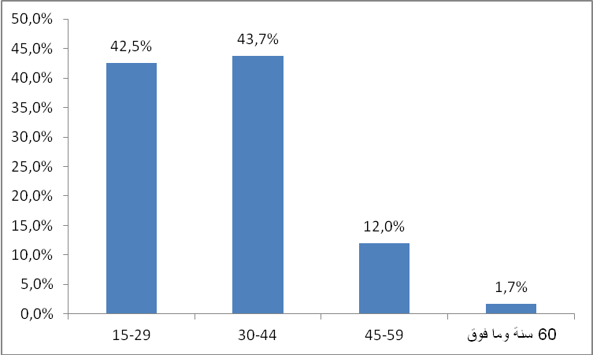
Source: High Commission for Planning, National Research on Forced Migration for 2021.

- More than half of immigrants are single :
More than half of the immigrants (54.1%) are single and 36.2% are married. These percentages are, respectively, 55.7% and 38.2% in men and 51.7% and 33.2% in women. Divorcees account for 3.7%, which is higher for women (5.6%) than for men (2.4%). As for the percentage of those who live outside the framework of the institution of marriage (concubinage), it is 2.6%, 2.5% for men and 2.7% for women.

Figure 2: Migrants by Marital Status (%)
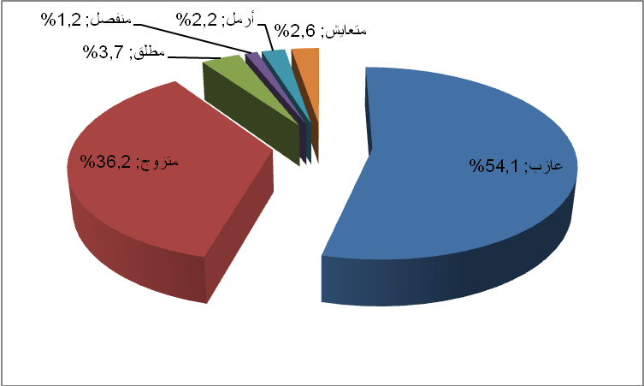
Source: High Commission for Planning, National Research on Forced Migration for 2021.

- The average size of immigrant families in Morocco is 4 members:
The average family size of immigrants is 4 people. It is relatively high among Senegalese (6 people) and Syrians (5), and lower among people from the Central
African Republic (3), from Cameroon (3), and from Côte d'Ivoire (3).
- More than a quarter of immigrants have a high level of education:
This research shows that more than a quarter of immigrants (27.3%) have a higher level of education, which is higher for men (30.6%) than for women (22.5%). The percentage of those with a qualified secondary education level was 23.5%, the preparatory level was 19.1%, and the primary level was 17.2%, without a significant difference between men and women. The proportion of immigrants without an educational level is about 12.8%, which is higher for women (16.4%) than for men (10.3%).

Figure 3: Migrants by educational level (%)
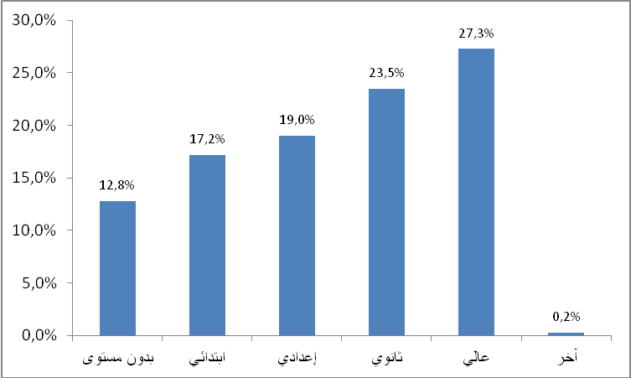
Source: High Commission for Planning, National Research on Forced Migration for 2021.

- One immigrant out of every 7 who received vocational training in Morocco:
About a third of immigrants (31.8%) received vocational training in a vocational training institution or civil society. Of them, 17.3% received this training in their country of origin, 13.9% in Morocco, and 0.6% in another country.
Citizens of the Democratic Republic of the Congo come first among migrants with a professional training with 53%, followed by citizens of the Central African Republic (46.3%), Côte d'Ivoire (42.5%) and Cameroon (41.3%). The lowest percentages were recorded among Syrians (11.4%), Malians (18.9%) and Yemenis (19.4%).

2 - Migration routes and paths:
- The majority of immigrants in an irregular situation or those whose status has been regularized are from West Africa:
Of all migrants in irregular or regularized status, 16.7% are from Côte d'Ivoire, 15.9% are from Senegal, 13.2% are from Guinea, 10.1% are from the Democratic Republic of the Congo, 8.7% are from Cameroon and 4.9 % from Mali, 2.3% from the Central African Republic, and 15.1% from other African countries.

Figure 4: Legal and Regulated Migrants by Country of Origin (%) (*)
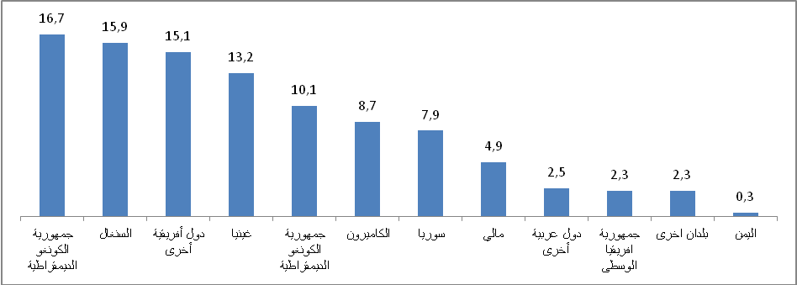
Source: High Commission for Planning, National Research on Forced Migration for 2021.
(*): We mean legal immigrants and those whose legal status has been settled, most of whom are from sub-Saharan Africa
And some Arab countries (Syria, Libya, Yemen and others)

- More than half of the refugees are Syrians:
More than half of the refugees in Morocco (54.4%) are of Syrian origin. Yemenis come in second place by a wide margin with 12.3%, followed by Central Africans with 9.9% and Ivorians with 4.5%.

Figure 5: Refugees by country of origin (%) (*)
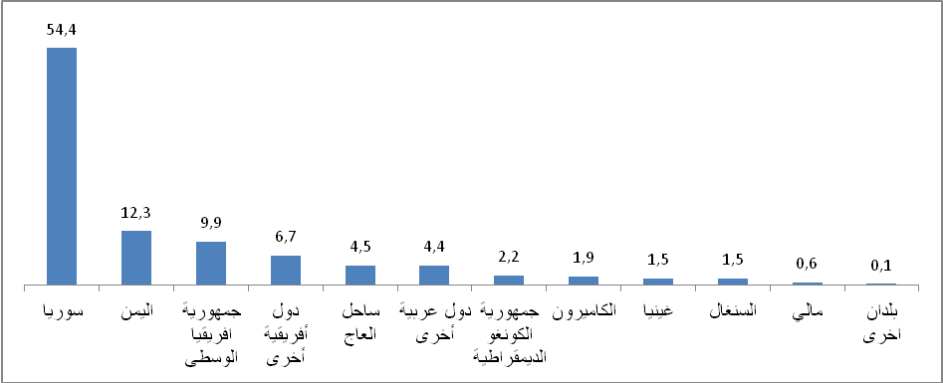
Source: High Commission for Planning, National Research on Forced Migration for 2021.
(*): Refugees are defined within the meaning of the United Nations High Commissioner for Refugees.

- More than 8 out of 10 migrants have left their country of origin since 2010:
The majority of migrants (84.9%) have left their countries of origin since 2010 (82% among men and 89.3% among women) compared to 1.15% before 2010. Almost half (46.4%) have left their countries of origin since 2016, including 30.4% between 2016 and 2018 and 16% between 2019 and 2021.

- About two thirds of the migrants arrived directly in Morocco:
About two-thirds of migrants (61.2%) arrived directly in Morocco from their countries of origin, women (65%) relatively more than men (58.7%). Also, about 38.8% have previously lived in other countries for three months or more (outside their countries of origin and outside Morocco), of which 22.8% are in only one country, 10.1% in two countries, 4.2% in three countries, and finally 1.8% in four or more countries.
It should be noted that approximately 5.8% of migrants have resided in Morocco more than once, which is a relatively high percentage among men (6.5%) compared to women (4.8%). The proportion of immigrants arriving in Morocco for the first time is 94.2%.
Figure 6: Migrants by number of countries in which they resided for a period of 3 months or more from their departure from the country of origin until their arrival in Morocco (%)
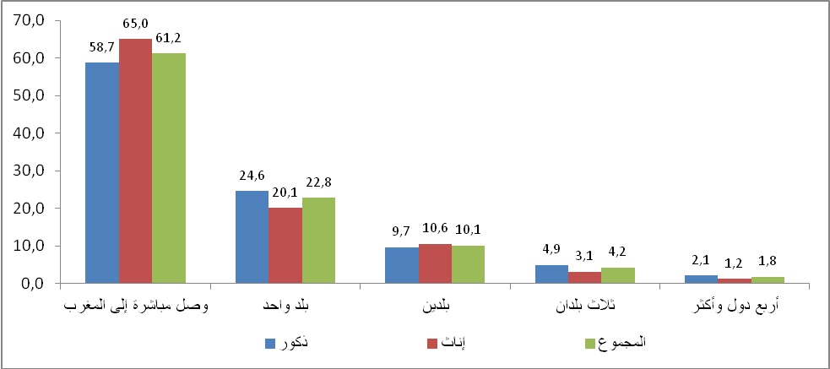
Source: High Commission for Planning, National Research on Forced Migration for 2021.

- The cost of the trip is higher for Syrians:
The cost of the migrants' journey from their countries of origin to Morocco was an average of $1,940, without any difference between men and women. This cost remains high for Syrians ($3,760), Yemenis ($2,280) and citizens of the Democratic Republic of the Congo ($2020), while it is low for Senegalese ($920) and Guineans ($1,040).
- More than three quarters of migrants emigrated for reasons related to the search for work, wars, insecurity and persecution:
More than a third of migrants (39.1%) left their country of origin for reasons mainly related to war, insecurity and persecution, 37.9% among men and 41% among women. The search for work or improvement of living conditions comes in second with 36.7% (39.9% in men and 32.1% in women). About 14.1% of immigrants stated that education and training were a reason for emigration, especially among men, as this percentage reached 16%, compared to 11.4% for women. The family gathering (marriage or joining the family) comes in fourth place with 4.7% and concerns women with 8.9% more than men (1.8%).

Figure 7: Migrants by main reason for leaving the country of origin (%)
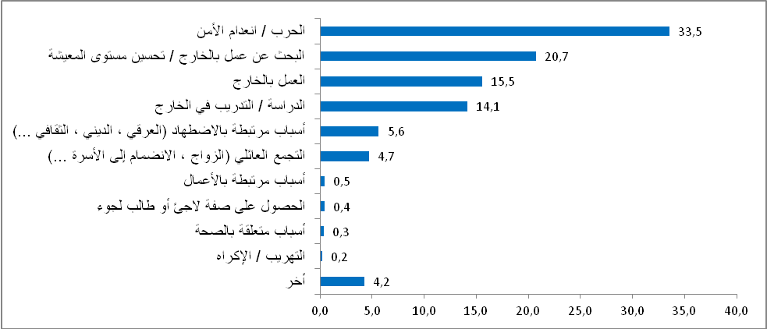
Source: High Commission for Planning, National Research on Forced Migration for 2021.
- More than 1 in 6 women who experienced sexual harassment or rape during the trip:
Less than half of the migrants (44.5%) reported experiencing difficulties during migration. The most important of these stated difficulties are lack of money at 17.7%, followed by physical exhaustion due to walking, hunger and thirst (17.5%), physical and psychological violence (13.7%), sexual harassment or rape 7.8% (17.7% in women versus 1.7% in men), arrest and detention (7.7%) and refoulement, expulsion and deportation (6%). It should also be noted that 4.3% of women experienced pregnancy or childbirth during the flight.

Table: Migrants by main difficulty encountered during migration (%)
Total | Male | Female | Difficulty type
7,7 | 10,1 | 3,8 | Arrest / Detention
6,0 | 7,7 | 3,3 | Deportation / expulsion / forced eviction
4,4 | 3,4 | 5,9 | Racism
13,7 | 14,9 | 11,7 | physical/psychological violence
6,2 | 6,9 | 5,0 | Extortion of money by border authorities/transit brokers/human traffickers)
6,0 | 6,6 | 5,0 | Theft/fraud
2,0 | 2,8 | ,7 | smugglers/human traffickers
17,7 | 19,1 | 15,2 | lack of money
4,6 | 4,5 | 4,9 | Illness during flight
17,5 | 16,3 | 19,4 | Walking fatigue/hunger/thirst
7,8 | 1,7 | 17,7 | sexual harassment/rape
2,3 | - | 4,3 | Pregnancy/delivery while traveling
1,0 | 1,3 | 0,6 | Abandoned in the middle of the road by smugglers / getting lost and lost from the group
100,0 | 100,0 | 100,0
Source: High Commission for Planning, National Research on Forced Migration for 2021
- Conditions of entry to Morocco: year of entry, reasons, entry points and companions:
- About 9 out of 10 migrants have settled in Morocco for the first time since 2010:
The majority of migrants (88.2%) arrived in Morocco for the first time between 2010 and 2021. This percentage is high among young people aged 15-29 with 97.8% compared to 61.1% for adults 45-59 years and 70% for elderly people (60 year and over). This percentage is recorded at 91.7% among immigrant women, compared to 85.8% among immigrant women.

Table: Migrants by year of arrival in Morocco for the first time and age:

Total | before 2010 | 2010-2021 | 2013-2015 | 2016-2018 | 2019-2021 | Age
100 | 2,2 | 4,3 | 18,3 | 41,1 | 34,1 | 15-29 years
100 | 12,9 | 17,7 | 25,8 | 28,9 | 14,7 | 30-44 years old
100 | 38,9 | 16,5 | 25,4 | 16,7 | 2,5% | 45-59 years
100 | 30,0 | 17,6 | 27,5 | 22,6 | 2,2 | 60 years and over
100 | 11,8 | 11,9 | 22,6 | 32,5 | 21,3 | Total

Source: High Commission for Planning, National Research on Forced Migration for 2021.

In addition, 5.8% of immigrants on Moroccan soil have resided there more than once. This percentage is 27.2% for adults 30 years and over, 6.5% for men, compared to 4.8% for women, and 18.8% for those who are divorced, separated or widowed, compared to 8% for married people and 4.3% for singles. By country of origin, the proportion of migrants who have resided more than once in Morocco is 9.7% for both Syrians and Yemenis, 6.6% for Senegalese and 3.9% for Cameroonians.
- Security and quality of living conditions are among the main reasons for choosing Morocco as a destination:
According to the results of the research, about one in five immigrants (19.1%) chose to come to Morocco due to the prevailing security in it, 19.3% among men and 18.9% among women. The second reason is related to the quality of living conditions in Morocco, at 18% (17.2% for men and 19% for women). Other reasons include advice from family members (10.7%), proximity to Europe (10.6%), schooling (7.9%), an immigration policy that provides more rights for migrants (6.1%), ease of access to Morocco (4.2%), and marriage or family gathering (4%).
Figure 8: Migrants according to the reasons for choosing Morocco as a destination (%)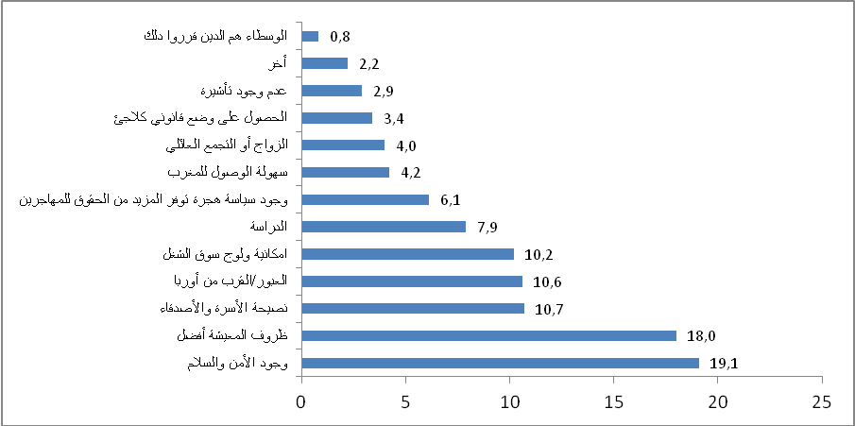
Source: High Commission for Planning, National Research on Forced Migration for 2021.

By country of origin, reasons related to security and quality of living conditions in Morocco were stated by about half of Syrians (47.5%), citizens of the Democratic Republic of the Congo (47.2%), about a third of Cameroonians (35%), citizens of Côte d'Ivoire (33.9%) and citizens of the Central African Republic (33.8) %), Senegalese and Guineans (31.8%).
- More than half of the migrants came to Morocco alone:
The majority of immigrants (55.3%) came to Morocco alone, men 61.4% more than women (46.7%). The percentage of immigrants who came to Morocco with their wives and/or children represented 28.5%, 33.7% of women and 24.8% of men. The immigrants who came with their brothers or sisters represented 7.2% of the total immigrants, and those who came to Morocco accompanied by their parents constitute 5.3%.
Figure 9: Migrants by family members accompanying them when they came to Morocco (%)
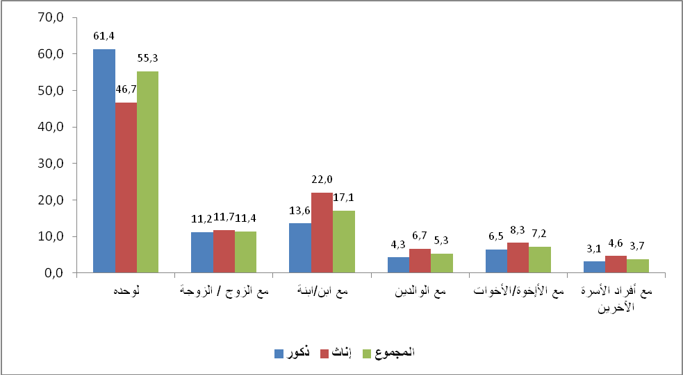
Source: High Commission for Planning, National Research on Forced Migration for 2021.

- Airports and the eastern borders are the most important entry points to Morocco:
About half of the migrants entered Morocco through airports (48.1%), 51.7% for women and 45.6% for men. Yemenis make up the most of this crossing with 76.5%, followed by Central Africans (73.7%), Côte d'Ivoire (69.7%) and Senegal (65.6%). The Moroccan-Algerian border comes in second place with 43.7% (men 47.4% more than women 38.2 %). Cameroonians come first among the migrants who took this crossing, with 83.9%, followed by Syrians (74.8%), Malians (62.2%) and people of Democratic Republic of the Congo (59.5%).
In third place comes the border with Mauritania, with a share of 7.4%, which attracts in particular the Senegalese (24.3%) and the citizens of Côte d'Ivoire (11.3%).
- Casablanca and Oujda, the first two cities to enter Morocco:
In answer to the question about the city through which migrants crossed after entering Moroccan soil, Casablanca comes first with 44%, followed by Oujda (40.9%). Other cities mentioned are Dakhla (5.1%), Rabat (2.6%) and Laayoune (1.3%).

Figure 10: Migrants by first transit city in Morocco (%)
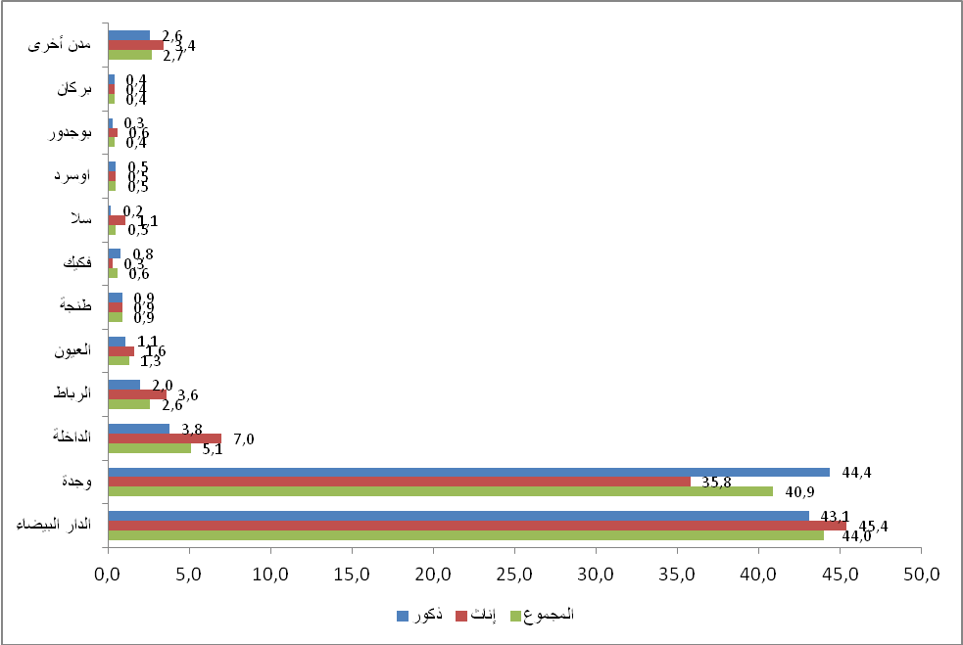
Source: High Commission for Planning, National Research on Forced Migration for 2021.

4- The intentions and prospects of migration:
Two-thirds of migrants cannot return to their countries of origin at any time due to insecurity, war and persecution
About two-thirds of immigrants (64.8%) say they cannot return to their countries of origin at any time. This situation concerns Syrians with 85.6%, Yemenis (77.2%), citizens of the Democratic Republic of the Congo (74.6%), Central Africans (72.4%) and Malians (70.2%).
It should be noted that about two thirds of migrants (58.8%) confirmed that they could not return to their countries of origin at any time, for reasons related to insecurity, war or persecution in the country of origin. The lack of financial means comes in second with 14.8%, and the intention to cross to another country comes in third with 7.8% (8.9% in men and 6.1% in women). And family gathering comes last with 5.8% (8.1% in women and 4.3% in men).
- More than half of the migrants intend to stay in Morocco and a quarter intend to migrate to another country:
More than half of the migrants (53.7%) intend to stay in Morocco (55% for women and 52.8% for men). Those who intend to migrate to a country other than Morocco represent 25.9% and they are more than those who intend to return to the country of origin, with or without conditions (11.8%). Finally, the immigration project remains ill-defined for 8.6% of immigrants.

- Syrians are the most willing to stay in Morocco with 72.4%, followed by Senegalese (62.7%) and then citizens of the Democratic Republic of the Congo (62%).
- The percentage of those wishing to migrate to another country increases among Central African citizens (52.3%), Malians (42.3%) and Cameroonians (40.9%), while it decreases among Syrians (12.3%) and Senegalese (18%).
- The rate of return to the country of origin is high among Yemenis (30.6%), Senegalese (13.3%) and Ivorians (12.3%) and low among citizens of the Democratic Republic of the Congo (3.2%) and Malians (7.1%). Finally, the rate of reluctance to re-migrate is 19.1% among Malians, 16.1% among Yemenis, and 12.7% among Central Africans.
- Less than half of the migrants wish to stay in Morocco for reasons related to security and the quality of living conditions:
- Among the reasons why migrants want to stay in Morocco, the feeling of safety comes first with 23.9%, followed by the quality of living conditions (20.6%), access to the labor market (10.5%), and the family's preference for residency in Morocco. Morocco (9.5%). and positive attitudes and behaviors of Moroccans towards immigrants (6.9%), and the settlement of conditions in Morocco (6%).
- The difficulty of living and getting a job in Morocco is one of the reasons for the desire of migrants who wish to return to their countries of origin:
- For those who expressed their desire to return to their countries of origin, the first reason was the difficulty of living or accessing the labor market in Morocco with 27.7%, followed by nostalgia for the country of origin with 21.9% (26.2% for women and 19.3% for men), then the desire to invest country of origin (15.5%), family difficulties (4.6%), and failure of the immigration project (4.6%).
- It should be noted that 10.2% of migrants who expressed their desire to return to their countries of origin stated that they had already contacted the relevant authorities for return (men (10.9%) and women (9.3%)). The highest percentage was recorded among citizens of Central Africa (33.1%), Guinea (27.3%), Cameroon (22.2%) and Côte d'Ivoire (11.8%).
- Regarding the fate of return requests, more than half of the migrants concerned stated that return procedures are still in progress (57.7%), while 33.6% have obtained approval and are preparing to return, and 8.8% have retracted the return project.

- Morocco is a transit stage for one third of migrants who intend to migrate to another country:

- The percentage of migrants who intend to immigrate to another country is 25.9%, and 30.4% of them stated that Morocco is only a stage of transit, and that their original project is to migrate towards Europe. Nationals of the Democratic Republic of the Congo (44.8%), Senegal (39.5%), Cameroon (37.3%) and Mali (36.6%) have the highest percentages.
- The second reason is the difficult living conditions in Morocco (19%), followed by better conditions for the rights and protection of migrants in other countries (11.9%), the difficulty of accessing the labor market in Morocco (10.7%), and the search for work (9.8%).

Figure 11: Migrants wishing to immigrate to another country by main reason (%)
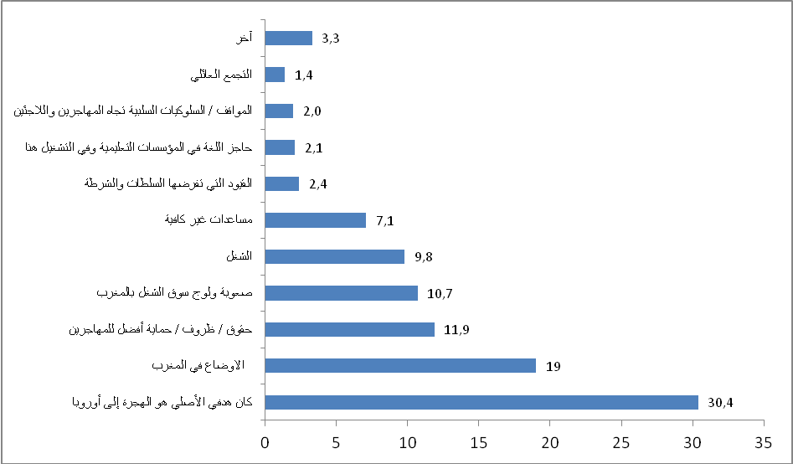
Source: High Commission for Planning, National Research on Forced Migration for 2021.

Canada is the top destination country for migrants wishing to immigrate outside Morocco with a percentage of 20.1%, followed by France (19.1%), Spain (15.5%), Germany (4.7%), Belgium (3.9%), the United States of America (2.8%) and England (2.2%)
Sub-Saharan African migrants present in Morocco in general and in the southern provinces in particular have a definite desire to integrate, which in itself is a positive factor, but it requires social convenience and calls for practical integration measures.
In the field of employment, health, schooling and housing, … and empowering the residents of them in a legitimate way from job opportunities, the reasons for economic and social integration, and the conditions for a decent living, in order to transform them into a productive and economic force that contributes to economic growth in Morocco.
The third axis: the situation of immigrants in the Laayoune-Sakia El-Hamra region:
At this time, when the Laayoune region is witnessing increased interest and activity with regard to immigration and migrants, we hope that this report, for the year 2021, will become a major reference point in helping to familiarize yourself with this health crisis, especially the problem that the country is going through. The situation of immigrants directly and created a state of anticipation among immigrants and those interested in the subject in the region, Which calls for thinking, during times that are more calm, in preparing regional social plans and policies that help integrate this category into the economic fabric, especially since the Laayoune-Sakia El Hamra region has become an essential transit station for migrants towards Europe, especially Spain and the Canary Islands across the Atlantic frontier of the region.
We often find that numbers and ratios are the usual starting point in most studies dealing with migration, but understanding the changes that occur as a result of changing the emerging paths and the fluctuating demographic factors related to social, planning, and economic changes in the future The migration policy in the region is effective and objective that respects human rights and is compatible with the social and economic peculiarities of the region. Current estimates indicate that there are less than 6000 international migrants in the region. To an important point, or this remains a small percentage of the population of the region, however, the increase in the number of immigrants has become clear over time - in number and percentage - and at a slightly faster rate than before. The vast majority of people migrate within the country as a new migration pattern, as most of the respondents reported that they have taken trips between multiple regions within Morocco for reasons related to work, family and study - which involves modern migration processes in general without achieving its essential goal and posing a challenge to them. To Europe via Spain, because a rather small percentage of the total number of immigrants can obtain legal documents delivered by the relevant authorities in the region However, this category remains in most cases the groups most in need of assistance and support. In general, Morocco usually remains a country of emigration, but it is constantly turning into a destination country, with immigrants coming from other sub-regions in Africa, and residing there and elsewhere. A way to cross to Europe.
- The phenomenon of migrant smuggling :
The Laayoune-Sakia El Hamra region, as a major transit center for migrants from many sub-Saharan countries, faces protection challenges related to irregular migration to Europe. As the number of migrants increased in the region and also with a shift in the routes used by most of the irregular migrants across the sea, the number of arrivals from Africa who entered Europe in 2019 and 2020 increased through the Atlantic frontier route to the southern regions of the Kingdom. This is despite the tightening of control measures undertaken by the Kingdom within the framework of cooperation between the European Union and Morocco - the transit country -. The authorities have intensified efforts to combat smuggling, in addition to increasing maritime security patrols off the coast of the region.
Immigrants from sub-Saharan Africa constituted the majority of irregular migrants who arrived in Spain by sea and who decided to settle in the region.
Smuggling, which amounts to human trafficking, remains a major challenge in the region, as it is a profitable sector supervised by organized criminal groups. Smuggling migrants is one of the most important features of the region, as people try to bypass the control of the coastal borders in the region. Along the coastal borders between Laayoune and the Canary Islands, especially the coasts of Tarfaya and Laayoune, it is known that smuggled migrants often fall victim to criminal practices ranging from soliciting bribes to mass kidnapping and extortion.
Some of the migrants who succeeded in reaching Morocco through Algeria through Libya spoke of exposing some of their companions to acts that include execution, physical and sexual assault, torture and kidnapping. The youth of the region rely heavily on smuggling, who are known locally as the Haraga.
There are great ways to smuggle migrants to, within and from North Africa, although smuggling is concentrated in the hands of a few organized criminal networks and with the help of smugglers. The Sahara Desert. It includes one of the main smuggling corridors of migrants moving from sub-Saharan Africa through Mauritania and the Sahara of Algeria, and this region still suffers from serious violations of human rights and protection challenges, and many of the trans-migrants are subjected to sexual abuse, atrocities, sexual harassment and abuse.
This applies in particular in the deserts of Mauritania and Algeria, where human smuggling often turns to human trafficking, especially after they get lost and stranded in the empty border areas, and some of them have fallen into the western and southern destinations. The stages of salvation from the torment of the difficult journey experienced by the majority of immigrants.
The socio-economic conditions and widespread violence at the level of the local community in a number of sub-Saharan African countries contribute to the high levels of incoming immigration, especially the emigration of large numbers of women and children. The phenomenon of illegal immigration at the national level, appeared on the forefront of “refuge areas” in the region, especially in the areas of the cities of Tarfaya and Boujdour, providing protection for migrants who do not have the necessary documents and who are at risk because of their situation, when they are in danger of leaving Morocco when they are in danger of being deported. Next European destination Which is the Canary Islands, and there also remains an inhumane environment where migrants are again exposed to the absence of humanitarian conditions to live in light of the scarcity of water and food with the spread of sexual exploitation of girls and minors, the victims of these difficult journeys, where this segment prefers to hide and not enter the cities .
Paragraph 1: the situation of vulnerable groups of immigrants:
The number of immigrants in Laayoune is about 5,200, according to the representatives of the immigrants, and most of them belong to the following nationalities: Mali, Senegal, Cote d'Ivoire, Cameroon, Gambia, Ghana, Guinea and others...
Only 700 immigrants reside legally and can obtain stable work in the region. After a series of direct meetings conducted by the Independent Commission for Human Rights with representatives of immigrants and through direct tracking and accompaniment of a group of them through repeated visits and meetings before and after the quarantine, the Commission records the great and growing concern Regarding the situation of this group, which lives in miserable conditions, which negatively affects coexistence with the local population of Laayoune.
- Most migrant women in the Laayoune region suffer from difficulty accessing health facilities due to the legal status of the majority of them, which leads some of them to resort to home delivery.
- As for working women and merchants, they were exposed to great harm during the quarantine period, which resulted in the spread of unemployment among their ranks due to the lack of work.
- As for children, this group still suffers greatly from homelessness, and consequently the spread of the phenomenon of beggary and overcrowding in social care centers.
Paragraph 2 : Social Protection for Migrants in the Laayoune-Sakia El Hamra Region:
Like other cities, migrants in the Laayoune region suffer from difficulties in the health, employment and education sectors, which can be summarized as follows:
- The difficulty of obtaining residence permits in the region (settling the legal status of immigrants, and therefore most of them are illegal).
- The inability to obtain work or housing due to the absence of identification papers or discrimination against them by the population due to the outbreak of the Corona pandemic in these circles.
- The spread of tuberculosis due to malnutrition and the necessary health conditions, and the lack of access to health facilities because the majority of immigrants did not obtain identification papers.
- Blackmailing the employers of the immigrant by refusing to provide him with documents that help him to settle his legal status.
- Extortion of employers by paying the immigrant very meager amounts below the minimum wage, as the wage sometimes does not exceed 700 dirhams per month.
- Difficulty accessing health services due to the absence of identification documents.
- - Illegal immigrants suffer from extortion and bribery in order to cross the border crossing to Morocco.
- Suffering from the extortion of organized crime owners and the smuggling of migrants towards the Canary Islands.
- Difficulty obtaining some basic necessities of clothing, food and cover due to the spread of poverty and unemployment among immigrants.
- The majority of immigrants come to El-Ayoun to settle and then to leave, considering Morocco as a transit station to Europe.
- A state of general fear of immigrants because of Corona, which makes the residents refuse to accept them for work and housing.
- Difficulty settling and discrimination against immigrants.
- The informal sector was affected, thus affecting 84 percent of immigrants who work in this sector.
- Not reaching the state's contributions to help needy immigrants (despite submitting a list of more than 1,400 needy and needy women).

Through the foregoing, the Independent Commission for Human Rights appeals to all stakeholders to intensify efforts to protect the rights of migrants and to interact with their immediate and necessary requirements. The local authorities must assume their full responsibility in coordinating efforts so that the immigrant can:
- Settling the legal status of immigrants wishing to settle permanently in Laayoune.
- Opening a door for communication with immigrants in order to meet their needs and facilitate their integration into society.
- Training and accompaniment in order to facilitate the ways of life for immigrants and integration with the population of the region.
- Access to health facilities smoothly and without discrimination.
- Access to the labor market with wages that can achieve a decent living.
- Obtaining adequate housing within what is guaranteed by law and custom.
- That the local citizen can protect his property and protect himself from any negative reflection of the situations referred to, such as crime and violence.
- The Independent Commission for Human Rights stresses that:
- Protection of children and minors and their enjoyment of their full rights, as guaranteed by national and international charters.
- Establishing special shelters for minors and enabling them to receive education and vocational training.
- Not to be lenient with members of organized crime and smuggling, which made the city of El-Ayoun a center for its operations.

The Independent Commission for Human Rights calls, through the foregoing, to:
- Organizing campaigns for donation and assistance in order to provide clothing, cover and medicine for this affected group.
- Concentrating the efforts of the local civil society in communicating with this group in order to overcome the social isolation experienced by the immigrant in the conditions of the spread of the pandemic.
- Establishing a regional mechanism for immigration and immigrant affairs.
- Training and accompaniment of immigrants in order to integrate with the population of the region.
- Involve the immigrant in all the procedures related to him for consultation, as he is the first and last concerned with the matter.
- Placing African culture at the center of the regional cultural policy's interest in order to ensure a smooth social and cultural integration between the components of society and the immigrant group.
Conclusion:
The Independent Commission for Human Rights always stresses the fulfillment of the international and national strategic commitments to the integration of migrants and refugees in Morocco, and the development of a memorandum of civil dialogue on the right to migration and human rights at the global, African and national levels through awareness-raising, advocacy and networking, and the launch of national and regional territorial plans in the framework of decentralization by creating National, regional and regional networks for the integration of migrants and refugees in Morocco.
It also stresses the need to push civil society by enabling it with the mechanisms and means necessary to play its role in the field of research, investigation, monitoring, tracking and training of migrants and refugees, and to contribute to their integration in a way that guarantees their rights and dignity and their effective contribution to comprehensive development.

