Migrant Forum in Asia
Submission to the Office of the United Nations High Commissioner for Human Rights for the Secretary-General’s Report on the Human Rights of Migrants

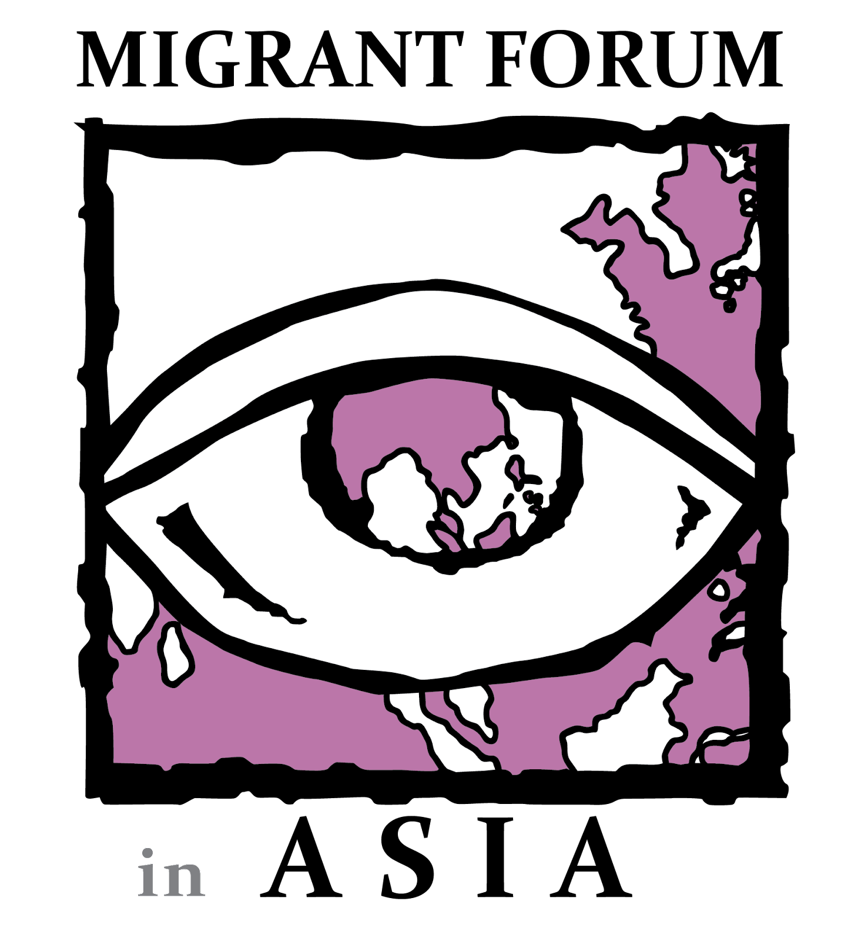

Migrant Forum in Asia Secretariat
25 Matiyaga St., Central District, Diliman, Quezon City, Philippines 1100
+63 (02) 8277 9484 | +63 921 540 5063
www.mfasia.org
- Introduction

The Backsliding and Erosion of the Human Rights of Migrants

As the number of migrant workers rises, the need to improve protection mechanisms also increases. The recognition of migrant rights as human rights is an integral step that needs to be undertaken as part of strengthening the safeguards of human rights protection. Despite the institutional recognition of the human right to freedom of movement and the acknowledgement of migrants as human rights holders, there are little to no policies placed at a regional level and above surrounding the migration sector despite the push for a more global society. Bilateral agreements, The Global Compact for Safe, Orderly and Regular Migration, various conventions on the protection of migrants, are present but do not come close to ensuring that bills be enacted, or actions be taken. Several factors have led to the backsliding of the decades-long battle for upholding migrant rights.

Xenophobia, Nativism, and Racial Discrimination all contribute to the rise in anti-immigrant sentiments, which furthers the backsliding of migrant rights. Nativism appears as a means of redefining existing notions of national identity in terms of the local and quasi groups. In that, the surge of anti-migrant policy can be grounded based on both ideological and cultural factors. The policies and frameworks in existence fall short in the widening of spaces for migrants vis-a-vis ideological movements that view migrants as security and economic threats. In turn, movements like these pose a barrier for the protection and promotion of migrant rights and trigger its backsliding.

The COVID-19 pandemic only amplified the anti-immigrant sentiments, specifically towards migrants from the Asian Region. It was also during this time period that migrant workers suffered detrimental effects in both countries of origin and destination. Many of them lost their jobs or have had their wages stolen, had to take unpaid time off or received lower pay, were confined to subpar living conditions, were actively disengaged from the available employment opportunities, forced to sign blank contracts or send scanned signatures to their employers, and were forced to continue working without a valid visa. Many migrants grappled with the challenge of exerting their right to return under these conditions, while others remained stranded in cities without access to services or support or in border regions, where they lived in difficult conditions.

A more globalized world calls for the protection of all, including migrants regardless of status. Human rights are applied globally notwithstanding the institutionalized policies of anti-immigrant sentiment. In as much, the backsliding of migrant rights function as a threat to both the individual and their family; so much more for families who migrate together. Labour migration provides opportunities for growth for COOs, CODs, and migrant workers. Nonetheless, transnational labor migration raises some concerns. Economic shocks cause an unprecedented number of people to migrate in search of new and better possibilities. Because labor migration is the search for new opportunities, its gains are dependent on the degree that migrant workers are protected.

While migration has been a positive and empowering opportunity for many, we have to acknowledge that there is a lack of human rights-based migration governance at both the international and local levels. This causes the systemic violation of the human rights of migrants at all phases of the migration cycle. Civil society organizations like Migrant Forum in Asia (MFA) have been active in their campaigns and in lobbying for the ratification of several human rights conventions, specifically conventions such as ILO C189 and the International Convention on the Protection of the Rights of All Migrant Workers and Members of Their Families.

By ratifying a convention, a country recognizes its legal duties under the treaty and will enact implementing laws after the convention enters into force. Other human rights treaties, such as conventions on the rights of the child and the rights of the woman, have had a significant impact on addressing rights violations.

- Issues on the Human Rights of Migrants

Wage Theft

​​There are numerous international measures in place to protect the rights of migrant workers. Access to justice for all is an essential component of the rule of law. Although there are numerous migrant worker instruments, such as the ILO Convention 95 on Wage Protection, their enforcement is contingent on member states' ratification. Convention 95, for example, is one tool available to combat wage theft. The primary provisions are timely and regular payment of wages in legal tender, protection against in-kind payments, and the worker's right to be informed of their wages before starting work and at the time of each salary payment. These provisions allow migrant workers to reclaim their wages; however, countries who have not ratified can use the argument that it is not legally obligatory, hence they are under no obligation to enact these measures. Surprisingly, several origin and destination countries have not ratified ILO C95.

Moreover, in 1990, the United Nations General Assembly adopted the Migrant Worker Convention, which guarantees fundamental rights for all migrants—documented and undocumented—including the right to effective State protection, consular assistance, a fair hearing, emergency medical care, overtime pay, and not being held in slavery. However, only 50 countries are signatories to this Convention, 16 are State Parties, and 132 countries, including the top migrant worker destinations, have taken little to no action.

In July 2020, MFA launched the “Justice for Wage Theft” (JFWT) campaign that aimed to call for an establishment of a transnational justice mechanism that would address and speed up the legal process for migrant workers to claim their unpaid dues and benefits. Since the program's inception, MFA and its collaborators have published three (3) reports and recorded thousands of instances of wage theft. MFA and its partners have also made use of the national judicial systems already in place in the countries of origin and destination to evaluate their efficacy and investigate the possibilities for migrant workers to access justice.

The campaign started from the efforts of civil society and trade unions to call the attention of states and employers to look into the grave rights violations concerning migrant workers’ wages and dues. The COVID-19 pandemic has exacerbated and further exposed the gaps in the current labor migration programs and policies and the flawed foundations that such programs and policies have been established. As part of the campaign, MFA and the coalition advocated for the establishment of an Urgent Justice Mechanism to address grievances, claims, and labor disputes. Subsequently, four more appeals were released to call for actions to be taken by UN bodies, governments, and businesses to combat wage theft and the lack of justice.

MFA, through its global JFWT campaign and with the help of its partners, has been systematically documenting cases of wage theft since its launch in 2020 The three (3) published reports, entitled “Crying Out for Justice: Wage Theft Against Migrant Workers During COVID-19,” denotes a huge number of wage theft victims during the pandemic as well as the estimated cost of unpaid wages and benefits. These reports only present a small proportion of migrant workers who have experienced wage theft due to a lack of political commitment to data gathering.

As of December 2021, 2,604 cases of wage theft across Asia have been recorded through the MFA JFWT-Uwazi platform. Of these cases, there are 50 group cases amounting to 1,219 workers in total. This means there are about 24-25 victims per group case. Additionally, as of June 2022, the total amount of wages lost has reached US $19,519,840.

The lack of an international legal framework and an international court of remedy, as well as weak cross-border cooperation and coordination and a lack of clarity on the roles and responsibilities of the various states make it more difficult for migrant workers to access international justice mechanisms, particularly when they are already back in their home country while their cases are still pending in their country of destination. A lack of legitimacy and trust in non-state-based systems, power inequalities and a lack of representation, criminalization and fear of deportation, lengthy procedures necessitating stay in the nation without pay, and limited transparency were also mentioned as problems.

The challenges faced by migrant workers vary per country. As a result, it is critical to encourage intergovernmental agreements, regional collaboration, and a shift in public consciousness to ensure a more proactive approach to tackling migrant workers' difficulties. Wage theft covers several systems and produces a matrix of exploitation, disenfranchising many migrant workers not just in Asia but across the world. Systemic changes are needed to support migrant employees in COOs and CODs.

Social Protection

Social protection, by definition, is a set of policies and programs intended to support individuals and families in dealing with vulnerability throughout their life cycle, assist poor and vulnerable groups become more resilient against crises and shocks, promoting social inclusion and the development of human and social capital through income and consumption, ensuring access to basic good and services, and stimulating productive inclusion through development of capabilities and scales. However, not everyone is privileged to obtain safety nets and save money during shocks and crises, especially migrant workers who continue to be low-wage earners, temporary, and unprotected.

Social protection covers the lives of migrant workers and their livelihoods from socioeconomic hazards and vulnerabilities. It is a fundamental human right to which migrant workers have restricted access. Concerns ranging from coverage to portability to inter-state coordination make it difficult for migrant workers to gain access to social protection programmes. Irregular migrant workers and undocumented migrant workers in the informal economy are especially particularly vulnerable, as they lack access to social protection. The International Convention on the Rights of All Migrant Workers and Members of Their Families recognizes migrant workers' and their families' right to social security (Article 27), as well as access to services such as health (Article 28) and education (Article 30).

Central to the United Nations 2030 Agenda for Sustainable Development and its Sustainable Development Goals (SDGs) is the inclusion of migrant workers in social protection mechanisms, specifically to SDG 1 on poverty reduction, SDG 3 on promoting healthy lives and well-being for all at all ages as well as to achieve SDG 5 on gender equality, SDG 8 on decent work and economic growth, and SDG 10 on promoting equality through “implementing nationally appropriate social protection systems and measures for all, including floors” (Target 10.3) and to “adopt policies, especially fiscal, wage and social protection policies and progressively achieve greater equality” (Target 10.4).

Similarly, Goal 22 of the Global Compact for Safe, Orderly, and Regular Migration (GCM) emphasizes the importance of portable social protection mechanisms. Along with the establishment of mechanisms in the countries of destination, the discussion of social protection schemes that are also transnational and portable has arisen as a result of the unique mobility situation that migrant workers face. The protection and advancement of migrant workers’ rights will depend on the development of a more responsive social protection system.

The Universal Declaration of Human Rights (UDHR) provides a strong argument for extending social protection to migrant workers and to the members of their families. The UDHR states that “everyone, as a member of society, has the right to social security” (Art. 22) and “…to a standard of living adequate for the health and well-being of himself and of his family, including food, clothing, housing and medical care and necessary social services and the right to security in the event of unemployment, sickness, disability, widowhood, old age or other lack of livelihood in circumstances beyond his control” (Art. 25).

MFA remains committed to ensure that sustainable and decent social protection is given to migrant workers and members of their families. MFA has put out research entitled “Migrant Workers’ Rights to Social Protection in ASEAN: Case Studies of Indonesia, Philippines, Singapore, and Thailand (2011)” which posits that the issue of social protection for migrant workers in and from ASEAN countries involves commitment on the part of both individual governments and the ASEAN area as a whole. Providing social protection for migrants is a complex process that requires clear rules in a country, effective implementation of those laws, access to information, and enforcement.

Because of the mobile nature of migrant workers and the fact that the majority of these workers will not be granted permanent status in any of the countries where they reside and work in the near future, much more work is required between nations and in the ASEAN level to ensure social protection rights are granted at the national level, and rights to which migrants have paid are then portable to move with them when they return to their home country or move on to another country. Access to such protection is hampered by a variety of challenges, ranging from legislative exemptions for migrants to bureaucratic or political impediments. Whatever the constraints are, the result is the same: migrants are denied access to social protection.

Women Migrants

The feminization of migration has presented new obstacles to migration governance. Structural inequalities have created a space in developed countries for the exploitation of women migrant workers from the Global South, including discriminatory economic gender and racial constructions, the classification of domestic work as informal work, inadequate labor coverage, and the burden of proof to provide evidence for sexual harassment, among other injustices. Furthermore, migrant women, particularly undocumented migrants, are frequently subjected to violations of their human and labor rights. Immigrant women, for example, are frequently victims of human trafficking due to their poor levels of education, inability to speak the language, and unfamiliarity with their labor rights.

Gender influences migration in a variety of ways, according to the International Organization for Migration. When it comes to migration, gender influences everything from the reasons for migrating to who migrates and where, how individuals migrate, the opportunities and resources available at destinations, and interactions with the country of origin. Furthermore, one's gender influences one's risks, vulnerabilities, and needs, which often differ between groups. The roles, expectations, relationships, and power dynamics connected with a person's sexual orientation, gender identity, and expression (SOGIE) influence several parts of the migration process and can be influenced by migration in various ways.

The world's elites have adopted feminist terminology to justify ruthless exploitation and neoliberal growth that disenfranchises women disproportionately, particularly the less privileged. Employers, governments, and businesses have adopted one of the central tenets of contemporary feminism — the right of women to paid labor — to legitimize the employment of women in harsh and inhumane working conditions. The legitimization of women's work in the Global North has allowed the portrayal of their use of mostly female labor as compliant with the feminist view that paid work liberates.

Women migrant workers are disproportionately victims of a myriad of rights abuses, especially wage theft. According to a survey of 10,161 women migrant workers in India, they bear the double strain of earning a living while providing unpaid care at home. Undocumented workers, particularly women domestic workers, are the most vulnerable. They are frequently excluded from social and labor protection and experience severe job insecurity. Domestic work is devalued, often deemed as informal and unseen, and is primarily performed by women and children, particularly girls.

Migrant women domestic workers are frequently denied decent work and living conditions, such as no rest days, lengthy and unregulated work hours, and the right to reproductive health care. Such conditions obstruct their self-representation and exacerbate problems in organizing and engaging in collective bargaining.

Women constitute almost half of all international migrants. On a global perspective, women’s work plays an important role in the prosperity of the global economy. For instance, the World Bank states that women played a vital role in the decline of poverty in Latin America and the Caribbean, with a 30% contribution to the reduction of extreme poverty within a ten-year period. Moreover, the participation of women will stimulate more benefits. Gender equality in societies not only offers better socioeconomic opportunities for women, but also stimulates a faster and more equitable growth in the society.

In the MFA policy brief on “Social Protection for Low-skilled Migrant Workers and Members of their Families (2013),” it was emphasized that the feminization of international labor migration is overlooked in gender-insensitive social security debates and initiatives. Migrant women, who are more prevalent in low-skilled and hazardous employment, are typically denied social security coverage and earn less than men. Migrant domestic workers, who are often women, are denied social security coverage due to their discriminatory exclusion from national labor laws, occupational health and safety legislation, and other protective mechanisms available to other workers, making them the most vulnerable.

There is a myriad of international human rights frameworks that focus on the guarantee of women’s rights such as the UN Convention on the Elimination of All Forms of Discrimination Against Women, UN Declaration on the Elimination of Violence Against Women, ILO Convention 189 or the Domestic Workers Convention, and most importantly, the UN UDHR. Additionally, the 2030 Agenda for Sustainable Development in its entirety, and with an emphasis on SDGs 8 and 10, include the protection of all workers, including migrant workers and in particular women migrants.

Recruitment

High recruitment fees are often solicited from migrants by recruitment agencies at the start of the migration cycle. Migrant workers often engage in economic mobility as an act to increase wage employment. Such can be observed in the patterns of migration is Asia, a region where migration had a key role in political economic transformation. Lowering of costs related to labor migration simultaneously lowers their probability of exploitation, although never guaranteed due to the lack of protective laws. This also limits the possibility of forced labor and modern slavery as individuals who intend on becoming migrant workers will not have to result in taking out loans to kickstart their pathway.

Enforcement policies have been weakened by an imbalance in a diptych-like system; fragmented and unethical. Where the former leads to situations where there is an imbalance of bargaining capacity between the migrant employee and their employer. This then acts as a gateway to the latter portion of the diptych - unethical practices. Often, migrants undergo exploitative forms of labor recruitment that systematize the impounding of personal identification documents such as passports and visas. Through this, recruiters and recruitment agencies are then able to leverage this over the migrants making them vulnerable to abuse.

In a joint effort, MFA and IOM take actions to combat exploitative and unethical practices. It is a response to the challenges migrant workers, employers and recruiters face IOM through its IRIS: Ethical Recruitment Initiative released Guidance for Employers and Labour Recruiters providing preliminary guidance about how to protect migrant workers and ensure the highest recruiting standards in the face of COVID-19. The IOM-MFA ties will support these as the globe advances toward recovery and a "post-crisis" new normal while also laying the groundwork for medium- and long-term responses.

MFA, in collaboration with the Center for Migrant Advocacy, has also released a “Manifesto on Building Resilient Communities for Migrants and Families by Promoting Safe, Fair and Ethical Recruitment” which was signed by Local Government Units from the Philippines, Community-based Migrant Organizations, Civil Societies, and Trade Unions. A meeting in 2018 was also convened by the MFA network, the International Trade Union Confederation (ITUC) Migrant Recruitment Advisor team members from Indonesia, Philippines, Nepal, and Malaysia. The program was co-organized with the Malaysian Bar Council and Our Journey, Malaysia. The meeting was done for the furthering advocacy on recruitment between trade unions and non-government organizations. The regional partners' meeting led to the development of national action plans aimed at improving ITUC affiliates and MFA members' cooperation in case management, educating the public about MRA and the Hamsa Complaints mechanism, and advocating for reforms in recruitment.

Migrant Health

The social exclusion of migrants, most especially the forced and undocumented, is a violation of human rights that has been carried out to an institutional level. In as much, migrants have difficulty in accessing health care as policy backed barriers have been placed. Access to healthcare regardless of race, gender, status, sexuality, and religion is the right of every individual; both in the country of destination and country of origin. Additionally, the barriers faced by migrants to health care have been brought upon by human factors such as racial discrimination and prejudice. The legality of a migrant’s status also affects their capacity to receive medical treatment and care.

Article 28 of the International Covenant on Civil and Political Rights Family Members of Migrant Workers provides that the right to emergency medical care is guaranteed to all migrant workers and their loved ones as an act of protecting their lives or the prevention of harm that cannot be undone. This however, is only applicable for medical emergencies and not in the context of preventative care. In many cases, migrants delay getting medical attention and only seek care when the situation has worsened. This then leads to much higher expenses, and sometimes to losing their lives. The International Covenant on Economic, Social and Cultural Rights ensures the possession of the best possible level of mental and physical wellness of every migrant.

While all of these covenants are in place, violations are being made at the level of municipal law due to the lack of migrant health policies. Often, migrants are then unable to access insurance this then leads to situations wherein they have to pay an exorbitant amount out of pocket. The consideration of the economics of migrants is essential when it comes to the creation and ratification of policies in order to realize the paradigm of a globalized society.

MFA started calling to action the need to address the rights of migrants in terms of health in 2002 through the Rubric of Right to Health. The organization was able to put out two policy briefs addressing the issue of migrants, with one focusing on the right to health and the other on social protection. MFA also dedicated its 8th Regional Conference on Migration, “Migration and Migrant Workers’ Health and Well-Being: Trends, Issues, Needs and Strategic Responses”, to discuss migrant workers' health and well-being.

As part of the COVID-19 response and recovery, 5,500 migrant workers from seven South and Southeast Asian countries as well as three countries of destination namely Hong Kong SAR (China), Malaysia, and Thailand-will directly benefit from a series of regional and national interventions carried out by IOM in collaboration with Migrant Forum in Asia (MFA).

- Recommendations
The following recommendations should be considered:

General Recommendations

- Resolutions must go beyond the recognition of existing problems and lead towards putting in place systemic changes to achieve protection for all migrants and prevent the further backsliding of their rights.
- The barring of recruitment fee solicitation for migrant workers must be practiced at the global level.
- The formation of government based working groups to address the threats and problems faced by migrant families and individuals.
- Uphold to a legislative level, the recommendations and declarations made aligned to forwarding the rights of migrants.
- Recommendations by nature have no legal binding, by placing a focus on having states sign legally-binding instruments will help boost the legal standards of migrants rights.
- Strengthening of monitoring agencies, if any, regarding the enforcements of programs, conventions, policies, and protocols of migrants around the world, regardless of status.

Recommendations for Wage Theft

- There should be a direct acknowledgement of the existence of wage theft and the term be used and recognized in official documents.
- There should be a legally binding treaty for wage theft which will have the natures of ILO C29, C95, C97, C131, C143, C190.
- Strong monitoring systems must be forged to ensure that migrant workers have de facto access to justice mechanisms.

Recommendations for Social Protection
- Strengthen legislation on social protection to ensure that coverage is extended to domestic workers, undocumented migrants, and irregular migrants.
- States must respect and apply the principles established in the ILO Convention on Social Security (Minimum Standards), 1952 (No. 102) and the Social Protection Floors Recommendation, 2012 (No. 202), particularly the principles of non-discrimination, gender equality, and responsiveness to special needs, universality of protection based on social solidarity, and social inclusion, including people in the informal economy.
- Encourage the negotiation of bilateral memorandums of understanding and/or labor and social security arrangements for migrant workers, including domestic workers, that adhere to international labor standards and in cooperation and coordination with key stakeholders and partners.

Recommendations for Women Migrants

- Governments and agencies must ensure that their policies take into consideration the overlapping and intersecting social stratification that contribute to the lived experiences of women migrants.
- Monitoring systems must ensure that national and local laws adhere to the Convention on the Elimination of All Forms of Discrimination Against Women (CEDAW) and other international human rights standards.
- The formalization of domestic work must be practiced at a global level to ensure that domestic workers, majority of which are women, have access to the basic rights and privileges enjoyed by those in the non-domestic sector.

Recommendations for Ethical and Fair Recruitment

- Abolishment of Recruitment Fees should be carried out to a global level.
- Stricter Regulatory practices must be mandated at a state-level most especially by Countries of Origin.
- Launch of a Global campaign on fair and ethical recruitment aligned with the Fair and Ethical Toolkit launched by the International Organization for migration.

Recommendations for Migrant Health

- In the formation of policies the perspective towards migrant health must not just focus on existing illnesses but also look at the preventative; while simultaneously covering the entirety of the migration cycle.
- Both the countries of destination should implement policies surrounding the health status of migrants and people of mobility.
- The susceptibility to debt of migrants is boosted even more by discriminatory policies; safeguards preventing this must be placed.

- Conclusion

There has, without a doubt, progress when it comes to the human rights of migrants. However, despite these improvements, we cannot deny the fact that there is still a lot of work that needs to be done. There are many local, national, and international instruments that have been instrumental in the improvement of the guarantee of the human rights of migrants. However, these do not come close to ensuring that bills are enacted or the appropriate actions are taken. As such, this has led to the backsliding of the decades-long battle for upholding migrant rights.

The rise of anti-immigrant sentiments, a direct result of the growing influence of xenophobia, nativism, and racial discrimination, has caused migrants rights to backslide even further. Because of both ideological and cultural factors, policies and frameworks lack in creating spaces for migrants vis-a-vis these ideological movements that view them as threats to the economy and security of the so-called “natives.”

Countries should have the legal obligation to extend protection mechanisms to migrant workers. Migrant rights are human rights and these are inherent to every individual, regardless of any social status and most especially their migration status. It is high time that we start envisioning ways forward and take the necessary steps to codify these to protect migrant workers and give them meaningful access to protection mechanisms.

The ratification and codifying of international frameworks available is essential in the prevention of the backsliding of the decades-long progress in the advocacy for migrants rights. However, these must be paired with systemic changes to the current frameworks in place in order to achieve and ensure genuine protection for all migrants during all stages of their migration cycle.

Migrant Forum in Asia

https://www.ohchr.org/en/migration/about-migration-and-human-rights
https://www.iom.int/gender-and-migration
https://jacobin.com/2015/06/kristof-globalization-development-third-world/
Abney, A. G. (2018, January 24). This is why women must play a greater role in the global economy. Retrieved from World Economic Forum: https://www.weforum.org/agenda/2018/01/this-is-why-women-must-play-a-greater-role-in-the-global-economy/

